Nudging customers towards healthier food and beverage purchases in a real-life online supermarket: A multi-arm randomized controlled trial
Online supplementary material
Josine M. Stuber et al

Supplementary Figure 1. Detailed description of the webpage banner explaining the nudging labels 2
Supplementary Figure 2. Example of the webpage banner placement on the bread category webpage, combined with a tastiness label on whole-grain breads 3
Supplementary Figure 3. Healthy product swaps (position nudge), including the tastiness labels and a heading ‘Also frequently purchased by other customers’ 4
Supplementary Figure 4. Healthy check-out suggestions (position nudge), including the popularity labels and a heading ‘Tasty alternatives’ 5
Supplementary Figure 5. Flow diagram of shoppers 6
Supplementary Table 1. Type of information nudges and food group assignment 7
Supplementary Table 2. Mean percentages (95% CI)ª of total healthy purchases and per food group in arm 1 (control arm), by area-level deprivation 8
Supplementary Table 3. Mean grams (95% CI)ª of healthy and unhealthy purchases per food group in arm 1 (control arm), by area-level deprivation 9
Supplementary Table 4. Mean differences (95% CI)ª in the percentage healthy purchases within food groups in Arm 2 (information nudge), Arm 3 (position nudge), and Arm 4 (information and position nudges) compared to arm 1, by area-level deprivation 10
Supplementary Table 5. Mean differences (95% CI)ª in total retailer revenue (Euros) in Arm 2 (information nudge), Arm 3 (position nudge), and Arm 4 (information and position nudges) compared to arm 1, by area-level deprivation 12
Supplementary Table 6. Mean differences (95% CI)ª in the grams healthy and grams unhealthy purchased within food groups in Arm 2 (information nudge), Arm 3 (position nudge), and Arm 4 (information and position nudges) compared to arm 1, by area-level deprivation 13
Supplementary Table 7. Mean differences (98% CI)ª in the percentage healthy purchases within food groups in Arm 2 (information nudge), Arm 3 (position nudge), and Arm 4 (information and position nudges) compared to arm 1, by area-level deprivation 15
Supplementary Table 8. Mean differences (98% CI)ª in the grams healthy and grams unhealthy purchased within food groups in Arm 2 (information nudge), Arm 3 (position nudge), and Arm 4 (information and position nudges) compared to arm 1, by area-level deprivation 17



‘Lots of choice…We are happy to help!’

‘Most delicious and  tastiest products’ | ‘Convenient and quickly  to prepare products’ | ‘Most popular products  from Coop customers’

Supplementary Figure 1. Detailed description of the webpage banner explaining the nudging labels

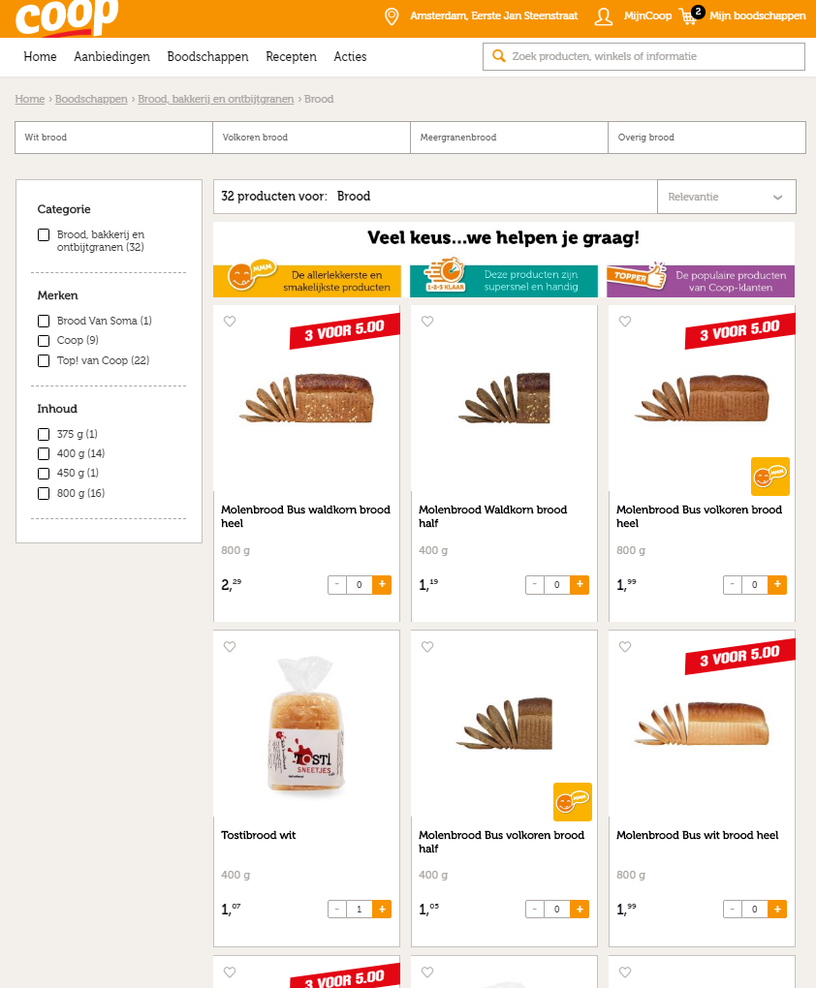

Supplementary Figure 2. Example of the webpage banner placement on the bread category webpage, combined with a tastiness label on whole-grain breads

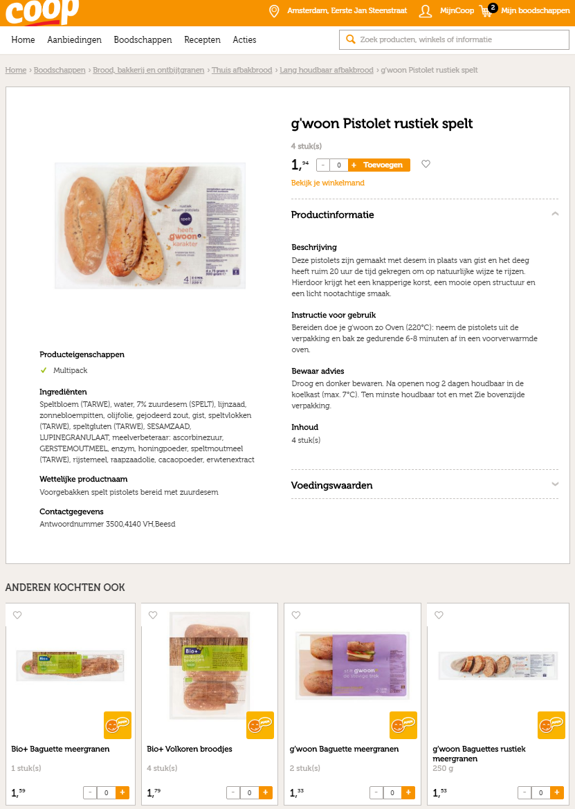

Supplementary Figure 3. Healthy product swaps (position nudge), including the tastiness labels and a heading ‘Also frequently purchased by other customers’

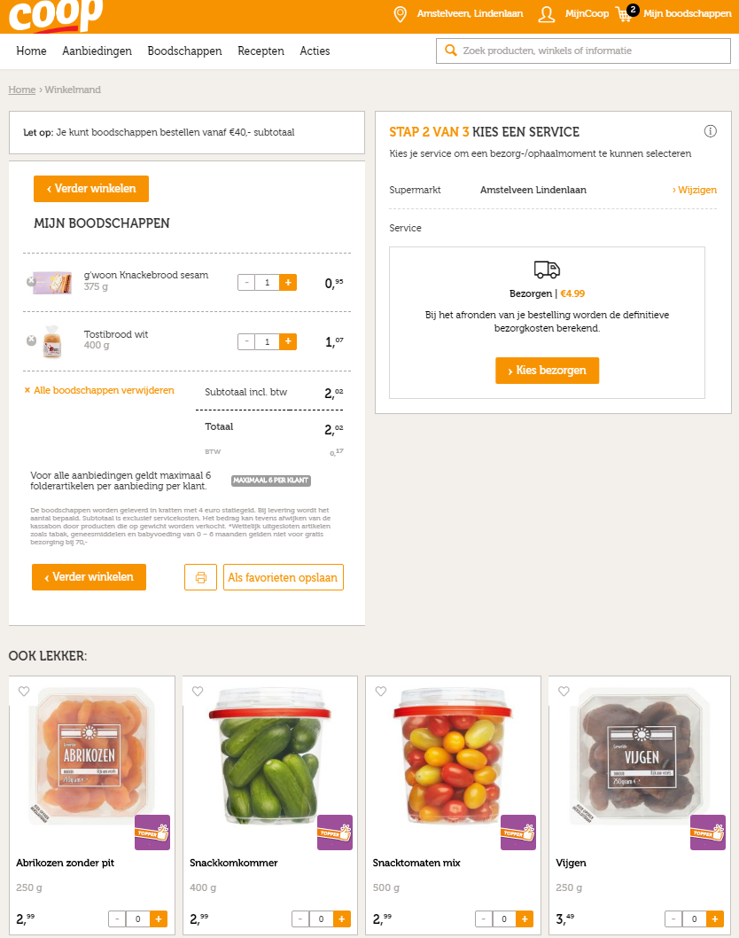

Supplementary Figure 4. Healthy check-out suggestions (position nudge), including the popularity labels and a heading ‘Tasty alternatives’

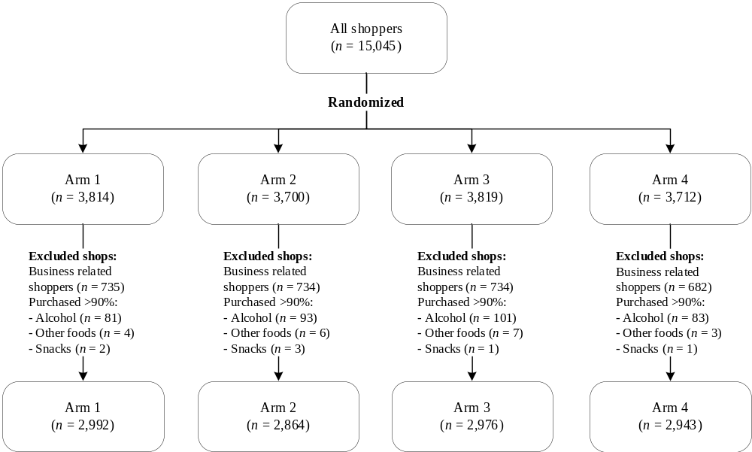

Supplementary Figure 5. Flow diagram of shoppers

Supplementary Table 1. Type of information nudges and food group assignment
Tastiness label | Convenience label | Popularity label
- Breads and bread substitutes  - Breakfast grains  - Pasta and rice  - Yogurt products  - Cheeses  - Peanut butters | - Canned legumes  - Canned fish  - Pre-cut and frozen vegetables  - Pre-cut and frozen fruits  - Nuts | - Fresh vegetables  - Fresh and dried fruits  - Cooking fats and butters  - Fresh fish  - Milk products  - Teas and coffees  - Sodas and waters

Supplementary Table 2. Mean percentages (95% CI)ª of total healthy purchases and per food group in arm 1 (control arm), by area-level deprivation
 | Deprived areas |  |  | Non-deprived areas
 | Mean | SD |  | Mean | SD
Total healthy purchases | 36.1 | 22.2 |  | 40.1 | 21.9
 | Mean | 95% | CI | Mean | 95% | CI
Fruits | 89.4 | 87.6, | 91.1 | 90.3 | 88.0, | 92.4
Vegetables | 85.7 | 83.7, | 87.6 | 89.0 | 87.5, | 90.5
Breads | 26.4 | 22.8, | 30.2 | 26.2 | 22.1, | 30.5
Bread substitutes | 18.0 | 14.0, | 22.1 | 20.5 | 16.8, | 24.4
Potatoes | 70.9 | 67.0, | 75.0 | 74.1 | 70.2, | 77.7
Pasta and rice | 13.6 | 9.9, | 17.5 | 19.6 | 15.2, | 24.1
Teas and coffees | 86.9 | 82.7, | 90.7 | 92.3 | 89.0, | 95.1
Sodas, juices and waters | 11.4 | 8.8, | 14.1 | 12.7 | 10.1, | 15.5
Cheeses | 12.7 | 10.2, | 15.4 | 10.9 | 8.6, | 13.2
Milk and yogurt products | 48.1 | 45.4, | 50.9 | 54.0 | 50.8, | 57.1
Meats | 34.5 | 31.5, | 37.7 | 35.4 | 32.3, | 38.4
Fish | 65.5 | 60.2, | 70.5 | 75.4 | 70.4, | 80.1
Legumes | 42.7 | 36.1, | 49.2 | 44.1 | 37.1, | 51.0
Nuts | 29.8 | 23.9, | 35.9 | 34.4 | 28.0, | 40.8
Fats | 46.2 | 41.8, | 50.6 | 46.4 | 42.7, | 50.1
Other foods^{b} | 10.7 | 9.9, | 11.5 | 9.3 | 8.7, | 10.0
Savoury snacks^{b} | 4.6 | 4.2, | 5.0 | 4.0 | 3.7, | 4.5
Sweet snacks^{b} | 6.6 | 6.2, | 7.1 | 6.0 | 5.6, | 6.4
Alcoholic drinks^{c} | 29.7 | 26.5, | 32.9 | 26.3 | 23.9, | 28.8
The number of shoppers within each food group is presented in Table 2.
ª Based on 10,000 non-parametric bootstrap replicates
^{b} Percentage was calculated based on the total grams purchased (considering the lack of healthy products in these food groups) excluding the grams purchased from alcohol
^{c} Percentage was calculated based on the total grams purchased

Supplementary Table 3. Mean grams (95% CI)ª of healthy and unhealthy purchases per food group in arm 1 (control arm), by area-level deprivation
 | Grams Healthy |  |  |  |  |  | Grams unhealthy
 | Deprived areas |  |  | Non-deprived areas |  |  | Deprived areas |  |  | Non-deprived areas
 | Mean | 95% CI |  | Mean | 95% CI |  | Mean | 95% CI |  | Mean | 95% CI
Fruits | 1620 | 1458, | 1811 | 1997 | 1801, | 2217 | 1039 | 910, | 1176 | 1245 | 1025, | 1475
Vegetables | 1968 | 1813, | 2134 | 2460 | 2255, | 2683 | 953 | 858, | 1058 | 803 | 720, | 891
Breads | 1459 | 1301, | 1631 | 1386 | 1176, | 1661 | 1493 | 1384, | 1606 | 1759 | 1577, | 1956
Bread substitutes | 136 | 102, | 171 | 202 | 148, | 265 | 582 | 528, | 640 | 610 | 551, | 673
Potatoes | 1249 | 1083, | 1439 | 1245 | 1119, | 1381 | 835 | 749, | 929 | 854 | 761, | 958
Pasta and rice | 850 | 698, | 1031 | 770 | 682, | 858 | 1123 | 956, | 1337 | 914 | 829, | 1009
Teas and coffees | 585 | 485, | 702 | 555 | 492, | 622 | 271 | 192, | 365 | 516 | 281, | 809
Sodas, juices and waters | 18482 | 14229, | 23037 | 12461 | 9982, | 15045 | 7571 | 6809, | 8421 | 7596 | 6802, | 8474
Cheeses | 276 | 246, | 306 | 259 | 236, | 284 | 652 | 591, | 725 | 651 | 599, | 706
Milk and yogurt products | 4574 | 4079, | 5151 | 5254 | 4716, | 5838 | 3195 | 2930, | 3472 | 3400 | 3048, | 3775
Meats | 883 | 827, | 942 | 966 | 893, | 1045 | 979 | 896, | 1067 | 976 | 907, | 1049
Fish | 469 | 420, | 523 | 476 | 420, | 535 | 548 | 492, | 608 | 574 | 473, | 714
Legumes | 838 | 690, | 999 | 849 | 720, | 1005 | 984 | 825, | 1167 | 888 | 751, | 1035
Nuts | 354 | 302, | 412 | 332 | 290, | 372 | 476 | 436, | 520 | 563 | 497, | 650
Fats | 890 | 804, | 986 | 905 | 801, | 1029 | 719 | 667, | 773 | 773 | 693, | 857
Other foods | NA |  |  | NA |  |  | 1971 | 1835, | 2122 | 2006 | 1878, | 2144
Savoury snacks | NA |  |  | NA |  |  | 853 | 778, | 933 | 846 | 772, | 928
Sweet snacks | NA |  |  | NA |  |  | 1251 | 1170, | 1333 | 1274 | 1164, | 1396
Alcoholic drinks | NA |  |  | NA |  |  | 8545 | 7477, | 9705 | 7897 | 6736, | 9211
The number of shoppers within each food group is presented in Table 2.
NA: Not applicable.
ª Based on 10,000 non-parametric bootstrap replicates.

Supplementary Table 4. Mean differences (95% CI)ª in the percentage healthy purchases within food groups in Arm 2 (information nudge), Arm 3 (position nudge), and Arm 4 (information and position nudges) compared to arm 1, by area-level deprivation
 | Deprived areas |  |  | Non-deprived areas
 | Mean diff. | 95% | CI | Mean diff. | 95% | CI
Fruits
Arm 2 | 0.9 | -1.8, | 3.5 | -1.3 | -4.1, | 1.5
Arm 3 | 1.2 | -1.3, | 3.6 | -1.3 | -4.0, | 1.3
Arm 4 | -0.7 | -3.7, | 2.3 | -3.0 | -5.8, | -0.2
Vegetables
Arm 2 | -0.6 | -3.6, | 2.3 | -2.1 | -4.5, | 0.2
Arm 3 | 0.1 | -2.5, | 2.8 | -2.1 | -4.6, | 0.4
Arm 4 | -0.1 | -3.2, | 2.9 | -2.8 | -5.5, | -0.3
Breads
Arm 2 | 5.0 | -0.3, | 10.1 | 4.7 | -1.0, | 10.5
Arm 3 | 1.1 | -3.6, | 5.9 | 3.5 | -1.5, | 8.4
Arm 4 | 3.5 | -1.6, | 8.3 | 3.3 | -2.2, | 8.4
Bread substitutes
Arm 2 | 0.5 | -4.9, | 6.0 | -1.4 | -7.2, | 4.5
Arm 3 | 1.8 | -4.5, | 8.2 | 0.4 | -5.0, | 5.9
Arm 4 | 3.2 | -2.6, | 9.2 | -3.5 | -8.6, | 1.8
Potatoes
Arm 2 | -1.9 | -7.9, | 4.0 | 3.5 | -1.8, | 8.7
Arm 3 | -0.5 | -6.6, | 5.5 | 2.6 | -2.9, | 8.0
Arm 4 | 1.4 | -4.2, | 7.0 | -1.0 | -7.3, | 5.4
Pasta and rice
Arm 2 | 4.1 | -1.4, | 9.6 | -2.3 | -8.3, | 3.9
Arm 3 | 2.6 | -4.1, | 9.5 | -1.2 | -7.5, | 5.7
Arm 4 | 7.6 | 2.4, | 12.7 | -0.4 | -5.8, | 5.4
Teas and coffees
Arm 2 | 1.1 | -4.2, | 6.6 | -4.2 | -9.4, | 1.0
Arm 3 | 0.0 | -5.0, | 5.2 | -1.5 | -5.8, | 2.7
Arm 4 | 2.1 | -3.0, | 7.4 | 1.7 | -1.9, | 5.6
Sodas, waters and juices
Arm 2 | 1.6 | -2.3, | 5.6 | -1.3 | -5.2, | 2.7
Arm 3 | -0.5 | -4.2, | 3.4 | 0.1 | -3.4, | 3.7
Arm 4 | -0.7 | -3.9, | 2.6 | -0.5 | -3.9, | 2.9
Cheeses
Arm 2 | 0.4 | -3.3, | 4.1 | -0.9 | -3.6, | 1.9
Arm 3 | -2.9 | -6.2, | 0.4 | 1.0 | -2.3, | 4.6
Arm 4 | -2.8 | -6.1, | 0.6 | -0.2 | -3.2, | 2.9
Milk and yogurt products
Arm 2 | 4.6 | 0.5, | 8.8 | -1.2 | -5.2, | 2.8
Arm 3 | 0.0 | -3.9, | 3.9 | -0.0 | -3.8, | 3.7
Arm 4 | 4.2 | -0.1, | 8.6 | -0.5 | -5.0, | 3.8
Meats
Arm 2 | -0.1 | -3.8, | 3.5 | 0.2 | -3.3, | 3.5
Arm 3 | 0.6 | -3.6, | 4.8 | 0.0 | -3.6, | 3.7
Arm 4 | -0.8 | -4.5, | 2.8 | -2.9 | -6.4, | 0.6
Fish
Arm 2 | 7.1 | -0.5, | 14.8 | -8.4 | -16.5, | -0.0
Arm 3 | 5.7 | -1.2, | 12.5 | -3.5 | -11.1, | 4.3
Arm 4 | 5.3 | -2.4, | 12.8 | -2.1 | -9.8, | 5.5
Legumes
Arm 2 | 0.6 | -7.9, | 9.3 | -10.2 | -19.3, | -1.0
Arm 3 | -0.4 | -10.3, | 9.8 | -2.2 | -11.6, | 7.2
Arm 4 | -5.5 | -16.1, | 5.0 | 5.6 | -3.6, | 14.8
Nuts
Arm 2 | 1.0 | -7.7, | 9.8 | -10.7 | -17.5, | -3.8
Arm 3 | -4.7 | -11.9, | 2.4 | -4.6 | -12.5, | 3.6
Arm 4 | -2.7 | -10.7, | 5.4 | -3.8 | -12.2, | 4.4
Fats
Arm 2 | 1.6 | -4.4, | 7.6 | -7.9 | -13.1, | -2.7
Arm 3 | 1.7 | -4.1, | 7.5 | -5.6 | -11.0, | 0.0
Arm 4 | -2.9 | -8.3, | 2.6 | -2.7 | -8.0, | 2.5
Unhealthy other foods^{b}
Arm 2 | -1.1 | -2.2, | -0.0 | 0.1 | -0.7, | 1.0
Arm 3 | -0.5 | -1.4, | 0.4 | -0.0 | -0.9, | 0.8
Arm 4 | -0.1 | -1.3, | 1.2 | 0.1 | -0.9, | 1.0
Unhealthy savoury snacks^{b}
Arm 2 | -0.6 | -1.1, | 0.0 | -0.0 | -0.6, | 0.6
Arm 3 | -0.3 | -0.9, | 0.4 | 0.1 | -0.4, | 0.7
Arm 4 | -0.1 | -0.8, | 0.5 | -0.3 | -0.8, | 0.2
Unhealthy sweet snacks^{b}
Arm 2 | -0.4 | -0.9, | 0.2 | 0.2 | -0.4, | 0.8
Arm 3 | -0.1 | -0.8, | 0.6 | 0.1 | -0.5, | 0.7
Arm 4 | -0.5 | -1.1, | 0.2 | 0.3 | -0.3, | 0.9
Unhealthy alcohol drinks^{c}
Arm 2 | -2.8 | -7.2, | 1.6 | -0.1 | -3.7, | 3.4
Arm 3 | -2.9 | -7.1, | 1.5 | -0.1 | -3.7, | 3.2
Arm 4 | -0.5 | -5.1, | 4.2 | -0.5 | -3.8, | 2.9

The number of shoppers within each food group is presented in Table 2.
ª Based on 10,000 non-parametric bootstrap replicates; Bold numbers represent statistically significant results.
^{b} Percentage difference was not based on the grams of healthy products purchased, but calculated based on the total grams purchased (considering the lack of healthy products in these food groups) excluding the grams purchased from alcohol
^{c} Percentage difference was not based on the grams of healthy products purchased, but calculated based on the total grams purchased (considering the lack of healthy products in these food groups)

Supplementary Table 5. Mean differences (95% CI)ª in total retailer revenue (Euros) in Arm 2 (information nudge), Arm 3 (position nudge), and Arm 4 (information and position nudges) compared to arm 1, by area-level deprivation
 | Deprived areas |  |  | Non-deprived areas
 | Mean diff. | 95% | CI | Mean diff. | 95% | CI
Arm 2 | 2.06 | -2.67; | 6.94 | -1.88 | -6.50; | 2.92
Arm 3 | 3.17 | -1.57; | 8.30 | -1.97 | -6.91; | 2.90
Arm 4 | 1.71 | -2.46; | 5.86 | 0.74 | -4.07; | 5.67
The number of shoppers within each group is presented in Table 2.
ª Based on 10,000 non-parametric bootstrap replicates

Supplementary Table 6. Mean differences (95% CI)ª in the grams healthy and grams unhealthy purchased within food groups in Arm 2 (information nudge), Arm 3 (position nudge), and Arm 4 (information and position nudges) compared to arm 1, by area-level deprivation
 | Grams healthy |  |  |  |  |  | Grams unhealthy
 | Deprived areas |  |  | Non-deprived areas |  |  | Deprived areas |  |  | Non-deprived areas
 | Mean diff. | 95% | CI | Mean diff. | 95% | CI | Mean diff. | 95% | CI | Mean diff. | 95% | CI
Fruits
Arm 2 | 126 | -174, | 462 | -366 | -639, | -119 | 59 | -170, | 304 | -129 | -390, | 127
Arm 3 | -79 | -299, | 116 | -331 | -582, | -91 | 60 | -165, | 314 | -48 | -322, | 237
Arm 4 | -14 | -253, | 227 | -352 | -599, | -125 | -8 | -196, | 183 | 53 | -231, | 334
Vegetables
Arm 2 | 271 | 15, | 560 | -263 | -533, | 3 | 20 | -133, | 190 | -37 | -149, | 77
Arm 3 | 119 | -93, | 334 | -212 | -478, | 38 | -108 | -244, | 23 | 35 | -76, | 144
Arm 4 | 249 | 41, | 452 | -122 | -397, | 145 | -13 | -160, | 138 | 85 | -43, | 223
Breads
Arm 2 | 40 | -227, | 319 | -224 | -526, | 23 | 38 | -110, | 181 | -148 | -393, | 103
Arm 3 | -41 | -284, | 190 | 74 | -232, | 347 | 105 | -49, | 259 | -145 | -384, | 121
Arm 4 | -39 | -258, | 183 | -15 | -298, | 235 | 168 | -32, | 367 | -163 | -397, | 62
Bread substitutes
Arm 2 | 1 | -48, | 50 | -40 | -115, | 27 | 25 | -54, | 105 | -2 | -95, | 99
Arm 3 | 7 | -42, | 57 | -55 | -125, | 7 | 38 | -45, | 129 | -25 | -110, | 58
Arm 4 | 29 | -25, | 84 | -58 | -133, | 7 | -24 | -109, | 66 | 76 | -62, | 246
Potatoes
Arm 2 | 219 | -50, | 486 | 144 | -91, | 384 | 63 | -100, | 238 | 49 | -86, | 183
Arm 3 | 9 | -240, | 249 | 158 | -53, | 376 | -4 | -120, | 111 | 49 | -99, | 193
Arm 4 | 8 | -248, | 242 | 108 | -100, | 316 | 50 | -93, | 212 | 107 | -81, | 312
Pasta and rice
Arm 2 | 11 | -242, | 283 | 121 | -15, | 267 | -68 | -313, | 147 | 2 | -118, | 124
Arm 3 | 87 | -188, | 339 | -24 | -146, | 101 | -231 | -461, | -38 | -13 | -148, | 127
Arm 4 | -1 | -244, | 231 | 63 | -64, | 208 | -274 | -505, | -75 | -52 | -165, | 58
Teas and coffees
Arm 2 | -7 | -150, | 142 | 1 | -71, | 75 | 44 | -44, | 132 | -246 | -540, | -6
Arm 3 | -15 | -170, | 136 | 6 | -85, | 95 | 54 | -61, | 166 | -206 | -511, | 51
Arm 4 | -34 | -171, | 89 | 31 | -57, | 128 | 2 | -122, | 127 | -273 | -576, | -21
Sodas, waters and juices
Arm 2 | -1209 | -7893, | 5790 | 15051 | 1618, | 37328 | -318 | -1465, | 814 | 154 | -1031, | 1315
Arm 3 | -6078 | -11643, | -579 | 4604 | -329, | 10649 | 786 | -273, | 1933 | -650 | -1654, | 281
Arm 4 | -1830 | -8028, | 4759 | -243 | -4183, | 3877 | -398 | -1468, | 624 | -664 | -1852, | 508
Cheeses
Arm 2 | 35 | -14, | 88 | 6 | -42, | 64 | -23 | -114, | 70 | -76 | -140, | -13
Arm 3 | 13 | -39, | 74 | 55 | 15, | 98 | -14 | -97, | 60 | -5 | -82, | 74
Arm 4 | 45 | -19, | 119 | 51 | 11, | 91 | -6 | -98, | 83 | 45 | -32, | 128
Milk and yogurt products
Arm 2 | 580 | -457, | 1793 | -100 | -642, | 509 | 322 | -282, | 1112 | -75 | -526, | 372
Arm 3 | 119 | -654, | 904 | -138 | -771, | 539 | 138 | -307, | 644 | 35 | -403, | 468
Arm 4 | 139 | -599, | 879 | -183 | -813, | 466 | -61 | -441, | 300 | 47 | -368, | 469
Meats
Arm 2 | 92 | -12, | 203 | -43 | -142, | 55 | 22 | -113, | 173 | 18 | -78, | 110
Arm 3 | 74 | -22, | 184 | -21 | -111, | 65 | 9 | -96, | 112 | 54 | -43, | 149
Arm 4 | 36 | -44, | 116 | -45 | -143, | 49 | 97 | -24, | 219 | 128 | 23, | 238
Fish
Arm 2 | 49 | -63, | 171 | -63 | -135, | 10 | 101 | -44, | 266 | 3 | -165, | 167
Arm 3 | 8 | -56, | 72 | -24 | -97, | 47 | -29 | -110, | 52 | -71 | -221, | 48
Arm 4 | 62 | -33, | 164 | 14 | -66, | 100 | -18 | -110, | 71 | 47 | -112, | 224
Legumes
Arm 2 | 39 | -177, | 261 | -87 | -269, | 92 | -58 | -267, | 141 | -37 | -193, | 108
Arm 3 | -22 | -214, | 167 | -96 | -286, | 81 | -152 | -361, | 49 | 42 | -153, | 240
Arm 4 | 8 | -205, | 211 | 5 | -224, | 236 | -50 | -295, | 202 | -31 | -211, | 149
Nuts
Arm 2 | 12 | -74, | 99 | -23 | -76, | 32 | 35 | -28, | 100 | -28 | -125, | 54
Arm 3 | 16 | -74, | 114 | -7 | -68, | 59 | 79 | 4, | 159 | -8 | -97, | 70
Arm 4 | -19 | -84, | 43 | 24 | -49, | 108 | 65 | -4, | 139 | -30 | -124, | 53
Fats
Arm 2 | 29 | -97, | 153 | -88 | -243, | 51 | 51 | -43, | 146 | 23 | -79, | 124
Arm 3 | -22 | -138, | 89 | -17 | -191, | 155 | 5 | -76, | 85 | 3 | -84, | 89
Arm 4 | -18 | -144, | 104 | -26 | -165, | 100 | -61 | -143, | 22 | -2 | -107, | 107
Other foods
Arm 2 | NA |  |  | NA |  |  | -50 | -259, | 152 | -160 | -337, | 12
Arm 3 | NA |  |  | NA |  |  | -74 | -266, | 118 | -196 | -346, | -50
Arm 4 | NA |  |  | NA |  |  | -75 | -264, | 109 | -154 | -342, | 49
Savoury snacks
Arm 2 | NA |  |  | NA |  |  | -24 | -142, | 91 | 43 | -76, | 163
Arm 3 | NA |  |  | NA |  |  | -66 | -153, | 22 | -14 | -118, | 90
Arm 4 | NA |  |  | NA |  |  | -32 | -140, | 75 | 12 | -100, | 125
Sweet snacks
Arm 2 | NA |  |  | NA |  |  | -11 | -127, | 109 | -43 | -155, | 66
Arm 3 | NA |  |  | NA |  |  | 64 | -147, | 384 | -90 | -204, | 22
Arm 4 | NA |  |  | NA |  |  | -78 | -190, | 32 | 23 | -128, | 181
Alcoholic drinks
Arm 2 | NA |  |  | NA |  |  | 72 | -2025, | 2465 | 641 | -1329, | 2675
Arm 3 | NA |  |  | NA |  |  | -142 | -1879, | 1571 | 573 | -1193, | 2151
Arm 4 | NA |  |  | NA |  |  | 2477 | -370, | 5761 | 710 | -1065, | 2453
The number of shoppers within each food group is presented in Table 2; NA: Not applicable.
ª Based on 10,000 non-parametric bootstrap replicates; Bold numbers represent statistically significant results.

Supplementary Table 7. Mean differences (98% CI)ª in the percentage healthy purchases within food groups in Arm 2 (information nudge), Arm 3 (position nudge), and Arm 4 (information and position nudges) compared to arm 1, by area-level deprivation
 | Deprived areas |  |  | Non-deprived areas
 | Mean diff. | 98% | CI | Mean diff. | 98% | CI
Fruits
Arm 2 | 0.9 | -2.2, | 3.9 | -1.3 | -4.8, | 2.1
Arm 3 | 1.2 | -1.8, | 4.0 | -1.3 | -4.5, | 1.7
Arm 4 | -0.7 | -4.2, | 2.9 | -3.1 | -6.6, | 0.2
Vegetables
Arm 2 | -0.6 | -4.2, | 3.0 | -2.1 | -4.9, | 0.7
Arm 3 | 0.1 | -2.9, | 3.2 | -2.1 | -5.1, | 0.8
Arm 4 | -0.1 | -3.7, | 3.6 | -2.8 | -6.0, | 0.2
Breads
Arm 2 | 5.0 | -1.2, | 11.0 | 4.7 | -2.0, | 11.6
Arm 3 | 1.1 | -4.4, | 6.7 | 3.5 | -2.5, | 9.5
Arm 4 | 3.5 | -2.5, | 9.2 | 3.3 | -3.3, | 9.3
Bread substitutes
Arm 2 | 0.4 | -6.0, | 7.0 | -1.3 | -8.2, | 5.5
Arm 3 | 1.8 | -5.7, | 9.5 | 0.5 | -5.9, | 7.3
Arm 4 | 3.1 | -3.7, | 10.4 | -3.5 | -9.6, | 2.7
Potatoes
Arm 2 | -1.9 | -9.0, | 5.0 | 3.4 | -2.7, | 9.7
Arm 3 | -0.4 | -7.4, | 6.8 | 2.6 | -3.8, | 9.0
Arm 4 | 1.4 | -5.2, | 8.1 | -1.0 | -8.3, | 6.6
Pasta and rice
Arm 2 | 4.1 | -2.4, | 10.7 | -2.3 | -9.3, | 5.0
Arm 3 | 2.6 | -5.5, | 10.6 | -1.2 | -8.7, | 7.1
Arm 4 | 7.6 | 1.1, | 13.6 | -0.4 | -6.7, | 6.7
Teas and coffees
Arm 2 | 1.1 | -5.2, | 7.6 | -4.2 | -10.3, | 2.0
Arm 3 | 0.1 | -6.0, | 6.3 | -1.4 | -6.5, | 3.7
Arm 4 | 2.0 | -3.8, | 8.6 | 1.7 | -2.5, | 6.3
Sodas, waters and juices
Arm 2 | 1.6 | -3.1, | 6.3 | -1.3 | -6.0, | 3.3
Arm 3 | -0.5 | -4.6, | 4.2 | 0.1 | -4.0, | 4.4
Arm 4 | -0.6 | -4.5, | 3.2 | -0.5 | -4.6, | 3.4
Cheeses
Arm 2 | 0.4 | -3.93, | 4.7 | -0.9 | -4.0, | 2.4
Arm 3 | -3.0 | -6.9, | 1.1 | 1.0 | -3.0, | 5.3
Arm 4 | -2.8 | -6.8, | 1.2 | -0.3 | -3.8, | 3.4
Milk and yogurt products
Arm 2 | 4.6 | -0.3, | 9.7 | -1.2 | -6.0, | 3.7
Arm 3 | 0.0 | -4.6, | 4.6 | 0.0 | -4.5, | 4.5
Arm 4 | 4.2 | -0.8, | 9.5 | -0.5 | -5.7, | 4.8
Meats
Arm 2 | -0.1 | -4.6, | 4.2 | 0.1 | -3.9, | 4.2
Arm 3 | 0.6 | -4.2, | 5.5 | 0.0 | -4.3, | 4.4
Arm 4 | -0.8 | -5.2, | 3.4 | -2.8 | -7.1, | 1.4
Fish
Arm 2 | 7.2 | -1.7, | 16.2 | -8.4 | -18.0, | 1.2
Arm 3 | 5.8 | -2.1, | 13.8 | -3.5 | -12.7, | 5.9
Arm 4 | 5.3 | -3.8, | 14.5 | -2.1 | -10.8, | 7.0
Legumes
Arm 2 | 0.6 | -9.8, | 10.7 | -10.1 | -20.9, | 0.9
Arm 3 | -0.4 | -12.1, | 11.6 | -2.1 | -13.1, | 8.9
Arm 4 | -5.6 | -17.9, | 6.8 | 5.7 | -4.9, | 16.4
Nuts
Arm 2 | 1.0 | -9.4, | 11.4 | -10.7 | -19.0, | -2.2
Arm 3 | -4.6 | -13.6, | 4.1 | -4.6 | -14.3, | 5.1
Arm 4 | -2.6 | -12.6, | 7.4 | -3.8 | -14.1, | 6.0
Fats
Arm 2 | 1.5 | -5.7, | 8.8 | -7.9 | -14.5, | -1.7
Arm 3 | 1.7 | -5.4, | 8.4 | -5.6 | -12.2, | 1.1
Arm 4 | -2.9 | -9.3, | 3.6 | -2.8 | -9.0, | 3.7
Other foods^{b}
Arm 2 | -1.1 | -2.4, | 0.2 | 0.1 | -0.9, | 1.2
Arm 3 | -0.5 | -1.6, | 0.6 | -0.0 | -1.0, | 0.9
Arm 4 | -0.1 | -1.6, | 1.4 | 0.1 | -1.1, | 1.2
Savoury snacks^{b}
Arm 2 | -0.6 | -1.2, | 0.1 | -0.0 | -0.7, | 0.7
Arm 3 | -0.3 | -1.0, | 0.5 | 0.1 | -0.5, | 0.8
Arm 4 | -0.1 | -0.9, | 0.7 | -0.3 | -0.9, | 0.3
Sweet snacks^{b}
Arm 2 | -0.3 | -1.0, | 0.3 | 0.2 | -0.5, | 0.9
Arm 3 | -0.1 | -0.9, | 0.8 | 0.1 | -0.6, | 0.8
Arm 4 | -0.5 | -1.2, | 0.3 | 0.3 | -0.4, | 1.0
Alcoholic drinks^{c}
Arm 2 | -2.8 | -8.0, | 2.7 | -0.1 | -4.5, | 3.9
Arm 3 | -2.9 | -7.9, | 2.2 | -0.1 | -4.3, | 3.7
Arm 4 | -0.5 | -6.1, | 5.2 | -0.5 | -4.4, | 3.4

The number of shoppers within each food group is presented in Table 2.
ª Based on 10,000 non-parametric bootstrap replicates; Bold numbers represent statistically significant results.
^{b} Percentage was calculated based on the total grams purchased (considering the lack of healthy products in these food groups) excluding the grams purchased from alcohol
^{c} Percentage was calculated based on the total grams purchased

Supplementary Table 8. Mean differences (98% CI)ª in the grams healthy and grams unhealthy purchased within food groups in Arm 2 (information nudge), Arm 3 (position nudge), and Arm 4 (information and position nudges) compared to arm 1, by area-level deprivation
 | Grams healthy |  |  |  |  |  | Grams unhealthy
 | Deprived areas |  |  | Non-deprived areas |  |  | Deprived areas |  |  | Non-deprived areas
 | Mean diff. | 98% | CI | Mean diff. | 98% | CI | Mean diff. | 98% | CI | Mean diff. | 98% | CI
Fruits
Arm 2 | 126 | -222, | 533 | -366 | -691, | -76 | 59 | -209, | 351 | -129 | -435, | 181
Arm 3 | -79 | -346, | 146 | -331 | -632, | -44 | 60 | -203, | 360 | -48 | -371, | 292
Arm 4 | -14 | -301, | 270 | -352 | -653, | -82 | -8 | -229, | 218 | 53 | -284, | 382
Vegetables
Arm 2 | 271 | -28, | 621 | -263 | -584, | 55 | 20 | -160, | 222 | -37 | -169, | 100
Arm 3 | 119 | -133, | 371 | -212 | -527, | 86 | -108 | -269, | 47 | 35 | -97, | 167
Arm 4 | 249 | 2, | 488 | -122 | -449, | 198 | -13 | -189, | 167 | 85 | -68, | 247
Breads
Arm 2 | 40 | -278, | 377 | -224 | -590, | 63 | 38 | -136, | 210 | -148 | -440, | 150
Arm 3 | -41 | -334, | 231 | 74 | -300, | 393 | 105 | -74, | 292 | -145 | -428, | 176
Arm 4 | -39 | -299, | 226 | -15 | -362, | 268 | 168 | -71, | 406 | -163 | -445, | 104
Bread substitutes
Arm 2 | 1 | -58, | 59 | -40 | -130, | 38 | 25 | -70, | 120 | -2 | -112, | 118
Arm 3 | 7 | -51, | 67 | -55 | -140, | 19 | 38 | -59, | 145 | -25 | -127, | 74
Arm 4 | 29 | -36, | 95 | -58 | -150, | 18 | -24 | -126, | 87 | 76 | -86, | 287
Potatoes
Arm 2 | 219 | -101, | 540 | 144 | -133, | 430 | 63 | -131, | 272 | 49 | -115, | 206
Arm 3 | 9 | -293, | 291 | 158 | -90, | 416 | -4 | -145, | 130 | 49 | -126, | 218
Arm 4 | 8 | -302, | 286 | 108 | -139, | 354 | 50 | -120, | 241 | 107 | -113, | 354
Pasta and rice
Arm 2 | 11 | -284, | 331 | 121 | -36, | 298 | -68 | -361, | 182 | 2 | -142, | 148
Arm 3 | 87 | -243, | 380 | -24 | -169, | 124 | -231 | -515, | -1 | -13 | -173, | 157
Arm 4 | -1 | -291, | 275 | 63 | -85, | 244 | -274 | -553, | -42 | -52 | -187, | 78
Teas and coffees
Arm 2 | -7 | -177, | 170 | 1 | -85, | 91 | 44 | -62, | 148 | -246 | -605, | 21
Arm 3 | -15 | -200, | 162 | 6 | -101, | 113 | 54 | -83, | 189 | -206 | -570, | 92
Arm 4 | -34 | -201, | 108 | 31 | -75, | 146 | 2 | -145, | 151 | -273 | -634, | 16
Sodas, waters and juices
Arm 2 | -1209 | -9082, | 7133 | 15051 | 450, | 43388 | -318 | -1680, | 1022 | 154 | -1242, | 1544
Arm 3 | -6078 | -12790, | 436 | 4604 | -1200, | 12099 | 786 | -470, | 2165 | -650 | -1847, | 449
Arm 4 | -1830 | -9403, | 6094 | -243 | -4837, | 4649 | -398 | -1701, | 810 | -664 | -2054, | 717
Cheeses
Arm 2 | 35 | -22, | 99 | 6 | -49, | 77 | -23 | -131, | 90 | -76 | -151, | -3
Arm 3 | 13 | -47, | 87 | 55 | 6, | 108 | -14 | -113, | 73 | -5 | -96, | 87
Arm 4 | 45 | -28, | 134 | 51 | 4, | 98 | -6 | -116, | 100 | 45 | -47, | 146
Milk and yogurt products
Arm 2 | 580 | -628, | 2032 | -100 | -751, | 628 | 322 | -383, | 1295 | -75 | -622, | 459
Arm 3 | 119 | -816, | 1054 | -138 | -883, | 671 | 138 | -382, | 738 | 35 | -476, | 547
Arm 4 | 139 | -768, | 1022 | -183 | -943, | 593 | -61 | -505, | 357 | 47 | -451, | 551
Meats
Arm 2 | 92 | -33, | 228 | -43 | -161, | 73 | 22 | -133, | 201 | 18 | -98, | 129
Arm 3 | 74 | -39, | 208 | -21 | -129, | 83 | 9 | -118, | 133 | 54 | -61, | 169
Arm 4 | 36 | -58, | 131 | -45 | -163, | 65 | 97 | -45, | 248 | 128 | 1, | 258
Fish
Arm 2 | 49 | -80, | 196 | -63 | -148, | 27 | 101 | -66, | 300 | 3 | -198, | 199
Arm 3 | 8 | -69, | 86 | -24 | -110, | 60 | -29 | -127, | 67 | -71 | -250, | 68
Arm 4 | 62 | -50, | 186 | 14 | -80, | 117 | -18 | -127, | 86 | 47 | -136, | 261
Legumes
Arm 2 | 39 | -221, | 301 | -87 | -305, | 121 | -58 | -313, | 176 | -37 | -225, | 134
Arm 3 | -22 | -256, | 202 | -96 | -322, | 107 | -152 | -403, | 87 | 42 | -191, | 289
Arm 4 | 8 | -246, | 244 | 5 | -264, | 279 | -50 | -341, | 250 | -31 | -244, | 181
Nuts
Arm 2 | 12 | -92, | 115 | -23 | -88, | 42 | 35 | -40, | 113 | -28 | -149, | 67
Arm 3 | 16 | -91, | 137 | -7 | -80, | 72 | 79 | -10, | 175 | -8 | -115, | 82
Arm 4 | -19 | -97, | 55 | 24 | -61, | 127 | 65 | -16, | 154 | -30 | -145, | 68
Fats
Arm 2 | 29 | -123, | 173 | -88 | -277, | 77 | 51 | -58, | 165 | 23 | -99, | 145
Arm 3 | -22 | -160, | 111 | -17 | -223, | 186 | 5 | -93, | 100 | 3 | -101, | 103
Arm 4 | -18 | -167, | 128 | -26 | -192, | 124 | -61 | -157, | 38 | -2 | -126, | 127
Other foods
Arm 2 | NA |  |  | NA |  |  | -51 | -300, | 193 | -160 | -370, | 42
Arm 3 | NA |  |  | NA |  |  | -73 | -302, | 159 | -196 | -376, | -27
Arm 4 | NA |  |  | NA |  |  | -76 | -302, | 140 | -154 | -378, | 89
Savoury snacks
Arm 2 | NA |  |  | NA |  |  | -24 | -161, | 111 | 42 | -98, | 186
Arm 3 | NA |  |  | NA |  |  | -66 | -167, | 37 | -14 | -140, | 107
Arm 4 | NA |  |  | NA |  |  | -32 | -159, | 94 | 12 | -124, | 147
Sweet snacks
Arm 2 | NA |  |  | NA |  |  | -11 | -148, | 135 | -43 | -175, | 87
Arm 3 | NA |  |  | NA |  |  | 61 | -171, | 439 | -89 | -227, | 41
Arm 4 | NA |  |  | NA |  |  | -78 | -212, | 61 | 23 | -156, | 206
Alcoholic drinks
Arm 2 | NA |  |  | NA |  |  | 71 | -2379, | 2998 | 632 | -1725, | 3050
Arm 3 | NA |  |  | NA |  |  | -152 | -2103, | 1890 | 566 | -1604, | 2444
Arm 4 | NA |  |  | NA |  |  | 2457 | -863, | 6446 | 700 | -1472, | 2770
The number of shoppers within each food group is presented in Table 2; NA: Not applicable.
ª Based on 10,000 non-parametric bootstrap replicates; Bold numbers represent statistically significant results.

