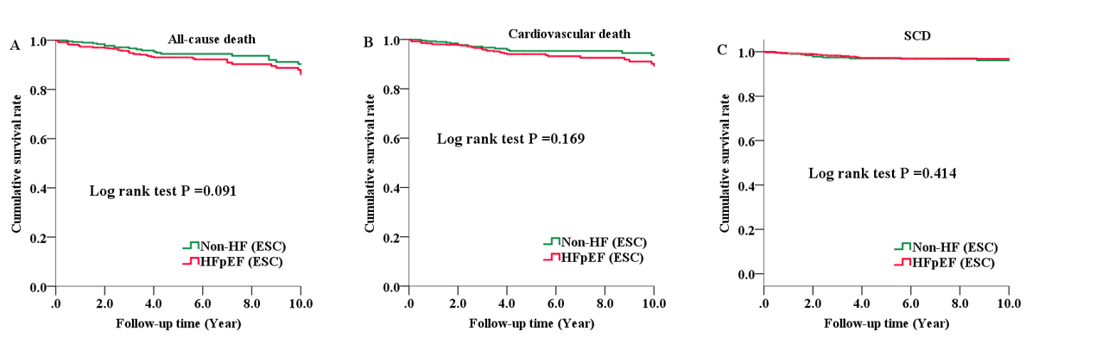
Figure S1. Kaplan-Meier curve for patients with HFpEF and non-HF patients using ESC criteria in HCM.
Cumulative survival rate curves for all-cause death (A), cardiovascular death (B), and SCD (C).
ESC, European Society of Cardiology; HCM, hypertrophic cardiomyopathy; HFpEF, heart failure with preserved ejection fraction; SCD, sudden cardiac death.

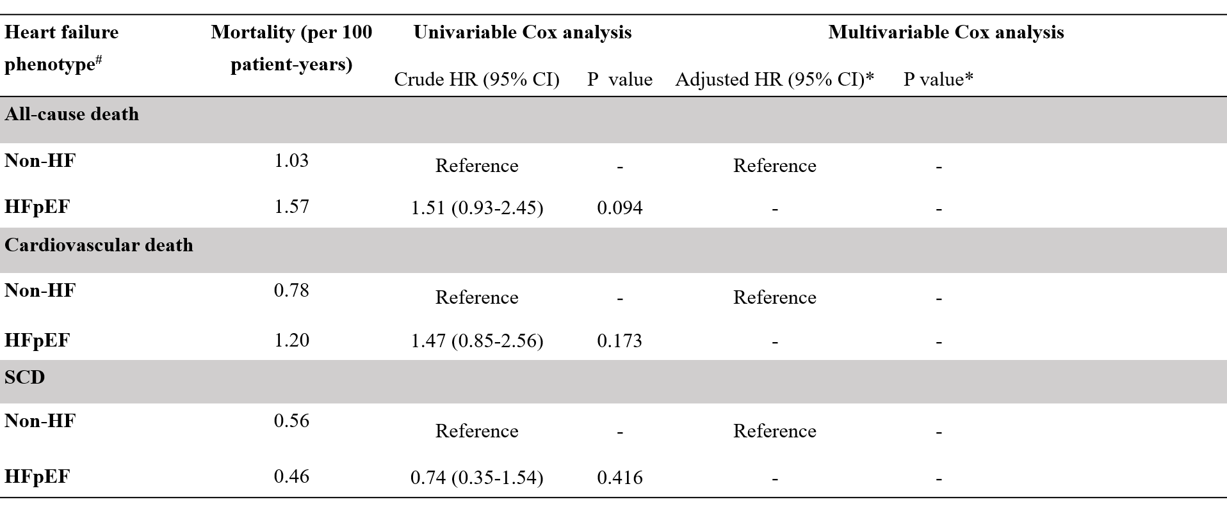
Figure S2. Hazard ratio of HFpEF versus non-HF using ESC criteria in 1178 patients with HCM.
#Heart failure phenotypes were identified using ESC criteria.
*Multivariable Cox regression analysis, models were adjusted for the following covariates using a backward method: age, sex, maximal left ventricular wall thickness, atrial fibrillation, maximal left ventricular outflow tract gradient, and NYHA class.
CI, confidence interval; ESC, European Society of Cardiology; HFpEF, heart failure with preserved ejection fraction; non-HF, patients without heart failure; HR, hazard ratio; SCD, sudden cardiac death.
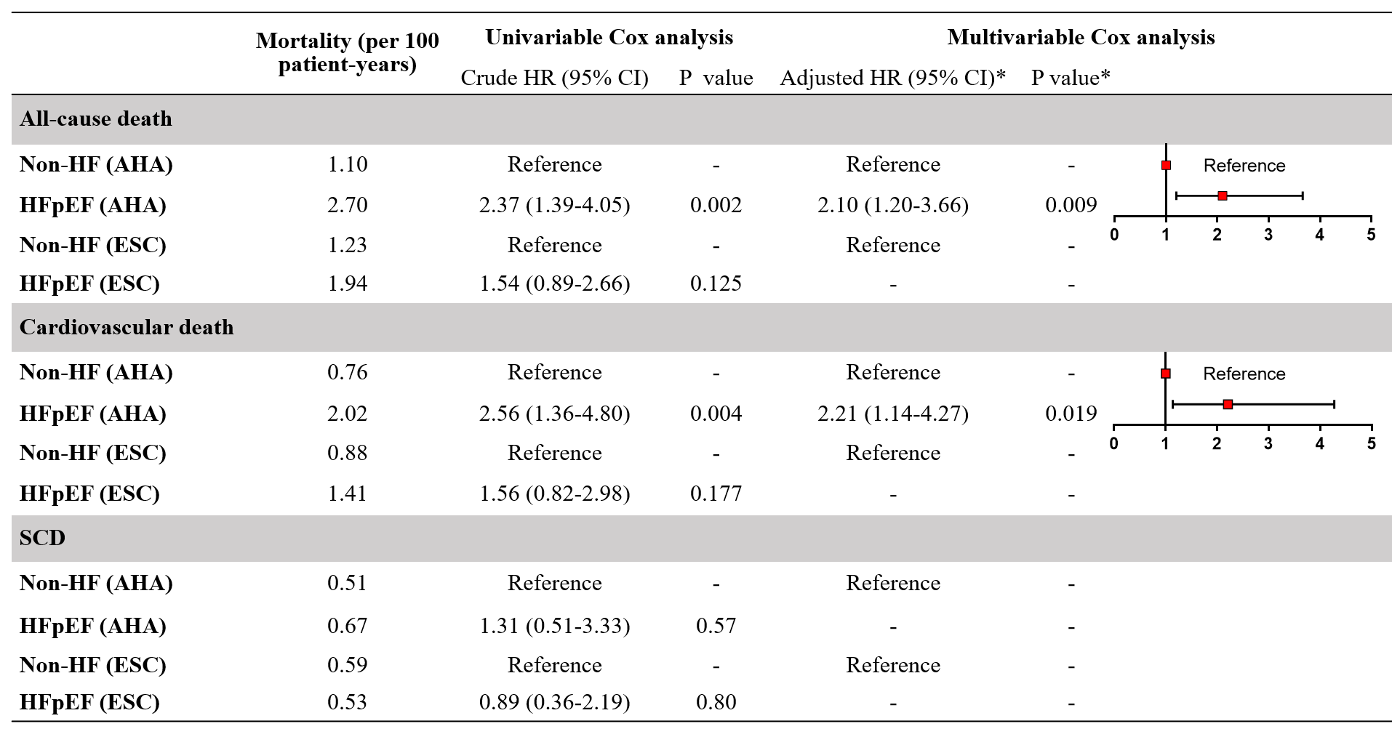
Figure S3. Hazard ratio of HFpEF versus non-HF in 613 HCM patients without septal reduction therapy.
AHA, American Heart Association; CI, confidence interval; ESC, European Society of Cardiology; HFpEF, heart failure with preserved ejection fraction; non-HF, patients without heart failure; HR, hazard ratio; SCD, sudden cardiac death
*Multivariable Cox regression analysis. Models were adjusted for the following covariates using a backward method: age, sex, maximal left ventricular wall thickness, atrial fibrillation, maximal left ventricular outflow tract gradient, and NYHA class.

