Figure S1.
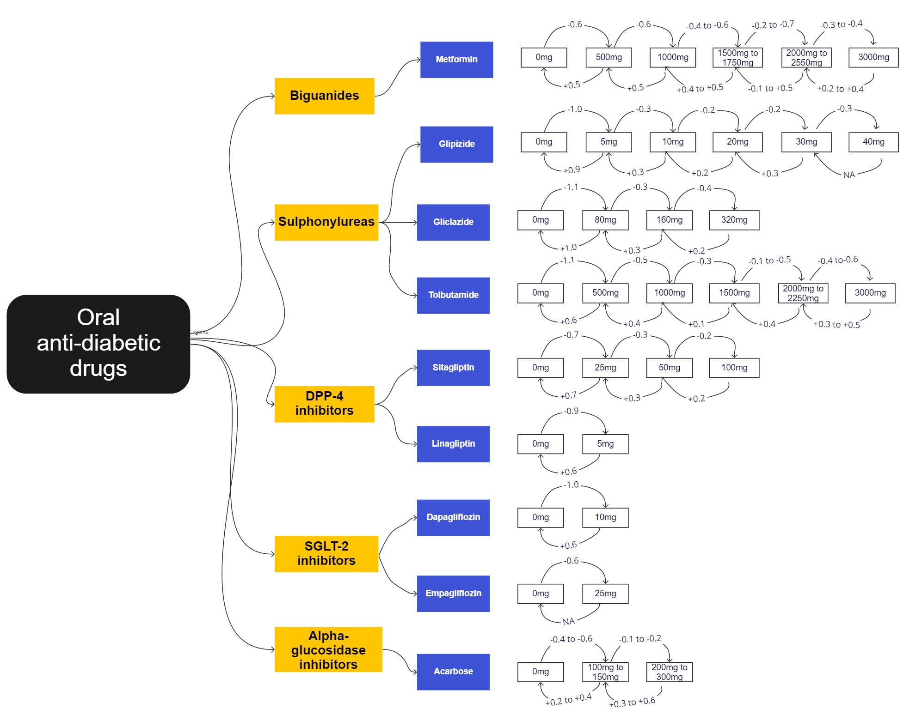Executive summary of HbA1c change (with HbA1c denoted in % units) with various OAD titration. The dosages in the white rectangle boxes refer to the total daily dosage of the medication. The numbers on the arrows represent the HbA1c change. The direction of the arrows represents an up-titration (rightward arrow), or down-titration (leftward arrow). Abbreviations: HbA1c = glycated haemoglobin, OAD = oral anti-diabetic drug.

Table S1a. Change in HbA1c values (with HbA1c denoted in % units) after metformin titration.
 |  | Metformin dose after titration
 |  | 0 | 125 | 250 | 500 | 750 | 850 | 1000 | 1500 | 1700 | 2000 | 2250 | 2550 | 3000
Metformin dose before titration | 0 |  |  | -0.3  (-0.4, -0.3)  #m=487 | -0.6  (-0.6, -0.6)  #m=1849 |  |  | -0.9  (-1.0, -0.8)  #m=676 | -0.7  (-1.1, -0.3)  #m=36 | -0.6  (-1.0, -0.3)  #m=60
Metformin dose before titration | 125 |  |  | -0.4  (-0.6, -0.2)  #m=34
Metformin dose before titration | 250 | 0.5  (0.4, 0.7)  #m=173 | 0.2  (0.1, 0.3)  #m=105 |  | -0.4  (-0.5, -0.4)  #m=906 |  |  | -0.9  (-1.2, -0.7)  #m=87
Metformin dose before titration | 500 | 0.5  (0.3, 0.7)  #m=220 |  | 0.3  (0.3, 0.4)  #m=1412 |  | -0.3  (-0.4, -0.2)  #m=282 |  | -0.6  (-0.6, -0.6)  #m=3108 | -0.8  (-1.1, -0.5)  #m=77 | -1.3  (-1.6, -1.0)  #m=53
Metformin dose before titration | 750 |  |  |  | 0.2  (0.1, 0.3)  #m=182 |  |  | -0.3  (-0.4, -0.2)  #m=225 | -0.6  (-0.8, -0.5)  #m=190 | -0.7  (-1.1, -0.4)  #m=31
Metformin dose before titration | 850 |  |  |  | 0.3  (-0.0, 0.5)  #m=34 |  |  | 0.1  (-0.1, 0.3)  #m=58 |  | -0.3  (-0.5, -0.2)  #m=161 |  |  | -0.2  (-0.5, 0.0)  #m=39
Metformin dose before titration | 1000 | 0.7  (0.4, 0.9)  #m=137 |  | 0.7  (0.3, 1.1)  #m=31 | 0.5  (0.4, 0.5)  #m=1953 | -0.1  (-0.2, 0.0)  #m=105 | -0.1  (-0.3, 0.0)  #m=57 |  | -0.4  (-0.5, -0.4)  #m=2150 | -0.6  (-0.6, -0.5)  #m=1670 | -0.4  (-0.6, -0.3)  #m=198 |  | -0.9  (-1.3, -0.6)  #m=47 | -0.5  (-0.7, -0.2)  #m=47
Metformin dose before titration | 1500 | 1.1  (0.6, 1.5)  #m=41 |  |  | 0.7  (0.4, 1.0)  #m=96 | 0.3  (0.1, 0.5)  #m=91 |  | 0.4  (0.3, 0.4)  #m=1128 |  | -0.3  (-0.3, -0.2)  #m=739 | -0.4  (-0.5, -0.3)  #m=418 | -0.6  (-0.6, -0.5)  #m=498 | -0.7  (-0.8, -0.6)  #m=398
Metformin dose before titration | 1700 | 1.2  (0.7, 1.7)  #m=46 |  |  | 0.7  (0.3, 1.1)  #m=38 |  | 0.2  (0.1, 0.3)  #m=240 | 0.5  (0.5, 0.6)  #m=773 | 0.1  (0.0, 0.2)  #m=142 |  | -0.2  (-0.3, -0.2)  #m=611 |  | -0.5  (-0.5, -0.4)  #m=1154
Metformin dose before titration | 2000 |  |  |  |  |  |  | 0.4  (0.3, 0.5)  #m=228 | 0.3  (0.1, 0.5)  #m=82 | 0.3  (0.1, 0.4)  #m=127 |  |  | -0.3  (-0.4, -0.2)  #m=178 | -0.3  (-0.5, -0.2)  #m=458
Metformin dose before titration | 2250 |  |  |  |  |  |  | 0.5  (0.2, 0.8)  #m=34 | 0.3  (0.3, 0.4)  #m=227 | 0.1  (-0.2, 0.3)  #m=30 | 0.1  (-0.2, 0.3)  #m=42 |  | -0.4  (-0.4, -0.3)  #m=311 | -0.4  (-0.6, -0.2)  #m=124
Metformin dose before titration | 2550 |  |  |  |  |  | 0.3  (0.0, 0.6)  #m=30 | 0.5  (0.3, 0.8)  #m=75 | 0.5  (0.4, 0.6)  #m=165 | 0.3  (0.3, 0.4)  #m=920 | -0.1  (-0.2, 0.0)  #m=182 | 0.3  (-0.0, 0.5)  #m=33 |  | -0.3  (-0.4, -0.2)  #m=642
Metformin dose before titration | 3000 |  |  |  |  |  |  | 0.9  (0.5, 1.3)  #m=41 | 0.8  (0.5, 1.0)  #m=65 |  | 0.4  (0.3, 0.4)  #m=438 | 0.4  (0.2, 0.6)  #m=35 | 0.2  (0.0, 0.3)  #m=129
Change in HbA1c values after metformin initiation, titration or discontinuation. The values above the diagonal represent the instances where the medication has been initiated or up-titrated, while the values below the diagonal represent instances where the medication has been down-titrated or discontinued. The values refer to the mean difference in HbA1c (MD) and 95% confidence intervals. MD below 0 indicate a lowering in HbA1c while those above 0 indicate an increase in HbA1c. #m refers to the number of HbA1c pairs for that dose titration.

Table S1b. Change in HbA1c values (with HbA1c denoted in % units) after glipizide titration.
 |  | Glipizide dose after titration
 |  | 0 | 2.5 | 5 | 7.5 | 10 | 12.5 | 15 | 20 | 25 | 30 | 40
Glipizide dose before titration | 0 |  | -0.7  (-0.8, -0.6)  #m=471 | -1.0  (-1.1, -0.9)  #m=1283 |  | -1.2  (-1.3, -1.0)  #m=364 |  |  | -0.1  (-0.6, 0.3)  #m=41
Glipizide dose before titration | 2.5 | 0.7  (0.7, 0.8)  #m=596 |  | -0.5  (-0.5, -0.4)  #m=660 |  | -0.8  (-1.3, -0.3)  #m=51
Glipizide dose before titration | 5 | 0.9  (0.9, 1.0)  #m=818 | 0.4  (0.3, 0.4)  #m=815 |  | -0.4  (-0.6, -0.1)  #m=82 | -0.3  (-0.3, -0.2)  #m=1686
Glipizide dose before titration | 7.5 |  |  | 0.2  (0.0, 0.5)  #m=59 |  | -0.0  (-0.2, 0.1)  #m=157 |  | -0.0  (-0.1, 0.1)  #m=133
Glipizide dose before titration | 10 | 0.9  (0.8, 1.1)  #m=260 | 0.3  (0.1, 0.5)  #m=32 | 0.3  (0.3, 0.3)  #m=1042 | -0.0  (-0.1, 0.1)  #m=267 |  |  | -0.2  (-0.2, -0.1)  #m=966 | -0.2  (-0.3, -0.2)  #m=753
Glipizide dose before titration | 12.5 |  |  |  |  |  |  |  |  | 0.0  (-0.2, 0.2)  #m=57
Glipizide dose before titration | 15 |  |  | 0.1  (-0.1, 0.3)  #m=30 | 0.1  (0.0, 0.3)  #m=50 | 0.2  (0.1, 0.3)  #m=376 |  |  | -0.1  (-0.1, -0.0)  #m=852 |  | -0.1  (-0.2, 0.1)  #m=294
Glipizide dose before titration | 20 | 0.9  (0.5, 1.2)  #m=47 |  |  |  | 0.2  (0.2, 0.3)  #m=514 | -0.1  (-0.2, 0.0)  #m=145 | 0.0  (-0.0, 0.1)  #m=362 |  | -0.2  (-0.3, -0.1)  #m=617 | -0.1  (-0.2, -0.0)  #m=465
Glipizide dose before titration | 25 |  |  |  |  |  |  | -0.0  (-0.2, 0.2)  #m=72 | 0.1  (-0.1, 0.2)  #m=95 |  | -0.1  (-0.2, -0.0)  #m=444
Glipizide dose before titration | 30 | 0.6  (0.2, 0.9)  #m=45 |  |  |  | 0.2  (-0.1, 0.4)  #m=68 |  | 0.3  (0.2, 0.4)  #m=259 | 0.3  (0.2, 0.4)  #m=323 | 0.2  (-0.0, 0.3)  #m=83 |  | -0.3  (-0.5, -0.0)  #m=73
Glipizide dose before titration | 40
Change in HbA1c values after glipizide initiation, titration or discontinuation. The values above the diagonal represent the instances where the medication has been initiated or up-titrated, while the values below the diagonal represent instances where the medication has been down-titrated or discontinued. The values refer to the mean difference in HbA1c (MD) and 95% confidence intervals. MD below 0 indicate a lowering in HbA1c while those above 0 indicate an increase in HbA1c. #m refers to the number of HbA1c pairs for that dose titration.

Table S1c. Change in HbA1c values (with HbA1c denoted in % units) after gliclazide titration.
 |  | Gliclazide dose after titration
 |  | 0 | 30 | 40 | 60 | 80 | 90 | 120 | 160 | 240 | 320
Gliclazide dose before titration | 0 |  | -0.9  (-1.2, -0.7)  #m=57 | -1.1  (-1.3, -0.9)  #m=89 |  | -1.1  (-1.3, -1.0)  #m=174
Gliclazide dose before titration | 30 | 0.7  (0.4, 0.9)  #m=44 |  |  | -0.2  (-0.4, -0.0)  #m=73
Gliclazide dose before titration | 40 | 1.2  (0.9, 1.4)  #m=108 |  |  |  | -0.5  (-0.6, -0.3)  #m=109
Gliclazide dose before titration | 60 |  | 0.4  (0.2, 0.5)  #m=49 |  |  |  | -0.3  (-0.6, 0.1)  #m=38 | -0.1  (-0.5, 0.3)  #m=33
Gliclazide dose before titration | 80 | 1.0  (0.8, 1.2)  #m=91 |  | 0.3  (0.2, 0.4)  #m=171 |  |  |  |  | -0.3  (-0.4, -0.2)  #m=233
Gliclazide dose before titration | 90
Gliclazide dose before titration | 120 |  |  |  |  |  |  |  |  | -0.3  (-0.5, -0.1)  #m=34
Gliclazide dose before titration | 160 |  |  |  |  | 0.3  (0.2, 0.4)  #m=172 |  | -0.1  (-0.4, 0.1)  #m=59 |  | -0.3  (-0.5, -0.1)  #m=113 | -0.4  (-0.6, -0.2)  #m=112
Gliclazide dose before titration | 240 |  |  |  |  |  |  |  | 0.1  (-0.2, 0.3)  #m=50 |  | -0.2  (-0.4, 0.1)  #m=77
Gliclazide dose before titration | 320 |  |  |  |  |  |  |  | 0.2  (0.1, 0.4)  #m=119 | 0.3  (-0.2, 0.7)  #m=31
Change in HbA1c values after gliclazide initiation, titration or discontinuation. The values above the diagonal represent the instances where the medication has been initiated or up-titrated, while the values below the diagonal represent instances where the medication has been down-titrated or discontinued. The values refer to the mean difference in HbA1c (MD) and 95% confidence intervals. MD below 0 indicate a lowering in HbA1c while those above 0 indicate an increase in HbA1c. #m refers to the number of HbA1c pairs for that dose titration.

Table S1d. Change in HbA1c values (with HbA1c denoted in % units) after tolbutamide titration.
 |  | Tolbutamide dose after titration
 |  | 0 | 250 | 500 | 750 | 1000 | 1500 | 2000 | 2250 | 3000
Tolbutamide dose before titration | 0 |  | -0.7  (-1.0, -0.5)  #m=52 | -1.1  (-1.3, -0.8)  #m=103
Tolbutamide dose before titration | 250 | 0.5  (0.3, 0.6)  #m=90 |  | -0.5  (-0.7, -0.3)  #m=92
Tolbutamide dose before titration | 500 | 0.6  (0.5, 0.7)  #m=177 | 0.3  (0.2, 0.4)  #m=243 |  | -0.3  (-0.6, 0.0)  #m=44 | -0.5  (-0.6, -0.4)  #m=203
Tolbutamide dose before titration | 750 |  |  | 0.1  (-0.1, 0.2)  #m=89 |  | 0.1  (-0.3, 0.5)  #m=37 | -0.5  (-0.7, -0.2)  #m=52
Tolbutamide dose before titration | 1000 | 0.7  (0.3, 1.0)  #m=45 |  | 0.4  (0.3, 0.4)  #m=277 |  |  | -0.3  (-0.5, -0.2)  #m=187
Tolbutamide dose before titration | 1500 |  |  |  | 0.3  (0.2, 0.5)  #m=64 | 0.1  (0.0, 0.2)  #m=190 |  | -0.1  (-0.4, 0.2)  #m=42 | -0.5  (-0.7, -0.3)  #m=96
Tolbutamide dose before titration | 2000 |  |  |  |  | 0.6  (0.3, 1.0)  #m=50 |  |  |  | -0.6  (-1.0, -0.3)  #m=42
Tolbutamide dose before titration | 2250 |  |  |  |  |  | 0.4  (0.3, 0.5)  #m=95 |  |  | -0.4  (-0.6, -0.2)  #m=62
Tolbutamide dose before titration | 3000 |  |  |  |  |  | 0.5  (0.2, 0.8)  #m=43 | 0.3  (0.2, 0.5)  #m=67
Change in HbA1c values after tolbutamide initiation, titration or discontinuation. The values above the diagonal represent the instances where the medication has been initiated or up-titrated, while the values below the diagonal represent instances where the medication has been down-titrated or discontinued. The values refer to the mean difference in HbA1c (MD) and 95% confidence intervals. MD below 0 indicate a lowering in HbA1c while those above 0 indicate an increase in HbA1c. #m refers to the number of HbA1c pairs for that dose titration.

Table S1e. Change in HbA1c values (with HbA1c denoted in % units) after sitagliptin titration.
 |  | Sitagliptin dose after titration
 |  | 0 | 25 | 50 | 75 | 100
Sitagliptin dose before titration | 0 |  | -0.7  (-0.8, -0.5)  #m=266 | -0.7  (-0.8, -0.6)  #m=411 |  | -0.5  (-0.8, -0.2)  #m=86
Sitagliptin dose before titration | 25 | 0.7  (0.5, 0.8)  #m=93 |  | -0.3  (-0.4, -0.2)  #m=225
Sitagliptin dose before titration | 50 | 0.7  (0.5, 0.9)  #m=156 | 0.3  (0.0, 0.5)  #m=56 |  | -0.3  (-0.6, -0.0)  #m=43 | -0.2  (-0.4, -0.1)  #m=439
Sitagliptin dose before titration | 75 |  |  |  |  | 0.1  (-0.3, 0.5)  #m=35
Sitagliptin dose before titration | 100 | 0.6  (0.4, 0.8)  #m=82 |  | 0.2  (0.0, 0.3)  #m=91
Change in HbA1c values after sitagliptin initiation, titration or discontinuation. The values above the diagonal represent the instances where the medication has been initiated or up-titrated, while the values below the diagonal represent instances where the medication has been down-titrated or discontinued. The values refer to the mean difference in HbA1c (MD) and 95% confidence intervals. MD below 0 indicate a lowering in HbA1c while those above 0 indicate an increase in HbA1c. #m refers to the number of HbA1c pairs for that dose titration.

Table S1f. Change in HbA1c values (with HbA1c denoted in % units) after linaliptin titration.
 |  | Linagliptin dose after titration
 |  | 0 | 2.5 | 5
Linagliptin dose before titration | 0 |  | -0.8  (-1.0, -0.6)  #m=139 | -0.9  (-0.9, -0.8)  #m=1807
Linagliptin dose before titration | 2.5 | 0.5  (0.2, 0.8)  #m=32 |  | -0.3  (-0.5, -0.1)  #m=79
Linagliptin dose before titration | 5 | 0.6  (0.5, 0.7)  #m=363 | 0.2  (0.0, 0.4)  #m=36
Change in HbA1c values after linagliptin initiation, titration or discontinuation. The values above the diagonal represent the instances where the medication has been initiated or up-titrated, while the values below the diagonal represent instances where the medication has been down-titrated or discontinued. The values refer to the mean difference in HbA1c (MD) and 95% confidence intervals. MD below 0 indicate a lowering in HbA1c while those above 0 indicate an increase in HbA1c. #m refers to the number of HbA1c pairs for that dose titration.

Table S1g. Change in HbA1c values (with HbA1c denoted in % units) after dapagliflozin titration.
 |  | Dapagliflozin dose after titration
 |  | 0 | 2.5 | 5 | 10
Dapagliflozin dose before titration | 0 |  | -0.8  (-1.0, -0.5)  #m=67 | -0.8  (-0.9, -0.7)  #m=570 | -1.0  (-1.0, -0.9)  #m=722
Dapagliflozin dose before titration | 2.5 |  |  | -0.1  (-0.4, 0.2)  #m=39
Dapagliflozin dose before titration | 5 | 0.3  (0.1, 0.6)  #m=85 |  |  | -0.3  (-0.4, -0.2)  #m=264
Dapagliflozin dose before titration | 10 | 0.6  (0.3, 0.8)  #m=96 |  | 0.1  (-0.1, 0.3)  #m=76
Change in HbA1c values after dapagliflozin initiation, titration or discontinuation. The values above the diagonal represent the instances where the medication has been initiated or up-titrated, while the values below the diagonal represent instances where the medication has been down-titrated or discontinued. The values refer to the mean difference in HbA1c (MD) and 95% confidence intervals. MD below 0 indicate a lowering in HbA1c while those above 0 indicate an increase in HbA1c. #m refers to the number of HbA1c pairs for that dose titration.

Table S1h. Change in HbA1c values (with HbA1c denoted in % units) after empagliflozin titration.
 |  | Empagliflozin dose after titration
 |  | 0 | 12.5 | 25
Empagliflozin dose before titration | 0 |  | -0.7  (-0.9, -0.5)  #m=152 | -0.6  (-0.8, -0.4)  #m=101
Empagliflozin dose before titration | 12.5
Empagliflozin dose before titration | 25
Change in HbA1c values after empagliflozin initiation, titration or discontinuation. The values above the diagonal represent the instances where the medication has been initiated or up-titrated, while the values below the diagonal represent instances where the medication has been down-titrated or discontinued. The values refer to the mean difference in HbA1c (MD) and 95% confidence intervals. MD below 0 indicate a lowering in HbA1c while those above 0 indicate an increase in HbA1c. #m refers to the number of HbA1c pairs for that dose titration.

Table S1i. Change in HbA1c values (with HbA1c denoted in % units) after acarbose titration.
 |  | Acarbose dose after titration
 |  | 0 | 50 | 100 | 150 | 200 | 300
Acarbose dose before titration | 0 |  | -0.3  (-0.5, -0.1)  #m=49 | -0.4  (-0.6, -0.3)  #m=221 | -0.6  (-0.7, -0.4)  #m=211 |  | -0.6  (-1.0, -0.1)  #m=37
Acarbose dose before titration | 50 | 0.2  (0.0, 0.4)  #m=52 |  | -0.3  (-0.7, 0.0)  #m=34
Acarbose dose before titration | 100 | 0.4  (0.2, 0.5)  #m=149 | 0.3  (0.1, 0.5)  #m=40 |  | -0.2  (-0.5, 0.0)  #m=72 | -0.2  (-0.4, -0.0)  #m=94
Acarbose dose before titration | 150 | 0.4  (0.2, 0.5)  #m=122 |  | 0.0  (-0.1, 0.2)  #m=65 |  |  | -0.2  (-0.3, 0.0)  #m=144
Acarbose dose before titration | 200 | 0.4  (0.2, 0.6)  #m=67 |  | 0.3  (0.2, 0.5)  #m=48 |  |  | -0.1  (-0.3, 0.1)  #m=75
Acarbose dose before titration | 300 | 0.6  (0.4, 0.9)  #m=82 |  |  | 0.6  (0.3, 0.8)  #m=49 | 0.3  (0.2, 0.5)  #m=92
Change in HbA1c values after acarbose initiation, titration or discontinuation. The values above the diagonal represent the instances where the medication has been initiated or up-titrated, while the values below the diagonal represent instances where the medication has been down-titrated or discontinued. The values refer to the mean difference in HbA1c (MD) and 95% confidence intervals. MD below 0 indicate a lowering in HbA1c while those above 0 indicate an increase in HbA1c. #m refers to the number of HbA1c pairs for that dose titration

