Figure Supplement to:
GWAS in people of Middle Eastern descent reveals a locus protective of kidney function – A cross-sectional study

Siham A Mohamed¹, Juan Fernadez-Tajes¹, Paul W Franks¹*, Louise Bennet¹*
¹ Department of Clinical Sciences, Lund University, Malmö, Sweden
² Clinical Research and Trial Center, Lund University Hospital, Sweden.

* These authors contributed equally

Correspondence: Paul W Franks (paul.franks@med.lu.se) and Louise Bennet (louise.bennet@med.lu.se)

Figure S1.Flow chart for eligible study participants

Individuals excluded
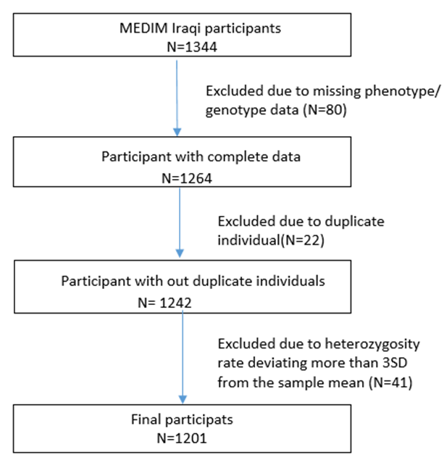

Figure S2. Two-dimensional plots for multidimensional scaling of MEDIM participant and 1000 genomes populations. The distances between points reflect the genetic similarity. Y axis = 2nd MDS component and x axis = first MDS component.

Figure S2a. There is a clear overlap between Swedish and Iraqi individuals.
+ = Native Swedes, o = Iraqi.

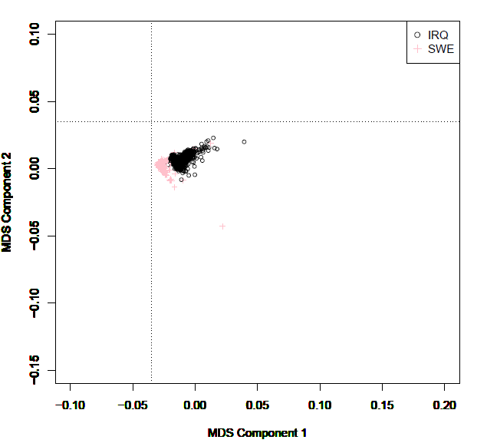

Figure S2b MEDIM participants clustering close to European population compared to other population, o= European, o= Asian, o= African, o= Mixed Americans and + = Iraqi and Swedish born MEDIM participants.

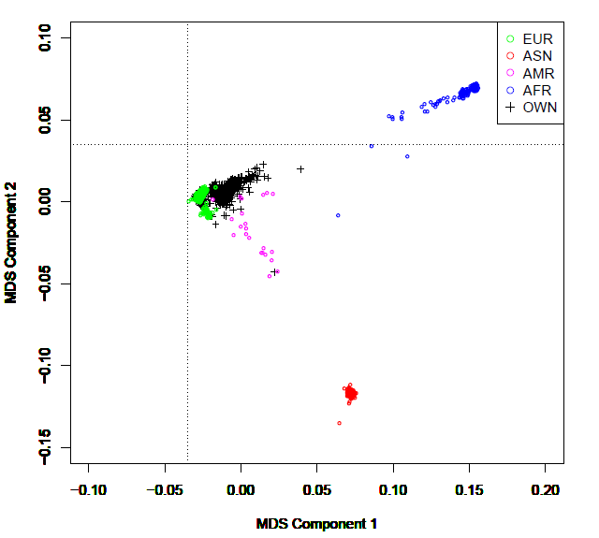

Figure 2c. Zoomed image of figure 2A, Two-dimensional plot for multidimensional scaling of MEDIM participant. The distances between points reflect the genetic similarity. Y axis = 2nd MDS component and x axis = first MDS component. Shows a clear overlap between Swedish and Iraqi born individuals, + = Native Swedes, o = Iraqi.

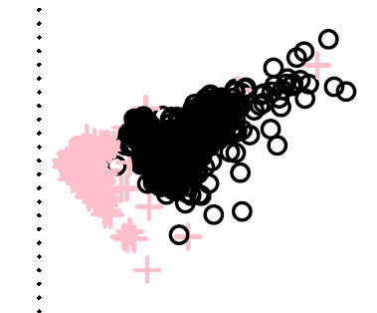

Figure S3. Histogram of pairwise genetic relatedness(PI-HAT) values calculated for all pairs in MEDIM participants. PI_HAT = 1 shows duplicate individuals or monozygotic twins, PI_HAT >0.20 indicates relatedness and PI_HAT value close to zero denotes not related.

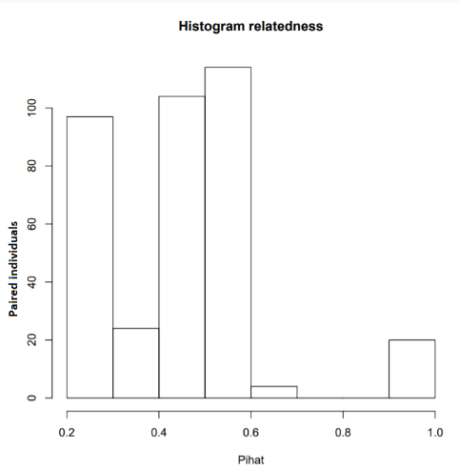
Manhattan plot illustrating the −log10 (p-values) from the MEDIM GWAS for all the 11 traits

Figure S4. Manhattan plots for the association of SNPs with BMI

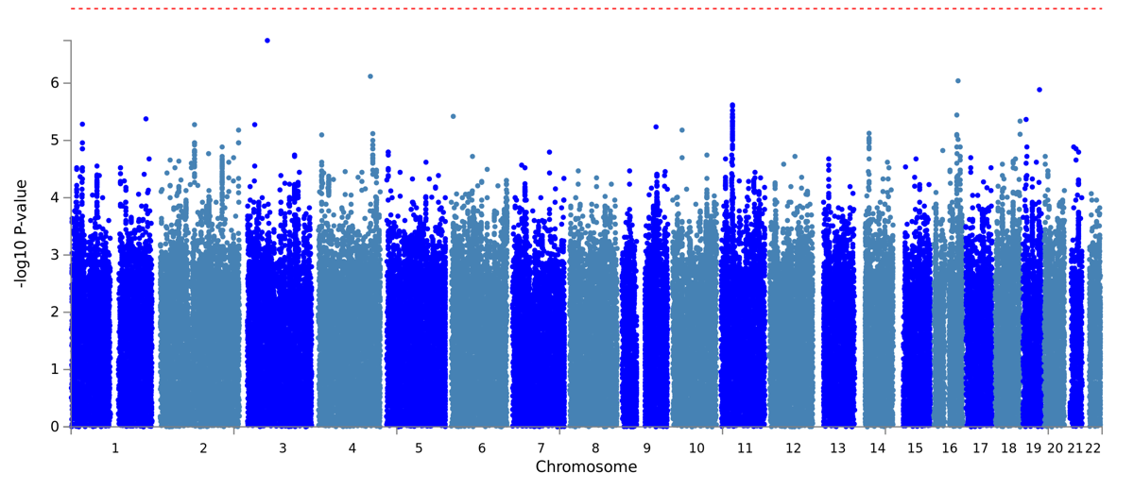

Figure S5. Manhattan plots for the association of SNPs with fasting glucose

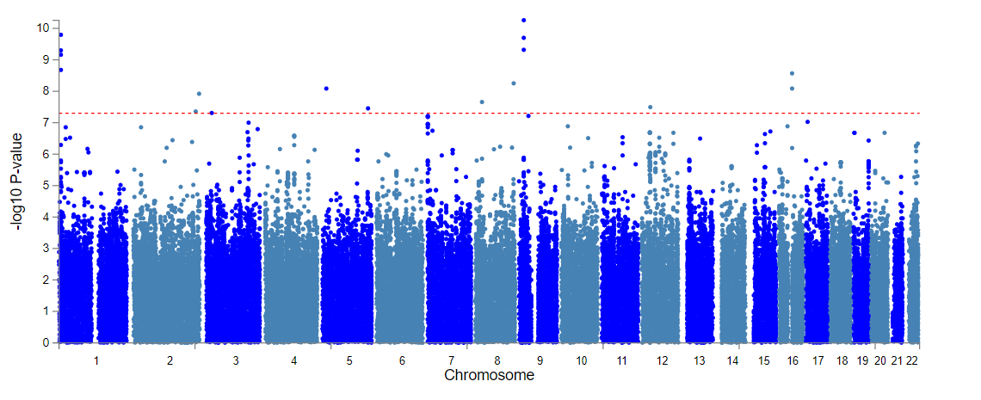

Figure S6. Manhattan plots for the association of SNPs with HOMA-β

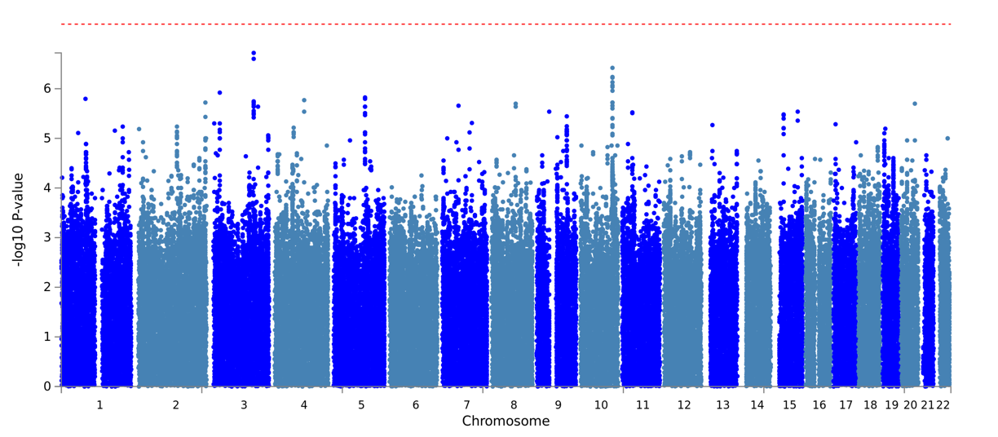
Figure S7. Manhattan plots for the association of SNPs with HbA1C

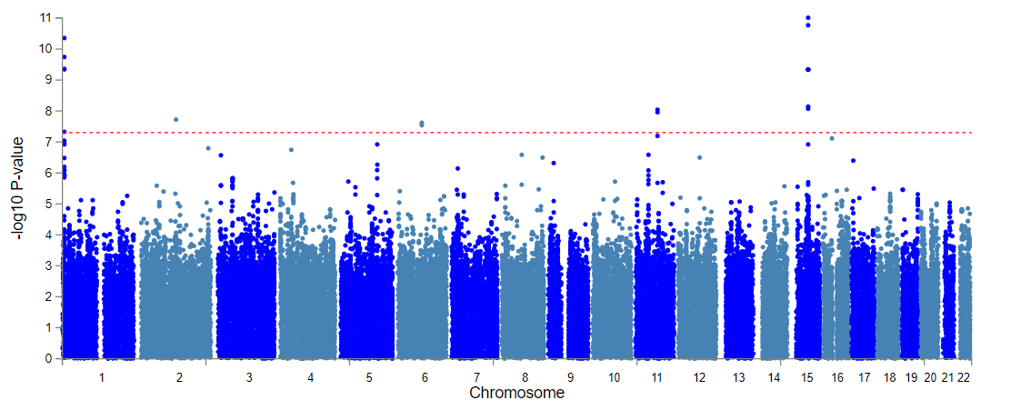
Figure S8. Manhattan plots for the association of SNPs with ISI

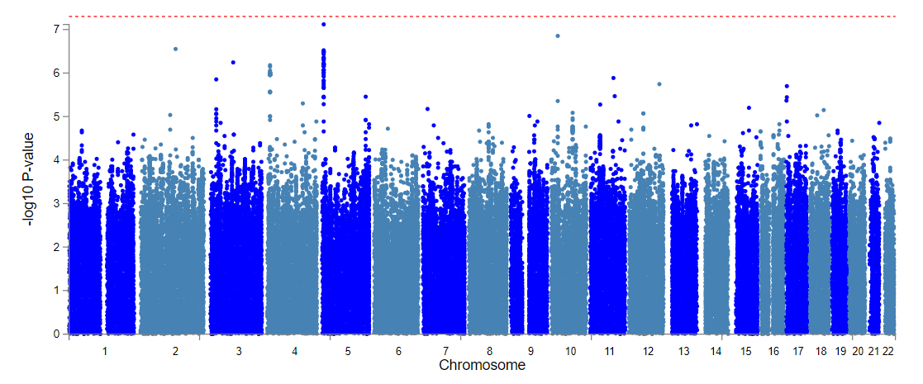

Figure S9. Manhattan plots for the association of SNPs with CIR

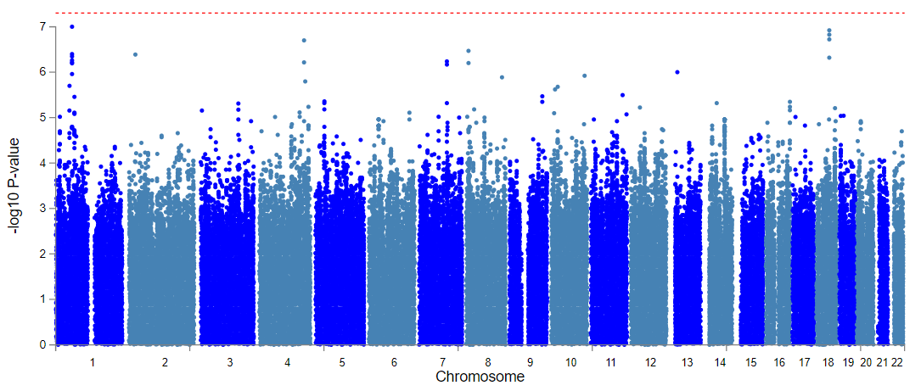
Figure S10. Manhattan plots for the association of SNPs with Dio

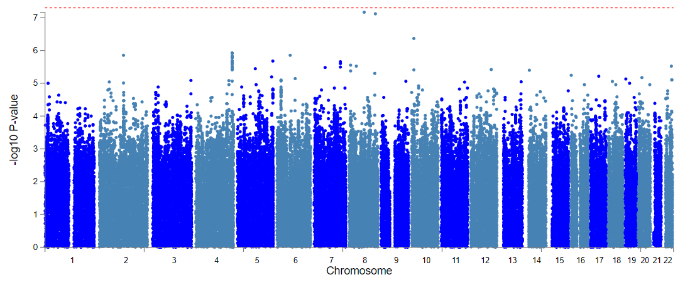
Figure S11. Manhattan plots for the association of SNPs with DBP

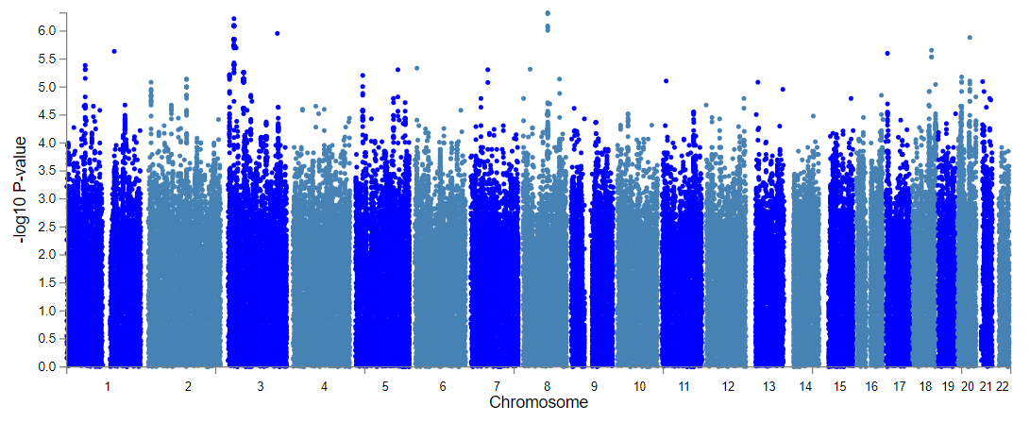

Figure S12. Manhattan plots for the association of SNPs with SBP

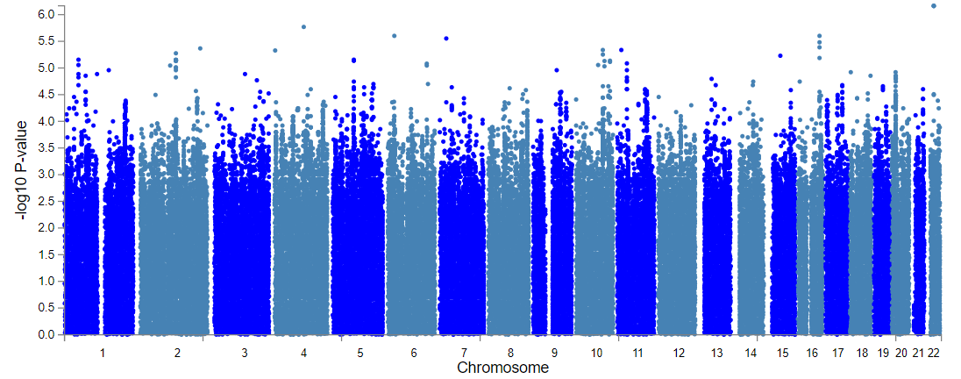
Figure S13. Manhattan plots for the association of SNPs with QUICKI

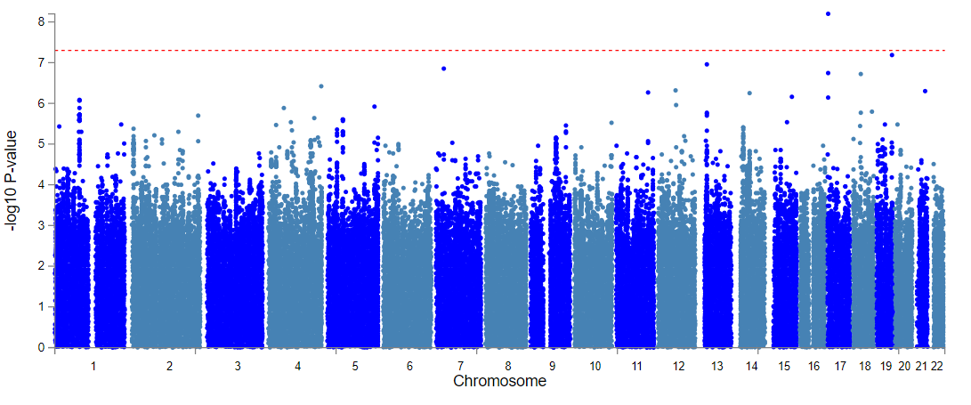
Figure S14. Manhattan plots for the association of SNPs with eGFR

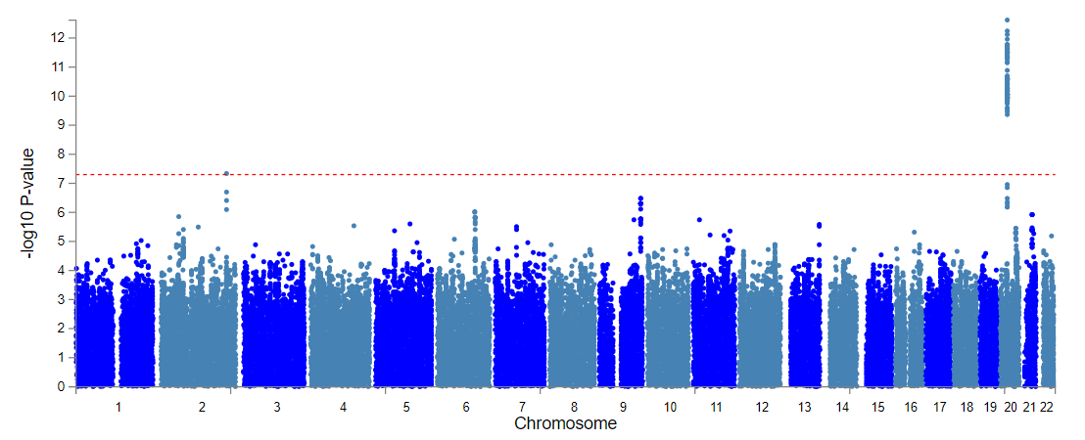

Regional plot for all significantly associated Locus

Figure S15. Regional plot for rs11120828 on chromosome 1 associated with fasting glucose. The –log10-transformed P values are plotted against the genomic position. Dark purple encircled with black represents rs11120828; grey represents SNPs below the significance level; red circles represent significant SNPs; and circles with color ranging from different shades of red to blue indicates the range of pairwise r 2 value with the lead SNP (rs11120828).

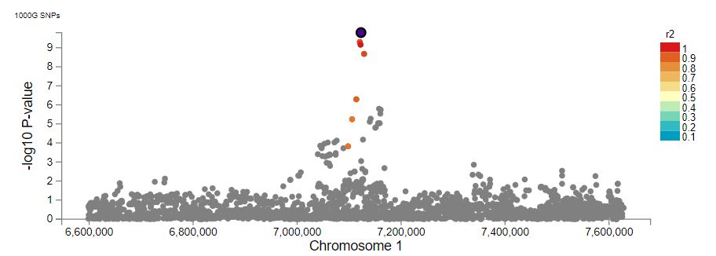

Figure S16. Regional plot for rs76150693 on chromosome 2 associated with fasting glucose. The –log10-transformed P values are plotted against the genomic position. Dark purple encircled with black represents rs76150693; grey represents SNPs below the significance level; red circles represent significant SNPs; and circles with color ranging from different shades of red to blue indicates the range of pairwise r 2 value with the lead SNP (rs76150693).

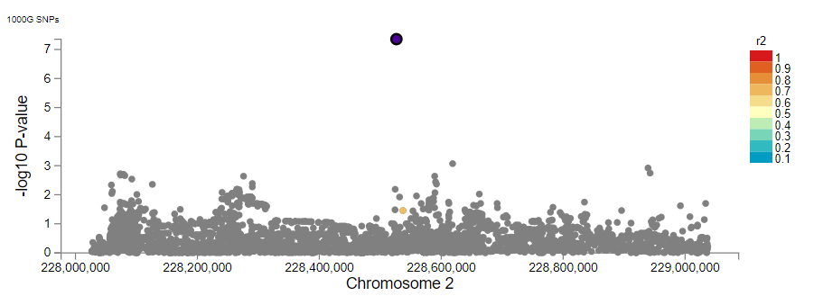

Figure S17. Regional plot for rs79451541 on chromosome 2 associated with fasting glucose. The –log10-transformed P values are plotted against the genomic position. Dark purple encircled with black represents rs79451541; grey represents SNPs below the significance level; and circles with color ranging from different shades of red to blue indicates the range of pairwise r 2 value with the lead SNP (rs79451541).

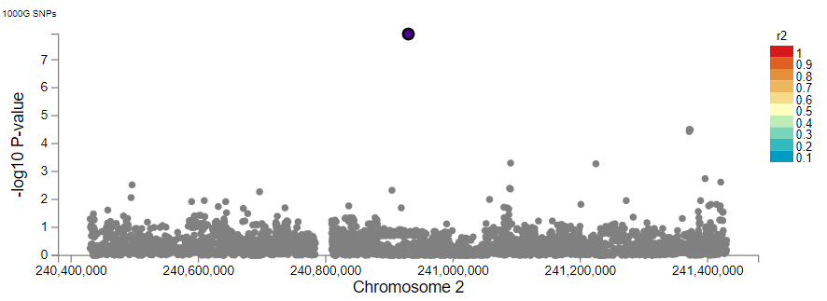
Figure S18. Regional plot for rs74591871 on chromosome 3 associated with fasting glucose. The –log10-transformed P values are plotted against the genomic position. Dark purple encircled with black represents rs74591871; grey represents SNPs below the significance level; and circles with color ranging from different shades of red to blue indicates the range of pairwise r 2 value with the lead SNP (rs74591871)

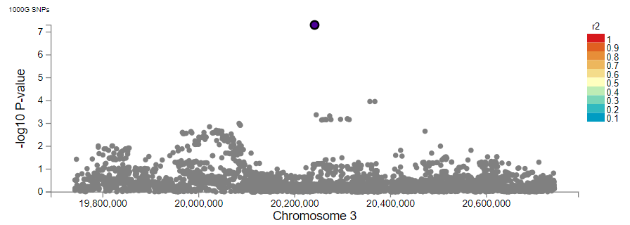

Figure S19. Regional plot for rs78223279 on chromosome 5 associated with fasting glucose. The –log10-transformed P values are plotted against the genomic position. Dark purple encircled with black represents rs78223279; grey represents SNPs below the significance level; and circles with color ranging from different shades of red to blue indicates the range of pairwise r 2 value with the lead SNP (rs78223279).
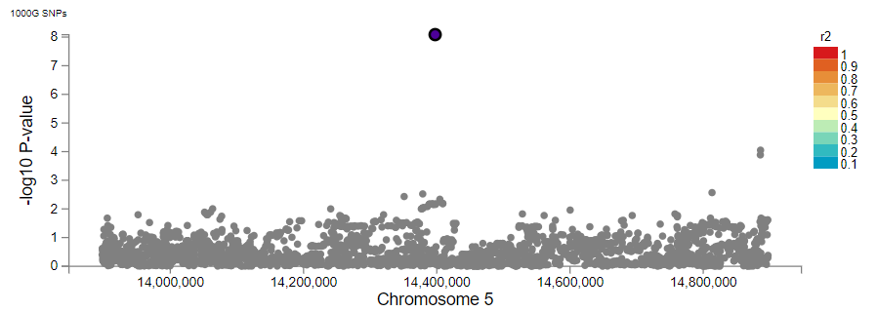
Figure S20. Regional plot for rs115873798 on chromosome 5 associated with fasting glucose. The –log10-transformed P values are plotted against the genomic position. Dark purple encircled with black represents rs115873798; grey represents SNPs below the significance level; and circles with color ranging from different shades of red to blue indicates the range of pairwise r 2 value with the lead SNP (rs115873798).

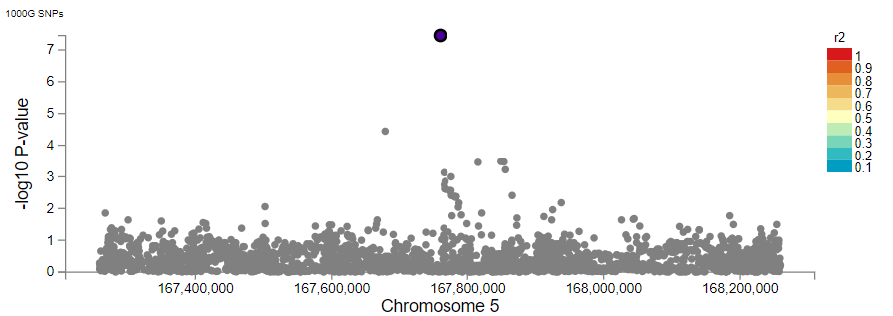

Figure S21. Regional plot for rs73231408 on chromosome 8 associated with fasting glucose. The –log10-transformed P values are plotted against the genomic position. Dark purple encircled with black represents rs73231408; grey represents SNPs below the significance level; red circles represent significant SNPs; and circles with color ranging from different shades of red to blue indicates the range of pairwise r 2 value with the lead SNP (rs73231408).

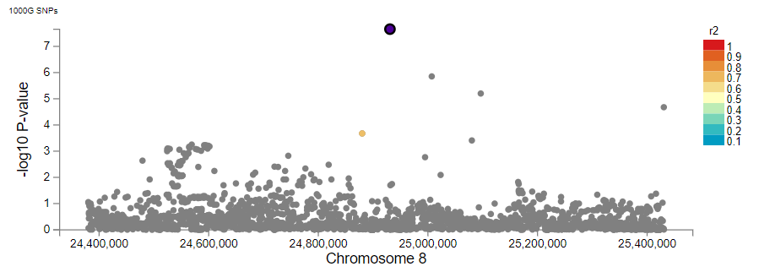

Figure S22. Regional plot for rs147360587 on chromosome 8 associated with fasting glucose. The –log10-transformed P values are plotted against the genomic position. Dark purple encircled with black represents rs147360587; grey represents SNPs below the significance level; and circles with color ranging from different shades of red to blue indicates the range of pairwise r 2 value with the lead SNP (rs147360587).

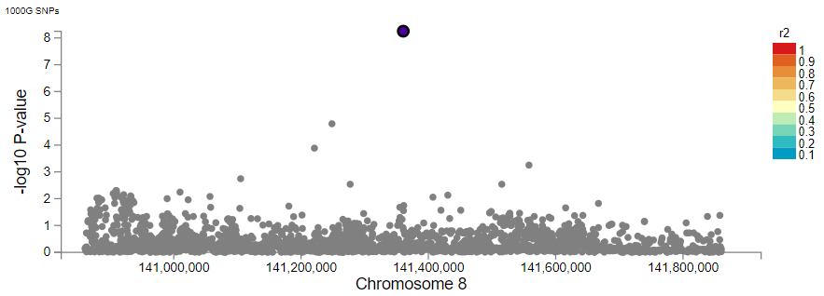

Figure S23. Regional plot for rs143653828 on chromosome 9 associated with fasting glucose. The –log10-transformed P values are plotted against the genomic position. Dark purple encircled with black represents rs143653828; grey represents SNPs below the significance level; red circles represent significant SNPs; and circles with color ranging from different shades of red to blue indicates the range of pairwise r 2 value with the lead SNP (rs143653828).

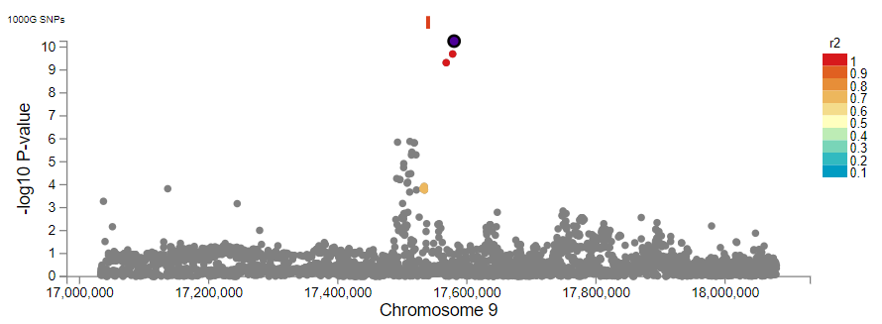

Figure S24. Regional plot for rs77023105 on chromosome 12 associated with fasting glucose. The –log10-transformed P values are plotted against the genomic position. Dark purple encircled with black represents rs77023105; grey represents SNPs below the significance level; red circles represent significant SNPs; and circles with color ranging from different shades of red to blue indicates the range of pairwise r 2 value with the lead SNP (rs77023105).

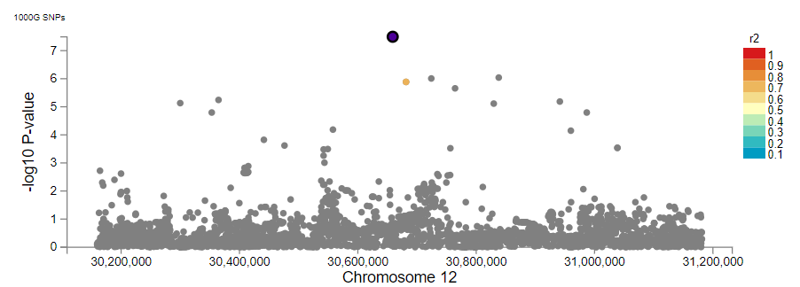

Figure S25. Regional plot for rs72802149 on chromosome 16 associated with fasting glucose. The –log10-transformed P values are plotted against the genomic position. Dark purple encircled with black represents rs72802149; grey represents SNPs below the significance level; red circles represent significant SNPs; and circles with color ranging from different shades of red to blue indicates the range of pairwise r 2 value with the lead SNP (rs72802149).

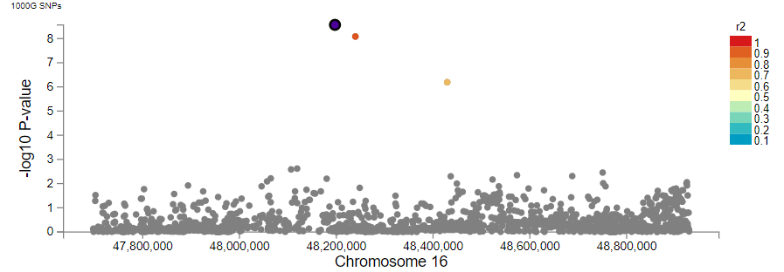
Figure S26. Regional plot for rs73985808 on chromosome 2 associated with eGFR. The –log10-transformed P values are plotted against the genomic position. Dark purple encircled with black represents rs73985808; grey represents SNPs below the significance level; red circles represent significant SNPs; and circles with color ranging from different shades of red to blue indicates the range of pairwise r 2 value with the lead SNP (rs73985808).

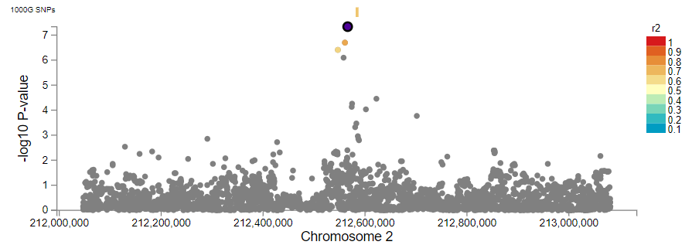

Figure S27. Regional plot for rs11120828 on chromosome 1 associated with HbA1C. The –log10-transformed P values are plotted against the genomic position. Dark purple encircled with black represents rs11120828; grey represents SNPs below the significance level; red circles represent significant SNPs; and circles with color ranging from different shades of red to blue indicates the range of pairwise r 2 value with the lead SNP (rs11120828).

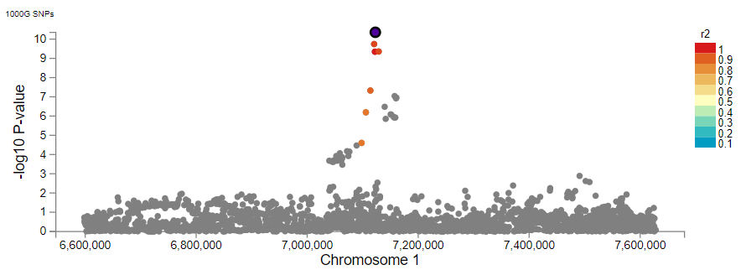
Figure S28. Regional plot for rs77145902 on chromosome 2 associated with HbA1C. The –log10-transformed P values are plotted against the genomic position. Dark purple encircled with black represents rs77145902; grey represents SNPs below the significance level; and circles with color ranging from different shades of red to blue indicates the range of pairwise r 2 value with the lead SNP (rs77145902).

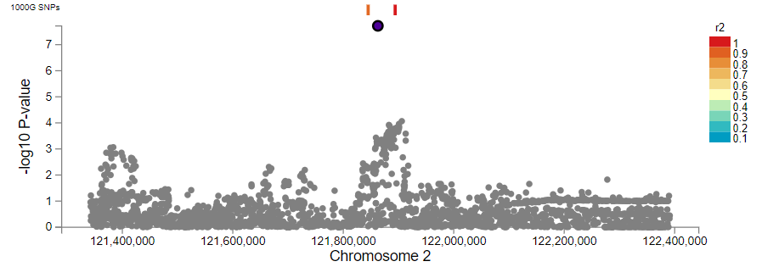

Figure S29. Regional plot for rs117580692 on chromosome 6 associated with HbA1C. The –log10-transformed P values are plotted against the genomic position. Dark purple encircled with black represents rs117580692; grey represents SNPs below the significance level; red circles represent significant SNPs and circles with color ranging from different shades of red to blue indicates the range of pairwise r 2 value with the lead SNP (rs117580692).

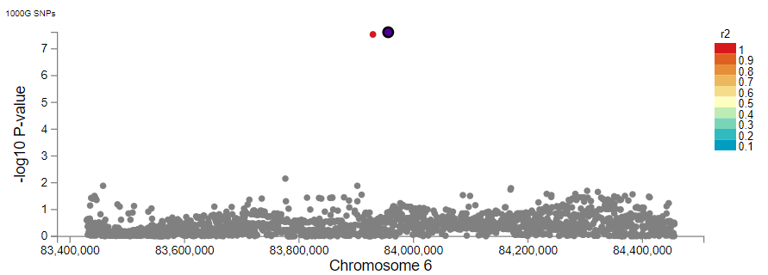

Figure S30. Regional plot for rs72941612 on chromosome 11 associated with HbA1C. The –log10-transformed P values are plotted against the genomic position. Dark purple encircled with black represents rs72941612; grey represents SNPs below the significance level; red circles represent significant SNPs and circles with color ranging from different shades of red to blue indicates the range of pairwise r 2 value with the lead SNP (rs72941612).

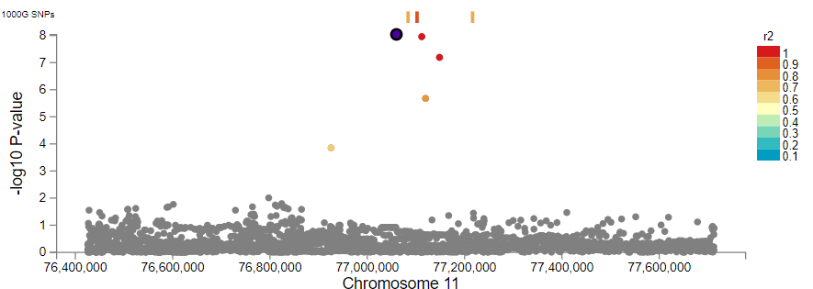

Figure S31. Regional plot for rs146006303 on chromosome 15 associated with HbA1C. The –log10-transformed P values are plotted against the genomic position. Dark purple encircled with black represents rs146006303; grey represents SNPs below the significance level; red circles represent significant SNPs and circles with color ranging from different shades of red to blue indicates the range of pairwise r 2 value with the lead SNP (rs146006303).

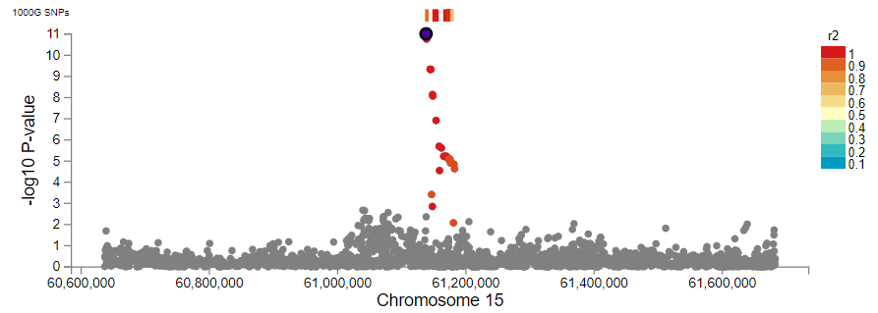

Figure S32. Regional plot for rs184544915 on chromosome 17 associated with QUICKI. The –log10-transformed P values are plotted against the genomic position. Dark purple encircled with black represents rs184544915; grey represents SNPs below the significance level; red circles represent significant SNPs and circles with color ranging from different shades of red to blue indicates the range of pairwise r 2 value with the lead SNP (rs184544915).

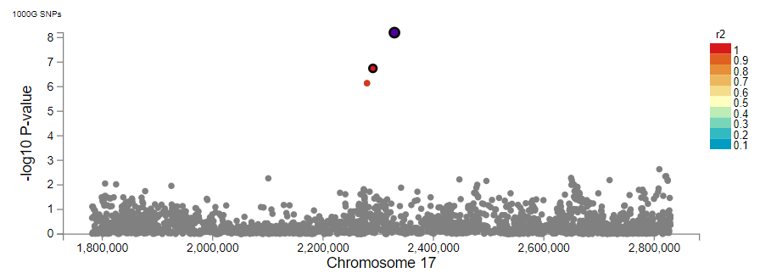

Q-Q plot

Figure S33. Quantile–quantile plots of significantly association traits. Red line denotes null hypothesis (X=Y), x-axis= observed −log10 [P] & y-axis = Expected log10 [P]. (A) eGFR, (B) HbA1C, (C) Fasting glucose and (D) QUICKI

A. B.
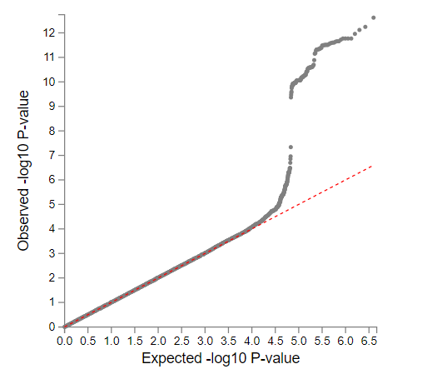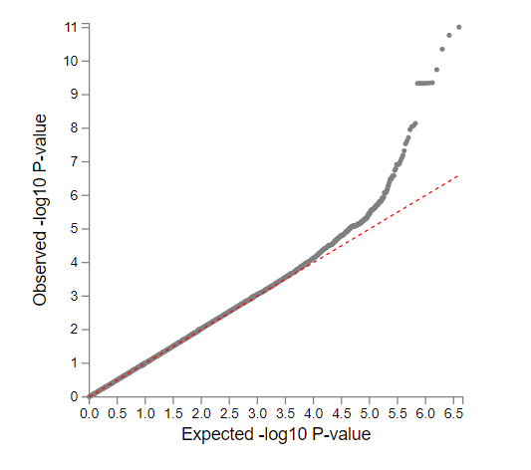
C. D.
