Figure S1. Depicts distribution of 10 principal components once 65 individuals with ancestral admixture were removed from the sample.
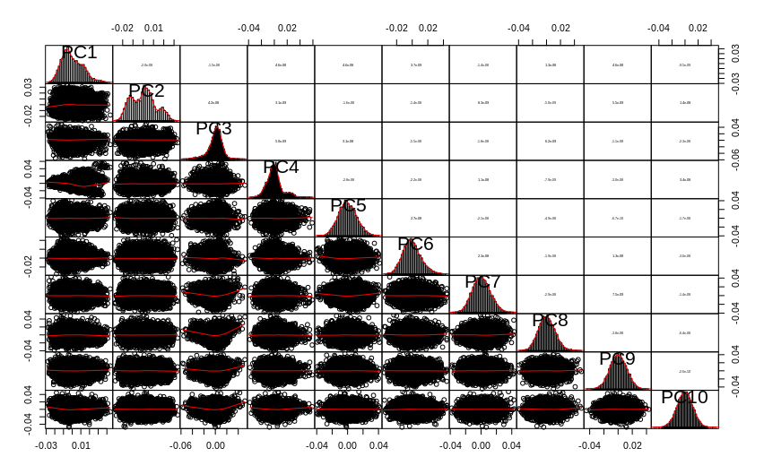

Figure S2. Depicts every step of quality control and assurance that was undertaken in preparation of the genetic data for the analyses in the ELLSA study.
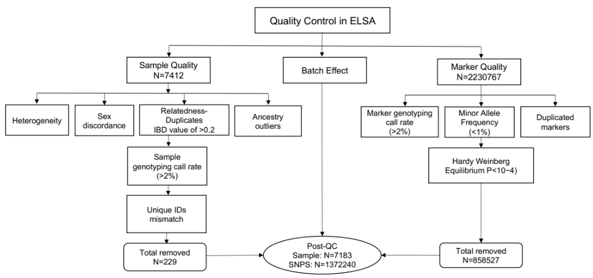

Table S1. Comparisons between the ELSA participants who were included in the analyses and those who were excluded
 |  |  | Excluded (n=4955) | Included (n=7133)
 |  |  | Mean (SD) / n(%) | Mean (SD) / n(%) | Statistics
Socio-demographic characteristics
 | Age (years) |  | 66.4 (10.3) | 64.7 (9.6) | t=8.8, df=11986, p<0.001
 | Gender (male) |  | 2147 (44.5) | 3294 (46.2) | x²=3.4, df=1, p=0.065
 | Education (years) |  | 13.2 (3.7) | 13.7 (3.8) | t=-7.1, df=10941, p<0.001
 | Married |  | 1759 (36.4) | 2227 (31.2) | x²=35.0, df=1, p<0.001
Accumulated wealth |  |  |  |  | x²=88.2, df=2, p<0.001
 | High |  | 1338 (29.2) | 2453 (35.3)
 | Intermediate |  | 1484 (32.4) | 2382 (34.3)
 | Low |  | 1762 (38.4) | 2109 (30.4)
Comorbid health issues
 | Limiting health conditions |  | 1902 (39.7) | 2313 (32.4) | x²=65.8, df=1, p<0.001
 | Depression (score ≥4) |  | 563 (18.8) | 800 (13.8) | x²=38.3, df=1, p<0.001
Behavioural outcomes
 | Currently a smoker |  | 800 (16.6) | 1047 (14.7) | x²=8.0, df=1, p=0.005

Table S2. The rate of mortality at each year of follow-up
Year of participation in the study | Mortality
Year of participation in the study | n (%) | Age, Median (IQR)
Year 1 | 69 (1.0) | 74.0 (16.0)
Year 2 | 91 (1.3) | 77.0 (10.5)
Year 3 | 93 (1.3) | 77.0 (15.0)
Year 4 | 121 (1.7) | 75.0 (13.0)
Year 5 | 107 (1.5) | 75.0 (16.0)
Year 6 | 145 (2.0) | 76.0 (12.0)
Year 7 | 159 (2.2) | 76.0 (15.0)
Year 8 | 152 (2.1) | 73.5 (12.0)
Year 9 | 157 (2.2) | 75.0 (11.0)
Year 10 | 141 (2.0) | 72.0 (13.0)
Year 11 | 168 (2.4) | 72.0 (12.3)
Year 12 | 142 (2.0) | 73.5 (12.0)
Year 13 | 169 (2.4) | 71.0 (12.0)
Year 14 | 64 (0.9) | 73.0 (11.5)
IQR – interquartile range (0.75-quantile minus 0.25-quantile)

Table S3. An overview of the summary of full QC procedure employed in the ELSA study and how many variants and/or participants were lost at each step
Quality Control steps in ELSA
Lost due to SNP-based QC |  | n | %
 | Missing SNPs (0.02) | 41614 | 1.87
 | Autosomal SNPs | 48578 | 2.18
 | MAF 0.01 | 759972 | 34.07
 | Update rsids | 2284 | 0.10
 | HWE (0.0001) | 6079 | 0.27
 | Total removed | 858527 | 38.49
 | Total remaining | 1372240 | 61.51
Lost due to Individual-based QC
 | Missingness (0.02) | 39 | 0.53
 | Heterogeneity | 76 | 1.03
 | Sex discordance | 5 | 0.07
 | Ancestry outliers | 64 | 0.86
 | Relatedness/Duplicates | 5 | 0.07
 | Unique IDs are not present | 41 | 0.50
 | Total removed | 229 | 3.09
 | Total remaining | 7183 | 96.91
HWE, Hardy-Weinberg equilibrium; MAF, minor allele frequency; SNP, single nucleotide polymorphisms

Table S4. Cox regression analyses highlighting associations between PGS-ADHD_{PT=1} and risk for all-cause mortality during a follow-up period
Polygenic scores for ADHD | The whole sample |  |  |  | Men |  |  |  | Women
Polygenic scores for ADHD | HR | 95% CI | p | R² | HR | 95% CI | p | R² | HR | 95% CI | p | R²
Participants all ages
PGS-ADHD_{PT=1} | 1.05 | 1.00-1.10 | 0.047 | 0.00% | 1.07 | 1.00-1.14 | 0.047 | 0.09% | 1.03 | 0.96-1.10 | 0.416 | 0.01%
PGS-ADHD _{PT=0.3} | 0.96 | 0.76-1.22 | 0.759 | 0.00% | 1.06 | 0.99-1.13 | 0.073 | 0.07% | 1.03 | 0.96-1.10 | 0.366 | 0.02%
PGS-ADHD _{PT=0.1} | 0.95 | 0.85-1.06 | 0.347 | 0.01% | 1.05 | 0.98-1.12 | 0.152 | 0.05% | 1.02 | 0.95-1.09 | 0.612 | 0.01%
PGS-ADHD _{PT=0.05} | 0.95 | 0.87-1.03 | 0.231 | 0.02% | 1.03 | 0.96-1.10 | 0.385 | 0.02% | 1.02 | 0.95-1.09 | 0.661 | 0.00%
PGS-ADHD _{PT=0.01} | 0.92 | 0.87-0.98 | 0.010 | 0.07% | 0.97 | 0.91-1.04 | 0.384 | 0.02% | 0.99 | 0.93-1.06 | 0.805 | 0.00%
PGS-ADHD _{PT=0.001} | 0.94 | 0.89-0.99 | 0.013 | 0.07% | 0.95 | 0.89-1.01 | 0.088 | 0.07% | 0.99 | 0.92-1.06 | 0.699 | 0.00%
Participants aged 50-75y at
PGS-ADHD_{PT=1} | 1.08 | 1.02-1.15 | 0.012 | 0.00% | 1.11 | 1.02-1.21 | 0.014 | 0.19% | 1.05 | 0.95-1.15 | 0.357 | 0.02%
PGS-ADHD _{PT=0.3} | 0.91 | 0.67-1.26 | 0.582 | 0.01% | 1.10 | 1.01-1.20 | 0.030 | 0.15% | 1.05 | 0.96-1.16 | 0.310 | 0.03%
PGS-ADHD _{PT=0.1} | 0.94 | 0.81-1.08 | 0.371 | 0.01% | 1.08 | 1.00-1.18 | 0.061 | 0.11% | 1.03 | 0.94-1.13 | 0.516 | 0.01%
PGS-ADHD _{PT=0.05} | 0.93 | 0.83-1.03 | 0.173 | 0.03% | 1.06 | 0.98-1.16 | 0.167 | 0.06% | 1.02 | 0.93-1.12 | 0.681 | 0.01%
PGS-ADHD _{PT=0.01} | 0.88 | 0.82-0.96 | 0.003 | 0.13% | 0.97 | 0.89-1.06 | 0.474 | 0.02% | 0.99 | 0.90-1.09 | 0.790 | 0.00%
PGS-ADHD _{PT=0.001} | 0.91 | 0.85-0.97 | 0.005 | 0.12% | 0.94 | 0.86-1.02 | 0.130 | 0.07% | 0.97 | 0.88-1.06 | 0.485 | 0.01%

ADHD, Attention Deficit Hyperactivity Disorder; HR, hazard ratio; CI, confidence intervals
Model was adjusted for baseline age, gender, interaction between age, gender and first 4 PCs to adjust for genetic ancestry; to capture non-linear effects of aging, we included age² and age³ as covariates.

Table S5. Results of a global test for violation of proportional hazards assumption for the fully adjusted Cox models.
 | The whole sample | Separate for each gender
 | The whole sample | Men | Women
Model | p=0.352¹ | p=0.764² | p=0.851²

P-values above 0.05 show that proportional hazards assumption cannot be ruled out
¹model passed the global test for proportional hazards assumption, however, by factor analysis revealed that the gender factor violated the test. Examination of the Schoenfield residuals showed that impact of gender was decreasing with time which indicated that a separate analysis for both genders could deliver better fitted models. ²Other factors did not violate PH assumptions and global test has higher p-values for separate models for each gender.

