Online Supplementary Material

Table S1. Database information and details of HER2 testing by study center
 | Combined | JBCR | NTUH | SMC | SNUH | JFCR | NCCHE
Data available | 2000-2015 | 2000-2015 | 2005-2015 | 2005-2014 | 2004-2015 | 2004-2015 | 2002-2015
Data cut-off | - | Dec 2019 | July 2021 | Nov 2018 | Dec 2019 | Nov 2020 | Jun 2020
No. of patients (%) | 28280 (100) | 6716 (100) | 4364 (100) | 4532 (100) | 7704 (100) | 2779 (100) | 2185 (100)
HER2-zero | 16020 (57) | 4281 (64) | 1684 (39) | 2695 (59) | 4178 (54) | 1622 (58) | 1560 (71)
HER2-low | 12260 (43) | 2435 (36) | 2680 (61) | 1837 (41) | 3526 (46) | 1157 (42) | 625 (29)
IHC 1+ | 8843 (31) | 1733 (26) | 1732 (40) | 1466 (32) | 2446 (32) | 949 (34) | 517 (24)
IHC 2+ ISH - | 3417 (12) | 702 (10) | 948 (22) | 371 (8) | 1080 (14) | 208 (7) | 108 (5)
HER2 antibody used |  | Dako (A0485) up to Jan 2005;  Thermo-scientific cerb-B2 SP3 (RM9103-S)  from Feb 2005 | 4B5 Ventana  (Roche) | 4B5 Ventana  (Roche) | 4B5 Ventana  (Roche) | Hercep Test (Dako) up to Feb 2012; HER2 4B5 (Roche) from Mar 2012 | 4B5 Ventana  (Roche)
HER2 detection system used |  | Ventana multimer detection kit | Ventana multimer detection kit | Ventana multimer detection kit | OptiView DAB IHC Detection Kit (Ventana) | Ventana multimer detection kit | I-VIEW (Ventana)
Type of ISH used |  | FISH | FISH | SISH | FISH | FISH from Jan 2009 to Feb 2012, DISH from March 2012 | FISH
Abbreviation: JBCR, Singapore Health Services’ Joint Breast Cancer Registry; NTUH, National Taiwan University Hospital; SMC, Samsung Medical Centre; SNUH, Seoul National University Hospital; JFCR, Japanese Foundation for Cancer Research; NCCHE, National Cancer Centre Hospital East; IHC, immunohistochemistry; ISH-, in-situ hybridization non-amplified; FISH, Fluorescence in-situ hybridization; SISH, Silver in-situ hybridization; DISH, Dual in-situ hybridization.

Table S2. Sensitivity analysis of relapse-free survival and overall survival by HER2 and hormone receptor status
 | Sensitivity analysisª
 | Center-adjusted |  |  |  | Multivariable-adjusted^{b}
 | Hazard ratio  (95% CI) | P | P (int) |  | Hazard ratio  (95% CI) | P | P (int)
Relapse-free survival
Overall: HER2-low vs HER2-zero | 0.89 (0.83 - 0.95) | <0.001 | - |  | 0.93 (0.87 - 0.99) | 0.022 | -
Hormone receptor-positive: HER2-low vs HER2-zero | 0.94 (0.87 - 1.02) | 0.118 | 0.995 |  | 0.92 (0.86 – 0.99) | 0.038 | 0.829
Hormone receptor-negative: HER2-low vs HER2-zero | 0.94 (0.82 - 1.08) | 0.378 | 0.995 |  | 0.94 (0.82 - 1.07) | 0.356 | 0.829
Overall survival
Overall: HER2-low vs HER2-zero | 0.83 (0.76 - 0.91) | <0.001 | - |  | 0.88 (0.81 - 0.97) | 0.006 | -
Hormone receptor-positive: HER2-low vs HER2-zero | 0.93 (0.84 - 1.03) | 0.170 | 0.143 |  | 0.92 (0.83 - 1.02) | 0.096 | 0.151
Hormone receptor-negative: HER2-low vs HER2-zero | 0.81 (0.68 – 0.95) | 0.012 | 0.143 |  | 0.80 (0.67 – 0.94) | 0.008 | 0.151
Abbreviation: int, interaction between HER2 and hormone receptor status.
a Patients diagnosed in 2000-2010 were censored at the maximum follow-up time of patients diagnosed in 2011-2015 (9.82 years)
b Covariates adjusted were study center, age at diagnosis, ethnicity, year of diagnosis, histology, overall stage, hormone receptor status, grade, received radiotherapy, endocrine therapy and chemotherapy.

Figure S1. Flowchart of patients included in the ABCCG cohort analysis.
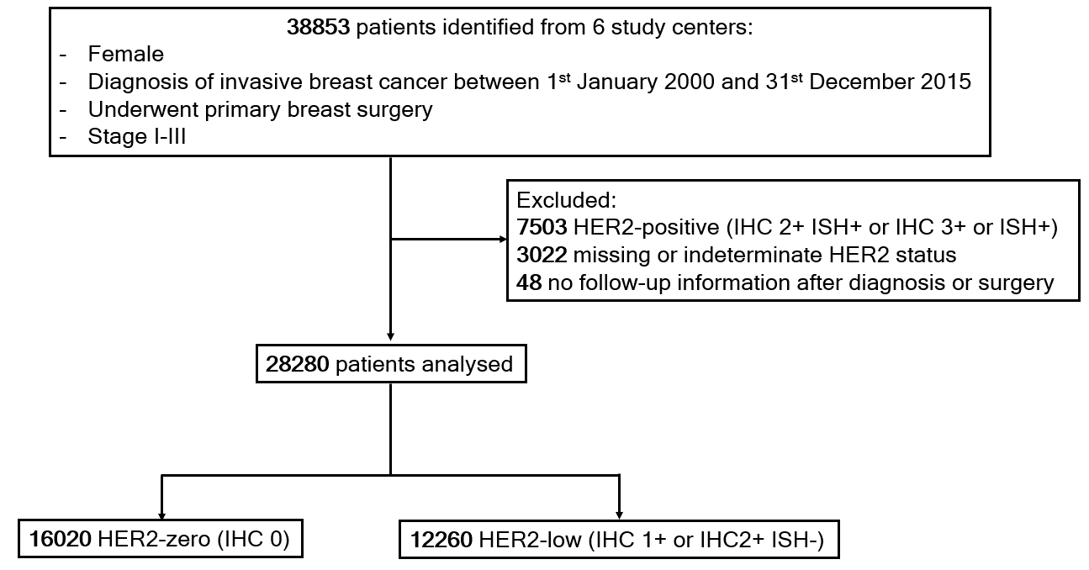
Figure S2. Estimated heterogeneity between study centers in (A) relapse-free survival, and (B) overall survival (based on pooling univariable HR estimate from each center with a random effect restricted maximum likelihood estimation model. HR, hazard ratio; I², index of heterogeneity)
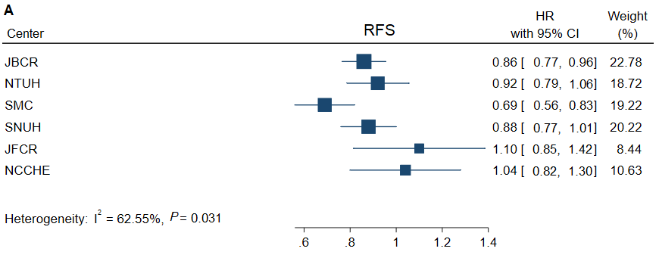
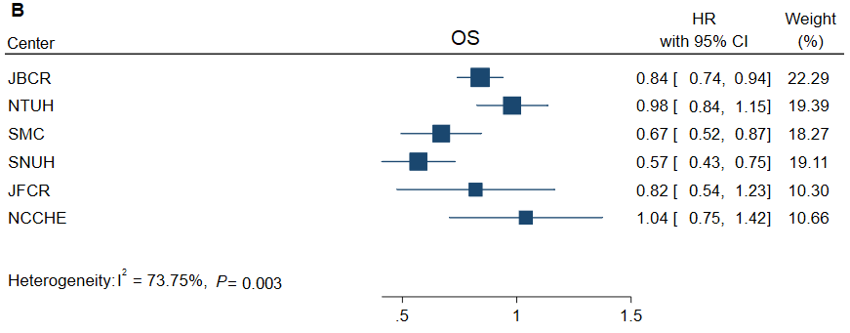

Figure S3. Association of ERBB2 mRNA expression with HER2 IHC and ERBB2 CNV by hormone receptor status (TCGA-BRCA): (A-D) Hormone receptor-positive subgroup of TCGA-BRCA dataset: ERBB2 mRNA expression by (A) HER2-low and HER2-zero, (B) HER2 IHC score, (C) ERBB2 CNV; (D) ERBB2 CNV against HER2 IHC. (E-H) Hormone receptor-negative subgroup of TCGA-BRCA dataset: ERBB2 mRNA expression by (E) HER2-low and HER2-zero, (F) HER2 IHC score, (G) ERBB2 CNV; (H) ERBB2 CNV against HER2 IHC.
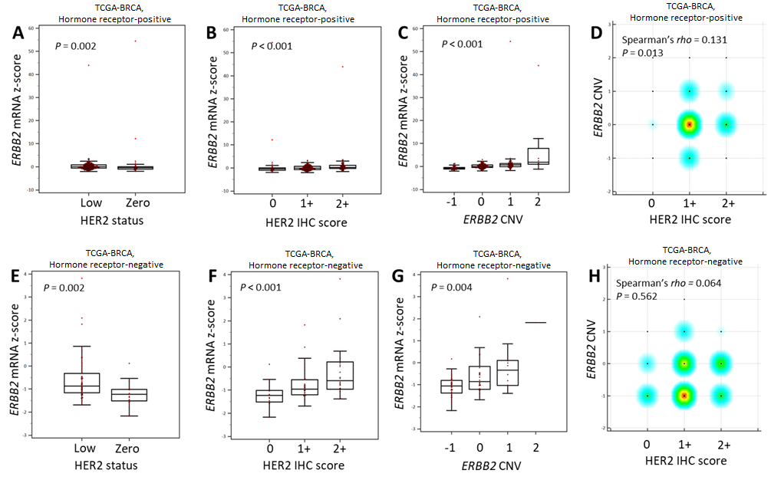

Figure S4. Relapse-free survival by ERBB2 mRNA expression levels in combined TCGA-BRCA and METABRIC dataset (Quartile 1: lowest; Quartile 4: highest)
