Additional file 5
Observational study data:
Fibre and all-cause mortality
Figure 1: Extreme quantile meta analyses of dietary fibre and all-cause mortality
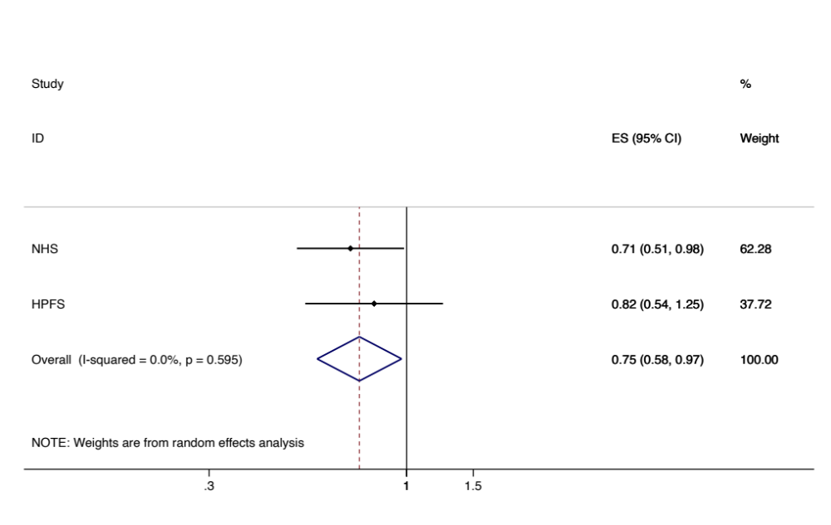
Figure 2: Extreme quantile meta analyses of cereal fibre and all-cause mortality
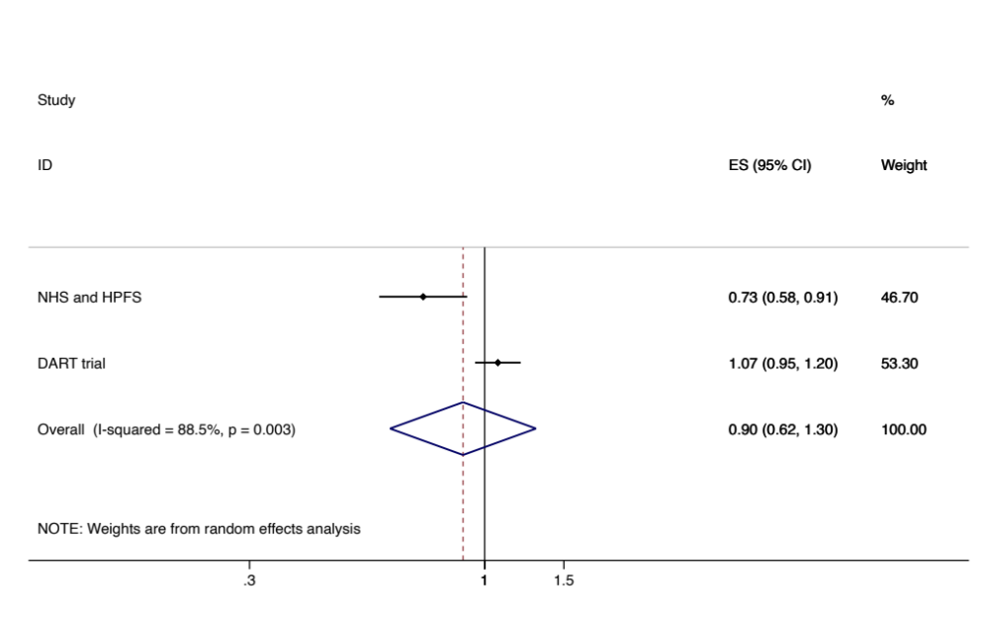

Fibre and cardiovascular disease mortality
Figure 3: Extreme quantile meta analyses of dietary fibre and cardiovascular disease mortality
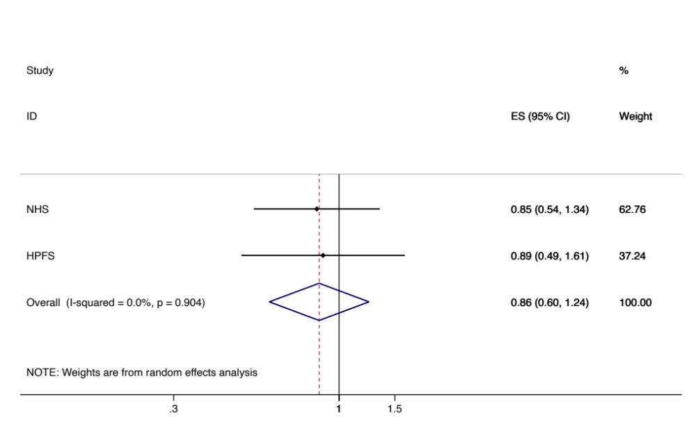
Figure 4: Extreme quantile meta analyses of cereal fibre and cardiovascular disease mortality
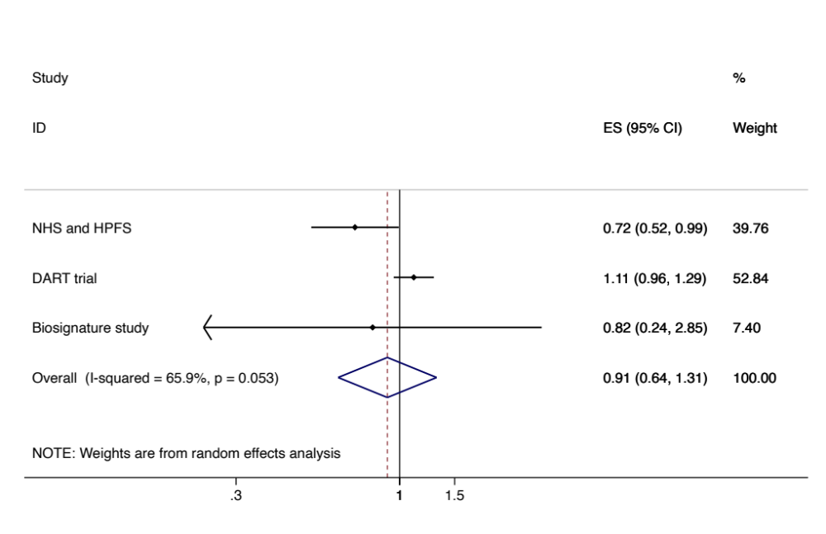
Egger p for bias 0573.
Influence analysis: The result from one study (DART trial) was observed to drive the pooled response. The point estimate of pooled sample without the DART trial was RR 0.73 (0.53 to 0.99) and the I² was reduced to 0%.

Trial data: sensitivity analyses for pooled data with four or more data points.
Fibre hypertension Total cholesterol
Figure 5: Meta analyses of fibre interventions regardless of dose
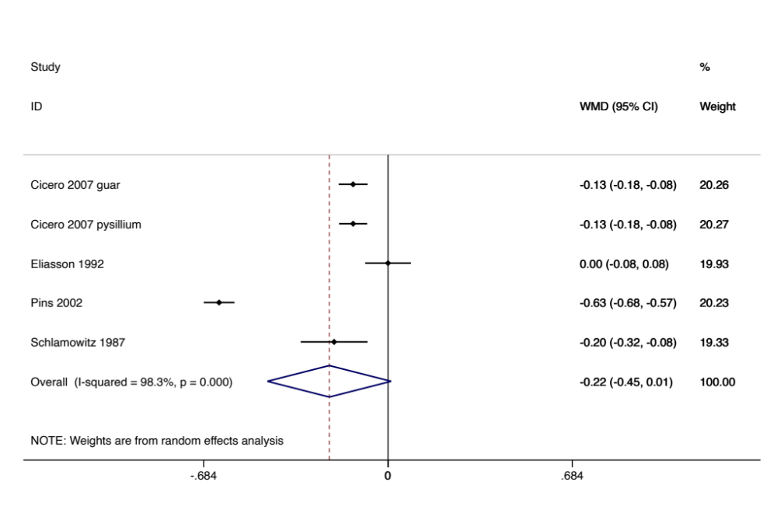
Egger p for bias 0.797
Influence analysis: point estimate of pooled sample without either Eliasson 1992 or Pins 2002 was outside the confidence interval of the complete data set (one in each direction). High I2 most likely due to the precision around each trial’s observed effect size.

Univariate
Meta regression by trial duration (<or =12 vs >12). -.15 (-.91 to 0.61) p 0.579
Meta regression by antihypertensive use -0.30 (-1.73 to 1.14) p 0.469
Meta regression by food or supplements -0.52 (-0.78 to -0.26) p 0.008 I2 reduced to 68%
Meta regression by higher BMI -0.20 (-0.83 to 0.53) p 0.454
Meta regression by placebo control -0.15 (-0.91 to 0.61) p 0.579
Meta regression by psyllium 0.11 (-0.86 to 1.08) p 0.740

Insufficient data to consider dose response.

Figure 6: Meta analyses of fibre interventions with effect size standardised to 5g of fibre per day
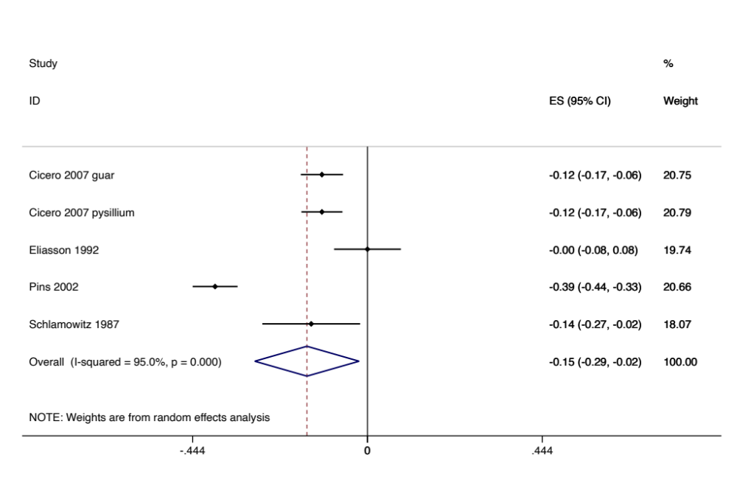

Fibre hypertension HDL cholesterol
Figure 7: Meta analyses of fibre interventions regardless of dose
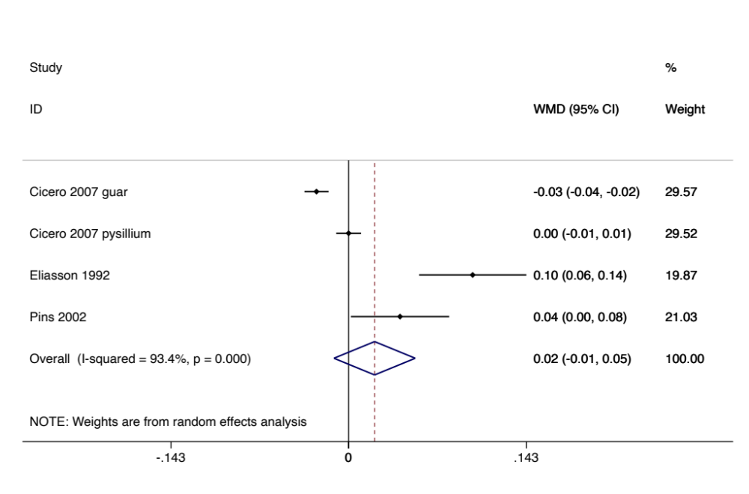
Egger p for bias 0.534
Influence analysis: point estimate of pooled sample without either Eliasson 1992 or Cicero 2007 guar gum intervention was outside the confidence interval of the complete data set (one in each direction).

Univariate
Meta regression by trial duration (<or =12 vs >12). 1.57 (-2.18 to 5.32) p 0.214
Meta regression by antihypertensive use -1.52 (-6.82 to 3.78) p 0.342
Meta regression by food or supplements 0.58 (-6.21 to 7.36) p 0.750
Meta regression by higher BMI -1.52 (-6.82 to 3.78) p 0.342
Meta regression by placebo control 1.57 (-2.18 to 5.32) p 0.214
Meta regression by psyllium 0.00 (-7.03 to 7.04) p0.999
Meta regression by geographic region (Europe or USA) -0.58 (-7.36 to 6.21) p 0.750

Insufficient data to consider dose response.

Figure 8: Meta analyses of fibre interventions with effect size standardised to 5g of fibre per day
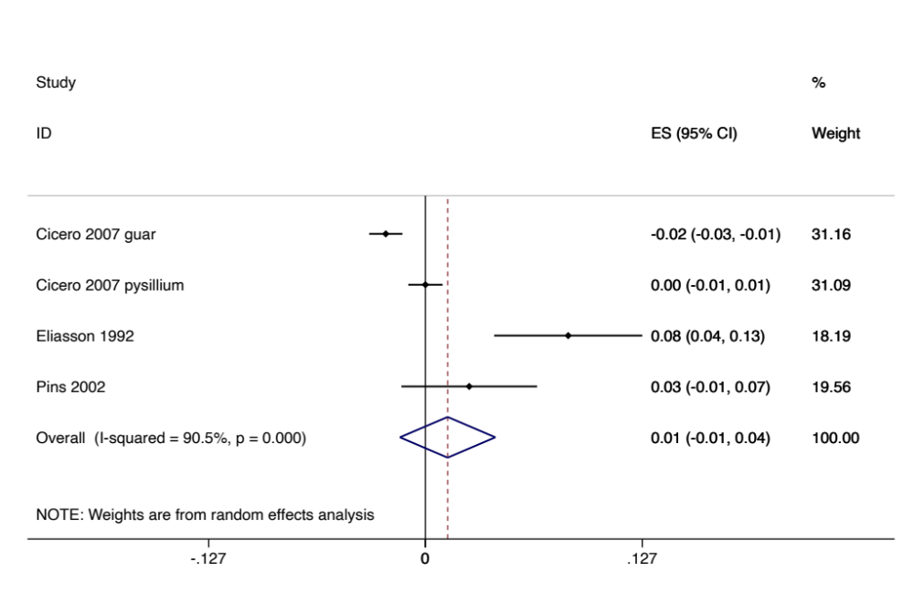

Fibre hypertension triglycerides
Figure 9: Meta analyses of fibre interventions regardless of dose
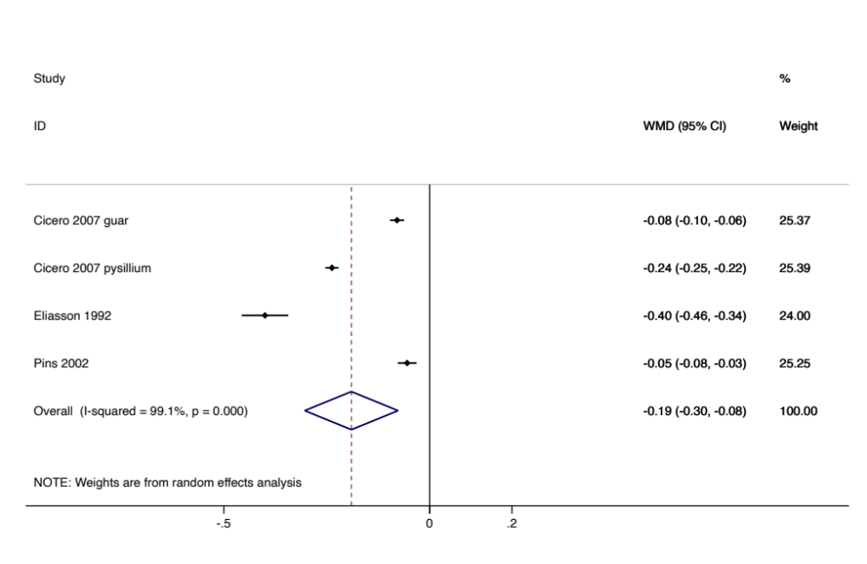
Egger p for bias 0.752
Influence analysis: One study, Pins 2002 appreciably influenced the pooled result. Without Pins 2002 the pooled effect size estimate was -0.24 (-0.38 to -0.10).

Univariate
Meta regression by trial duration (<or =12 vs >12). -0.07 (-0.88 to 0.748) p 0.756
Meta regression by antihypertensive use 0.28 (-0.23 to 0.78) p 0.144
Meta regression by food or supplements 0.18 (-0.61 to 0.98) p 0.426
Meta regression by higher BMI 0.28 (-0.23 to 0.78) p 0.144
Meta regression by placebo control -0.07 (-0.88 to 0.748) p 0.756
Meta regression by psyllium -0.6 (-1.01 to 0.89) p 0.809
Meta regression by geographic region (Europe or USA) -0.18 (-0.98 to 0.61) p 0.426

Insufficient data to consider dose response.

Figure 10: Meta analyses of fibre interventions with effect size standardised to 5g of fibre per day
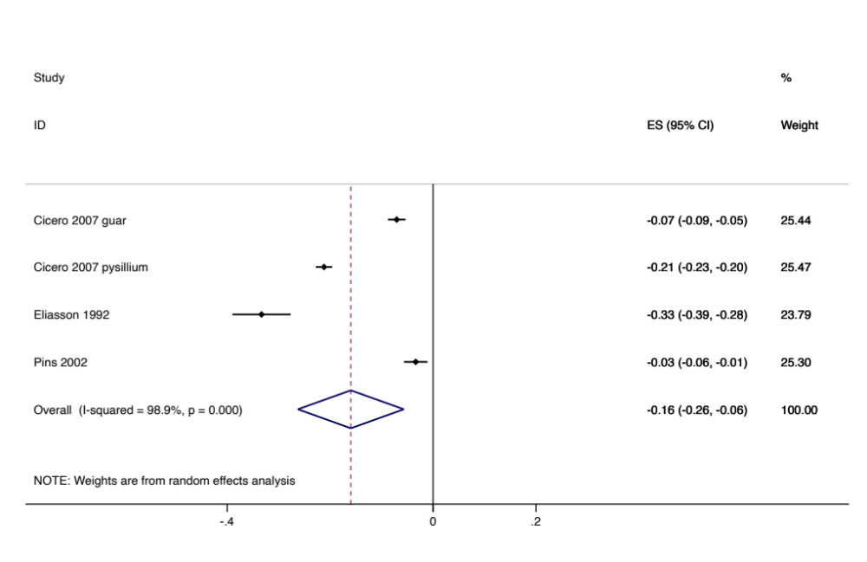
Fibre hypertension fasting plasma glucose
Figure 11: Meta analyses of fibre interventions regardless of dose
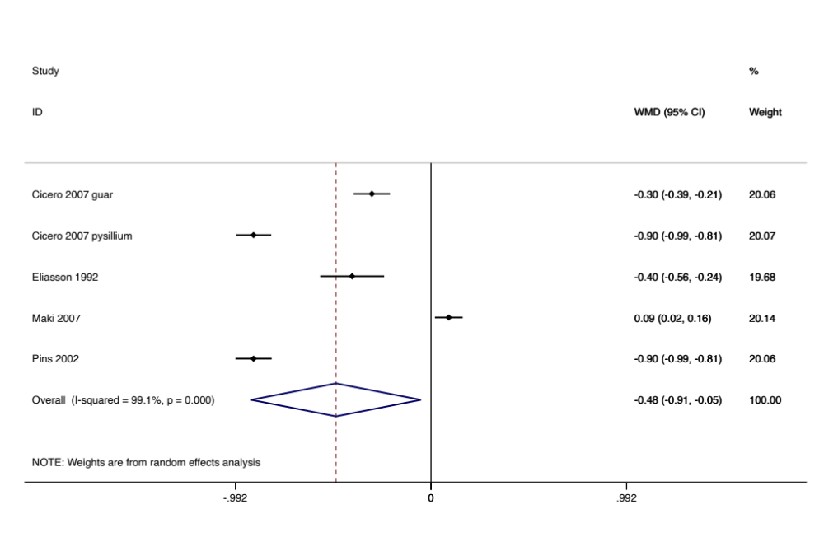
Egger p for bias 0.547
Influence analysis: point estimate of pooled sample without either Maki 2007 or Pins 2002 was outside the confidence interval of the complete data set (one in each direction).

Univariate
Meta regression by trial duration (<or =12 vs >12). 0.20 (-1.18 to 1.58) p 0.680
Meta regression by antihypertensive use -0.10 (-1.85 to 1.64) p 0.864
Meta regression by food or supplements 0.13 (-1.28 to 1.54) P 0.787
Meta regression by higher BMI -0.10 (-1.85 to 1.64) p 0.864
Meta regression by placebo control 0.20 (-1.18 to 1.58) p 0.680
Meta regression by psyllium -0.52 (-1.98 to 0.93) p 0.336
Meta regression by geographic region (Europe or USA) -0.13 (-1.54 to 1.28) p 0.787

Insufficient data to consider dose response.

Figure 12: Meta analyses of fibre interventions with effect size standardised to 5g of fibre per day
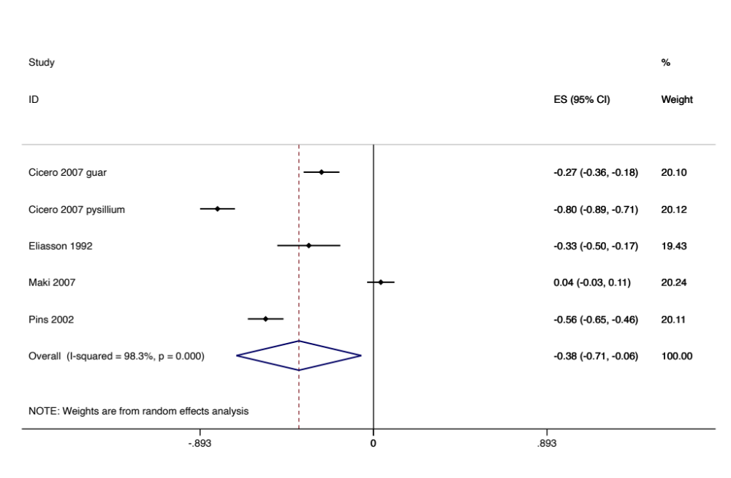

Fibre hypertension fasting plasma insulin
Figure 13: Meta analyses of fibre interventions regardless of dose
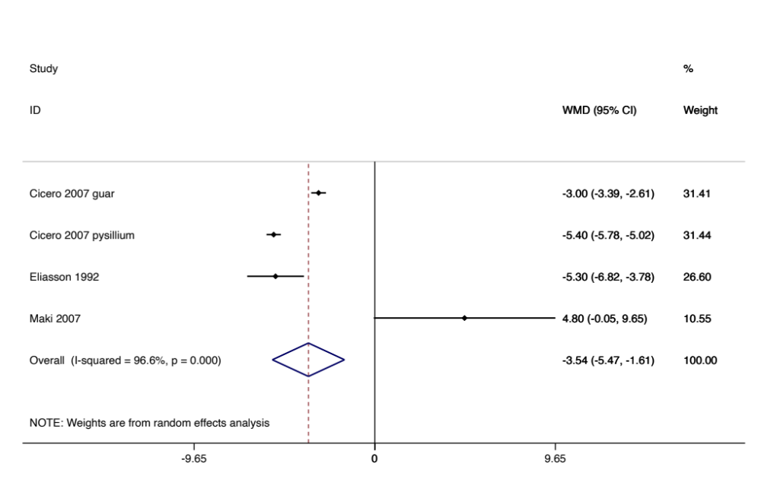
Egger p for bias 0.770
Influence analysis: point estimate of pooled sample without either Maki 2007 or Cicero 2002 was outside the confidence interval of the complete data set (one in each direction).

Univariate
Meta regression by trial duration (<or =12 vs >12). 3.4 (-18.2 to 25.0) p 0.568
Meta regression by antihypertensive use 3.6 (-21.3 to 28.6) p 0.594
Meta regression by food or supplements 9.3 (-3.3 to 22.0) p 0.087
Meta regression by higher BMI 3.6 (-21.3 to 28.6) p 0.594
Meta regression by placebo control 3. (-18.2 to 25.0) p 0.568
Meta regression by psyllium -3.8 (-28.2 to 20.6) p 0.572
Meta regression by geographic region (Europe or USA) -9.3 (-22.0 to 3.3) p 0.087

Insufficient data to consider dose response.

Figure 14: Meta analyses of fibre interventions with effect size standardised to 5g of fibre per day
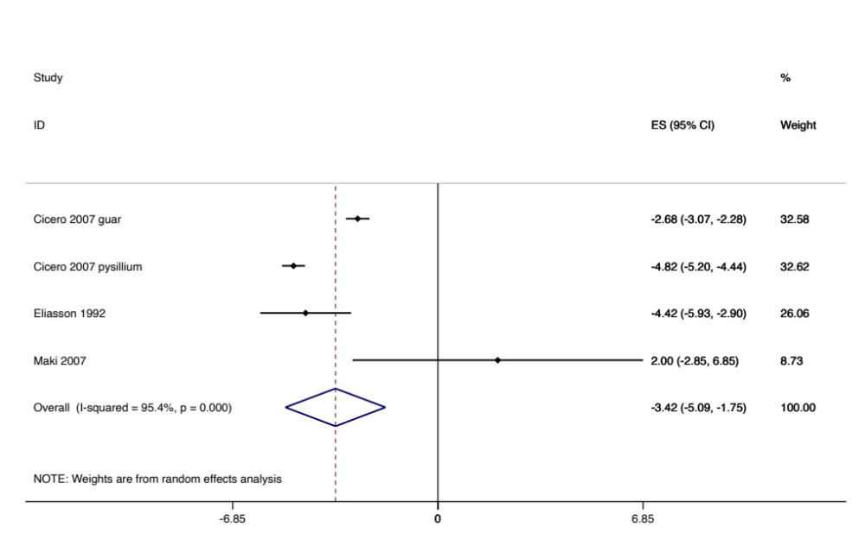

Fibre hypertension systolic blood pressure
Figure 15: Meta analyses of fibre interventions regardless of dose
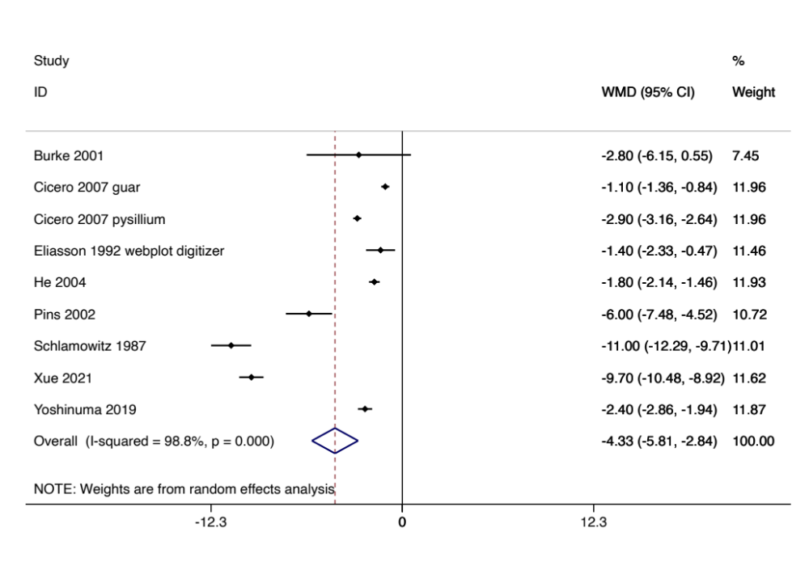
Egger p for bias 0.119
Influence analysis: One study, Eliasson 1992 appreciably influenced the pooled result. Without Eliasson 1992 the pooled effect size estimate was -4.7 (-6.3 to -3.1) I2 99%.

Univariate
Meta regression by trial duration (<or =12 vs >12). -3.0 (-10.0 to 3.9) p 0.337
Meta regression by antihypertensive use -3.0 (-9.6 to 3.7) p 0.306
Meta regression by food or supplements 0.6 (-6.9 to 8.2) p 0.851
Meta regression by higher BMI 1.6 (-4.9 to 8.1) p 0.583
Meta regression by placebo control 0.3 (-6.3 to 7.0) p 0.915
Meta regression by psyllium 2.4 (-3.9 to 8.8) p 0.396
Meta regression by geographic region (Europe or other) 0.5 (-5.8 to 6.8) p 0.852
Meta regression by geographic region (Asia or other) -2.2 (-9.5 to 5.1) p 0.499
Meta regression by geographic region (North America or other) 0.6 (-6.9 to 8.2) p 0.851

Figure 16: Meta analyses of fibre interventions with effect size standardised to 5g of fibre per day
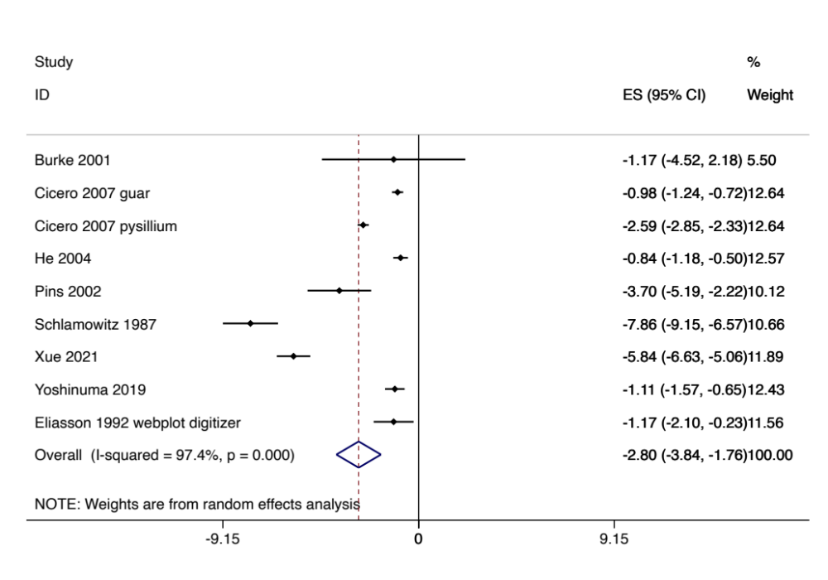
Fibre hypertension diastolic blood pressure
Figure 17: Meta analyses of fibre interventions regardless of dose
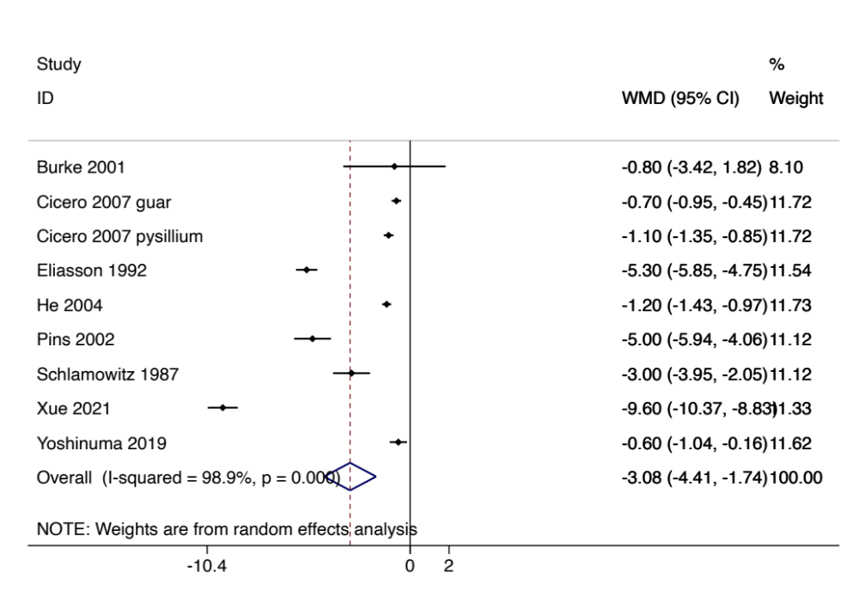
Egger p for bias 0.859
Influence analysis: One study, Yoshinuma 2019 appreciably influenced the pooled result. Without Yoshinuma 2019 the pooled effect size estimate was -3.4 (-4.9 to -1.9) I2 99%.

Univariate
Meta regression by trial duration (<or =12 vs >12). -2.8 (-8.5 to 2.9) p 0.281
Meta regression by antihypertensive use -0.2 (-8.2 to 7.7) p 0.941
Meta regression by food or supplements -0.0 (-6.3 to 6.2) p 0.990
Meta regression by higher BMI 1.2 (-4.2 to 6.6) p 0.608
Meta regression by placebo control 1.1 (-4.3 to 6.5) p 0.649
Meta regression by psyllium 3.3 (-1.5 to 8.0) p 0.148
Meta regression by geographic region (Europe or other) 1.0 (-4.2 to 6.1) p 0.666
Meta regression by geographic region (Asia or other) -2.6 (-8.4 to 3.2) p 0.323
Meta regression by geographic region (North America or other) -0.0 (-6.2 to 6.2) p 0.990

Figure 18: Meta analyses of fibre interventions with effect size standardised to 5g of fibre per day
