Additional File

Recovery of serum testosterone levels is an accurate predictor
of survival from COVID-19 in male patients

Emily Toscano-Guerra^{1,2, 11}, Mónica Martínez Gallo^{3,4,5}*, Iria Arrese-Muñoz^{3,4,5}, Anna Giné^{1,2}, Noelia Díaz-Troyano¹, Pablo Gabriel-Medina¹, Mar Riveiro-Barciela⁶, Moisés Labrador-Horrillo⁶, Fernando Martinez-Valle⁶, Adrián Sánchez-Montalvá⁷, Manuel Hernández-González^{3,4,5}, Ricardo Pujol Borrell^{3,4,5}, Francisco Rodríguez-Frias¹, Roser Ferrer¹, Timothy M. Thomson^{8,9,10, 11}*, and Rosanna Paciucci^{1,2}*

¹ Biochemistry Service, Vall d’Hebron Hospital, Autonomous University of Barcelona (UAB), Barcelona, Spain
² Cell Signaling and Cancer Progression Laboratory, Vall d’Hebron Institute of Research (VHIR), Barcelona, Spain
³ Immunology Division, Vall d’Hebron Hospital, Barcelona, Spain
⁴ Diagnostic Immunology Research Group, Vall d’Hebron Research Institute (VHIR), Barcelona, Spain
⁵ Department of Cell Biology, Physiology and Immunology, Autonomous University of Barcelona (UAB), Barcelona, Spain
⁶ Internal Medicine Service, Vall d’Hebron Hospital, Barcelona, Spain
⁷ Infectious Diseases Department. International Health and Tuberculosis Unit National Referral Centre for Tropical Diseases, Vall d'Hebron University Hospital, Vall d'Hebron Institute of Research (VHIR), Barcelona, Spain
⁸ Barcelona Institute for Molecular Biology, National Science Council (IBMB-CSIC), Barcelona, Spain
⁹ Networked Center for Hepatic and Digestive Diseases (CIBER-EHD), Instituto Nacional de la Salud Carlos III, Madrid, Spain
¹⁰ Plataforma Temática Interdisciplinar Salud Global (PTI-Global Health) CSIC, Spain
¹¹ Universidad Peruana Cayetano Heredia, Lima, Perú.

Table ST1. Treatment comparison by outcome in male patients.
- Comparison between Mild-moderate and Severe outcomes
Treatments | Total  249 (%) | Mild-Moderate  114 (%) |  | Severe  135 (%) |  | p-value*
Hydroxychloroquine | 241 (96.79) |  | 112 (98.24) | 129 (95.55) | 0.2953
Antibiotics | 238 (95.58) |  | 104 (91.23) | 134 (99.26) | 0.0031
Antivirals | 196 (78.71) |  | 93 (81.58) | 103 (76.30) | 0.3528
Corticoids | 66 (26.5) |  | 13 (11.40) | 53 (39.26) | <0.0001
Immunomodulators | 130 (52.21) |  | 23 (20.17) | 107 (79.26) | <0.0001
Anticoagulants | 123 (49.40) |  | 34 (29.82) | 89 (65.92) | <0.0001
Analgesics | 28 (11.24) |  | 13 (11.40) | 15 (11.11) | 0.9999

- Comparison between Severe-survivor and Severe-deceased
Treatments | Severe-survivor  97 (%) | Severe-deceased  38 (%) |  | p-value*
Hydroxychloroquine | 95 (97.93) |  | 34 (89.47) | 0.0526
Antibiotics | 96 (98.97) |  | 38 (100.0) | 0.9999
Antivirals | 76 (78.35) |  | 27 (71.05) | 0.3764
Corticoids | 33 (34.02) |  | 20 (52.63) | 0.0525
Immunomodulators | 76 (78.35) |  | 31 (81.57) | 0.8149
Anticoagulants | 68 (70.10) |  | 21 (55.26) | 0.1108
Analgesics | 13 (13.40) |  | 2 (5.26) | 0.2322

Table ST2. Treatment comparison by outcome in female patients.
Treatments | Total  248 (%) | Mild-Moderate  145 (%) | Severe  103 (%) | P-value*
Hydroxychloroquine | 228 (91.94) | 133 (91.72) | 95 (92.23) | 0.9999
Antibiotics | 231 (93.15) | 128 (88.28) | 103 (100.00) | 0.0001
Antivirals | 215 (86.69) | 129 (88.97) | 86 (83.5) | 0.2557
Corticosteroids | 41 (16.53) | 11 (7.59) | 30 (29.13) | <0.0001
Immunomodulators | 95 (38.31) | 23 (15.86) | 72 (69.90) | <0.0001
Anticoagulants | 70 (28.23) | 10 (6.90) | 60 (58.25) | <0.0001
Analgesics | 65 (26.21) | 40 (27.59) | 25 (24.27) | 0.6605

*Two-by-two Contingency analyses were performed to compare outcomes in each treatment. P-values are from Fisher exact test.

Table ST3. WHO classification of disease outcome (adapted from Grain et al.²⁶)

Group | Outcome | Definition | Stay Type
1 | Mild | Not hospitalized or hospitalized without oxygen | Discharge from emergency to home or Ward
2 | Moderate | Hospitalized with low flow oxygen by mask or nasal prongs or with high flow oxygen | Ward
3 | Severe-Survivor | Hospitalized with non-invasive ventilation or with invasive mechanical ventilation | ICU
4 | Severe-Deceased | Death | Exitus

Table ST4. Panels and antibodies used for immunophenotyping.

General lymphocyte populations | Fluorophore | Isotype | Clone
CD45/CD8/CD4/CD3 | FITC/PE/ECD/PC5 | IgG2b/IgG1/IgG1/IgG1 | B3821F4A/SFCI12T4D11/SFCI21Thy2D3/UCHT1
CD45/CD56/CD19/CD3 | FITC/PE/EDC/PC5 | IgG2b/IgG1/IgG1/IgG1 | B3821F4A/SFCI12T4D11/SFCI21Thy2D3/UCHT1
T-cell populations
CXCR3/CD183 | AF488 | IgG1 | G025H7
CCR7/CD197 | PE | IgG2a | G043H7
CD45RA | ECD | IgG1 | ALB11
CCR6/CD196 | PC7 | IgG2a | B-R35
CD4 | APC | IgG1 | 13B8.2
CD8 | APC700 | IgG1 | SFCI21Thy2D3 (T8)
CD3 | APC750 | IgG1 | UCHT1
HLA-DR | PB | IgG1 | Immu-357
CD45 | KRO | IgG1 | J.33
Recent Thymic Emigrant
CD31 | FITC | IgG1 | 5.6E
CD62L | PE | IgG1 | DREG56
CD3 | ECD | IgG1 | UCHT1
CD27 | PC7 | IgG1 | 1A4CD27
CD4 | APC | IgG1 | 13B8.2
CD45RA | PB | IgG1 | 2H4LDH11LDB9 (2H4)
CD45 | KRO | IgG1 | J.33
T regulatory cell population
CD45RO | FITC | IgG2a | UCHL1
CD25 | PE | IgG2a | B1.49.9
CD3 | ECD | IgG1 | UCHT1
CCR4/ CD194 | PC7 | IgG1 | 1G1
CD4 | APC | IgG1 | 13B8.2
CD127 | APC700 | IgG1 | R34.34
HLA-DR | PB | IgG1 | Immu-357
CD45 | KRO | IgG1 | J.33
DC/Monocytes/NK
CD16 | FITC | IgG1 | 3G8
CD11c | PE | IgG1 | BU15
CD3 | ECD | IgG1 | UCHT1
CD19 | ECD | IgG1 | J3-119
CD20 | ECD | IgG2a | B9E9(HRC20)
CD56 | PC7 | IgG1 | N901 (NKH-1)
CD123 | APC | IgG1 | SSDCLY107D2
CD14 | APC750 | IgG1 | RMO52
HLA-DR | PB | IgG1 | Immu-357
B-cell populations
IgD | FITC | IgG2a | IA6-2
CD21 | PE | IgG1 | BL13
CD19 | ECD | IgG1 | J3.119
CD27 | PC7 | IgG1 | 1A4CD27
CD24 | APC | IgG1 | ALB9
CD38 | APC750 | IgG1 | LS198-4-3
IgM | PB | IgG1 | SA-DA4
CD45 | KRO | IgG1 | J.33

Figure SF1 (linked to Tables 1 and 2). Patient distributions by (a) outcome: Mild-moderate (n = 259), severe-survivor (n =173) and severe-deceased (n = 65). Two by two Contingency analyses shows more proportion of female patients in mild-moderate than severe-survivor outcome (Fisher exact test p= 0.0183) b), age, (c) age and outcome (d) and comorbidities and outcome. For 1c, unpaired T-test (two-tailed) was performed between male and female for each status and between status for males and females

Figure SF2 (linked to Figure 2). Distribution of male patients with comorbidities according to age and Testosterone levels. Mann-Whitney test (two-tailed) was applied for pairwise group comparisons.

Figure SF3 (linked to Figure 3). Longitudinal analysis of serum levels of IL-6, C-reactive protein (CRP), ferritin and lactate dehydrogenase (LDH) in male patients. For severe survivor and severe deceased outcomes, the trajectories of longitudinal determinations were submitted to linear regression analysis, and the resulting slopes compared for significance by two-way ANOVA. ns denotes not significant.

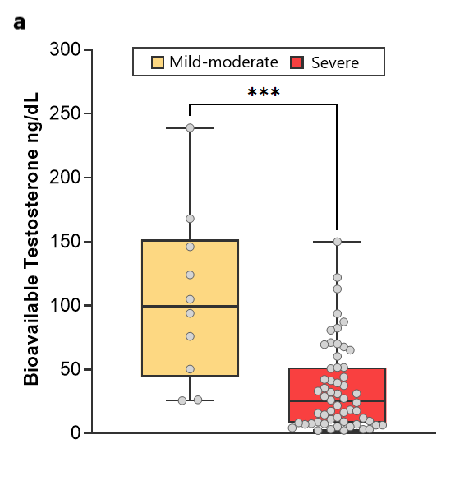

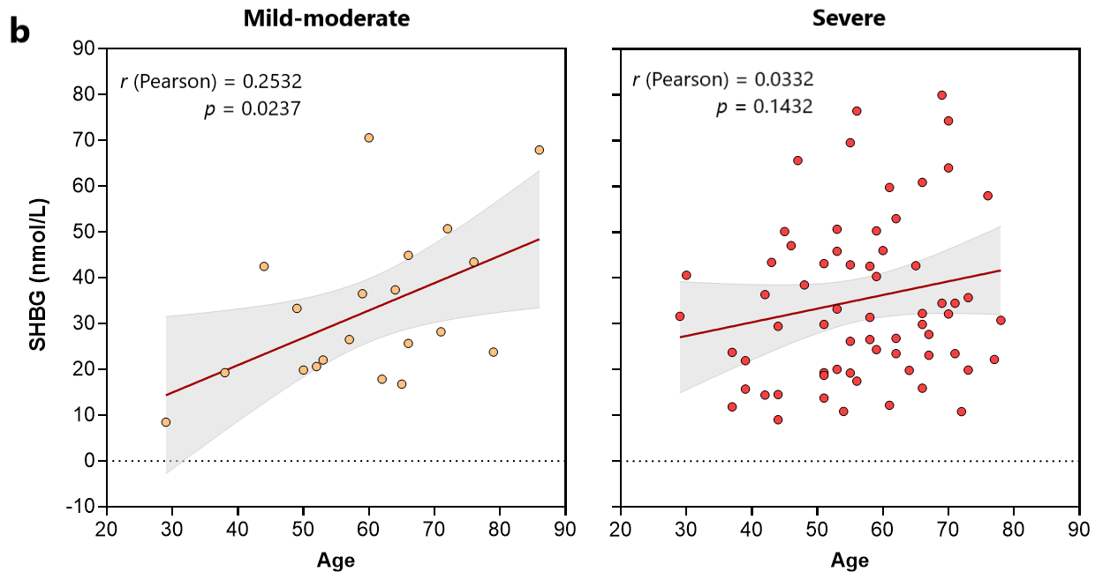

Figure SF4. Bioavailable testosterone serum levels and correlation between age and sex-hormone binding globulin (SHBG). (a) Bioavailable testosterone levels were inferred from SHBG and albumin levels as described ⁽²⁷⁾. There is a significant difference (p = 0.0002, Mann-Whitney test) between severe and mild-moderate outcomes. (b) Values for serum SHBG levels from 86 male patients were plotted against age. Significant correlation was observed for patients with mild-moderate (r² = 0.2532, p = 0.0237) but not severe outcomes.

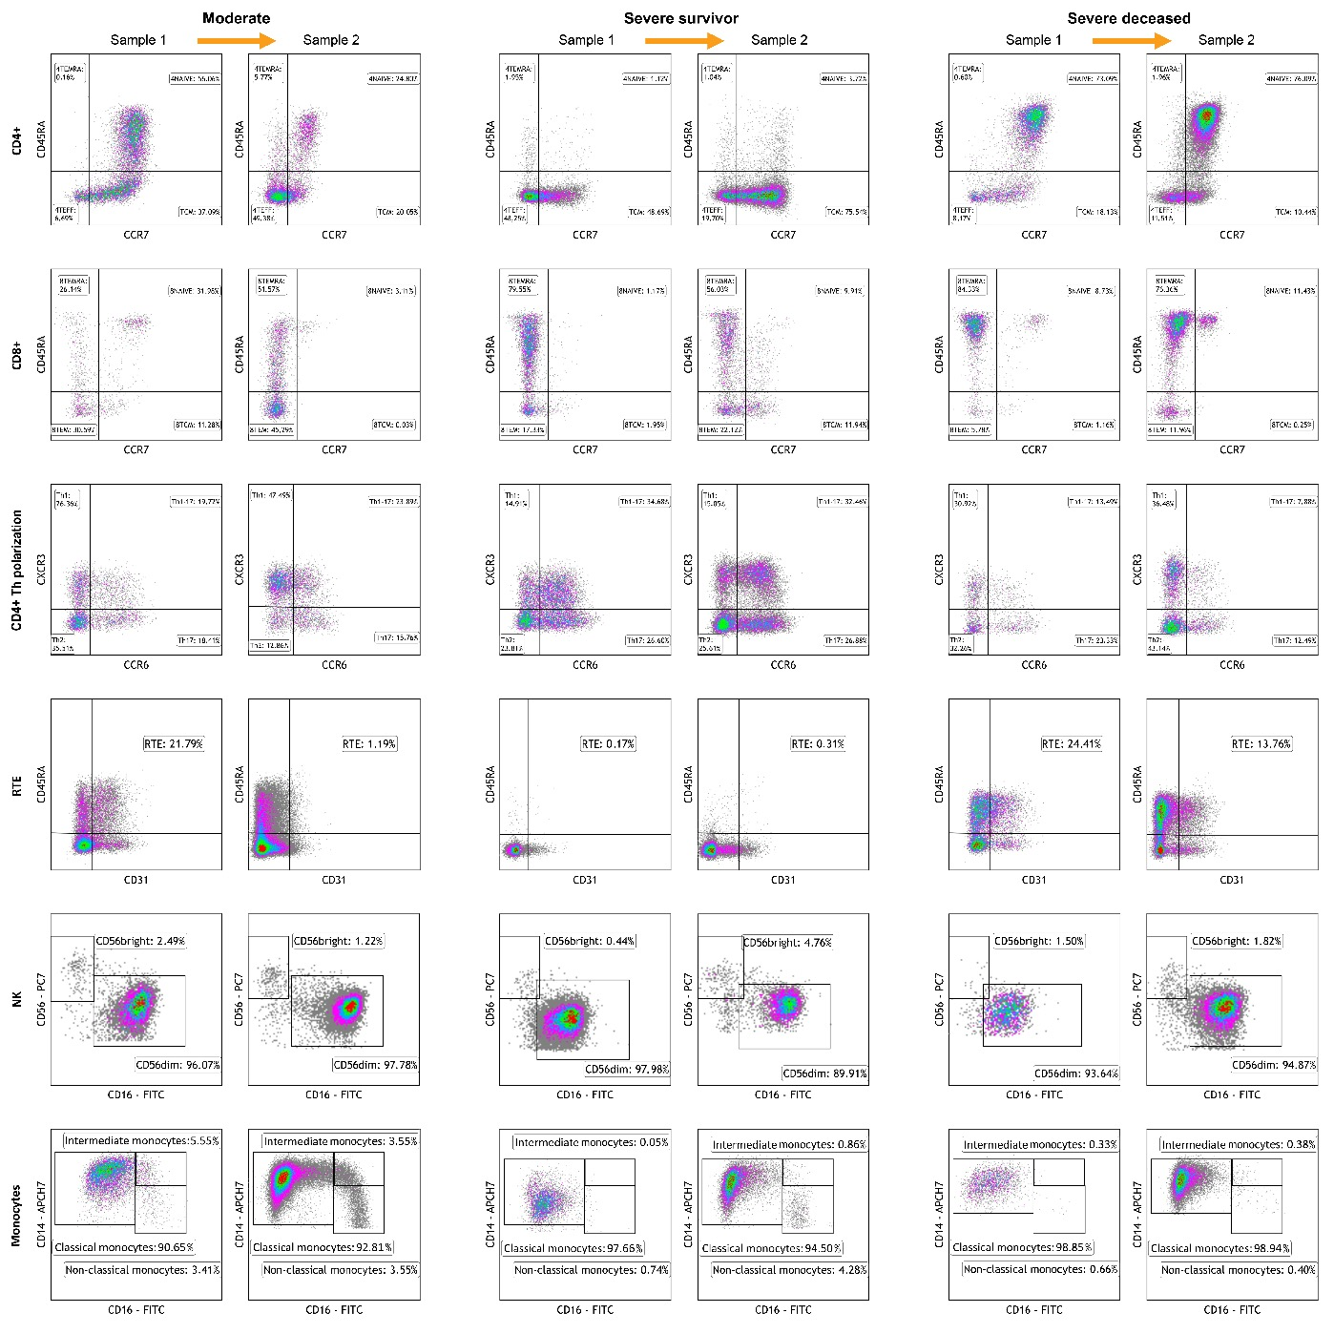

Figure SF5 (linked to Figure 5). Flow cytometry analysis of circulating immune subpopulations in three illustrative cases with moderate, severe survivor and severe deceased outcomes. For each case, Sample 1 corresponds to the first available analysis post-admission, and Sample 2 corresponds to a subsequent analysis, separated from Sample 1 by 6-12 days. CD4+ and CD8+ subpopulations were further segmented into the indicated subpopulations by analyzing for CD45RA and CCR7 expression. CD3+ subpopulations were further segmented into subpopulations by analyzing the expression of the polarization markers CXCR3 and CCR6. Recent thymic emigrant (RTE) populations were identified and scored through the expression of CD3, CD45RA and CD31. Natural killer (NK) cell subpopulations were segmented by analyzing the expression of CD56 and CD16. Monocyte subpopulations were segmented by analyzing the expression of CD14 and CD16. Not shown are B cell and dendritic cell subpopulations, which did not show significant shifts in repertoire between outcomes and longitudinal sampling. 4TEFF, 4TCM, 4TEMRA, 8TEFF, 8TCM, 8TEMRA: CD4+ or CD8+ effector, central memory or T effector memory re-expressing CD45RA, respectively.

