Additional file 11. SUBGROUP ANALYSES

1 Depending on AF detection device
Detection devices with recording times ≥7 (21 RCTs) | Detection devices with recording times <7 (46 RCTs)
τ²= 0.066  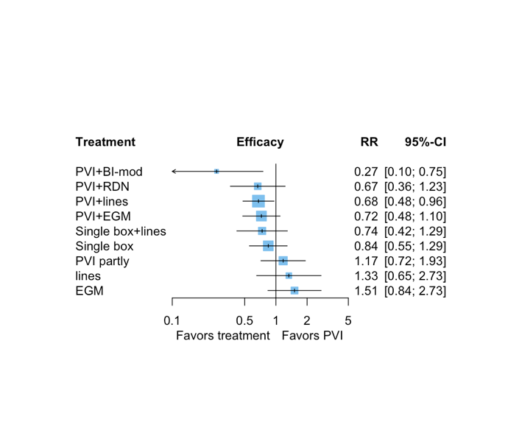Disconnected components excluded:  - GP vs PVI+GP  - PVI+posterior+lines vs PVI+SUB-mod | τ²=0.123  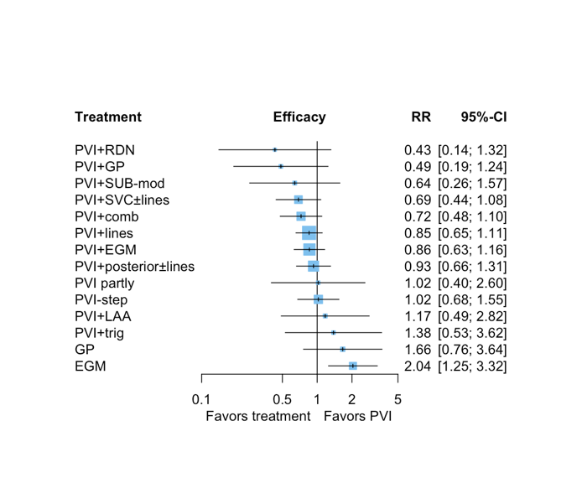
τ²= 0.0825 | τ²= 0.000  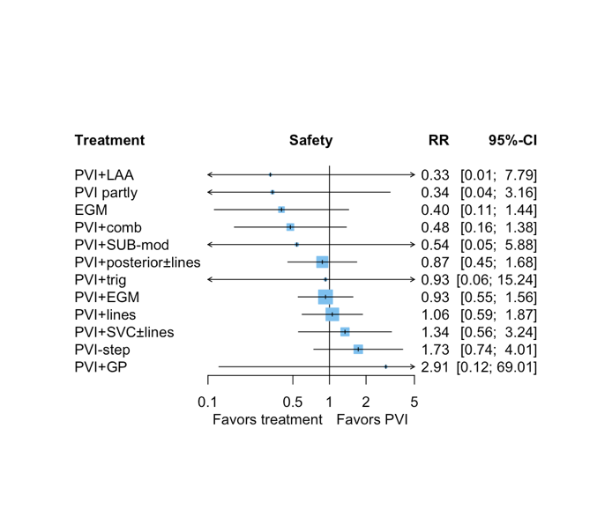

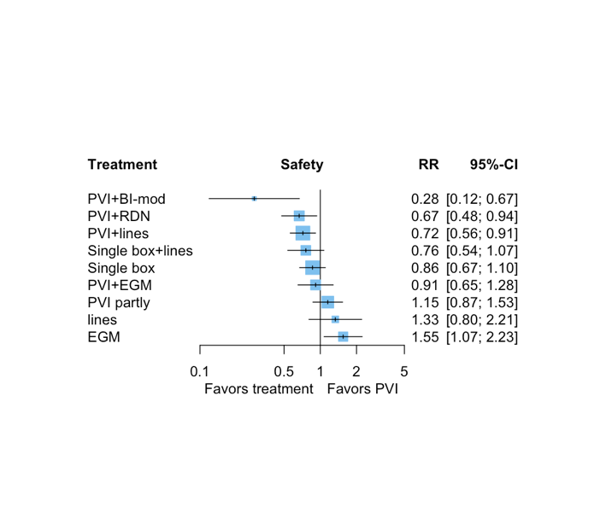

2 Depending on AAD or reablation allowance during the follow-up

Not allowing for ADD (48 RCTs) | Allowing for ADD (19 RCTs)
τ²= 0.084  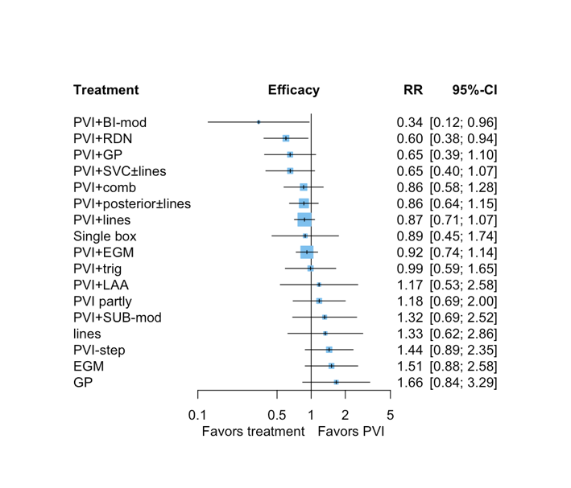 | τ²=0.1645  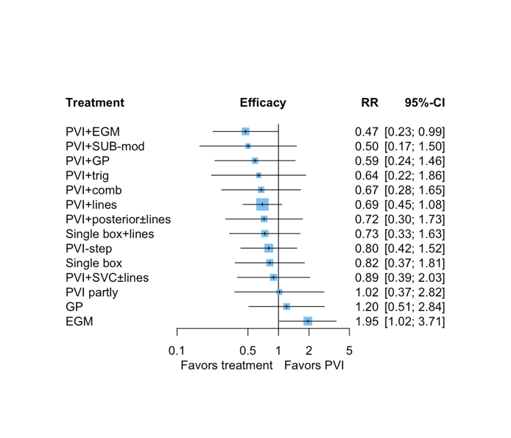
τ²=0  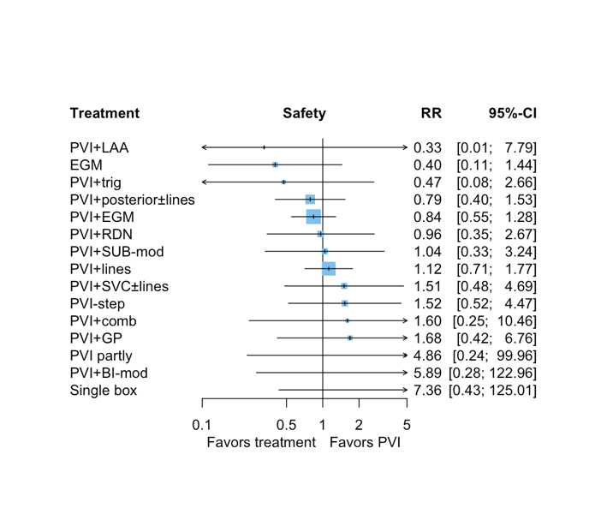 | τ²=0.1802  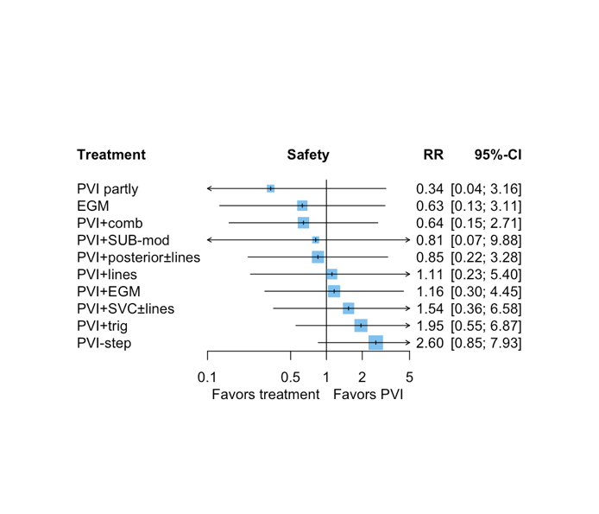

3 Depending on follow-up duration

Follow-up $≥$ 12 months (64 studies) | Follow-up < 12 months (3 studies)
τ²= 0.0915  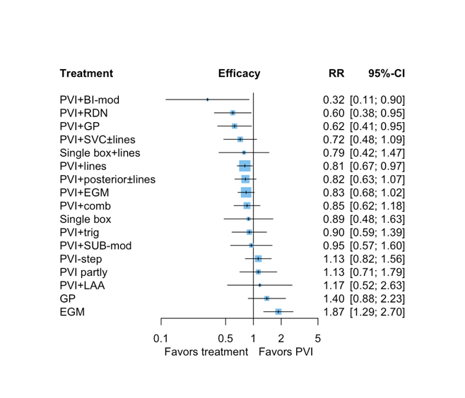 | τ²=0.3221  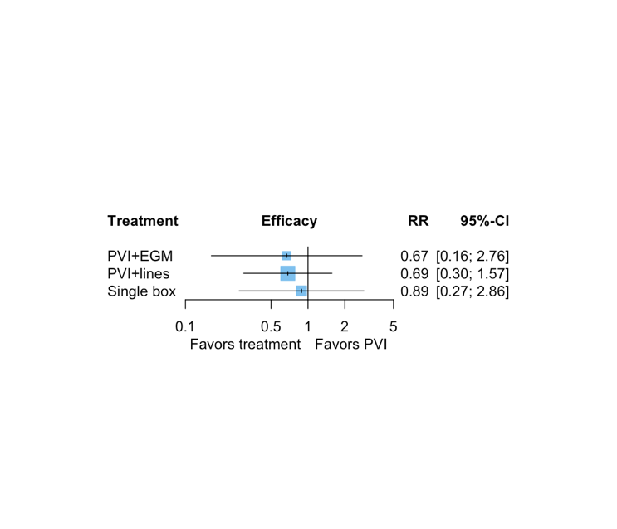
τ²=0  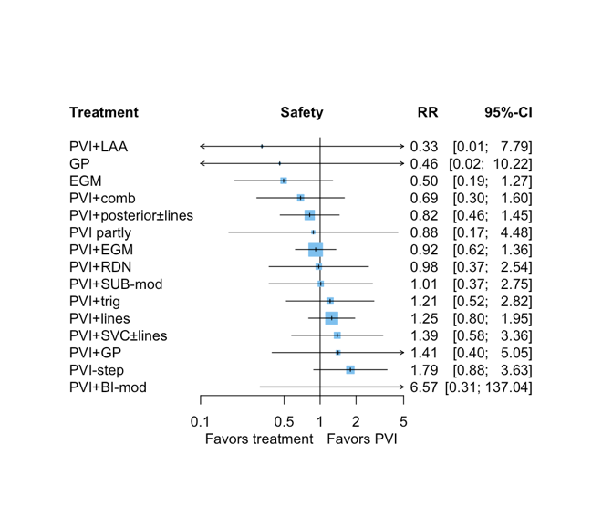 | τ²=0  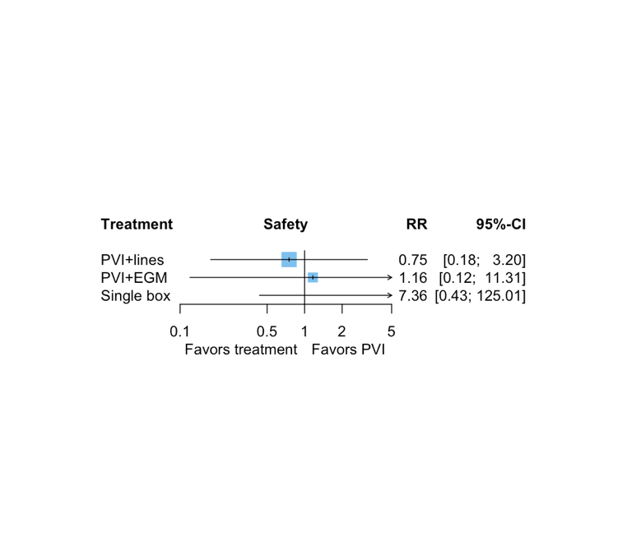

4 Depending on publication year

Publication year $≥$ 2011 (45 studies) | Publication year < 2011 (22studies)
τ²=0.0683  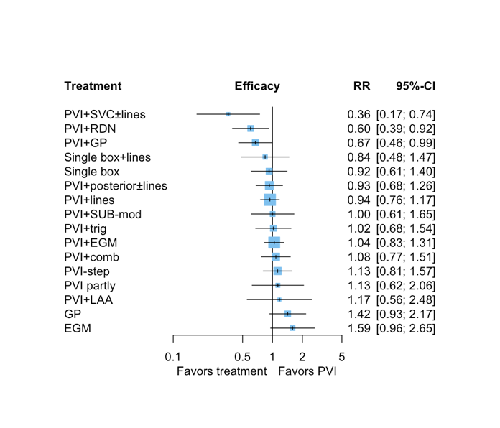 | τ²=0.0827  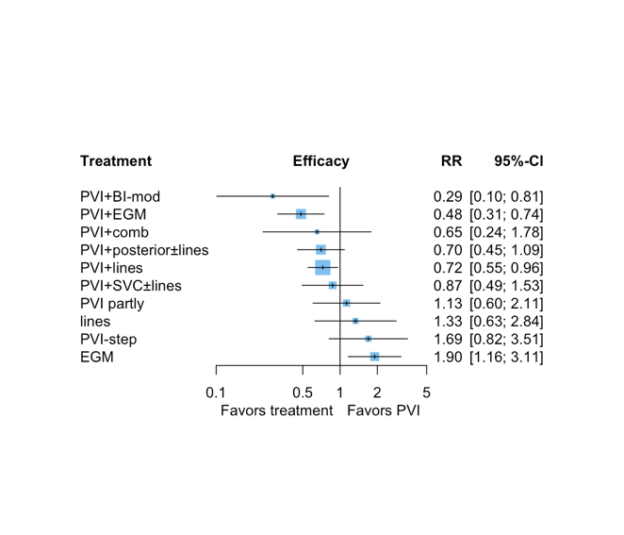
τ²=0  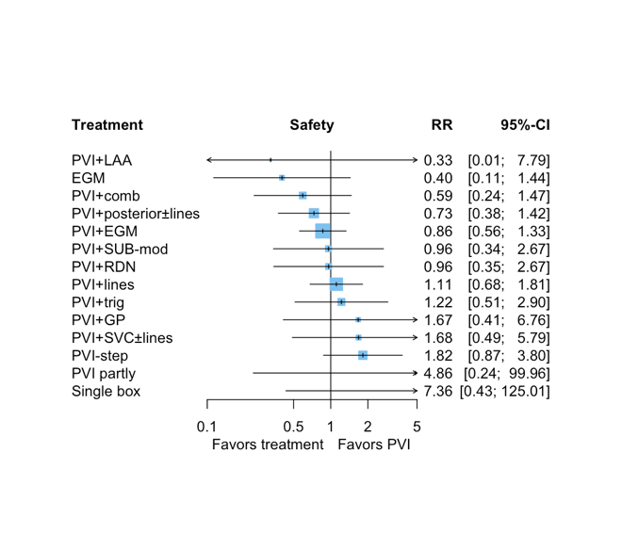 | τ²=0.000  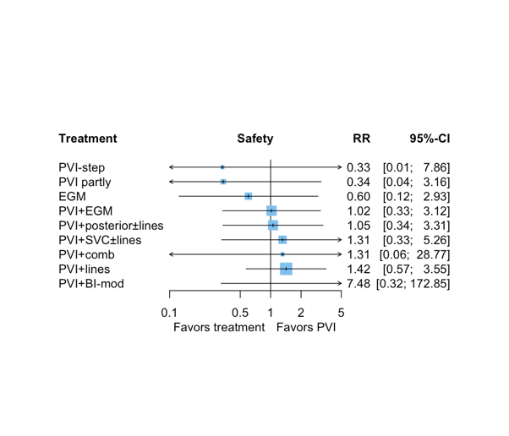

PAF (25 RCTs)
5. Subgroup analysis on the type of AF included in the original studies (PAF, non-PAF, and mixed)

Non PAF (24 RCTs)

τ²= 0.1041  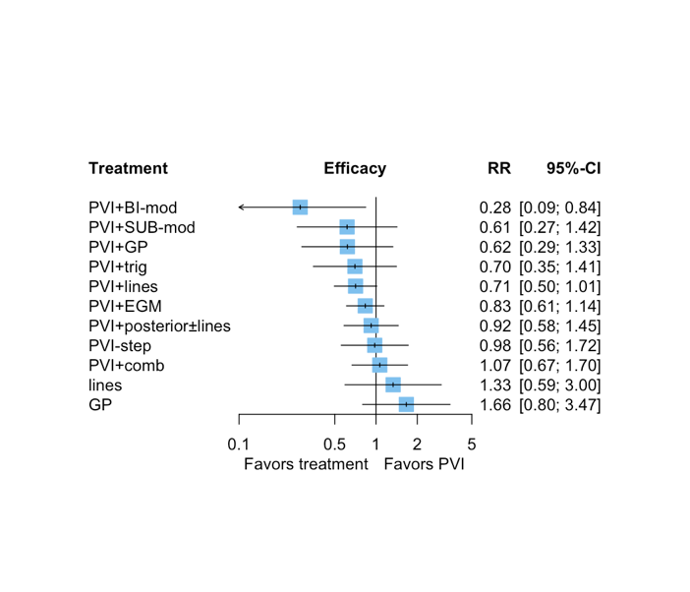 | τ²= 0  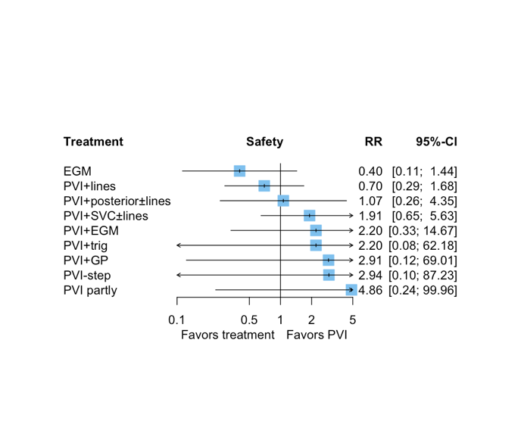

τ²= 0.2015  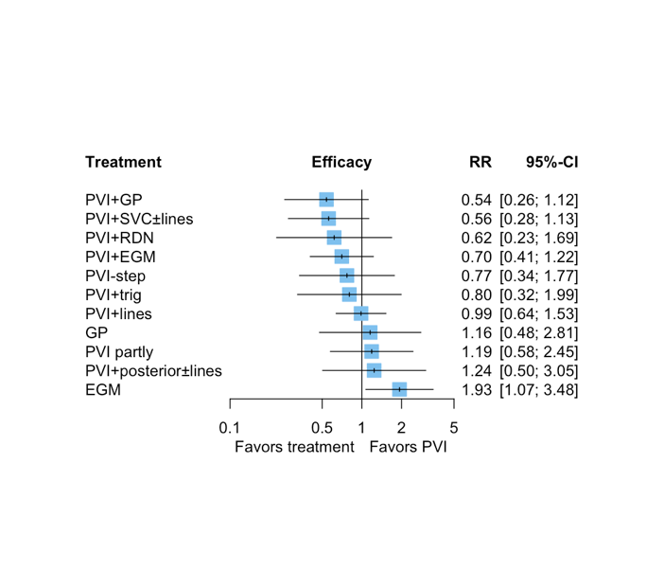 | τ²= 0

MIXED (18 RCTs)

τ²=0.01132  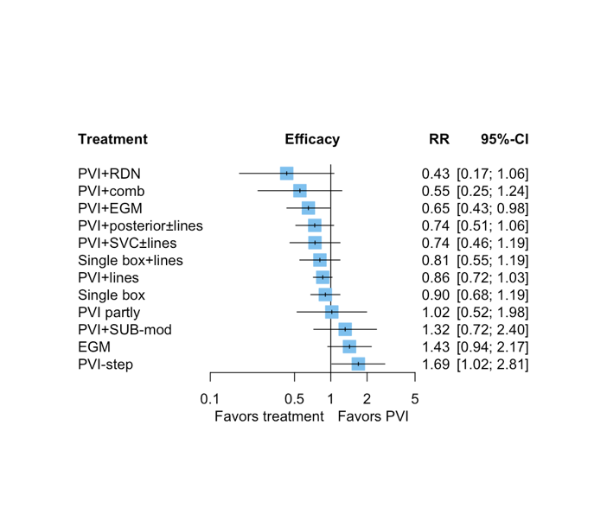 | τ²= 0

6 Subgroup analysis depending on the blanking period (cut-off $≥$ 8 weeks)

Blanking < 8 weeks (13 RCTs) Blanking $≥$8 weeks (53 RCTs)

τ²= 0  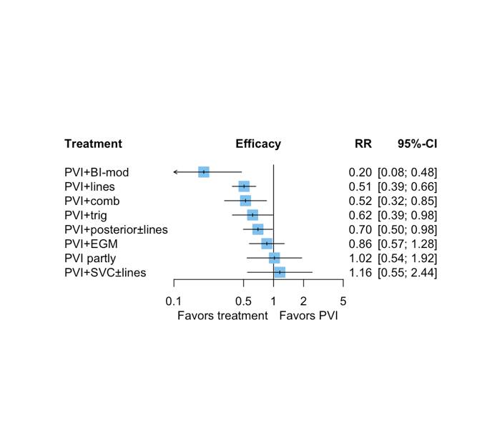 | τ²= 0.066  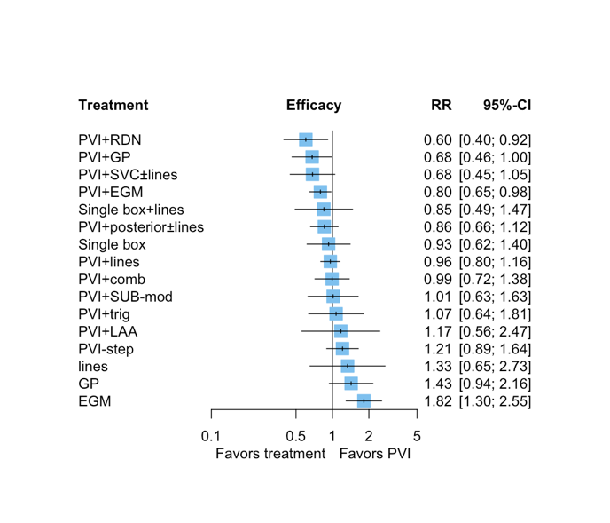
τ²= 0  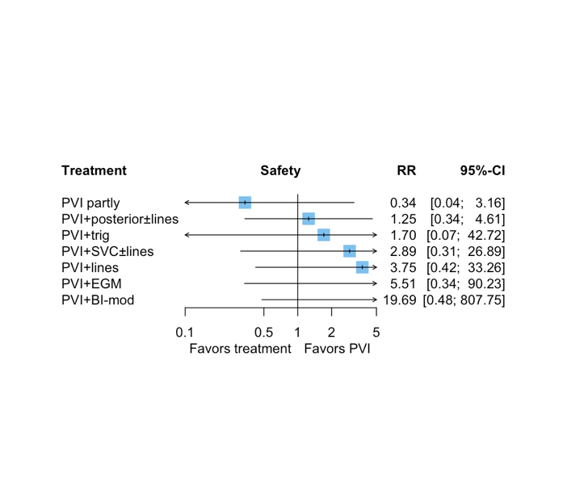 | τ²= 0  