Appendix 9. EVALUATION OF INCONSISTENCY

Consistency means that direct evidence in a network for the effect size between two treatments A and treatment B does not statistically differ from the indirect evidence for that same comparison. The presence of inconsistency in the network has been evaluated with the global design-by-treatment interaction model and with the net-split approach.
The design-by-treatment interaction model is a general model for the inconsistency that provides a single inference test, based on the χ² test, about the plausibility of assuming consistency for the entire network. However, inconsistency models may have low power and may sometimes fail to detect inconsistency.
The net-split approach splits the network estimates into the contribution of direct and indirect evidence, which allows us to check for inconsistency in specific comparisons in our network.

Table S1. Design-by-treatment interaction test, with global p-value, Q statistic and degrees of freedom for each outcome.

Outcome | p-value | Q (df)
Efficacy | 0.8411 | 16.32 (23)
Safety | 0.9610 | 8.95 (18)
Procedural time | 0.8547 | 14.34 (21)

Table S2. Results of the inconsistency net-split approach for all outcomes. For each comparison the direct and indirect estimates are provided along with the respective z-values and p-values of differences. P-values<0.10 indicate significant disagreement between direct and indirect evidence (in red).

 | Comparisons | NMA | direct | indirect | z | p-value
Efficacy | EGM vs PVI  EGM vs PVI+EGM  GP vs PVI  GP vs PVI+GP  PVI-step vs PVI  PVI+EGM vs PVI  PVI+GP vs PVI  PVI+lines vs PVI  PVI+posterior±lines vs PVI  PVI+SVC±lines vs PVI  Single box vs PVI  Single box+lines vs PVI  PVI-step vs PVI+lines  PVI-step vs PVI+SUB-mod  PVI-step vs PVI+trig  PVI+comb vs PVI+EGM  PVI+comb vs PVI+lines  PVI+comb vs PVI+posterior±lines  PVI+comb vs PVI+SVC±lines  PVI+EGM vs PVI+lines  PVI+EGM vs PVI+posterior±lines  PVI+EGM vs PVI+trig  PVI+GP vs PVI+lines  PVI+lines vs PVI+posterior±lines  PVI+lines vs PVI+trig  PVI+lines vs Single box  PVI+lines vs Single box+lines  PVI+posterior±lines vs PVI+SUB-mod  Single box vs Single box+lines | 1.8588  2.2415  1.3985  2.2414  1.1251  0.8289  0.6239  0.8018  0.8161  0.7200  0.8842  0.7885  1.4032  1.1875  1.2564  1.0228  1.0573  1.0389  1.1775  1.0337  1.0157  0.9256  0.7781  0.9826  0.8954  0.9069  1.0169  0.8612  1.1214 | 1.6969  2.8640  1.4061  2.0476  1.0217  0.8141  0.5426  0.8749  0.8458  0.6302  0.9098  0.8333  1.2083  1.5914  1.2587  1.1138  1.2500  0.9412  0.7500  1.2171  0.8558  1.0181  0.8714  1.2857  0.8250  0.9643  1.0800  0.5588  1.1200 | 2.6900  1.6744  1.3178  2.5327  1.2848  0.8530  0.7415  0.6438  0.7657  1.2149  0.7250  0.6693  1.4634  0.6634  1.2546  0.9123  1.0051  1.0917  1.4459  0.9116  1.1140  0.7772  0.7087  0.9618  0.9376  0.8614  0.8600  1.3405  1.1301 | -1.0001  1.4004  0.0781  -0.3830  -0.7034  -0.2302  -0.7406  1.5747  0.3627  -1.2796  0.3312  0.3163  -0.4641  1.6911  0.0072  0.6505  0.5569  -0.3943  -1.2796  1.3012  -0.8811  0.6157  0.4846  0.5103  -0.2846  0.2397  0.3312  -1.6911  -0.0095 | 0.3173  0.1614  0.9325  0.7013  0.4818  0.8179  0.4589  0.1153  0.7168  0.2007  0.7405  0.7517  0.6426  0.0908  0.9942  0.5153  0.5776  0.6933  0.2007  0.1932  0.3782  0.5381  0.6280  0.6099  0.7759  0.8106  0.7405  0.0908  0.9925
Safety | EGM vs PVI  EGM vs PVI+EGM  PVI-step vs PVI  PVI+EGM vs PVI  PVI+GP vs PVI  PVI+lines vs PVI  PVI+posterior±lines vs PVI  PVI+SVC±lines vs PVI  PVI-step vs PVI+lines  PVI-step vs PVI+SUB-mod  PVI-step vs PVI+trig  PVI+comb vs PVI+EGM  PVI+comb vs PVI+posterior±lines  PVI+comb vs PVI+SVC±lines  PVI+EGM vs PVI+lines  PVI+EGM vs PVI+posterior±lines  PVI+EGM vs PVI+trig  PVI+GP vs PVI+lines  PVI+lines vs PVI+posterior±lines  PVI+lines vs PVI+trig  PVI+posterior±lines vs PVI+SUB-mod | 0..4685  0.5022  1.7672  0.9329  1.7726  1.1931  0.8182  1.3930  1.4812  1.7548  1.4748  0.7418  0.8458  0.4968  0.7819  1.1402  0.7786  1.4857  1.4582  0.9957  0.8125 | 0.4273  1.0000  2.0711  0.8450  2.9130  1.1249  0.9409  1.5067  1.2500  2.7216  1.3333  0.4810  1.1897  1.0000  0.7385  1.0568  2.0301  1.3333  0.3333  2.2000  0.5714 | 4.7064  0.3744  1.5513  1.2635  1.5763  1.3458  0.5669  0.6442  1.6131  0.9789  4.0646  1.2673  0.5710  0.4275  0.8401  1.1513  0.5613  2.4640  1.6918  0.8807  1.5888 | -0.9177  0.8479  0.3991  -0.8733  0.3420  -0.3877  0.7792  0.5479  -0.3200  1.0013  -1.1223  -1.1380  0.8497  0.5479  -0.2703  -0.0833  1.2558  -0.3420  -1.3607  0.7046  -1.0013 | 0.3588  0.3965  0.6898  0.3825  0.7323  0.6983  0.4358  0.5837  0.7490  0.3167  0.2618  0.2551  0.3955  0.5837  0.7870  0.9336  0.2092  0.7323  0.1736  0.4810  0.3167
Procedural  time | EGM vs PVI  EGM vs PVI+EGM  PVI-step vs PVI 3  PVI+EGM vs PVI  PVI+GP vs PVI  PVI+lines vs PVI  PVI+posterior±lines vs PVI  PVI+SVC±lines vs PVI  Single box vs PVI  Single box+lines vs PVI  PVI-step vs PVI+lines  PVI-step vs PVI+SUB-mod  PVI-step vs PVI+trig  PVI+comb vs PVI+EGM  PVI+comb vs PVI+lines  PVI+comb vs PVI+posterior±lines  PVI+comb vs PVI+SVC±lines  PVI+EGM vs PVI+lines  PVI+EGM vs PVI+posterior±lines  PVI+EGM vs PVI+trig  PVI+GP vs PVI+lines  PVI+lines vs PVI+posterior±lines  PVI+lines vs PVI+trig  PVI+lines vs Single box  PVI+lines vs Single box+lines  PVI+posterior±lines vs PVI+SUB-mod  Single box vs Single box+lines | 0.3780  -0.3819  0.8746  0.7599  0.6670  0.3178  0.3344  0.2291  0.0850  0.2063  0.5568  0.7103  0.4145  0.0607  0.5028  0.4862  0.5914  0.4421  0.4255  0.2997  0.3492  -0.0166  -0.1424  0.2328  0.1115  0.1700  0.1213 | 0.4010  -0.3817  0.8216  0.8228  0.3467  0.3589  0.4265  0.1887  0.0880  0.2667  0.6833  0.8074  0.2350  -0.0056  0.8167  0.4233  0.4333  0.2004  0.8039  0.4098  0.6500  -0.2012  0.0833  0.1667  0.1167  -0.0500  -0.0500 | 0.2509  -0.3823  0.9495  0.6326  0.9964  0.2337  0.0968  0.4454  0.0660  -0.0091  0.5161  0.4136  0.6009  0.1058  0.3732  0.5107  0.6901  0.6031  0.3163  0.1659  0.0002  0.0238  -0.2355  0.3197  0.0969  0.3437  -0.7706 | 0.2737  0.0016  -0.4274  0.9154  -1.4285  0.6295  1.2382  -0.6326  0.0268  0.3547  0.4487  0.8814  -0.8000  -0.3175  1.1467  -0.2092  -0.6326  -1.7156  1.4433  0.5367  1.4285  -0.6124  0.6292  -0.2632  0.0268  -0.8814  0.5874 | 0.7843  0.9987  0.6691  0.3600  0.1531  0.5290  0.2156  0.5270  0.9786  0.7228  0.6537  0.3781  0.4237  0.7509  0.2515  0.8343  0.5270  0.0862  0.1489  0.5914  0.1531  0.5402  0.5292  0.7924  0.9786  0.3781  0.5569

Figure S1. Forest plots of the net-split approach separating direct and indirect evidence for efficacy.
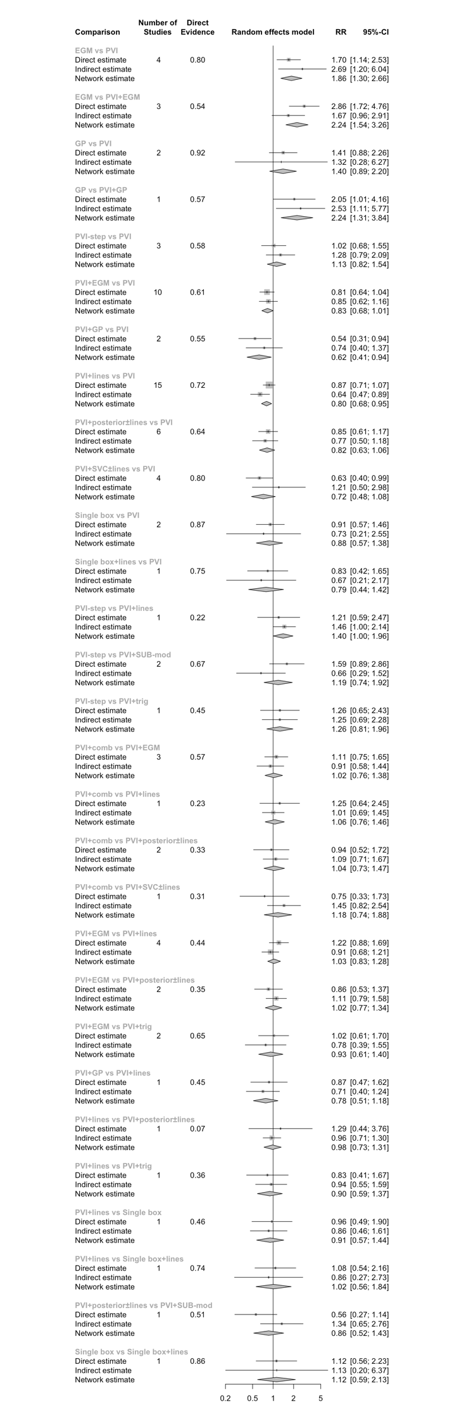

Figure S2. Forest plots of the net-split approach separating direct and indirect evidence for safety.

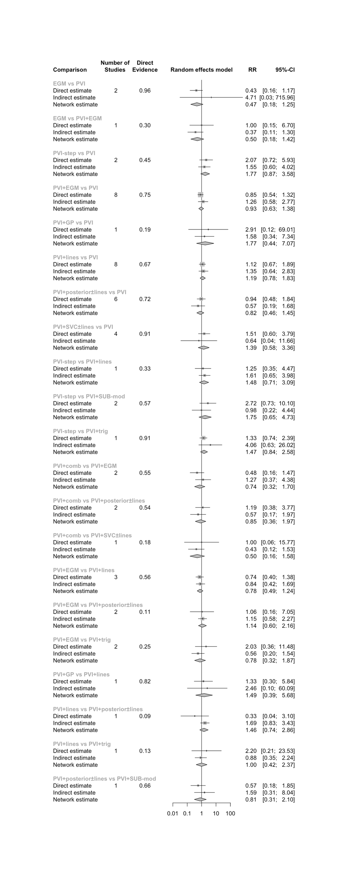

Figure S3. Forest plots of the net-split approach separating direct and indirect evidence for procedural time.
