Genetic predictors for survival in amyotrophic lateral sclerosis: a systematic review, pairwise and network meta-analysis

SUPPLEMENTARY MATERIALS
Section | Description | Pages
Supplementary Tables
 | Table S1 Characteristics of the articles included in network meta-analysis for variants in ALS causative genes. | 2-8
 | Table S2 Characteristics of the articles included in pairwise meta-analysis for other modification loci. | 9-12
 | Table S3 Characteristics of the articles included in systematic review for other modification loci. | 13-19
 | Table S4 The quality of articles included in network meta-analysis and pairwise meta-analysis by NOS. | 20-21
 | Table S5 The feathers for different variants in SOD1, FUS, TARDBP. | 22
Supplementary Figures
 | Figure S1 Forest plot for inconsistency test in network meta-analysis | 23
 | Figure S2-S12 Heterogeneity analysis n network meta-analysis. | 24-34
 | Figure S13 publication bias for studies reporting C9orf72 expansion in patients with ALS compared to those without ALS-related mutation | 35

Table S1 Characteristics of the articles included in network meta-analysis for variants in ALS causative genes.
Table S1-1 articles with 2-arm studies
2-arm studies: ATXN2 polyQ repeats (≥ 31) vs without ATXN2 polyQ repeats (<31)
First author | Year | Country/region | Type of study | Number of ALS patients | Number of patients with variants | Median or mean survival from onset |  | Diagnosis |  | HR (95%CI) | HR source*
 |  |  |  |  |  | patients with variants | patients without variants | Diagnostic criteria | level | HR (95%CI) | HR source*
G. Borghero | 2015 | Sardinian | retrospective cohort | 375 | 4 | median 1.2 y, IQR (0.9-2.7) | median 4.2y, IQR (2.2-10） | revised El Escorial criteria | definite, probable, probable  laboratory-supported or possible ALS | 4.71 (1.75, 12.67) | Estimated
A. Chiò (discovery cohort) | 2015 | Italy | prospective cohort | 672 | 19 | median 1.8y, IQR (1.3-2.2) | median 2.7y, IQR (1.6-5.1) | revised El Escorial criteria | definite, probable, and probable  laboratory-supported ALS | 2.79 (1.67, 4.64) | Available
A. Chiò (validation cohort) | 2015 | Rome, Italy | prospective cohort | 661 | 16 | median 2.0y, IQR (1.3-5.4) | median 3.2y, IQR (2.0-6.4) | revised El Escorial criteria | definite, probable, and probable  laboratory-supported ALS | 5.38 (3.71, 7.81) | Estimated
2-arm studies: C9orf72 repeat expansion (>30) vs without C9orf72 repeat expansion (≤30)
S. Byrne | 2012 | Ireland | retrospective cohort | 191 | 21 | median 1.7y, 95%CI (0.74–2.60) | median 2.2y, 95%CI (1.76–2.56) | NA | NA | 1.9 (1.1, 3.7) | Available
A. Ratti | 2012 | Italy | retrospective case-control | 1534 | 128 | median 1.3y | median 2.3y | revised El Escorial criteria | NA | 2.61 (2.21, 3.1) | Estimated
M. Sabatelli | 2012 | Italy | retrospective cohort | 1757 | 69 | median 2.7y, 95%CI (2.1–3.3) | median 3.6y, 95% CI (3.3–3.8) | revised El Escorial criteria | definite, probable, probable laboratory-supported or possible ALS | 1.79 (1.26, 2.98) | Available
W. van Rheenen | 2012 | Netherlands | prospective cohort | 1759 | 171 | median 2.5y, range (0.45–13.0) | median 2.7y, range (0.13–31.8) | revised El Escorial criteria | possible, probable laboratory-supported, probable, or definite ALS | 1.46 (1.17, 1.83) | Available
S. Millecamps | 2012 | France | retrospective cohort | 170 | 130 | median 2.42y, range (0.25y-7.08y) | meidan 3.25y, range (0.67-28) | NA | probable or definite ALS | 1.9 (1.33, 2.7) | Estimated
S. Debray(sALS cohort) | 2013 | Belgium | retrospective cohort | 62 | 32 | mean±SD (2.45±1.58) | mean±SD (5.64y±4.97) | revised El Escorial or Awaji criteria | probable ALS | 2.54 (1.52,4.27) | Available
S. Debray(fALS cohort) | 2013 | Belgium | retrospective cohort | 471 | 45 | mean±SD (2.55±1.51) | mean±SD (3.03y±1.96) | revised El Escorial or Awaji criteria | probable ALS | 1.09 (0.78,1.52) | Available
A. García-Redondo | 2012 | Spain | retrospective cohort | 936 | 67 | median 3.42y, range(2.83,3.92) | median 4.42y, range(3.75,5.0) | revised El Escorial criteria | definite or probable ALS | 1.93 (1.51,2.48) | Estimated
D. J. Irwin | 2013 | USA | retrospective case-control | 67 | 31 | mean±SD (2.6y±0.3) | mean±SD (3.8y±0.4) | revised El Escorial criteria | NA | 1.91 (1.1,3.31) | Estimated
K. Van Laere | 2014 | Leuven, Belgium | prospective cohort | 70 | 11 | NA | NA | revised El Escorial and Awaji-Shima criteria | NA | 1.43 (0.39, 5.21) | Estimated
A. Calvo | 2016 | Italy | prospective cohort | 526 | 33 | NA | NA | revised El Escorial criteria | possible, probable laboratory supported, probable, definite ALS | 1.66 (1.16, 2.39) | Available
R. Govaarts | 2016 | Netherlands | prospective cohort | 110 | 3 | NA | NA | revised El Escorial criteria | possible, probable laboratory supported, probable, definite ALS | 1.54 (1.17,2.03) | Available
M. E. Umoh | 2016 | USA | retrospective cohort | 781 | 61 | median 2.4y, 95%CI (1.9–2.9) | median 4.3y, 95%CI (3.8–4.7) | revised El Escorial criteria | NA | 2.16 (1.596,2.927) | Available
T. F. Gendron | 2017 | USA | prospective cohort | 106 | 68 | NA | NA | revised El Escorial criteri | NA | 4.08 (2.24,7.43) | Available
W. Reniers | 2017 | Belgium | prospective cohort | 364 | 56 | NA | NA | revised El Escorial or Awaji criteria | at least possible ALS | 2.52 (1.37, 4.64) | Available
G. Miltenberger-Miltenyi | 2019 | Portugal | prospective cohort | 344 | 31 | NA | NA | revised El Escorial criteria | NA | 2.05 (1.46,2.89) | Estimated
A. J. Cammack | 2019 | USA | retrospectiv  cohort | 413 | 199 | median 2.49y | median 2.50y | revised El Escorial criteria | a minimum diagnosis of possible ALS | 1.2 (0.99,1.45) | Estimated
J. Rooney | 2019 | Ireland | retrospective cohort | 630 | 58 | NA | NA | El Escorial criteria | NA | 1.62 (1.21, 2.15) | Available
F. Trojsi | 2019 | Italy | retrospective cohort | 728 | 47 | median 2.95y, 95%CI (2.15–3.67) | median 3.67y, 95%CI (3.33–4.0) | revised El Escorial criteria | definite or clinical and laboratory-supported probable ALS | 1.58 (1.07, 2.33) | Available
M. Benatar | 2020 | USA | prospective cohort | 229 | NA | NA | NA | NA | NA | 1.7 (0.91,3.18) | Available
M. De Schaepdryver | 2020 | Belgium, Italy | retrospective cohort | 269 | NA | NA | NA | revised El Escorial criteria | suspected, possible, probable and definite ALS | 1.08 (0.62,1.89) | Available
D. Brand | 2021 | USA | retrospective cohort | 1298 | 91 | NA | NA | El Escorial criteria | clinically definite, probable, possible, or suspected ALS | 2.06 (1.61,2.65) | Available
U. Klappe | 2021 | Sweden | retrospective case-control | 93 | 10 | NA | NA | revised El Escorial criteria | clinically definite, probable, and possible ALS | 0.68 (0.14,3.2) | Available
F. Puentes | 2021 | UK | prospective cohort | 37 | 11 | NA | NA | revised El Escorial criteria | NA | 2.39 (1.4,4.12) | Estimated
2-arm studies: SOD1 vs none
M. E. Cudkowicz | 1997 | USA and Europe | retrospective case-control | 318 | 184 | median 2.1y | median 2.0y | revised El Escorial criteria | NA | 0.9 (0.71,1.14) | Estimated
2-arm studies: FUS vs none
A. Hubers | 2015 | Germany | prospective cohort | 14 | 6 | median 3.33, 95%CI (0.58-3.33) | median NA, 95%CI (3.5, NA) | revised El Escorial criteria | NA | 6.89 (1.15,41.4) | Estimated

Table S1-2 articles with 3-arm studies
3-arm studies: TARDBP vs SOD1 vs none
First author | Year | Country/region | Type of study | Number of ALS patients | Number of patients with mutation |  |  |  | Median or mean survival from onset |  |  | Diagnosis |  | HR (95%CI) | HR source
 |  |  |  |  | TARDBP |  | SOD1
 |  |  |  |  |  |  |  |  | TARDBP | SOD1 | none(ref) | Diagnostic criteria | level | HR (95%CI) | HR source
P. Corcia | 2012 | France | retrospective cohort | 823 | 28 |  | 58 |  | median 5.25y, 95%CI (2.67–6.43) | median 3.42y, 95%CI (2.08–4.10) | median 2.56y, 95%CI (2.42–2.67) | revised El Escoril criteria | NA | TARDBP:0.59 (0.36,0.95)  SOD1: 0.78 (0.57,1.06) | Estimated
3-arm studies: TARDBP vs FUS vs SOD1
First author | Year | Country/region | Type of study | Number of ALS patients | Number of patients with mutation |  |  |  | Median or mean survival from onset |  |  | Diagnosis |  | HR (95%CI) | HR source
 |  |  |  |  | TARDBP | FUS |  | SOD1
 |  |  |  |  |  |  |  |  | TARDBP | FUS | SOD1(ref) | Diagnostic criteria | level | HR (95%CI) | HR source
W. Liu | 2021 | China | retrospective cohort | 242 | 53 | 28 |  | 159 | median 9.67y, range (0.82–18) | median 3.0y, range (1.0–6.67y) | median5.0y, range (0.5–20) | revised El Escoril criteria | definite, probable, probable laboratory-supported ALS | TARDBP: 0.81(0.56,1.18)  FUS: 2.12(1.4,3.21) | Estimated

Table S1-3 articles with 4-arm studies
4-arm studies:C9orf72 vs TARDBP vs SOD1 vs none
First author | Year | Country/region | Type of study | Number of ALS patients | Number of patients with mutation |  |  | Median or mean survival from onset |  |  |  | Diagnosis |  | HR (95%CI) | HR source
 |  |  |  |  | TARDBP | C9orf72 | SOD1
 |  |  |  |  |  |  |  | TARDBP | C9orf72 | SOD1 | none(ref) | criteria | level | HR (95%CI) | HR source
S. Lattante | 2012 | Lazio, Italy | retrospective cohort | 462 | 13 | 12 | 10 | median 5.50y | median 3.12y | median 8.42y | median 3.30y | El Escoril criteria | definite, probable, or laboratory-supported probable ALS | TARDBP: 0.89(0.49,1.62)  C9orf72: 3.07(1.85,5.01)  SOD1: 0.47(0.21,1.04) | Estimated
G. Borghero | 2014 | Sardinia, Italy | retrospective cohort | 350 | 75 | 51 | 4 | median 6.5y, IQR (3.3±10.5) | median 2.7y, IQR(1.9±3.8) | NA | NA | revised El Escoril criteria | definite, probable, probable laboratory-supported, possible ALS | TARDBP: 0.83(0.6,1.16)  C9orf72: 2.24(1.63,3.07)  SOD1: 0.71(0.18,2.84) | Estimated
4-arm studies: TARDBP vs FUS vs SOD1 vs none
First author | Year | Country/region | Type of study | Number of ALS patients | Number of patients with mutation |  |  | Median or mean survival from onset |  |  |  | Diagnosis |  | HR (95%CI) | HR source
 |  |  |  |  | TARDBP | FUS | SOD1
 |  |  |  |  |  |  |  | TARDBP | FUS | SOD1 | none(ref) | criteria | level | HR (95%CI) | HR source
S. Millecamps | 2010 | France | retrospective cohort | 233 | 23 | 29 | 55 | median 4.25y, SE 0.75 | median  2.17y, SE 0.25 | median 3.0y, SE 0.83 | median 2.67y,  SE 0.17 | El Escoril criteria | probable or definite ALS | TARDBP: 0.71(0.46,1.1)  FUS: 1.48(1.01,2.17)  SOD1: 0.64(0.47,0.88) | Estimated

Table S1-4 articles with 5-arm studies
5-arm studies: C9orf72 vs TARDBP vs FUS vs SOD1 vs none
First author | Year | Country/region | Type of study | Number of ALS patients | Number of patients with mutation |  |  |  | Median or mean survival from onset |  |  |  |  | Diagnosis |  | HR (95%CI) | HR source
 |  |  |  |  | C9of72 | TARDBP | FUS | SOD1
 |  |  |  |  |  |  |  |  | C9of72 | TARDBP | FUS | SOD1 | none(ref) | criteria | level | HR (95%CI) | HR source
A. Chiò | 2012 | Italy | prospective cohort | 177 | 45 | 13 | 6 | 38 | median 3.2y, 95%CI (2.9–3.4) | median 5.0y, 95% CI (3.6–7.2) | median 1.9y, 95% CI (1.7–2.1) | median 3.8y, 95% CI (3.1–6.5) | NA | NA | NA | C9orf72: 2.44 (1.55,3.84)  TARDBP: 1.82 (0.66,5.05)  FUS: 6.29 (2.44,16.22)  SOD1: 1.66 (1.01,2.71) | Estimated

Table S1-5 articles with 6-arm studies
6-arm studies: C9orf72 vs TARDBP vs FUS vs UBQLN2 vs CCNF vs SOD1
First author | Year | Country/region | Type of study | Number of ALS patients | Number of patients with mutation |  |  |  |  |  | Median or mean survival from onset |  |  |  |  |  | Diagnosis |  | HR (95%CI)
 |  |  |  |  | C9orf72 | TARDBP | FUS | UBQLN2 | CCNF | SOD1 |  |  |  |  |  |  |  |  | HR (95%CI) | HR source
 |  |  |  |  |  |  |  |  |  |  | C9orf72 | TARDBP | FUS | UBQLN2 | CCNF | SOD1(ref) | criteria | level | HR (95%CI)
E. P. McCann | 2017 | Australia | retrospective cohort | 265 | 121 | 5 | 27 | 8 | 7 | 97 | NA | NA | NA | NA | NA | NA | El Escorial criteria | definite, probable, probable laboratory-supported ALS | C9orf72: 1.39 (1.03,1.88)  TARDBP: 1.01 (0.39,2.61)  FUS: 2.06 (1.29,3.3)  UBQLN2: 1.07 (0.53,2.18)  CCNF: 3.05 (1.35,6.85) | Estimated

Table S1-6 articles with 7-arm studies
7-arm studies: C9orf72 vs SOD1vs TARDBP vs FUS vs TBK1vs NEK1 vs none
First author | Year | Country/region | Type of study | Number of ALS patients | Number of patients with mutation |  |  |  |  |  | Median or mean survival from onset |  |  |  |  |  |  | Diagnosis |  | HR (95%CI) | HR source
 |  |  |  |  | C9orf72 | SOD1 | TARDBP | FUS | TBK1 | NEK1
 |  |  |  |  |  |  |  |  |  |  | C9orf72 | SOD1 | TARDBP | FUS | TBK1 | NEK1 | none (ref) | criteria | level | HR (95%CI) | HR source
Y. P. Chen | 2021 | China | retrospective cohort | 1496 | 23 | 43 | 15 | 19 | 10 | 10 | median 2.58y, 95% CI (2.12 -3.04) | median 2.54y, 95% CI (2.09-2.99) | median 2.98y, 95% CI (2.63-3.33) | median 2.98y, 95% CI (2.62-3.33) | median 2.24y, 95% CI (1.40-3.08) | median 5.04y, 95% CI (2.08-7.99) | median 3.55y, 95% CI (3.33- 3.78) | revised El Escoril criteria | NA | C9orf72: 2.81(1.81,4.36)  SOD1: 1.84(1.33,2.56)  TARDBP: 3.93(2.39,6.47)  FUS: 2.35(1.55,3.58)  TBK1: 2.88(1.61,5.15)  NEK1: 1.44(0.85,2.43) | Estimated
*‘Estimated’: HR was evaluated from Kaplan-Meier curve or other curves by Engauge Digitizer version 12.1, and HRs and 95 % CI were estimated by using Richard Steven’s excel workbook. ‘Available’: HR was reported in the article. ALS: amyotrophic lateral sclerosis; HR: hazard ratio; CI: confidence interval; SD: standard deviation; NA: not available. IQR: interquartile range.

Table S2 Characteristics of the articles included in pairwise meta-analysis for other modification loci.
Table S2-1 APOE ε4
APOE ε4 vs non-ε4 carriers
First author | Year | Country/region | Type of study | Total ALS patients | Number of ε4 carriers | Number of non-e4 carriers | Median or mean survival from onset |  | Diagnosis |  | HR (95%CI) | HR source | systematic review or pairwise meta-analysis
 |  |  |  |  |  |  | ε4 carriers | non-ε4 carriers(ref) | criteria | level | HR (95%CI) | HR source | systematic review or pairwise meta-analysis
A. Al-Chalabi | 1996 | England | prospective cohort | 117 | 33 | 84 | median 2.5y, 95%CI (1.67-4.08) | median 4.08y, 95%CI (3.0-3.5) | NA | NA | 1.01 (0.52,1.94) | Available | meta-analysis
V. E. Drory | 2001 | Israel | retrospective cohort | 100 | 21 | 79 | median 3.17y | median 3.0y | revised El Escorial criteria | definite or probable ALS | 2.12 (1.09,4.12) | Estimated | meta-analysis
H. Zetterberg | 2008 | Sweden | retrospective cohort | 79 | 25 | 54 | For one ε4-carriers: median5.6y, range (2.0–16) in sALS; median2.6y, range (0.75–4.0) in fALS; For two ε4-carriers: median 3.5y, range (1.4–9.4) in sALS; median 5.1y in fALS; | median 3.8y, range (2.3–26) in sALS; median 2.1y, range (0.67–14) in fALS | revised El Escorial criteria | NA | 0.92 (0.53,1.6) | Estimated | meta-analysis
K. Steenland | 2010 | USA | retrospective cohort | 64 | 16 | 48 | NA | NA | NA | NA | 1.96(0.89,4.31) | Available | meta-analysis

Table S2-2 UNC13A rs12608932
UNC13A rs12608932 CC vs AC + CC
First author | Year | Country/region | Type of study | Total ALS patients | Number of CC carriers | Number of AC or CC carriers | Median or mean survival from onset |  | Diagnosis |  | HR (95%CI) | HR source | systematic review or pairwise meta-analysis
 |  |  |  |  |  |  | CC carriers | AC or CC carriers(ref) | criteria | level | HR (95%CI) | HR source | systematic review or pairwise meta-analysis
F. P. Diekstra  (GWAS cohort) | 2012 | Netherlands, Belgium, Sweden | retrospective case-control | NA | NA | NA | NA | NA | El Escorial criteria | possible, probable, or definite ALS | 1.23(1.06,1.43) | Available | meta-analysis
A. Chiò | 2013 | Italy | retrospective case-control | 500 | 61 | 439 | median 2.5 y, IQR, (1.6, 4.2) | median3.5 y, IQR, (2.2, 6.4) | revised El Escorial criteria | probable, probable laboratory-supported, or definite ALS | 1.4(1.05,1.87) | Available | meta-analysis
J. M. Vidal-Taboada | 2015 | Spain | retrospective case-control | 136 | 22 | 114 | median 2.0 y, 95%CI (1.78, 2.22) | median4.75 y, 95%CI (4.08, 5.43) | revised El Escorial criteria | Definite ALS, Probable ALS, or Probable ALS-Laboratory supported | 1.439(1.105,1.873) | Available | meta-analysis
I. Fogh | 2016 | Europe, USA | retrospective case-control | 3574 | NA | NA | NA | NA | revised El Escorial criteria | NA | 1.17 (1.1,1.24) | Available | meta-analysis
H. H. G. Tan | 2020 | Netherlands | retrospective cohort | 2201 | 371 | 1830 | NA | NA | NA | NA | 1.16 (1.06,1.26) | Available | meta-analysis

Table S2-3 ZNF512B rs2275294
ZNF512B rs2275294 CC+CT vs TT
First author | Year | Country/region | Type of study | Total ALS patients | Number of CC+CT carriers | Number of TT  carriers | Median or mean survival from onset |  | Diagnosis |  | HR (95%CI) | HR source | systematic review or pairwise meta-analysis
 |  |  |  |  |  |  | CC+CT carriers | TT carriers | criteria | level | HR (95%CI) | HR source | systematic review or pairwise meta-analysis
S. Tetsuka | 2012 | Japan | retrospective case-control | 176 | 128 | 48 | Mean ±SD:2.03±1.15 | Mean ±SD: 3.05±1.64 | revised El Escorial criteria | definite ALS | 1.807(1.018,3.209) | Available | meta-analysis
C. J. Yu | 2018 | China | prospective cohort | 59 | 39 | 20 | NA | NA | both clinical symptoms, signs and electromyography (EMG) positive manifestation | NA | 2.587(1.161,5.765) | Available | meta-analysis
H. Jiang | 2021 | China | retrospective case-control | 212 | 166 | 46 | NA | NA | revised El Escorial criteria | NA | 1.98(1.21,3.24) | Available | meta-analysis

Table S2-4 KIFAP3 rs1541160
KIFAP3 rs1541160 CC vs CT vs TT
First author | Year | Country/region | Type of study | Total ALS patients | Number of CC carriers | Number of CT carriers | Number of TT  carriers | Median or mean survival from onset |  |  | Diagnosis |  | HR (95%CI) | HR source | systematic review or pairwise meta-analysis
 |  |  |  |  |  |  |  | CC carriers | CT carriers | TT carriers(ref) | criteria | level | HR (95%CI) | HR source | systematic review or pairwise meta-analysis
J. E. Landers | 2009 | England,France, Netherlands, USA | retrospective case-control | 1014 | 100 | 403 | 511 | median3.96y | median 2.84y | median 2.67y | revised El Escorial criteria | probable or definite ALS | CC: 0.78(0.62,0.99)  CT: 0.91(0.8,1.04) | Estimated | meta-analysis
B. J. Traynor | 2010 | northwestern Italy | retrospective case-control | 504 | 39 | 233 | 232 | median 4.09y, 95%CI (2.69，NA) | median 3.48y, 95%CI (3.15,3.94) | median 3.58y, 95%CI (3.12,4.33) | revised El Escorial criteria | probable or definite ALS | CC: 1.12(0.79,1.59)  CT: 1.15(0.95,1.38)  CC+CT: 1.17(0.98,1.39) | Estimated | meta-analysis for CC, CT. systematic review for CC+CT.
V. Orsetti | 2011 | Padua, Italy | retrospective case-control | 109 | 15 | 83 | 111 | median 4.0y, 95% CI (1.78,6.21) | median 4.92y ,95% CI (3.27,5.80) | median 4.0y, 95%CI (2.45,5.54) | revised El Escorial criteria | NA | CC: 1.62(0.95,2.78)  CT:0.85(0.61,1.19) | Estimated | meta-analysis
P. T. van Doormaal | 2014 | Belgium, Germany, Ireland, Italy, Netherlands, and Sweden | retrospective case-control | 2261 | 192 | 949 | 1120 | median2.6y; mean3.14y | median2.39y; mean3.01y | median 2.4y; mean 3.13y | revised El Escorial criteria | possible ALS or higher | CC: 0.87(0.72,1.04)  CT: 1.1(0.92,1.12)  TT+CT vs CC (ref): 0.86(0.72,1.03) | Available | meta-analysis for CC, CT.  systematic review for TT+CT.
D. Czell | 2017 | Switzerland and Sweden | retrospective case-control | 71 | 6 | 31 | 34 | median 2.43y | median 3.82y | median 3.27y | revised El Escorial criteria | probable or definite ALS | CC: 1.38(0.61,3.15)  CT:0.89(0.55,1.44) | Estimated | meta-analysis
I. Fogh | 2016 | Europe and USA | retrospective case-control | 4256 | NA | NA | NA | NA | NA | NA | El Escorial revised criteria | NA | CC+CT vs TT (ref): 1.04(0.98,1.1) | Available | systematic review

Table S3 Characteristics of the articles included in systematic review for other modification loci.
SMN2 with deletion vs without deletion
First author | Year | Country/region | Type of study | Total ALS patients | patients with deletion |  | patients without deletion |  | Median or mean survival from onset |  |  |  | Diagnosis |  | HR (95%CI) | HR source | systematic review or pairwise meta-analysis
 |  |  |  |  |  |  |  |  | with deletion |  |  | without deletion  (ref) | criteria | level | HR (95%CI) | HR source | systematic review or pairwise meta-analysis
J. Gamez | 2002 | Spain | retrospective case-control | 124 | 11 |  | 113 |  | NA |  |  | NA | El Escorial criteria | NA | 1.46 (0.8,2.66) | Estimated | systematic review
CX3CR1 V249I VI+II vs VV
First author | Year | Country/region | Type of study | Total ALS patients | patients with V249I VI+II |  | patients with V249I II |  | Median or mean survival from onset |  |  |  | Diagnosis |  | HR (95%CI) | HR source | systematic review or pairwise meta-analysis
 |  |  |  |  |  |  |  |  | V249I VI+II |  |  | V249I VV (ref) | criteria | level | HR (95%CI) | HR source | systematic review or pairwise meta-analysis
A. Lopez-Lopez (sALS cohort) | 2014 | Spain | retrospective case-control | 107 | 51 |  | 56 |  | median ± SEM 5.63y±0.62 |  |  | median ± SEM 3.52y±0.41 | revised El Escorial criteria | Laboratory supported or definite ALS | 1.72 (1.15,2.67) | Available | systematic review
A. Calvo | 2018 | Italy | retrospective case-control | 755 | 387 |  | 368 |  | median 3.1y, IQR (1.7-5.3) |  |  | median 2.7y, IQR (1.7-4.4) | revised El Escorial criteria | definite, probable, and probable laboratory-supported ALS | 1.24 (1.07,1.44) | Estimated | systematic review
CX3CR1 T280M MM vs MT vs TT
First author | Year | Country/region | Type of study | Total ALS patients | patients with T280M MM | patients with T280M MT | patients with T280M TT |  | Median or mean survival from onset |  |  |  | Diagnosis |  | HR (95%CI) | HR source | systematic review or pairwise meta-analysis
 |  |  |  |  |  |  |  |  | MM |  | MT | TT (ref) | criteria | level | HR (95%CI) | HR source | systematic review or pairwise meta-analysis
A. Calvo | 2018 | Italy | retrospective case-control | 755 | 22 | 175 | 558 |  | median 3.7y, IQR (1.9-2.8) |  | median 2.8y, IQR (1.8-5.6) | median 2.7y, IQR (1.8-4.6) | revised El Escorial criteria | definite, probable, and probable laboratory-supported ALS | MM: 1.24 (0.78,1.97)  MT: 1.1 (0.92,1.31) | Estimated | systematic review
CX3CR1 249V/V + 280T/T or 249V/I and 280T/M or 249V/V + 280M/M or 249I/I + 280T/T vs V249I II & T280M MM + V249 II & T280 TM + V249I VI and T280M MM (ref)
First author | Year | Country/region | Type of study | Total ALS patients | patients with the former haplotype |  | patients with the later haplotype |  | Median or mean survival from onset |  |  |  | Diagnosis |  | HR (95%CI) | HR source | systematic review or pairwise meta-analysis
 |  |  |  |  |  |  |  |  | the former haplotype |  |  | the later haplotype | criteria | level | HR (95%CI) | HR source | systematic review or pairwise meta-analysis
A. Calvo | 2018 | Italy | retrospective case-control | 755 | 42 |  | 713 |  | NA |  |  | NA | revised El Escorial criteria | definite, probable, and probable laboratory-supported ALS | 0.69 (0.46,0.93) | Available | systematic review
ABCC8 rs4148646 GG vs GC+CC
First author | Year | Country/region | Type of study | Total ALS patients | patients with GG carriers |  | patients with GG+GC carriers |  | Median or mean survival from onset |  |  |  | Diagnosis |  | HR (95%CI) | HR source | systematic review or pairwise meta-analysis
 |  |  |  |  |  |  |  |  | GG carriers |  |  | GC+CC carriers(ref) | criteria | level | HR (95%CI) | HR source | systematic review or pairwise meta-analysis
J. M. Vidal-Taboada(bublar onset cohort) | 2018 | Spain | retrospective case-control | NA | NA |  | NA |  | median 12.8y, 95% CI 0, 33.4) |  |  | median 2.0y, 95% CI (1.21, 2.94) | revised El Escorial criteria | NA | 0.25 (0.07,0.86) | Available | systematic review
KCNJ11 rs5219 TT vs CT+CC
First author | Year | Country/region | Type of study | Total ALS patients | patients with TT carriers |  | patients with CT+CC carriers |  | Median or mean survival from onset |  |  |  | Diagnosis |  | HR (95%CI) | HR source | systematic review or pairwise meta-analysis
 |  |  |  |  |  |  |  |  | TT carriers |  |  | CT+CC carriers | criteria | level | HR (95%CI) | HR source | systematic review or pairwise meta-analysis
J. M. Vidal-Taboada (bublar onset cohort) | 2018 | Spain | retrospective case-control | NA | NA |  | NA |  | median 12.8y, 95% CI (0, 33.2) |  |  | median 2.0y, 95% CI (0.83, 3.17) | revised El Escorial criteria | NA | 0.31 (0.1,0.91) | Available | systematic review
LXRs rs2279238 TT vs CT vs CC
First author | Year | Country/region | Type of study | Total ALS patients | patients with TT carriers | patients with CT carriers | patients with CC carriers |  | Median or mean survival from onset |  |  |  | Diagnosis |  | HR (95%CI) | HR source | systematic review or pairwise meta-analysis
 |  |  |  |  |  |  |  |  | TT carriers |  | CT carriers | CC carriers(ref) | criteria | level | HR (95%CI) | HR source | systematic review or pairwise meta-analysis
K. Mouzat | 2017 | France | retrospective case-control | 438 | 11 | 104 | 323 |  | NA |  | NA | NA | revised El Escorial criteria | definite or probable ALS | TT: 1.64 (0.89,3.05)  CT: 1.27 (0.99,1.56) | Estimated | systematic review
LXRs rs7120118 CC vs CT vs TT
First author | Year | Country/region | Type of study | Total ALS patients | patients with CC carriers | patients with CT carriers | patients with TT carriers |  | Median or mean survival from onset |  |  |  | Diagnosis |  | HR (95%CI) | HR source | systematic review or pairwise meta-analysis
 |  |  |  |  |  |  |  |  | CC  carriers |  | CT carriers | TT carriers(ref) | criteria | level | HR (95%CI) | HR source | systematic review or pairwise meta-analysis
K. Mouzat | 2017 | France | retrospective case-control | 438 | 15 | 182 | 241 |  | NA |  | NA | NA | revised El Escorial criteria | definite or probable ALS | CC: 1.66 (0.97,2.84)  CT: 0.97 (0.81,1.18) | Estimated | systematic review
LXRs rs35463555 AA vs AG vs GG
First author | Year | Country/region | Type of study | Total ALS patients | patients with AA carriers | patients with AG carriers | patients with GG carriers |  | Median or mean survival from onset |  |  |  | Diagnosis |  | HR (95%CI) | HR source | systematic review or pairwise meta-analysis
 |  |  |  |  |  |  |  |  | AA  carriers |  | AG carriers | GG carriers(ref) | criteria | level | HR (95%CI) | HR source | systematic review or pairwise meta-analysis
K. Mouzat | 2017 | France | retrospective case-control | 438 | 50 | 181 | 207 |  | NA |  | NA | NA | revised El Escorial criteria | definite or probable ALS | AA: 0.88 (0.64,1.2)  AG: 1.05 (0.86,1.28) | Estimated | systematic review
LXRs rs2695121 TT vs CT vs CC
First author | Year | Country/region | Type of study | Total ALS patients | patients with TT carriers | patients with CT  carriers | patients with CC carriers |  | Median or mean survival from onset |  |  |  | Diagnosis |  | HR (95%CI) | HR source | systematic review or pairwise meta-analysis
 |  |  |  |  |  |  |  |  | TT  carriers |  | CT  carriers | CC carriers(ref) | criteria | level | HR (95%CI) | HR source | systematic review or pairwise meta-analysis
K. Mouzat | 2017 | France | retrospective case-control | 438 | 72 | 224 | 142 |  | median 2.47y, IQR(1.65,4.03) |  | median 3.12y, IQR (2,5.5) | median 2.9y, IQR (1.71–5.82) | revised El Escorial criteria | definite or probable ALS | TT: 1.46 (1.24,1.99)  CT: 0.98 (0.78,1.24)  TT+CT:1.47(1.12,1.93) | Available | systematic review
PRGN IVS2+21G>A (rs9897526 GG vs GA+AA)
First author | Year | Country/region | Type of study | Total ALS patients | patients with GG carriers | patients with GA+AA carriers |  |  | Median or mean survival from onset |  |  |  | Diagnosis |  | HR (95%CI) | HR source | systematic review or pairwise meta-analysis
 |  |  |  |  |  |  |  |  | GG carriers |  |  | GA+AA carriers(ref) | criteria | level | HR (95%CI) | HR source | systematic review or pairwise meta-analysis
K. Sleegers(Belgium cohort) | 2008 | Belgium | retrospective case-control | 230 | NA | NA |  |  | NA |  |  | NA | revised El Escorial criteria | definite, probable, or laboratory supported probable ALS | 1.7 (1.1,2.64) | Available | systematic review
PRGN IVS3-47-46insGTCA and IVS4+24G>A ( rs34424835 and rs850713)
First author | Year | Country/region | Type of study | Total ALS patients | patients with rare allele | patients without rare allele |  |  | Median or mean survival from onset |  |  |  | Diagnosis |  | HR (95%CI) | HR source | systematic review or pairwise meta-analysis
 |  |  |  |  |  |  |  |  | with rare allele |  |  | without rare allele(ref) | criteria | level | HR (95%CI) | HR source | systematic review or pairwise meta-analysis
K. Sleegers(Belgium cohort) | 2008 | Belgium | retrospective case-control | 230 | NA | NA |  |  | NA |  |  | NA | revised El Escorial criteria | definite, probable, or laboratory supported probable ALS | 1.82 (0.84,3.95) | Available | systematic review
PRGN IVS3-47-46insGTCA (rs34424835)
First author | Year | Country/region | Type of study | Total ALS patients | patients with rare allele | patients without rare allele |  |  | Median or mean survival from onset |  |  |  | Diagnosis |  | HR (95%CI) | HR source | systematic review or pairwise meta-analysis
 |  |  |  |  |  |  |  |  | with rare allele |  |  | without rare allele(ref) | criteria | level | HR (95%CI) | HR source | systematic review or pairwise meta-analysis
K. Sleegers(Dutch cohort) | 2008 | Netherlands | retrospective case-control | 308 | NA | NA |  |  | NA |  |  | NA | revised El Escorial criteria | NA | 2.29 (1.15,4.55) | Available | systematic review
HTR2B rs10199752 AA vs AC+CC
First author | Year | Country/region | Type of study | Total ALS patients | patients with AA | patients with AC+CC |  |  | Median or mean survival from onset |  |  |  | Diagnosis |  | HR (95%CI) | HR source | systematic review or pairwise meta-analysis
 |  |  |  |  |  |  |  |  | AA carriers |  |  | AC+CC carriers(ref) | criteria | level | HR (95%CI) | HR source | systematic review or pairwise meta-analysis
H. El Oussini | 2016 | Netherlands | retrospective case-control | 1677 | 759 | 918 |  |  | NA |  |  | NA | revised El Escorial criteria | probable or definite ALS | 0.88 (0.79,0.98) | Available | systematic review
STMN2 CA repeat long/long 24 CA vs other
First author | Year | Country/region | Type of study | Total ALS patients | patients with long/long 24 CA | patients with other genotypes |  |  | Median or mean survival from onset |  |  |  | Diagnosis |  | HR (95%CI) | HR source | systematic review or pairwise meta-analysis
 |  |  |  |  |  |  |  |  | long/long 24 CA |  |  | other genotypes (ref) | criteria | level | HR (95%CI) | HR source | systematic review or pairwise meta-analysis
F. Theunissen  (USA cohort) | 2021 | USA | retrospective case-control | 143 | 37 | 106 |  |  | NA |  |  | NA | revised El Escorial criteria | NA | 1.21 (0.82,1.78) | Available | systematic review
F. Theunissen  (Australian cohort) | 2021 | Australian | prospective cohort | 67 | 41 | 26 |  |  | NA |  |  | NA | revised El Escorial criteria | NA | 1.79 (0.62,5.2) | Available | systematic review
BDNF C270T CT vs. CC
First author | Year | Country/region | Type of study | Total ALS patients | patients with CT | patients with CC |  |  | Median or mean survival from onset |  |  |  | Diagnosis |  | HR (95%CI) | HR source | systematic review or pairwise meta-analysis
 |  |  |  |  |  |  |  |  | CT carriers |  |  | CC carriers(ref) | criteria | level | HR (95%CI) | HR source | systematic review or pairwise meta-analysis
Lianping Xu | 2017 | China | retrospective cohort | 499 | 53 | 446 |  |  | NA |  |  | NA | El Escorial criteria | definite or probable ALS | 1.28 (0.84,1.96) | Estimated | systematic review
C7 gene rs3792646 AA vs AC
First author | Year | Country/region | Type of study | Total ALS patients | patients with AA | patients with AC + CC |  |  | Median or mean survival from onset |  |  |  | Diagnosis |  | HR (95%CI) | HR source | systematic review or pairwise meta-analysis
 |  |  |  |  |  |  |  |  | AA carriers |  |  | AC carriers(ref) | criteria | level | HR (95%CI) | HR source | systematic review or pairwise meta-analysis
Ji He | 2020 | China | prospective cohort | 262 | 22 | 240 |  |  | mean ± SD 2.56y ± 0.25 |  |  | mean ± SD 3.40y ± 0.13 | revised El Escorial criteria | possible, probable, or definite ALS | 0.427 (0.238,0.768) | Available | systematic review
PON1 L55M (rs854560) MM vs LM vs LL
First author | Year | Country/region | Type of study | Total ALS patients | patients with MM | patients with LM |  | patients with LL | Median or mean survival from onset |  |  |  | Diagnosis |  | HR (95%CI) | HR source | systematic review or pairwise meta-analysis
 |  |  |  |  |  |  |  |  | MM carriers | LM carriers |  | LL carriers(ref) | criteria | level | HR (95%CI) | HR source | systematic review or pairwise meta-analysis
F. P. Diekstra  (Rural cohort) | 2009 | England | retrospective case-control | 49 | 12 | 19 |  | 18 | NA | NA |  | NA | NA | NA | MM: 2.83 (1.6,1.67)  LM: 1.93 (0.85,4.35) | Estimated | systematic review
F. P. Diekstra  (Urban cohort) | 2009 | England | retrospective case-control | 49 | 0 | 24 |  | 25 | NA | NA |  | NA | NA | NA | LM: 0.75 (0.41,1.37) | Estimated | systematic review
PON1 rs662 GG+GA vs AA
First author | Year | Country/region | Type of study | Total ALS patients | patients with GG+GA | patients with AA |  |  | Median or mean survival from onset |  |  |  | Diagnosis |  | HR (95%CI) | HR source | systematic review or pairwise meta-analysis
 |  |  |  |  |  |  |  |  | GG+GA carriers |  |  | AA carriers(ref) | criteria | level | HR (95%CI) | HR source | systematic review or pairwise meta-analysis
F. Verde | 2019 | Italy | prospective cohort | 409 | NA | NA |  |  | Mean 3.71y |  |  | Mean 4.21y | revised El Escorial criteria | NA | 1.38(1.07,1.77) | Available | systematic review
NIPA1 polyalanine repeat expansions long vs short vs normal
First author | Year | Country/region | Type of study | Total ALS patients | patients with long expansions | patients with short expansions | patients with normal expansions |  | Median or mean survival from onset |  |  |  | Diagnosis |  | HR (95%CI) | HR source | systematic review or pairwise meta-analysis
 |  |  |  |  |  |  |  |  | long expansions |  | short expansions | normal expansions(ref) | criteria | level | HR (95%CI) | HR source | systematic review or pairwise meta-analysis
H. M. Blauw  (the Netherlands cohort) | 2012 | Netherlands | retrospective case-control | 924 | 59 | 10 | 855 |  | median 2.83y, SD1.78 |  | median 4.39y, SD 1.08 | median 2.78y, SD 3.34 | the 1994 El Escorial criteria | probable or definite  ALS | Long: 1.73 (1.3,2.32)  Short: 0.67 (0.32,1.41) | Available | systematic review
H. M. Blauw  (Belgium cohort) | 2012 | Belgium | retrospective case-control | 362 | 16 | 1 | 345 |  | median 2.0y, SD NA |  | median 2.5y, SD2.37 | median 2.98y, SD1.50 | the 1994 El Escorial criteria | probable or definite  ALS | Long:1.16 (0.66,2.06)  Short:2.75 (0.38,19.77) | Available | systematic review
SLC11A2 rs407135 C carriers vs non-C carriers
First author | Year | Country/region | Type of study | Total ALS patients | patients with C allele | patients without C allele |  |  | Median or mean survival from onset |  |  |  | Diagnosis |  | HR (95%CI) | HR source | systematic review or pairwise meta-analysis
 |  |  |  |  |  |  |  |  | C carriers |  |  | non-C carriers | criteria | level | HR (95%CI) | HR source | systematic review or pairwise meta-analysis
H. Blasco | 2011 | France | prospective case-control | 197 | 113 | 84 |  |  | median 4.15y, range (0.23,29.8) |  |  | median 5.61y, range (0.57-26.67) | Airlie House | NA | 1.5 (1.1,2.1) | Available | systematic review
CAMTA1 s2412208 GG+GT vs TT
First author | Year | Country/region | Type of study | Total ALS patients | patients with GG + GT | patients with TT |  |  | Median or mean survival from onset |  |  |  | Diagnosis |  | HR (95%CI) | HR source | systematic review or pairwise meta-analysis
 |  |  |  |  |  |  |  |  | GG + GT carriers |  |  | TT carriers | criteria | level | HR (95%CI) | HR source | systematic review or pairwise meta-analysis
I. Fogh | 2016 | Europe and USA | retrospective case-control | 4256 | NA | NA |  |  | median 3.05y, 95%CI (2.93,3.17) |  |  | median 3.4y, 95%CI (2.56,3.54) | revised El Escorial criteria | NA | 1.18 (1.09,1.26) | Available | systematic review
GSTP1 rs1695 GG vs GA vs AA
First author | Year | Country/region | Type of study | Total ALS patients | patients with GG | patients with GA | patients with AA |  | Median or mean survival from onset |  |  |  | Diagnosis |  | HR (95%CI) | HR source | systematic review or pairwise meta-analysis
 |  |  |  |  |  |  |  |  | GG carriers |  | GA carriers | AA carriers(ref) | criteria | level | HR (95%CI) | HR source | systematic review or pairwise meta-analysis
J. B. S. Barros | 2021 | Brazil | retrospective case-control | 101 | 6 | 42 | 53 |  | NA |  | NA | NA | the laboratory and imaging guidelines | regardless of the stage of the disease | GG: 0.52 (0.16,1.62)  GA: 0.66 (0.42,1.05) | Estimated | systematic review
CNTF MM vs NM vs NN (The wild-type allele is coded as N, the null mutant as M)
First author | Year | Country/region | Type of study | Total ALS patients | patients with MM | patients with NM | patients with NN |  | Median or mean survival from onset |  |  |  | Diagnosis |  | HR (95%CI) | HR source | systematic review or pairwise meta-analysis
 |  |  |  |  |  |  |  |  | MM carriers |  | NM carriers | NN carriers(ref) | criteria | level | HR (95%CI) | HR source | systematic review or pairwise meta-analysis
A. Al-Chalabi | 2003 | USA, UK, Scandinavia | retrospective case-control | 231 | 5 | 53 | 5 |  | median 2.58y |  | median 3.42y | median 3.0y | NA | NA | MN: 1.13 (0.82,1.57)  NN: 2.33 (0.75,7.28) | Estimated | systematic review
CNTF splice site mutation AA vs GA vs GG
First author | Year | Country/region | Type of study | Total ALS patients | patients with AA | patients with GA | patients with GG |  | Median or mean survival from onset |  |  |  | Diagnosis |  | HR (95%CI) | HR source | systematic review or pairwise meta-analysis
 |  |  |  |  |  |  |  |  | AA carriers |  | GA carriers | GG carriers(ref) | criteria | level | HR (95%CI) | HR source | systematic review or pairwise meta-analysis
P. W. Van Vught | 2007 | Netherlands | retrospective case-control | NA | NA | NA | NA |  | NA |  | NA | NA | revised El Escorial criteria | Probable and definite ALS | AA: 1.14 (0.8,1.64)  GA: 0.74 (0.32,1.72) | Available | systematic review
HLA-DRA or HLA-DRB5 rs9268856 AA vs AC + CC
First author | Year | Country/region | Type of study | Total ALS patients | patients with AA | patients with AC+CC |  |  | Median or mean survival from onset |  |  |  | Diagnosis |  | HR (95%CI) | HR source | systematic review or pairwise meta-analysis
 |  |  |  |  |  |  |  |  | AA carriers |  |  | AC+CC carriers(ref) | criteria | level | HR (95%CI) | HR source | systematic review or pairwise meta-analysis
X. Yang | 2017 | China | retrospective cohort | 400 | 33 | 367 |  |  | mean 3.08y ± 1.66 |  |  | mean 2.07y ± 1.35 | revised El Escorial criteria | NA | 2.431 (1.55,43.83) | Available | systematic review
rs4623951 CC vs AC vs AA
First author | Year | Country/region | Type of study | Total ALS patients | patients with AA | patients with AC | patients with CC |  | Median or mean survival from onset |  |  |  | Diagnosis |  | HR (95%CI) | HR source | systematic review or pairwise meta-analysis
 |  |  |  |  |  |  |  |  | AA carriers |  | AC carriers | CC carriers | criteria | level | HR (95%CI) | HR source | systematic review or pairwise meta-analysis
I. Fogh | 2016 | Europe, USA | retrospective case-control | 4256 | NA | NA | NA |  | NA |  | NA | NA | revised El Escorial criteria | NA | additive genetic model: 1.07 (1.03,1.13) | Available | systematic review
EPHA4 rs6436254 AA vs GA vs GG
First author | Year | Country/region | Type of study | Total ALS patients | patients with AA | patients with GA | patients with GG |  | Median or mean survival from onset |  |  |  | Diagnosis |  | HR (95%CI) | HR source | systematic review or pairwise meta-analysis
 |  |  |  |  |  |  |  |  | AA carriers |  | AC carriers | CC carriers(ref) | criteria | level | HR (95%CI) | HR source | systematic review or pairwise meta-analysis
I. Fogh | 2016 | Europe, USA | retrospective case-control | 4256 | NA | NA | NA |  | NA |  | NA | NA | revised El Escorial criteria | NA | additive genetic model: 1.07 (1.02,1.26) | Available | systematic review
IDE rs139550538 AA/AT/TT
First author | Year | Country/region | Type of study | Total ALS patients | patients with AA | patients with AT | patients with TT |  | Median or mean survival from onset |  |  |  | Diagnosis |  | HR (95%CI) | HR source | systematic review or pairwise meta-analysis
 |  |  |  |  |  |  |  |  | AA carriers |  | AT  carriers | TT carriers(ref) | criteria | level | HR (95%CI) | HR source | systematic review or pairwise meta-analysis
I. Fogh | 2016 | Europe, USA | retrospective case-control | 4256 | 2 | 224 | 4030 |  | 19 |  | 31 | 39 | revised El Escorial criteria | NA | additive genetic model: 1.61 (1.38,1.89)  AA+AT:1.52(1.31,1.77) | Available | systematic review
SMN1 4 vs 3 vs 2 vs 1 copy numbers
First author | Year | Country/region | Type of study | Total ALS patients | Number of 4 copies carriers | Number of 3 copies carriers | Number of 2 copies carriers | Number of 1 copy carriers | Median or mean survival from onset |  |  |  | Diagnosis |  | HR (95%CI) | HR source | systematic review or pairwise meta-analysis
 |  |  |  |  |  |  |  |  | 4 copies | 3 copies | 2 copies | 1 copy  (ref) | criteria | level | HR (95%CI) | HR source | systematic review or pairwise meta-analysis
M. Moisse | 2021 | Europe (Project MinE) | retrospective case-control | 5872 | 20 | 364 | 5731 | 117 | NA | NA | NA | NA | revised El Escorial criteria | NA | 4 copies: 1.53(0.93,2.51)  3 copies: 0.93(0.74,1.16)  2 copies: 0.91(0.75,1.1) | Estimated | systematic review;

SMN2 4 vs 3 vs 2 vs 1 vs 0 copy numbers
First author | Year | Country/region | Type of study | Total ALS patients | Number of 3/4 copies carriers | Number of 2 copies carriers | Number of 1 copy carriers | Number of 0 copy carriers | Median or mean survival from onset |  |  |  |  | Diagnosis |  | HR (95%CI) | HR source | systematic review or pairwise meta-analysis
 |  |  |  |  |  |  |  |  | 4 copies | 3 copies | 2 copies | 1 copy | 0 copy(ref) | criteria | level | HR (95%CI) | HR source | systematic review or pairwise meta-analysis
M. Moisse | 2021 | Europe (Project MinE) | retrospective case-control | 5872 | 178 | 2855 | 2363 | 476 | NA | NA | NA | NA | NA | revised El Escorial criteria | NA | 3/4 copies: 1.06(0.86,1.28)  2 copies: 1.06(0.96,1.17)  1 copy: 1.08(0.98,1.2) | Estimated | systematic review

‘Estimated’: HR was evaluated from Kaplan-Meier curve or other curves. ‘Available’: HR was reported in the article. ALS: amyotrophic lateral sclerosis; HR: hazard ratio; CI: confidence interval; SD: standard deviation; NA: not available.

Table S4 The quality of articles included in network meta-analysis and pairwise meta-analysis by NOS.
Network meta-analysis (n=35)
Study ID | Selection (4’) | Comparability (2’) | Exposure/outcome measure (3’) | NOS score
G. Borghero (2015) | ☆☆☆ | ☆ | ☆☆ | 6
A. Chiò (2015) | ☆☆☆ | ☆ | ☆☆☆ | 7
S. Byrne (2012) | ☆☆ | ☆ | ☆☆ | 5
A. Ratti (2012) | ☆☆☆ | ☆ | ☆☆ | 6
M. Sabatelli (2012) | ☆☆☆ | ☆ | ☆☆☆ | 7
W. van Rheenen(2012) | ☆☆☆☆ | ☆ | ☆☆☆ | 8
S. Millecamps (2012) | ☆☆☆ | ☆ | ☆☆☆ | 7
S. Debray (2013) | ☆☆☆☆ | ☆☆ | ☆☆☆ | 9
A. García-Redondo (2012) | ☆☆☆ | ☆ | ☆☆☆ | 7
D. J. Irwin (2013) | ☆☆ | ☆ | ☆☆☆ | 6
K. Van Laere (2014) | ☆☆ | ☆☆ | ☆☆ | 6
A. Calvo (2016) | ☆☆☆ | ☆ | ☆☆☆ | 7
R. Govaarts (2016) | ☆☆☆ | ☆ | ☆☆☆ | 7
M. E. Umoh (2016) | ☆☆☆ | ☆☆ | ☆☆☆ | 8
T. F. Gendron (2017) | ☆☆ | ☆ | ☆☆☆ | 6
W. Reniers (2017) | ☆☆ | ☆ | ☆☆ | 5
G. Miltenberger-Miltenyi (2019) | ☆☆ | ☆ | ☆☆ | 5
A. J. Cammack (2019) | ☆☆☆☆ | ☆☆ | ☆☆☆ | 9
J. Rooney (2019) | ☆☆ | ☆ | ☆☆☆ | 6
F. Trojsi (2019) | ☆☆☆ | ☆☆ | ☆☆☆ | 7
M. Benatar (2020) | ☆☆ | ☆ | ☆☆ | 5
M. De Schaepdryver (2020) | ☆☆ | ☆ | ☆☆ | 5
D. Brand (2021) | ☆☆ | ☆ | ☆☆☆ | 6
U. Kläppe (2021) | ☆☆☆ | ☆ | ☆☆☆ | 7
F. Puentes (2021) | ☆☆ | ☆ | ☆ | 4
M. E. Cudkowicz (1997) | ☆☆ | ☆ | ☆ | 4
A. Hübers (2015) | ☆☆☆ | ☆ | ☆☆☆ | 7
P. Corcia (2012) | ☆☆☆ | ☆ | ☆☆☆ | 7
W. Liu (2021) | ☆☆☆ | ☆ | ☆☆☆ | 7
S. Lattante (2012) | ☆☆☆☆ | ☆ | ☆☆☆ | 8
G. Borghero (2014) | ☆☆ | ☆ | ☆☆☆ | 6
S. Millecamps (2010) | ☆☆☆ | ☆ | ☆☆☆ | 7
A. Chiò (2012) | ☆☆☆ | ☆☆ | ☆☆☆ | 8
E. P. McCann (2017) | ☆☆ | ☆ | ☆☆ | 5
Y. P. Chen (2021) | ☆☆☆ | ☆ | ☆☆☆ | 7
Pairwise meta-analysis(n=20)
Study ID | Selection (4’) | Comparability (2’) | Exposure/outcome measure (3’) | NOS score
A. Al-Chalabi (1996) | ☆☆ | ☆ | ☆☆ | 5
V. E. Drory (2001) | ☆☆☆ | ☆ | ☆☆ | 6
H. Zetterberg (2008) | ☆☆☆ | ☆ | ☆☆☆ | 7
K. Steenland (2010) | ☆☆ | ☆ | ☆ | 4
F. P. Diekstra (2012) | ☆☆ | ☆ | ☆☆ | 5
A. Chiò (2013) | ☆☆☆ | ☆ | ☆☆☆ | 7
J. M. Vidal-Taboada (2015) | ☆☆☆ | ☆ | ☆☆☆ | 7
I. Fogh (2016) | ☆☆ | ☆ | ☆☆ | 5
H. H. G. Tan (2020) | ☆☆☆ | ☆ | ☆☆☆ | 7
S. Tetsuka (2012) | ☆☆☆ | ☆ | ☆☆ | 6
C. J. Yu (2018) | ☆☆ | ☆ | ☆☆ | 5
H. Jiang (2021) | ☆☆☆ | ☆ | ☆☆ | 6
J. E. Landers (2009) | ☆☆☆ | ☆ | ☆☆☆ | 7
B. J. Traynor (2010) | ☆☆☆ | ☆☆ | ☆☆☆ | 8
V. Orsetti (2011) | ☆☆☆ | ☆ | ☆☆☆ | 7
P. T. van Doormaal (2014) | ☆☆☆ | ☆ | ☆☆☆ | 7
D. Czell (2017) | ☆☆☆ | ☆ | ☆☆☆ | 7
NOS：Newcastle-Ottawa Scale

Table S5 The feathers for different variants in SOD1, FUS, TARDBP.
Gene | Variants | Position(hg19) | HGVS | Effect | Survival
SOD1 | A4V | Chr21:33032096 | NM_000454.4:  c.14C>T | missense + splice_region | Mean disease duration of SOD1^{A4V} ALS (year) ± SD:1.4±0.7, significantly decreased compared with SOD1^{non-A4V} (6.6±7.0).
SOD1 | H46R | Chr21:33036170 | NM_000454.4:  c.140A>G | missense | Mean disease duration of SOD1^{H46R} ALS (year) ± SD:12±7.6.
SOD1 | D90A | Chr21:33036155 | NM_000454.4:  c.272A>C | missense | Mean disease duration of SOD1^{G41A} ALS (year) ± SD: 9.7±5.4.
SOD1 | I113T | Chr21:33039672 | NM_000454.4:  c.341T>C | missense | Mean disease duration of SOD1^{I113T} ALS (year) ± SD: 5.3±4.8.
FUS | P525L | Chr16:31202752 | NM_004960.3:  c.1574C>T | missense | Median OTSE (year) (95%CI): 1.08 (0.83–1.67)
FUS | R521 mutations | NA | NA | missense | Median OTSE (year) (95%CI): 2.58 (2.08–3.33)
FUS | frameshift/truncation | NA | NA | frameshift/ nonsense | Median OTSE (year) (95%CI): 1.58 (1.04–2.17)
TARDBP | G348C | Chr1: 11082508 | NM_007375.3:  c.1042G>T | missense | Median (year), (range) 6.78 (3.0–13)
TARDBP | A382T | Chr1: 11082610 | NM_007375.3:c.1144G>A | missense | Median (year), (range) 4.84 (1.42–15)
TARDBP | M337V | Chr1: 11082475 | NM_007375.3:  c.1009A>G | missense | Median (year), (range) 8.75 (1.0–17)
HGVS：Human Genome Variation Society; SD：Standard Deviation; NA: Not Applicable. OTSE：survival time until severe event; CI：Confidence interval;

Figure S1 forest plot for inconsistency test in network meta-analysis.
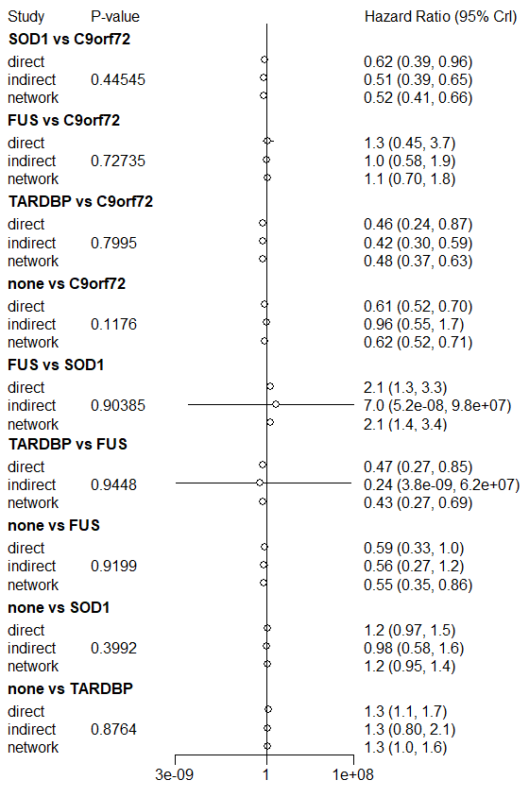

Figure S2 forest plot for heterogeneity test for none vs ATXN2, CCNF vs C9orf72, FUS vs C9orf72.
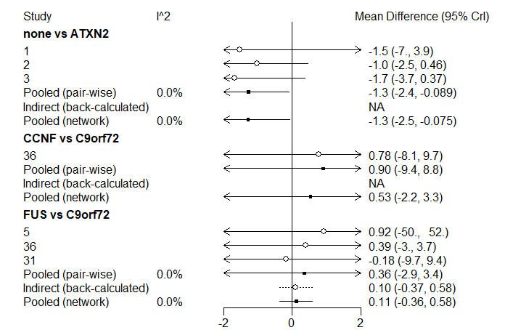
Note:1, G. Borghero (2015). 2, A. Chiò(discovery cohort, 2015). 3, A. Chiò (validation cohort, 2015). 5, A. Chiò (2012). 31, Y. P. Chen (2021). 36, E. P. McCann (2017)

Figure 3 forest plot for heterogeneity test for NEK1 vs C9orf72, none vs C9orf72.
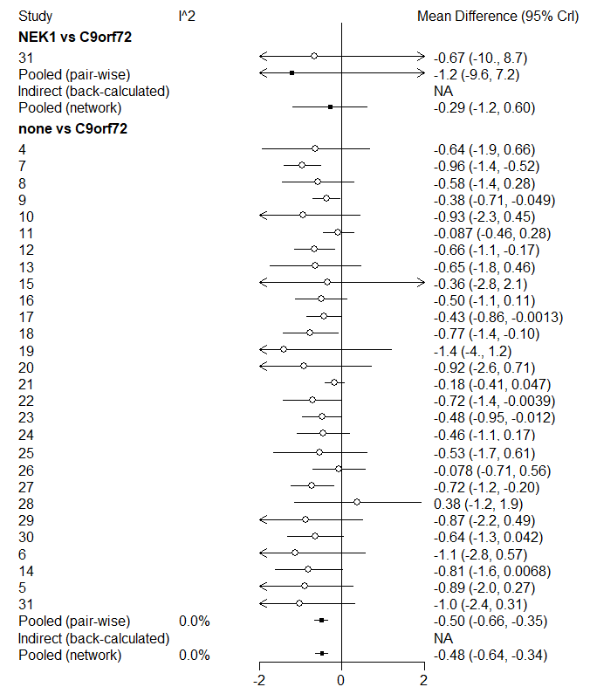
Note: 4, S. Byrne (2012). 5, A. Chiò (2012). 6, S. Lattante (2012). 7. A. Ratti (2012). 8, M. Sabatelli (2012). 9, W. van Rheenen (2012). 10, S. Debray(sALS cohort,2013). 11, S. Debray(fALS cohort, 2013). 12, A. García-Redondo (2012). 13, D. J. Irwin (2013). 14, G. Borghero (2014). 15, K. Van Laere (2014). 16, A. Calvo (2016).17, R. Govaarts (2016). 18, M. E. Umoh (2016). 19, T. F. Gendron (2017). 20, W. Reniers (2017). 21, A. J. Cammack (2019). 22, G. Miltenberger-Miltenyi (2018). 23, J. Rooney (2019). 24, F. Trojsi (2019). 25, M. Benatar (2020). 26, M. De Schaepdryver (2020). 27, D. Brand (2021). 28, U. Kläppe (2021). 29, F. Puentes (2021). 30, S. Millecamps (2012). 31, Y. P. Chen (2021). 33, S. Millecamps (2010). 34, P. Corcia (2012). 36, E. P. McCann (2017). 37, W. Liu (2021).

Figure S4 forest plot for heterogeneity test for SOD1 vs C9orf72, TARDBP vs C9orf72, TBK1 vs C9orf72.
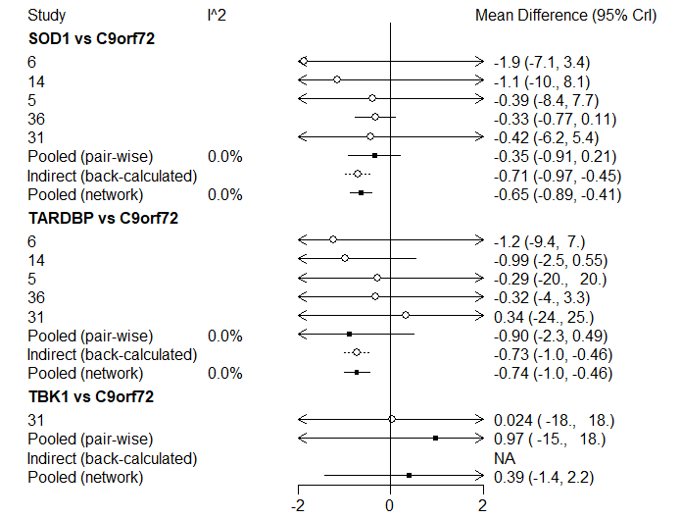
Note: 5, A. Chiò (2012). 6, S. Lattante (2012). 14, G. Borghero (2014). 31, Y. P. Chen (2021). 36, E. P. McCann (2017).

Figure S5 forest plot for heterogeneity test for UBQLN2 vs C9orf72, FUS vs CCNF, SOD1 vs CCNF, TARDBP vs CCNF.
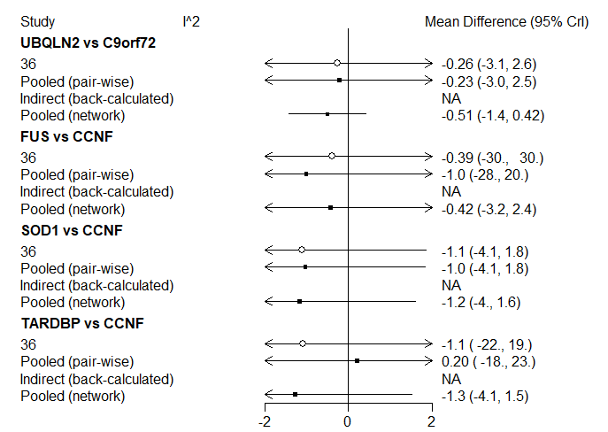
Note: 36, E. P. McCann (2017).

Figure S6 forest plot for heterogeneity test for UBQLN2 vs CCNF, NEK1vs FUS, none vs FUS.
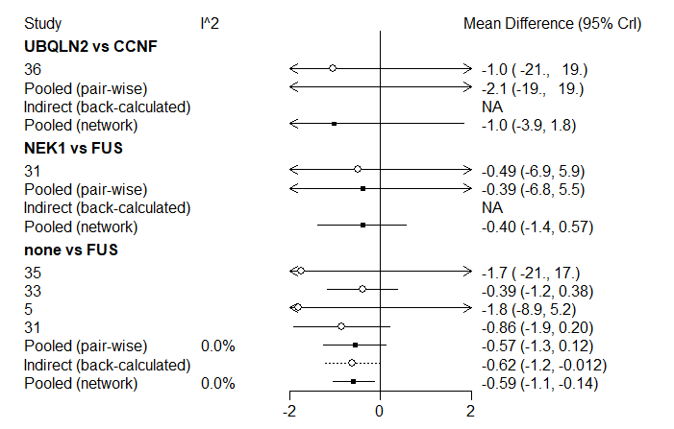
Note: 5, A. Chiò (2012). 31, Y. P. Chen (2021). 33, S. Millecamps (2010). 34, P. Corcia (2012). 35, A. Hübers (2012). 36, E. P. McCann (2017).

Figure S7 forest plot for heterogeneity test for SOD1 vs FUS, TARDBP vs FUS, TBK1 vs FUS.
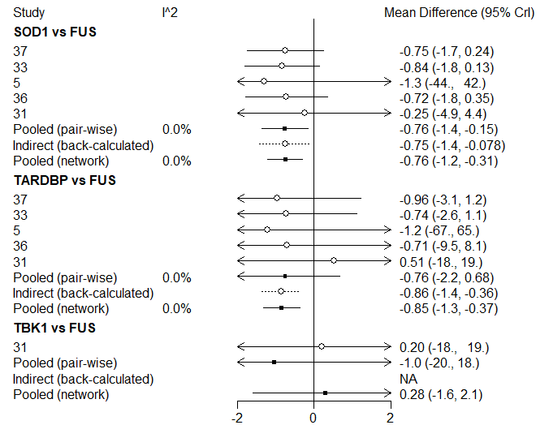
Note: 5, A. Chiò (2012). 31, Y. P. Chen (2021). 33, S. Millecamps (2010). 36, E. P. McCann (2017). 37, W. Liu (2021).

Figure S8 forest plot for heterogeneity test for UBQLN2 vs FUS, none vs NEK1, SOD1 vs NEK1, TARDBP vs NEK1.
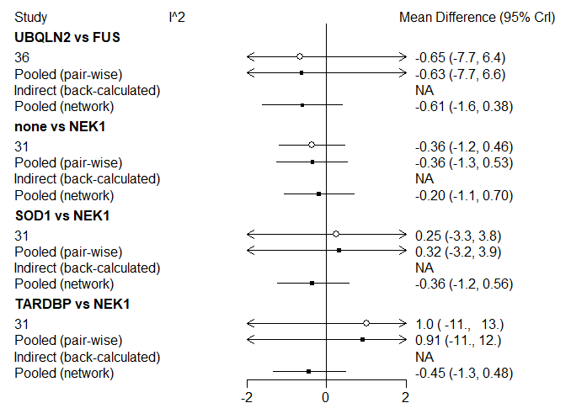
Note: 31, Y. P. Chen (2021). 36, E. P. McCann (2017).

Figure S9 forest plot for heterogeneity test for TBK1 vs NEK1, SOD1 vs none.
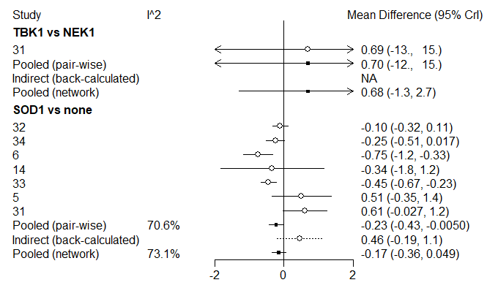
Note: 5, A. Chiò (2012). 6, S. Lattante (2012). 14, G. Borghero (2014). 31, Y. P. Chen (2021). 32, M. E. Cudkowicz (1997). 33, S. Millecamps (2010). 34, P. Corcia (2012).

Figure S10 forest plot for heterogeneity test for TARDBP vs none, TBK1 vs none.
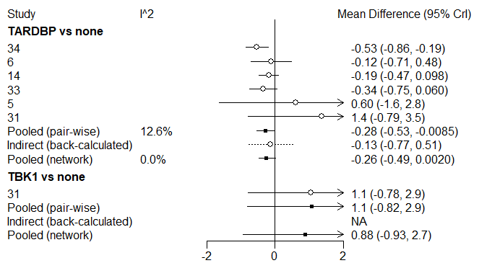
Note: 5, A. Chiò (2012). 6, S. Lattante (2012). 14, G. Borghero (2014). 31, Y. P. Chen (2021). 33, S. Millecamps (2010). 34, P. Corcia (2012).

Figure S11 forest plot for heterogeneity test for TARDBP vs SOD1, TBK1 vs SOD1, UBQLN2 vs SOD1.
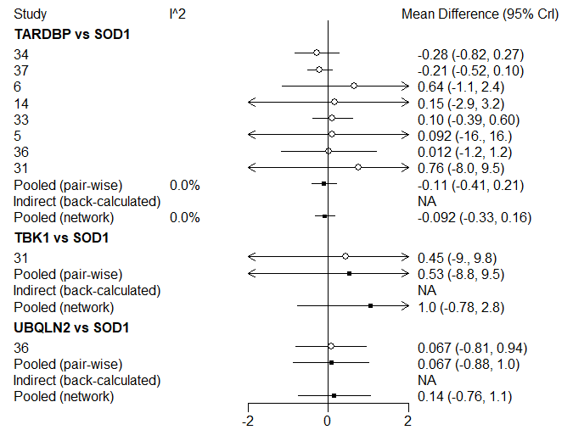
Note: 5, A. Chiò (2012). 6, S. Lattante (2012). 14, G. Borghero (2014). 31, Y. P. Chen (2021). 33, S. Millecamps (2010). 34, P. Corcia (2012). 36, E. P. McCann (2017). 37, W. Liu (2021).

Figure S12 forest plot for heterogeneity test for TBK1 vs TARDBP, UBQLN2 vs TARDBP.
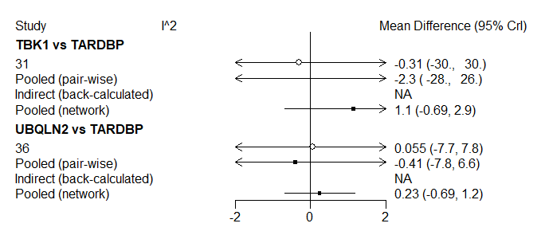Note: 31, Y. P. Chen (2021). 36, E. P. McCann (2017).

Figure S13 publication bias for studies reporting C9orf72 expansion in patients with ALS compared to those without ALS-related mutation.
Note: Begg's Test
Kendall's Score (P-Q) = 24
Std. Dev. of Score = 50.62
Number of Studies = 28
z = 0.47
Pr > |z| = 0.635
z = 0.45 (continuity corrected)
Pr > |z| = 0.650 (continuity corrected)

