ADDITIONAL FILES
Table of contents
Additional File 1: Figure S1: Kaplan-Meier survival curve comparing post-AKI survival according to AKI category.
Additional File 2: Table S1: Patients’ recovery status at 7- and 90-days post-AKI (%)
Additional File 3: Table S2: Characteristics of patients with community-acquired/community-managed AKI tested versus untested within the first seven days post AKI diagnosis.
Additional File 4: Table S3: 90-day status of patients untested within the first 7 days post AKI diagnosis.
Additional File 5: Figure S2: Forest plot displaying the association between individual predictors and progression to AKD, excluding patients who died or initiated chronic KRT within the first 7 days.
Additional File 6: Table S4: Results of univariable and multivariable logistic regression assessing the association between individual predictors and non-recovery at day 7, including patients who died or initiated chronic KRT within the first 7 days in the non-recovery group.
Additional File 6: Figure S3: Forest plot displaying the association between individual predictors and non-recovery at day 7, including patients who died or initiated chronic KRT within the first 7 days in the non-recovery group.
Additional File 7: Figure S4: Forest plot displaying the association between individual predictors and non-recovery at day 90 in patients who entered the AKD phase, excluding patients who died or initiated chronic KRT between day 8 and day 90.
Additional Files 8: Table S5: Results of univariable and multivariable logistic regression assessing the association between individual predictors and non-recovery at day 90 in patients who entered the AKD phase, including patients who died or initiated chronic KRT between day 8 and day 90 in the non-recovery group.
Additional File 8: Figure S5: Forest plot the association between individual predictors and non-recovery at day 90 in patients who entered the AKD phase, including patients who died or initiated chronic KRT between day 8 and day 90 in the non-recovery group.
Additional File 9: Figure S6: Correlation matrix displaying the strength of association between pairs of candidate risk factors.
Additional File 10: Table S6: Association between progression to AKD (versus early recovery) and subsequent risk of death or development of de novo CKD within the year following the AKI episode (results of multivariable Cox model).

Figure S1: Kaplan-Meier survival curve comparing post-AKI survival according to AKI category (N=56,906).
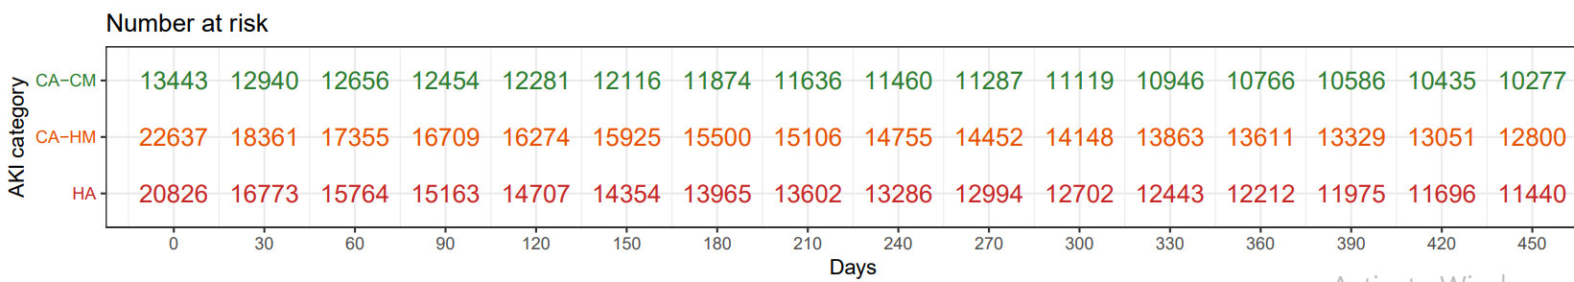
Days
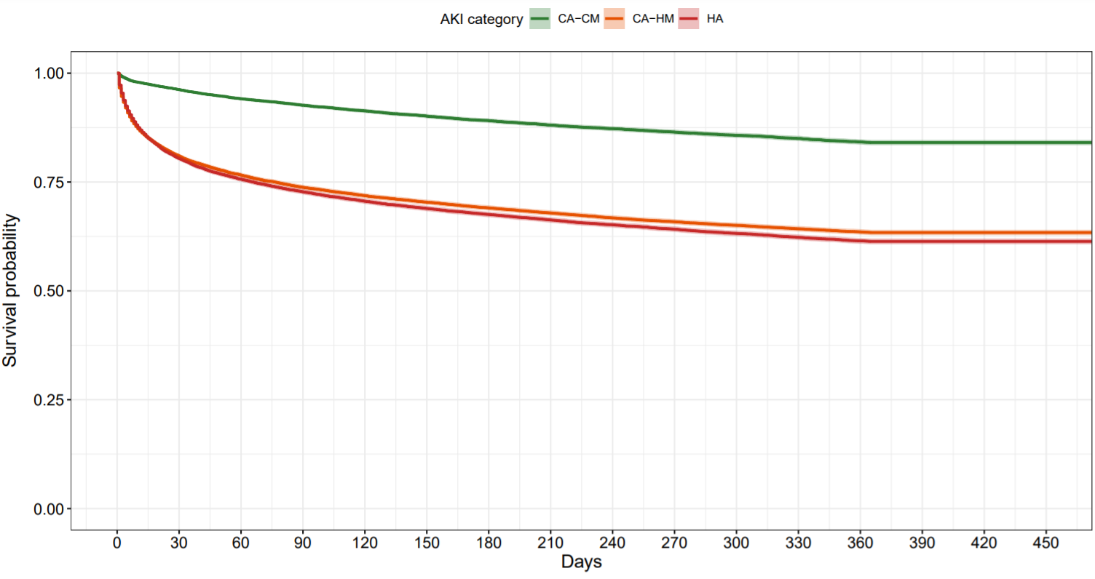

Table S1: Patients’ recovery status at 7- and 90-days post-AKI (%)

 | Creatinine-recovery | No creatinine-recovery | Death | KRT | Untested | Total
Patients’ status at day 7
Community-acquired/community-managed AKI
Stage 1 | 1,231 (10.3) | 2,276 (19.0) | 145 (1.2) | <5 | 8,332 (69.5) | 11,984 (100)
Stage 2 | 140 (12.5) | 425 (38.0) | 63 (5.6) | <5 | 490 (43.8) | 1,118 (100)
Stage 3 | 27 (7.9) | 124 (36.4) | 35 (10.3) | <5 | 151 (44.3) | 341 (100)
All stages | 1,398 (10.4) | 2,825 (21.0) | 243 (1.8) | <5 | 8,973 (66.7) | 13,443 (100)
Community-acquired/hospital-managed AKI
Stage 1 | 7,624 (49.5) | 4,605 (29.9) | 1,370 (8.9) | <5 | 1,785 (11.6) | 15,385 (100)
Stage 2 | 2,035 (46.1) | 1,589 (36.0) | 640 (14.5) | <5 | 148 (3.3) | 4,412 (100)
Stage 3 | 986 (34.7) | 1,333 (46.9) | 475 (16.7) | 18 (0.63) | 28 (0.98) | 2,840 (100)
All stages | 10,645 (47.0) | 7,527 (33.2) | 2,485 (11.0) | 19 (0.084) | 1,961 (8.7) | 22,637 (100)
Hospital-acquired AKI
Stage 1 | 7,085 (39.4) | 7,185 (39.9) | 1,639 (9.1) | <5 | 2,083 (11.6) | 17,992 (100)
Stage 2 | 721 (34.8) | 863 (41.7) | 374 (18.1) | <5 | 110 (5.3) | 2,069 (100)
Stage 3 | 192 (25.1) | 373 (48.8) | 151 (19.7) | 22 (2.9) | 27 (3.5) | 765 (100)
All stages | 7,998 (38.4) | 8,421 (40.4) | 2,164 (10.4) | 23 (0.11) | 2,220 (10.7) | 20,826 (100)
All AKI | 20,041 (35.2) | 18,773 (33.0) | 4,892 (8.6) | 46 (0.081) | 13,154 (23.1) | 56,906 (100)
Patients’ status at day 90
Community-acquired/community-managed AKI
Stage 1 | 993 (43.6) | 673 (29.6) | 191 (8.4) | <5 | 417 (18.3) | 2,276 (100)
Stage 2 | 164 (38.6) | 160 (37.6) | 42 (9.9) | <5 | 59 (13.9) | 425 (100)
Stage 3 | 37 (29.8) | 54 (43.5) | 14 (11.3) | 17 (13.7) | <5 | 124 (100)
All stages | 1,194 (42.3) | 887 (31.4) | 247 (8.7) | 19 (0.67) | 478 (16.9) | 2,825 (100)
Community-acquired/hospital-managed AKI
Stage 1 | 1,999 (43.4) | 981 (21.3) | 968 (21.0) | 10 (0.22) | 647 (14.0) | 4,605 (100)
Stage 2 | 668 (42.0) | 383 (24.1) | 384 (24.2) | <5 | 150 (9.4) | 1,589 (100)
Stage 3 | 582 (43.7) | 363 (27.2) | 290 (21.7) | 56 (4.2) | 42 (3.1) | 1,333 (100)
All stages | 3,249 (43.2) | 1,727 (22.9) | 1,642 (21.8) | 70 (0.93) | 839 (11.1) | 7,527 (100)
Hospital-acquired AKI
Stage 1 | 2,794 (38.9) | 2,084 (29.0) | 1,498 (20.8) | 11 (0.15) | 798 (11.1) | 7,185 (100)
Stage 2 | 331 (38.3) | 242 (28.0) | 225 (26.1) | <5 | 65 (7.5) | 863 (100)
Stage 3 | 130 (34.8) | 119 (31.9) | 83 (22.2) | 29 (7.8) | 12 (3.2) | 373 (100)
All stages | 3,255 (38.6) | 2,445 (29.0) | 1,806 (21.4) | 40 (0.47) | 875 (10.4) | 8,421 (100)
All AKI | 7,698 (41.0) | 5,059 (26.9) | 3,695 (19.7) | 129ª (0.69) | 2,192 (11.7) | 18,773 (100)

Table S2: Characteristics of patients with community-acquired/community-managed AKI tested versus untested within the first seven days post AKI diagnosis, excluding patients who died or initiated chronic KRT within this time period.

 | Tested  (n=4,223) | Untested  (n=8,973)
AKI severity at diagnosis
Stage 1 | 3507 (83) | 8332 (93)
Stage 2 | 565 (13) | 490 (5)
Stage 3 | 151 (4) | 151 (2)
Age at AKI diagnosis (median, [IQR]) | 72 [57 – 82] | 68 [50 – 79]
Sex = Male | 4706 (37) | 3049 (34)
SIMD quintile
1 (most deprived) | 753 (18) | 1862 (21)
2 | 819 (19) | 1856 (21)
3 | 815 (19) | 1801 (20)
4 | 1130 (27) | 2093 (23)
5 (least deprived) | 706 (17) | 1361 (15)
AKI identified by
SCr ratio | 4116 (97) | 8856 (99)
SCr increment | 107 (3) | 117 (1)
Baseline eGFR category
≥ 90 | 1229 (29) | 4223 (47)
60 – 89 | 1494 (35) | 2894 (32)
45 – 59 | 730 (17) | 978 (11)
30 – 44 | 551 (13) | 630 (7)
< 30 | 219 (5) | 248 (3)
Comorbidity
Chronic kidney disease (CKD) | 1603 (38) | 2346 (26)
Cancer | 1159 (27) | 2117 (24)
Coronary arterial disease (CAD) | 865 (20) | 1569 (17)
Congestive heart failure (CHF) | 440 (10) | 726 (8)
Diabetes | 1133 (27) | 2266 (26)
Hypertension | 1361 (32) | 2469 (27)
Medication in prior 90 days
ACEi/ARB | 1821 (43) | 3313 (37)
Loop diuretic | 1129 (27) | 1914 (21)
Metformin | 464 (11) | 949 (11)
NSAID | 328 (8) | 846 (9)
Statin | 1537 (36) | 2933 (33)

Table S3: 90-day status of patients untested within the first 7 days post AKI diagnosis.
 |  | Creatinine-recovery |  | No creatinine-recovery | Death | KRT | Untested | Total
Patients’ status at day 90 for patients untested at day 7
Community-acquired/community-managed AKI
Stage 1 | 2,656 (31.9) |  | 2,185 (26.2) |  | 364 (4.4) | <5* | 3,124 (37.5) | 8,332 (100)
Stage 2 | 145 (29.6) |  | 179 (36.5) |  | 44 (9.0) | <5* | 119 (24.3) | 490 (100)
Stage 3 | 32 (21.2) |  | 56 (37.1) |  | 26 (17.2) | 19 (12.6) | 18 (11.9) | 151 (100)
All stages | 2,833 (31.6) |  | 2,420 (27.0) |  | 434 (4.8) | 25 (0.3) | 3,261 (36.3) | 8,973 (100)
Community-acquired/hospital-managed AKI
Stage 1 | 664 (37.2) |  | 295 (16.5) |  | 145 (8.1) | <5* | 681 (38.1) | 1,785 (100)
Stage 2 | 52 (35.1) |  | 17 (11.5) |  | 21 (14.2) | <5* | 58 (39.2) | 148 (100)
Stage 3 | 7 (25.0) |  | 5 (17.9) |  | 5 (17.9) | <5* | 7 (25.0) | 28 (100)
All stages | 723 (36.9) |  | 317 (16.2) |  | 171 (8.7) | <5* | 746 (38.0) | 1,961 (100)
Hospital-acquired AKI
Stage 1 | 714 (34.3) |  | 445 (21.4) |  | 210 (10.1) | <5* | 714 (34.3) | 2,083 (100)
Stage 2 | 29 (26.4) |  | 17 (15.4) |  | 24 (21.8) | <5* | 40 (36.4) | 110 (100)
Stage 3 | 7 (25.9) |  | 4 (14.8) |  | 8 (29.6) | <5* | 5 (18.5) | 27 (100)
All stages | 750 (33.8) |  | 466 (21.0) |  | 242 (10.9) | <5* | 759 (34.2) | 2,220 (100)
All AKI | 4,306 (32.7) |  | 3,203 (24.3) |  | 847 (6.4) | 32 (0.24) | 4,766 (36.2) | 13,154 (100)

*Count data below 5 are non-disclosable to protect patients’ confidentiality.

Figure S2: Forest plot displaying the results of multivariable logistic regression assessing the association between individual predictors and progression to AKD, excluding patients who died or initiated chronic KRT within the first 7 days.

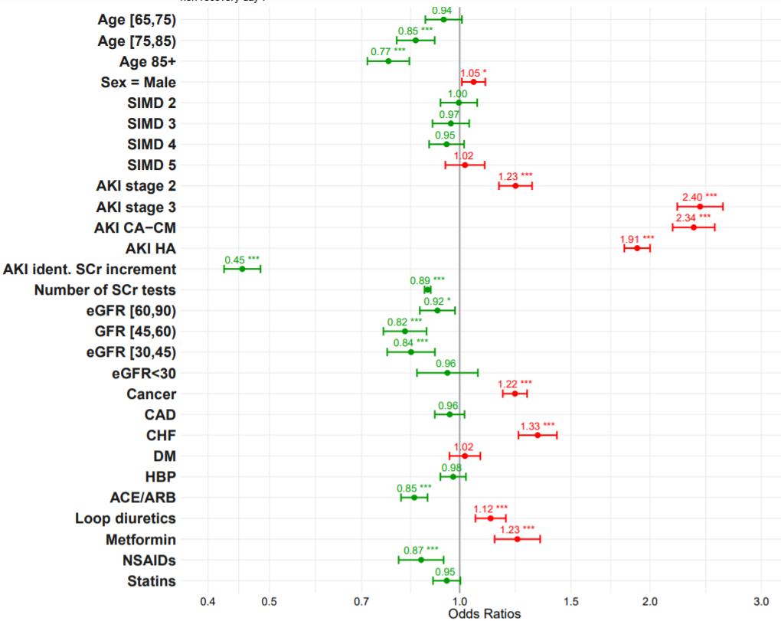

Table S4: Results of univariable and multivariable logistic regression assessing the association between individual predictors and non-recovery at day 7, including patients who died or initiated chronic KRT within the first 7 days in the non-recovery group.

 |  | Unadjusted |  | Adjusted
 |  | OR (95% CI) | p-value | OR (95% CI) | p-value
 | N | 43,752 |  | 43,752
No recovery at day 7, N (%) |  | 23,711 (54.2%) |  | 23,711 (54.2%)
Age at AKI diagnosis
<65 (Ref) | 11,075 | -- | -- | -- | --
65-74 | 9,949 | 0.94 (0.89 – 1.00) | 0.04 | 1.00 (0.94 – 1.07) | 0.42
75-84 | 13,520 | 0.86 (0.82 – 0.91) | <0.001 | 1.00 (0.94 – 1.06) | 0.84
85+ | 9,208 | 0.86 (0.82 – 0.91) | <0.001 | 0.99 (0.92 – 1.06) | 0.88
Sex = Male | 20,995 | 0.98 (0.95 - 1.02) | 0.36 | 1.05 (1.01 – 1.09) | 0.02
SIMD quintile
1 (Ref) | 8,172 | -- | -- | -- | --
2 | 8,773 | 0.99 (0.93 – 1.05) | 0.64 | 0.99 (0.93 – 1.05) | 0.74
3 | 8,743 | 0.94 (0.88 – 0.99) | 0.03 | 0.94 (0.88 – 1.00) | 0.04
4 | 11,201 | 0.91 (0.86 to 0.97) | 0.002 | 0.90 (0.85 – 0.96 | <0.001
5 | 6,863 | 0.98 (0.92 – 1.04) | 0.51 | 0.97 (0.91 – 1.04) | 0.4
AKI category
CA-HM (Ref) | 20,676 | -- | -- | -- | --
CA-CM | 4,470 | 2.33 (2.18 – 2.50) | <0.001 | 2.56 (2.39 – 2.75) | <0.001
HA | 18,606 | 1.41 (1.35 – 1.46) | <0.001 | 1.76 (1.69 – 1.84) | <0.001
AKI identified by
SCr ratio (Ref) | 37,410 | -- | -- | -- | --
SCr increment | 6,342 | 0.43 (0.40 - 0.46) | <0.001 | 0.47 (0.44 – 0.49) | <0.001
AKI severity at diagnosis
Stage 1 (Ref) | 33,161 | -- | -- | -- | --
Stage 2 | 6,851 | 1.26 (1.20 - 1.33) | <0.001 | 1.27 (1.21 – 1.35) | <0.001
Stage 3 | 3,740 | 1.95 (1.81 - 2.09) | <0.001 | 2.26 (2.10 – 2.44) | <0.001
Number of tests |  | 0.81 (0.81 – 0.82) | <0.001 | -- | --
Baseline eGFR category
≥ 90 (Ref) | 9,918 | -- | -- | -- | --
60 – 89 | 17,175 | 0.84 (0.80 - 0.88) | <0.001 | 0.89 (0.84 – 0.95) | <0.001
45 – 59 | 7,913 | 0.71 (0.67 - 0.75) | <0.001 | 0.79 (0.74 – 0.85) | <0.001
30 – 44 | 6,007 | 0.68 (0.64 - 0.72) | <0.001 | 0.79 (0.73 – 0.86) | <0.001
< 30 | 2,739 | 0.79 (0.73 – 0.86) | <0.001 | 0.90 (0.82 – 1.00) | 0.05
Comorbidity
Cancer | 15,778 | 1.25 (1.21 - 1.30) | <0.001 | 1.29 (1.24 – 1.34) | <0.001
CAD | 11,271 | 0.96 (0.92 - 1.00) | 0.05 | 1.01 (0.96 – 1.06) | 0.74
CHF | 5,685 | 1.22 (1.15 - 1.29) | <0.001 | 1.34 (1.25 – 1.43) | <0.001
Diabetes | 11,992 | 0.97 (0.93 - 1.01) | 0.12 | 1.00 (0.94 – 1.05) | 0.89
Hypertension | 16,843 | 0.91 (0.88 – 0.95) | <0.001 | 0.97 (0.93 – 1.02) | 0.23
Medication in prior 90 days
ACEi/ARB | 16,190 | 0.78 (0.75 - 0.81) | <0.001 | 0.78 (0.75 – 0.82) | <0.001
Loop diuretic | 9,973 | 1.08 (1.04 - 1.13) | <0.001 | 1.16 (1.10 – 1.22) | <0.001
Metformin | 4,232 | 1.04 (0.98 - 1.11) | 0.19 | 1.17 (1.08 – 1.27) | <0.001
NSAID | 2,981 | 0.91 (0.85 - 0.97) | 0.016 | 0.87 (0.80 – 0.94) | <0.001
Statin | 15,931 | 0.85 (0.82 - 0.89) | <0.001 | 0.93 (0.89 – 0.98) | 0.003

Figure S3: Forest plot displaying the results of multivariable logistic regression assessing the association between individual predictors and non-recovery at day 7, including patients who died or initiated chronic KRT within the first 7 days in the non-recovery group.
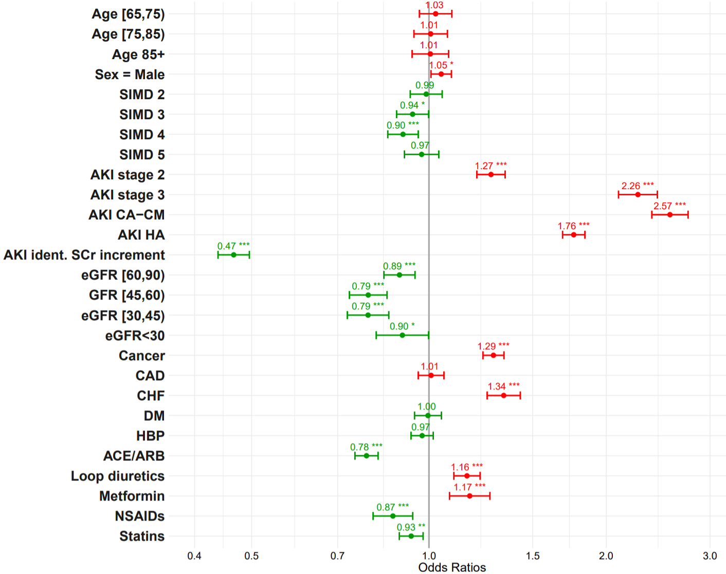

Figure S4: Forest plot displaying the results of multivariable logistic regression assessing the association between individual predictors and non-recovery at day 90 in patients who entered the AKD phase, excluding patients who died or initiated chronic KRT between day 8 and day 90.

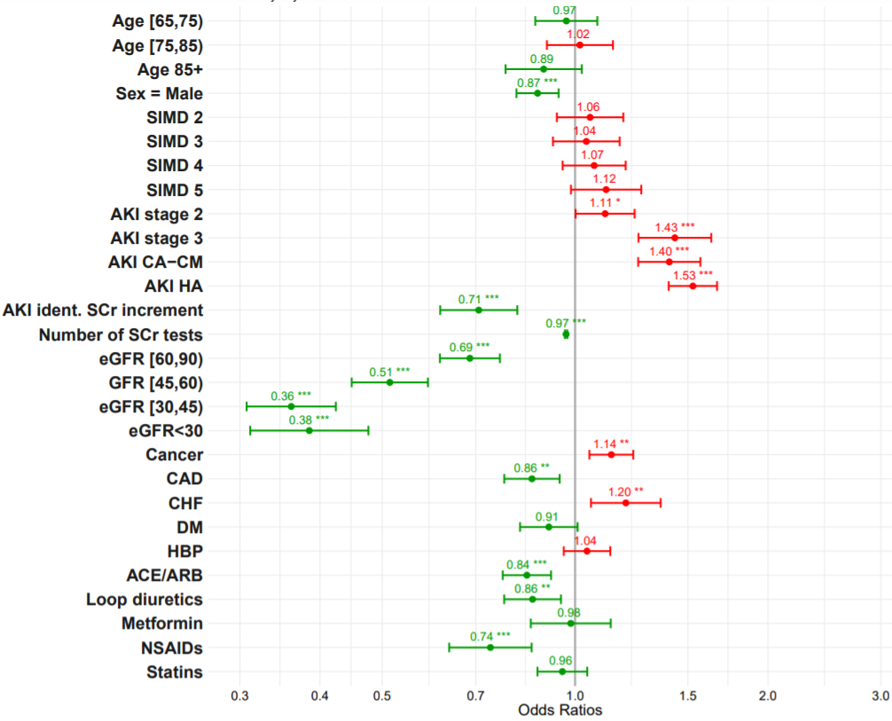

Table S5: Results of univariable and multivariable logistic regression assessing the association between individual predictors and non-recovery at day 90 in patients who entered the AKD phase, including patients who died or initiated chronic KRT between day 8 and day 90 in the non-recovery group.

 |  | Unadjusted |  | Adjusted
 |  | OR (95% CI) | p-value | OR (95% CI) | p-value
 | N | 16,581 |  | 16,581
No recovery at day 90, N (%) |  | 8,883 (53.6%) |  | 8,883 (53.6%)
Age at AKI diagnosis
<65 (Ref) | 4,161 | -- | -- | -- | --
65-74 | 3,832 | 0.95 (0.87 – 1.04) | 0.2 | 1.17 (1.06-1.29) | 0.002
75-84 | 4,986 | 0.94 (0.87 – 1.02) | 0.1 | 1.30 (1.17-1.44) | <0.001
85+ | 3,602 | 1.09 (1.00 – 1.20) | 0.05 | 1.48 (1.32-1.66) | <0.001
Sex = Male | 7,975 | 0.89 (0.83 – 0.94) | <0.001 | 0.91 (0.86-0.97) | 0.005
SIMD quintile
1 (Ref) | 3,094 | -- | -- | -- | --
2 | 3,312 | 1.05 (0.95 – 1.16) | 0.3 | 1.05 (0.95-1.16) | 0.3
3 | 3,259 | 1.01 (0.91 – 1.11) | 0.8 | 1.00 (0.91-1.11) | 0.9
4 | 4,233 | 1.01 (0.92 – 1.11) | 0.8 | 0.98 (0.89-1.08) | 0.7
5 | 2,683 | 1.06 (0.96 – 1.18) | 0.3 | 1.01 (0.91-1.13) | 0.8
AKI category
CA-HM (Ref) | 6,688 | -- | -- | -- | --
CA-CM | 2,347 | 0.91 (0.83 – 1.00) | 0.06 | 0.99 (0.90-1.09) | 0.8
HA | 7,546 | 1.24 (1.17 – 1.33) | <0.001 | 1.28 (1.19-1.37) | <0.001
AKI identified by
SCr ratio (Ref) | 14,880 | -- | -- | -- | --
SCr increment | 1,701 | 0.69 (0.63 - 0.77) | <0.001 | 0.71 (0.63-0.79) | <0.001
AKI severity at diagnosis
Stage 1 (Ref) | 12,204 | -- | -- | -- | --
Stage 2 | 2,603 | 1.12 (1.02 - 1.21) | 0.01 | 1.17 (1.07-1.28) | <0.001
Stage 3 | 1,774 | 1.23 (1.11 – 1.36) | <0.001 | 1.42 (1.28-1.59) | <0.001
Number of tests | Median = 5 [IQR: 2 – 11] | 0.97 (0.97 – 0.98) | <0.001 | -- | --
Baseline eGFR category
≥ 90 (Ref) | 3,923 | -- | -- | -- | --
60 – 89 | 6,621 | 0.79 (0.73 - 0.86) | <0.001 | 0.71 (0.65-0.78) | 0.01
45 – 59 | 2,851 | 0.65 (0.59 - 0.72) | <0.001 | 0.58 (0.52-0.65) | <0.001
30 – 44 | 2,144 | 0.57 (0.51 - 0.63) | <0.001 | 0.50 (0.44-0.57) | <0.001
< 30 | 1,042 | 0.76 (0.66 – 0.87) | <0.001 | 0.64 (0.55-0.76) | 0.4
Comorbidity
Cancer | 6,311 | 1.44 (1.35 - 1.53) | <0.001 | 1.42 (1.33-1.52) | <0.001
CAD | 4,211 | 0.89 (0.83 – 0.95) | <0.001 | 0.96 (0.88-1.04) | 0.3
CHF | 2,361 | 1.09 (1.00 - 1.19) | 0.06 | 1.27 (1.15-1.41) | <0.001
Diabetes | 4,789 | 0.79 (0.74 – 0.85) | <0.001 | 0.99 (0.91-1.08) | 0.8
Hypertension | 6,376 | 0.91 (0.85 – 0.97) | 0.003 | 1.01 (0.95-1.09) | 0.7
Medication in prior 90 days
ACEi/ARB | 6,201 | 0.65 (0.61 - 0.70) | <0.001 | 0.76 (0.70-0.81) | <0.001
Loop diuretic | 3,968 | 0.94 (0.87 - 1.00) | 0.07 | 1.08 (0.99-1.17) | 0.07
Metformin | 1,827 | 0.68 (0.62 – 0.75) | <0.001 | 0.85 (0.75-0.96) | 0.009
NSAID | 1,110 | 0.85 (0.75 – 0.96) | 0.008 | 0.83 (0.73-0.94) | 0.003
Statin | 6,033 | 0.72 (0.68 - 0.77) | <0.001 | 0.88 (0.81-0.94) | <0.001

Figure S5: Forest plot displaying the results of multivariable logistic regression assessing the association between individual predictors and non-recovery at day 90 in patients who entered the AKD phase, including patients who died or initiated chronic KRT between day 8 and day 90 in the non-recovery group.

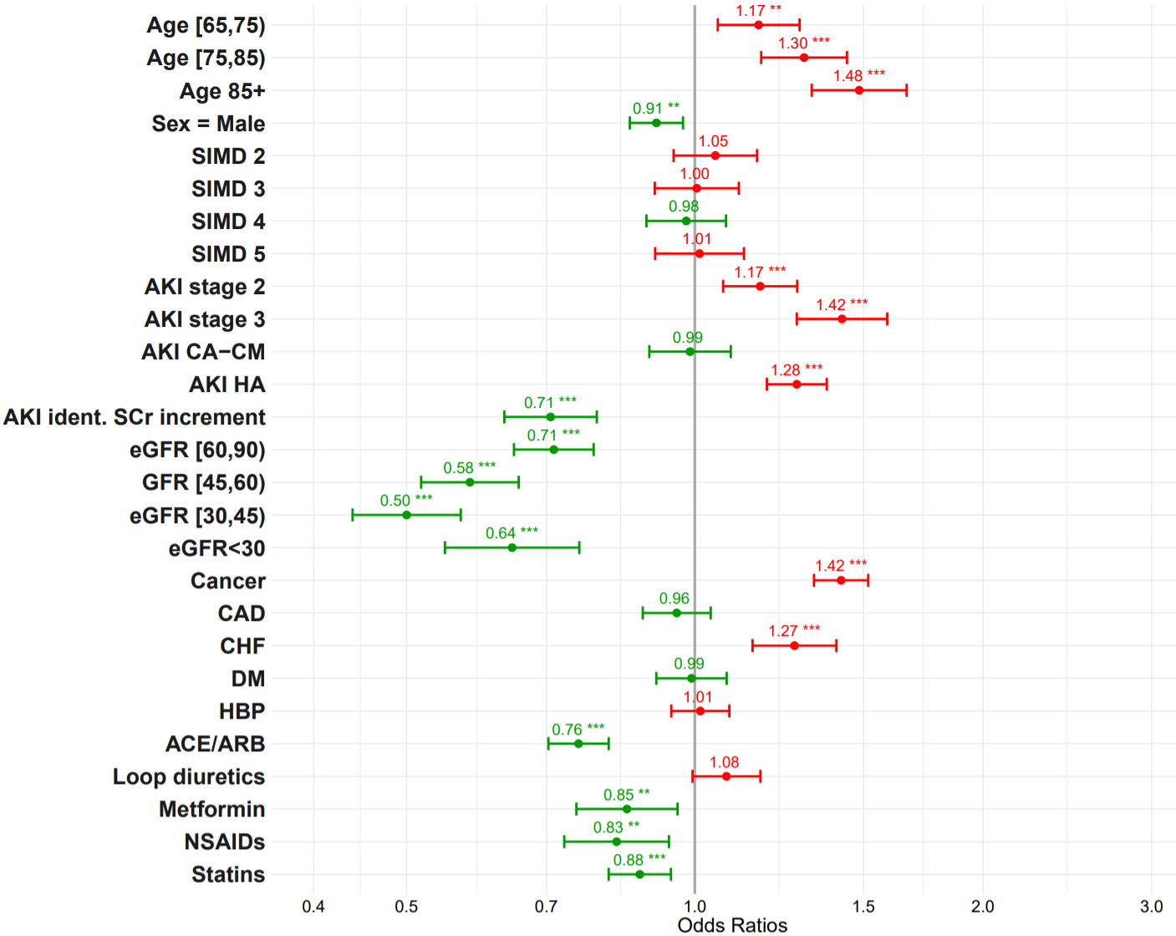

Figure S6: Correlation matrix displaying the strength of association between pairs of candidate risk factors.
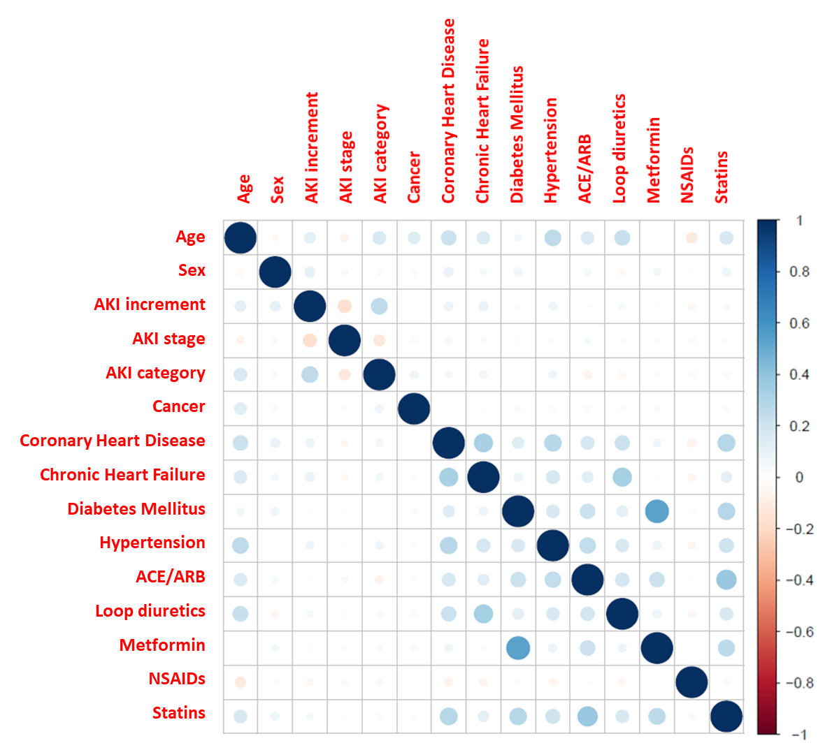

Table S6: Association between progression to AKD (versus early recovery) and subsequent risk of death or development of de novo CKD within the year following the AKI episode (results of multivariable Cox model).

 | N | HR for 1-year mortality* | N | HR for 1-year risk of de novo CKD*
All | 29,330 | 1.20 (1.13 to 1.26) | 14,486 | 2.21 (1.91 to 2.57)
CA-CM | 2,682 | 1.55 (1.23 to 1.95) | 1,334 | 3.25 (1.99 to 5.31)
CA-HM | 14,624 | 1.28 (1.18 to 1.39) | 7,890 | 2.12 (1.72 to 2.60)
HA | 12,024 | 1.14 (1.06 to 1.24) | 5,262 | 2.00 (1.57 to 2.55)

*Adjusted for all baseline covariates (age, sex, SIMD, baseline eGFR, comorbidities and previous medications), frequency of SCr tests, AKI stage and recovery eGFR category (+AKI category when pooling all categories together).

CA-CM: Community-acquired/community-managed AKI; CA-HM: Community-acquired/hospital-managed AKI; HA: Hospital-acquired AKI
6 patients initiated KRT and then died during the 8 to 90 days period, their status was considered as “Death”
Patients who entered AKD phase, i.e: have been tested at day 7 but did not recover within 7 days, did not die or initiate RRT during first 7 days. * Count data below 5 are non-disclosable in order to protect patient’s confidentiality.
Variables associated with progression to AKD are in red whilst those associated with early recovery are in green. Significance level: * <0.05, **<0.01, *** <0.001
Variables associated with non-recovery at day 7 are in red whilst those associated with early recovery (between day 1 and day 7) are in green. Significance level: * <0.05, **<0.01, *** <0.001.
Variables associated with non-recovery at day 90 are in red whilst those associated with recovery during the AKD phase (between day 8 and day 90) are in green. Significance level: * <0.05, **<0.01, *** <0.001.
Variables associated with non-recovery at day 90 are in red whilst those associated with recovery during the AKD phase (between day 8 and day 90) are in green. Significance level: * <0.05, **<0.01, *** <0.001.

