Additional file 1: eMethods, etables 1-7, eFigure 1
eMethods. The calculation of an E value
eTable 1. Maternal smoking status during pregnancy by levels of covariates in the full cohort
eTable 2. Timing of maternal smoking during pregnancy and offspring type 1 diabetes in different study designs
eFigure 1. HRs/ORs (95% CIs) of type 2 diabetes for maternal smoking versus nonsmoking during pregnancy in different study designs
eTable 3. Risk of offspring type 1 diabetes for maternal smoking versus nonsmoking during pregnancy by subgroups: cohort analysis
eTable 4. Risk of offspring type 1 diabetes for maternal smoking versus nonsmoking during pregnancy by subgroups: cousin and sibling analysis
eTable 5. Sensitivity analyses of type 1 diabetes risk in the offspring for maternal smoking versus nonsmoking during pregnancy: cohort analysis
eTable 6. Sensitivity analyses of type 1 diabetes risk in the offspring for maternal smoking versus nonsmoking during pregnancy: cousin analysis
eTable 7. Sensitivity analyses of type 1 diabetes risk in the offspring for maternal smoking versus nonsmoking during pregnancy: sibling analysis

eMethods. The calculation of an E value
The E value represents the minimum strength of association, on the risk ratio scale, that an uncontrolled confounder would need to have with both maternal smoking and offspring type 1 diabetes to fully explain away the observed maternal smoking-type 1 diabetes association. E-value equals to OR + sqrt[OR × (OR − 1)] when OR>1 and equals to OR* + sqrt[OR* × (OR* − 1)] when OR<1 (OR* = 1/OR).

eTable 1. Maternal smoking status during pregnancy by levels of covariates in the full cohort ª
 | Nonsmoking | Maternal smoking during pregnancy
Overall | 2,524,655 (84.3) | 470,666 (15.7)
Sex
Boys | 1,296,932 (84.2) | 242,732 (15.8)
Girls | 1,227,723 (84.3) | 227,934 (15.7)
Year of birth
1983-1984 | 115,056 (69.4) | 50,800 (30.6)
1985-1989 | 340,310 (72.1) | 131,885 (27.9)
1990-1994 | 418,988 (77.8) | 119,296 (22.2)
1995-1999 | 350,338 (85.3) | 60,534 (14.7)
2000-2004 | 381,097 (89.7) | 43,766 (10.3)
2005-2009 | 437,113 (92.7) | 34,215 (7.3)
2010-2014 | 481,753 (94.1) | 30,170 (5.9)
Gestational age in weeks
Very preterm: 22–32 | 17,300 (77.6) | 5,005 (22.4)
Preterm: 33–36 | 95,191 (80.0) | 23,791 (20.0)
Early term: 37–38 | 457,033 (82.6) | 96,112 (17.4)
Term: 39–40 | 1,310,620 (84.7) | 236,883 (15.3)
Postterm: 41+ | 643,795 (85.6) | 108,513 (14.4)
Unknown | 716 (66.4) | 362 (33.6)
Birth weight for gestational age
Small for gestational age | 50,069 (70.4) | 21,076 (29.6)
Normal | 2,372,383 (84.4) | 438,402 (15.6)
Large for gestational age | 95,194 (91.1) | 9,301 (8.9)
Unknown | 7,009 (78.8) | 1,887 (21.2)
Birth order
1 | 1,080,712 (84.9) | 192,688 (15.1)
2 | 934,043 (85.8) | 155,185 (14.2)
3+ | 509,900 (80.6) | 122,793 (19.4)
Maternal age in years
<20 | 38,647 (63.2) | 22,524 (36.8)
20-24 | 389,615 (76.0) | 123,183 (24.0)
25-29 | 858,663 (84.6) | 155,979 (15.4)
30-34 | 808,588 (88.0) | 110,074 (12.0)
35-39 | 358,952 (88.0) | 48,816 (12.0)
40+ | 70,190 (87.4) | 10,090 (12.6)
Maternal marital status
Living with child's father | 2,367,701 (85.5) | 401,232 (14.5)
Single | 33,515 (59.1) | 23,217 (40.9)
Other | 60,637 (67.4) | 29,339 (32.6)
Unknown | 62,802 (78.8) | 16,878 (21.2)
Maternal educational level
Pre-secondary | 270,605 (69.6) | 118,401 (30.4)
Upper-secondary | 451,625 (79.0) | 119,919 (21.0)
High school | 518,739 (90.8) | 52,286 (9.2)
Post-secondary or higher | 891,488 (96.9) | 28,110 (3.1)
Unknown | 392,198 (72.1) | 151,950 (27.9)
Paternal educational level
Pre-secondary | 368,832 (74.5) | 126,378 (25.5)
Upper-secondary | 589,473 (81.7) | 132,075 (18.3)
High school | 496,077 (90.1) | 54,453 (9.9)
Post-secondary or higher | 759,163 (96.1) | 31,207 (3.9)
Unknown | 311,110 (71.1) | 126,553 (28.9)
Maternal BMI during pregnancy ^{b}
Underweight | 66,664 (75.7) | 21,409 (24.3)
Normal | 1,385,045 (86.1) | 223,954 (13.9)
Overweight | 470,000 (86.8) | 71,740 (13.2)
Obese | 185,107 (85.2) | 32,187 (14.8)
Unknown | 417,839 (77.5) | 121,376 (22.5)
Maternal caesarean section at delivery
No | 2,182,653 (84.2) | 410,282 (15.8)
Yes | 342,002 (85.0) | 60,384 (15.0)
Maternal diabetes at childbirth
No | 2,503,118 (84.3) | 466,687 (15.7)
Yes | 21,537 (84.4) | 3,979 (15.6)
Paternal diabetes at childbirth
No | 2,505,190 (84.3) | 467,535 (15.7)
Yes | 19,465 (86.1) | 3,131 (13.9)
Maternal asthma at childbirth
No | 2,387,280 (84.2) | 448,688 (15.8)
Yes | 137,375 (86.2) | 21,978 (13.8)
Paternal asthma at childbirth
No | 2,493,615 (84.2) | 466,211 (15.8)
Yes | 31,040 (87.4) | 4,455 (12.6)
BMI: body mass index.
ª Values are presented as numbers (proportions [%]).
^{b} At first antenatal visit, mostly during 8-12 weeks’ of pregnancy.

eTable 2. Timing of maternal smoking during pregnancy and offspring type 1 diabetes in different study designs
 | Never smoking | Only at first antenatal visit | Only at 30-32 weeks of pregnancy | Sustained smoking ª
Cohort analysis
No. of cases | 6,850 | 143 | 52 | 312
Person years | 15,972,446 | 332,364 | 133,308 | 881,869
Incidence (No./10,000 person years) | 6.3 | 30.1 | 7.5 | 11.3
HR (95% CI) | 1.00 | 1.00 (0.85-1.19) | 0.92 (0.70-1.21) | 0.83 (0.74-0.93)
Cousin analysis
No. of cases | 2,006 | 39 | 23 | 115
OR (95% CI) | 1.00 | 0.78 (0.51-1.21) | 1.09 (0.61-1.93) | 0.83 (0.62-1.11)
Sibling analysis
No. of cases | 4,142 | 64 | 22 | 135
OR (95% CI) | 1.00 | 0.81 (0.55-1.19) | 0.66 (0.36-1.21) | 0.74 (0.48-1.13)
ª Smoking at both first antenatal visit (8-12 weeks of pregnancy) and at 30-32 weeks of pregnancy.
Models were adjusted for sex, year of birth, maternal education, paternal education, maternal age at delivery, maternal body mass index during pregnancy, maternal history of diabetes, paternal history of diabetes, birth order, gestational age and birth weight for gestational age. The model in the cohort analysis was fitted with a gamma-frailty component to account for the clustering of children born by the same mother. The cousin (or sibling) analysis was conditioning on cousin (or sibling) groups.
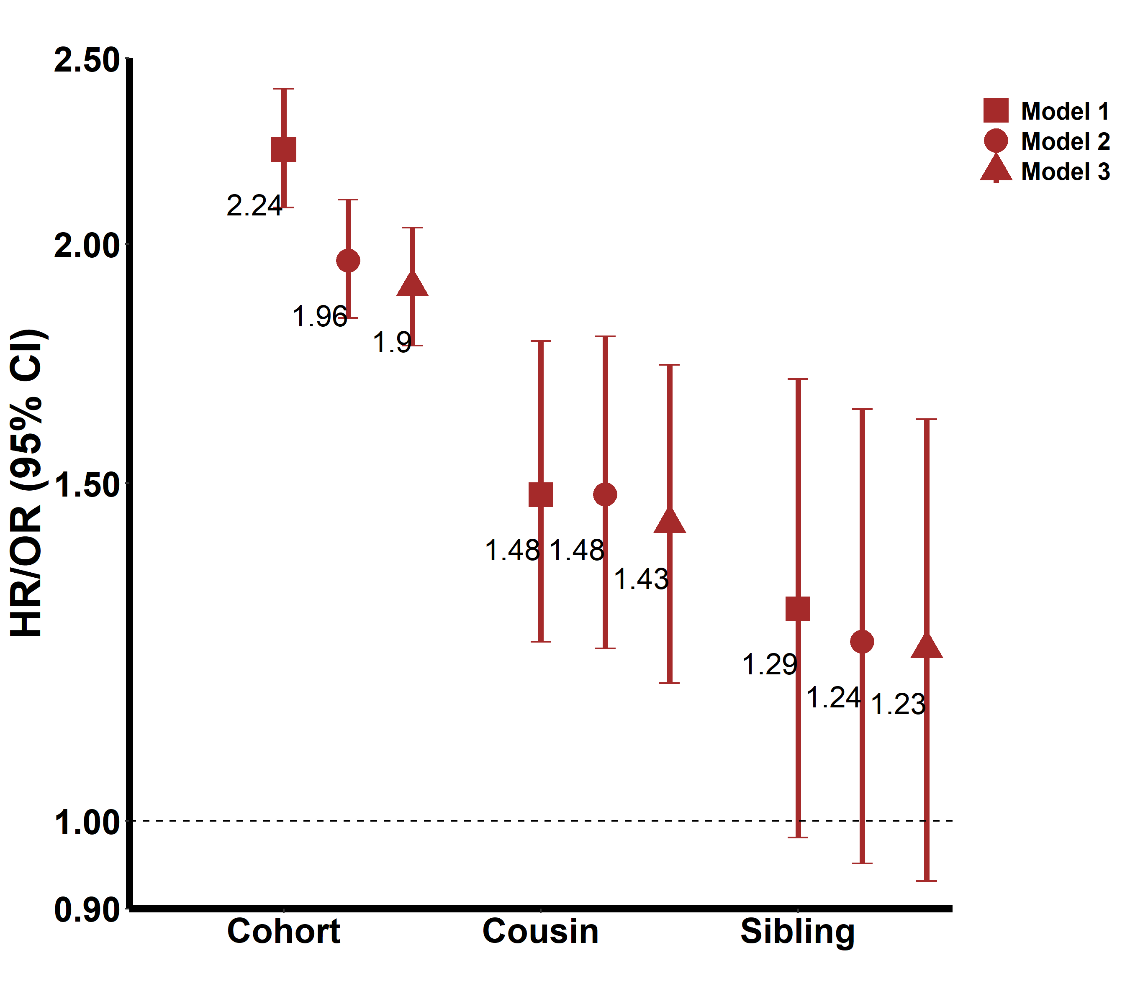

eFigure 1. HRs/ORs (95% CIs) of type 2 diabetes for maternal smoking versus nonsmoking during pregnancy in different study designs
HR: hazard ratio; OR: odds ratio; CI: confidence interval
Model 1 was adjusted for sex and year of birth. The model in the cohort analysis was fitted with a gamma-frailty component to account for the clustering of children born by the same mother. The model in the cousin (or sibling) analysis was conditioning on cousin (or sibling) groups.
Model 2 was additionally adjusted for maternal education, paternal education, maternal age at delivery, maternal body mass index during pregnancy, maternal diabetes, paternal diabetes, and birth order on the basis of model 1.
Model 3 was additionally adjusted for gestational age and birth weight for gestational age on the basis of model 2.

eTable 3. Risk of offspring type 1 diabetes for maternal smoking versus nonsmoking during pregnancy by subgroups: cohort analysis
 | Subgroups | No. of cases | HR (95% CI)
Sibling status | Without siblings | 1,704 | 0.82 (0.71-0.93)
 | With siblings | 16,913 | 0.78 (0.74-0.82)
Sex | Boys | 10,166 | 0.80 (0.75-0.85)
Sex | Girls | 8,451 | 0.77 (0.72-0.82)
Year of birth | before 2000 | 10,995 | 0.77 (0.73-0.81)
 | 2000 onwards | 7,622 | 0.82 (0.74-0.90)
OR: odds ratio; CI: confidence interval
Models fitted with a gamma-frailty to account for the clustering of children born by the same mother. They were adjusted for sex (when appropriate), year of birth, maternal education, paternal education, maternal age at delivery, maternal body mass index during pregnancy, maternal history of diabetes, paternal history of diabetes, birth order, gestational age and birth weight for gestational age.

eTable 4. Risk of offspring type 1 diabetes for maternal smoking versus nonsmoking during pregnancy by subgroups: cousin and sibling analysis
 | Subgroups | Cousin analysis |  |  | Sibling analysis
 | Subgroups | No. of cases | OR (95% CI) |  | No. of cases | OR (95% CI)
Sex | Boys | 3,311 | 0.72 (0.63-0.83) |  | 4,750 | 0.81 (0.66-1.00)
Sex | Girls | 2,665 | 0.85 (0.72-1.00) |  | 3,789 | 0.84 (0.67-1.06)
Sex | P for interaction | 0.668 |  |  | 0.948
Year of birth | Before 2000 | 4,158 | 0.71 (0.64-0.80) |  | 7,794 | 0.78 (0.67-0.90)
Year of birth | 2000 onwards | 2,310 | 0.76 (0.60-0.97) |  | 4,584 | 0.82 (0.62-1.10)
Year of birth | P for interaction | 0.585 |  |  | 0.541
OR: odds ratio; CI: confidence interval
Models were conditioning on cousin (or sibling) groups, and were adjusted for sex (when appropriate), year of birth, maternal education, paternal education, maternal age at delivery, maternal body mass index during pregnancy, maternal history of diabetes, paternal history of diabetes, birth order, gestational age and birth weight for gestational age.

eTable 5. Sensitivity analyses of type 1 diabetes risk in the offspring for maternal smoking versus nonsmoking during pregnancy: cohort analysis
Sensitivity analyses | No. of cases | Incidence (no./10,000 person years) | HR (95% CI)
Additionally adjusted for maternal marital status | 18,617 | 4.0 | 0.78 (0.75-0.82)
Additionally adjusted for mode of delivery | 18,617 | 4.0 | 0.78 (0.75-0.82)
Additionally adjusted for parental asthma ª | 18,617 | 4.0 | 0.78 (0.75-0.82)
Complete-case analysis ^{b} | 12,526 | 4.3 | 0.81 (0.76-0.86)
Only among children without parental diabetes at childbirth | 17,198 | 3.7 | 0.78 (0.74-0.82)
HR: hazard ratio; CI: confidence interval
Models were fitted with a gamma-frailty component to account for the clustering of children born by the same mother, and were adjusted for sex, year of birth, maternal education, paternal education, maternal age at delivery, maternal body mass index during pregnancy, maternal history of diabetes (when appropriate), paternal history of diabetes (when appropriate), birth order, gestational age and birth weight for gestational age. Models were additionally adjusted for maternal marital status, mode of delivery and parental asthma, when appropriate.
ª Parental history of asthma might affect the possibility of maternal smoking during pregnancy, and asthma shares some genetic susceptibility with type 1 diabetes.
^{b} Participants with missing information on maternal level of education, paternal level of education, maternal body mass index, gestational age, or birth weight were excluded from the analysis.

eTable 6. Sensitivity analyses of the risk of type 1 diabetes in the offspring for maternal smoking versus nonsmoking during pregnancy: cousin analysis
Sensitivity analyses | No. of cases | OR (95% CI)
Additionally adjusted for maternal marital status | 7,988 | 0.73 (0.66-0.80)
Additionally adjusted for mode of delivery | 7,988 | 0.72 (0.66-0.79)
Additionally adjusted for parental asthma | 7,988 | 0.72 (0.66-0.79)
Complete-case analysis | 4,493 | 0.76 (0.66-0.87)
Only among children without parental diabetes at childbirth | 7,269 | 0.72 (0.66-0.79)
Full cousins | 6,663 | 0.77 (0.69-0.85)
First-born cousins | 3,381 | 0.74 (0.64-0.86)
Only among cousins within 5 years of birth year gap | 5,684 | 0.78 (0.70-0.87)
OR: odds ratio; CI: confidence interval
Models were conditioning on cousin groups, and were adjusted for maternal education, paternal education, maternal age at delivery, maternal body mass index during pregnancy, maternal history of diabetes (when appropriate), paternal history of diabetes (when appropriate), birth order, gestational age and birth weight for gestational age. Models were additionally adjusted for maternal marital status, mode of delivery and parental asthma, when appropriate.

eTable 7. Sensitivity analyses of the risk of type 1 diabetes in the offspring for maternal smoking versus nonsmoking during pregnancy: sibling analysis
Sensitivity analyses | No. of cases | OR (95% CI)
Additionally adjusted for maternal marital status | 14,284 | 0.78 (0.69-0.87)
Additionally adjusted for mode of delivery | 14,284 | 0.78 (0.70-0.88)
Additionally adjusted for parental asthma | 14,284 | 0.78 (0.69-0.88)
Complete-case analysis | 8,076 | 0.78 (0.66-0.93)
Only among children without parental diabetes at childbirth | 13,227 | 0.78 (0.69-0.88)
Full siblings | 13,129 | 0.76 (0.66-0.86)
Only among siblings within 5 years of birth year gap | 12,301 | 0.76 (0.66-0.87)
OR: odds ratio; CI: confidence interval
Models were conditioning on sibling groups, and were adjusted for maternal education, paternal education, maternal age at delivery, maternal body mass index during pregnancy, maternal history of diabetes (when appropriate), paternal history of diabetes (when appropriate), birth order, gestational age and birth weight for gestational age. Models were additionally adjusted for maternal marital status, mode of delivery and parental asthma, when appropriate.

