Figure S2. Summary presentations of study sample sizes (n) and numbers of data pairs compared (N), accuracy root mean square (Arms), mean bias (SD) and limits of agreement (LoA) of pulse oximeters for the subgroup of medium skin pigmentation
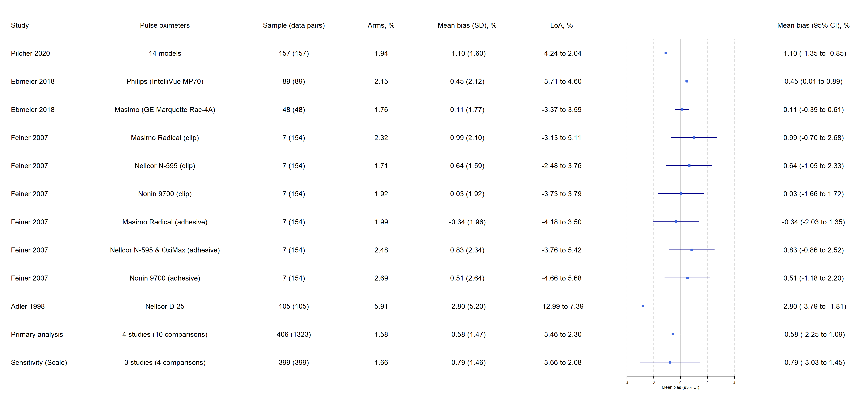
Note:
- The Chi² test for heterogeneity in the primary analysis suggested a Q(df = 9) = 81.92, with P value < 0.0001.
- Tau² between the 4 studies = 1.47 (95% CI 0 to 10.91); Tau² between the 10 comparisons = 0.18 (0.02 to 1.17).
- The estimated overall I² for the primary analysis = 92.65%, of which about 82.39% is due to between-studies heterogeneity, and 10.25% due to within-study heterogeneity.

