Figure S6. Summary presentations of study sample sizes (n) and numbers of data pairs compared (N), accuracy root mean square (Arms), mean bias (SD) and limits of agreement (LoA) of pulse oximeters for the subgroup of non-Black, non-White ethnic groups
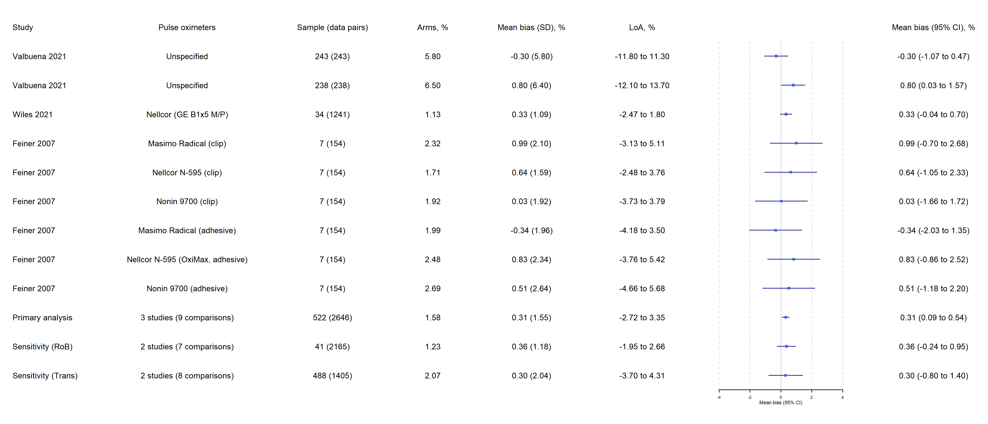
Note:
- The Chi² test for heterogeneity in the primary analysis suggested a Q(df = 8) = 56.20, with P value < 0.0001.
- Tau² between the 3 studies = 0 (95% CI 0 to 2.34); Tau² between the 9 comparisons = 0.23 (0.07 to 0.90).
- The estimated overall I² for the primary analysis = 47.95%, of which about 0% is due to between-studies heterogeneity, and 47.95% due to within-study heterogeneity.

