Figure S8. Summary presentations of study sample sizes (n) and numbers of data pairs compared (N), accuracy root mean square (Arms), mean bias (SD) and limits of agreement (LoA) of pulse oximeters for ethnic groups by the different types of pulse oximeters
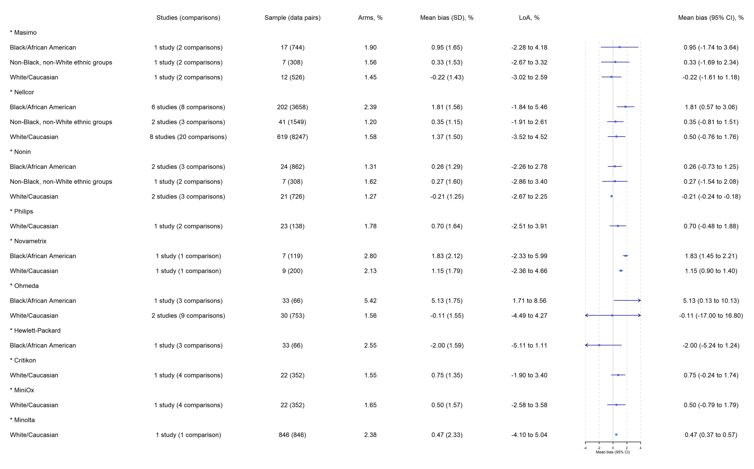

This figure presents the impact of ethnicity on pulse oximetry accuracy according to types of pulse oximeters evaluated. Results of analyses suggested that:
- Masimo, Nellcor, Novametrix, and Ohmeda appear to have higher SpO₂ measures than SaO₂ readings by on average 1% in people from Black/African American ethnic groups.
- Hewlett-Packard appears to obtain SpO₂ by 2% lower than SaO₂ readings in people with high skin pigmentation.
- Novametrix gives a SpO₂ measure higher than SaO₂ readings by on average 1% in people from White/Caucasian ethnic groups whilst others of these devices appear to produce SpO₂ measures with a bias no more than 1% compared with SaO₂ readings in White/Caucasians and those from ethnicity other than Black or White.
- Nonin does not result in over- or underestimation of oxygen saturation in people from any ethnic group.

