Additional File 1
Table 1: Candidate list of variables based on the Andersen’s framework for health service use
Factor Group | Variable Group | Variable
Predisposing characteristics | Sociodemographic | Age at enrolment, years
Predisposing characteristics | Sociodemographic | Gender
Predisposing characteristics | Sociodemographic | Male
Predisposing characteristics | Sociodemographic | Female
Predisposing characteristics | Sociodemographic | Ethnicity
Predisposing characteristics | Sociodemographic | Chinese
Predisposing characteristics | Sociodemographic | Malay
Predisposing characteristics | Sociodemographic | Indian
Predisposing characteristics | Sociodemographic | Others
Predisposing characteristics | Sociodemographic | Religion
Predisposing characteristics | Sociodemographic | Christianity (all denominations)
Predisposing characteristics | Sociodemographic | Buddhism
Predisposing characteristics | Sociodemographic | Taoism
Predisposing characteristics | Sociodemographic | Islam
Predisposing characteristics | Sociodemographic | Others
Predisposing characteristics | Sociodemographic | No religion
Predisposing characteristics | Sociodemographic | Missing
Predisposing characteristics | Sociodemographic | Marital status
Predisposing characteristics | Sociodemographic | Single
Predisposing characteristics | Sociodemographic | Married
Predisposing characteristics | Sociodemographic | Separated / Divorced
Predisposing characteristics | Sociodemographic | Widowed
Predisposing characteristics | Sociodemographic | Residential status
Predisposing characteristics | Sociodemographic | Singapore citizen
Predisposing characteristics | Sociodemographic | Permanent resident
Predisposing characteristics | Health Beliefs | At least one component of ACP¹ done at baseline
Predisposing characteristics | Health Beliefs | Yes
Predisposing characteristics | Health Beliefs | Preferred place of care at baseline
Predisposing characteristics | Health Beliefs | Hospital
Predisposing characteristics | Health Beliefs | Home
Predisposing characteristics | Health Beliefs | Others
Predisposing characteristics | Health Beliefs | Missing
Predisposing characteristics | Health Beliefs | ACP not done
Predisposing characteristics | Health Beliefs | Preferred place of death at baseline
Predisposing characteristics | Health Beliefs | Home
Predisposing characteristics | Health Beliefs | Hospice
Predisposing characteristics | Health Beliefs | Others
Predisposing characteristics | Health Beliefs | Missing
Predisposing characteristics | Health Beliefs | ACP not done
Predisposing characteristics | Health Beliefs | Preferred plan of care at baseline
Predisposing characteristics | Health Beliefs | Full active
Predisposing characteristics | Health Beliefs | Limited intervention
Predisposing characteristics | Health Beliefs | Comfort only
Predisposing characteristics | Health Beliefs | Missing
Predisposing characteristics | Health Beliefs | ACP not done
Predisposing characteristics | Health Beliefs | Patient awareness of diagnosis at baseline
Predisposing characteristics | Health Beliefs | No
Predisposing characteristics | Health Beliefs | Yes
Predisposing characteristics | Health Beliefs | Missing
Predisposing characteristics | Health Beliefs | Patient awareness of prognosis at baseline
Predisposing characteristics | Health Beliefs | No
Predisposing characteristics | Health Beliefs | Yes
Predisposing characteristics | Health Beliefs | Missing
Predisposing characteristics | Health Beliefs | Family awareness of diagnosis at baseline
Predisposing characteristics | Health Beliefs | No
Predisposing characteristics | Health Beliefs | Yes
Predisposing characteristics | Health Beliefs | Missing
Predisposing characteristics | Health Beliefs | Family awareness of prognosis at baseline
Predisposing characteristics | Health Beliefs | No
Predisposing characteristics | Health Beliefs | Yes
Predisposing characteristics | Health Beliefs | Missing
Enabling resources | Socioeconomic status | Housing value Index (HI)
Enabling resources | Socioeconomic status | HI-low (high subsidy)
Enabling resources | Socioeconomic status | HI-med (moderate subsidy)
Enabling resources | Socioeconomic status | HI-high (minimal or no subsidy)
Enabling resources | Socioeconomic status | Others (nursing home, sheltered homes, etc)
Enabling resources | Socioeconomic status | Medical subsidy means testing
Enabling resources | Socioeconomic status | 0% (no subsidy)
Enabling resources | Socioeconomic status | 1% - 25%
Enabling resources | Socioeconomic status | 26% – 50%
Enabling resources | Socioeconomic status | 51% – 80%
Enabling resources | Socioeconomic status | Not done
Enabling resources | Social Structure | Main caregiver
Enabling resources | Social Structure | Self
Enabling resources | Social Structure | Spouse
Enabling resources | Social Structure | Relatives (including children)
Enabling resources | Social Structure | Others
Enabling resources | Social Structure | Missing
Enabling resources | Social Structure | Primary decision maker
Enabling resources | Social Structure | Self
Enabling resources | Social Structure | Spouse
Enabling resources | Social Structure | Children
Enabling resources | Social Structure | Relatives
Enabling resources | Social Structure | Others
Enabling resources | Social Structure | Missing
Enabling resources | Social Structure | Living arrangement
Enabling resources | Social Structure | Alone
Enabling resources | Social Structure | With spouse only
Enabling resources | Social Structure | With children only
Enabling resources | Social Structure | With spouse and children
Enabling resources | Social Structure | With relatives
Enabling resources | Social Structure | Others
Enabling resources | Social Structure | Missing
Need factors for care | Symptom and Psychosocial Needs  (Time-varying variable) | Presence of U1 symptoms within 2 weeks²
Need factors for care | Symptom and Psychosocial Needs  (Time-varying variable) | Yes
Need factors for care | Symptom and Psychosocial Needs  (Time-varying variable) | No
Need factors for care | Symptom and Psychosocial Needs  (Time-varying variable) | Presence of P3 or P4 symptoms within 2 weeks³
Need factors for care | Symptom and Psychosocial Needs  (Time-varying variable) | Yes
Need factors for care | Symptom and Psychosocial Needs  (Time-varying variable) | No
Need factors for care | Clinical Characteristics | Primary cancer diagnosis
Need factors for care | Clinical Characteristics | Lip, oral cavity and pharynx
Need factors for care | Clinical Characteristics | Digestive organs
Need factors for care | Clinical Characteristics | Respiratory and intrathoracic
Need factors for care | Clinical Characteristics | Breast
Need factors for care | Clinical Characteristics | Female genital organs
Need factors for care | Clinical Characteristics | Male genital organs
Need factors for care | Clinical Characteristics | Urinary tract
Need factors for care | Clinical Characteristics | Lymphoid, hematopoietic, and related tissue
Need factors for care | Clinical Characteristics | Others
Need factors for care | Clinical Characteristics | Charlson Comorbidity Index (CCI) at enrolment
Need factors for care | Clinical Characteristics | ECOG⁴ at enrolment
Need factors for care | Clinical Characteristics | 0 – 2
Need factors for care | Clinical Characteristics | 3 – 4
Need factors for care | Clinical Characteristics | Not done
Need factors for care | Clinical Characteristics | Missing
¹ACP = Advance Care Plan (components are 1) Preferred place of care, 2) Preferred place of death, and 3) Preferred plan of care); ²U1 = Clinically unwell with acute unstable symptoms such as acute pain; ³P3 = Signs of inability to cope with rising psychological and spiritual distress; ³P4 = Acute psychological distress impacting patient care with possible indicators of neglect, abuse, or suicidal ideation; ⁴ECOG = Eastern Cooperative Oncology Group

Table 2: Preferred plan of care categories and definitions

Comfort measures only | Patient is to be treated with dignity and respect. Reasonable measures are made to offer food and fluids. Medications, oxygen, and other measures may be used as needed for comfort. Do not intubate. These measures may be used where the patient resides. Consider transfer only if comfort needs cannot be met in current location.
Limited interventions | Include care described above. To initiate limited trial of treatment. May include oral/intravenous medications. Continue with comfort measures if there is no clinical improvement. Do not use endotracheal intubation or long-term life support measures. May consider non-invasive ventilation support. Transfer to hospital if indicated. Avoid transfer to intensive care unit.
Full treatment | Includes care described above. May consider intubation, mechanical ventilation, and cardioversion. Management may include transfer to intensive care if indicated. These measures are subject to the assessment and decisions of the hospital care.

Table 3: Comparison of size, income ceiling for eligibility to purchase average price after subsidy of public housing and derived categories of Housing value Index (HI).

Apartment Type | Average Size (m²) | Income Ceiling (SGD/Month) | Average price after subsidy (SGD) | Housing value Index (HI) category
1 – 2 rooms | 33-45 | 1 500 | 43 000 | HI (low)
3 rooms | 65 | 4 000 – 8 000 | 132 000 | HI (med)
4 rooms | 90 | 12 000 – 18 000 | 270 000 | HI (med)
5 rooms | 110 | 12 000 – 18 000 | 396 000 | HI (high)
Executive | 130 | 12 000 – 18 000 | >396 000 | HI (high)
Private Housing | ~85 | Nil | 1 250 000 | HI (high)

Replicated with permission from Wong FY, Wong RX, Zhou S, Ong WS, Pek PP, Yap Y-S, et al. Effects of housing value and medical subsidy on treatment and outcomes of breast cancer patients in Singapore: A retrospective cohort study. Lancet Reg Health West Pac. 2021 Jan;6:100065.

Table 4a: Patient symptom categories
Category | Description
S0  Stable-stable | Asymptomatic with no other problems or outstanding issues
S1  (Stable – chair/bedbound)  Stable – appliance  Stable – poor social support | Dependent for activities of daily living (e.g. hemiplegia, paraplegia, quadriplegia)  Stable but with an appliance such as urinary catheter, stomas, nasogastric tube, drainage tubes, dressings for chronic wounds.  Living alone or all family working during the day
S2  Stable-active | Active disease. Symptoms controlled. Recently in unstable category.
U1  Unstable | Acute symptoms such as uncontrolled pain, anorexia, dehydration, nausea, vomiting, acute urinary retention and constipation  New onset confusion or delirium  High fever, especially on concurrent chemotherapy.  Uncontrolled dyspnea or new onset of dyspnea.  Acute onset of weakness  Recent fall  Any emotional, social crisis such as suicidal intent
U2  Deteriorating / Terminal | On Care of Dying pathway  High chance of dying in days or within a week

Table 4b: Patient psychosocial categories and definitions
Category | Description
P1  Stable | - Able to function and cope well in most biopsychosocial and spiritual (BPSS) aspects  - Good support system  - In control of BPSS and life’s issues
P2  Observe | - Able to function and cope well generally  - Some indicators of BPSS concerns that requires monitoring such as low mood, care concerns, financial concerns.
P3  Active | - Signs of inability to cope  - Distress arising from symptoms due to illness progression or health condition  - Signs of mental health, psychological and spiritual distress  - Presence of social stressors that affects coping  - Presence of ethical concerns and dilemmas that affect patient’s quality of life and care  - Presence of indicators that can affect bereavement
P4  Very active | - Acute psychosocial and spiritual distress arising from pain, symptoms, and psychosocial stressors  - Relationship conflict/stressors impacting immediate care and caregiver coping  - Indicators of neglect and abuse  - Suicide ideation

Table 5. Performance of the optimum model for the trajectories of the composite healthcare utilization measure
Trajectory group | Estimated group size by model, % | No. of patients classified into group | % of patients classified into group | Average posterior probabilities of group membership
1 | 31.9 | 551 | 35.1 | 0.83
2 | 44.1 | 664 | 42.2 | 0.88
3 | 24.0 | 357 | 22.7 | 0.90
Total | 100.0 | 1572 | 100.0

Figure 1: Trajectories of emergency department (ED) visits using group-based trajectory modelling. Best-fit model based on (A) monthly time-unit, (B) thrice-weekly time-unit, (C) bi-weekly time-unit and (D) weekly time-unit, and (E) the optimum model is the model with bi-weekly time-unit based on trade-off comparison between cohort size and Bayesian Information Criterion (BIC).
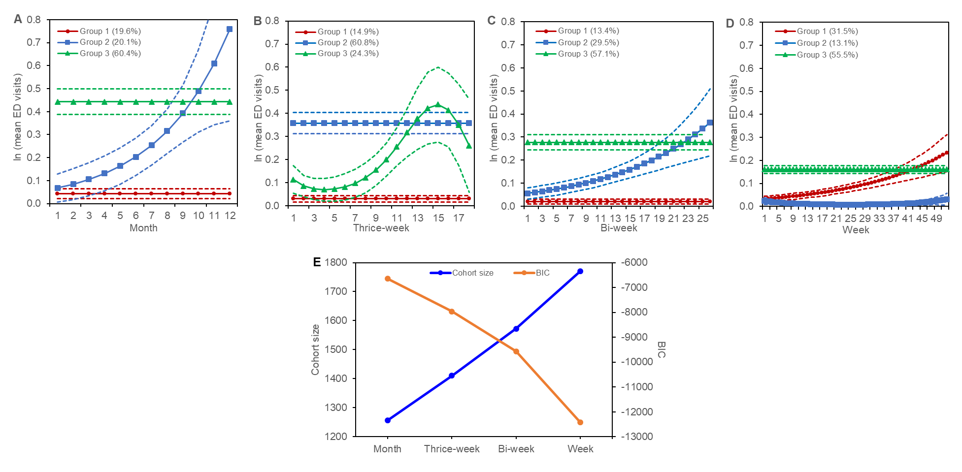

Figure 2: Trajectories of outpatient visits using group-based trajectory modelling. Best-fit model based on (A) monthly time-unit, (B) thrice-weekly time-unit, (C) bi-weekly time-unit and (D) weekly time-unit, and (E) the optimum model is the model with bi-weekly time-unit based on trade-off comparison between cohort size and Bayesian Information Criterion (BIC).
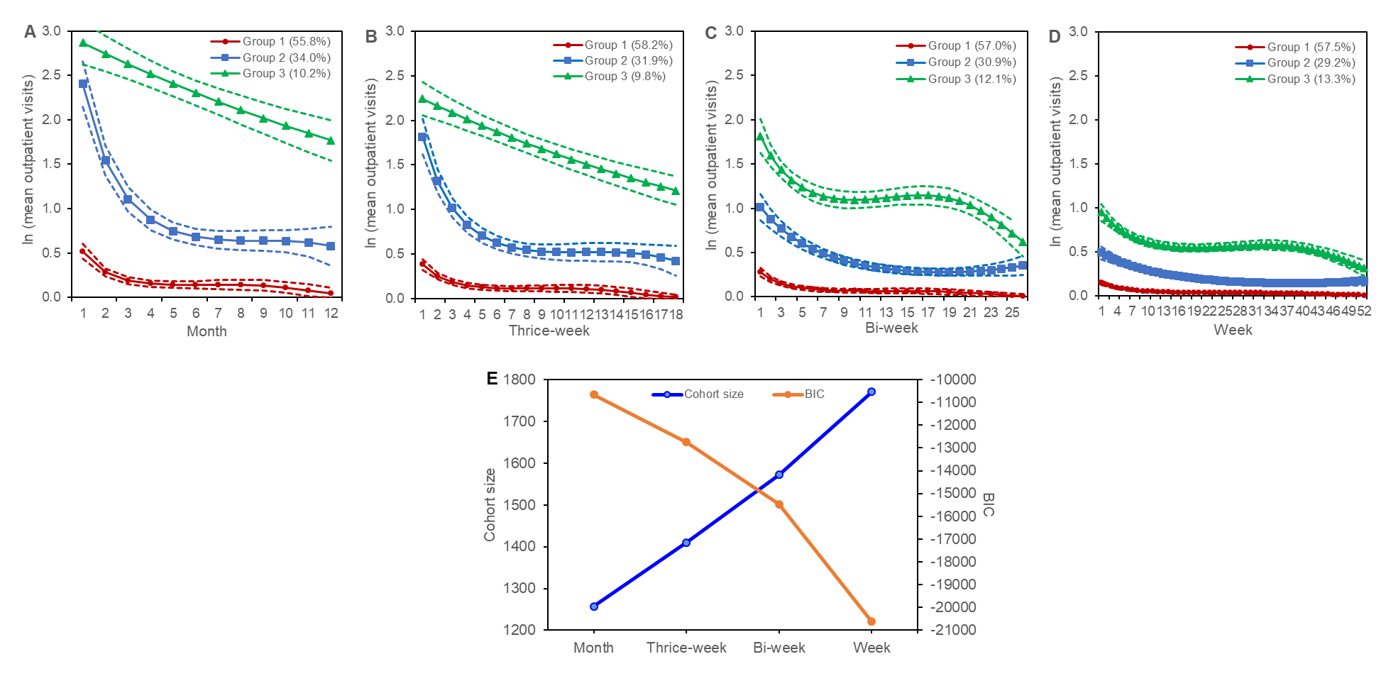

Figure 3: Trajectories of hospitalizations using group-based trajectory modelling. Best-fit model based on (A) monthly time-unit, (B) thrice-weekly time-unit, (C) bi-weekly time-unit and (D) weekly time-unit, and (E) the optimum model is the model with bi-weekly time-unit based on trade-off comparison between cohort size and Bayesian Information Criterion (BIC).
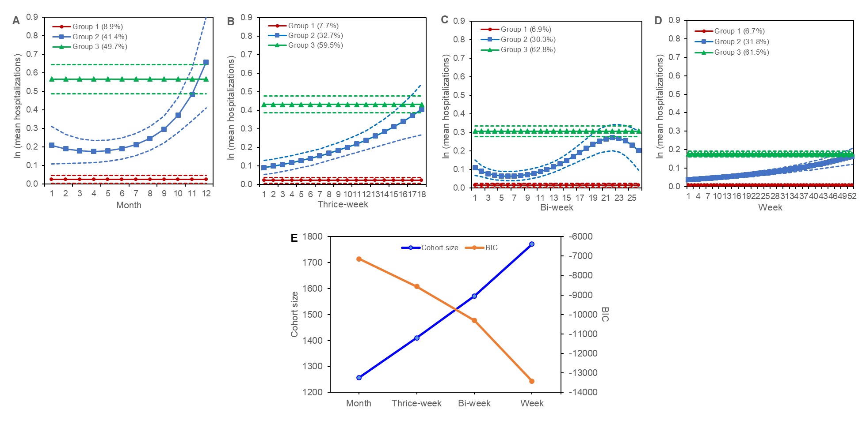

Supplementary Information on Group-based trajectory modelling (GBTM) and Group-based multi-trajectory modelling (GBMTM) Analyses

GBTM is an application of finite mixture modelling in which maximum likelihood estimation is used to identify latent subgroups of individuals who follow similar trajectories for a variable over time.¹ We applied GBTM to determine trajectories for the number of emergency department (ED) visits, hospitalizations and outpatient visits individually, with extensions to account for non-random patient attrition due to death.² This means that the trajectories of each of these measures is modelled jointly with the probability of dying, and the estimated probability of each trajectory group by the model is the estimated size of the group at baseline.
We used Poisson distribution to model each measure with time as an independent variable. We examined four time-units viz. weekly, bi-weekly, thrice-weekly and monthly, as we hypothesized that relevant changes in health service usage over the 1-year study period would occur over weeks rather than days. For each time-unit analysis, we excluded patients who passed away within the first time-unit interval. The shape of each trajectory group in GBTM is specified by a polynomial function of time-unit. To determine the optimum number of groups and trajectory shape of each group, we fitted all possible models for 2-3 groups with the order of polynomial for the time variable varied between 0 and 3. We kept the number of groups to 3, as models fitted with 4 groups showed extensive overlapping between some of the fitted trajectory groups and there were frequently less than 5% of patients estimated for the smallest group. We kept the maximum polynomial order to 3 as this order has been suggested to be sufficiently flexible to capture meaningful changes when modelling about 12-15 months of data.³ Among fitted models with statistical significant trajectory shape for all the groups in the model, we selected the one with the highest Bayesian Information Criteria (BIC) as the best fit model for the time-unit. To determine the optimum model for each healthcare utilization measure, we compared the cohort size and BIC between the best fit model of the 4 time-units and identified the time-unit that provided a balance between information loss and goodness of model fit.
GBMTM is a generalization of GBTM in that it identifies latent clusters of individuals following similar trajectories across multiple variables of an outcome of interest.⁴ We applied GBMTM to identify distinct trajectories for the composite outcome of the number of ED, hospitalizations, and outpatient visits. Based on the narrowest time-unit interval and the highest number of groups across the optimum GBTM model of the 3 measures, we fit all possible models with a maximum polynomial order of 3 using GBMTM. Following a similar approach as the GBTM analyses, we selected the model with the highest BIC as the optimum GBMTM model for the composite outcome measure. We classified patients into one of the trajectory groups in the optimum GBMTM model based on the maximum posterior probability assignment rule. We assessed the performance of the optimum GBMTM model using these criteria: 1) close correspondence between model’s estimated group size and actual percentage of patients classified into each group, 2) high (>0.7) average posterior probabilities of group membership, 3) enough patients (>5% in proportion) classified in each group, and 4) reasonably narrow confidence band for each group.

1. Nagin DS. Group-Based Modeling of Development. Harvard University Press; 2005.
2. Haviland AM, Jones BL, Nagin DS. Group-based Trajectory Modeling Extended to Account for Nonrandom Participant Attrition. Sociological Methods & Research. 2011;40(2):367-390. doi:10.1177/0049124111400041
3. Franklin JM, Shrank WH, Pakes J, et al. Group-based trajectory models: a new approach to classifying and predicting long-term medication adherence. Med Care. 2013;51(9):789-796. doi:10.1097/MLR.0b013e3182984c1f
4. Nagin DS, Jones BL, Passos VL, Tremblay RE. Group-based multi-trajectory modeling. Stat Methods Med Res. 2018;27(7):2015-2023. doi:10.1177/0962280216673085

