additional file: Supplemental Methods:
Search strategies and number of studies yielded from each database.
Pubmed: 3378 Results
((immunotherapy [Title/Abstract]) OR (PD-1 inhibitor [Title/Abstract]) OR (PD-L1 inhibitor [Title/Abstract]) OR (programmed death 1 inhibitor [Title/Abstract]) OR (programmed death ligand 1 inhibitor [Title/Abstract]) OR (CTLA-4 inhibitor [Title/Abstract]) OR (cytotoxic T-lymphocyte antigen 4 inhibitor [Title/Abstract])) AND (((early lung cancer [Title/Abstract]) OR (early stage of lung cancer [Title/Abstract])) OR ((advanced lung cancer [Title/Abstract]) OR (Late stage lung cancer [Title/Abstract]))) AND ((Randomized Controlled Trial [Title/Abstract]) OR (clinical trial [Title/Abstract]) OR (RCT [Title/Abstract]))
Cochrane: 989 Results
('non small cell lung cancer'/exp OR 'early lung cancer':ab,ti OR 'early stage of lung cancer':ab,ti OR 'advanced lung cancer':ab,ti OR 'Late stage lung cancer':ab,ti) AND ('immunotherapy'/exp OR 'pd-1 inhibitor':ab,ti OR 'pd-l1 inhibitor':ab,ti OR 'programmed death 1 inhibitor':ab,ti OR 'programmed death ligand 1 inhibitor':ab,ti OR 'CTLA-4 inhibitor':ab,ti OR 'cytotoxic T-lymphocyte antigen 4 inhibitor':ab,ti) AND (Randomized Controlled Trial/exp OR clinical trial:ab,ti OR RCT:ab,ti)
Embase: 400 Results
#1 'immunotherapy' OR 'pd 1 inhibitor' OR 'pd-l1 inhibitor' OR 'programmed death 1 inhibitor' OR 'programmed death ligand 1 inhibitor' OR 'ctla-4 inhibitor' OR 'cytotoxic t-lymphocyte antigen 4 inhibitor'
#2 'early lung cancer' OR 'early stage of lung cancer' OR 'advanced lung cancer' OR 'late stage lung cancer'
#3 'Randomized Controlled Trial' OR 'clinical trial' OR 'RCT'
#4 #1 AND #2 AND #3

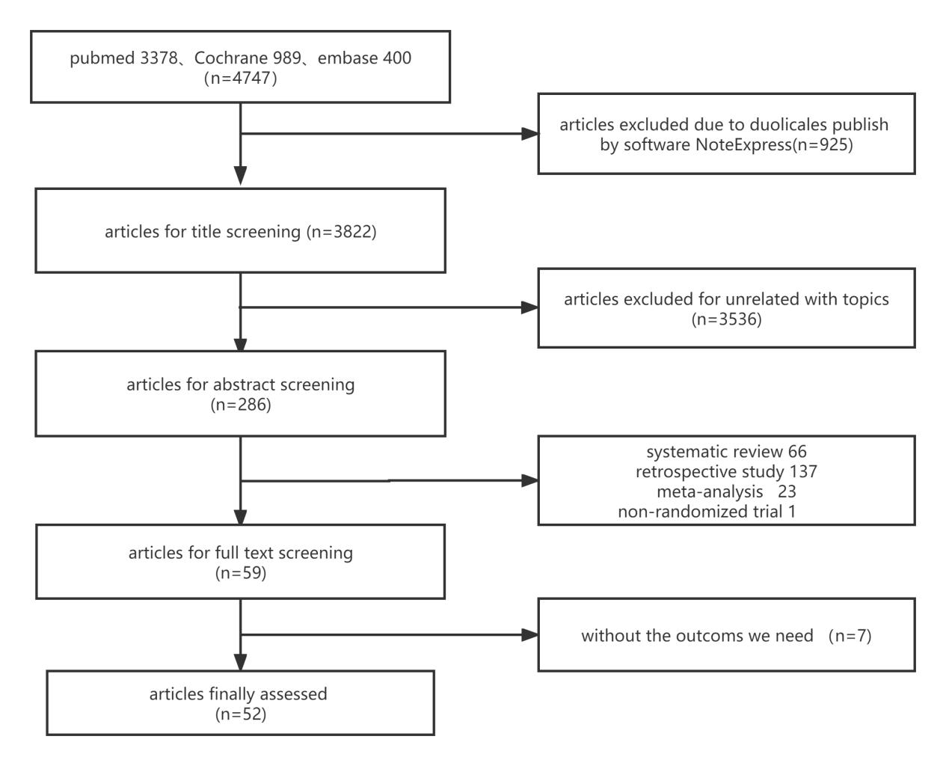
Additional file: Fig. S1: A selection flowchart for the searched articles.

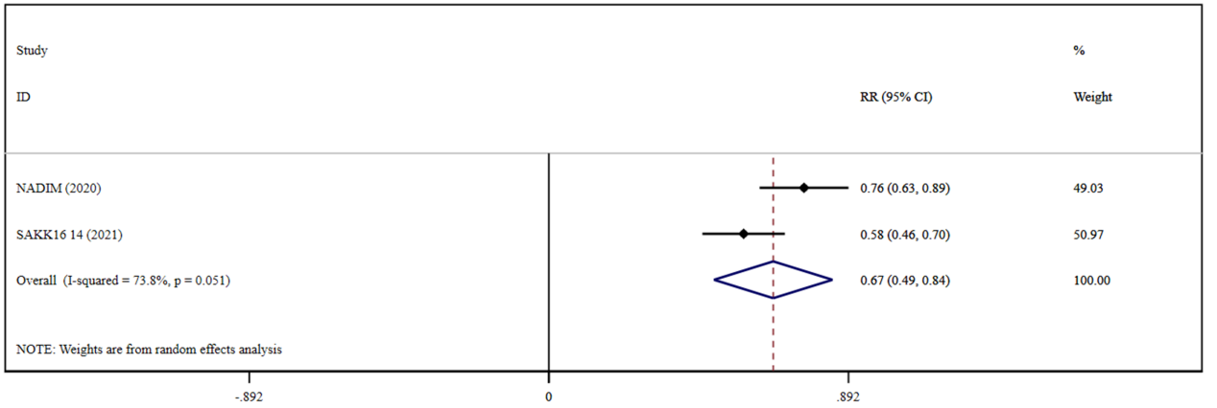
Additional file: Fig. S2: Forest plots presenting pooled ORR risk ratio analysis in early-stage lung cancer for the cohort of immunotherapy combined with chemotherapy.

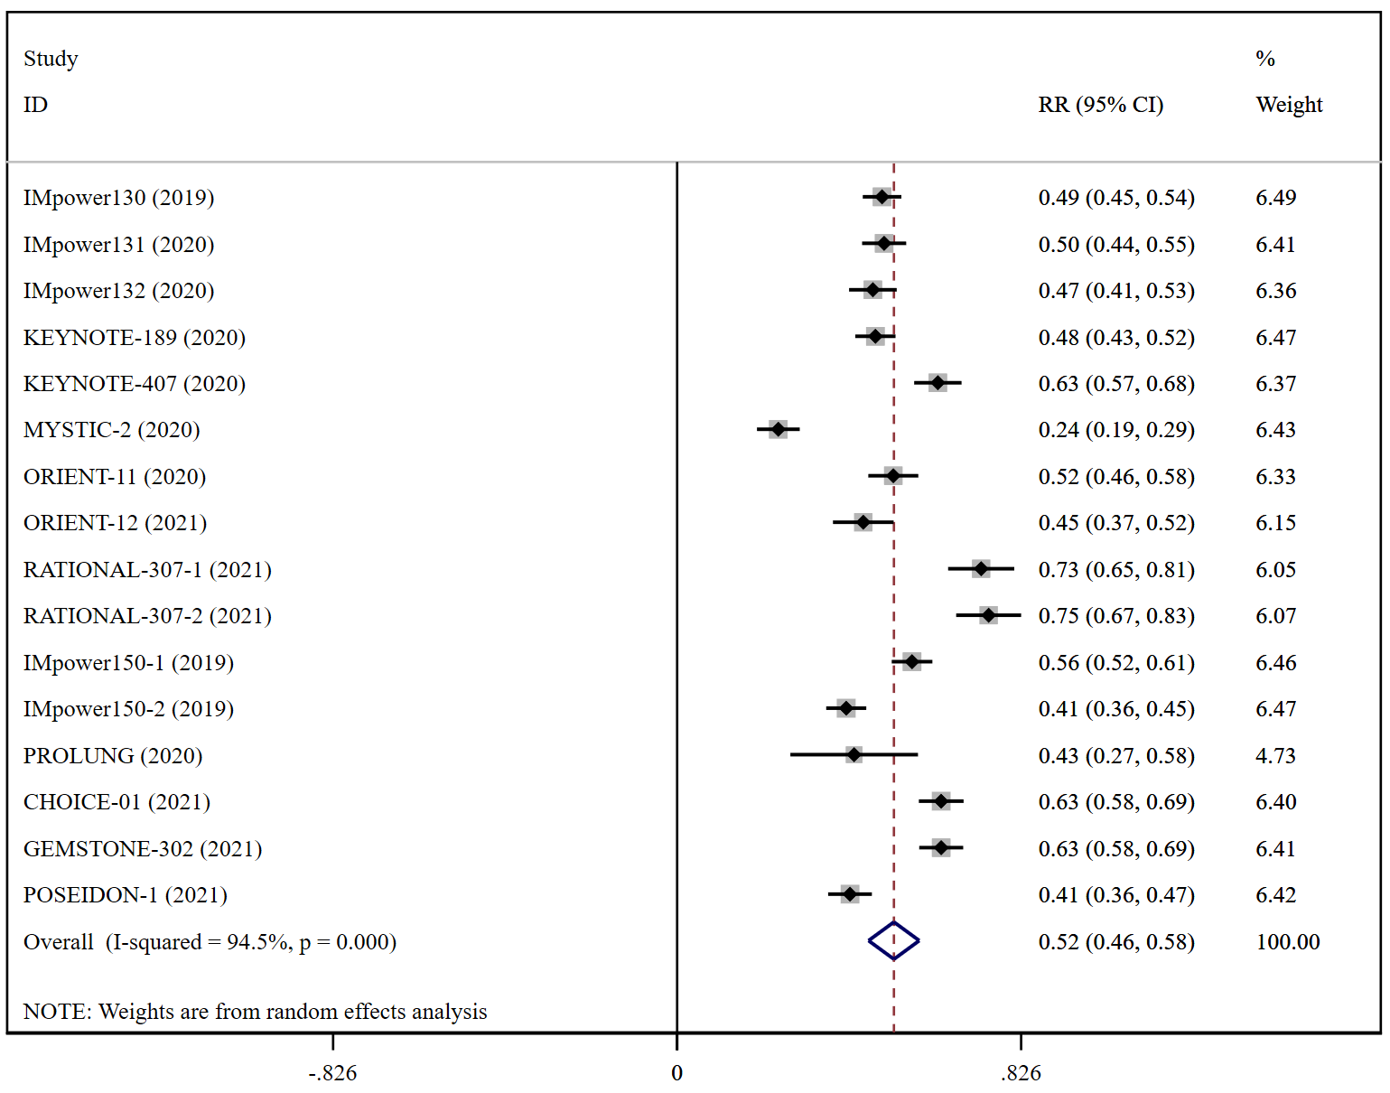
Additional file: Fig. S3: Forest plots presenting pooled ORR risk ratio analysis in advanced lung cancer for the cohort of immunotherapy combined with chemotherapy.

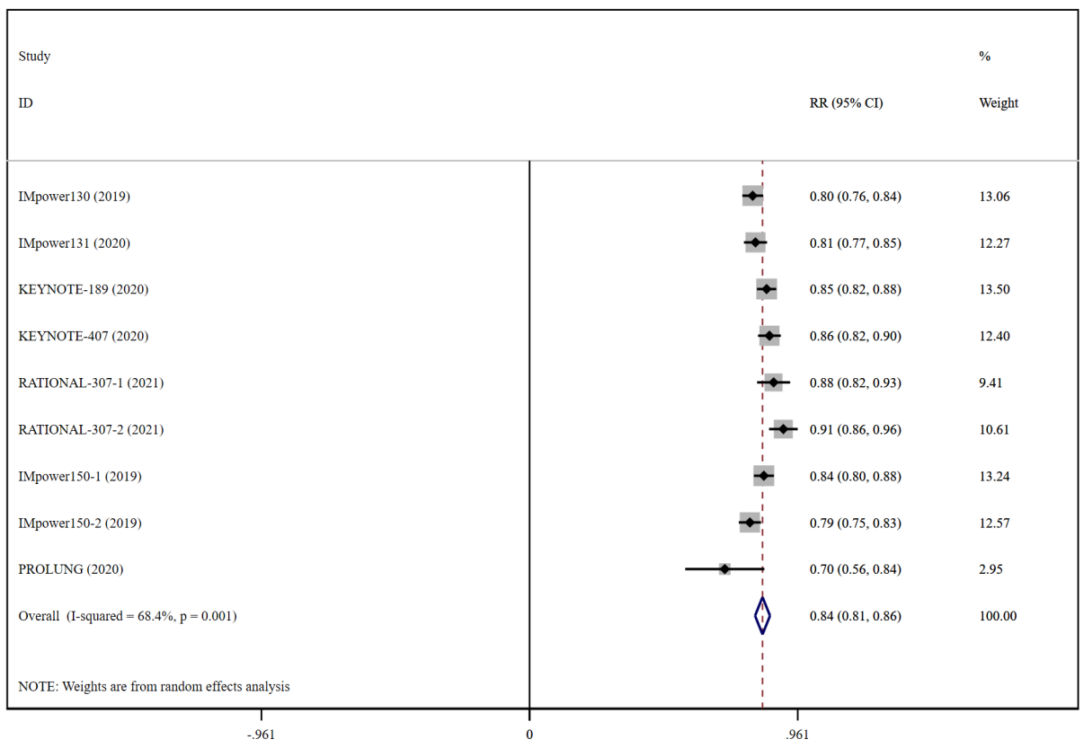
Additional file: Fig. S4: Forest plots presenting pooled DCR risk ratio analysis in advanced lung cancer for the cohort of immunotherapy combined with chemotherapy.

