Supplemental material

Psoriasis and cardiovascular disease risk in European and East Asian populations: evidence from meta-analysis and Mendelian randomization analysis

Supplementary Table 1. Search strategy of psoriasis and coronary artery disease
Database | Search Terms
PubMed | ((psoriasis[Title/Abstract]) AND (coronary artery disease*[Title/Abstract] OR ischaemic heart disease*[Title/Abstract]) AND (("1966/1/1"[Date - Publication] : "2021/12/31"[Date - Publication]))
Web of Science | (TS=(psoriasis)) AND TS=(coronary artery disease* or ischaemic heart disease*) by 1960-2021
Embase | #1 psoriasis:ab,ti AND 'coronary artery disease':ab,ti AND [<1966-2021]/py  #2 psoriasis:ab,ti AND 'ischaemic heart disease':ab,ti AND [<1966-2021]/py  #3 #1 OR #2
Google Scholar | "psoriasis" AND "coronary artery disease" or "ischaemic heart disease"
Cochrane Library | #1 (psoriasis):ti,ab,kw AND (coronary artery disease):ti,ab,kw with Publication Year to 2021, in Trials (Word variations have been searched)  #2 (psoriasis):ti,ab,kw AND (ischaemic heart disease):ti,ab,kw with Publication Year to 2021, in Trials (Word variations have been searched)  #3 #1 OR #2

Supplementary Table 2. Characteristics and methodological quality of the qualified studies of the 3 meta-analyses
Study | Country | Prevalence of CAD (n/N) |  |  | Prevalence of MI (n/N) |  |  | Prevalence of HF (n/N) |  |  | NOS  score
Study | Country | Psoriasis cases | Controls |  | Psoriasis cases | Controls |  | Psoriasis cases | Controls |  | NOS  score
Sommer DM, et al (2006)¹ | Germany | 32/581 | 38/1044 |  |  |  |  |  |  |  | 7
Ludwig RJ, et al (2007)² | Germany | 19/32 | 9/32 |  |  |  |  |  |  |  | 7
Dowlatshahi EA, et al (2013)³ | Netherlands | 14/259 | 536/7931 |  |  |  |  | 20/259 | 1091/7931 |  | 6
Hjuler KF, et al (2015)⁴ | Denmark | 16/58 | 5/33 |  |  |  |  |  |  |  | 7
Mahiques-Santos L, et al (2015)⁵ | Spain | 417/9181 | 450/21925 |  |  |  |  |  |  |  | 6
Shiba M, et al (2016)⁶ | Japan | 108/1197 | 5059/111868 |  |  |  |  |  |  |  | 6
Yan C, et al (2019)⁷ | China | 20/322 | 12/297 |  |  |  |  |  |  |  | 7
Tinggaard AB, et al (2021)⁸ | Denmark | 232/1192 | 6238/38598 |  |  |  |  |  |  |  | 7
Yang YW, et al (2011)⁹ | China | 27/1685 | 52/5055
Wakkee M, et al (2009)¹⁰ | Dutch |  |  |  | 37/15820 | 65/27577 |  |  |  |  | 7
Xiao J, et al (2009)¹¹ | China |  |  |  | 215/3092 | 45/1521 |  |  |  |  | 7
Brauchli YB, et al (2009)¹² | UK |  |  |  | 238/36702 | 211/36702 |  |  |  |  | 7
Schmitt J, et al (2010)¹³ | Germany |  |  |  | 73/3147 | 64/3147 |  |  |  |  | 7
Lin HW, et al (2011)¹⁴ | China |  |  |  | 22/4752 | 48/23760 |  |  |  |  | 7
Yeung H, et al (2013)¹⁵ | UK |  |  |  | 95/9035 | 693/90350 |  | 34/9035 | 303/90350 |  | 7
Koch M, et al (2015)¹⁶ | Germany |  |  |  | 11/199 | 101/3986 |  |  |  |  | 7
Jung KJ, et al (2019)¹⁷ | Korea |  |  |  | 75/99875 | 16369/29962276 |  |  |  |  | 6
Shiba M, et al (2019)¹⁸ | Japan |  |  |  | 32/1197 | 934/111868 |  |  |  |  | 6
Ahlehoff O, et al (2010)¹⁹ | Denmark |  |  |  |  |  |  | 39/36992 | 6842/4003265 |  | 6
Yang YW, et al (2011)²⁰ | China |  |  |  |  |  |  | 76/1685 | 140/5055 |  | 7
Khalid U, et al (2014)²¹ | Denmark |  |  |  |  |  |  | 286/66389 | 15169/5376842 |  | 6
Parisi R, et al (2015)²² | UK |  |  |  |  |  |  | 719/48523 | 2733/208187 |  | 6
CAD coronary artery disease, MI myocardial infarction, HF heart failure, NOS Newcastle-Ottawa Scale, UK United Kingdom. n: the number of CAD/MI/HF patients in psoriasis patients or controls. N: the number of all psoriasis patients or all controls investigated.
Supplemental Table 3 SNPs (p < 5 X 10⁻⁸) associated with psoriasis of European ancestry were previous reported
SNP | Beta | SE | P
rs10789285^{ref23} | 0.113 | 0.019 | 3.00E-09
rs10865331^{ref25} | 0.113 | 0.018 | 5.00E-10
rs11053802^{ref24} | 0.104 | 0.018 | 4.00E-09
rs118086960^{ref24} | 0.113 | 0.02 | 7.00E-09
rs12118303^{ref24} | 0.113 | 0.018 | 3.00E-10
rs240993^{ref18} | 0.223 | 0.024 | 5.00E-20
rs2700987^{ref25} | 0.104 | 0.018 | 4.00E-09
rs28512356^{ref22} | 0.157 | 0.029 | 4.00E-08
rs28998802^{ref25} | 0.199 | 0.024 | 3.00E-16
rs41298997^{ref24} | 0.122 | 0.022 | 2.00E-08
rs4685408^{ref23} | 0.113 | 0.015 | 7.00E-14
rs702873^{ref18} | 0.113 | 0.019 | 4.00E-09
rs7637230^{ref23} | 0.131 | 0.021 | 2.00E-10
rs76959677^{ref24} | 0.247 | 0.045 | 3.00E-08
rs9504361^{ref25} | 0.113 | 0.017 | 2.00E-11
rs9513593^{ref24} | 0.113 | 0.021 | 4.00E-08
rs9533962^{ref22} | 0.113 | 0.017 | 8.00E-11
rs9988642^{ref25} | 0.419 | 0.039 | 1.00E-26
rs2395029^{ref16} | 1.411 | 0.133 | 2.00E-26
rs2201841^{ref17} | 0.122 | 0.022 | 3.00E-08
rs2066808^{ref17} | 0.293 | 0.048 | 1.00E-09
rs4112788^{ref18} | 0.255 | 0.04 | 3.00E-10
rs10484554^{ref18} | 1.539 | 0.049 | 4.00E-214
rs2546890^{ref20} | 0.432 | 0.046 | 1.00E-20
rs1047781^{ref21} | 0.168 | 0.031 | 4.00E-08
rs34394770^{ref22} | 0.148 | 0.027 | 3.00E-08
rs8128234^{ref22} | 0.157 | 0.029 | 4.00E-08
rs114934997^{ref23} | 0.157 | 0.027 | 6.00E-09
rs2675662^{ref23} | 0.113 | 0.015 | 2.00E-14
rs11059675^{ref24} | 0.095 | 0.017 | 2.00E-08
rs11065979^{ref24} | 0.077 | 0.014 | 2.00E-08
rs28624578^{ref24} | 0.166 | 0.027 | 9.00E-10
rs2944542^{ref24} | 0.077 | 0.014 | 2.00E-08
rs34517439^{ref24} | 0.166 | 0.028 | 4.00E-09
rs492602^{ref24} | 0.104 | 0.015 | 7.00E-13
rs559406^{ref24} | 0.095 | 0.015 | 1.00E-10
rs61871342^{ref24} | 0.095 | 0.016 | 2.00E-09
rs10979182^{ref25} | 0.113 | 0.02 | 2.00E-08
rs3802826^{ref25} | 0.113 | 0.019 | 1.00E-09
rs545979^{ref25} | 0.113 | 0.018 | 4.00E-10
rs963986^{ref25} | 0.14 | 0.024 | 5.00E-09

Supplemental Table 3 continued
SNP | Beta | SE | P
rs11795343^{ref25} | 0.104 | 0.016 | 8.00E-11
rs12720356^{ref25} | 0.223 | 0.035 | 3.00E-10
rs4561177^{ref25} | 0.131 | 0.018 | 8.00E-13
rs8016947^{ref25} | 0.148 | 0.018 | 3.00E-17
rs1056198^{ref25} | 0.148 | 0.019 | 2.00E-14
rs12445568^{ref25} | 0.148 | 0.018 | 1.00E-16
rs1295685^{ref25} | 0.166 | 0.026 | 3.00E-10
rs2066819^{ref25} | 0.329 | 0.039 | 5.00E-17
rs2111485^{ref25} | 0.131 | 0.024 | 3.00E-08
rs4821124^{ref25} | 0.122 | 0.022 | 4.00E-08
rs62149416^{ref25} | 0.157 | 0.018 | 2.00E-17
rs2082412^{ref17} | 0.365 | 0.033 | 2.00E-28
rs12191877^{ref17} | 0.971 | 0.046 | 1.00E-100
rs20541^{ref17} | 0.239 | 0.031 | 5.00E-15
rs610604^{ref17} | 0.174 | 0.026 | 9.00E-12
rs280519^{ref18} | 0.122 | 0.021 | 4.00E-09
rs3213094^{ref18} | 0.329 | 0.05 | 5.00E-11
rs458017^{ref18} | 0.315 | 0.038 | 2.00E-16
rs27524^{ref18} | 0.122 | 0.018 | 3.00E-11
rs10782001^{ref19} | 0.148 | 0.024 | 9.00E-10
rs12586317^{ref19} | 0.14 | 0.025 | 2.00E-08
rs4795067^{ref19} | 0.174 | 0.026 | 4.00E-11
rs465969^{ref21} | 0.339 | 0.05 | 8.00E-12
rs495337^{ref21} | 0.176 | 0.03 | 3.00E-09
rs12564022^{ref22} | 0.157 | 0.026 | 2.00E-09
rs1990760^{ref22} | 0.166 | 0.029 | 1.00E-08
rs17728338^{ref22} | 0.47 | 0.051 | 6.00E-20
rs2066807^{ref22} | 0.336 | 0.049 | 5.00E-12
rs2853694^{ref22} | 0.207 | 0.033 | 5.00E-10
rs3747517^{ref22} | 0.262 | 0.03 | 1.00E-18
rs4845459^{ref22} | 0.239 | 0.029 | 5.00E-17
rs4921493^{ref22} | 0.207 | 0.029 | 7.00E-13
rs643177^{ref22} | 0.223 | 0.033 | 9.00E-12
rs6590334^{ref22} | 0.131 | 0.022 | 2.00E-09
rs7709212^{ref22} | 0.322 | 0.028 | 2.00E-30
rs842625^{ref22} | 0.148 | 0.023 | 2.00E-10
rs55823223^{ref24} | 0.14 | 0.024 | 1.00E-08
rs11121129^{ref25} | 0.122 | 0.022 | 2.00E-08
rs11652075^{ref25} | 0.104 | 0.019 | 3.00E-08
rs2451258^{ref25} | 0.113 | 0.02 | 3.00E-08
rs367569^{ref25} | 0.122 | 0.022 | 5.00E-08
rs892085^{ref25} | 0.157 | 0.019 | 3.00E-17
Supplemental Table 3 continued
SNP | Beta | SE | P
rs17716942^{ref25} | 0.239 | 0.027 | 3.00E-18
rs2233278^{ref25} | 0.464 | 0.034 | 2.00E-42
rs582757^{ref25} | 0.207 | 0.02 | 2.00E-25
rs7536201^{ref25} | 0.122 | 0.017 | 2.00E-12
rs12188300^{ref25} | 0.457 | 0.03 | 3.00E-53
rs13437088^{ref25} | 0.278 | 0.021 | 3.00E-40
rs27432^{ref25} | 0.182 | 0.02 | 2.00E-20
rs2910686^{ref25} | 0.113 | 0.02 | 2.00E-08
rs33980500^{ref25} | 0.419 | 0.03 | 4.00E-45
rs34536443^{ref25} | 0.631 | 0.055 | 9.00E-31
rs4379175^{ref25} | 0.27 | 0.02 | 9.00E-40
rs4406273^{ref25} | 1.463 | 0 | 5.00E-723
rs6677595^{ref25} | 0.231 | 0.019 | 2.00E-33
rs7552167^{ref25} | 0.191 | 0.028 | 9.00E-12
SNP single nucleotide polymorphism.

Supplemental Table 4 The pleiotropic psoriasis-associated SNPs with cardiometabolic traits in European ancestry
SNP | Trait | p value
rs2395029 | Total cholesterol | 2.46E-05
 | Heart failure | 1.09E-04
rs2082412 | Body mass index | 1.64E-04
rs12191877 | Total cholesterol | 1.47E-04
rs2066808 | Coronary artery disease | 1.85E-04
rs3213094 | Body mass index | 8.64E-05
rs458017 | HDL cholesterol | 3.50E-04
rs10484554 | HDL cholesterol | 1.01E-04
rs27524 | Body mass index | 3.20E-11
 | Obesity | 1.08E-04
rs10782001 | Body mass index | 3.20E-11
 | Diastolic blood pressure | 1.38E-08
rs12586317 | Glycated haemoglobin | 5.15E-05
rs4795067 | Diastolic blood pressure | 4.93E-04
rs2546890 | Body mass index | 3.07E-06
rs1047781 | Type 2 diabetes | 6.20E-06
rs465969 | HDL cholesterol | 5.90E-07
rs1990760 | Coronary artery disease | 4.40E-07
rs2066807 | Coronary artery disease | 1.57E-04
 | HbA1C | 2.90E-08
rs2853694 | Systolic blood pressure | 2.20E-04
rs34394770 | HbA1C | 1.20E-05
rs3747517 | HDL cholesterol | 7.26E-06
rs6590334 | Coronary artery disease | 3.10E-04
 | Myocardial infarction | 3.00E-04
rs7709212 | Body mass index | 2.77E-06
rs8128234 | Diastolic blood pressure | 3.97E-08
 | Systolic blood pressure | 2.03E-05
rs2675662 | Atrial fibrillation | 1.20E-06
 | Diastolic blood pressure | 2.11E-08
 | Type 2 diabetes | 4.91E-07
rs11059675 | Body mass index | 1.10E-08
 | Diastolic blood pressure | 4.03E-05
rs11065979 | Body mass index | 1.40E-06
 | Cardiovascular diseases | 1.32E-08
rs28624578 | HDL cholesterol | 3.51E-07
rs2944542 | Body mass index | 4.60E-04
rs34517439 | Body mass index | 3.60E-37
 | Diastolic blood pressure | 2.02E-19

Supplemental Table 4 continued
SNP | Trait | p value
rs492602 | Diastolic blood pressure | 9.10E-06
rs55823223 | Body mass index | 3.10E-08
 | Diastolic blood pressure | 1.13E-09
 | Type 2 diabetes | 1.63E-04
rs559406 | Body mass index | 2.60E-04
rs61871342 | Diabetes diagnosed by doctor | 2.50E-08
rs11121129 | Cholesterol | 8.00E-05
rs2451258 | HDL cholesterol | 1.78E-05
rs367569 | Cholesterol | 2.28E-05
rs545979 | Coronary artery disease | 8.60E-05
 | Diastolic blood pressure | 9.27E-10
rs892085 | Body mass index | 2.80E-05
 | Ischemic stroke | 8.43E-05
 | Coronary artery disease | 1.39E-04
rs963986 | HDL cholesterol | 7.33E-08
rs11795343 | HDL cholesterol | 4.29E-05
 | Type 2 diabetes | 1.31E-04
rs12720356 | Body mass index | 3.20E-04
rs17716942 | Coronary artery disease | 4.79E-05
rs4561177 | HDL cholesterol | 1.90E-06
rs8016947 | Body mass index | 8.53E-05
rs12445568 | Body mass index | 5.00E-12
rs13437088 | Cholesterol | 3.08E-19
rs2066819 | Coronary artery disease | 1.42E-04
rs2111485 | Coronary artery disease | 2.41E-07
rs27432 | Body mass index | 1.70E-05
rs2910686 | Coronary artery disease | 5.45E-05
 | Diastolic blood pressure | 1.51E-12
rs34536443 | Cholesterol | 2.74E-04
rs4379175 | Body mass index | 3.23E-05
rs4406273 | Cholesterol | 7.55E-10
rs4821124 | Cholesterol | 1.08E-14
rs7552167 | Triglycerides | 7.12E-06
SNP single nucleotide polymorphism, HDL high-density lipoprotein, HbA1C glycosylated hemoglobin.
Supplemental Table 5 Heterogeneity and pleiotropy analysis of the psoriasis on CAD, MI and HF risk.
Trait | MR Method | MR Result in Europeans |  |  |  |  | MR Result in East Asian
Trait | MR Method | Cochran Q statistic | Heterogeneity  p value | Intercept | Intercept p value |  | Cochran Q statistic | Heterogeneity  p value | Intercept | Intercept p value
CAD | Inverse variance weighted | 4.66 | 0.990 | 0.0006 | 0.896 |  | 10.02 | 0.528 | 0.054 | 0.049
CAD | MR Egger | 4.64 | 0.982 |  |  |  | 4.65 | 0.913
MI | Inverse variance weighted | 11.19 | 0.798 | 0.003 | 0.699 |  | 8.22 | 0.768 | 0.009 | 0.255
MI | MR Egger | 11.03 | 0.750 |  |  |  | 6.77 | 0.818
HF | Inverse variance weighted | 22.16 | 0.138 | 0.003 | 0.731 |  | 10.36 | 0.584 | 0.003 | 0.718
HF | MR Egger | 21.98 | 0.108 |  |  |  | 10.22 | 0.510
MR Mendelian randomization, CAD coronary artery disease, MI myocardial infarction, HF heart failure.

Supplemental Table 6 SNPs (p < 5 X 10⁻⁸) associated with psoriasis of East Asian ancestry were previous reported
SNP | Beta | SE | P
rs1050414^{ref30} | 1.161 | 0.155 | 6.00E-14
rs11544355^{ref29} | -1.772 | 0.272 | 7.00E-11
rs12884468^{ref28} | -0.128 | 0.022 | 1.00E-08
rs143700362^{ref29} | -3.507 | 0.391 | 3.00E-19
rs144706178^{ref29} | -2.207 | 0.278 | 2.00E-15
rs149442660^{ref29} | -3.219 | 0.468 | 6.00E-12
rs149798287^{ref29} | -0.994 | 0.173 | 1.00E-08
rs2233278^{ref27} | 0.673 | 0.108 | 4.00E-10
rs2276405^{ref28} | -0.186 | 0.031 | 3.00E-09
rs249038^{ref28} | -0.174 | 0.031 | 2.00E-08
rs2778031^{ref28} | -0.186 | 0.015 | 1.00E-36
rs2781377^{ref28} | -0.163 | 0.025 | 4.00E-11
rs41268474^{ref28} | 0.157 | 0.024 | 6.00E-11
rs4141001^{ref28} | -0.151 | 0.022 | 2.00E-11
rs5063^{ref28} | -0.163 | 0.028 | 3.51E-09
rs6444895^{ref28} | 0.104 | 0.015 | 1.00E-12
rs72933970^{ref28} | 0.148 | 0.026 | 1.00E-08
rs9808753^{ref28} | -0.083 | 0.015 | 3.00E-08
rs671^{ref28} | 0.145 | 0.018 | 1.00E-15
rs1042636^{ref28} | 0.094 | 0.015 | 2.00E-10
rs1265181^{ref26} | 3.119 | 0 | 2.00E-208
rs76337351^{ref28} | 0.186 | 0.033 | 2.00E-08
rs12602912^{ref28} | 0.081 | 0.014 | 2.00E-08
rs3213094^{ref26} | 0.247 | 0.023 | 3.00E-26
rs610037^{ref28} | 0.104 | 0.016 | 4.00E-11
rs10036748^{ref28} | 0.095 | 0.016 | 4.00E-09
rs1473247^{ref28} | 0.131 | 0.02 | 6.00E-11
rs9394026^{ref27} | 0.621 | 0.08 | 7.00E-15
rs4085613^{ref26} | 0.278 | 0.024 | 7.00E-30
rs27044^{ref28} | 0.134 | 0.014 | 8.00E-21
rs3174808^{ref28} | 0.095 | 0.017 | 1.00E-08
rs35960711^{ref28} | 0.14 | 0.009 | 4.00E-53
rs10888501^{ref28} | 0.148 | 0.021 | 6.00E-13
SNP single nucleotide polymorphism.

Supplemental Table 7 The pleiotropic psoriasis-associated SNPs with cardiometabolic traits in East Asian ancestry
SNP | Trait | p value
rs671 | Ischemic stroke | 2.40E-18
rs671 | Arrhythmia stratified | 2.80E-13
rs671 | Type 2 diabetes | 8.30E-05
rs1042636 | Type 2 diabetes | 3.90E-07
rs12602912 | Body mass index | 3.50E-08
rs3213094 | Body mass index | 8.60E-05
rs610037 | Coronary artery disease | 5.70E-05
rs1473247 | Body mass index | 5.40E-04
rs9394026 | Coronary artery disease | 2.60E-05
rs27044 | Ischemic stroke | 1.40E-03
SNP single nucleotide polymorphism.
Supplemental Table 8 MR Steiger directionality test
Ancestry | Exposure | Outcome | snp_R².exposure | snp_R².outcome | correct_causal_direction
European population | psoriasis | CAD | 0.023896 | 2.26E-05 | TRUE
 | psoriasis | MI | 0.026605 | 0.0001748 | TRUE
 | psoriasis | HF | 0.026605 | 6.50E-05 | TRUE
East Asian population | psoriasis | CAD | 0.027294 | 0.0002851 | TRUE
 | psoriasis | MI | 0.02762 | 6.78E-05 | TRUE
 | psoriasis | HF | 0.02762 | 6.80E-05 | TRUE
R² values are approximate; correct_causal_direction: the inferred causal direction between exposures and outcome.
MR Mendelian randomization, CAD coronary artery disease, MI myocardial infarction, HF heart failure.

Supplementary Figure 1 Sensitivity analysis of the meta-analyses about psoriasis and CAD risk (a), MI risk (b) and HF risk (c). CAD, coronary artery disease; MI, myocardial infarction; HF, heart failure.
(a)

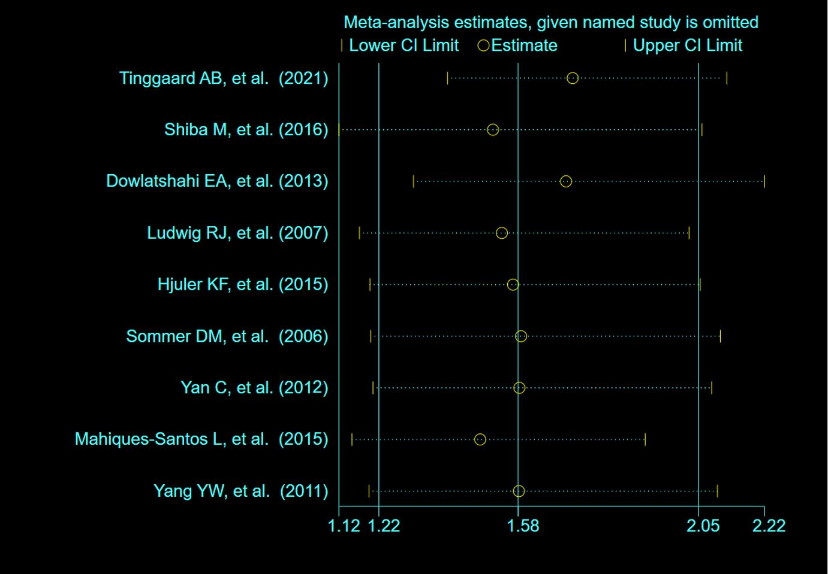
(b)
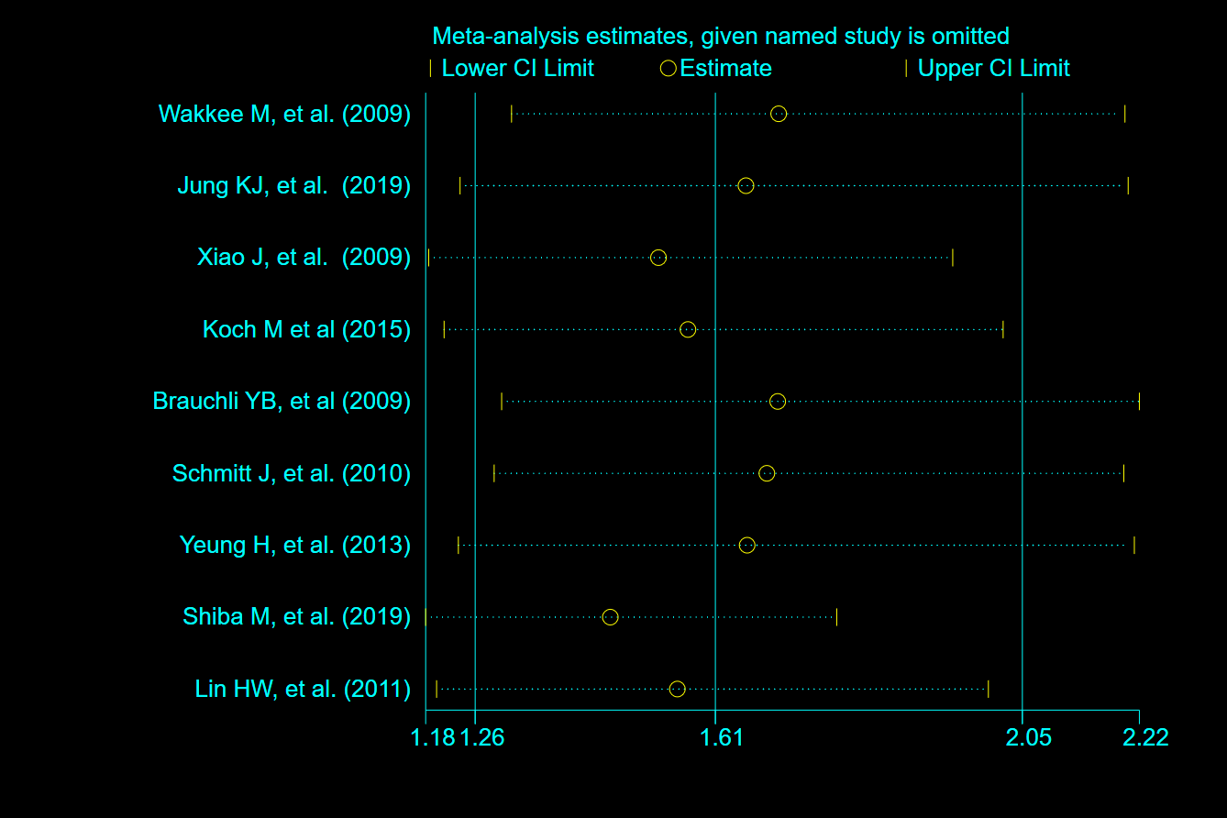

(c)
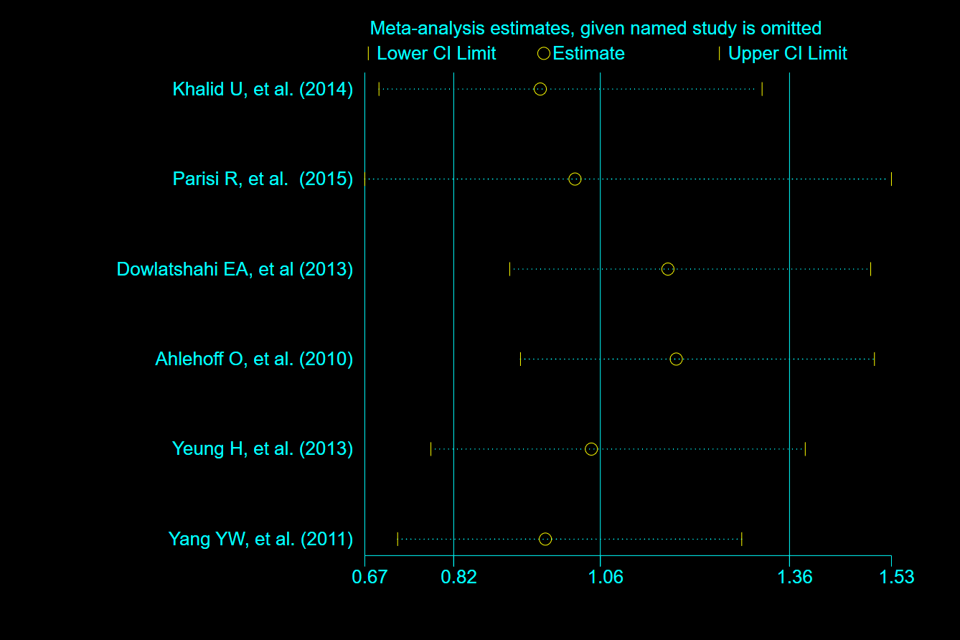

Supplementary Figure 2
A plot relating the effect sizes of the SNP-psoriasis association (x-axis, log OR) and the SNP-CVD associations (y-axis, log OR) with standard error bars. The plot relating the effect sizes of the SNP-psoriasis association and the SNP-CAD (a), SNP-MI (b) and SNP-HF (c) in European population and the plot relating the effect sizes of the SNP-psoriasis association and the SNP-CAD (d), SNP-MI (e) and SNP-HF (f) in East Asian population. The slopes of the lines correspond to causal estimates using each of the five different methods.

(a)

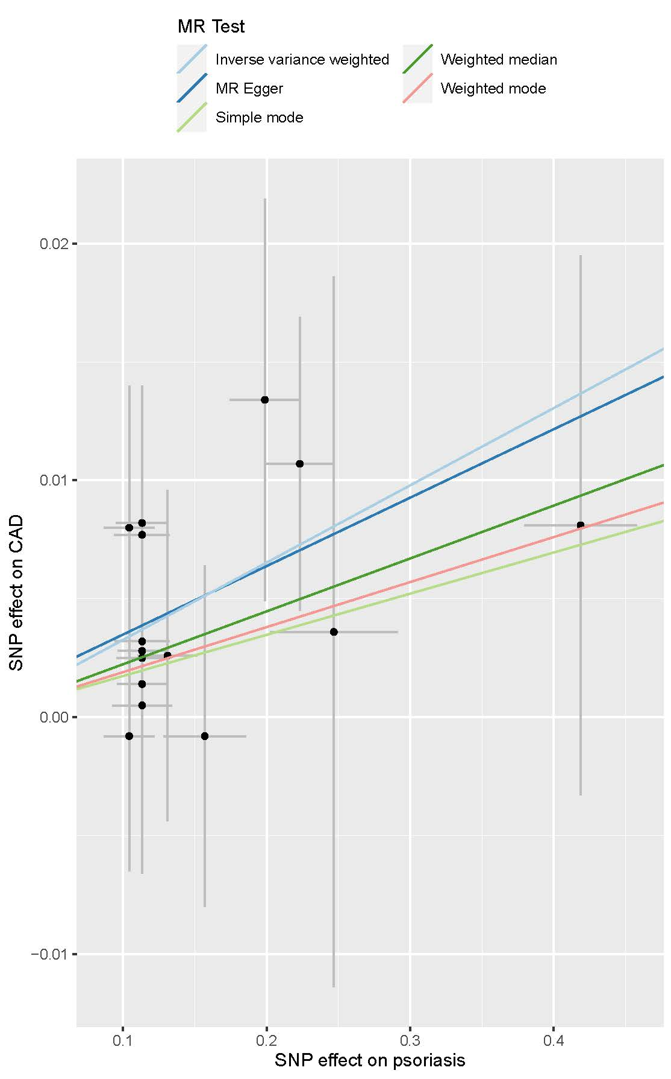

(b)

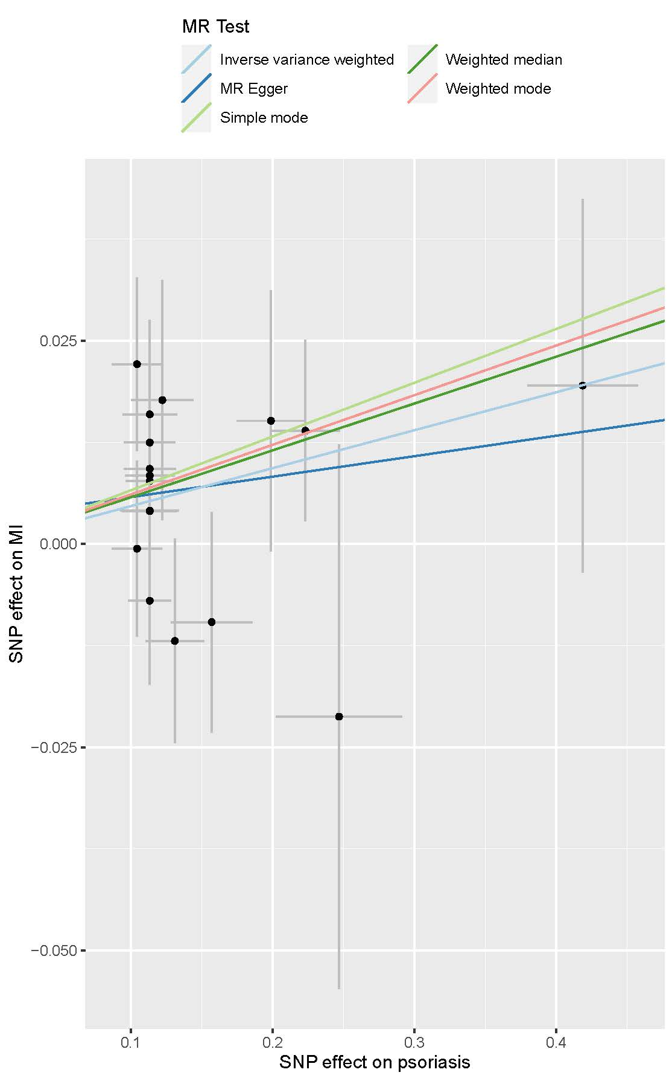

(c)

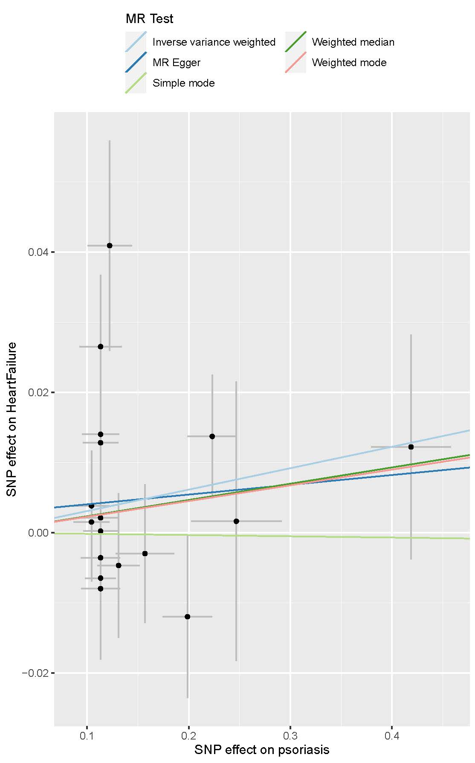

(d)

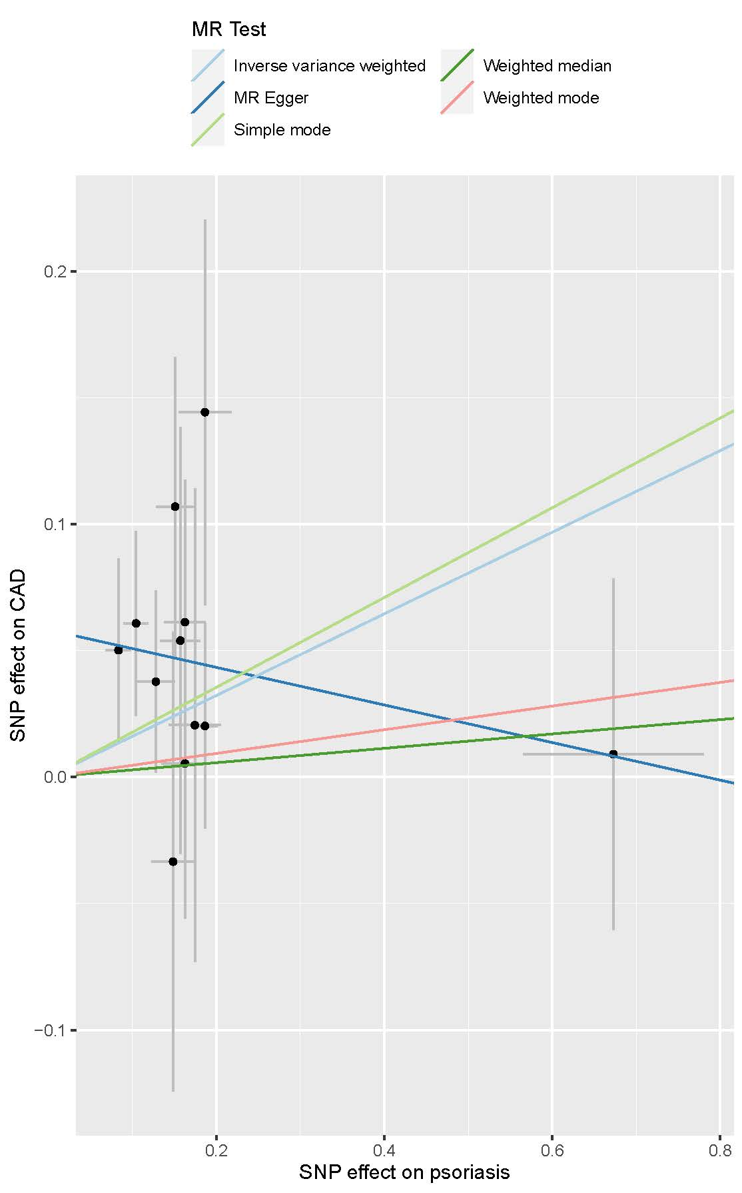

(e)

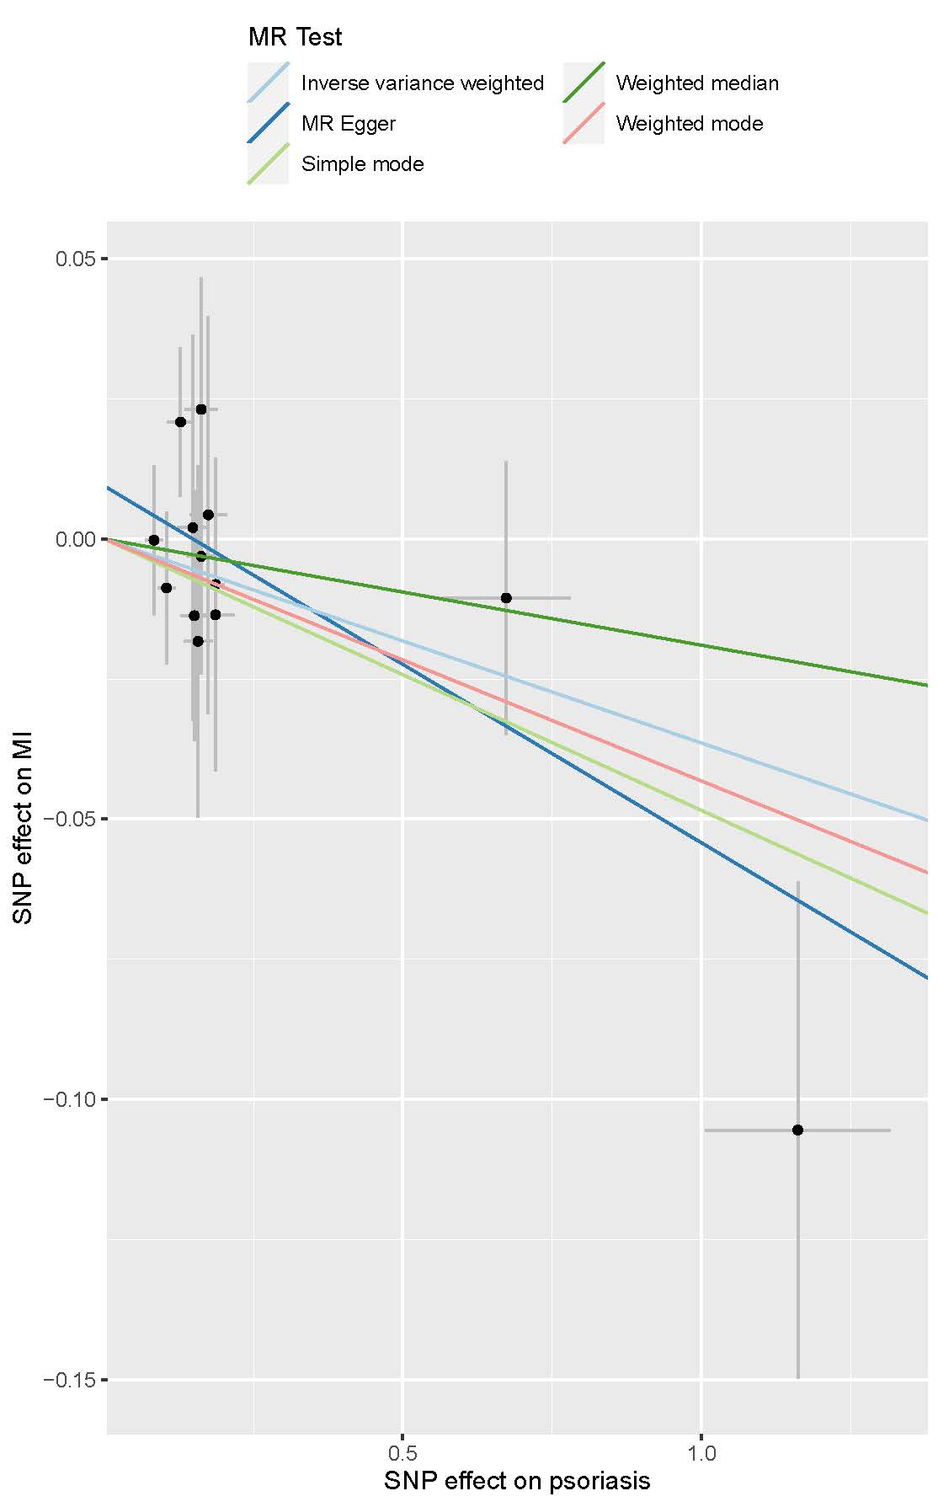

(f)

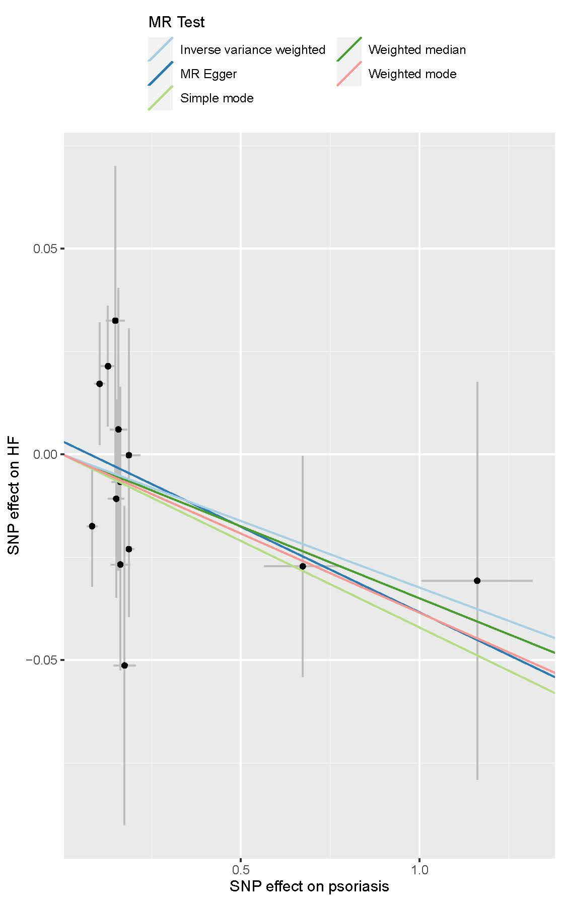

Supplementary Figure 3 Leave-one-out MR analysis for SNPs used as instruments MR analysis (black). The impact of psoriasis on CAD (a), MI (b) and HF (c) in European population and the impact of psoriasis on CAD (d), MI (e) and HF (f) in East Asian population. MR, Mendelian randomization; SNP, single nucleotide polymorphism, CAD, coronary artery disease; MI, myocardial infarction; HF, heart failure.

(a)
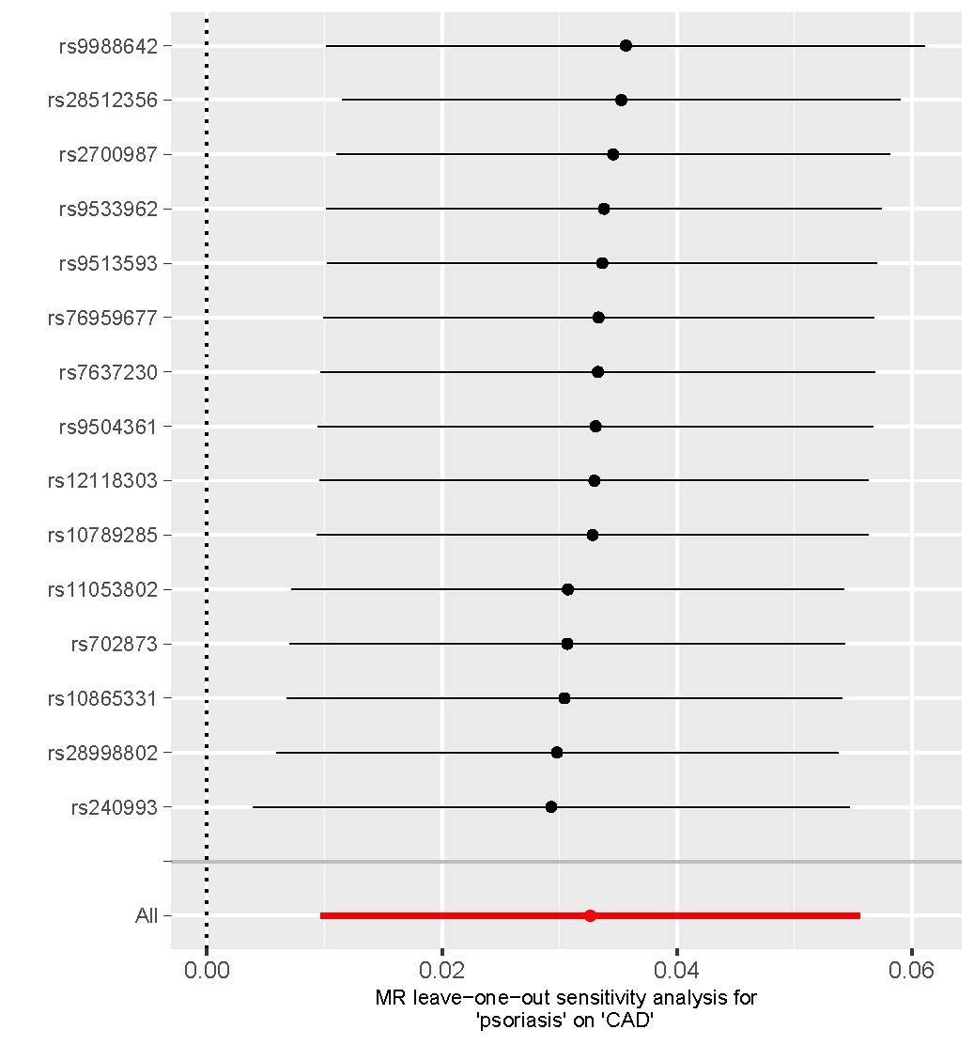

(b)
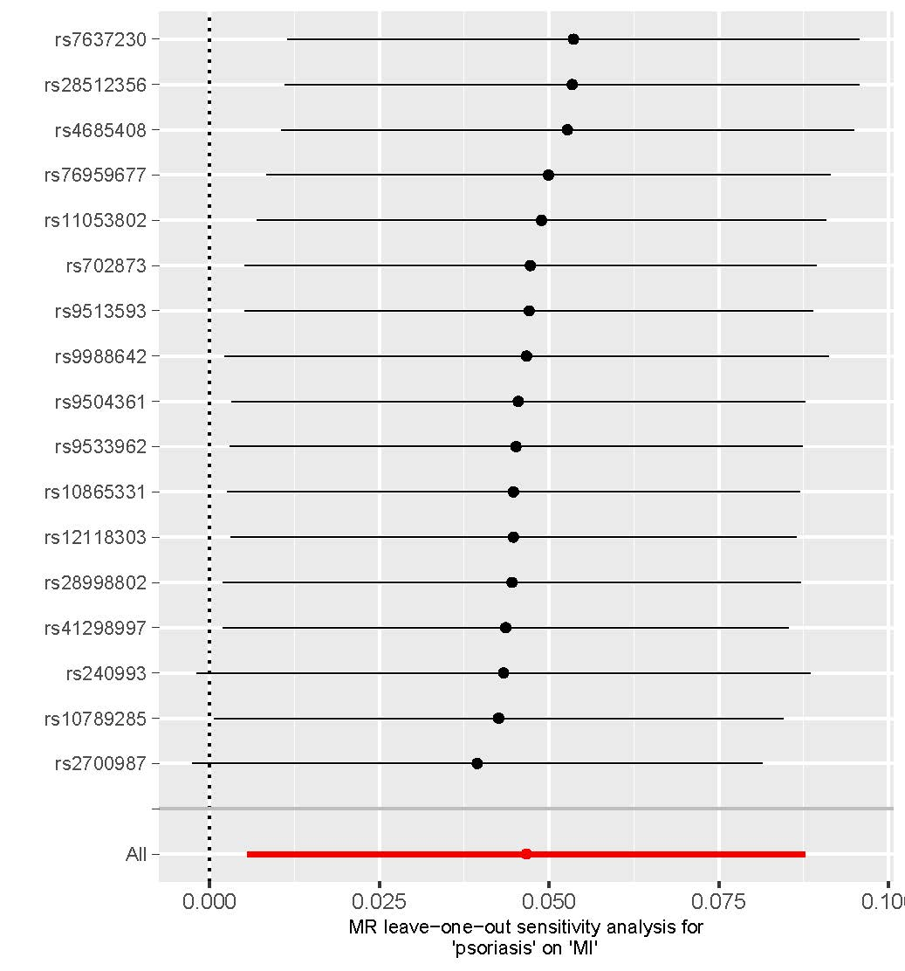

(c)
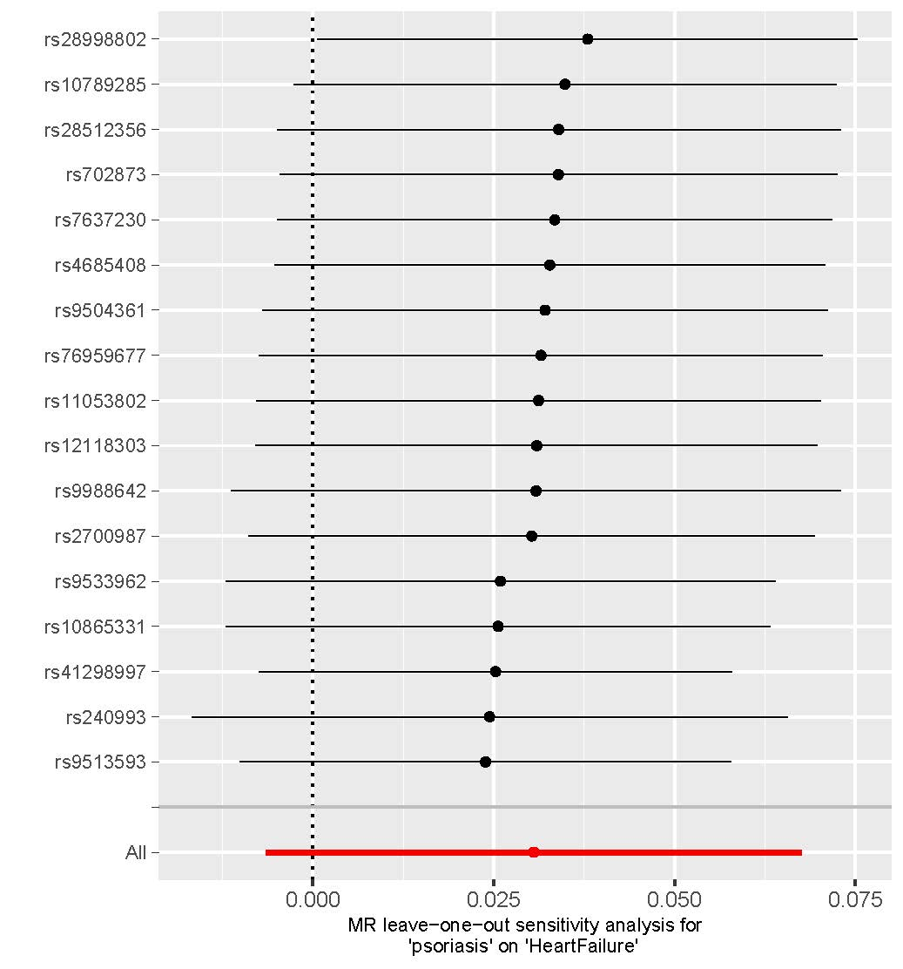

(d)

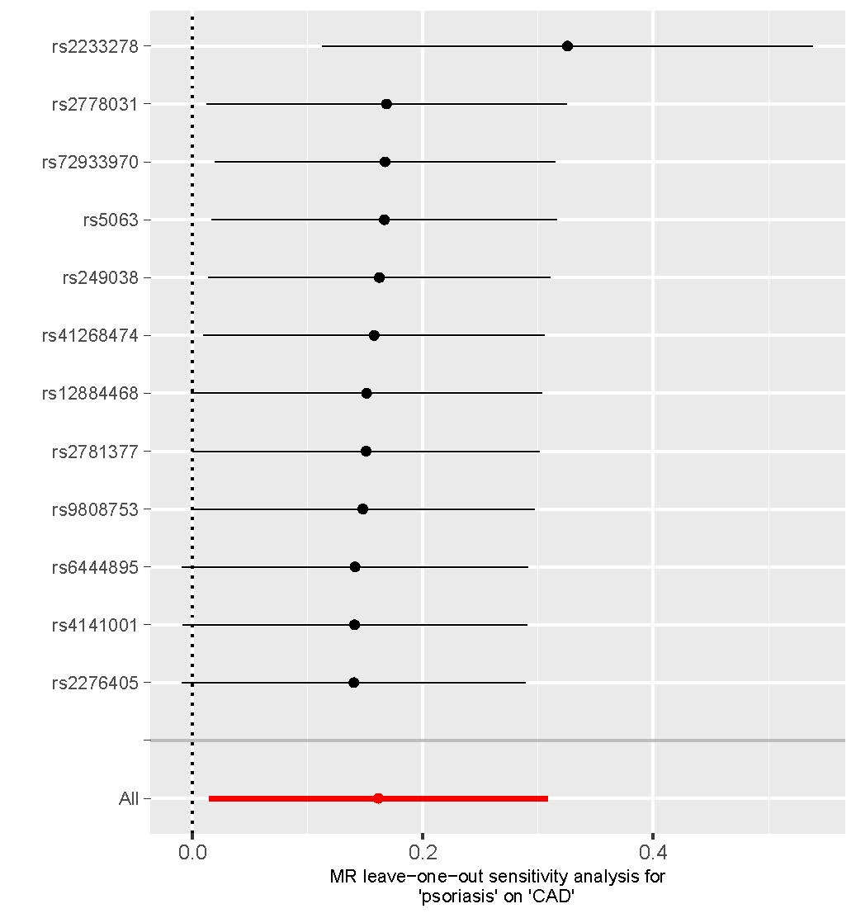

(e)
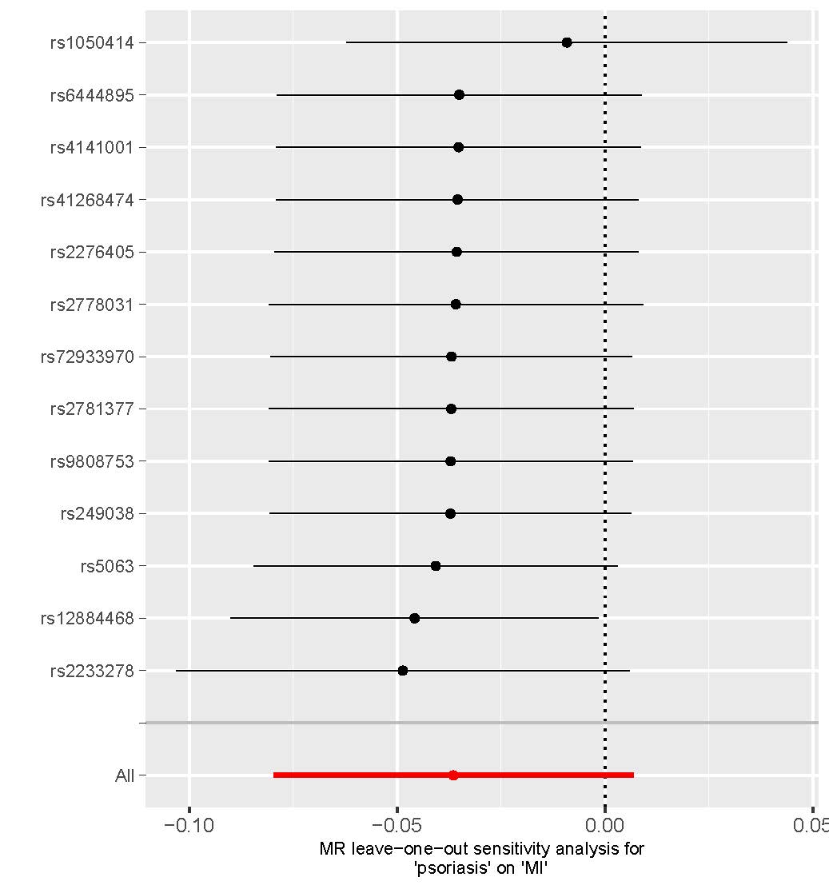

(f)
