Additional file 2

Figure S1. Susceptibility of P. falciparum field isolates to antimalarial drugs. PPQ; Piperaquine, ART; Artemether, DHA; Dihydroartemisinin, LM; Lumefantrine, CQ; Chloroquine. Reference clones D6 and 3D7 (Sensitive to chloroquine), W2 (Resistant to chloroquine)
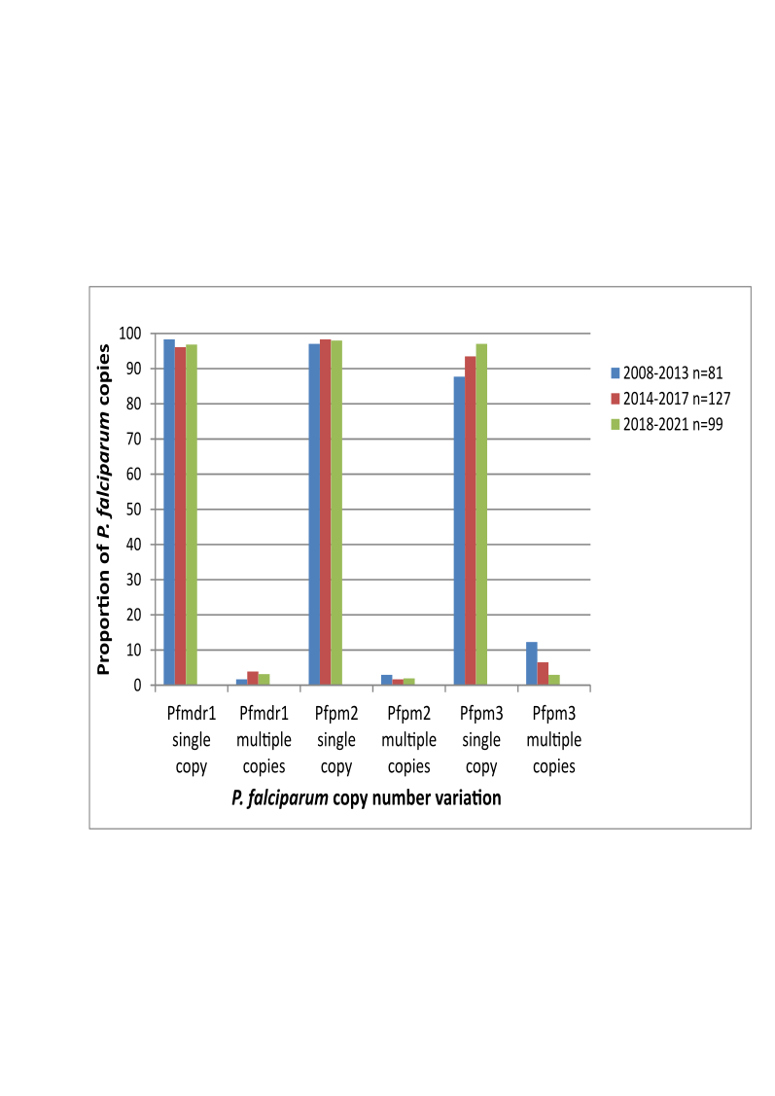

Figure S2: The frequency of Pfmdr1, Pfpm2 and Pfpm3 copy numbers in infections during the study period. Pfmdr1; Plasmodium falciparum multi-drug resistance 1 gene, Pfpm2; Plasmodium falciparum plasmepsin-2 gene, Pfpm3; Plasmodium falciparum plasmepsin-3 gene

