Additional file 2

- Supplemental tables
Table S1. Search strategy in PubMed.
Patient | N/A
Intervention and  Control | (("sacubitril and valsartan sodium hydrate drug combination" [Supplementary Concept]) OR (sacubitril valsartan[Title/Abstract])) OR ((((((("Angiotensin-Converting Enzyme Inhibitors"[Mesh]) OR (Angiotensin-Converting Enzyme Inhibitors[Title/Abstract])) OR (("Renin-Angiotensin System"[Mesh]) AND (inhibitor[Title/Abstract]))) OR (Angiotensin-Converting Enzyme Inhibitors[Title/Abstract])) OR (angiotensin-receptor blockers[Title/Abstract])) OR (Renin-Angiotensin System inhibitor[Title/Abstract])) AND (placebo[Title/Abstract]))
Outcome | N/A
Filter | Randomized Controlled Trial, Humans
Note: N/A, not applicable.

Table S2. Search strategy in Embase.
Patient | N/A
Intervention and  Control | #1. 'sacubitril plus valsartan'/exp OR 'sacubitril and valsartan':ti,ab  #2. 'angiotensin receptor antagonist'/exp OR 'dipeptidyl carboxypeptidase inhibitor'/exp  #3. 'renin angiotensin aldosterone system'/exp AND inhibitor:ti,ab  #4. 'angiotensin converting' AND enzyme AND inhibitors:ti,ab  #5. 'angiotensin receptor antagonist':ti,ab  #6. 'renin angiotensin' AND system AND inhibitor:ti,ab  #7. 'placebo':ti,ab  #8. #2 OR #3 OR #4 OR #5 OR #6  #9. #7 AND #8  #10. #1 OR #9
Outcome | N/A
Filter | Randomized Controlled Trial, Humans, Embase, Preprints
Note: N/A, not applicable.

Table S3. Search strategy in Cochrane Central Register of Controlled Trials.
Patient | N/A
Intervention and  Control | #1 (sacubitril valsartan):ti,ab,kw OR (sacubitril valsartan sodium hydrate):ti,ab,kw OR (sacubitril valsartan drug combination):ti,ab,kw OR (LCZ 696):ti,ab,kw  #2 MeSH descriptor: [Angiotensin-Converting Enzyme Inhibitors] explode all trees  #3 MeSH descriptor: [Angiotensin Receptor Antagonists] explode all trees  #4 MeSH descriptor: [Renin-Angiotensin System] explode all trees  #5 (Angiotensin-Converting Enzyme Inhibitors):ti,ab,kw  #6 (angiotensin-receptor blockers):ti,ab,kw  #7 (inhibitor):ti,ab,kw  #8 (Renin-Angiotensin System inhibitor):ti,ab,kw  #9 (placebo):ti,ab,kw  #10 #4 and #7  #11 #2 or #3 or #5 or #6 or #8 or #10  #12 #9 and #11  #13 #1 or #12  #14 (randomised):ti,ab,kw OR (randomized):ti,ab,kw  #15 #13 and #14
Outcome | N/A
Filter | ICTRP, CINAHL
Note: N/A, not applicable.

Table S4. Search strategy in ClinicalTrials.gov.
Patient | N/A
Intervention and  Control | (sacubitril/valsartan OR sacubitril valsartan sodium hydrate OR sacubitril valsartan drug combination OR LCZ696 OR LCZ 696 OR LCZ-696) OR ((ACEI OR ARB OR Renin-Angiotensin System inhibitor) AND (placebo))
Outcome | N/A
Filter | Terminated, Completed, Unknown status, Adult (18–64), Older Adult (65+), Interventional (Clinical Trial), With Results
Note: N/A, not applicable.

Table S5: Eligibility criteria of included studies.
 | Inclusion criteria | Exclusion criteria
Study design | Randomized controlled trials | Reviews or non-RCTs; cross-over study designs
Participants | Adults | Patients with contraindications to the study drugs; Pregnant women
Intervention and Comparators | Sacubitril/valsartan vs. ACEI/ARB/placebo; ACEI/ARB vs. placebo | Non-pharmaceutical treatment (e.g., exercise and apparatus)
Main outcomes | N/A | N/A
Included outcomes | New-onset DM, hypoglycaemia, elevated glycaemia, DM inadequate control, diabetic complications, DM treatment | Outcomes that cannot be specified
Note: N/A, not applicable; DM, diabetes mellitus; ACEI, angiotensin-converting enzyme inhibitors; ARB, angiotensin-receptor blocker.

Supplemental Figures
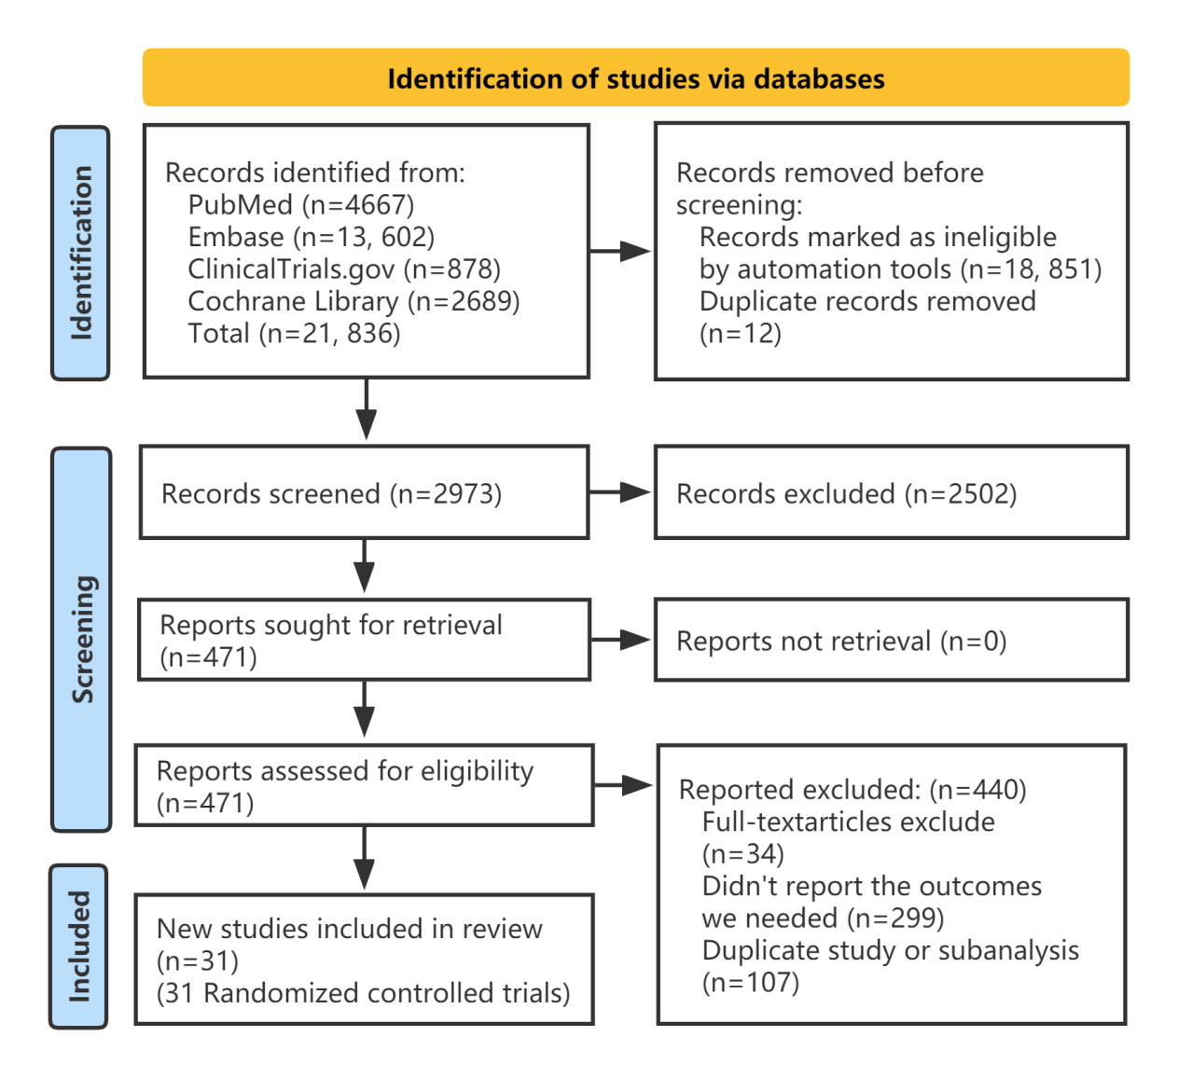
Figure S1. Flow chart of literature search and study selection.
Figure S2. The effect of sacubitril/valsartan compared with placebo on new-onset DM among all patients (non-DM).

Figure S3. The effect of sacubitril/valsartan compared with placebo on hypoglycaemia among all patients.

Figure S4. The effect of sacubitril/valsartan compared with placebo on elevated glycaemia among all patients.

Figure S5. The effect of sacubitril/valsartan compared with placebo on DM inadequate control among all patients.

Figure S6. The effect of sacubitril/valsartan compared with placebo on diabetes complication among all patients.

Figure S7. The effect of sacubitril/valsartan compared with placebo on diabetes treatment among all patients.

Figure S8. Funnel plot of the effect of ACEI/ARB compared with placebo on new-onset DM.

Figure S9. Funnel plot of the effect of ACEI/ARB compared with placebo on diabetes complications.

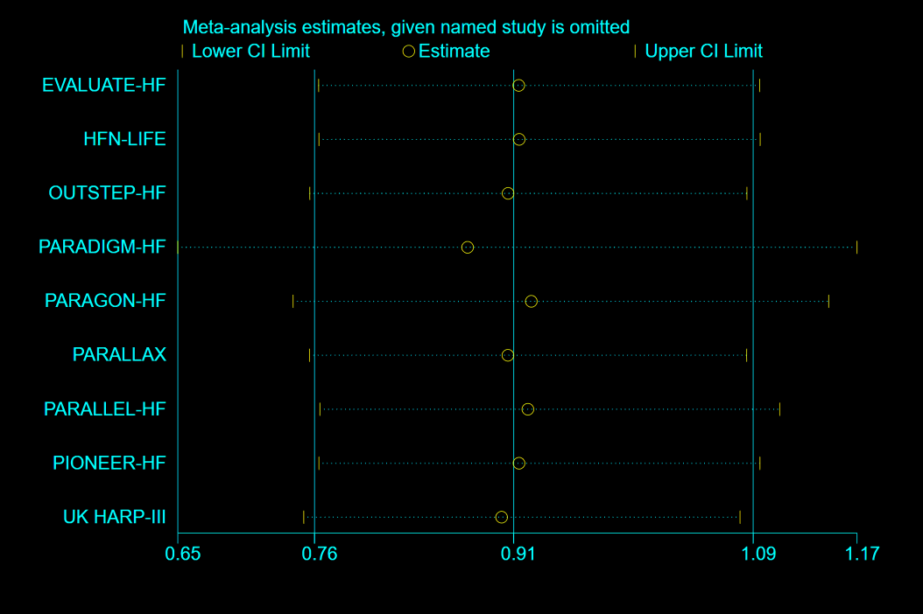
Figure S10. Sensitivity analysis for the effect of sacubitril/valsartan compared with ACEI/ARB on new-onset DM.

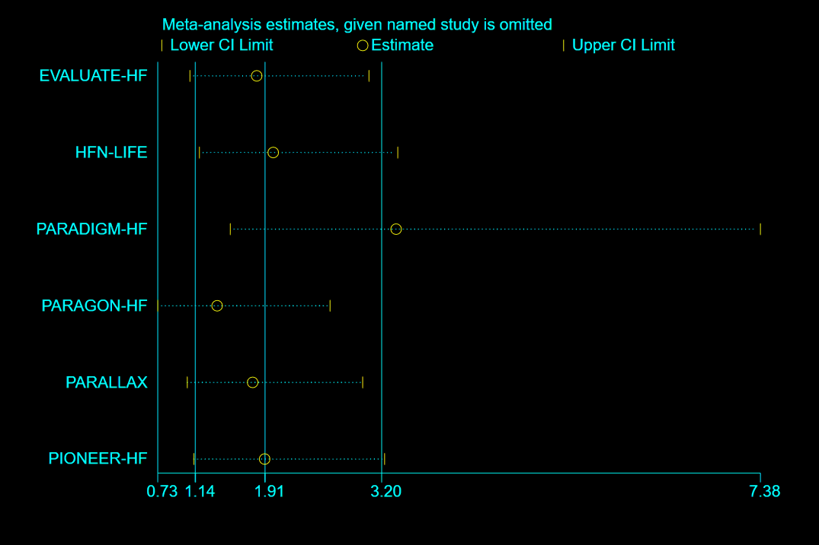
Figure S11. Sensitivity analysis for the effect of sacubitril/valsartan compared with ACEI/ARB on hypoglycaemia.

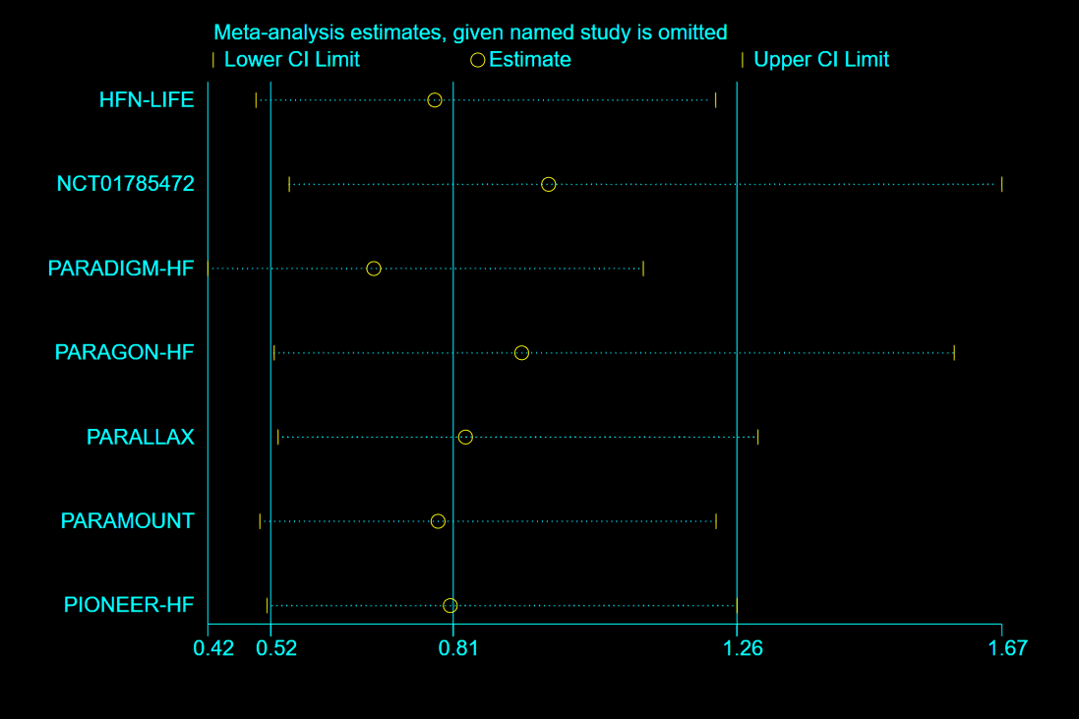
Figure S12. Sensitivity analysis for the effect of sacubitril/valsartan compared with ACEI/ARB on elevated glycaemia.

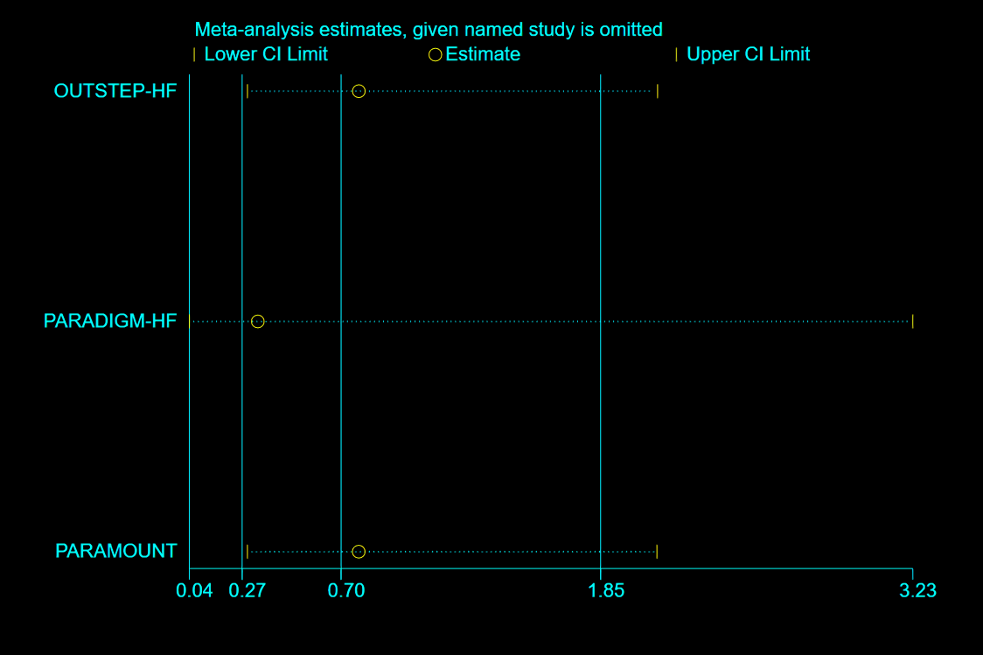
Figure S13. Sensitivity analysis for the effect of sacubitril/valsartan compared with ACEI/ARB on DM inadequate control.

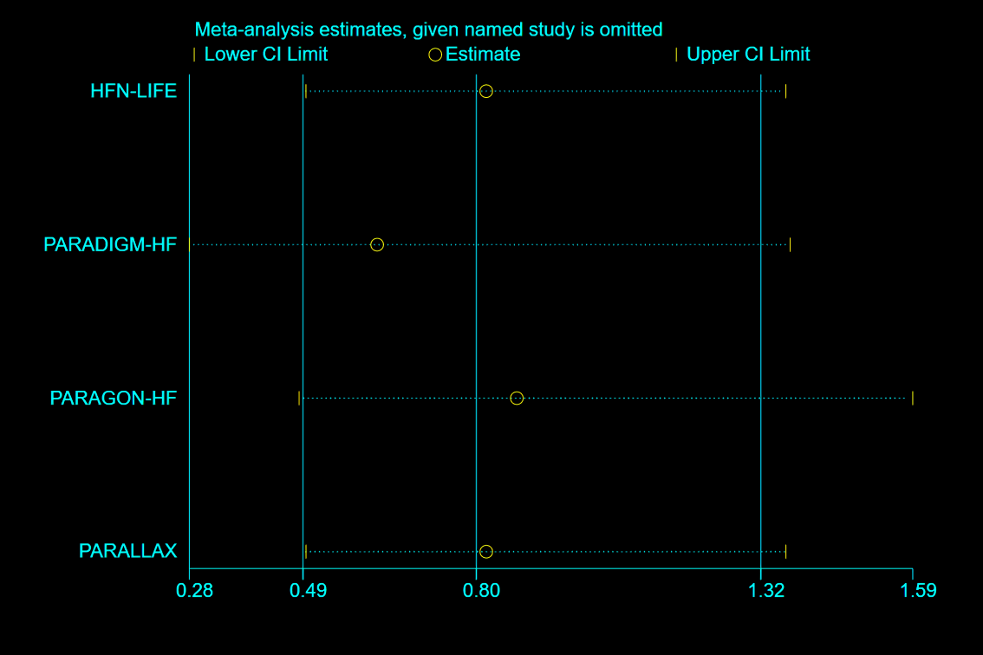
Figure S14. Sensitivity analysis for the effect of sacubitril/valsartan compared with ACEI/ARB on diabetic complications.

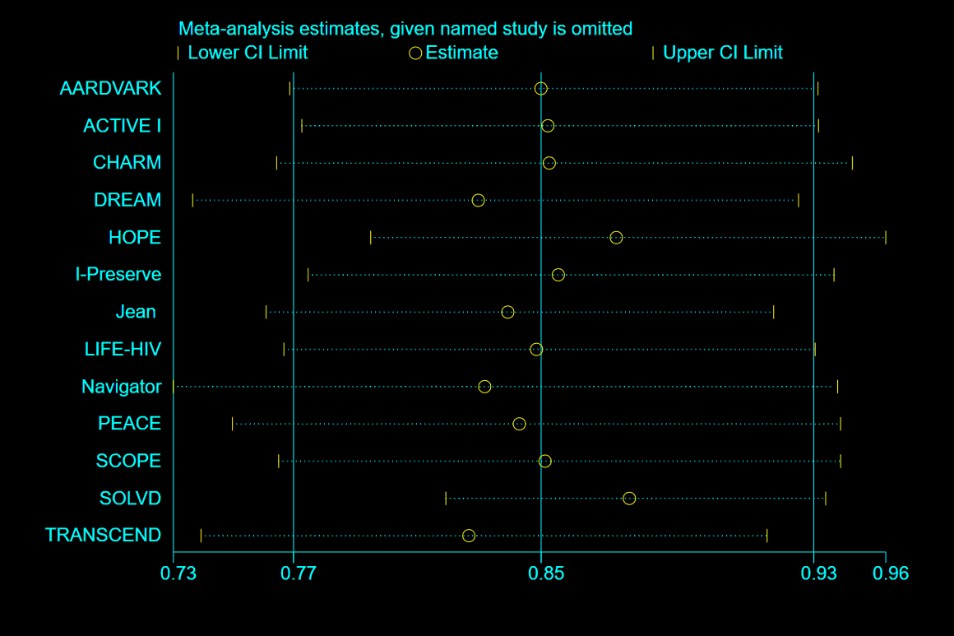
Figure S15. Sensitivity analysis for the effect of ACEI/ARB compared with placebo on new-onset DM.

Figure S16. Sensitivity analysis for the effect of ACEI/ARB compared with placebo on hypoglycaemia.

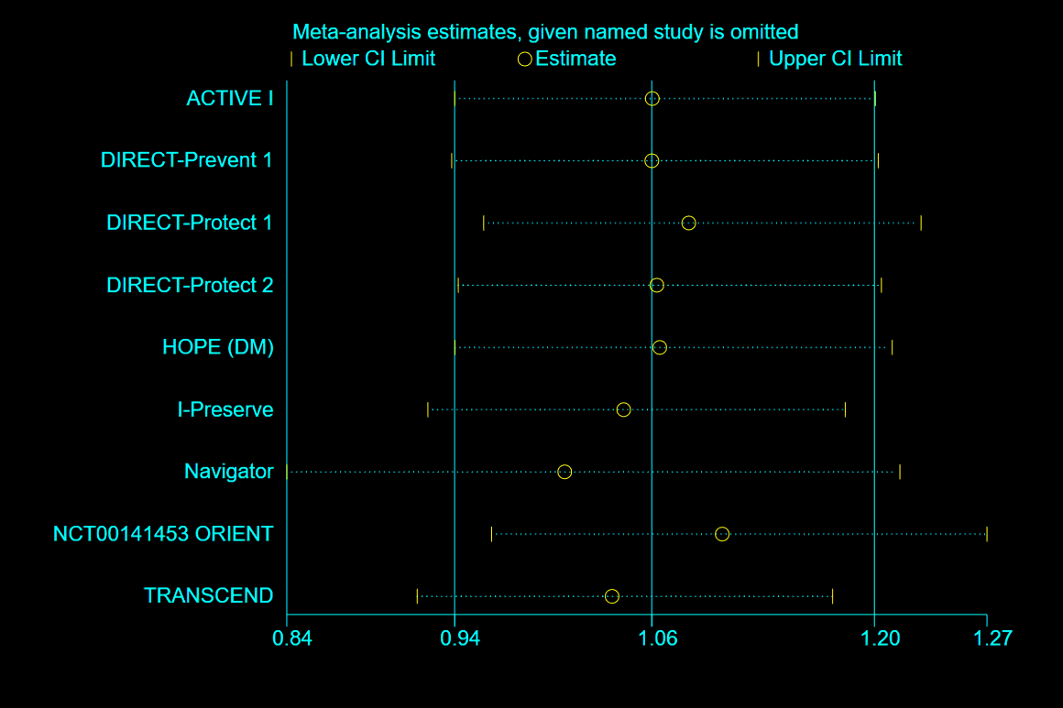
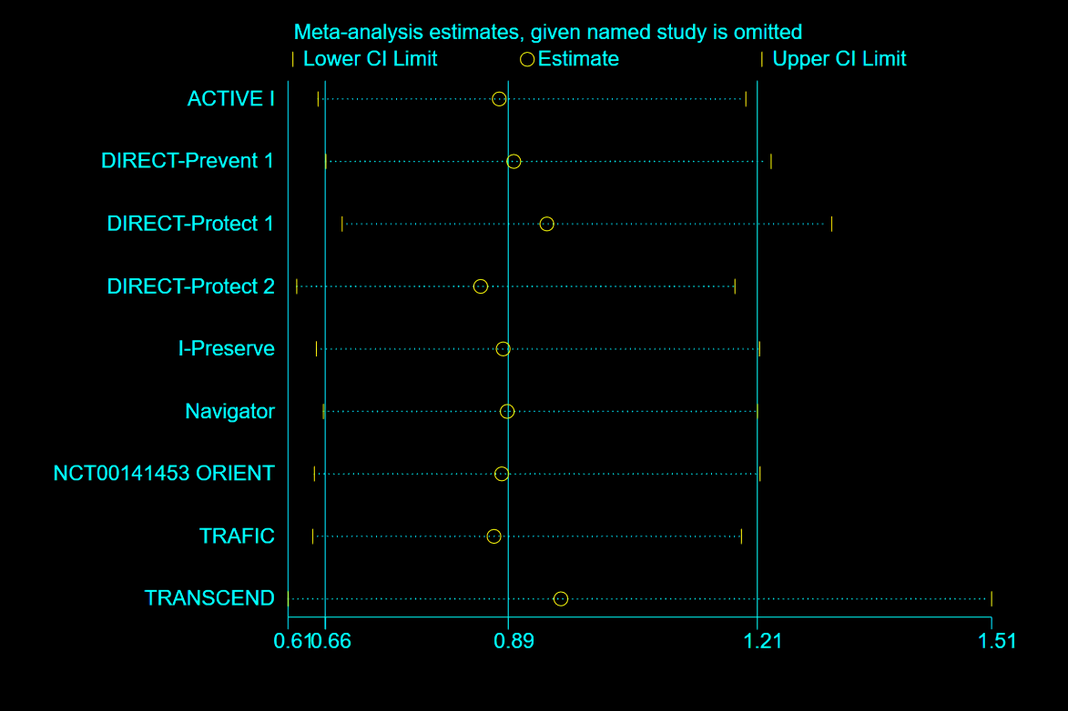
Figure S17. Sensitivity analysis for the effect of ACEI/ARB compared with placebo on elevated glycaemia.

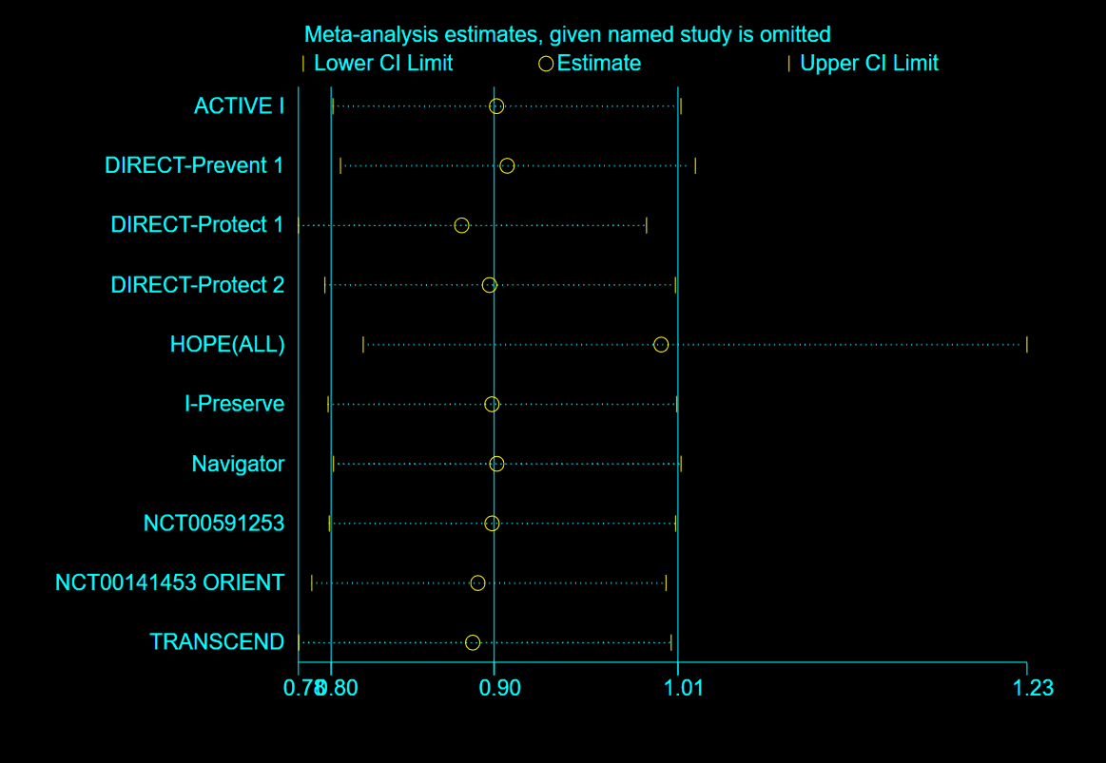
Figure S18. Sensitivity analysis for the effect of ACEI/ARB compared with placebo on DM inadequate control.
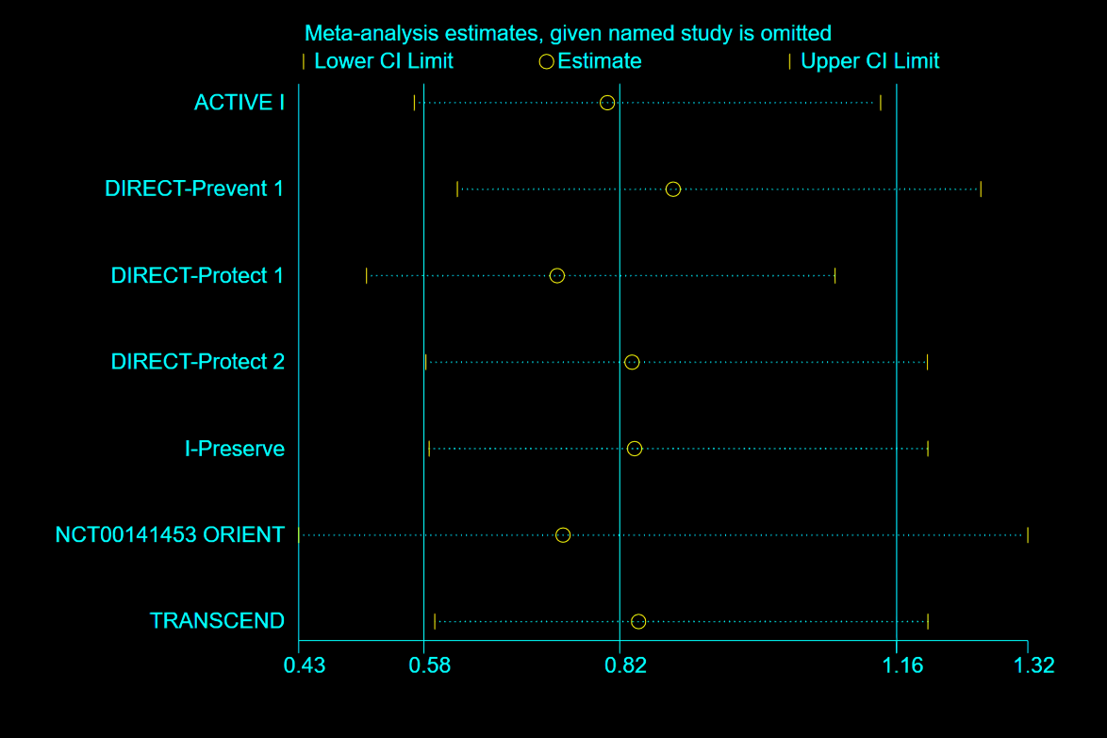
Figure S19. Sensitivity analysis for the effect of ACEI/ARB compared with placebo on diabetes complications

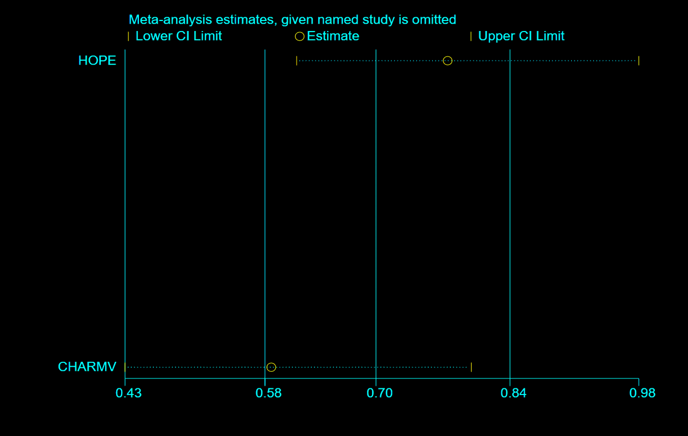
Figure S20. Sensitivity analysis for the effect of ACEI/ARB compared with placebo on diabetes treatment.

Figure S21. Funnel plot of the effect of sacubitril/valsartan compared with placebo on new-onset DM among all patients (non-DM).
Figure S22. Funnel plot of the effect of sacubitril/valsartan compared with placebo on hypoglycaemia among all patients.

Figure S23. Funnel plot of the effect of sacubitril/valsartan compared with placebo on elevated glycaemia among all patients.
Figure S24. Funnel plot of the effect of sacubitril/valsartan compared with placebo on elevated glycaemia among patients with not all-DM.
Figure S25. Funnel plot of the effect of sacubitril/valsartan compared with placebo on diabetes complication among all patients.

