Additional file 4: eFigure 3. Kaplan-Meier curves according to Reti-CVD and QRISK3
A QRISK3 in non-statin cohort B Reti-CVD in non-statin cohort
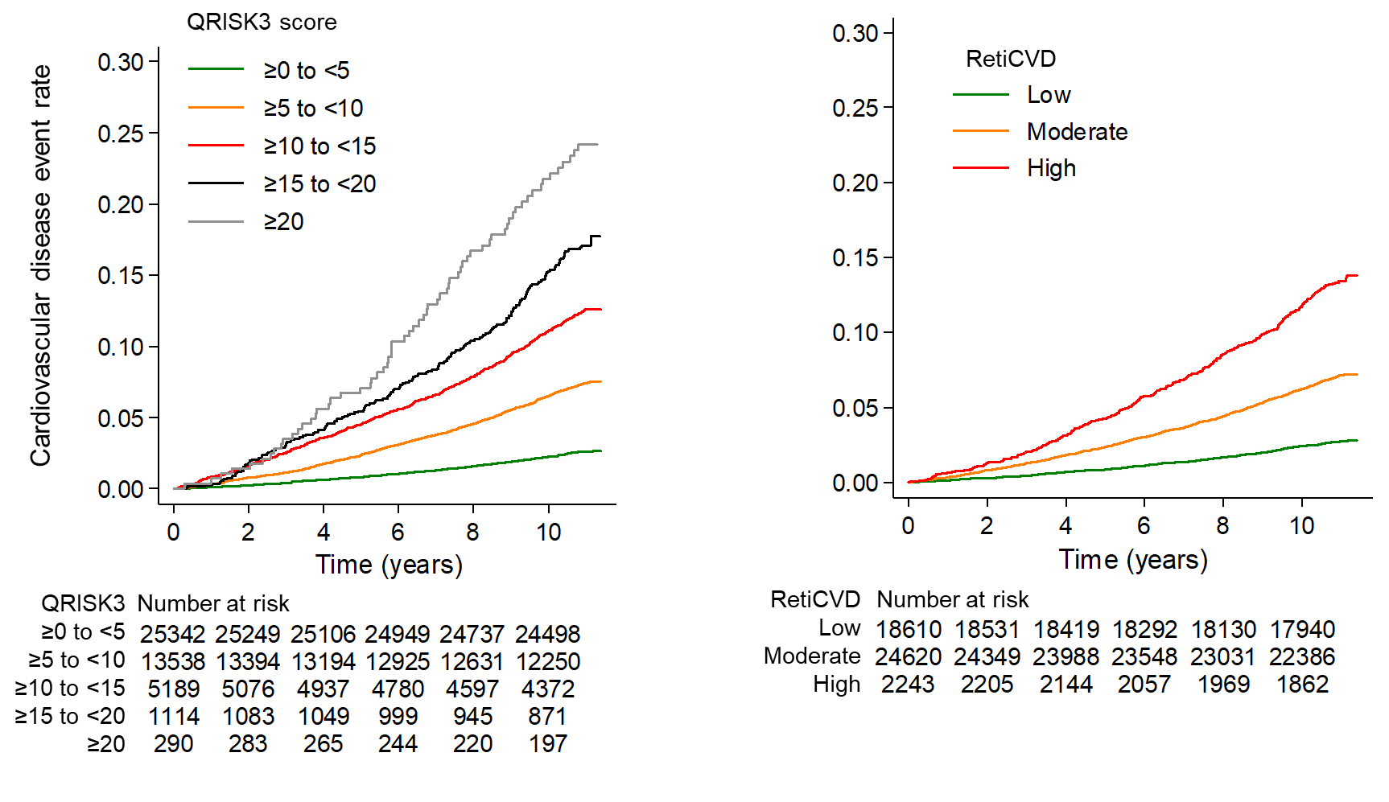
C QRISK3 in stage 1 hypertension cohort D Reti-CVD in stage 1 hypertension cohort
