Additional File 3: Figures S1-S12 of
Cord blood epigenome-wide meta-analysis in six European-based child cohorts identifies signatures linked to rapid weight growth
Alfano R et al

Figures S1-S12:

FigS1. QQ-plot of I² p-values of the meta-analysis of EWASs of rapid weight growth. 3
FigS2. Forrest plots and plots from leave out one cohort at time meta-analysis from EWASs of rapid weight growth for the CpGs with P_{Suggestive} < 1e-05. 4
FigS3. Quality control of cohort specific EWAS of rapid weight growth. Coefficients, standard errors and p-values distributions visualized via box plots and QQ-plot. 13
FigS4. Cohort specific correlation plots between chronological and DNA methylation gestational age. 14
FigS5. Forrest plot of the meta-analysis of gestational age acceleration and rapid weight growth in sensitivity analyses adding (A) delivery mode, (B) removing cell types from confounders, excluding mothers with (C) gestational diabetes and (D) non-white European children. 15
FigS6. Calibration plots of Random Forest models of rapid weight growth including (A) conventional risk factors, (B) CpGs related to rapid weight growth and (C) both. 16
FigS7. Calibration plots of Random Forest models of rapid weight growth including (A) conventional risk factors, (B) CpGs belonging to DMRs related to rapid weight growth and (C) both. 17
FigS8. Heatmap shows Pearson’s correlation between methylation levels of the 44 CpGs associated with P_{Suggestive} <1e-05 in the meta-analysis of EWAS of rapid weight growth. Red boxes indicate the three CpGs identified in mediation analyses. 18
FigS9. Volcano plots of the association between the 44 CpGs associated with rapid weight growth at P_{Suggestive} < 1e-05/the 96 CpGs belonging to the 16 DMRs associated with rapid weight growth at FDR-adjusted p-value in DMRcate and Siddak p-values in ENmix-comb-p <0.01 and the entire transcriptome (A/C) and restricted to cis transcripts (B/D). Red lines represent Bonferroni-significant threshold, and black lines suggestive threshold (p-value=10-e05). For analyses restricted to cis transcripts only Bonferroni-significant threshold is represented. 19
FigS10. Volcano plots of the association between the 44 CpGs associated with rapid weight growth at P_{Suggestive} < 1e-05/the 96 CpGs belonging to the 16 DMRs associated with rapid weight growth at FDR-adjusted p-value in DMRcate and Siddak p-values in ENmix-comb-p <0.01 and the entire metabolome (A/B). Red lines represent Bonferroni-significant threshold, and black lines suggestive threshold (p-value=10-e05). 20
FigS11. Forrest plot of the meta-analysis of the analysis of gestational age acceleration and childhood overweight. 21
FigS12. Volcano plot from the look-up in the study population of the CpG sites associated with child anthropometrics in a previous systematic review by Alfano et al. [60] 22

FigS1. QQ-plot of I² p-values of the meta-analysis of EWASs of rapid weight growth.
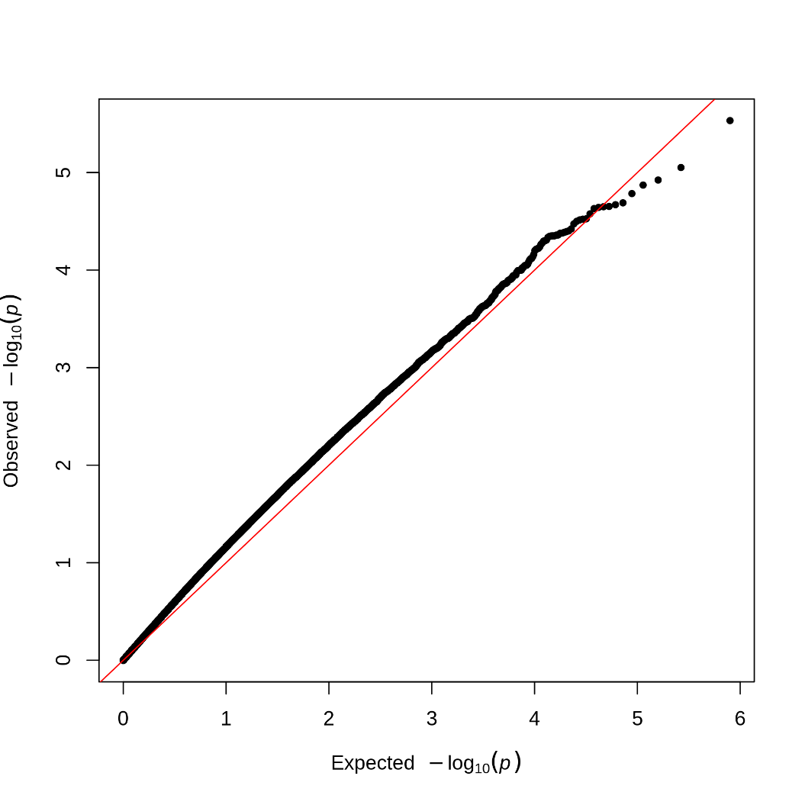

FigS2. Forrest plots and plots from leave out one cohort at time meta-analysis from EWASs of rapid weight growth for the CpGs with P_{Suggestive} < 1e-05.
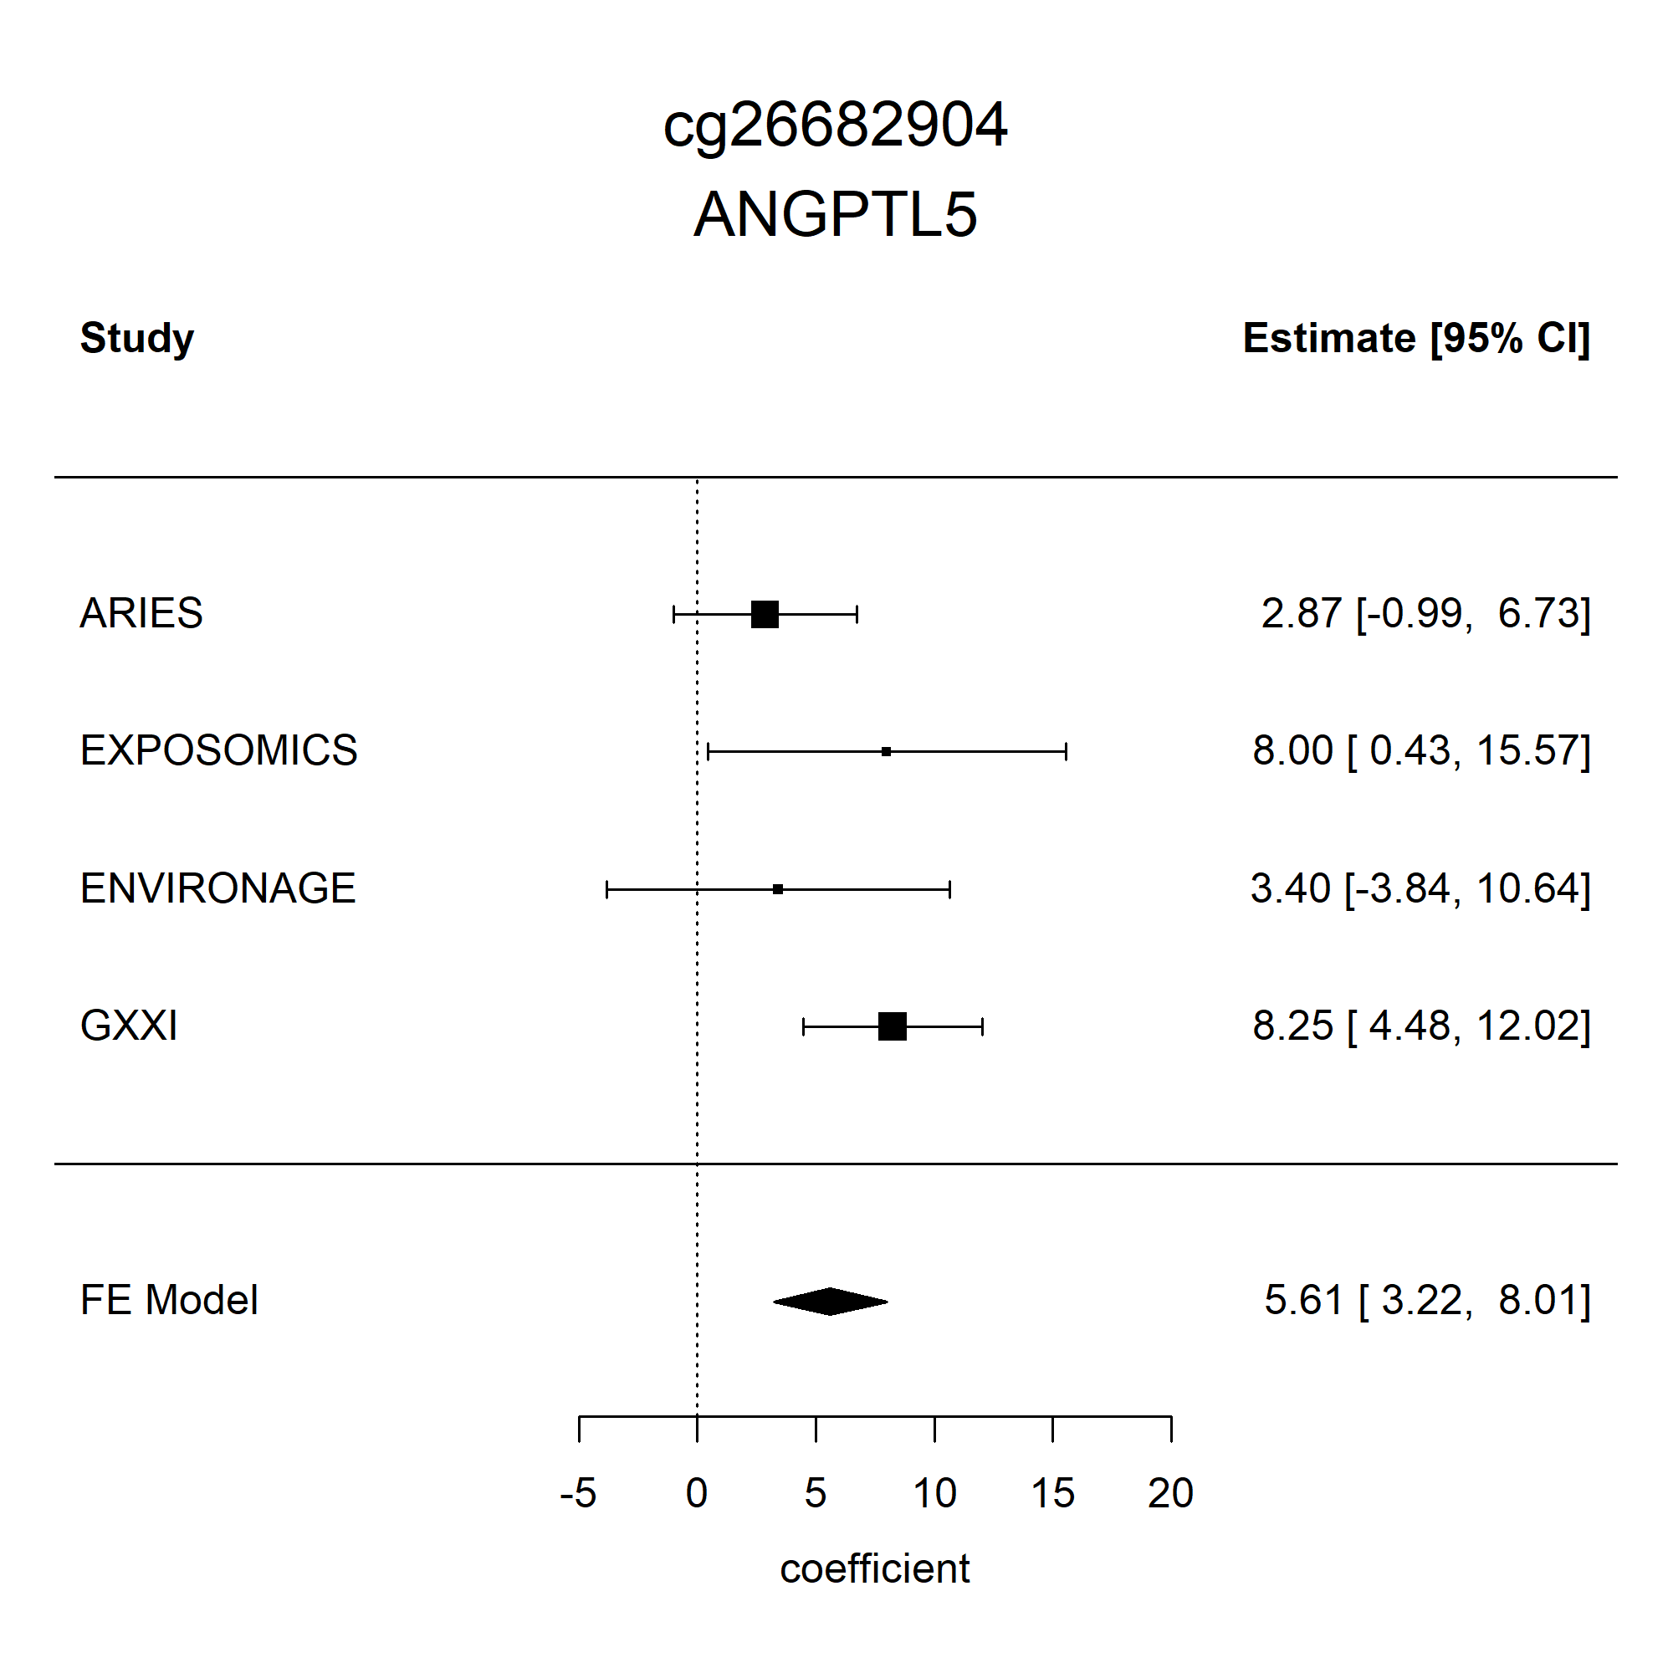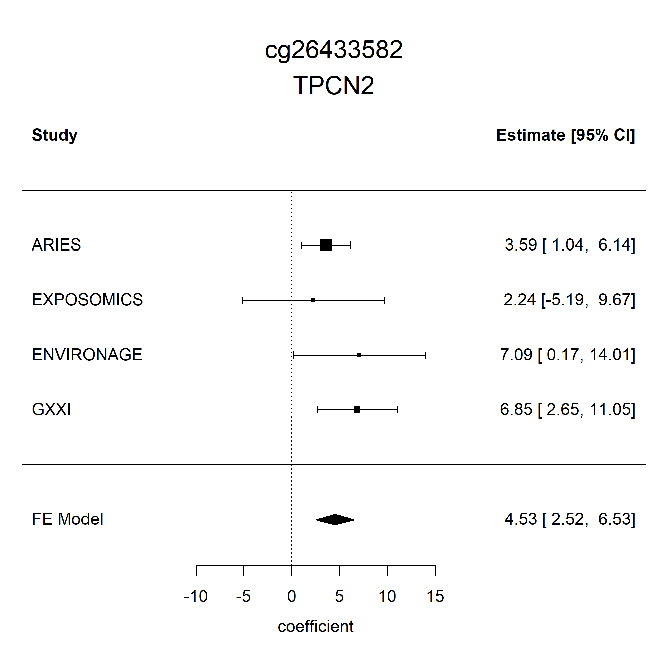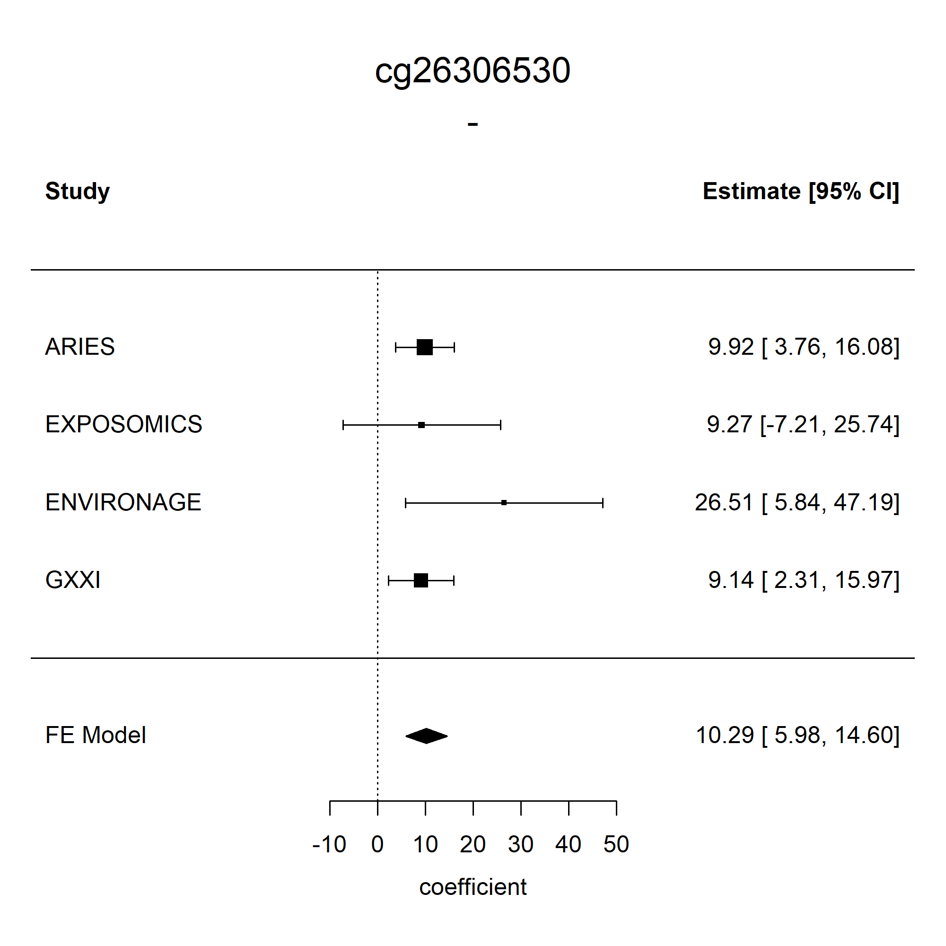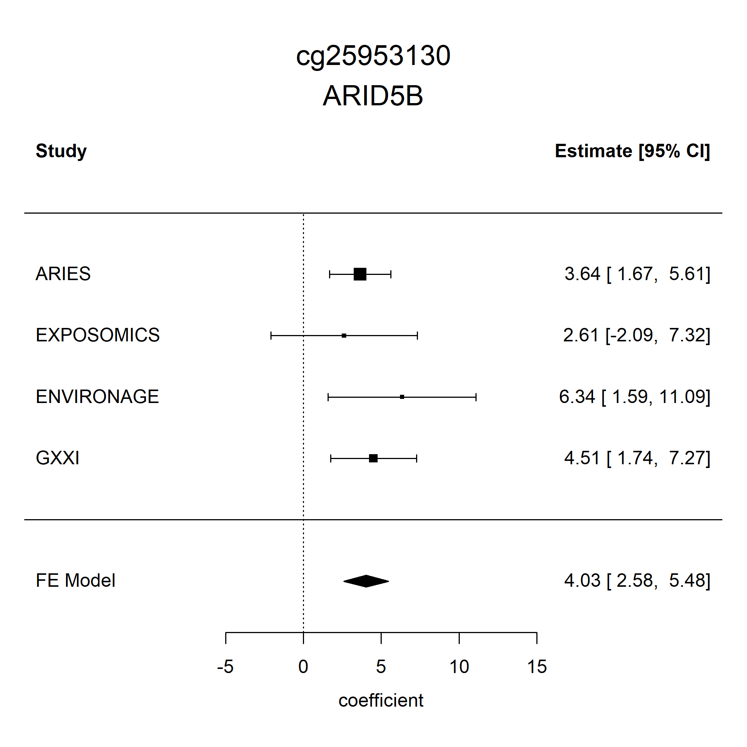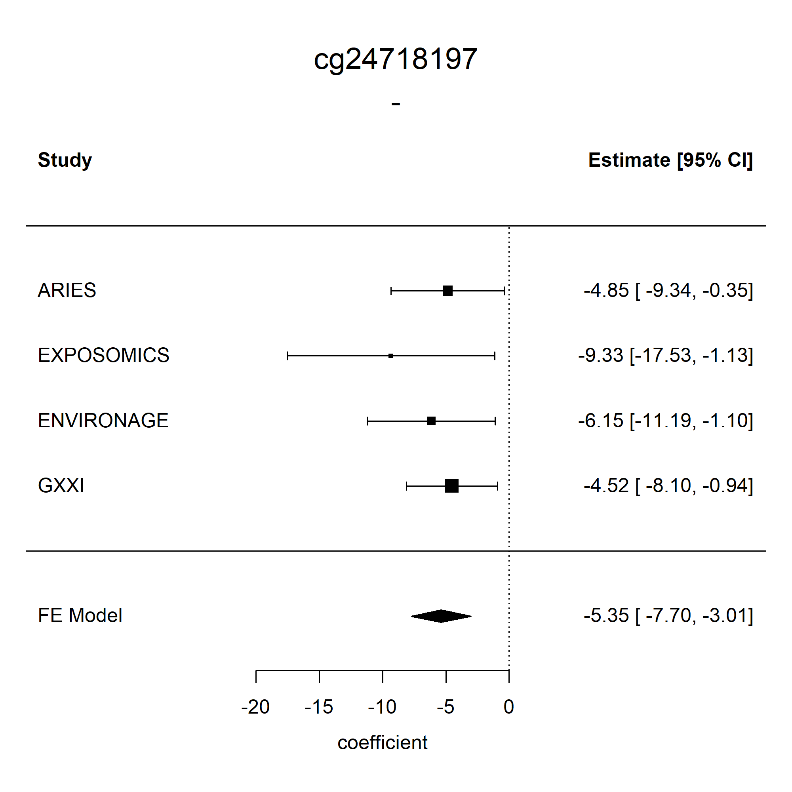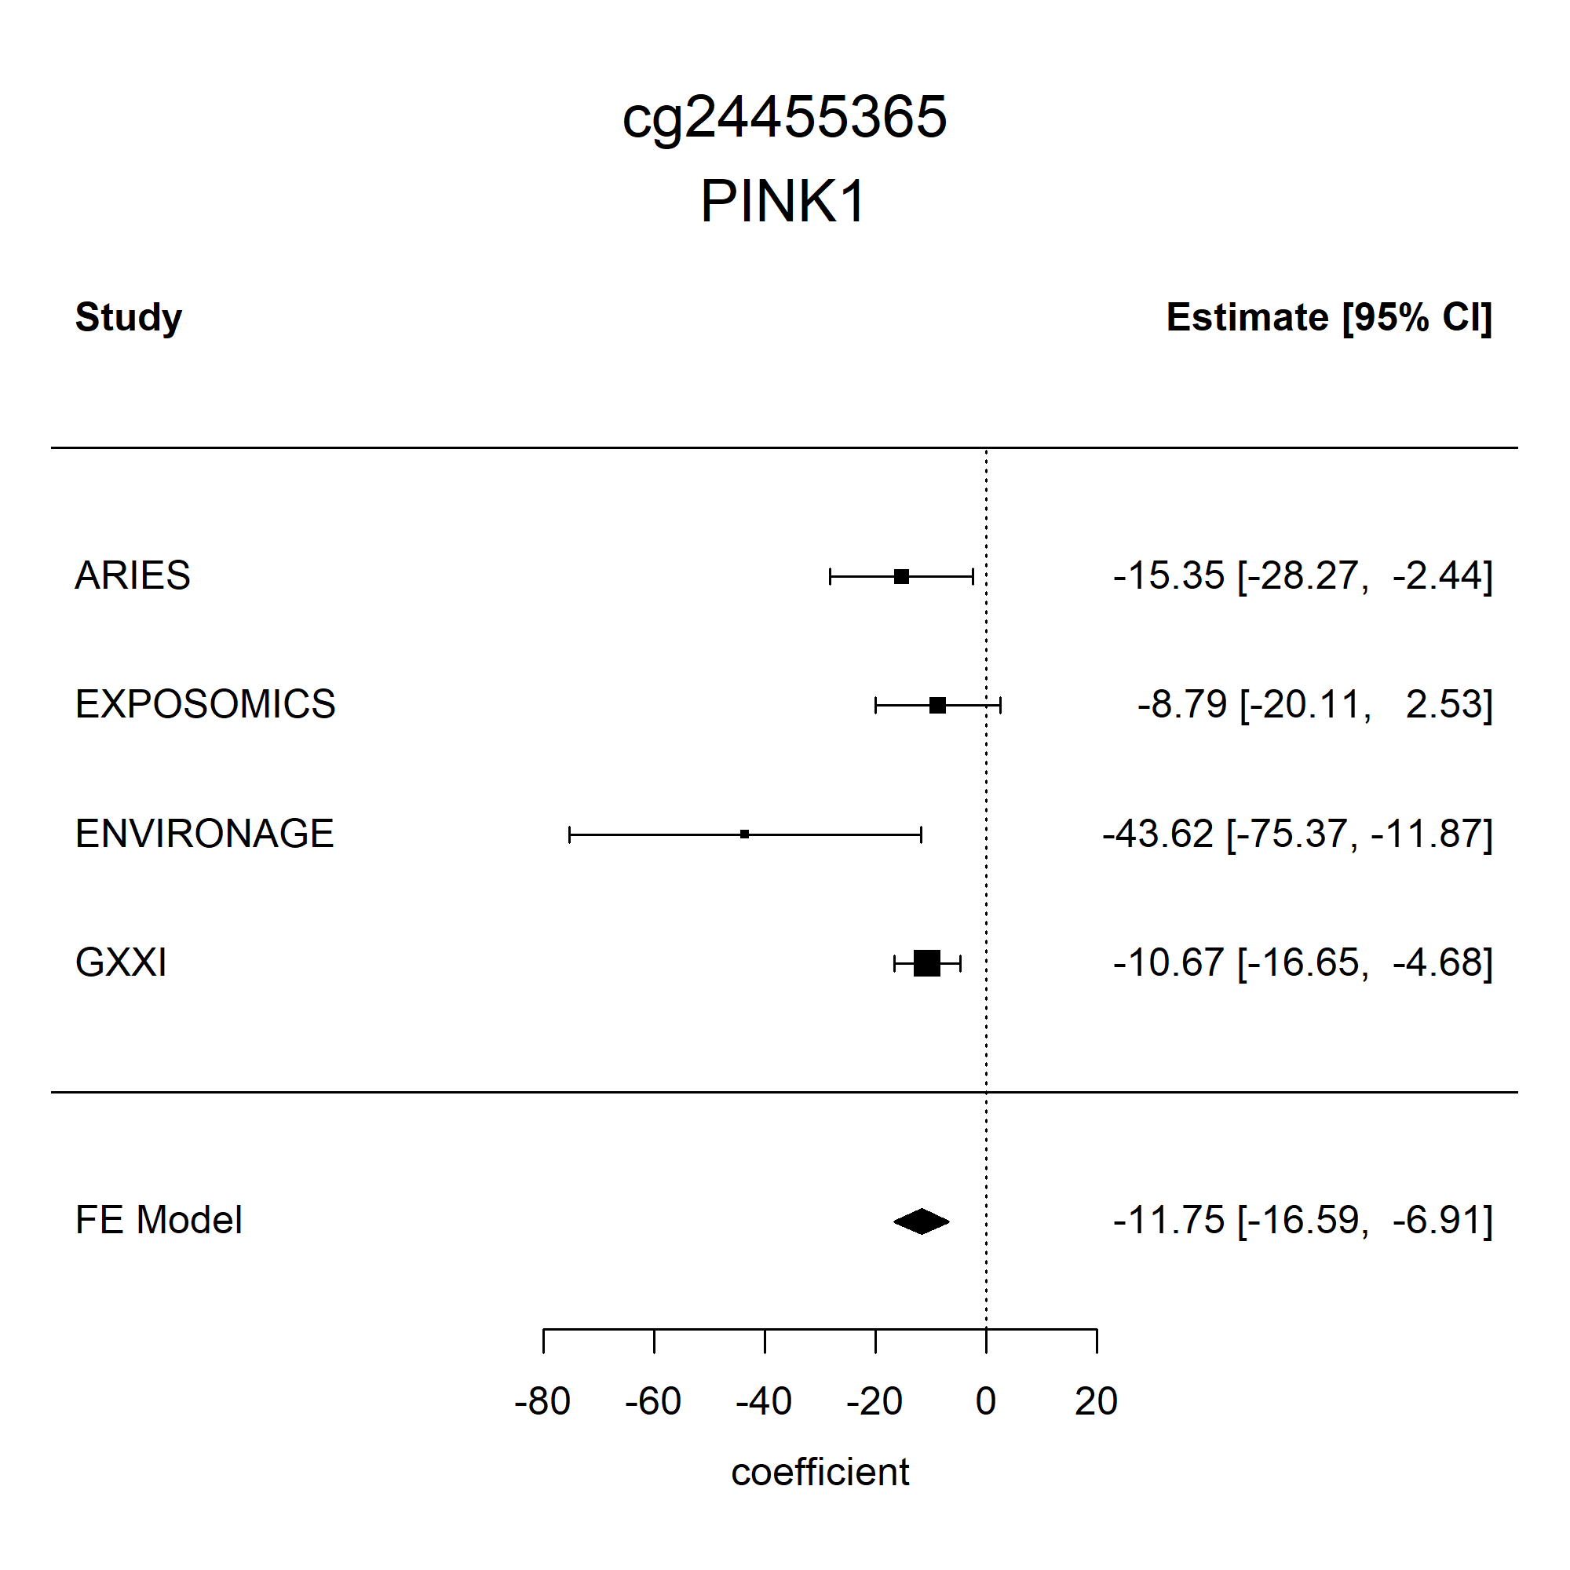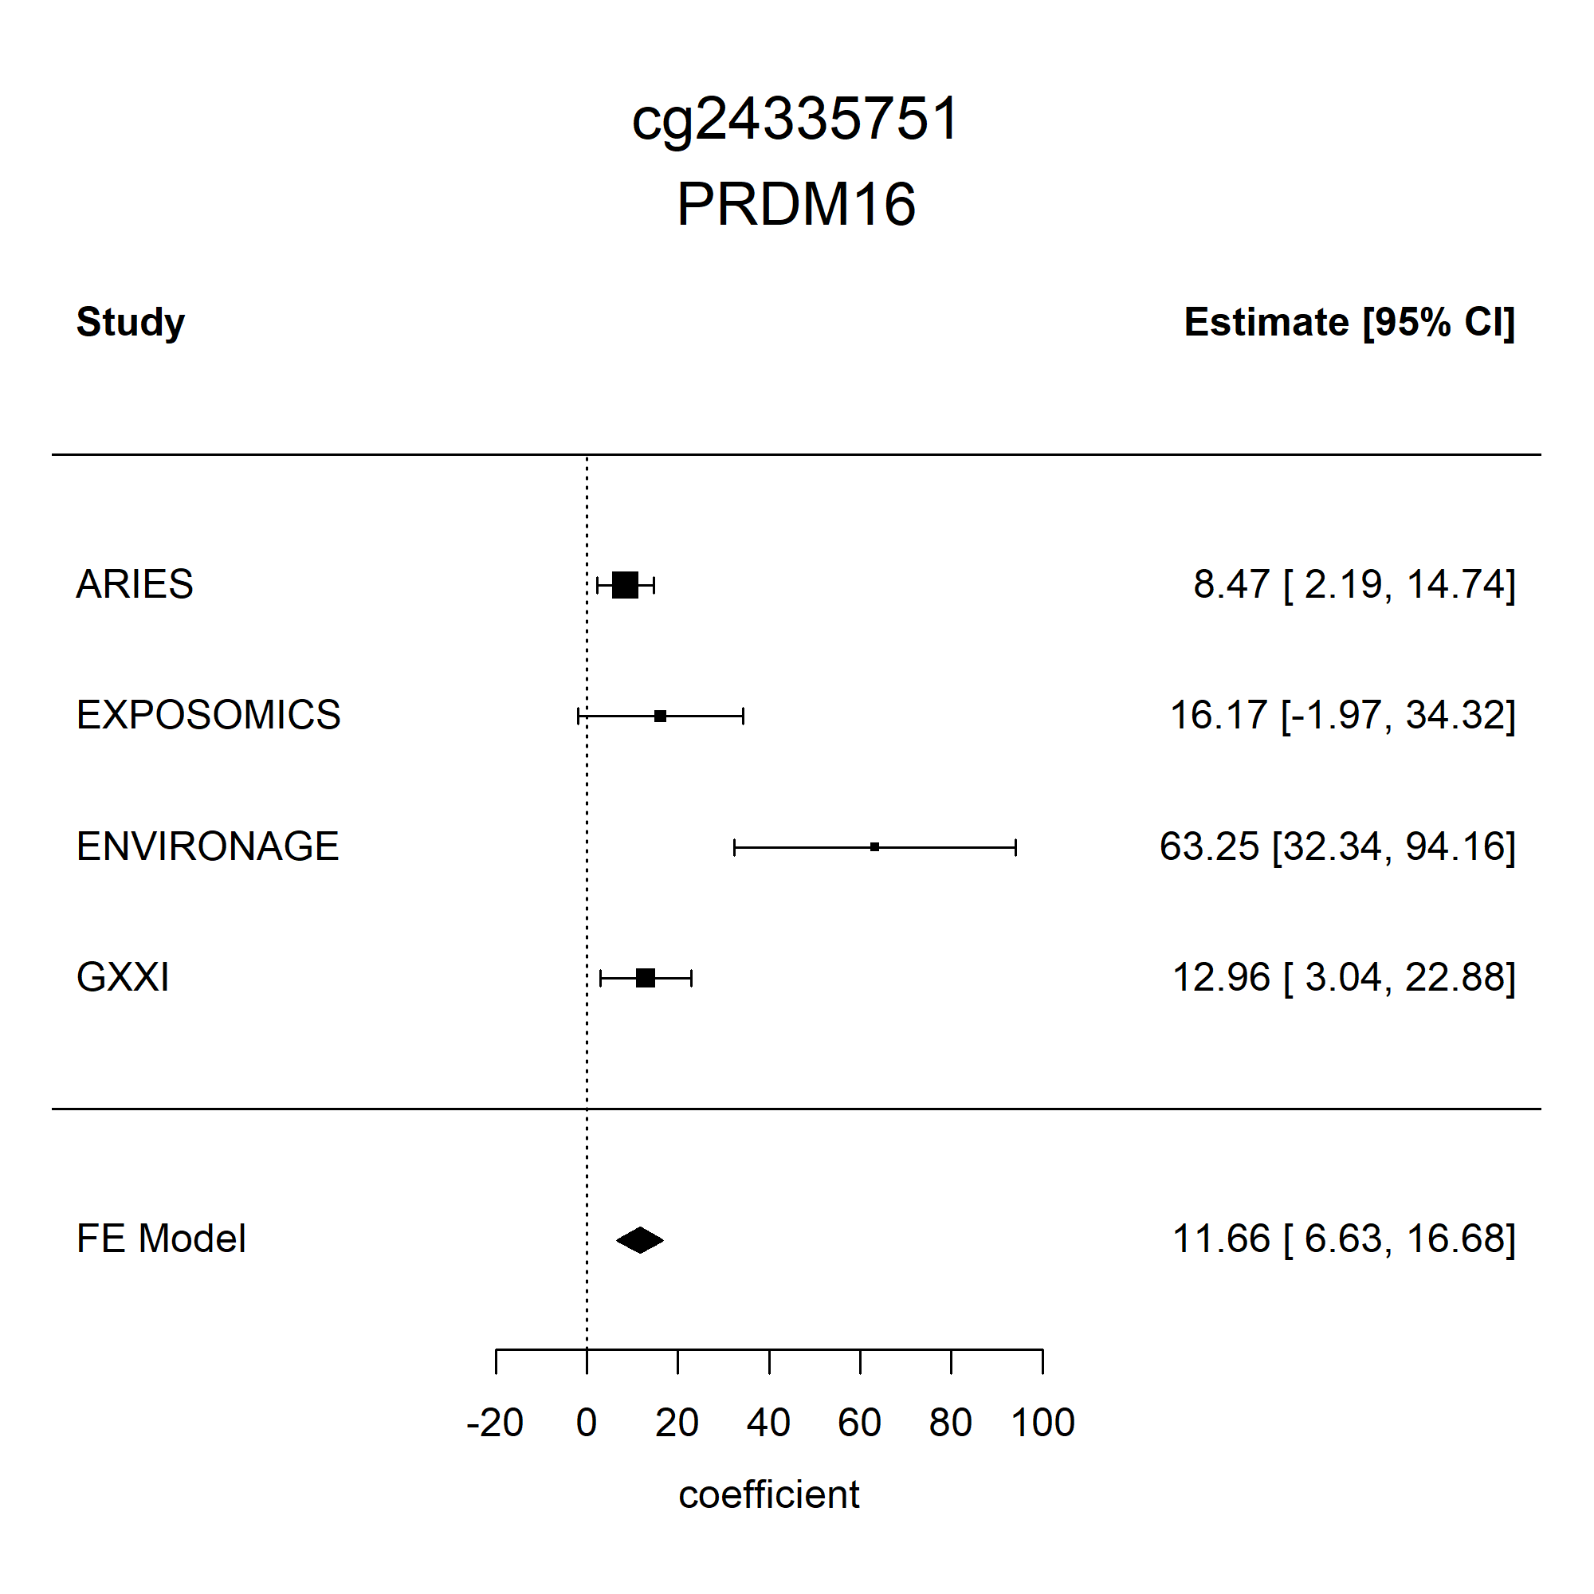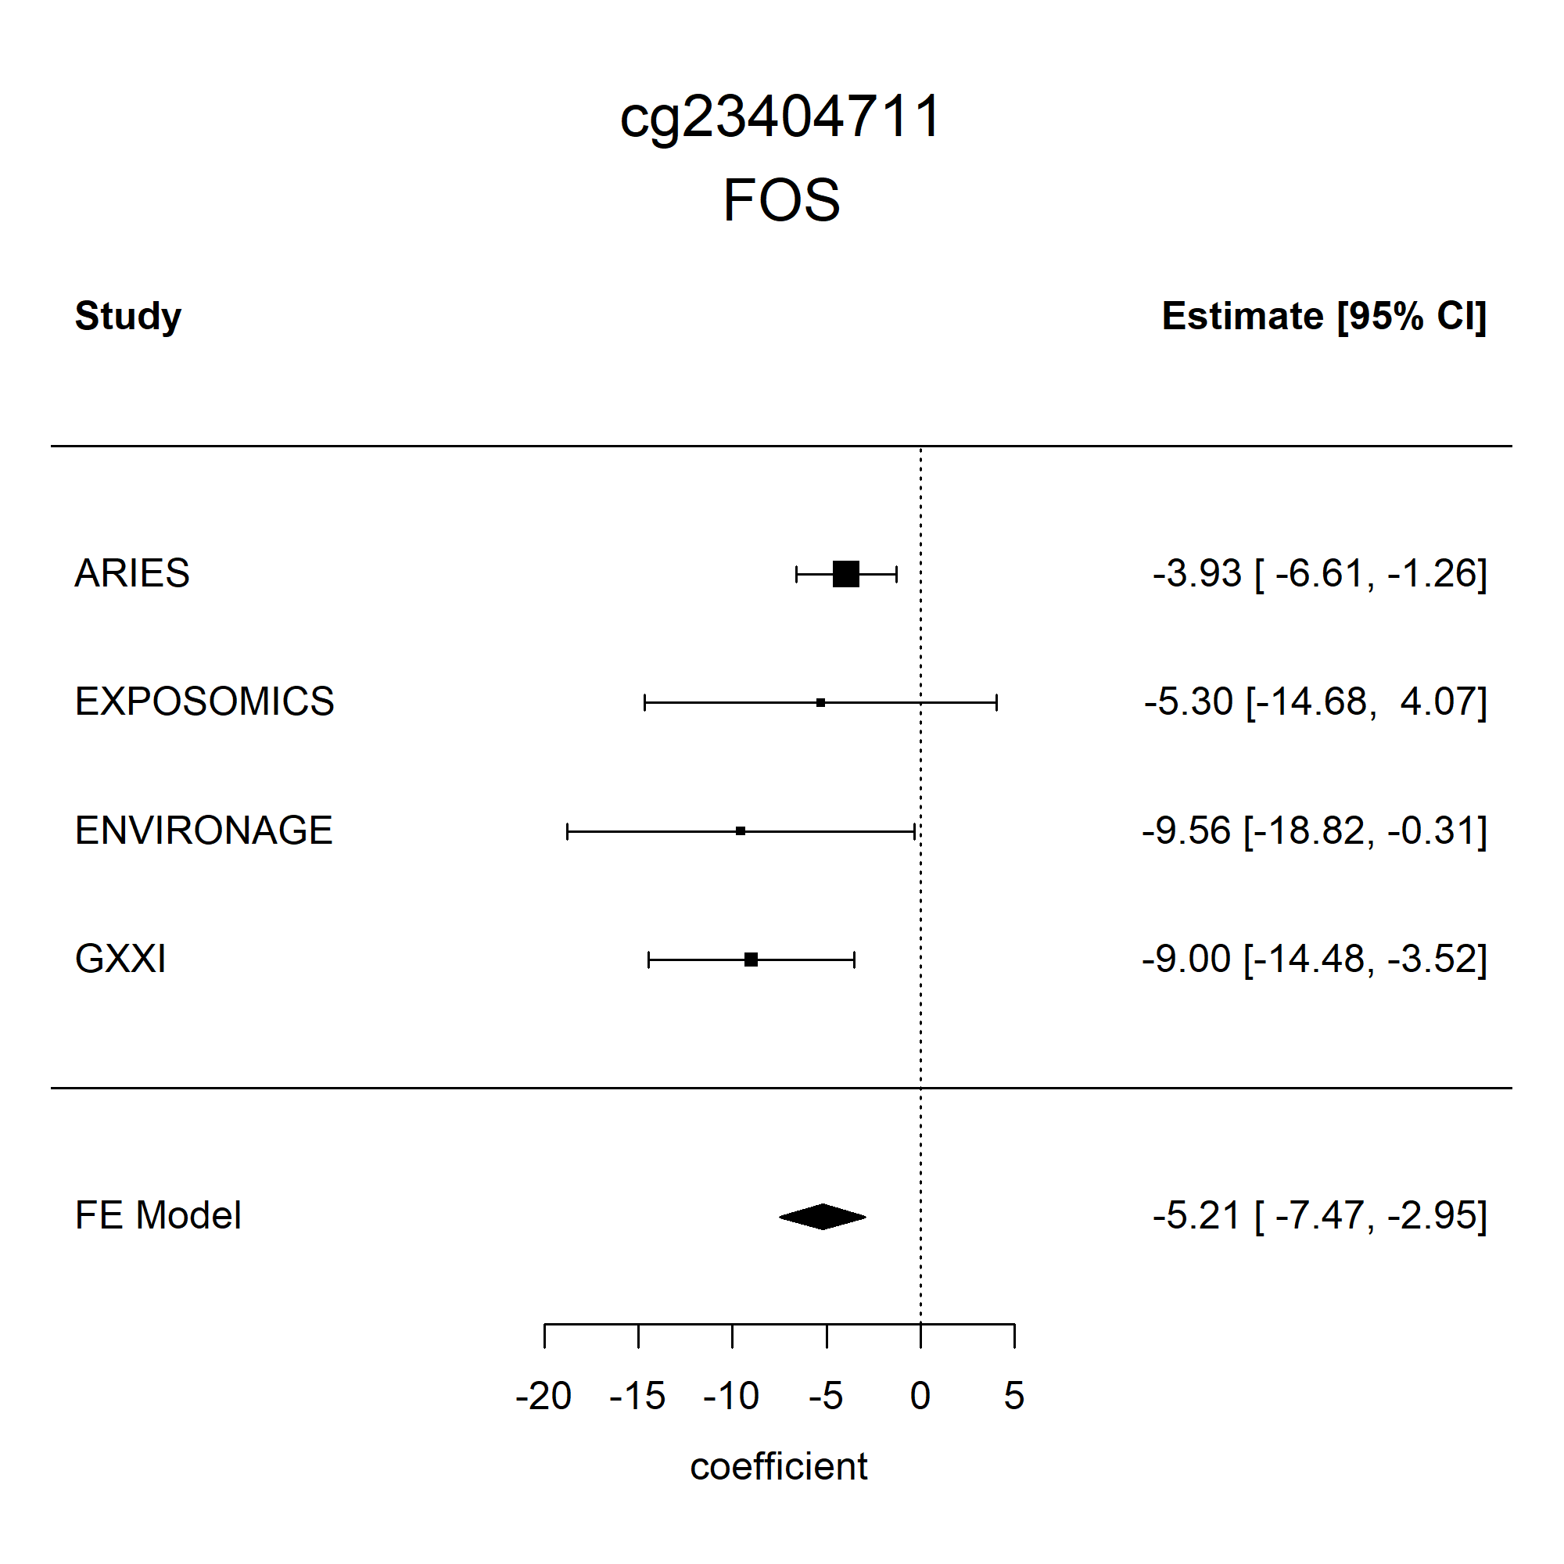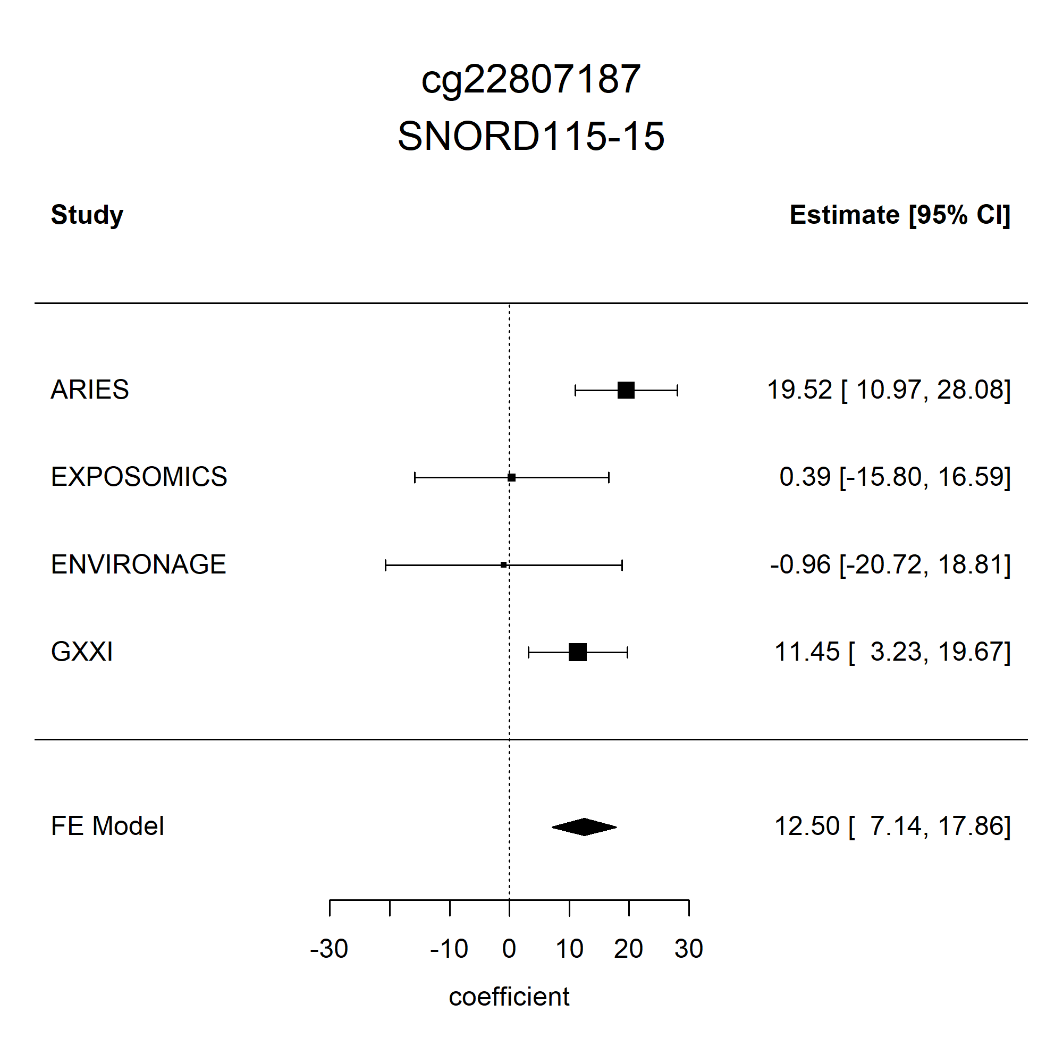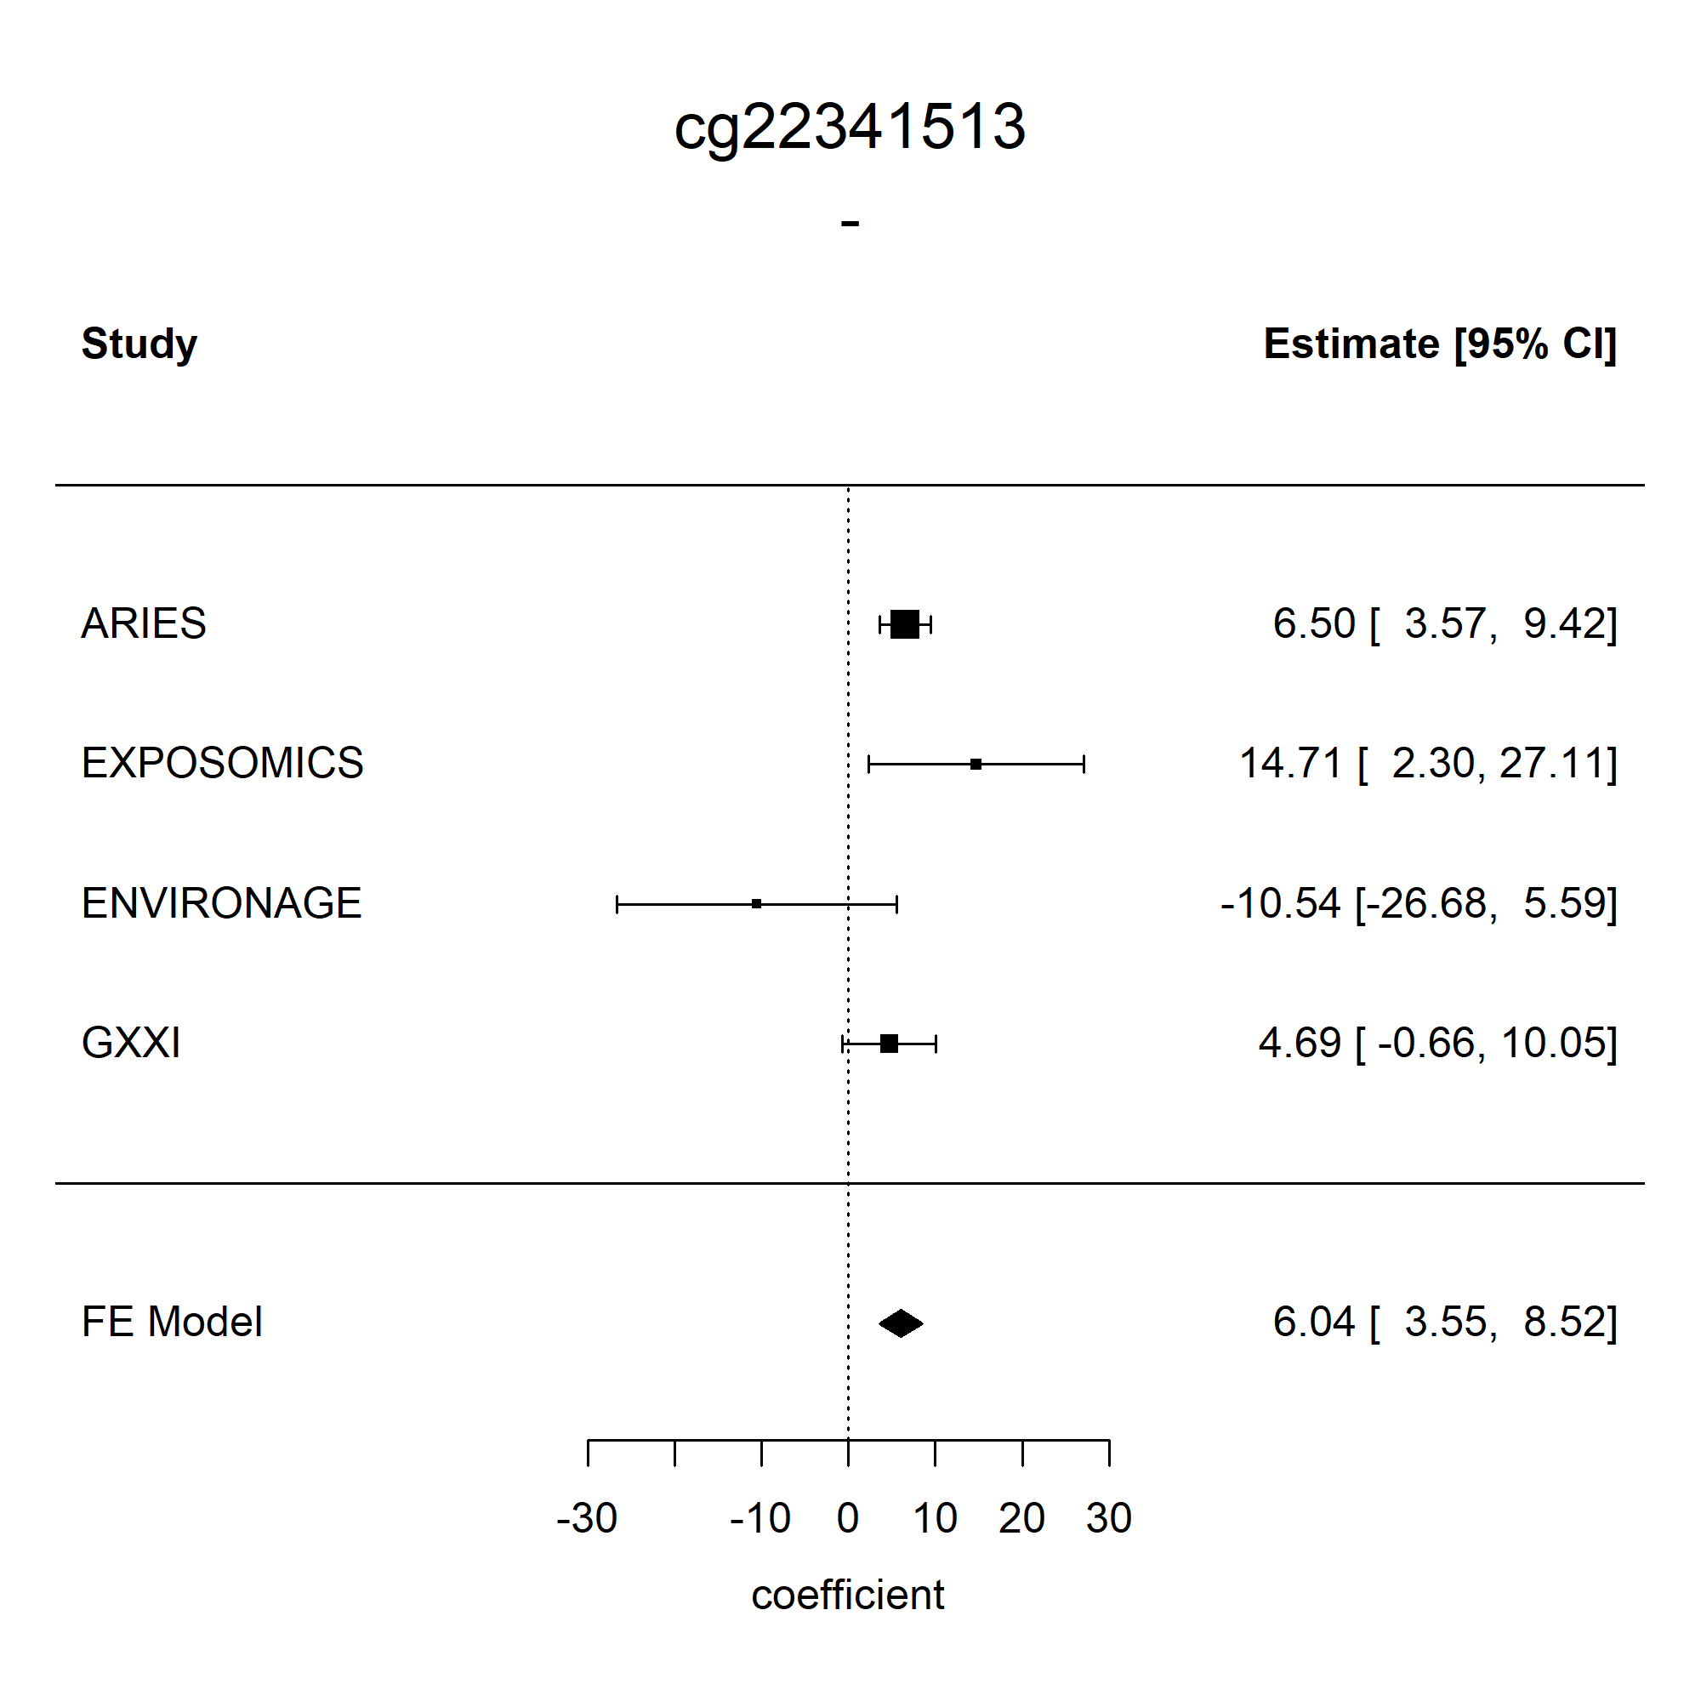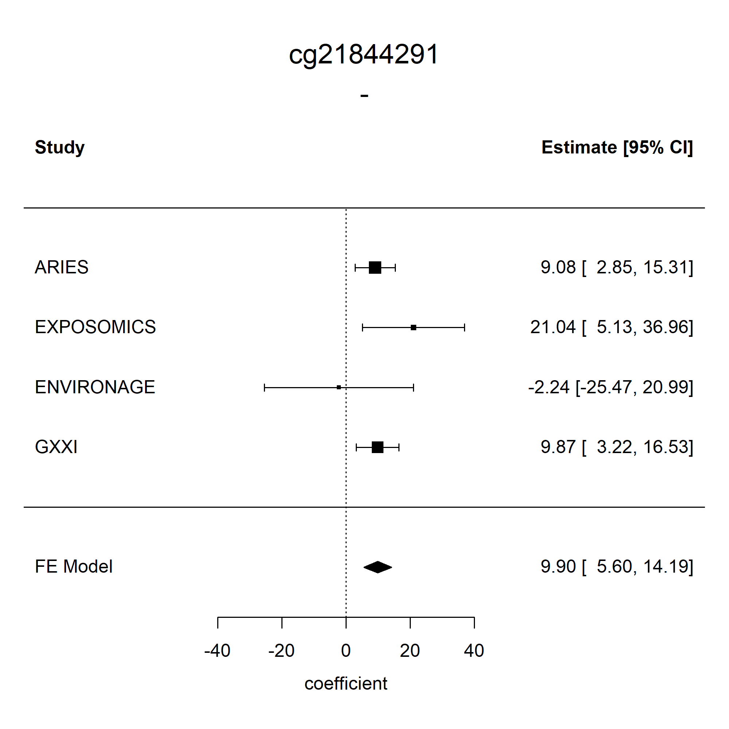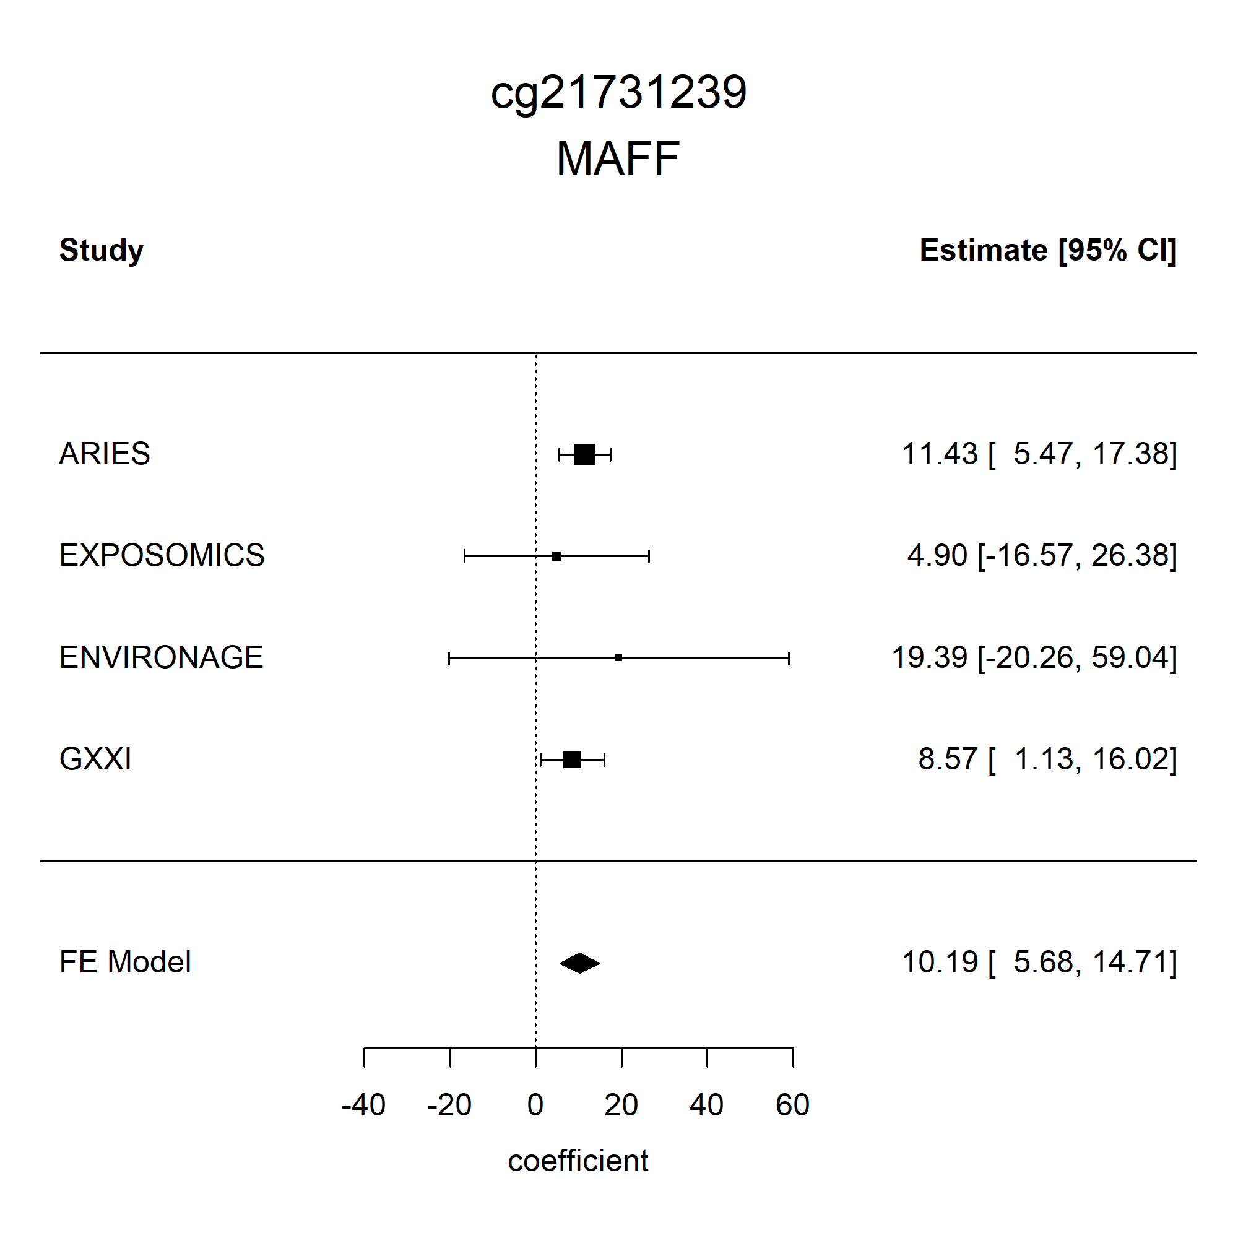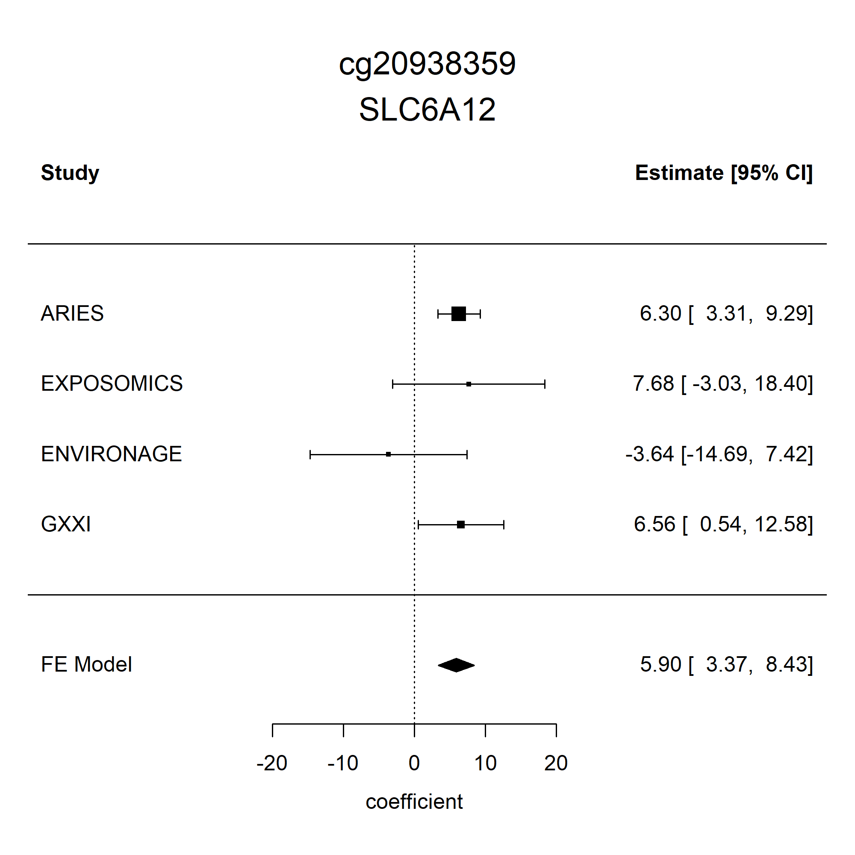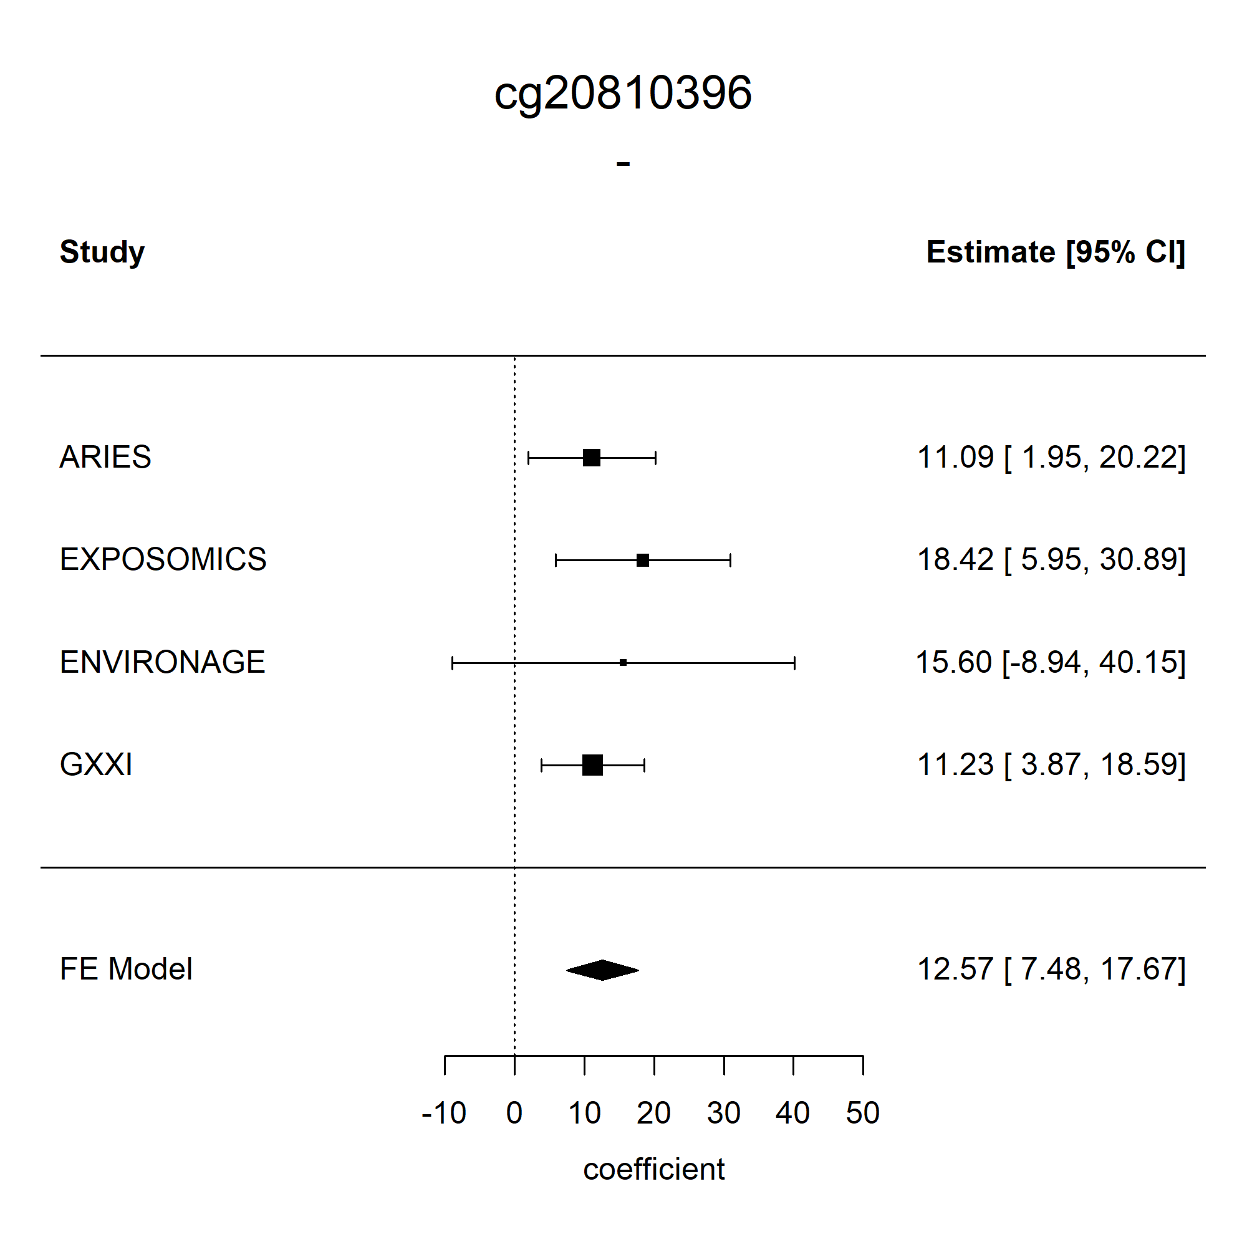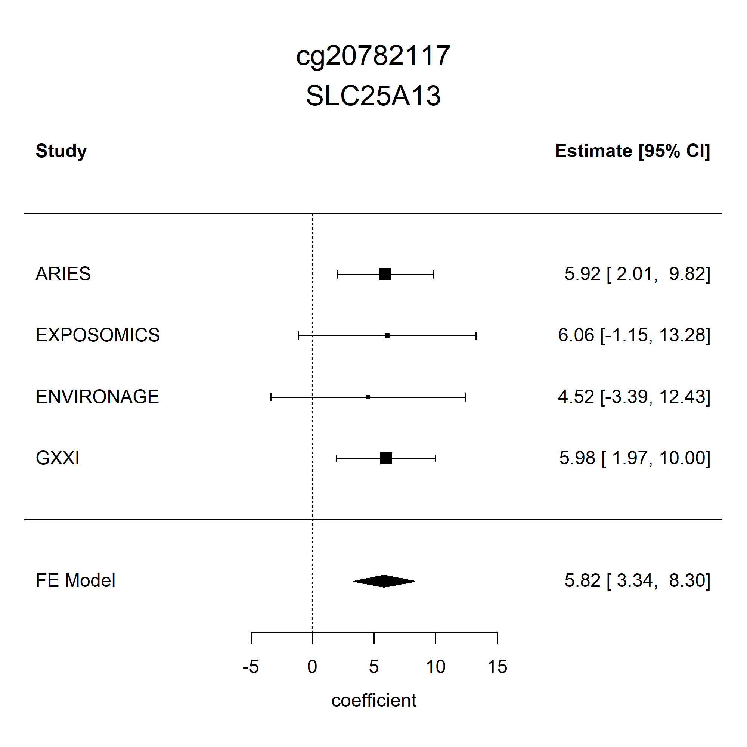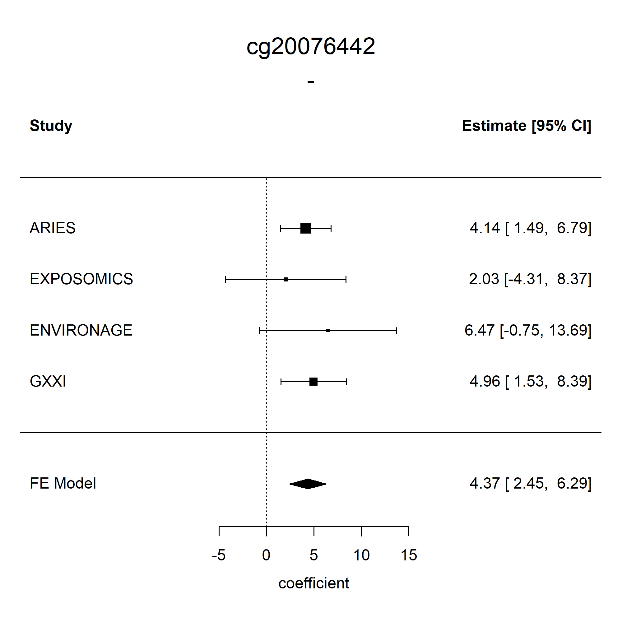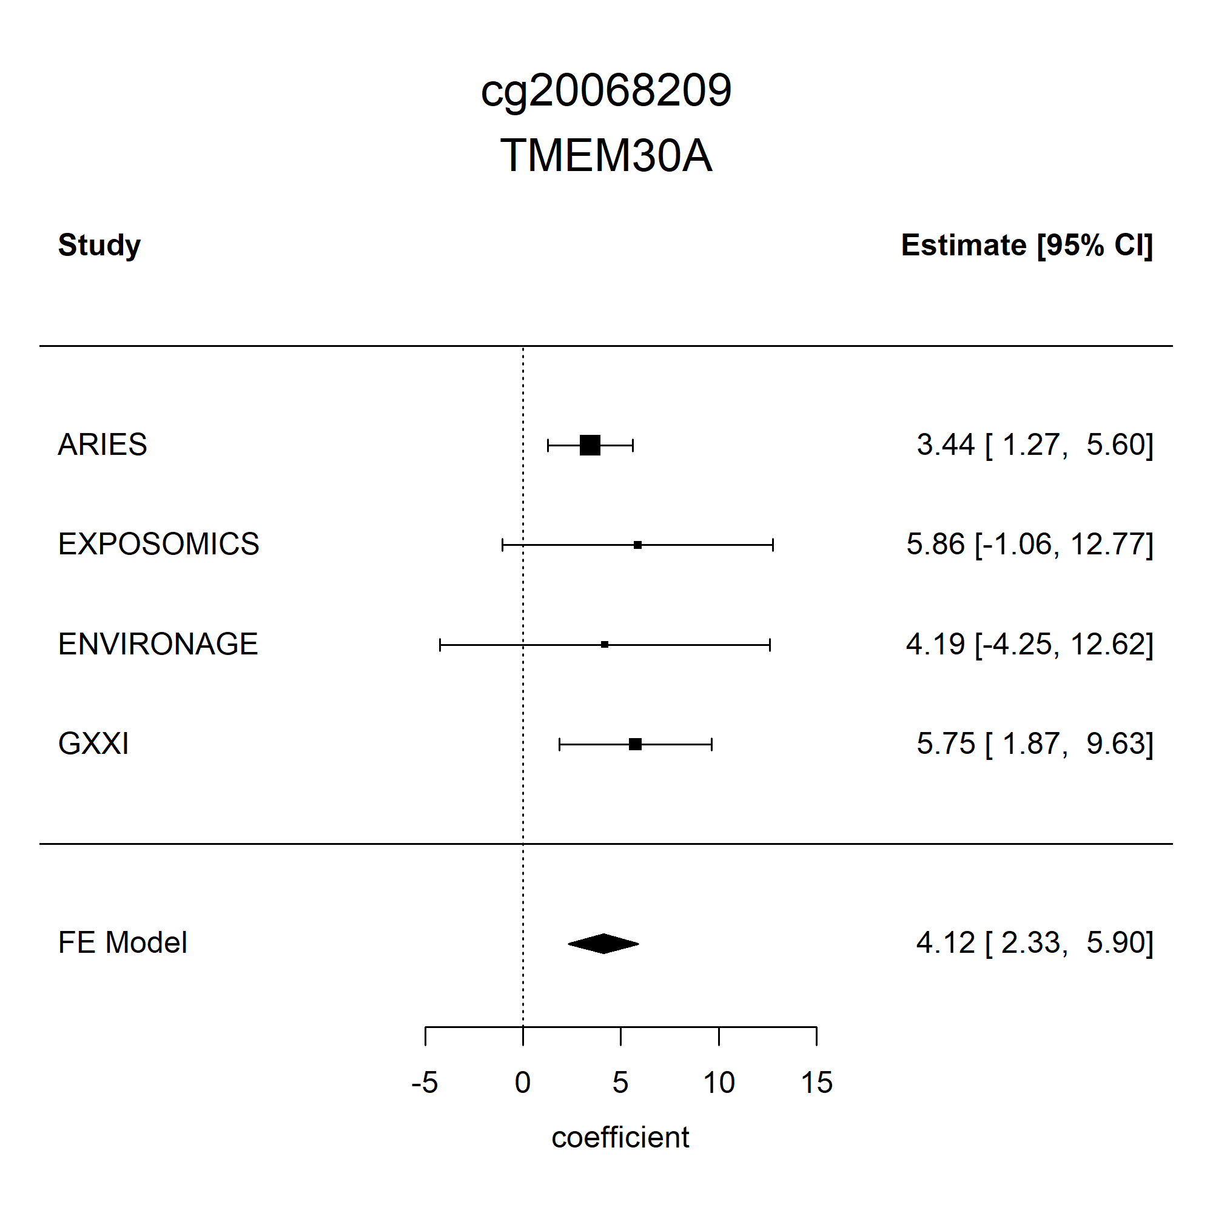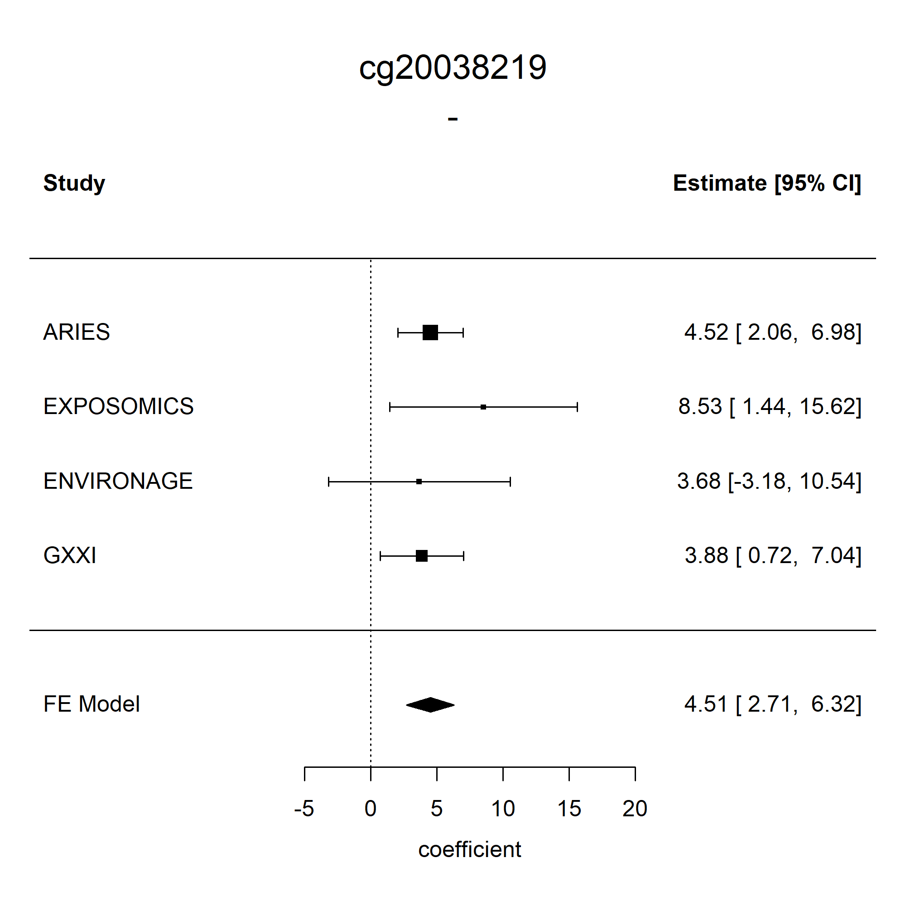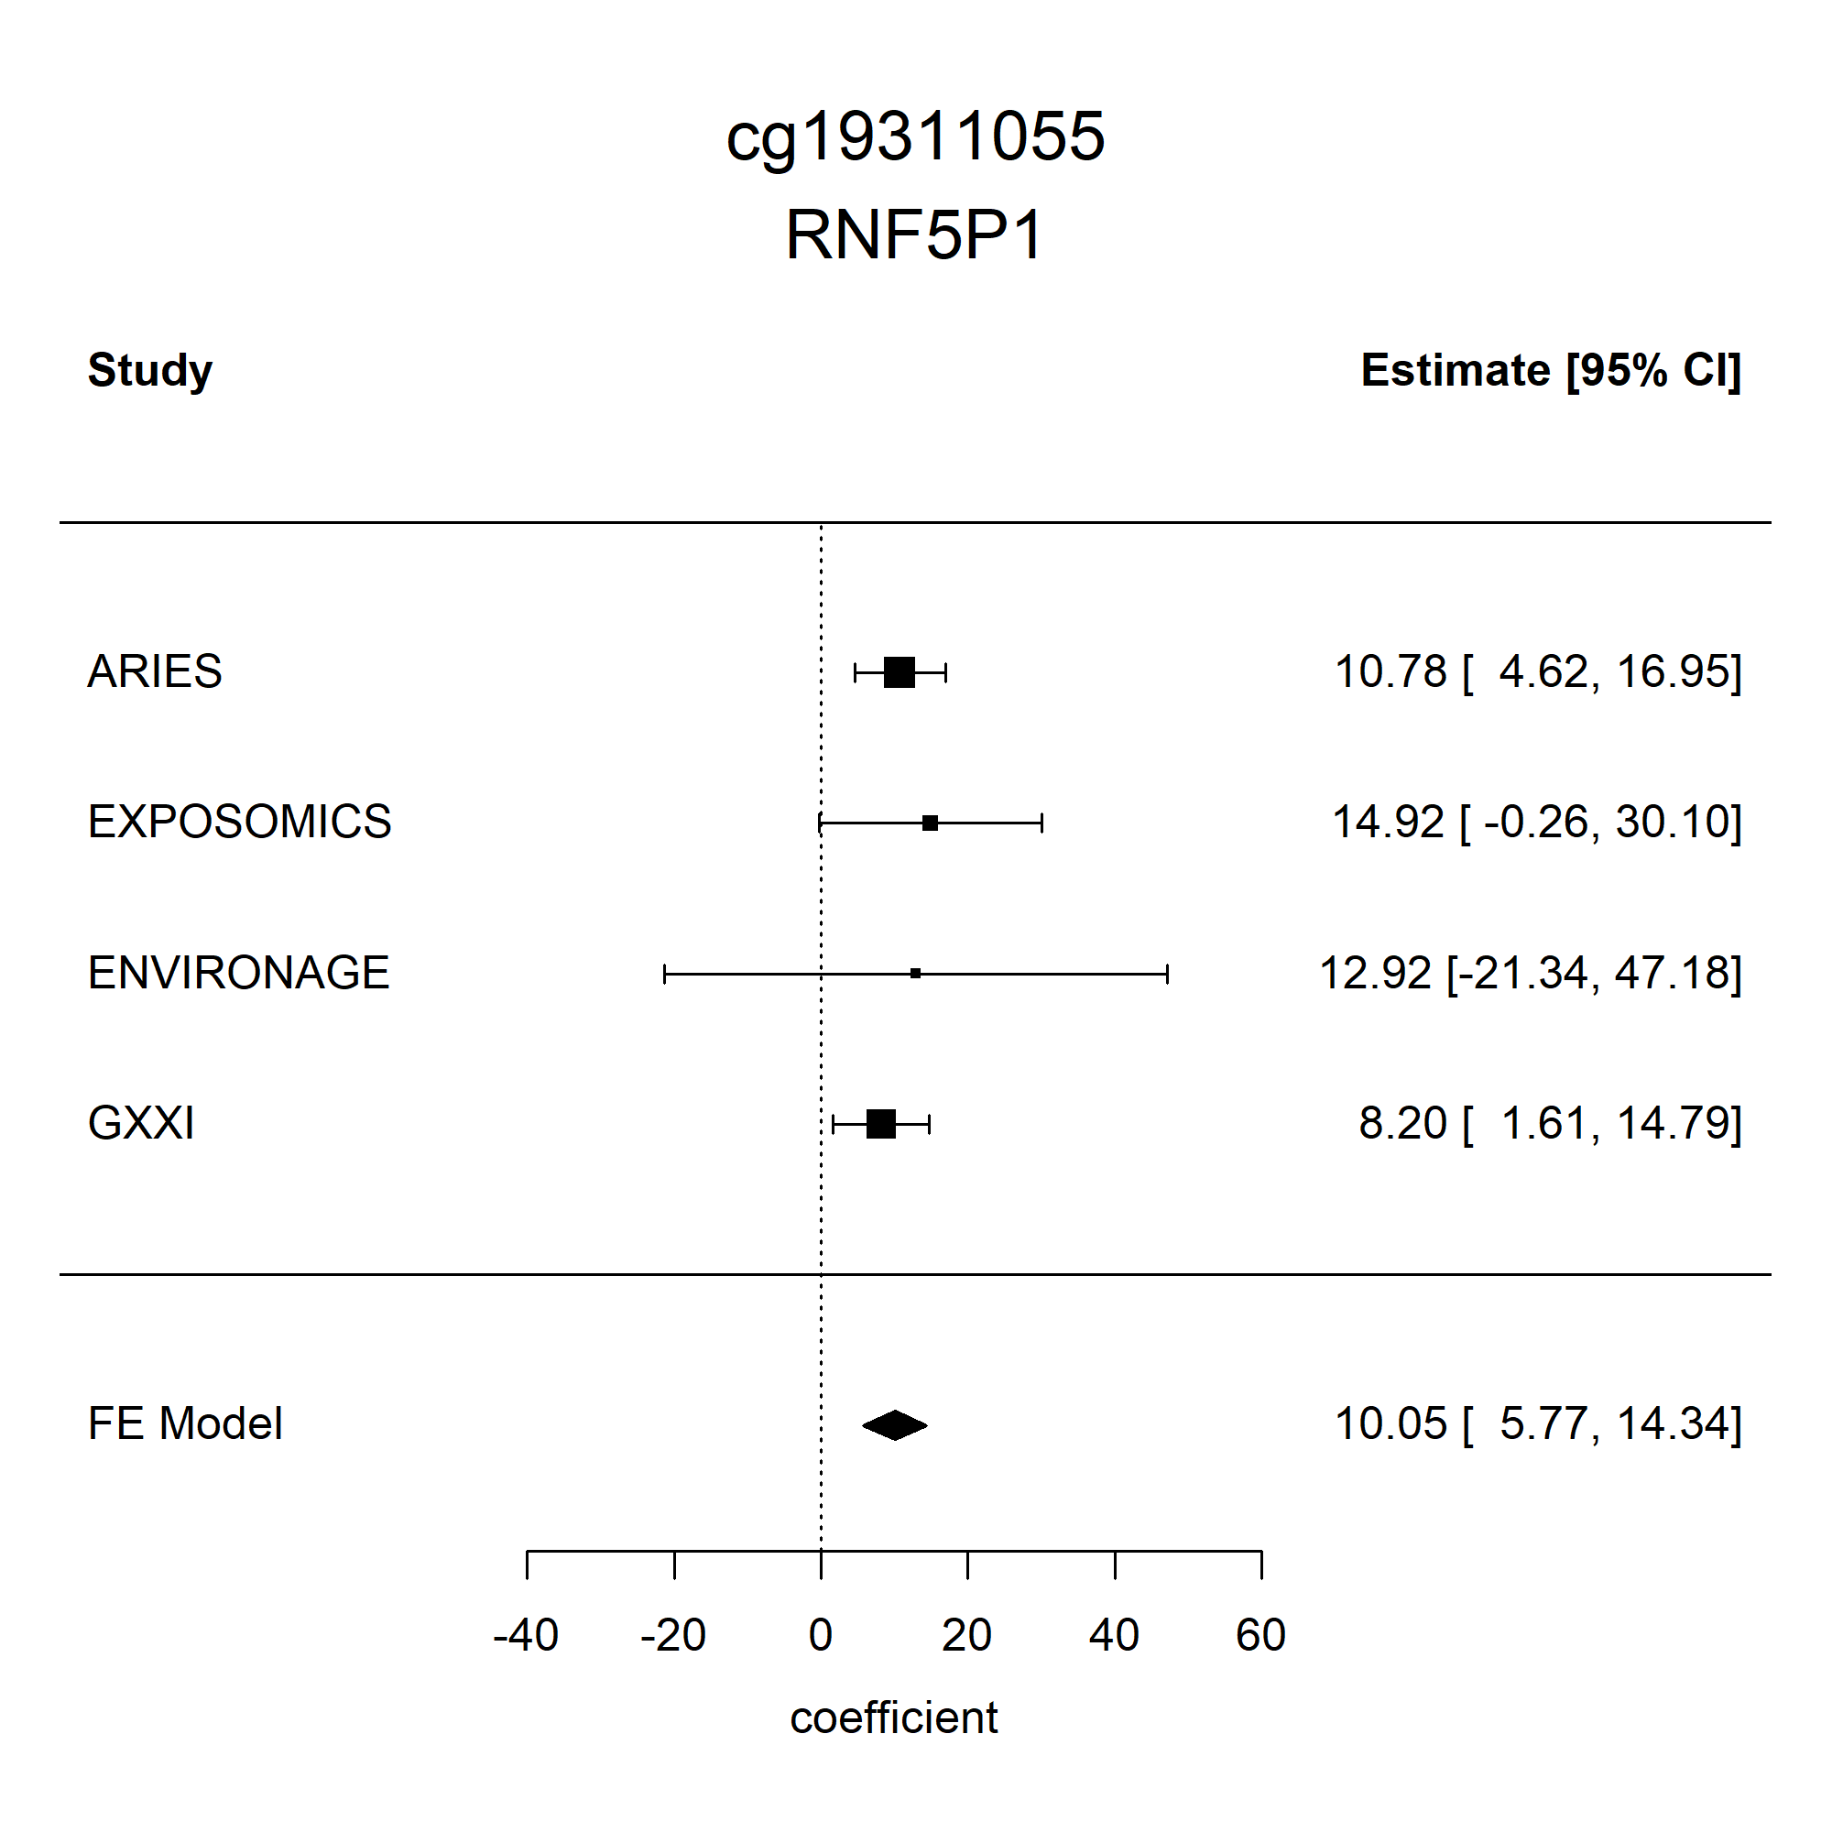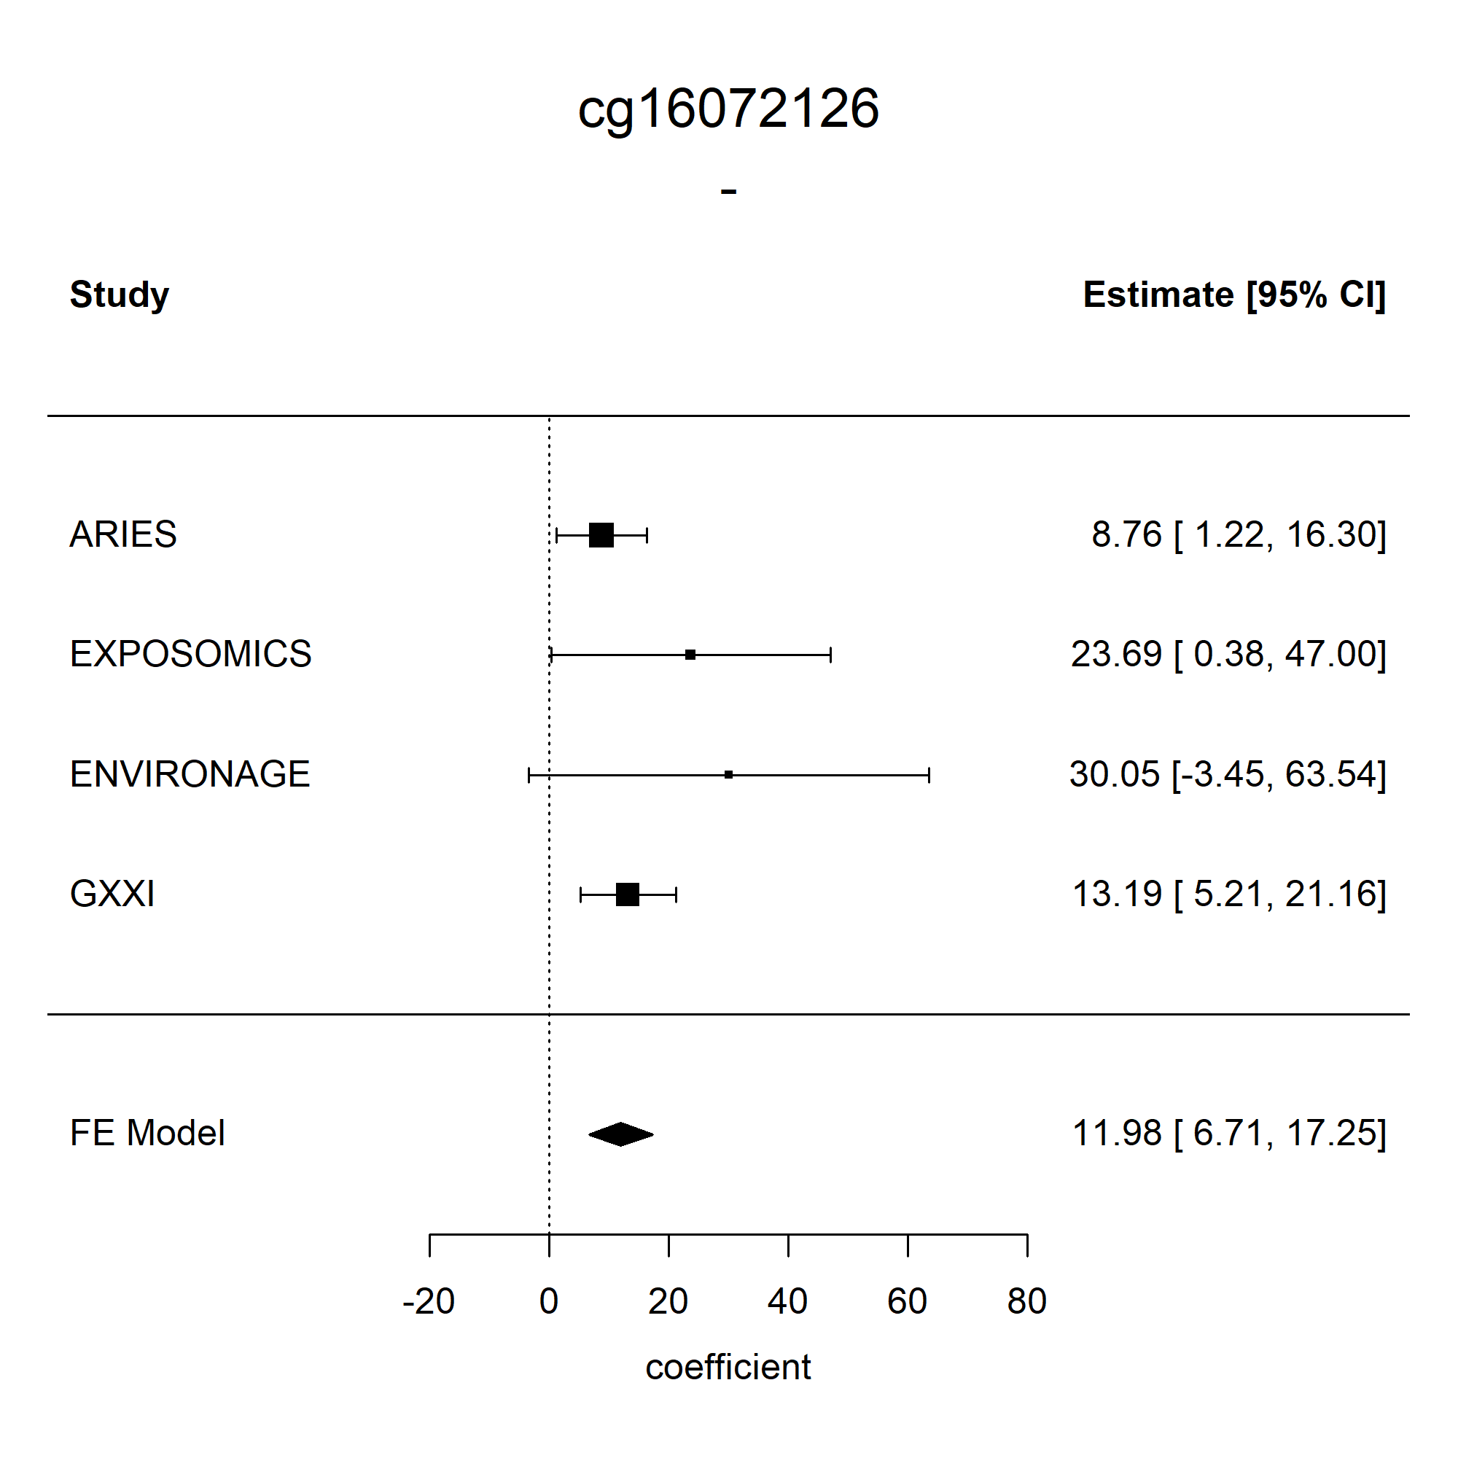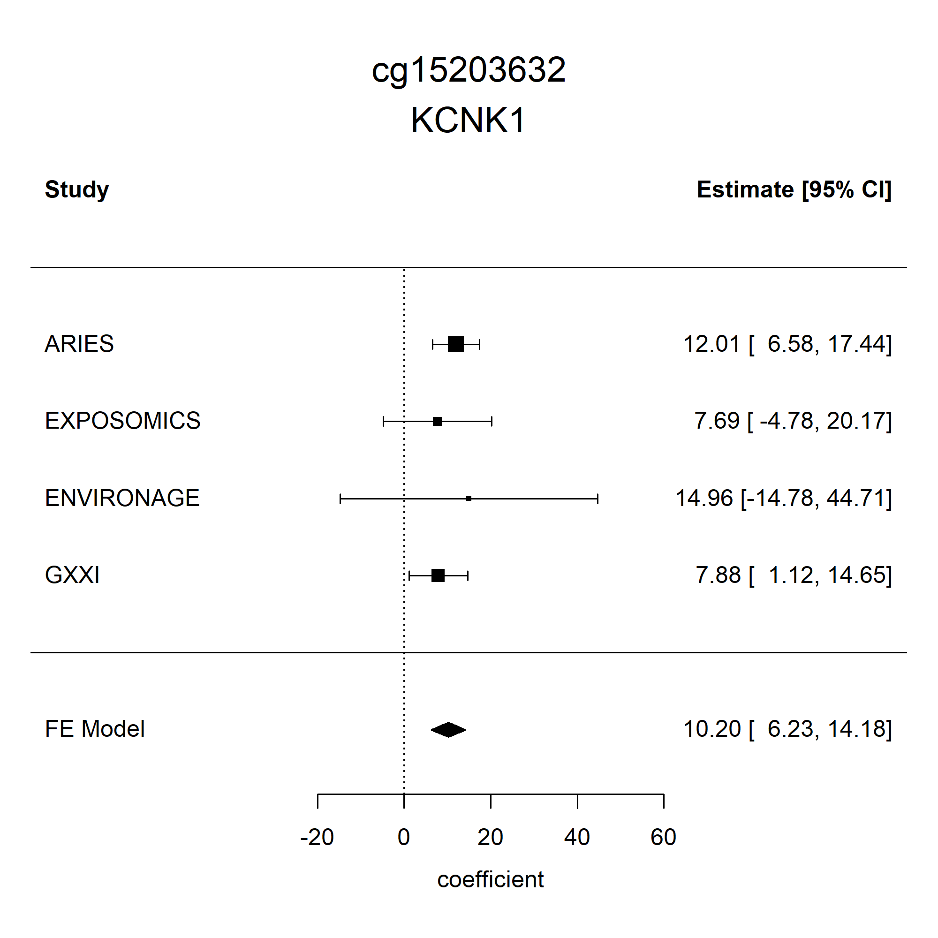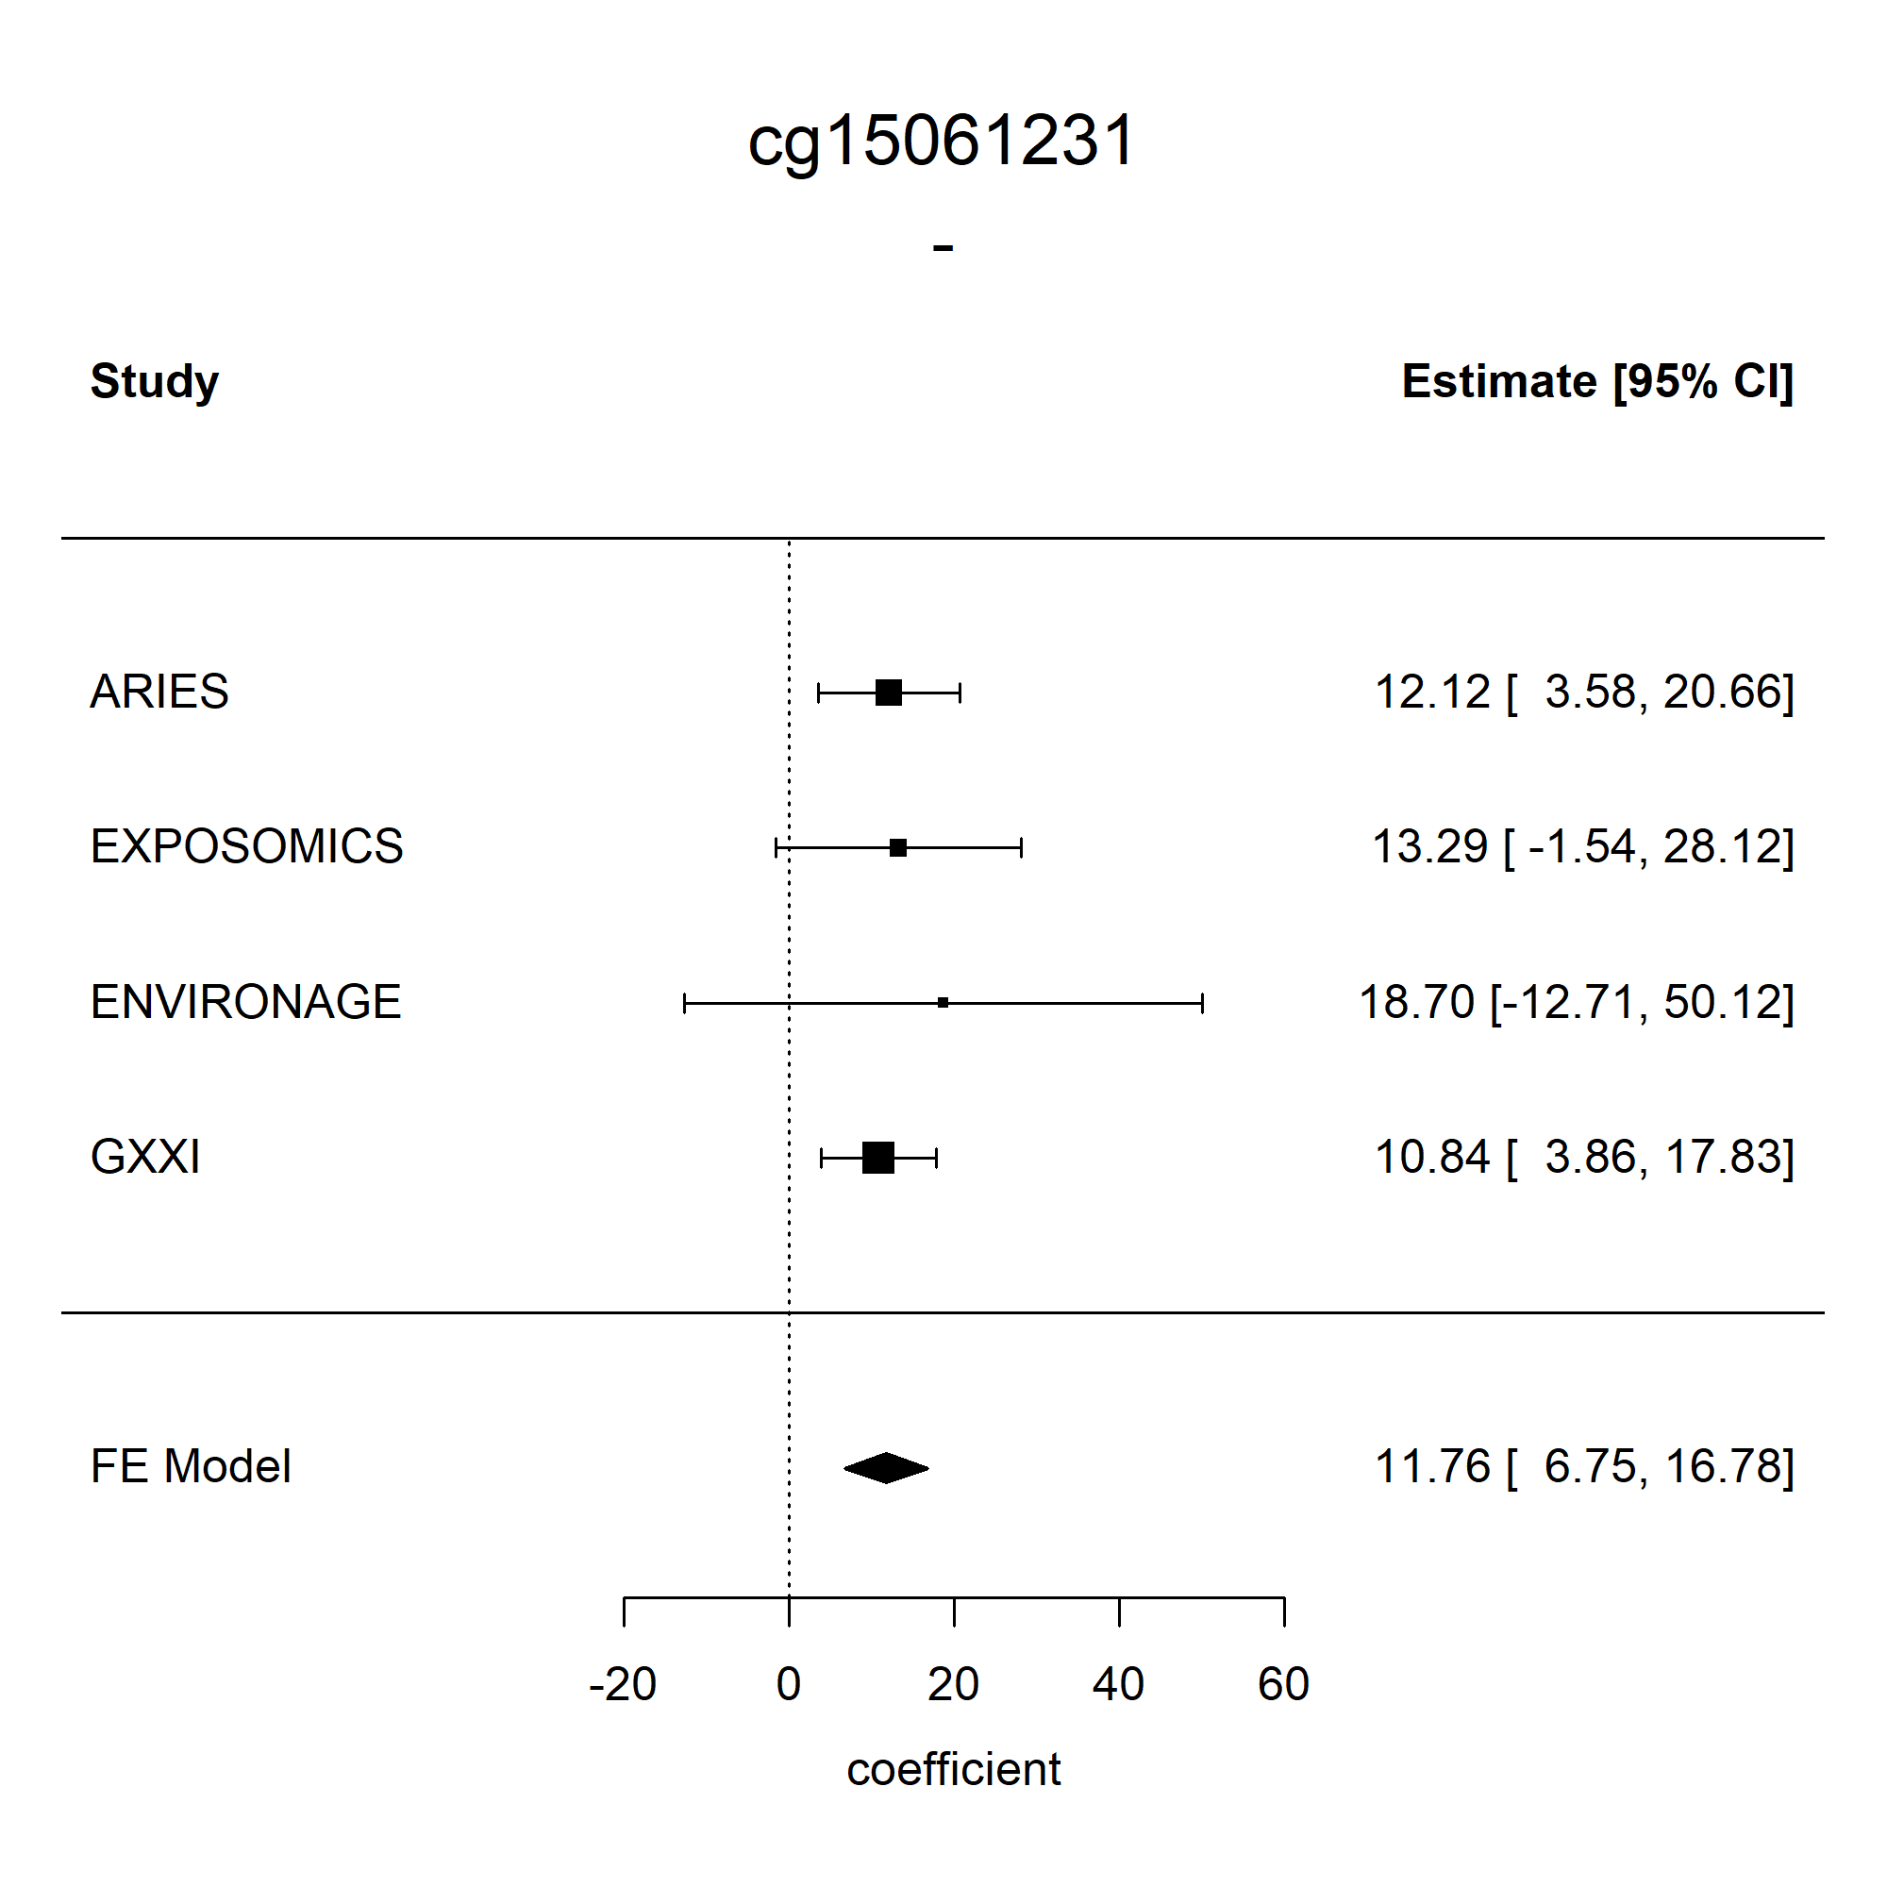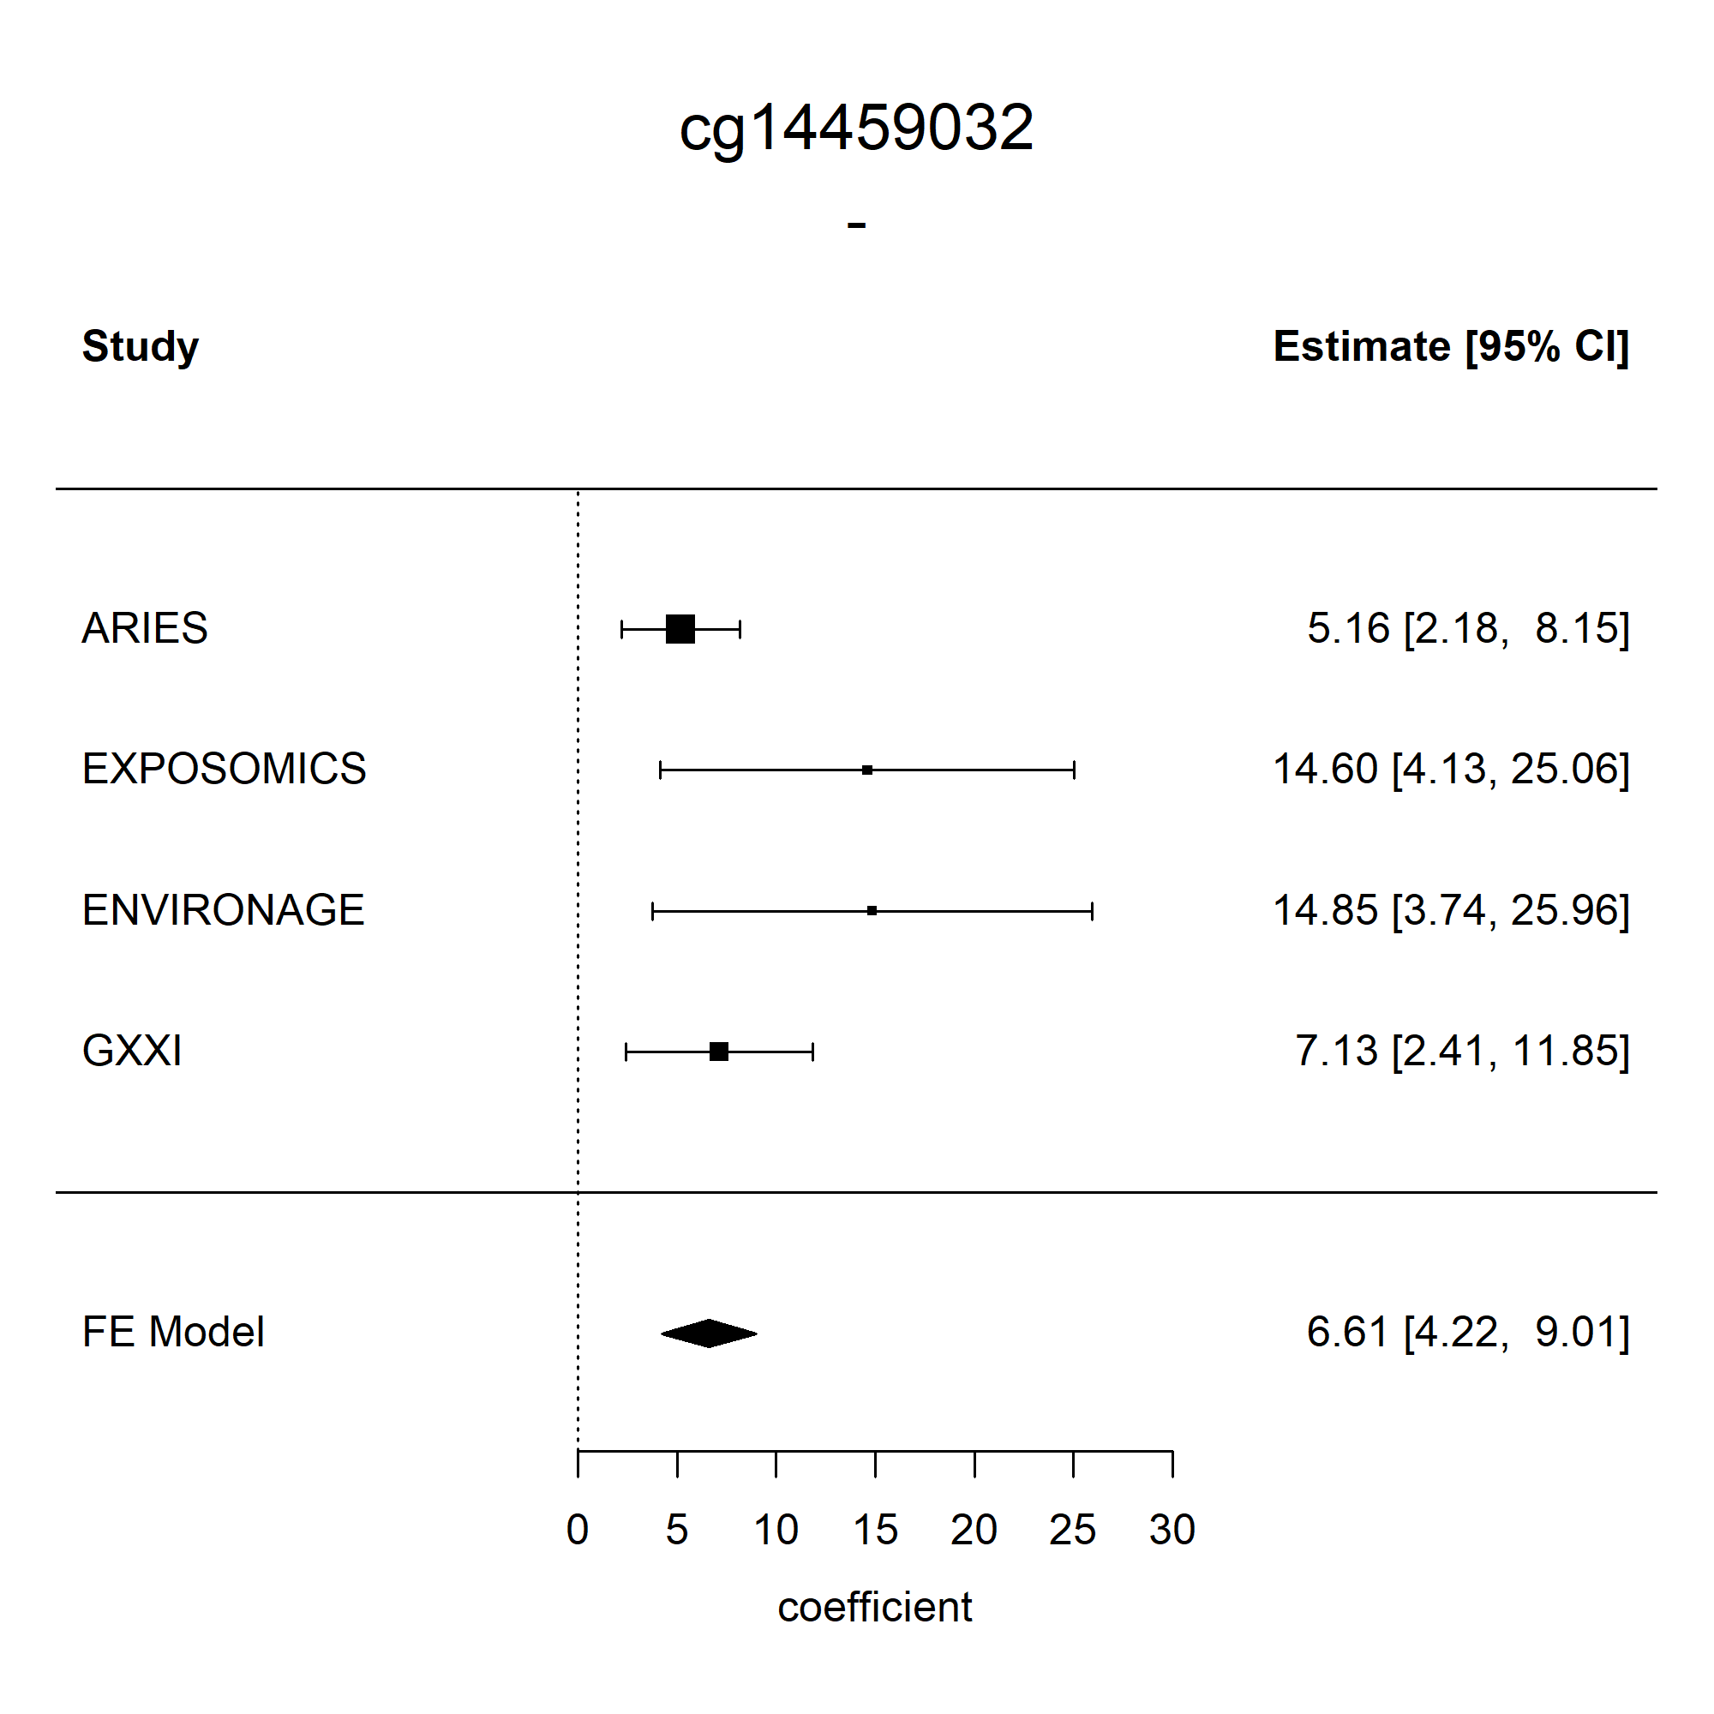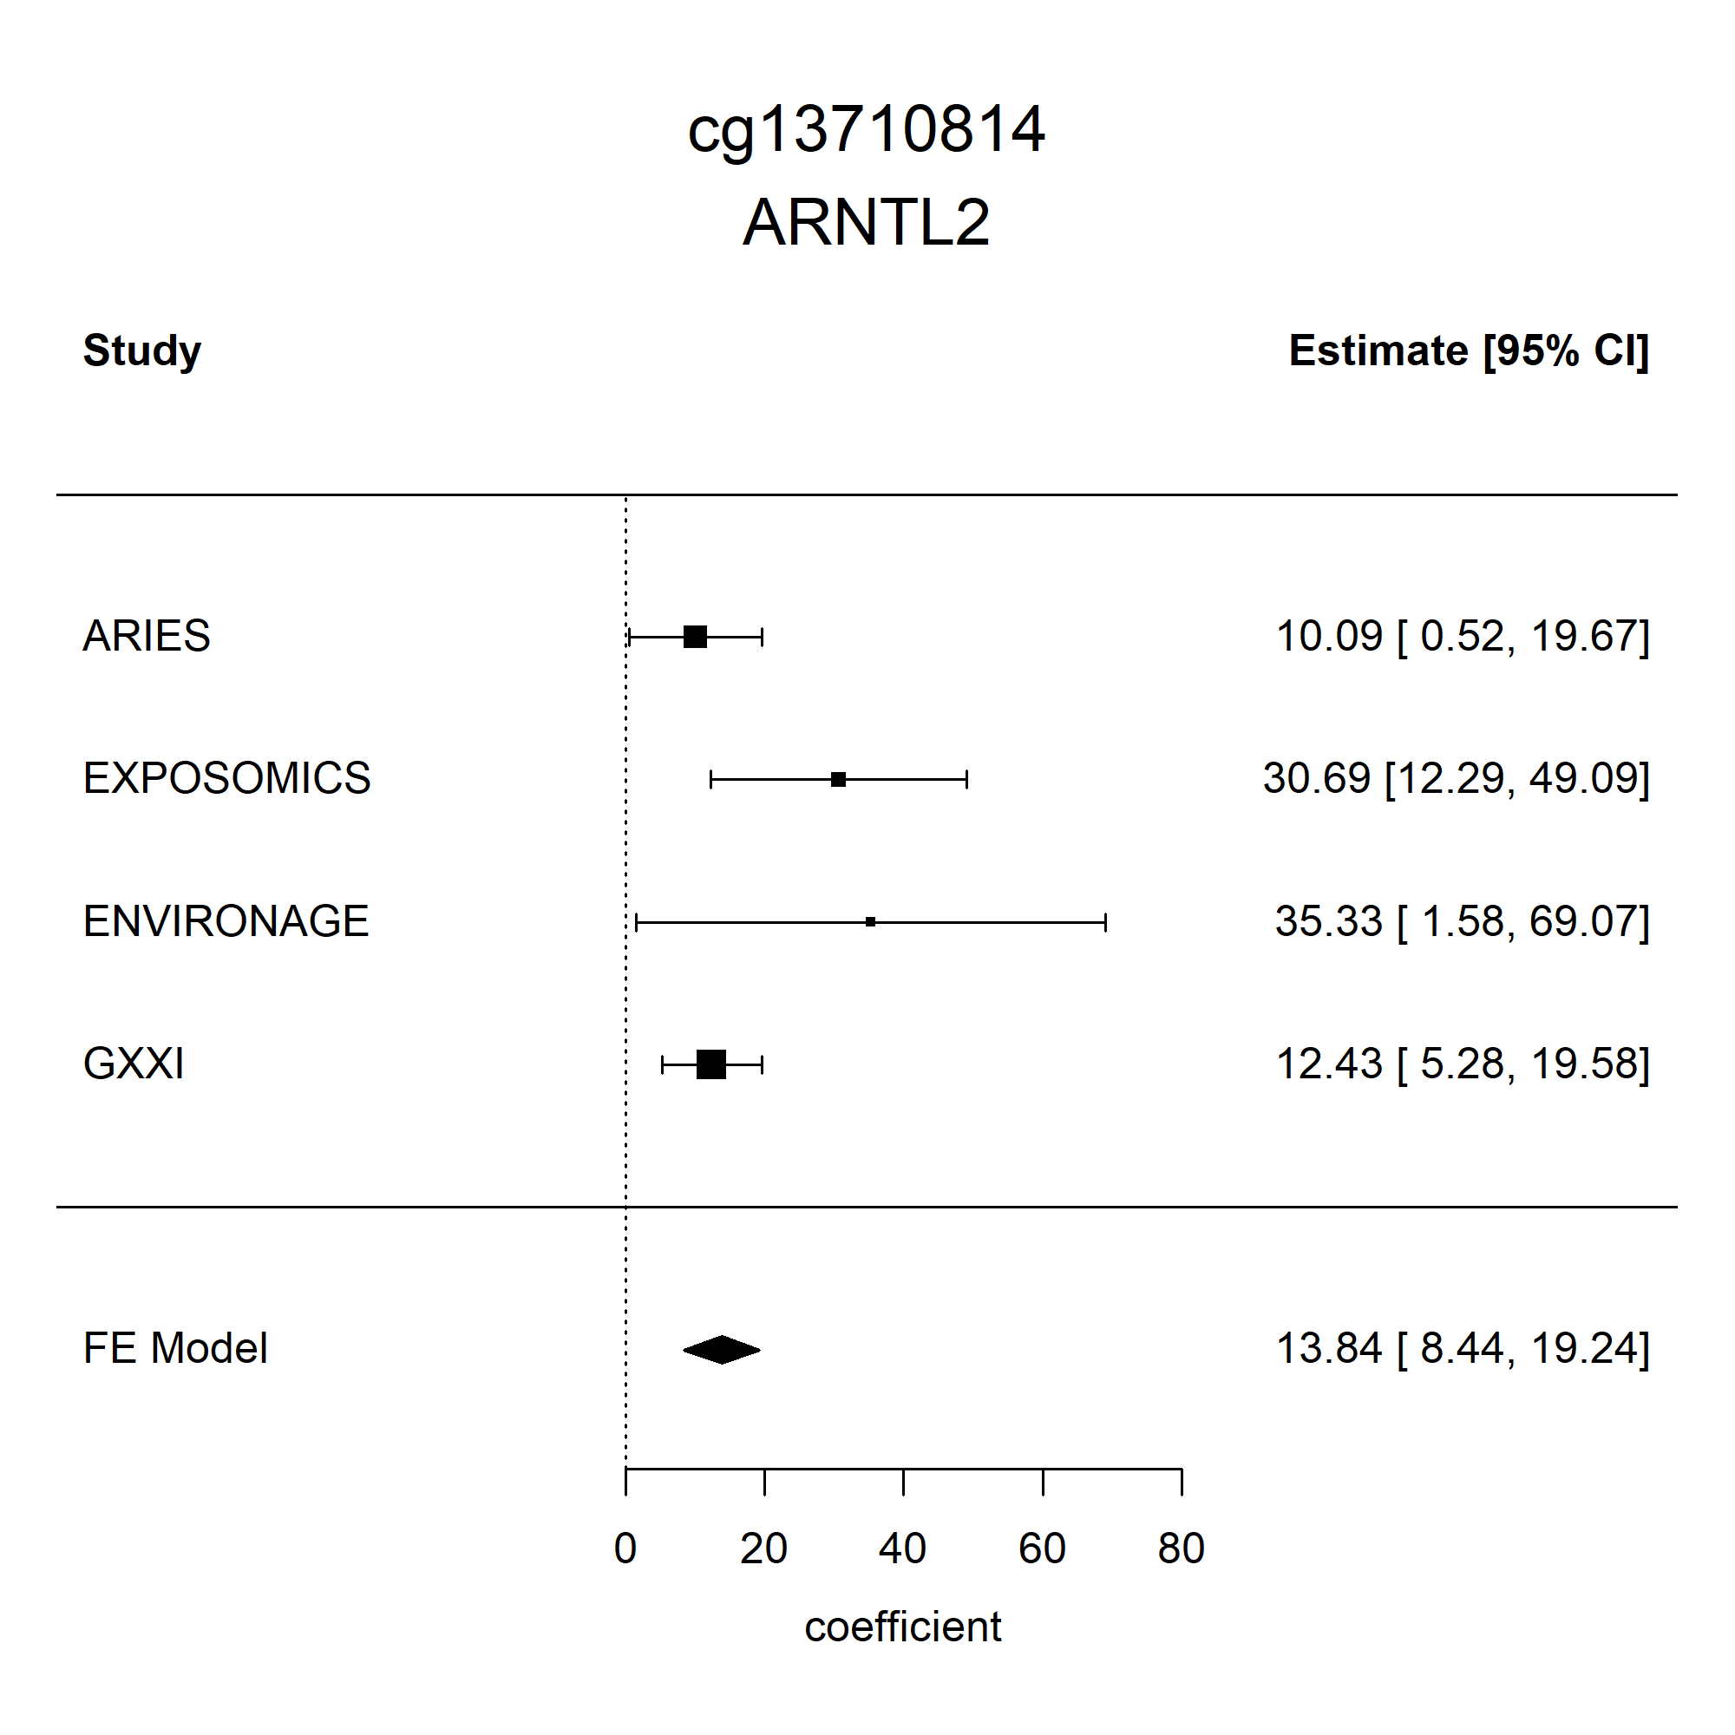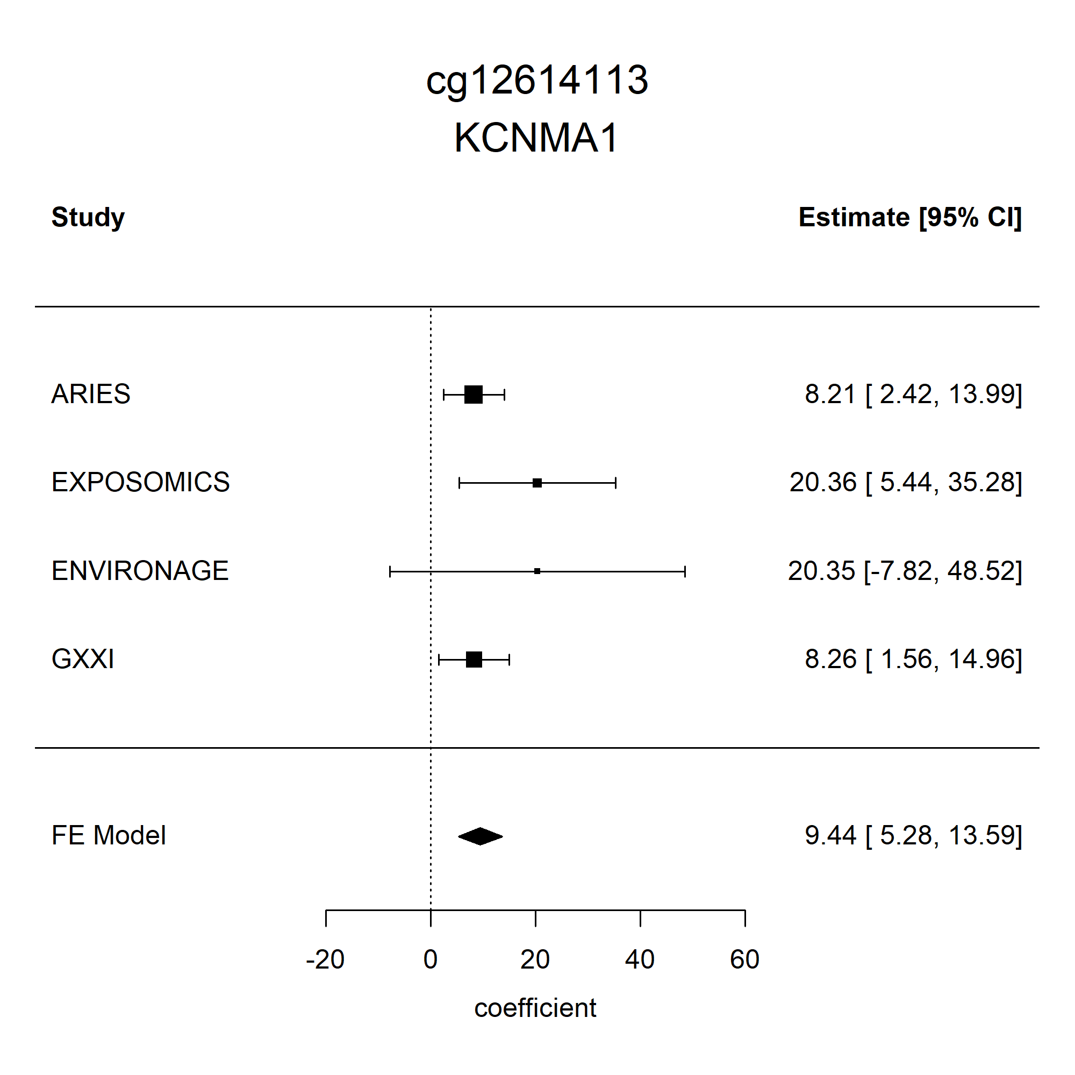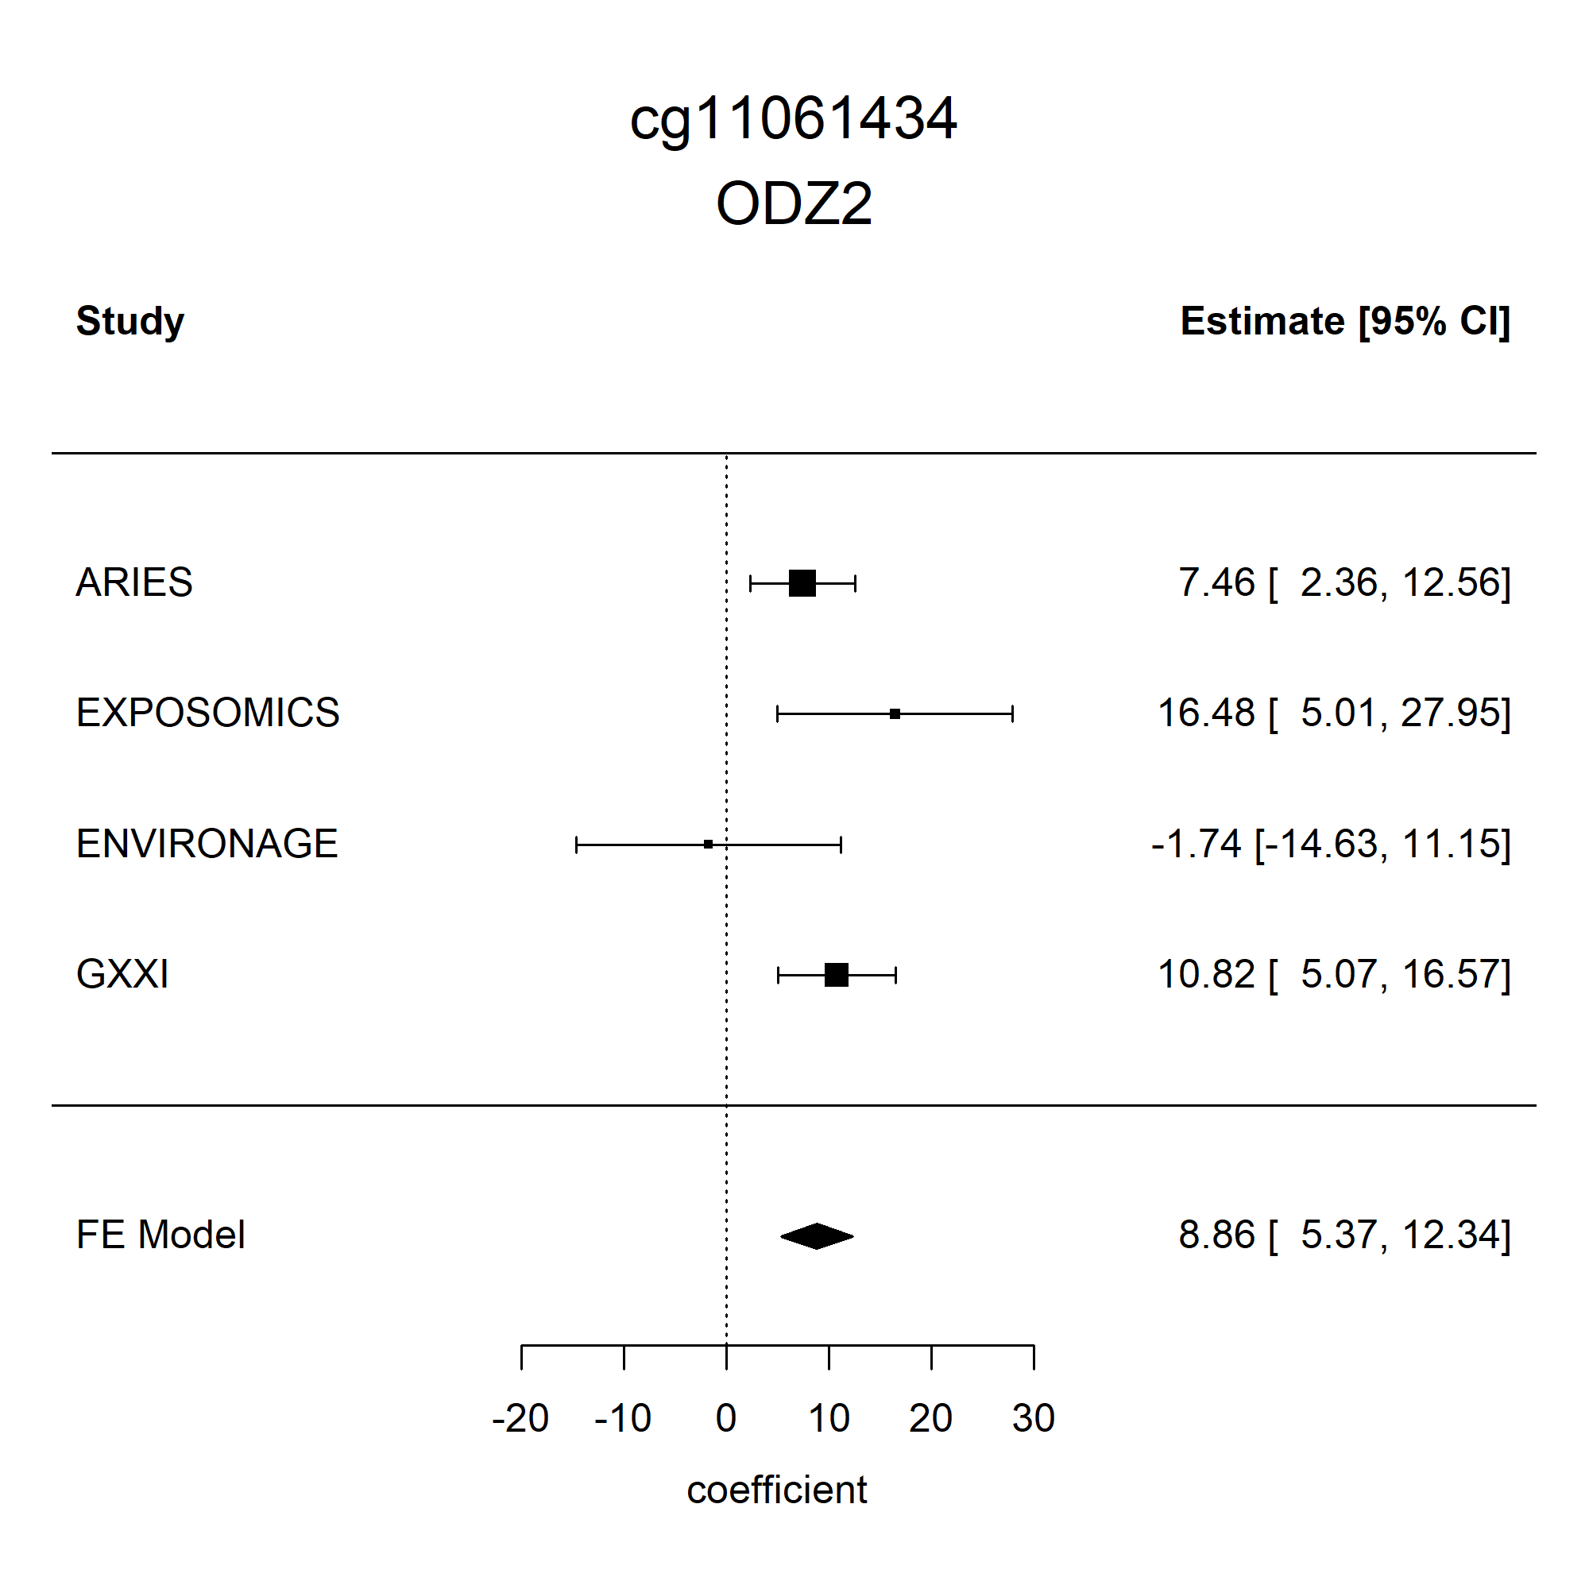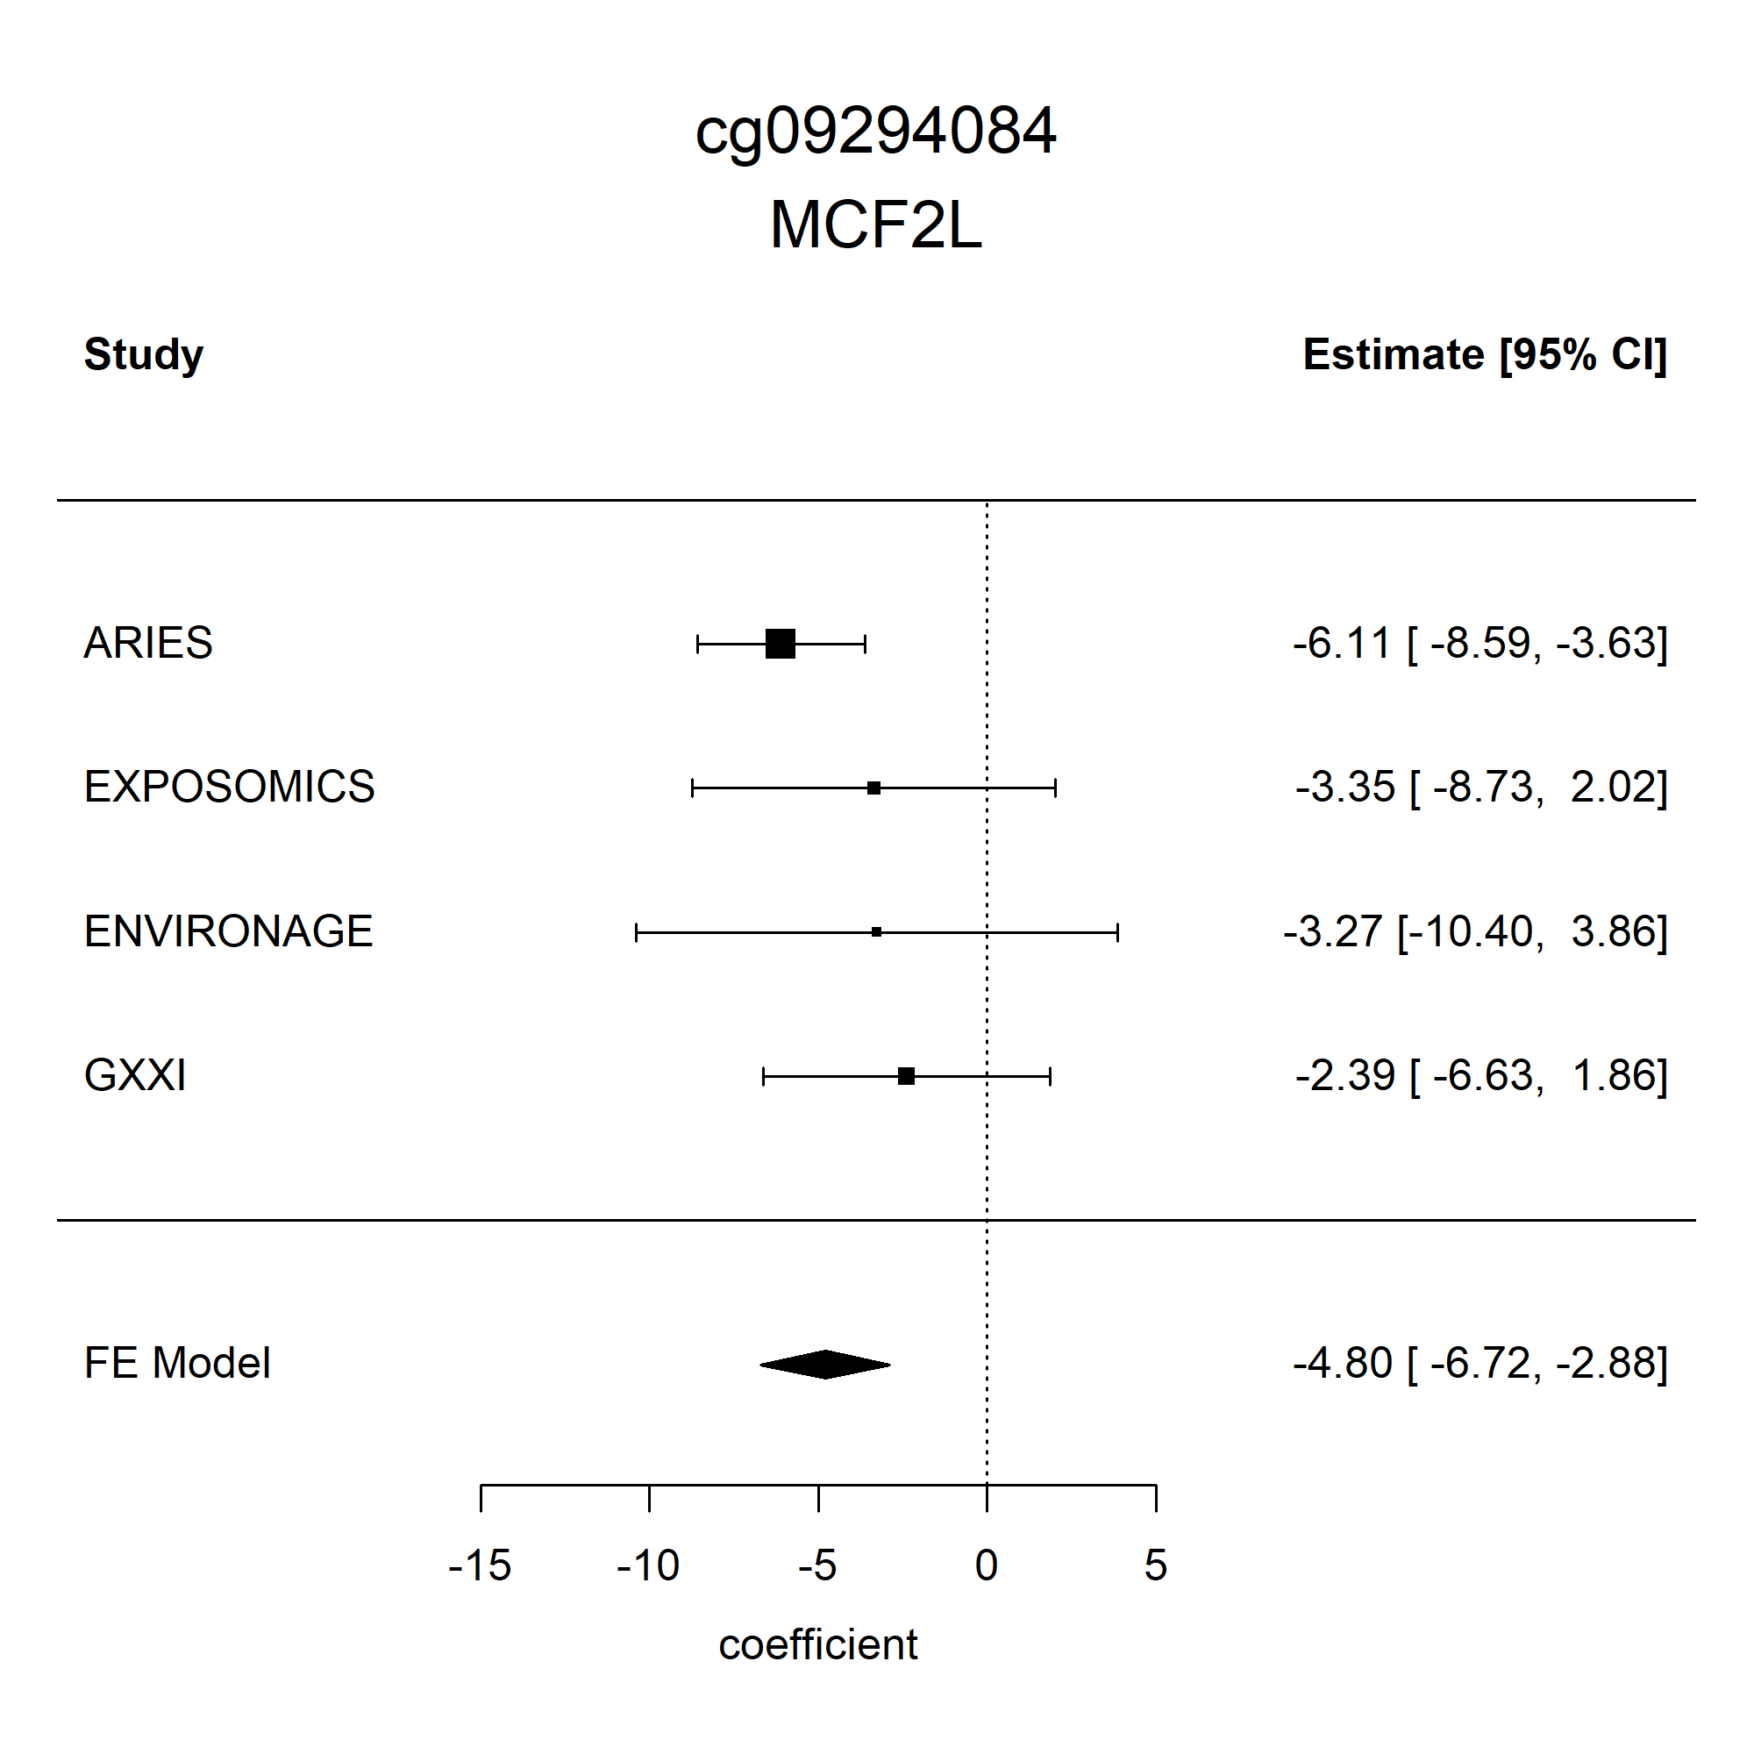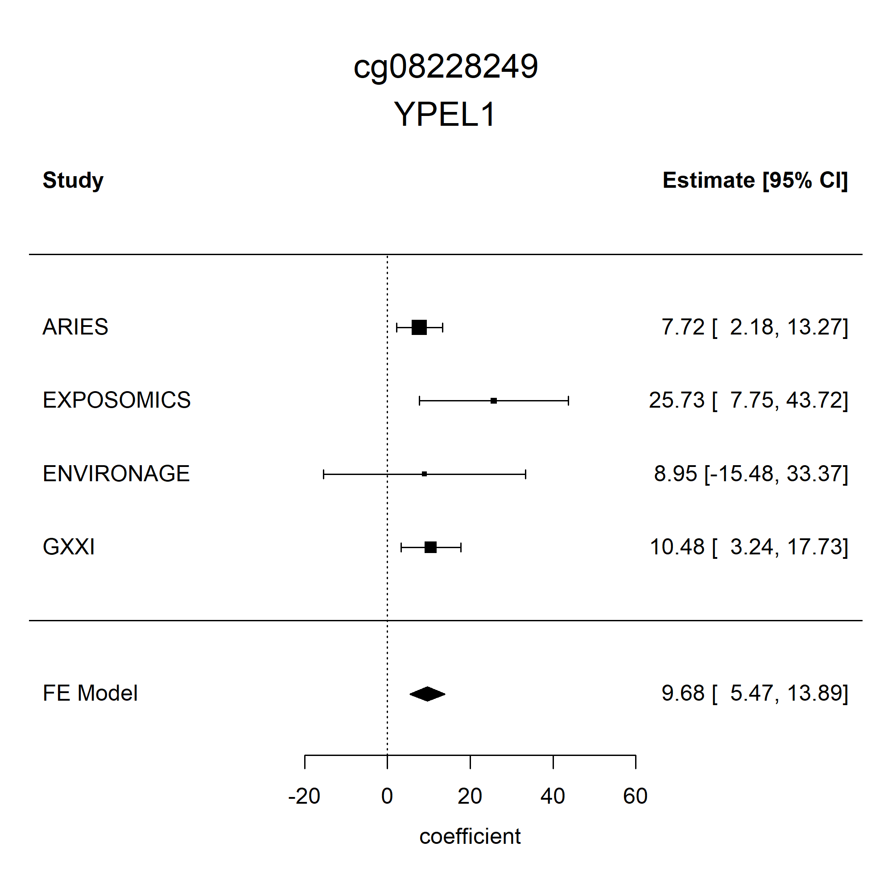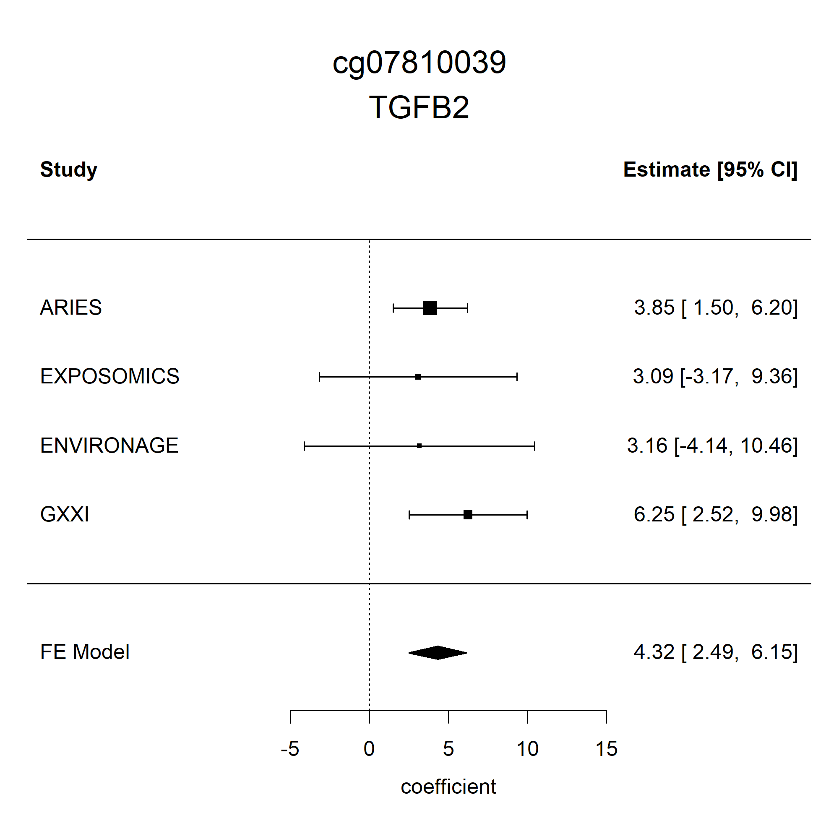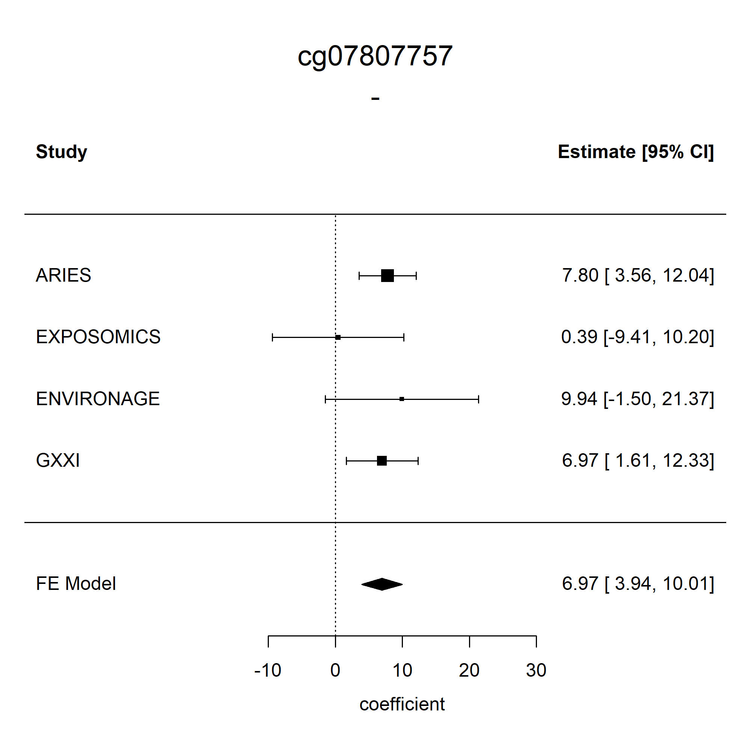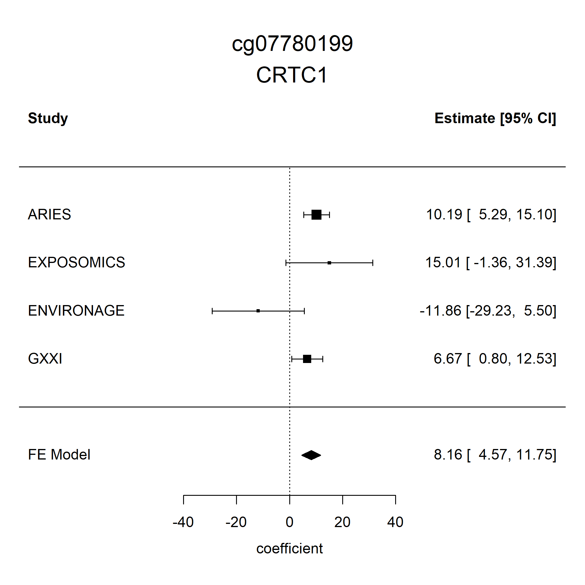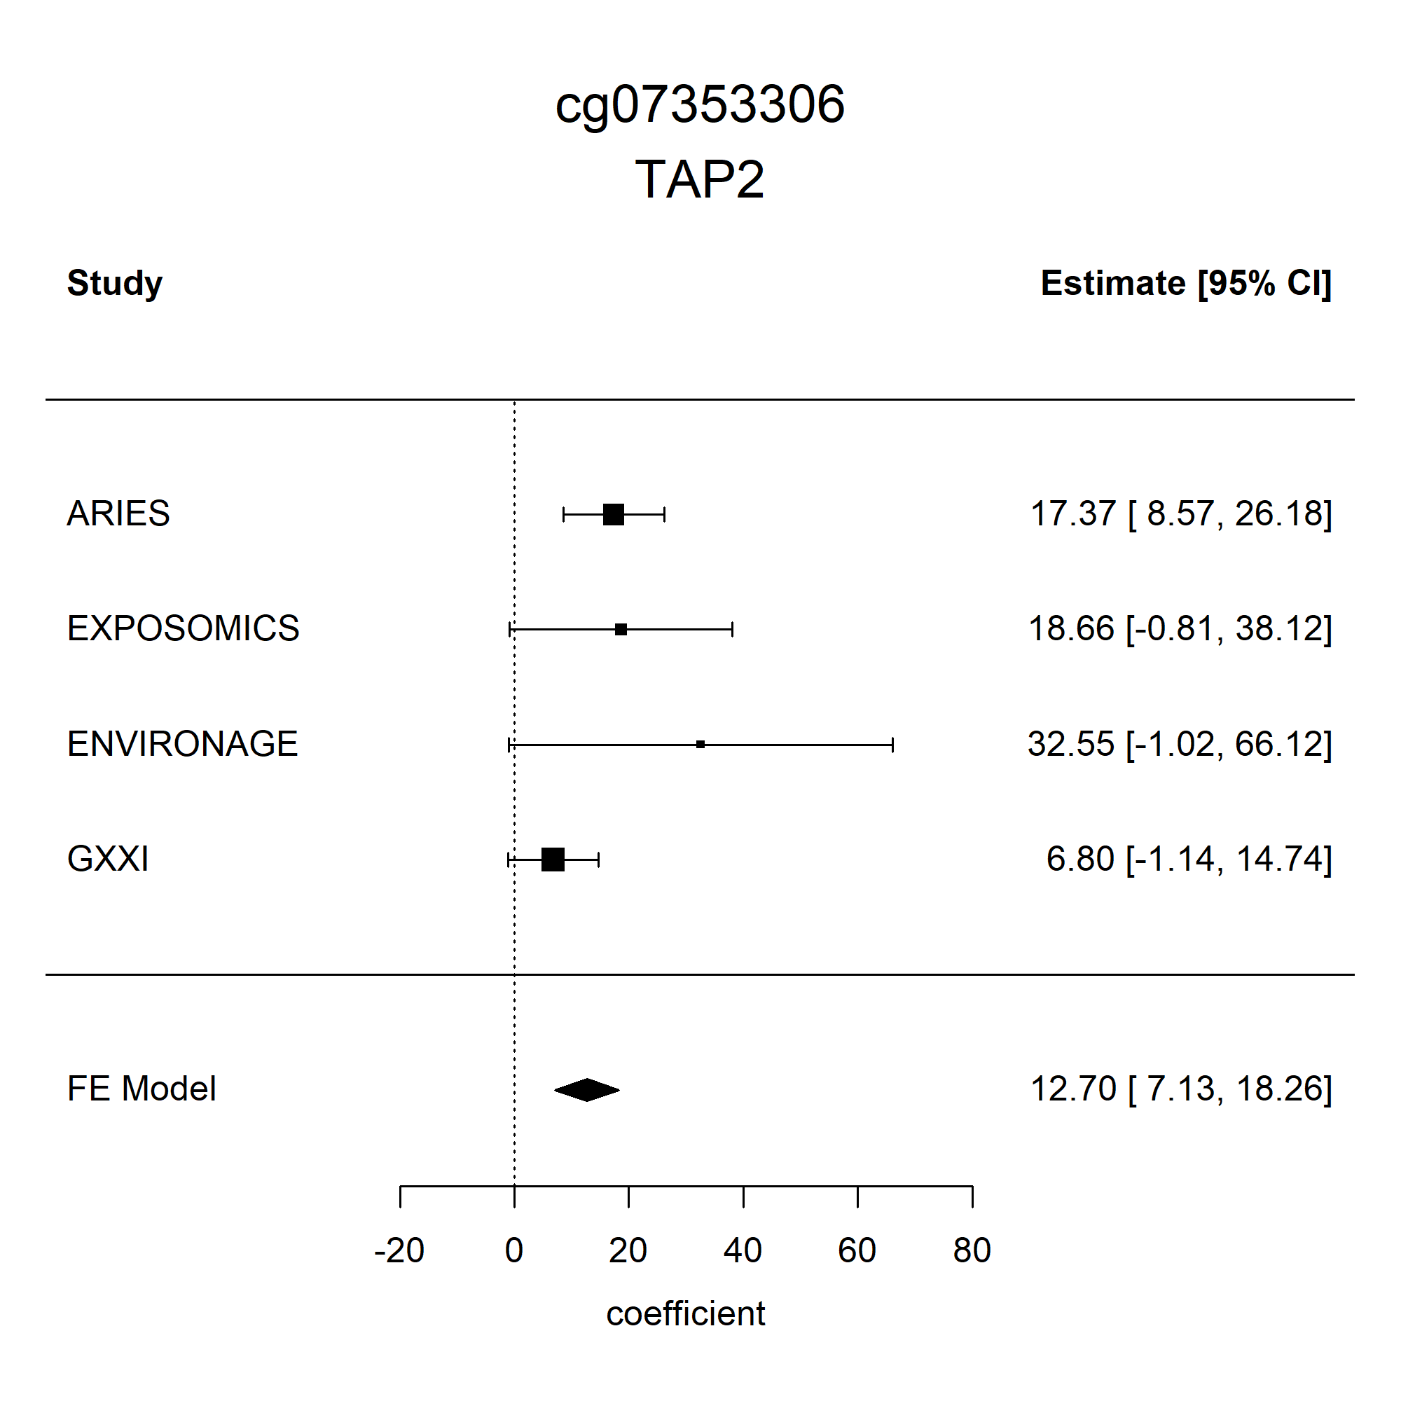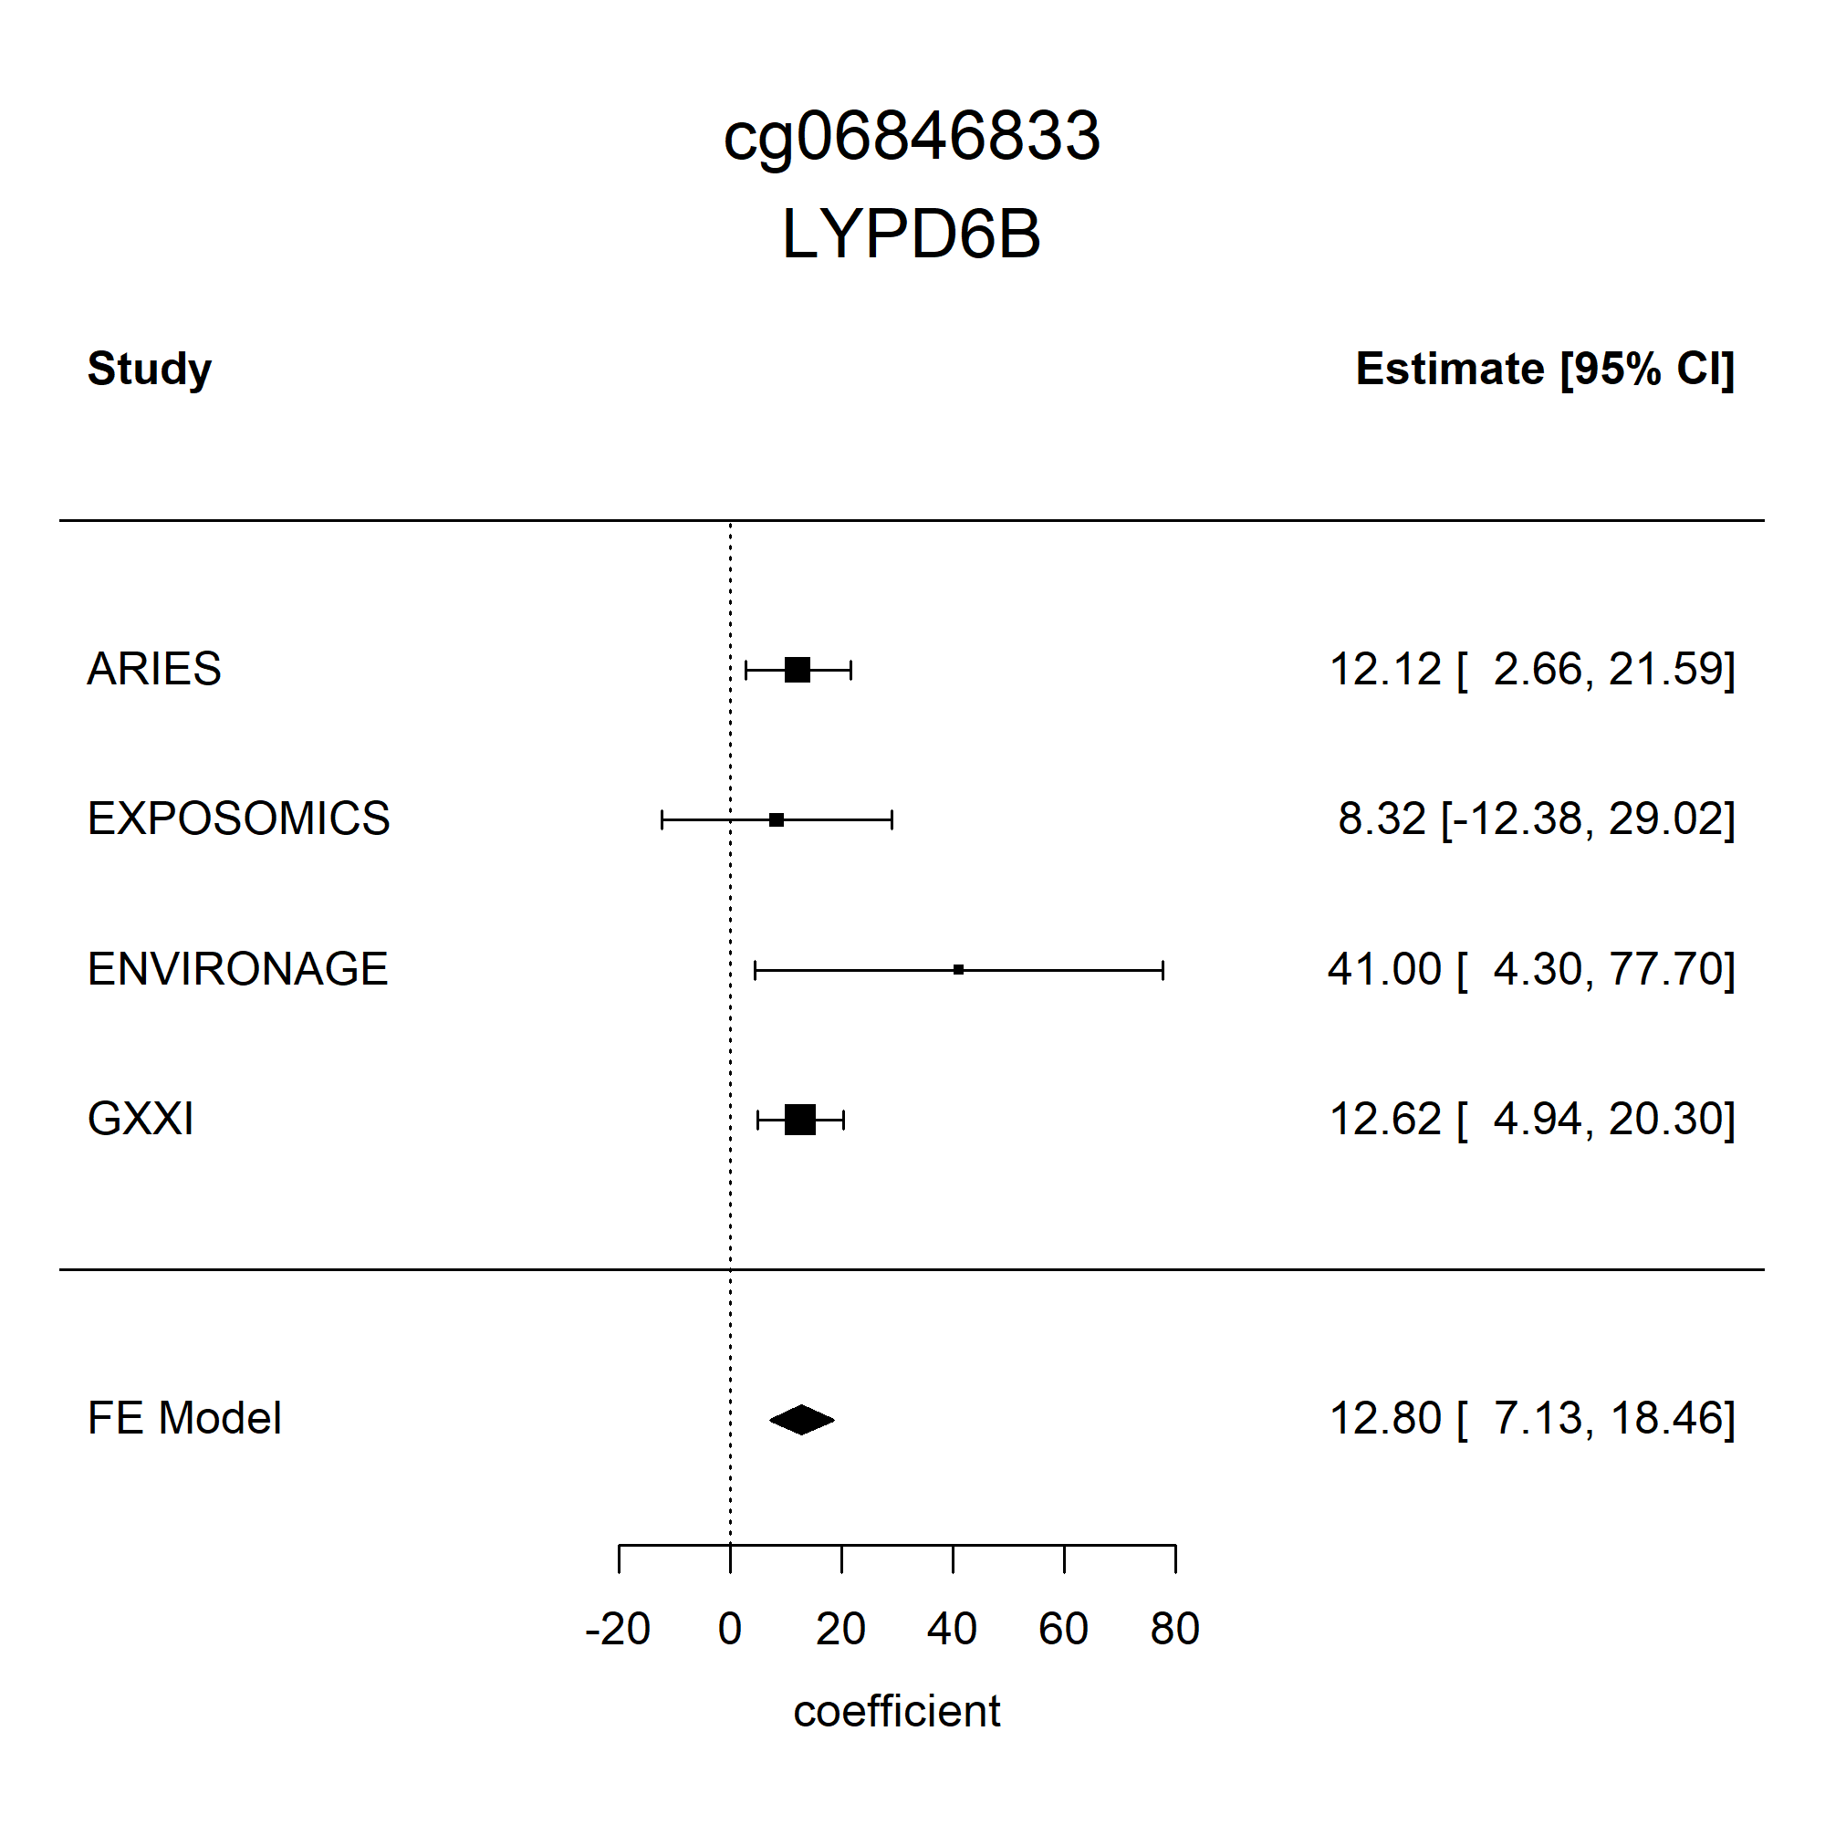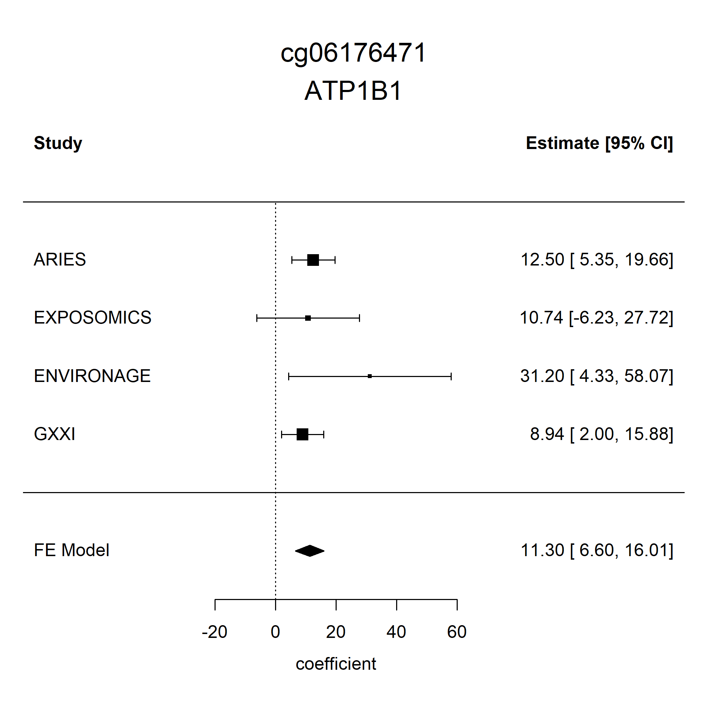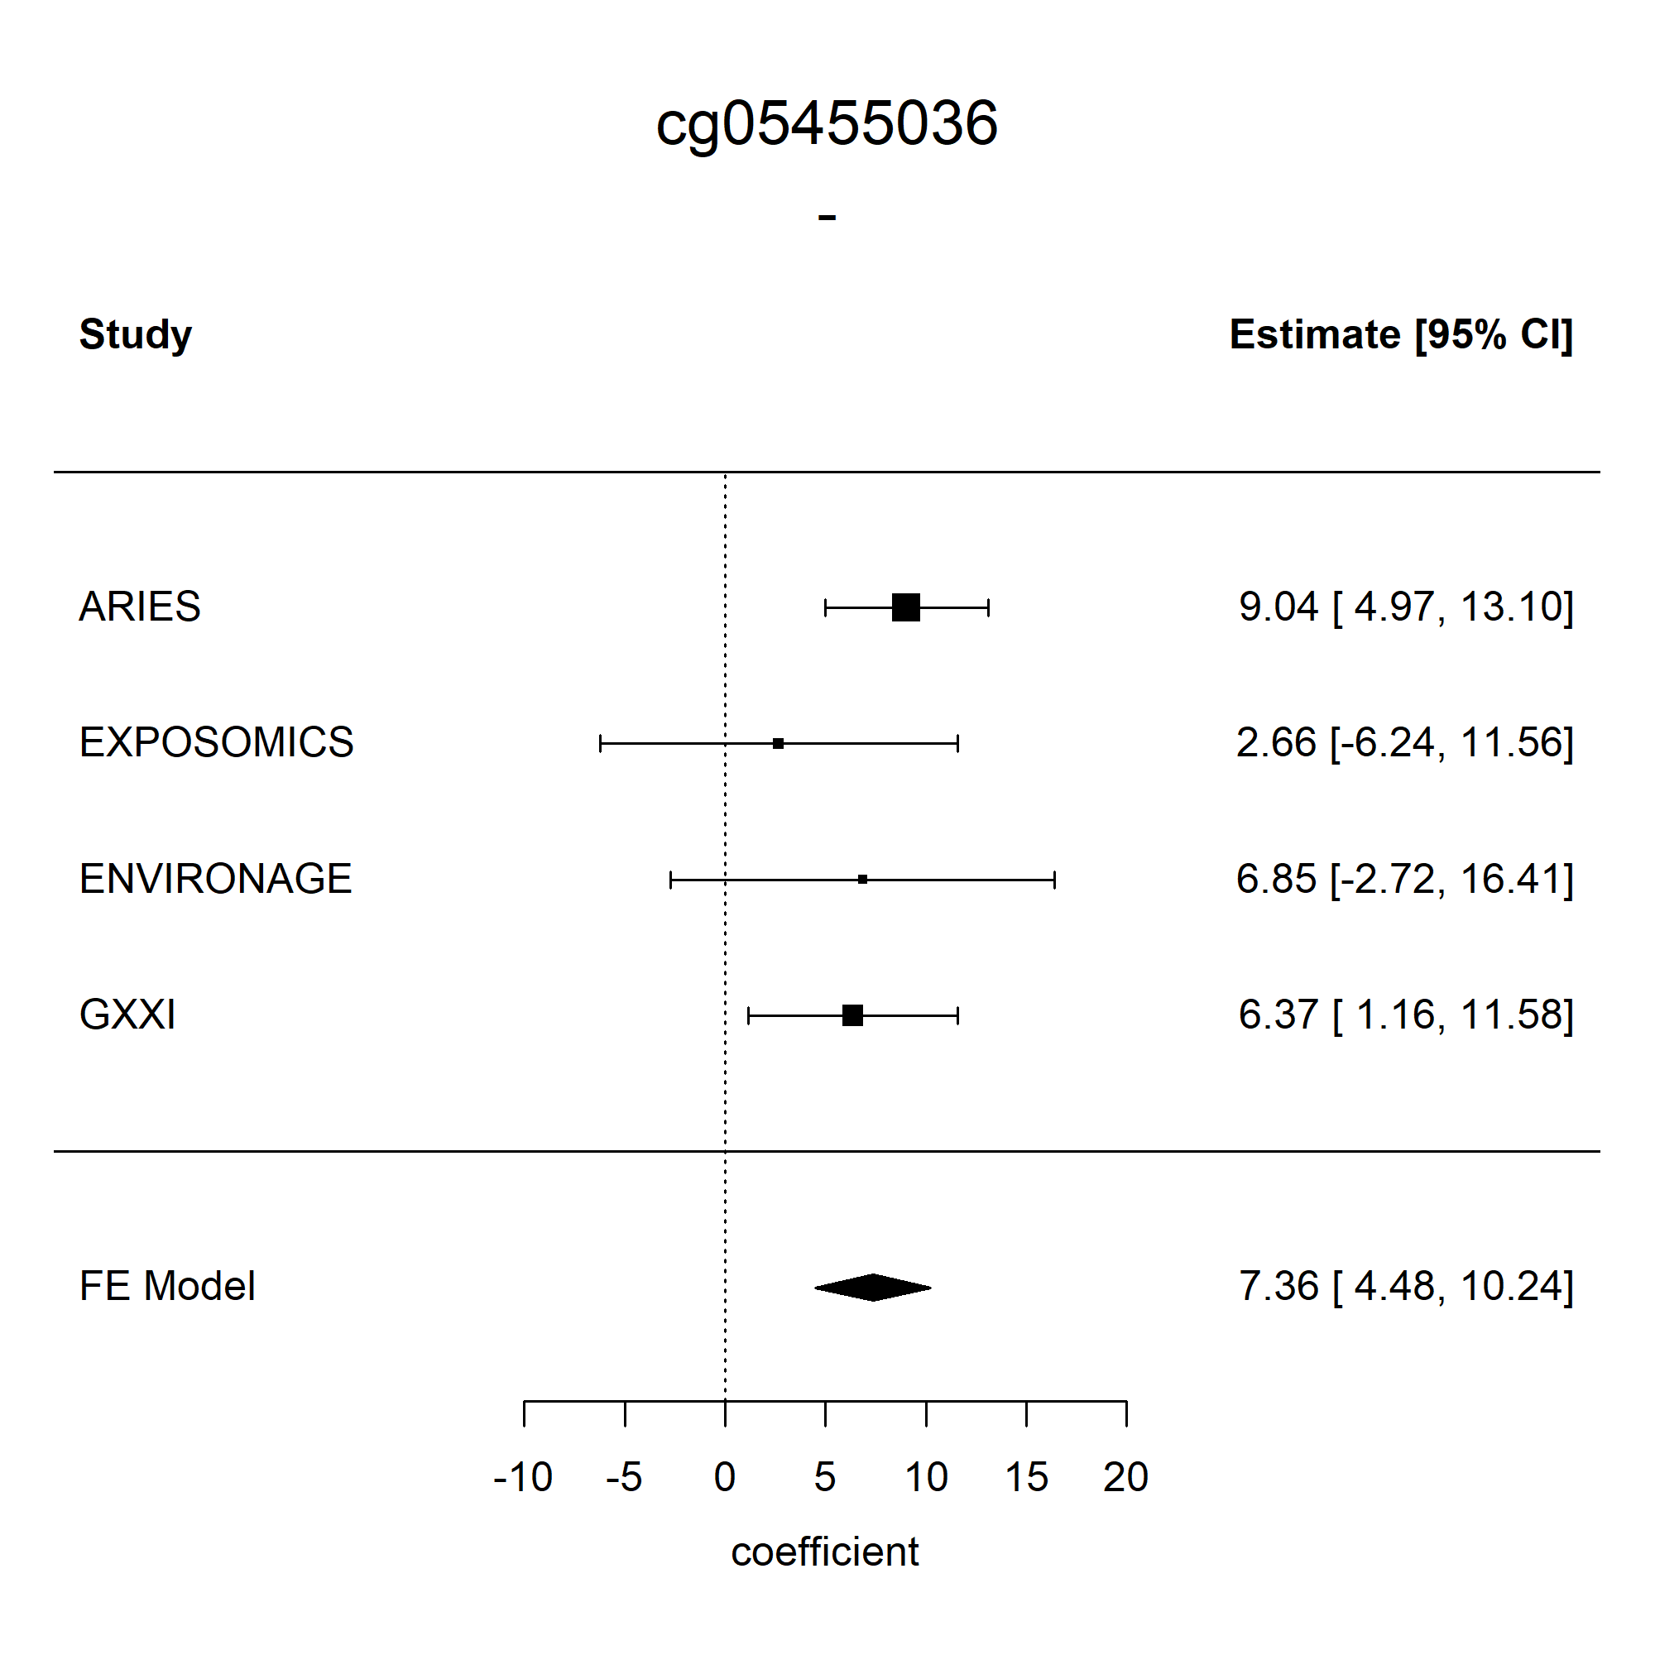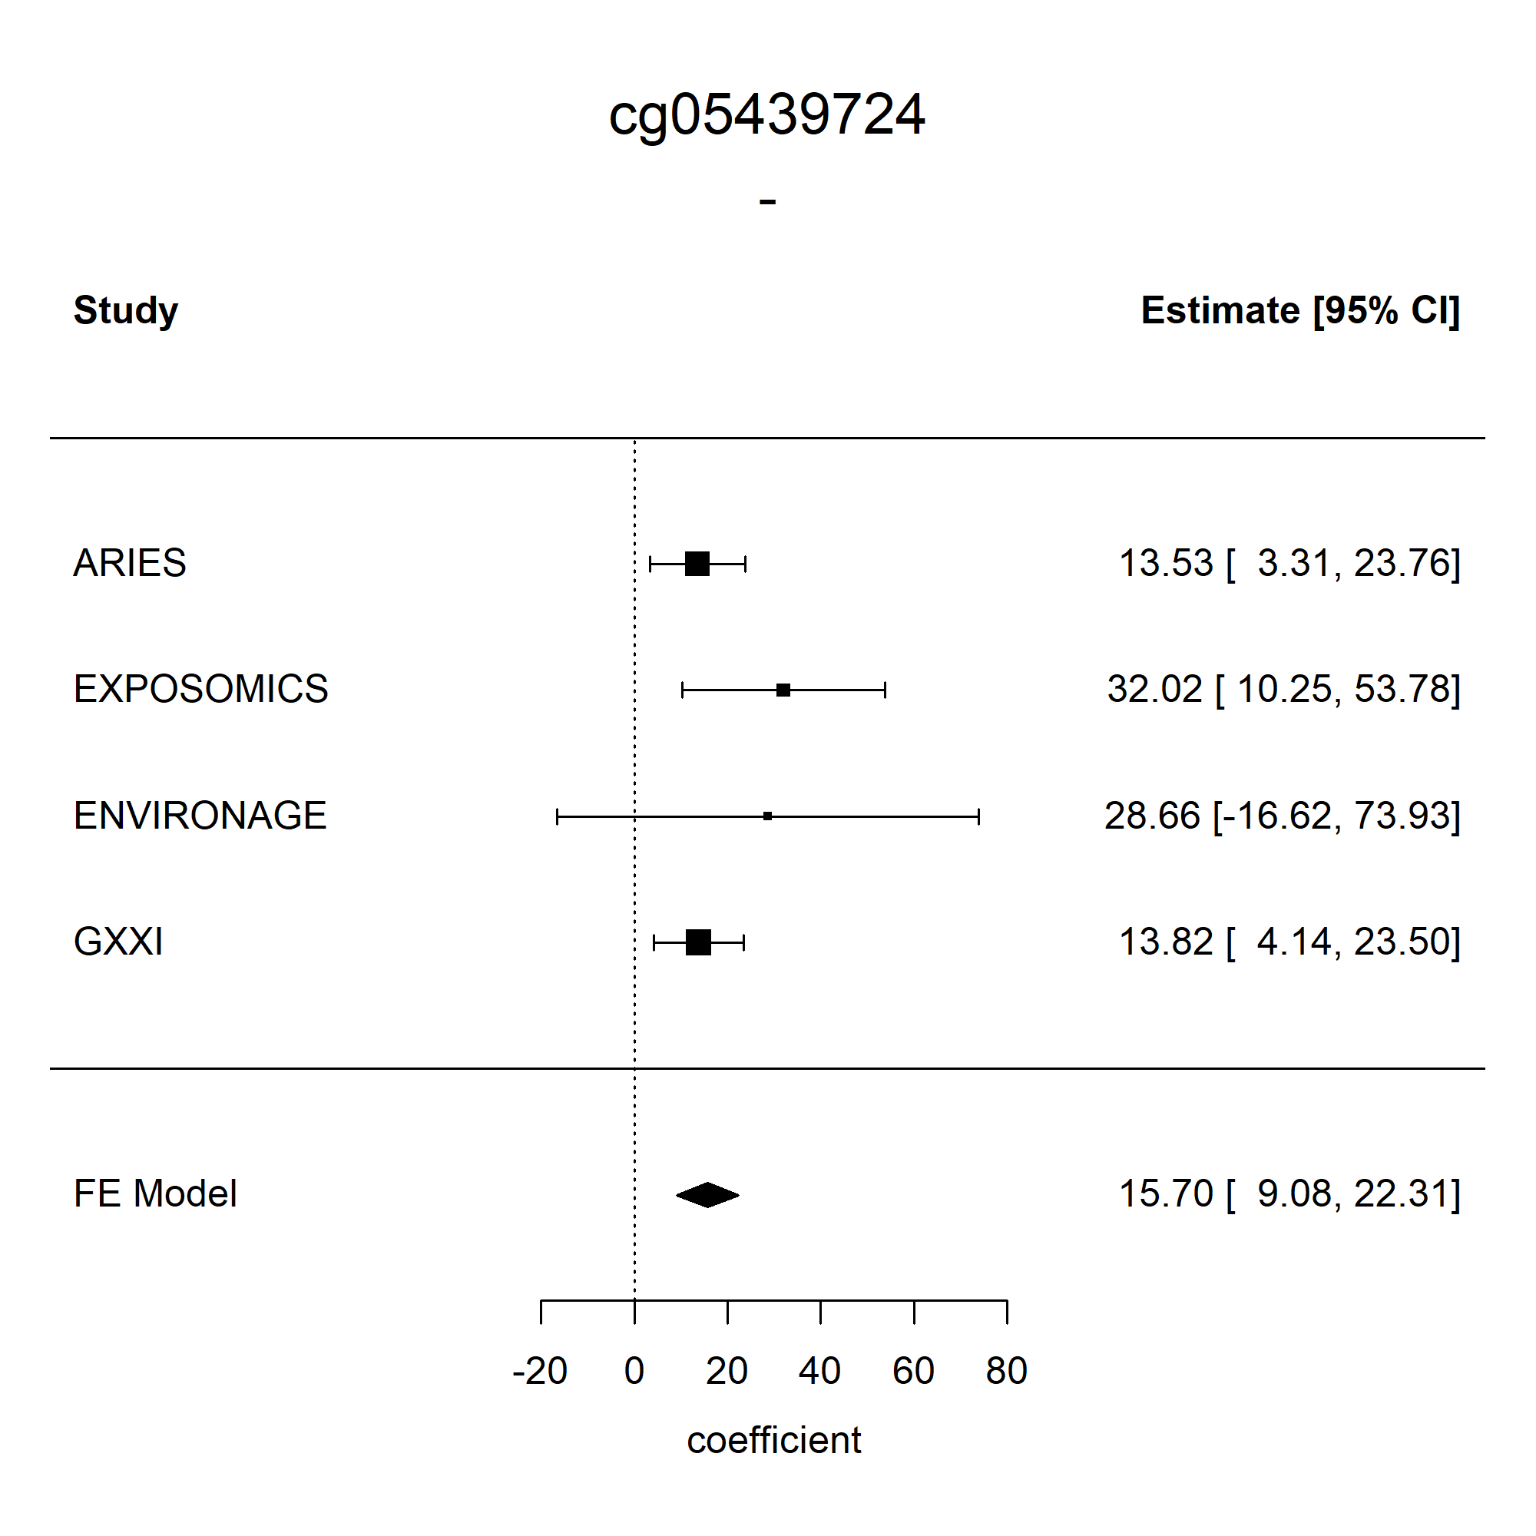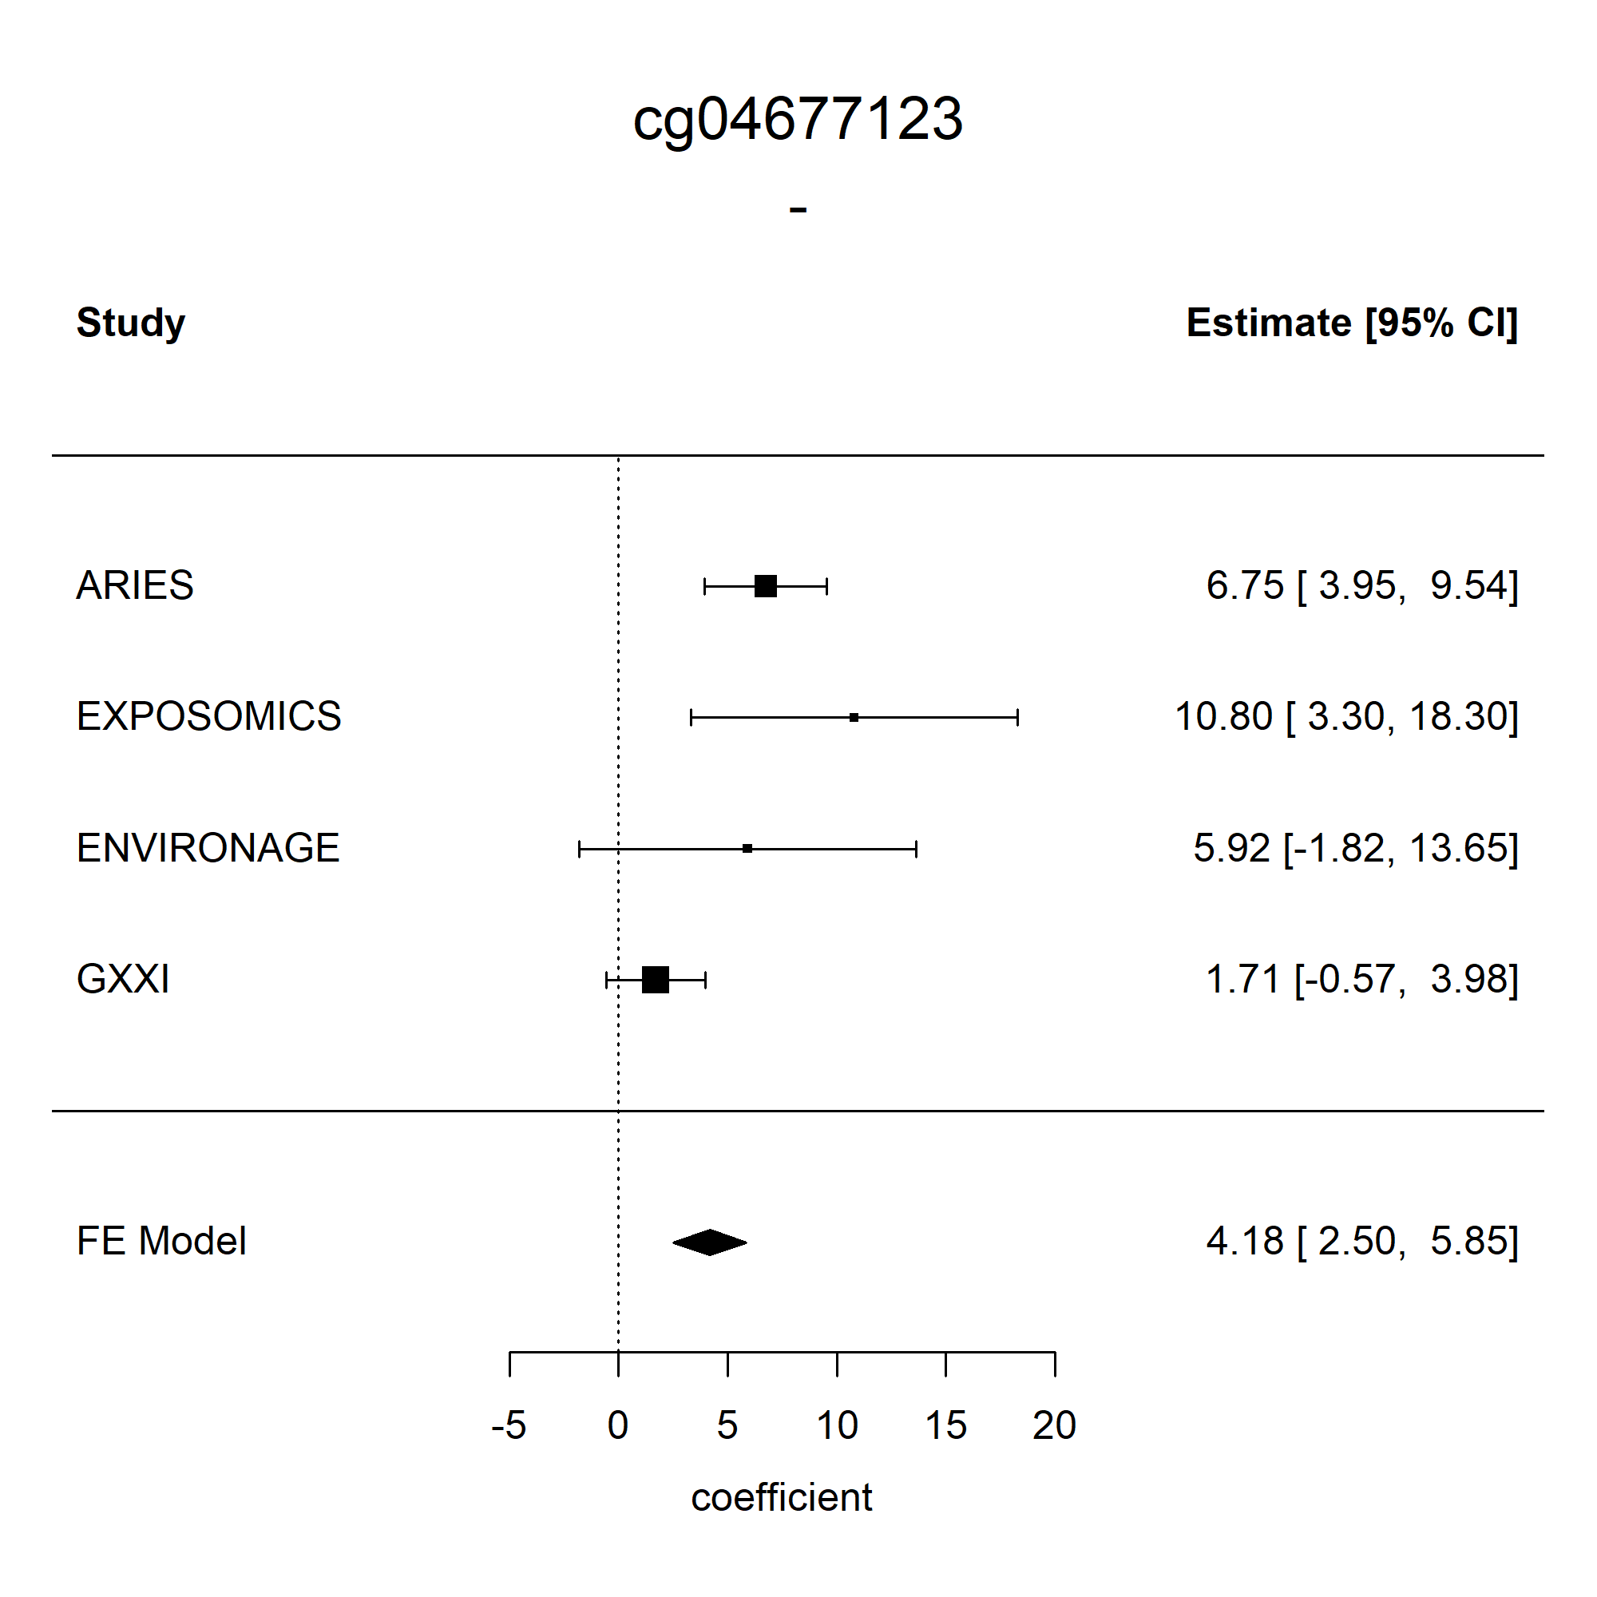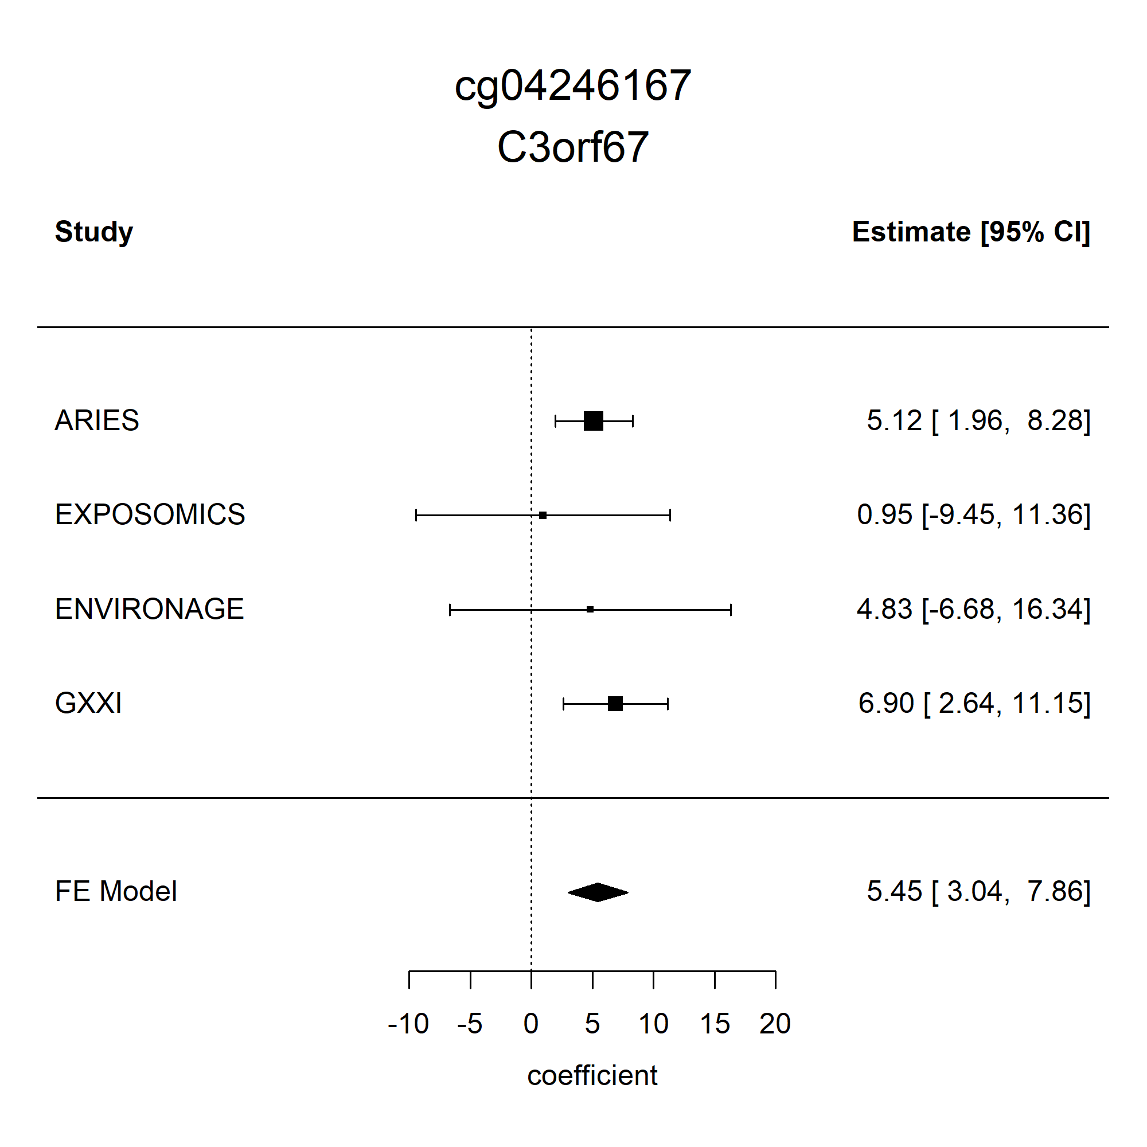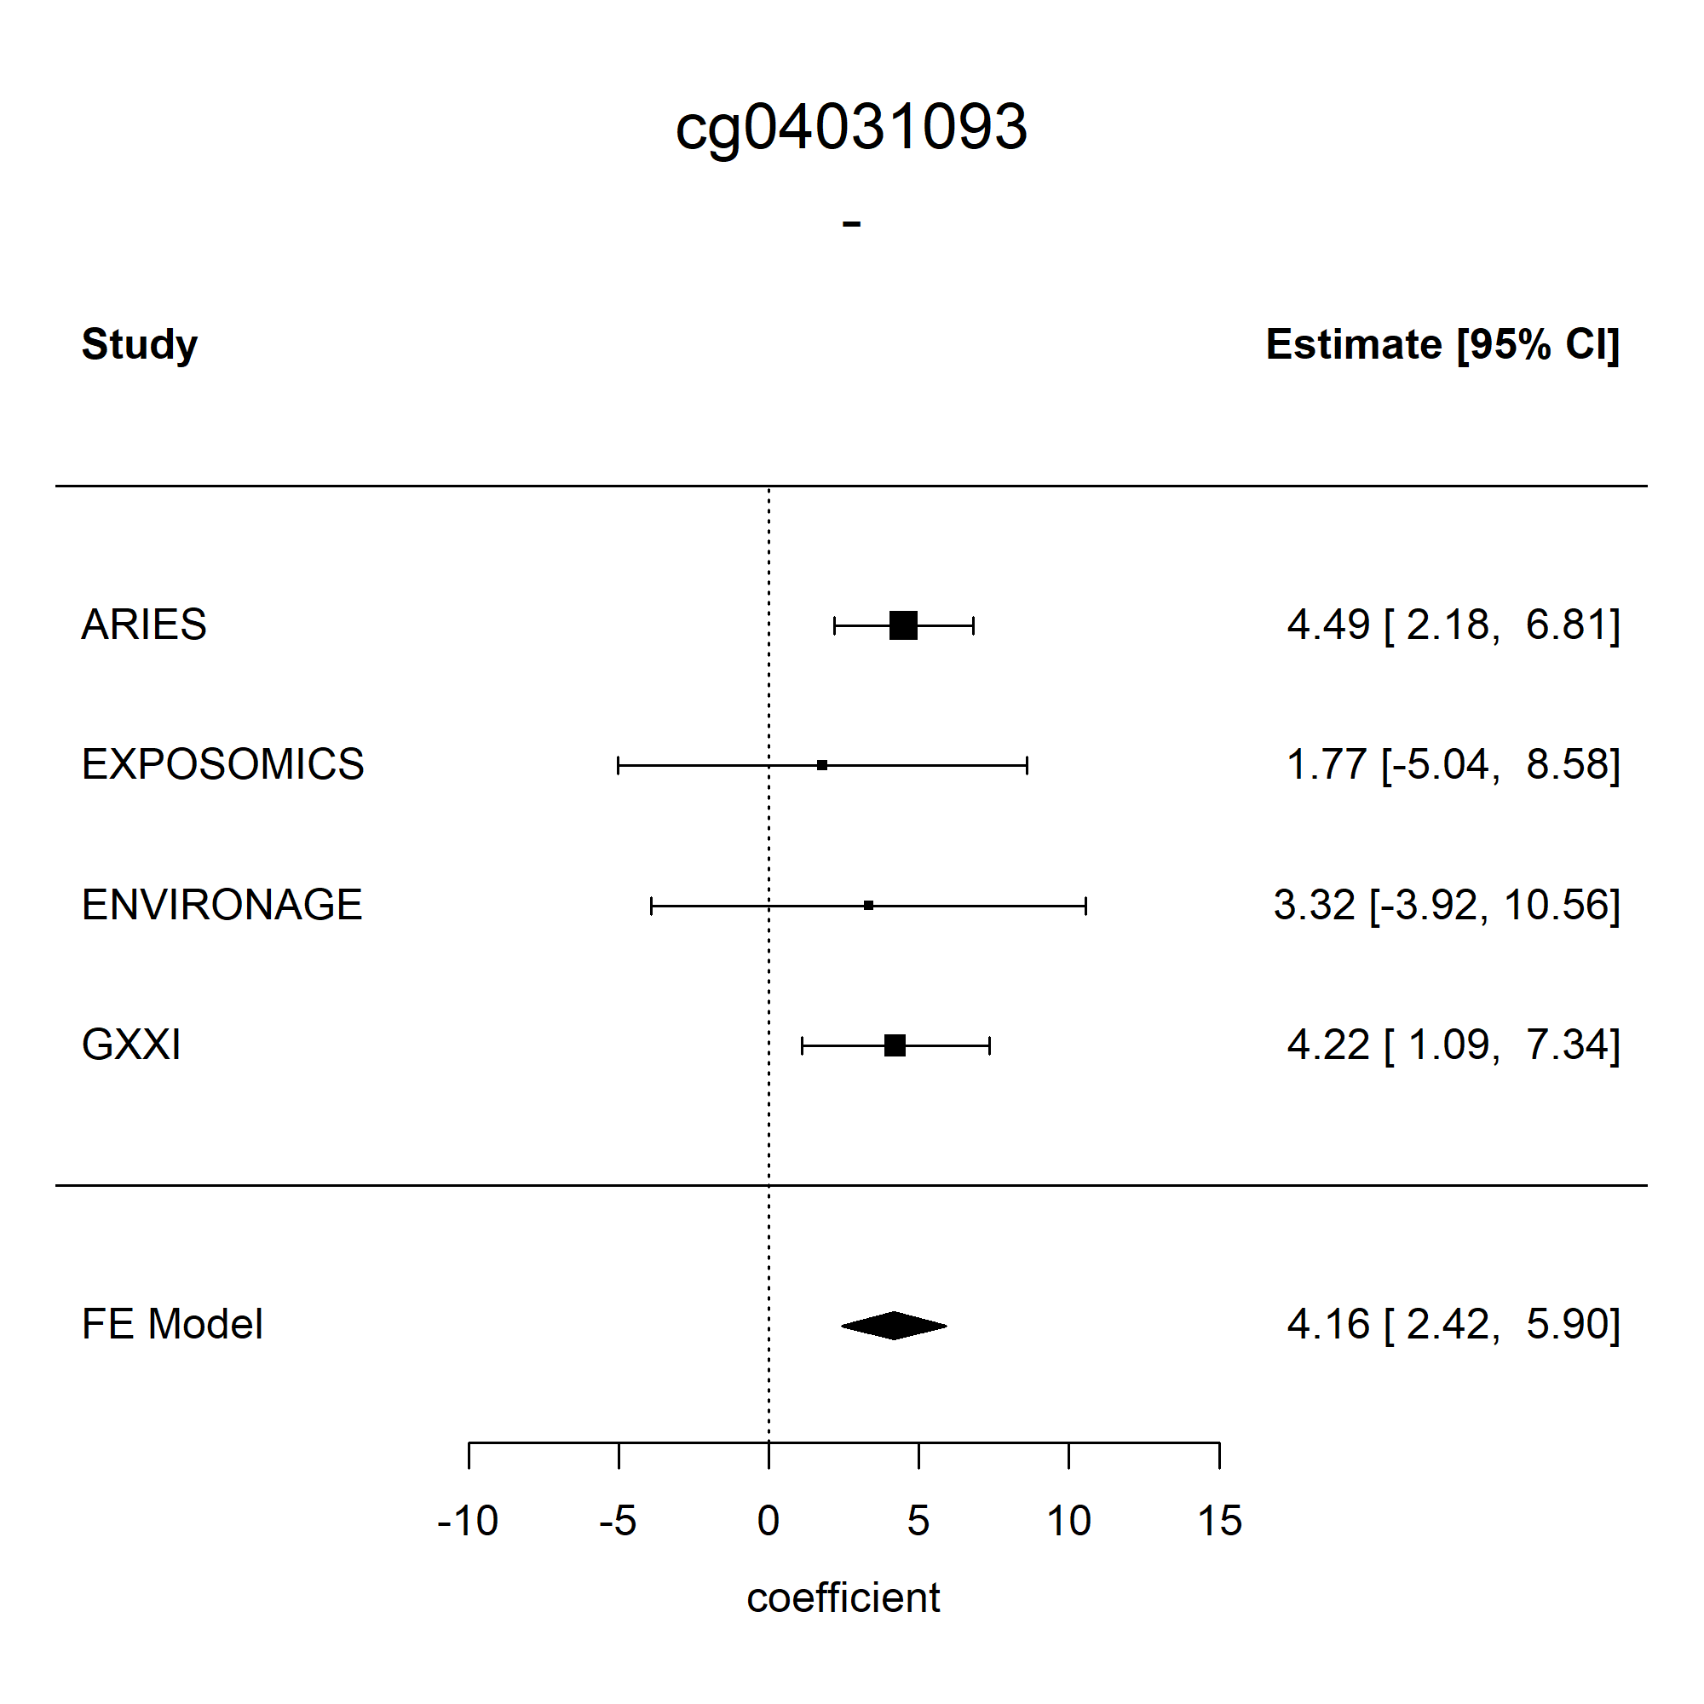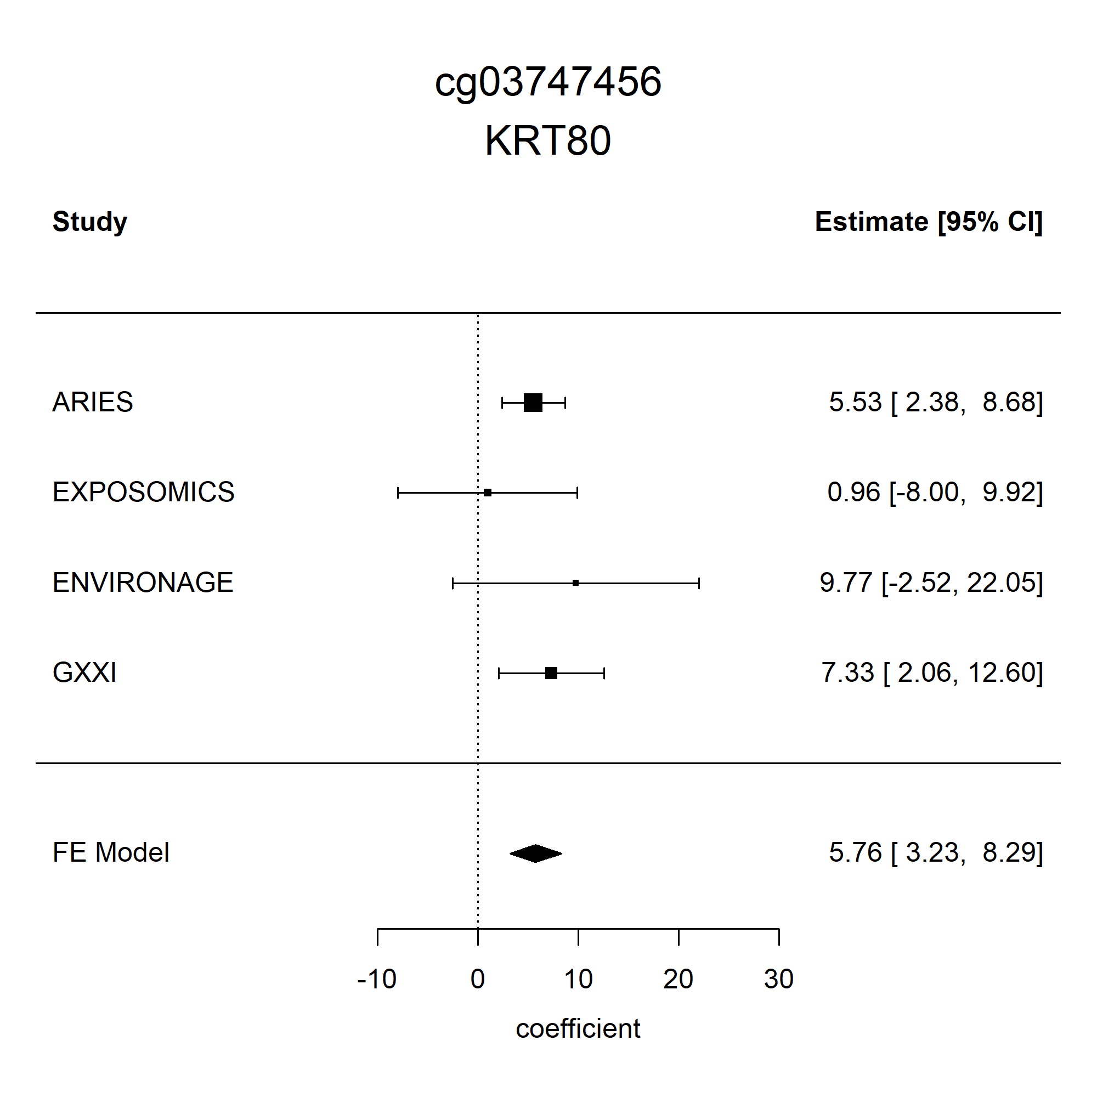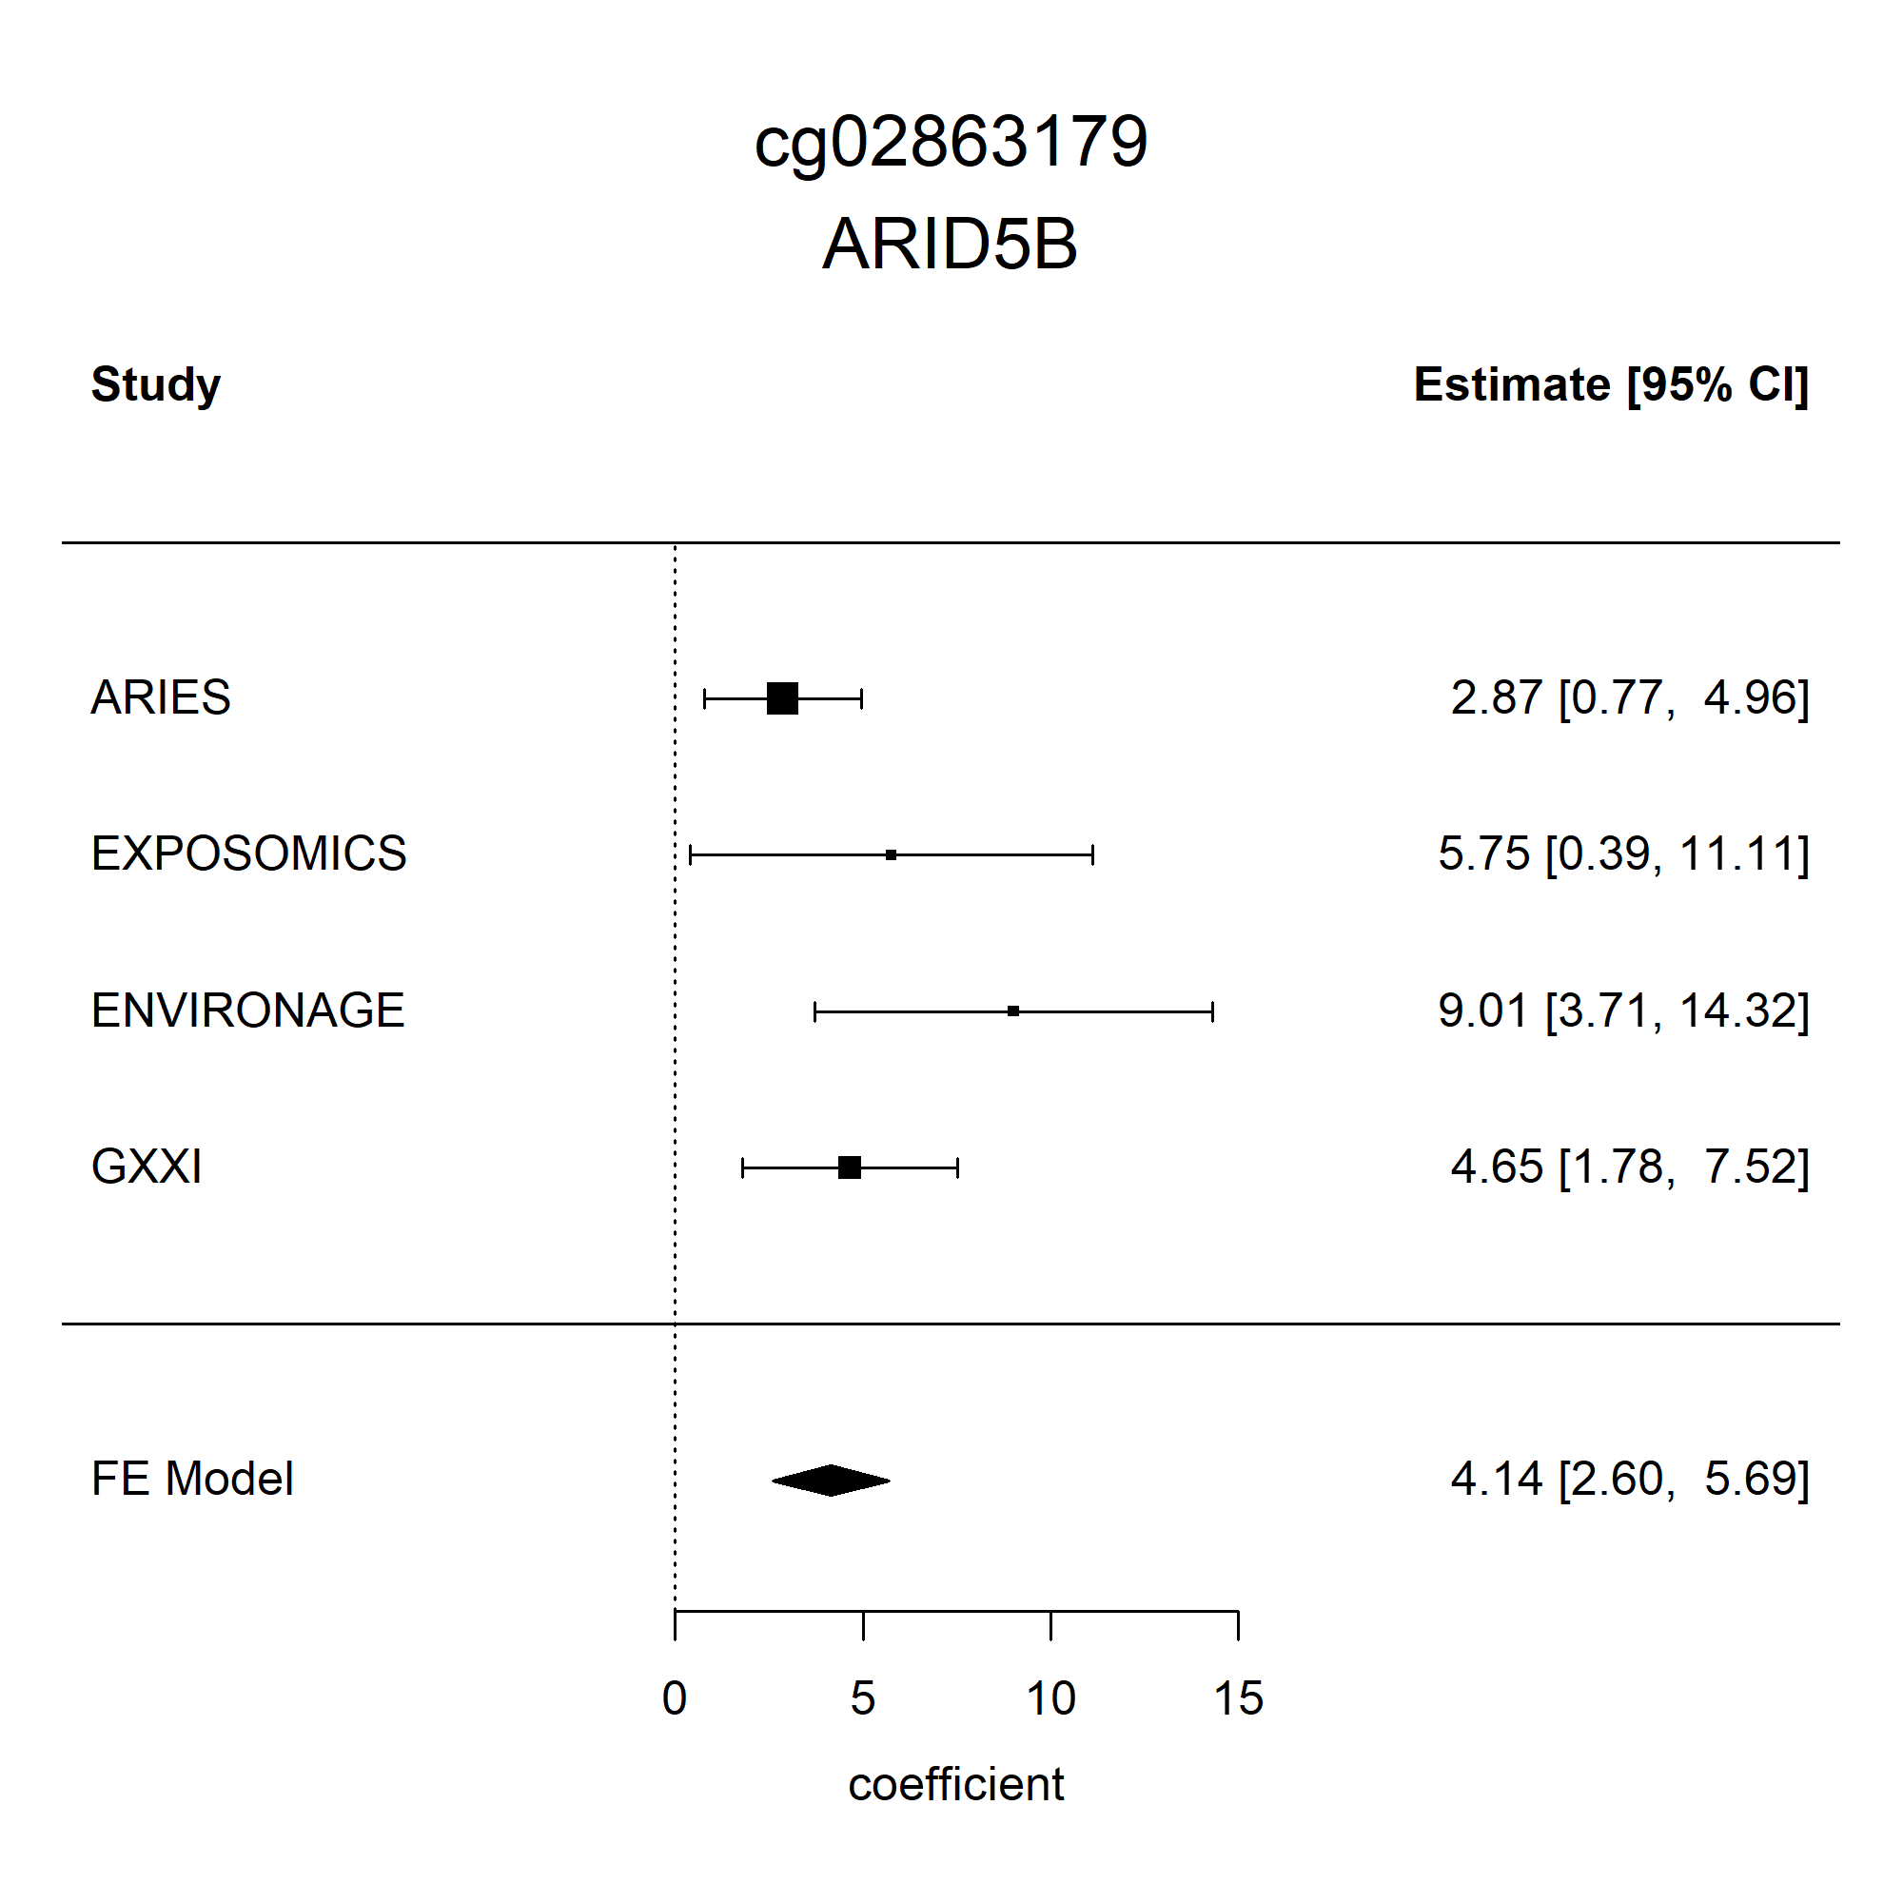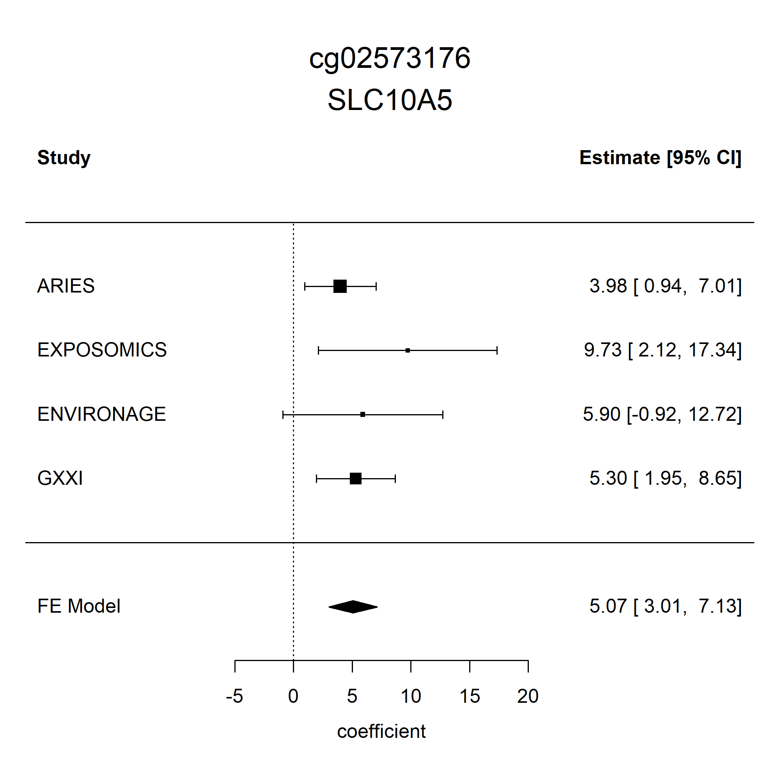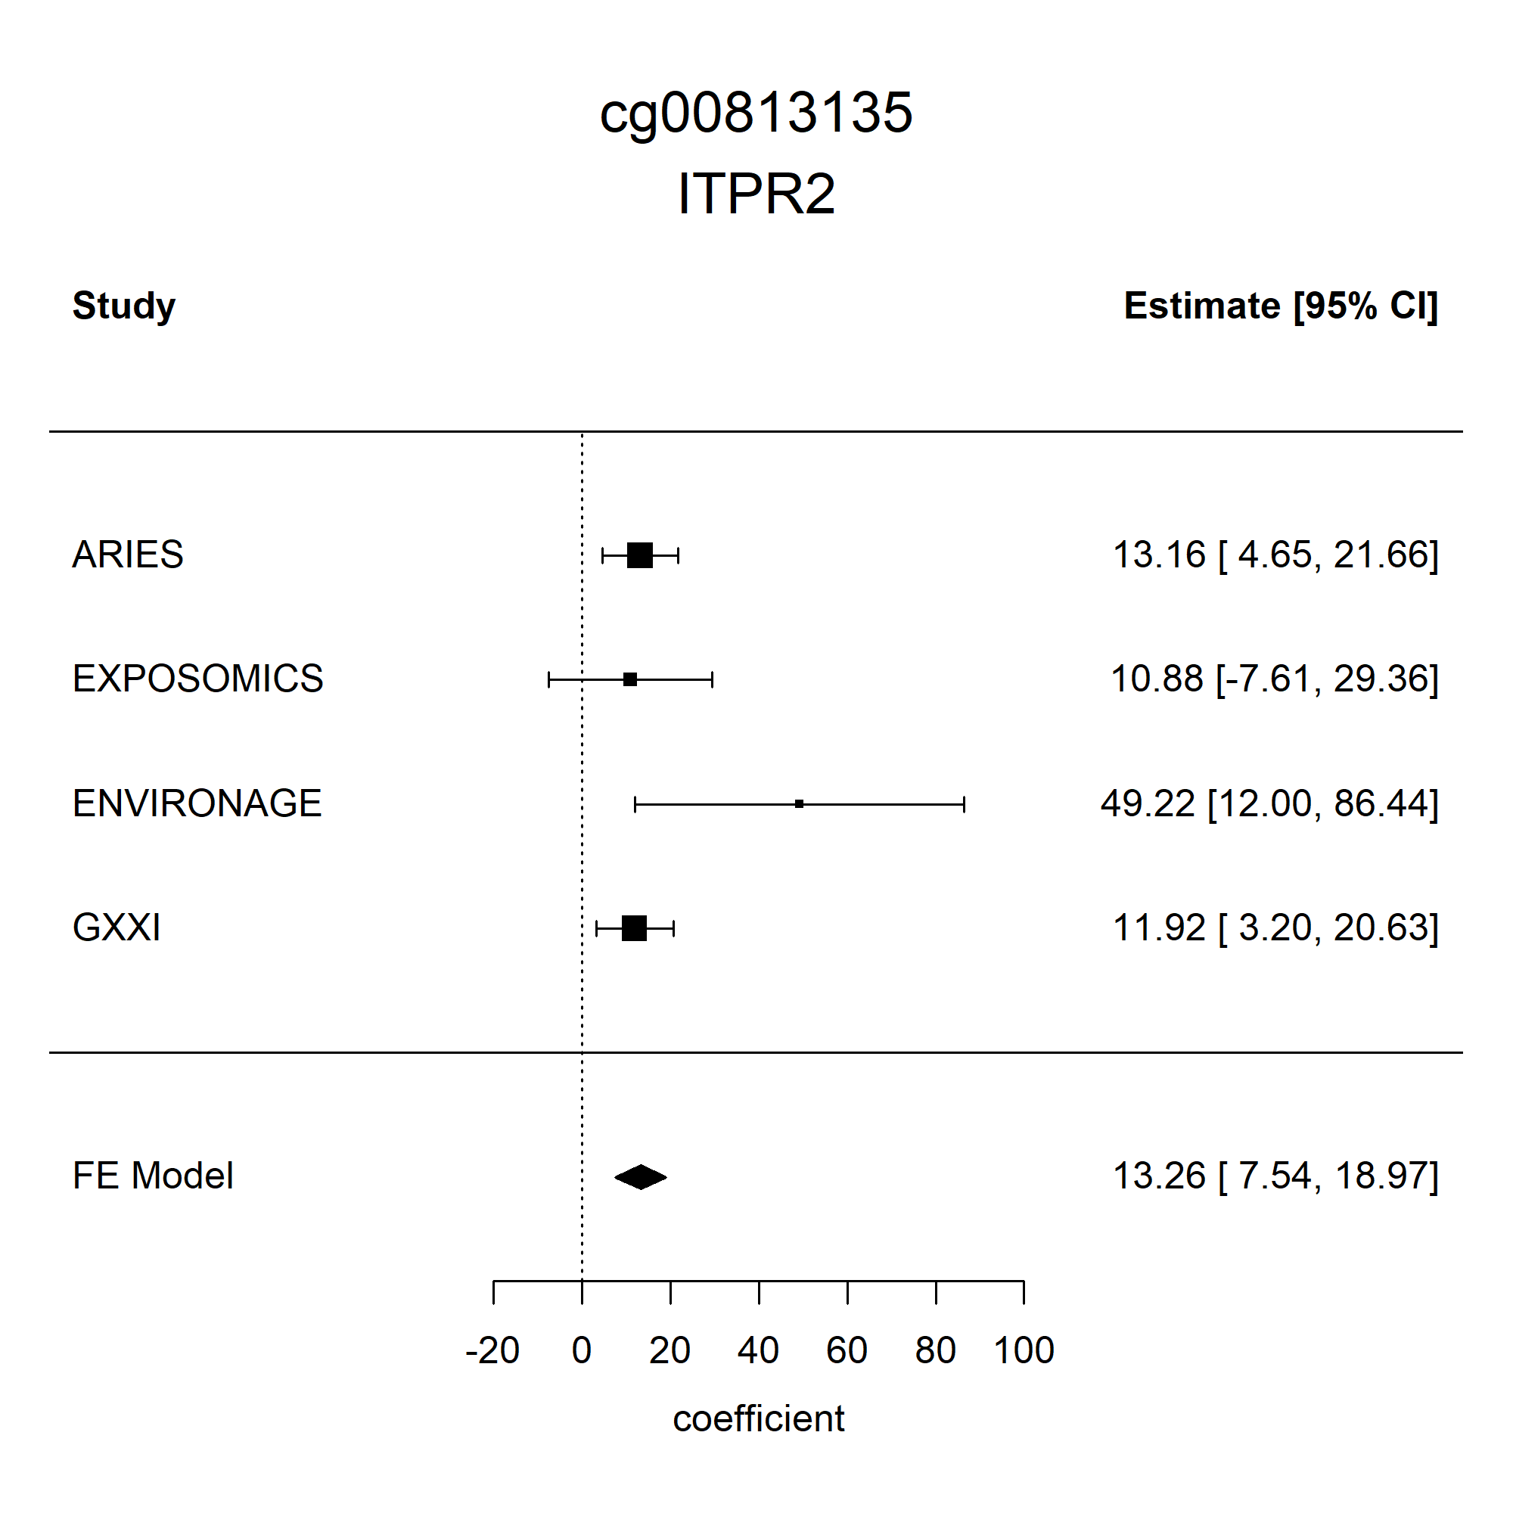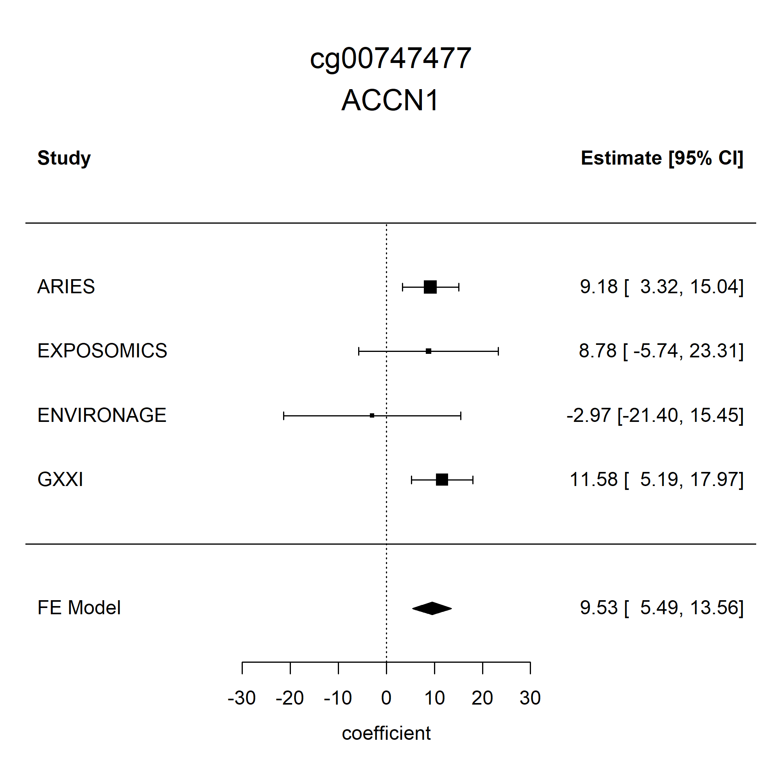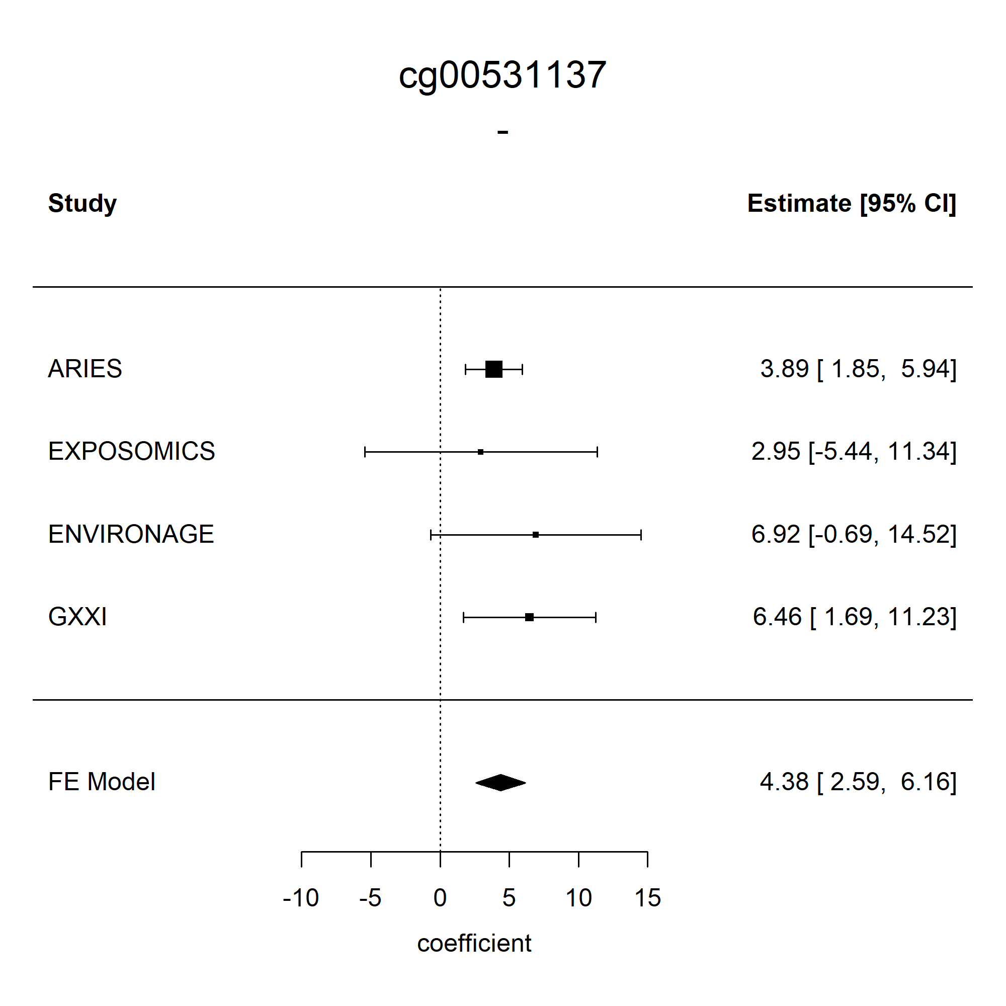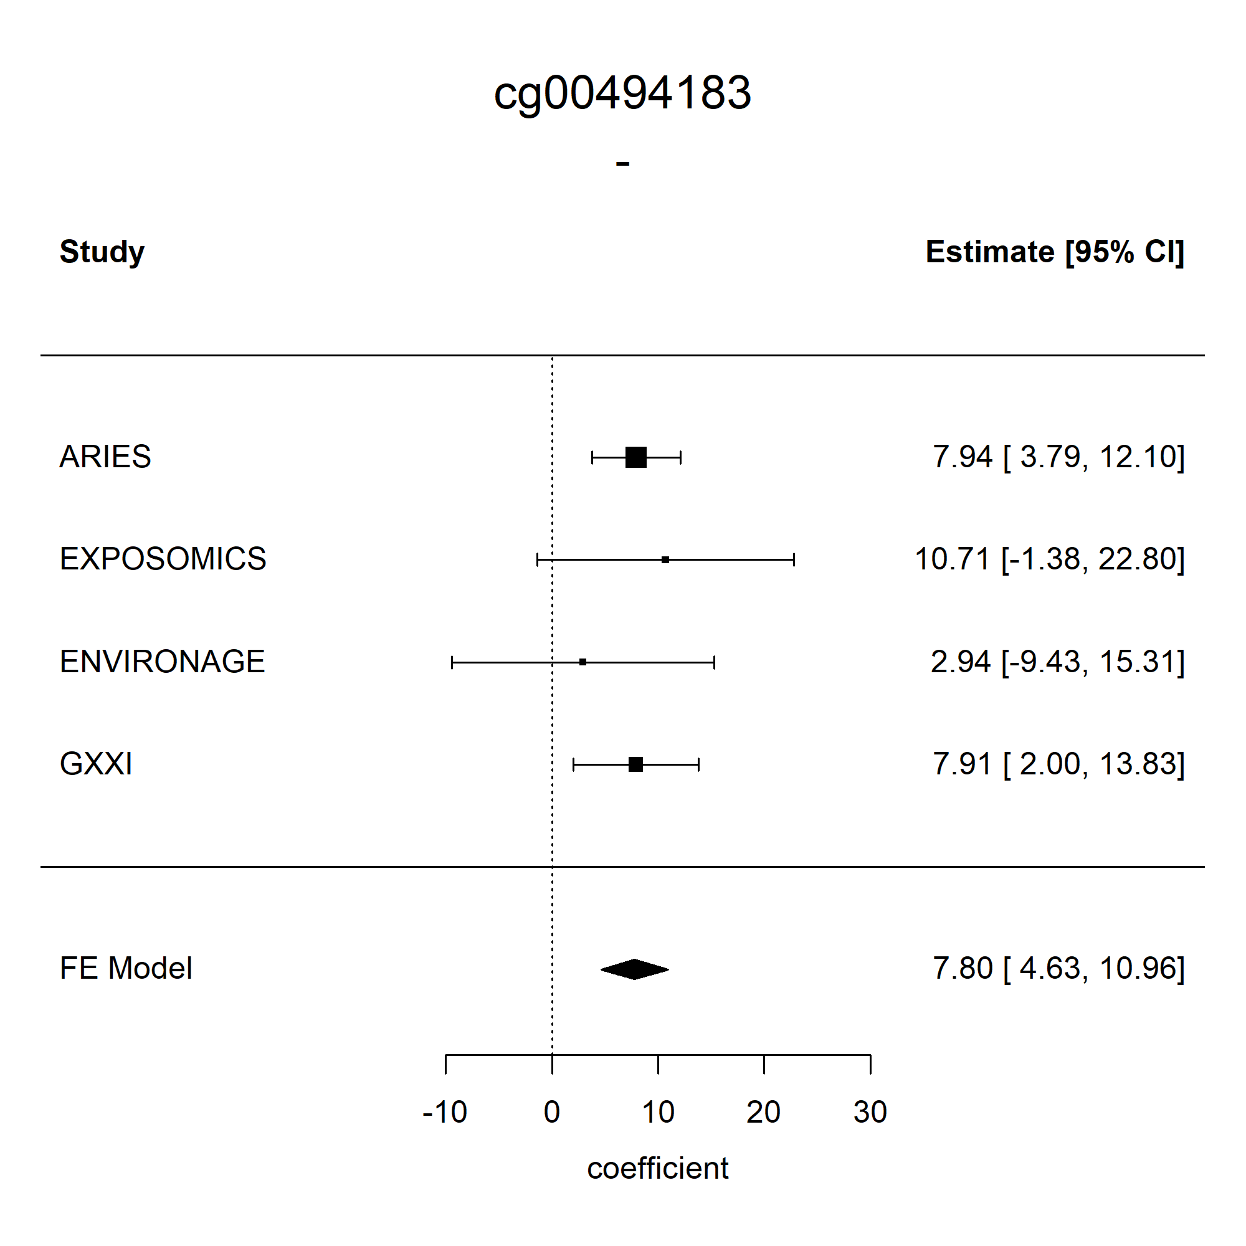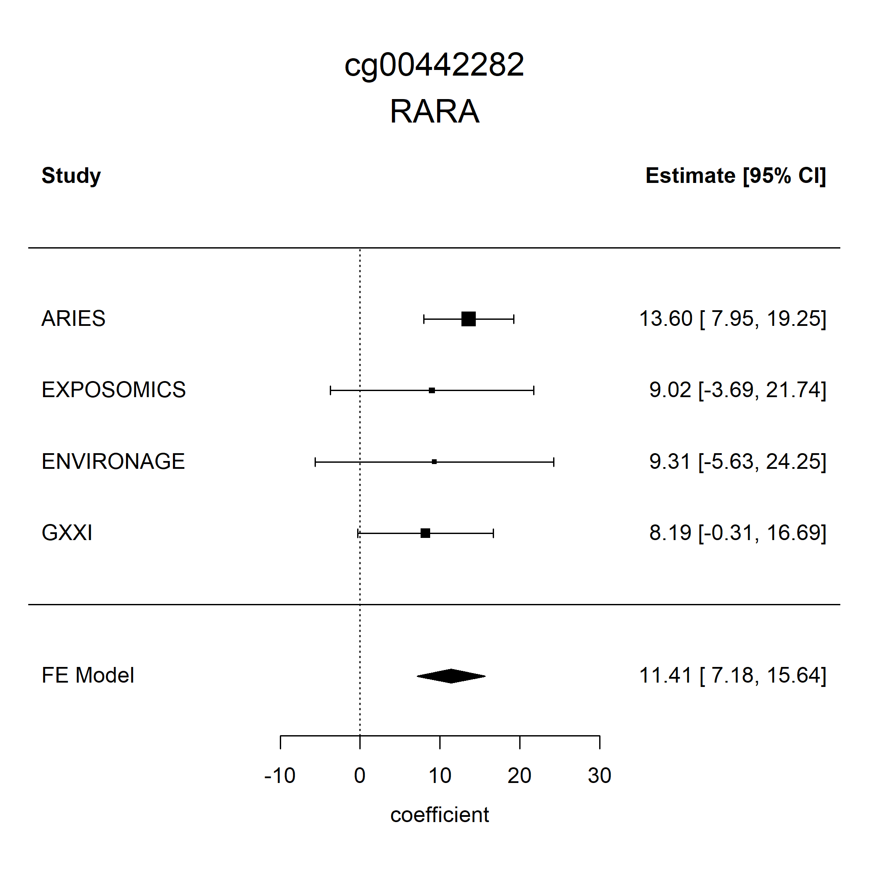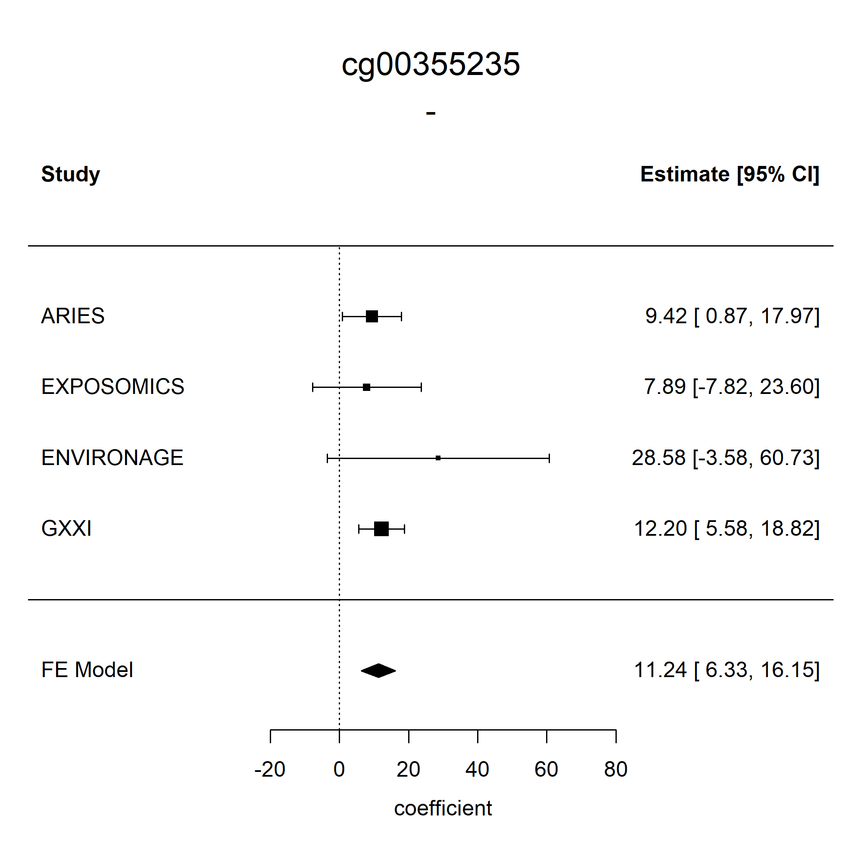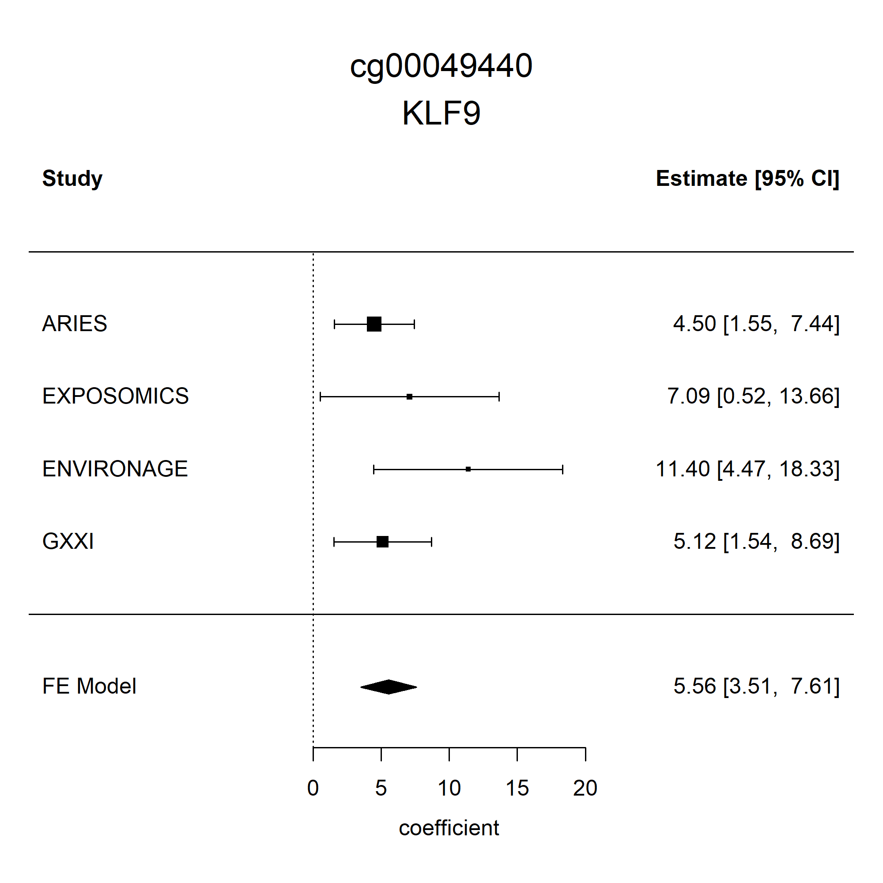
95% CI=95% confidence interval

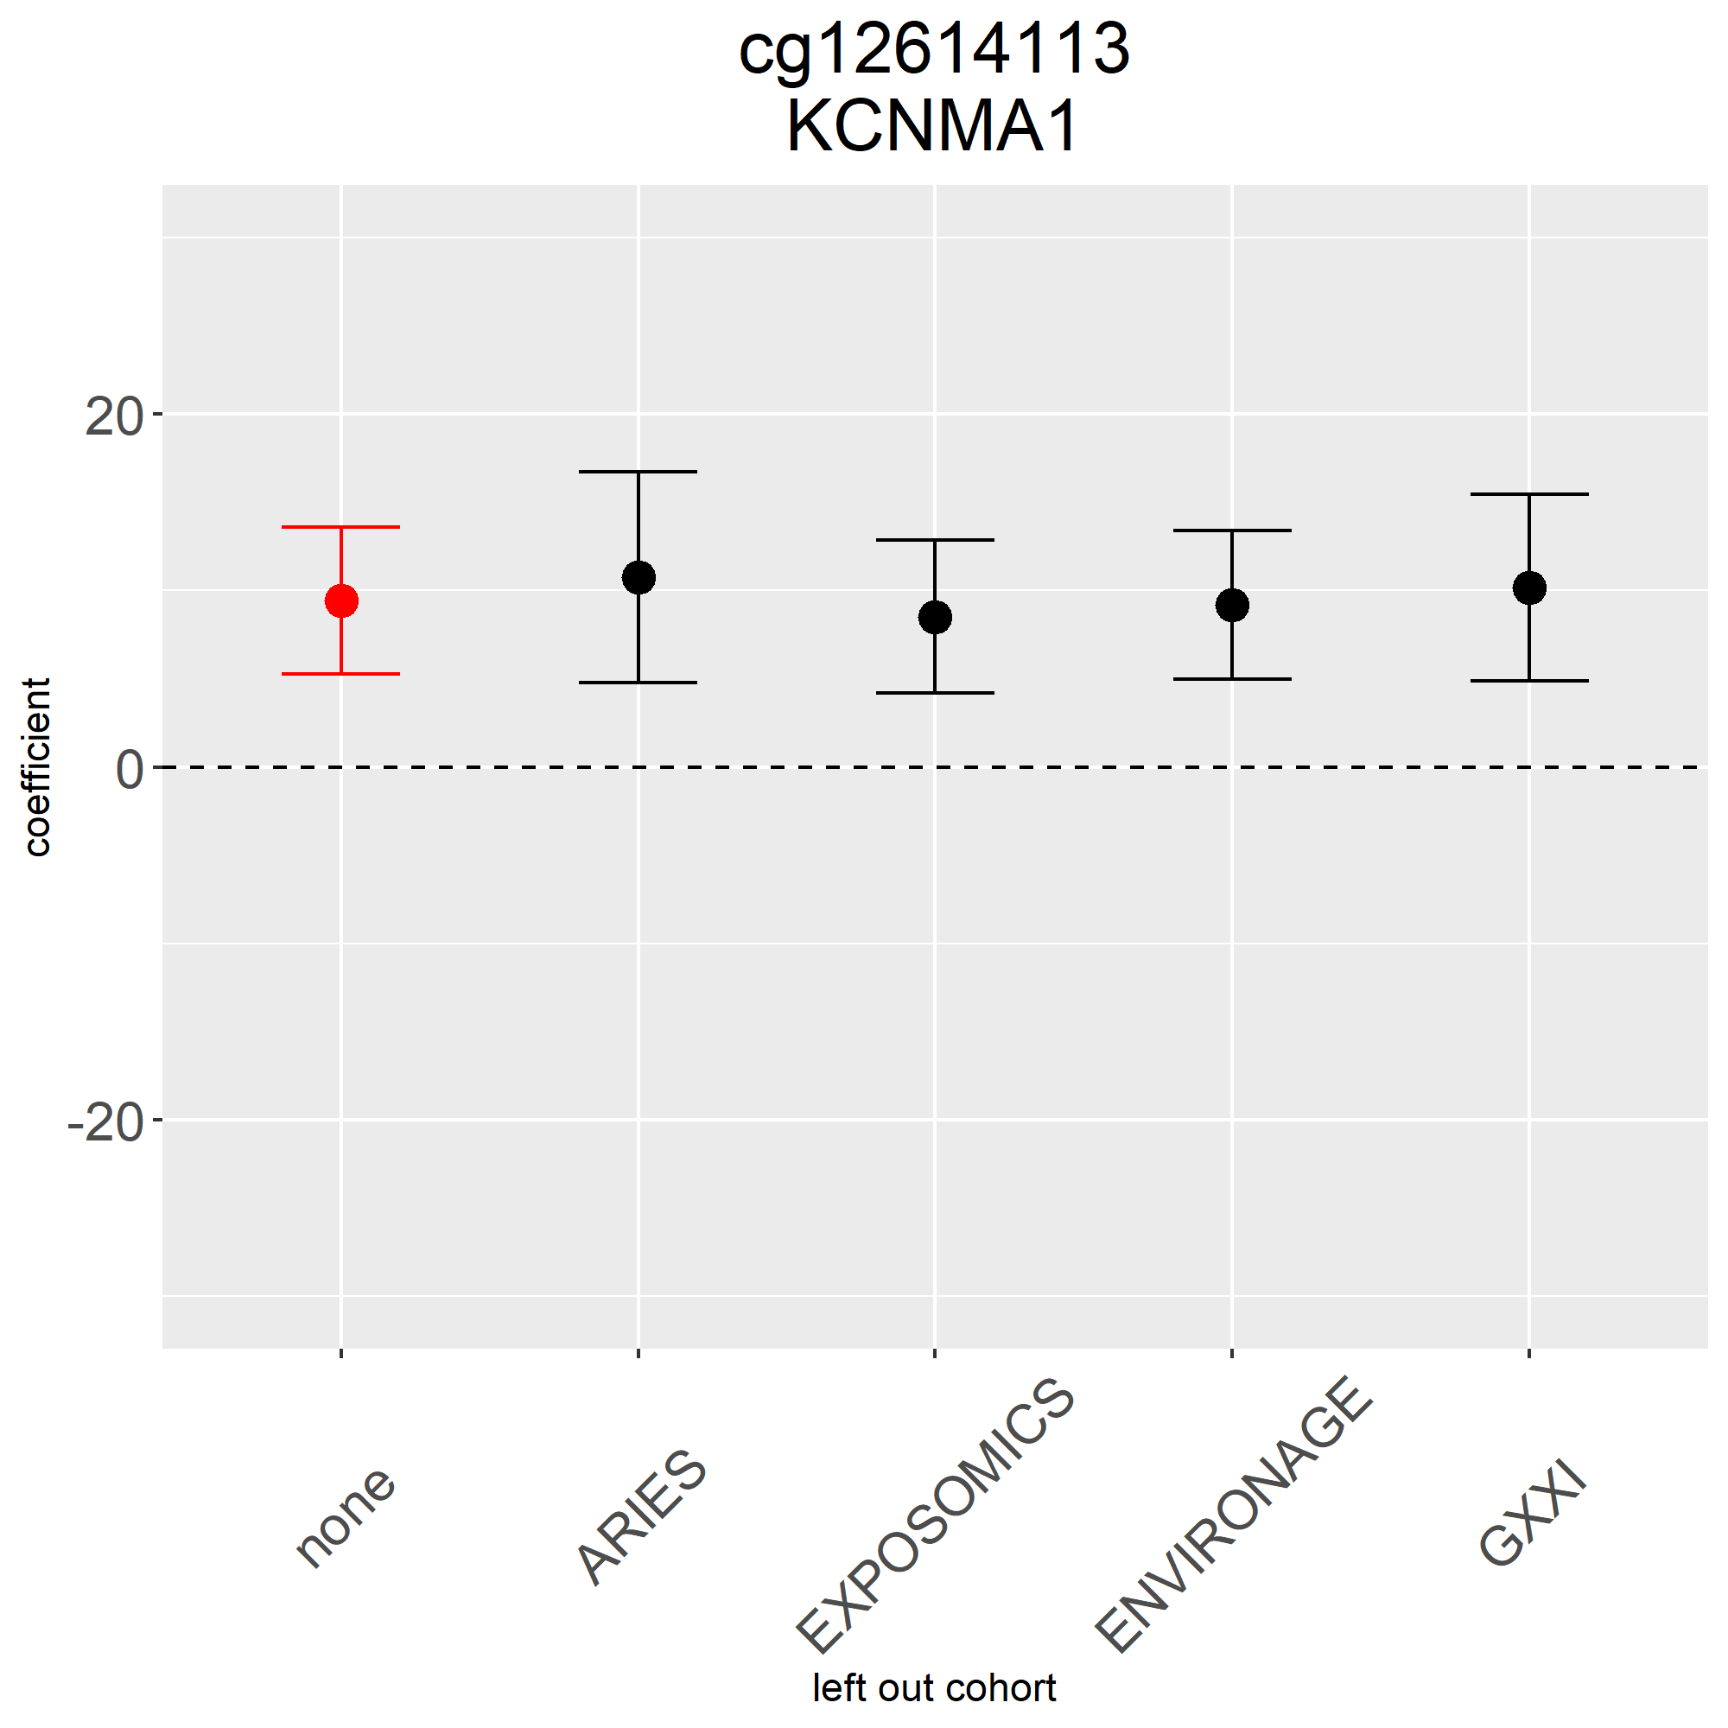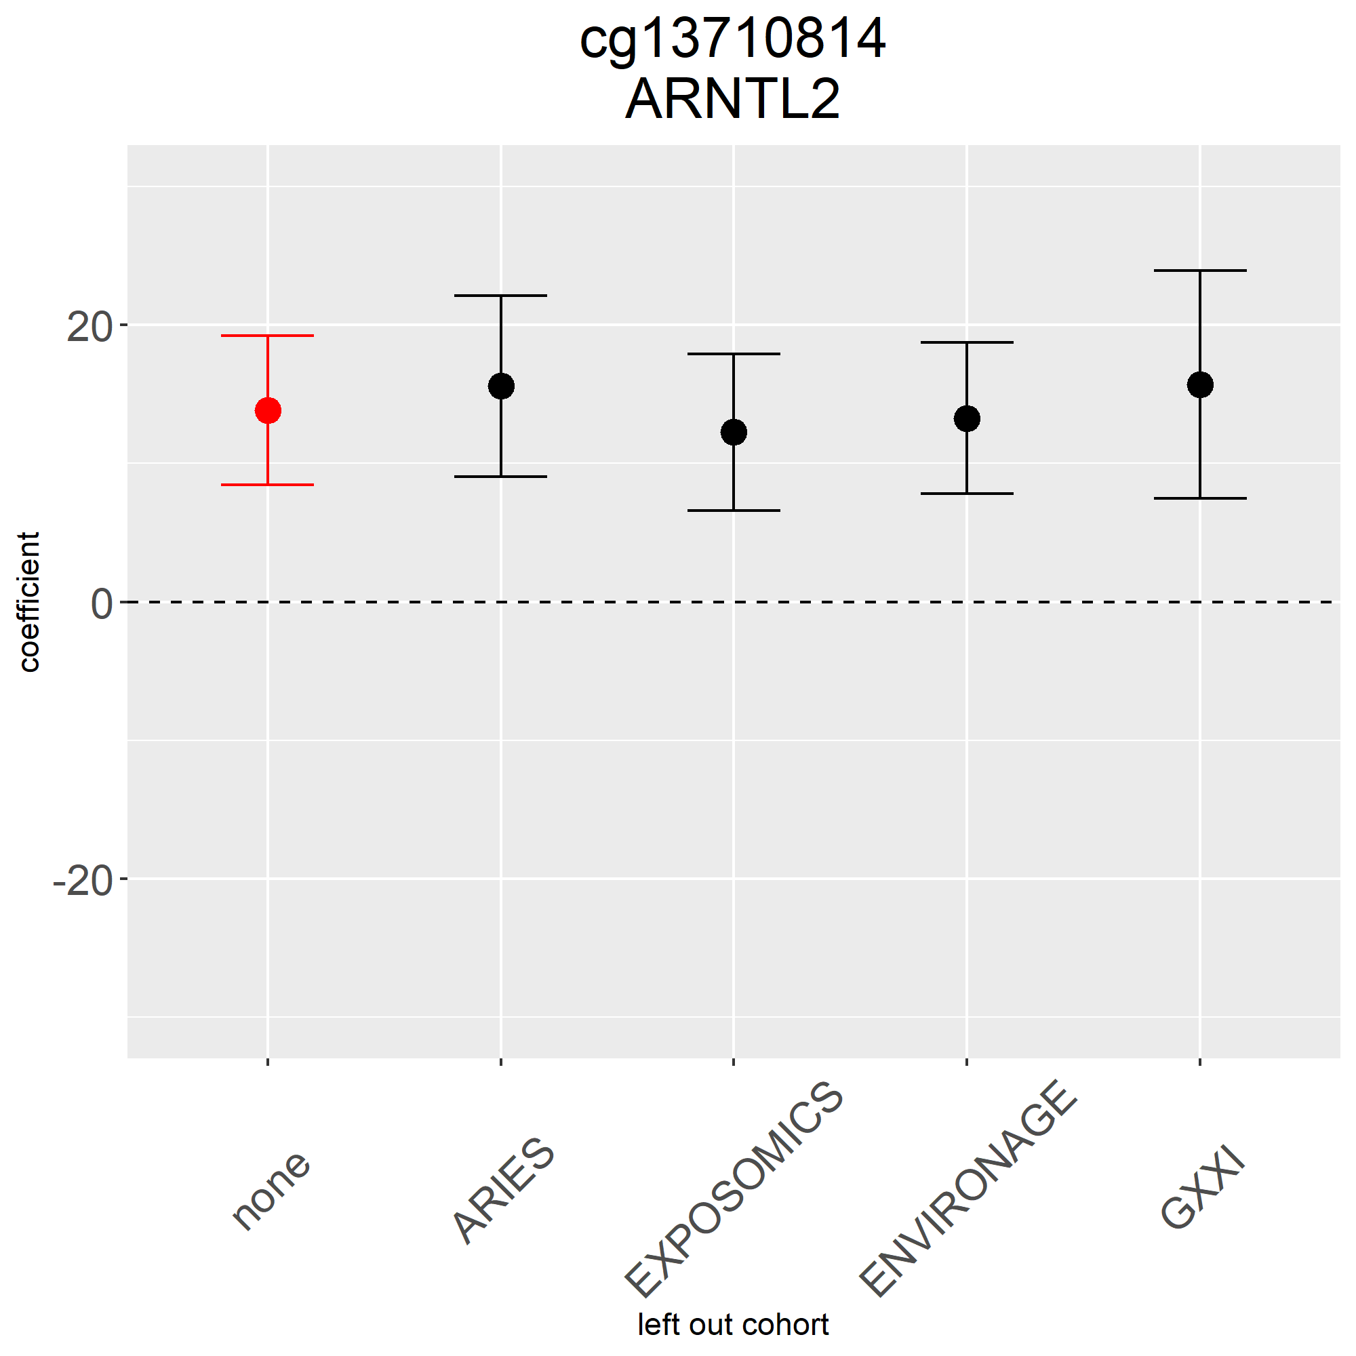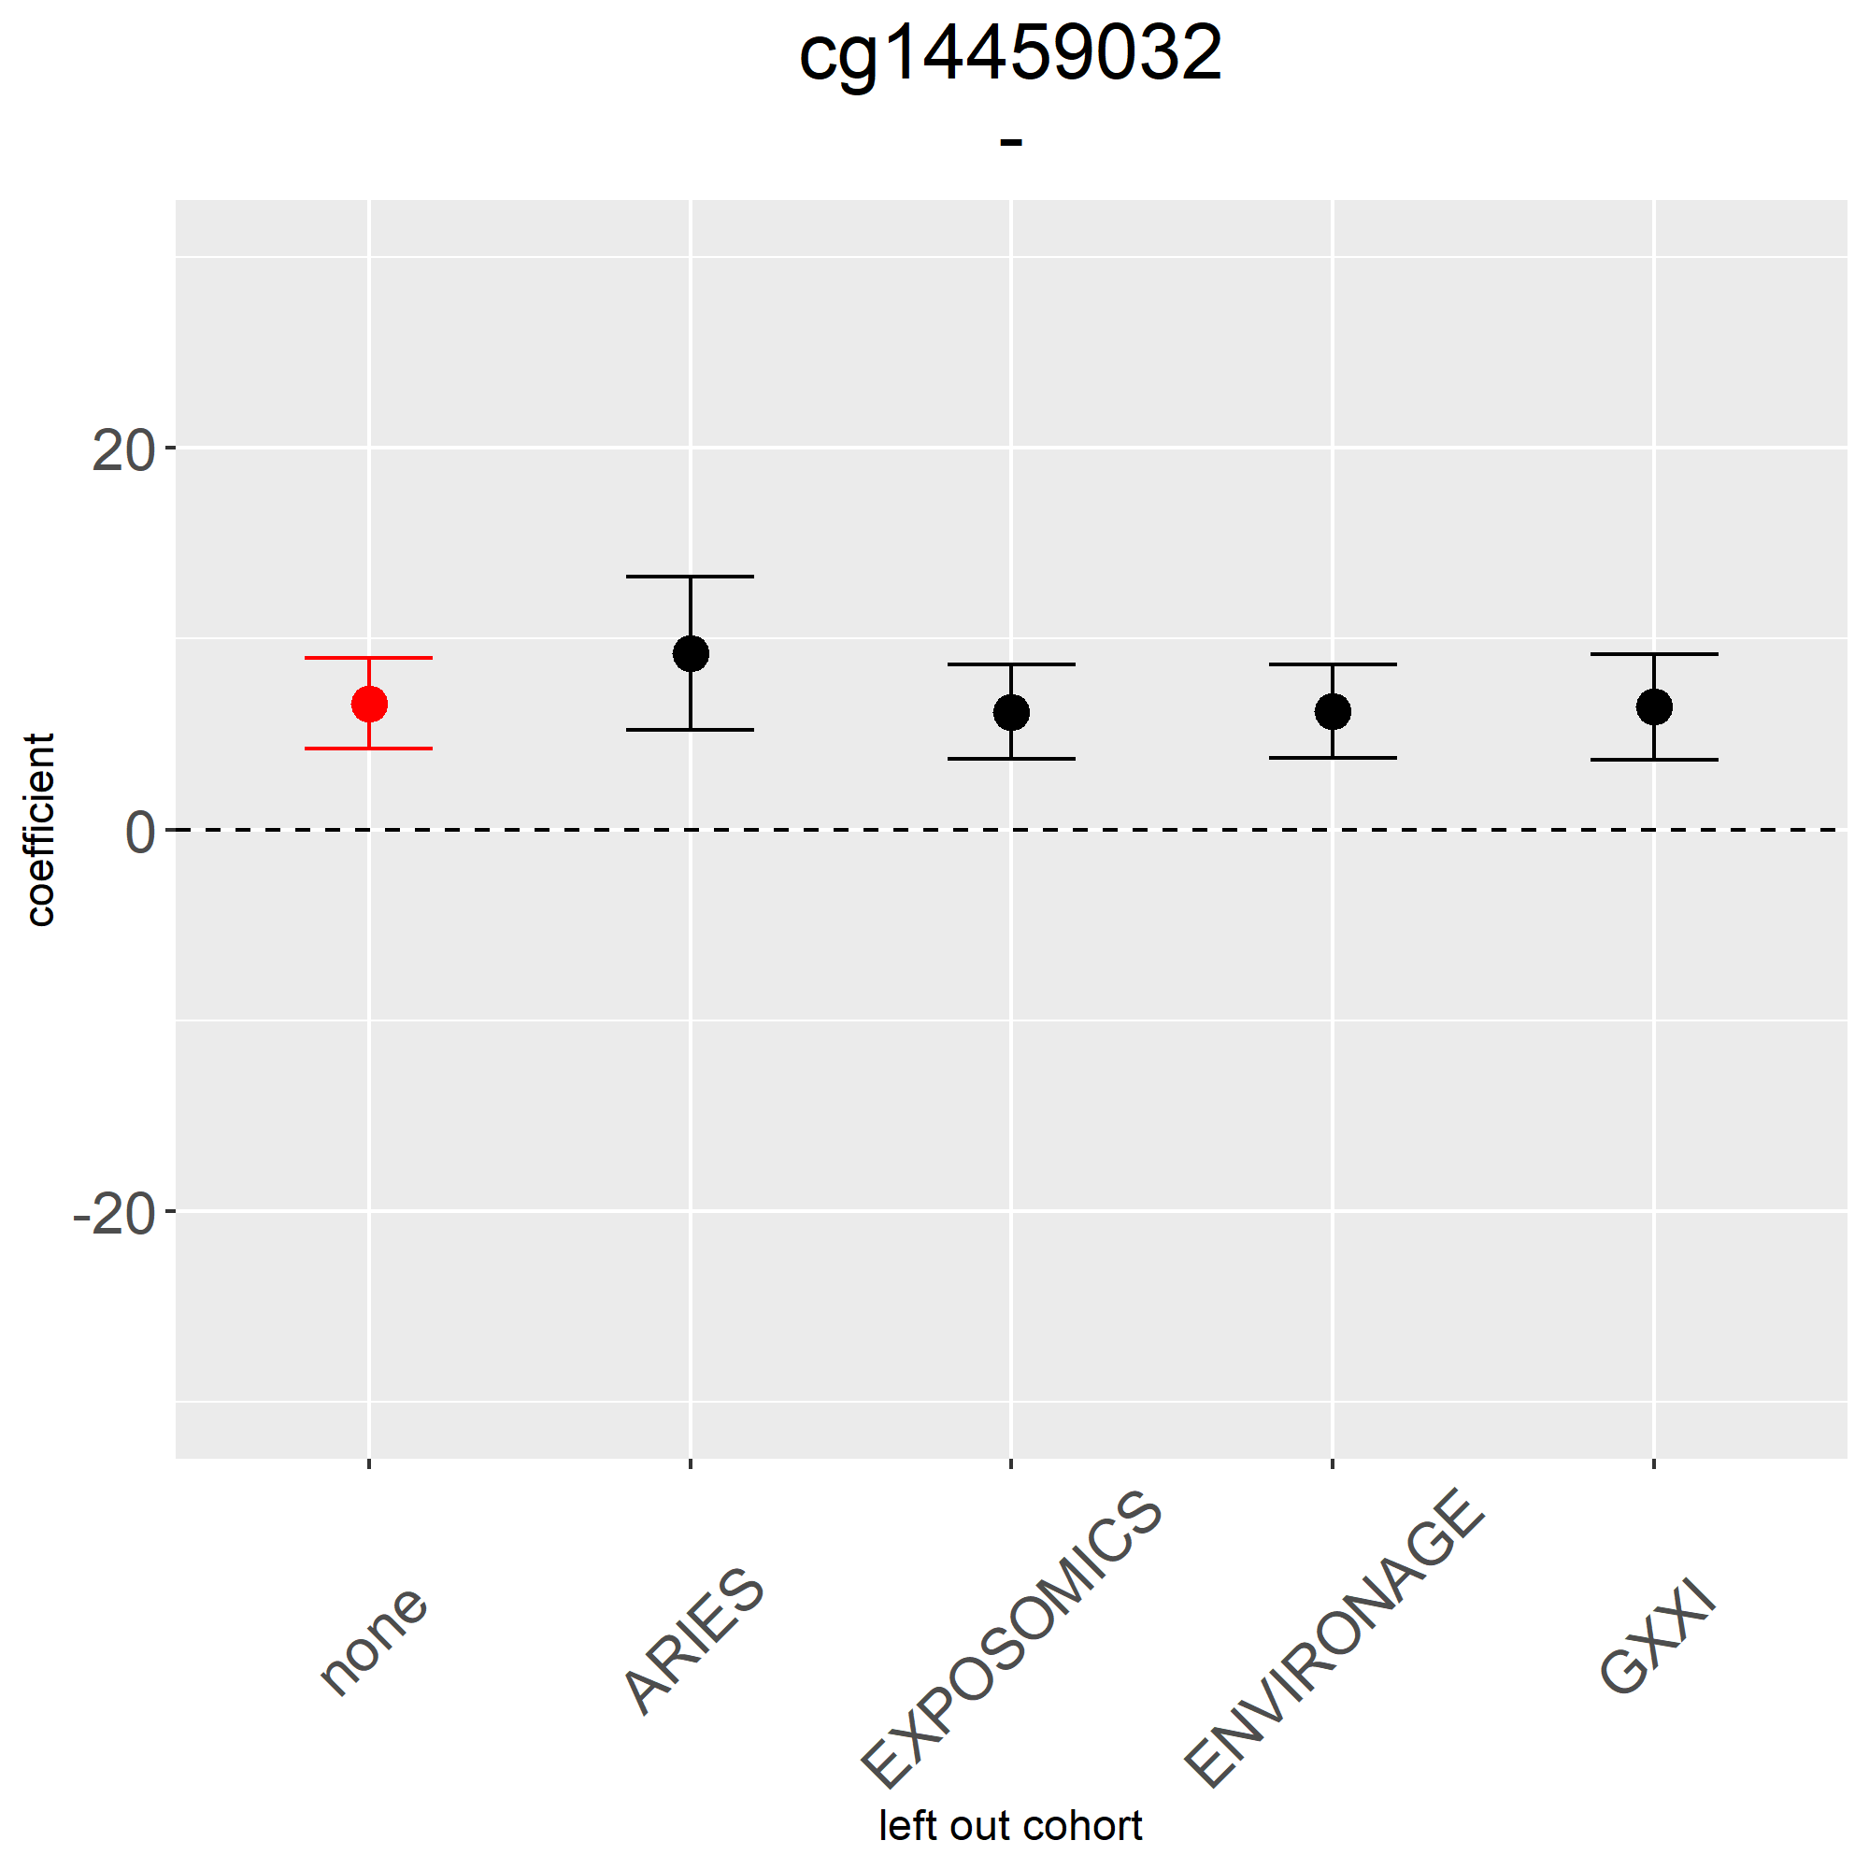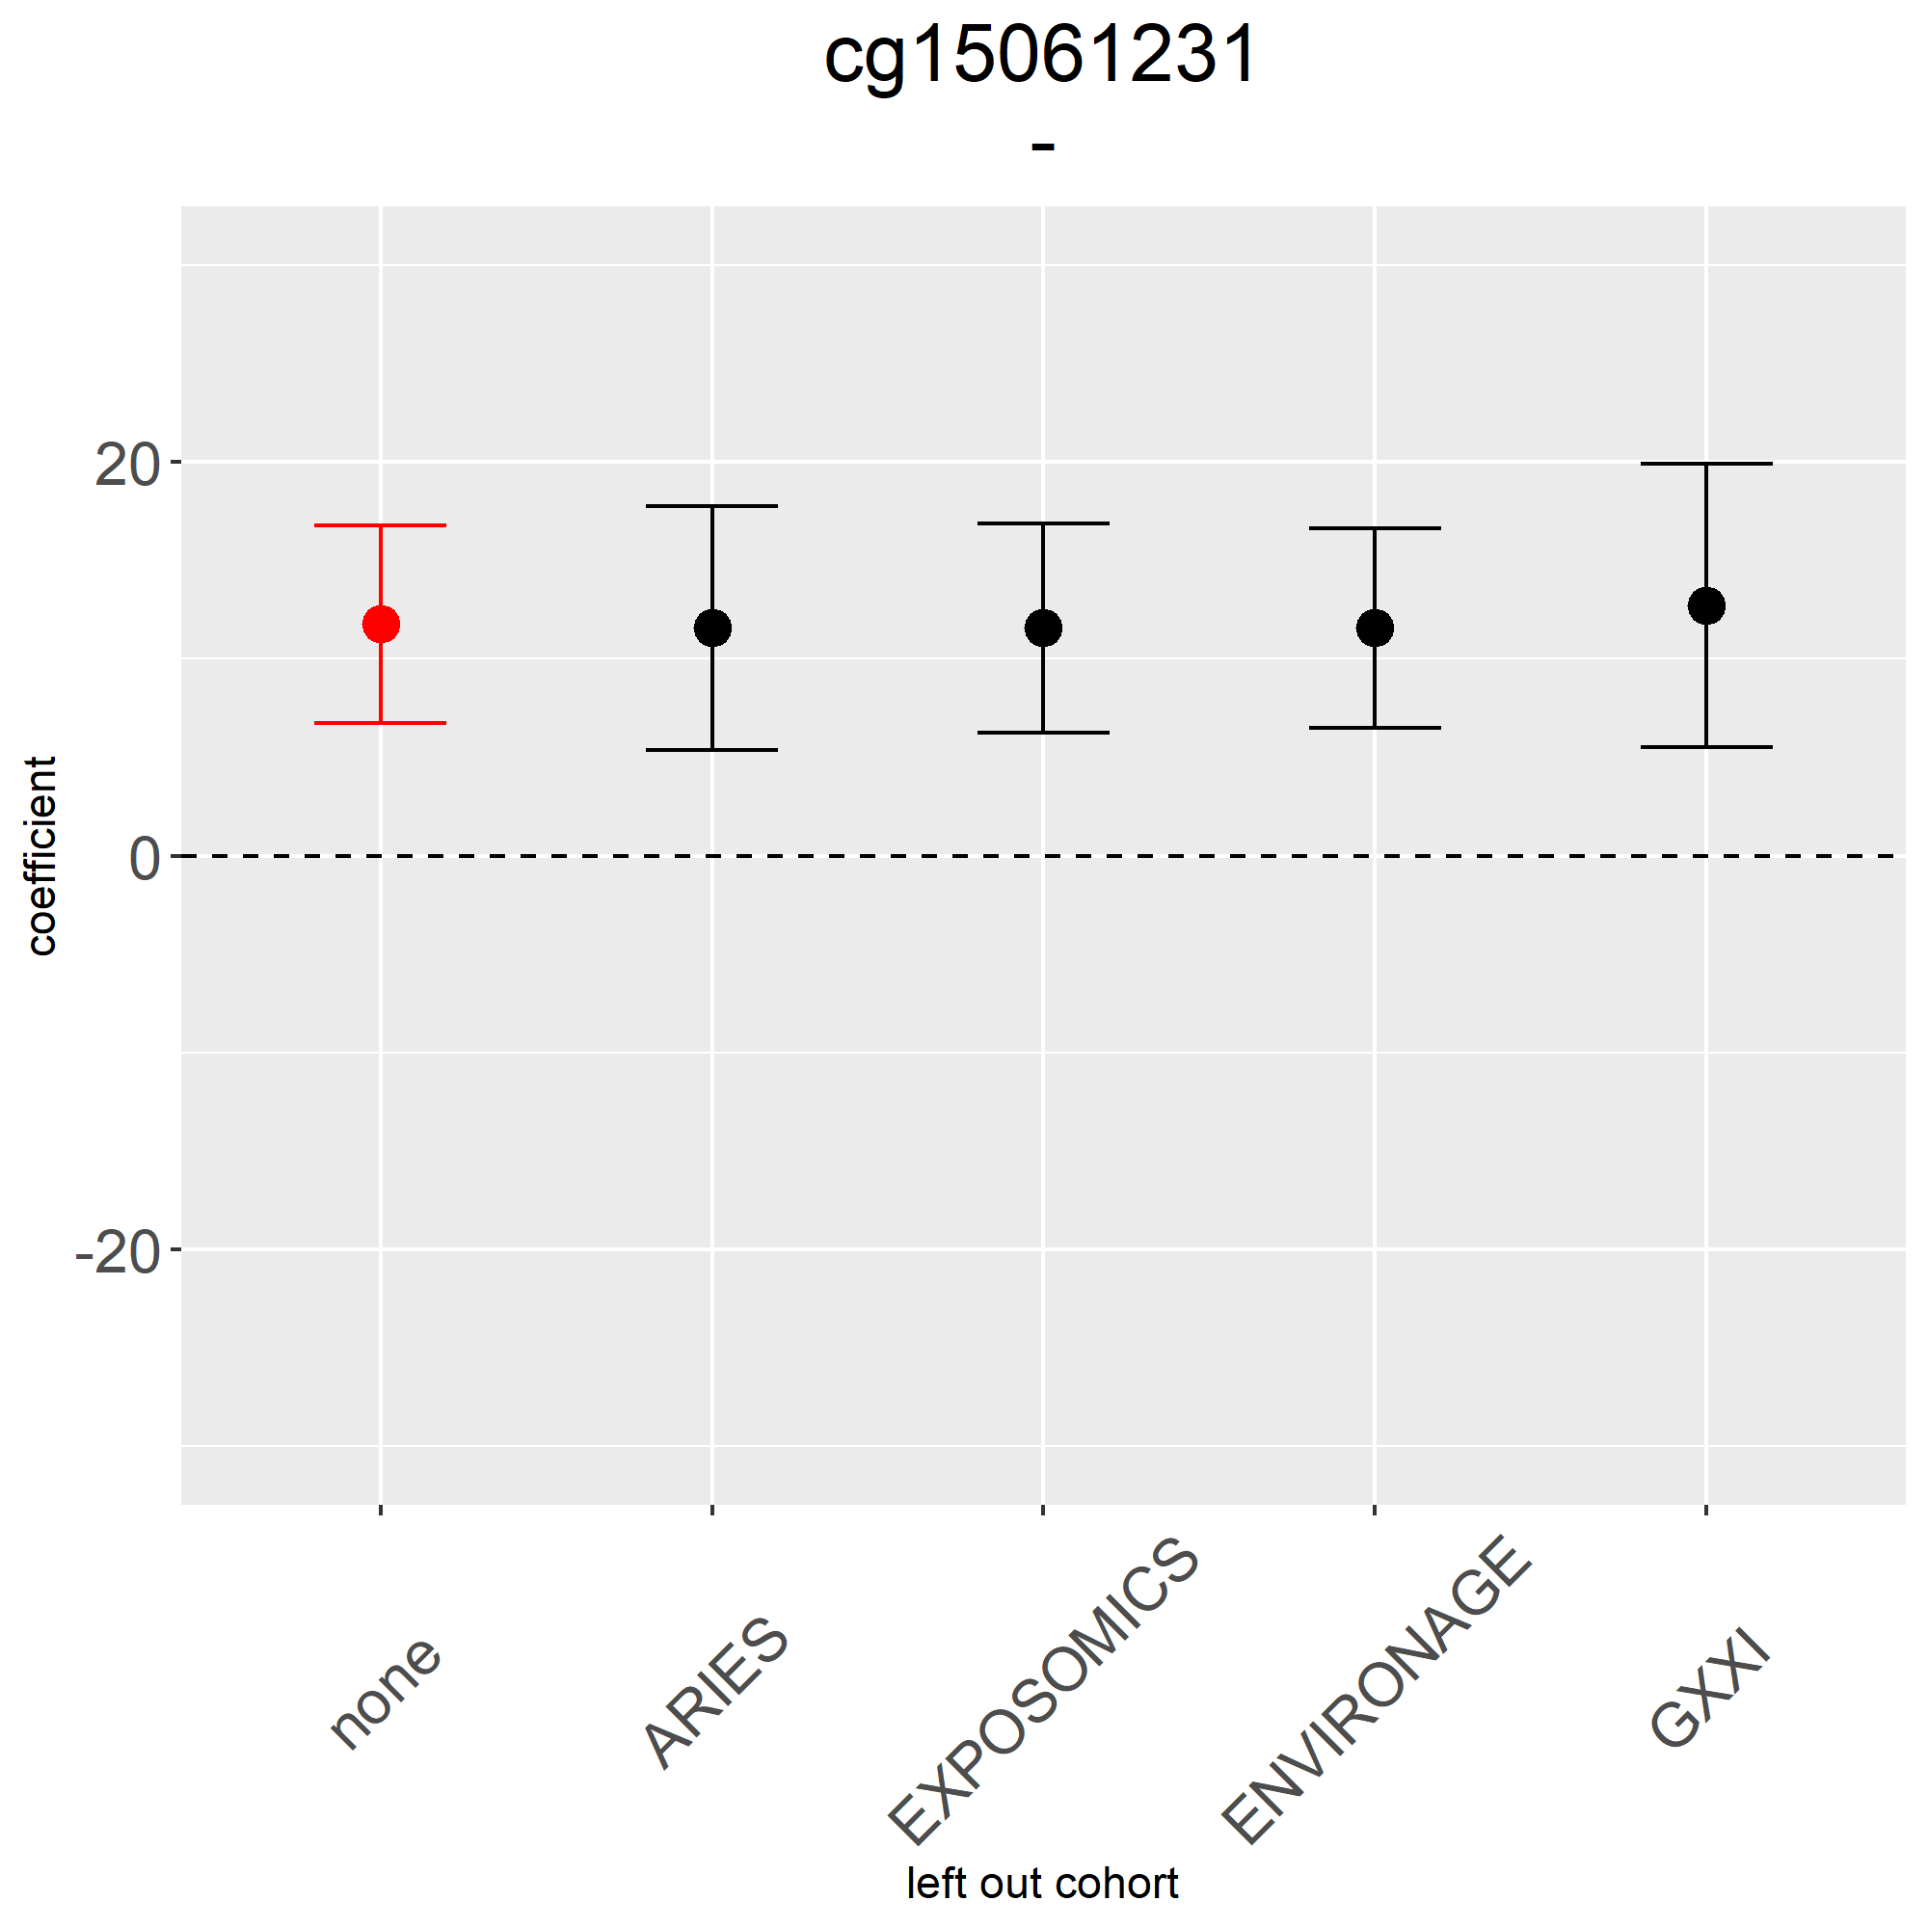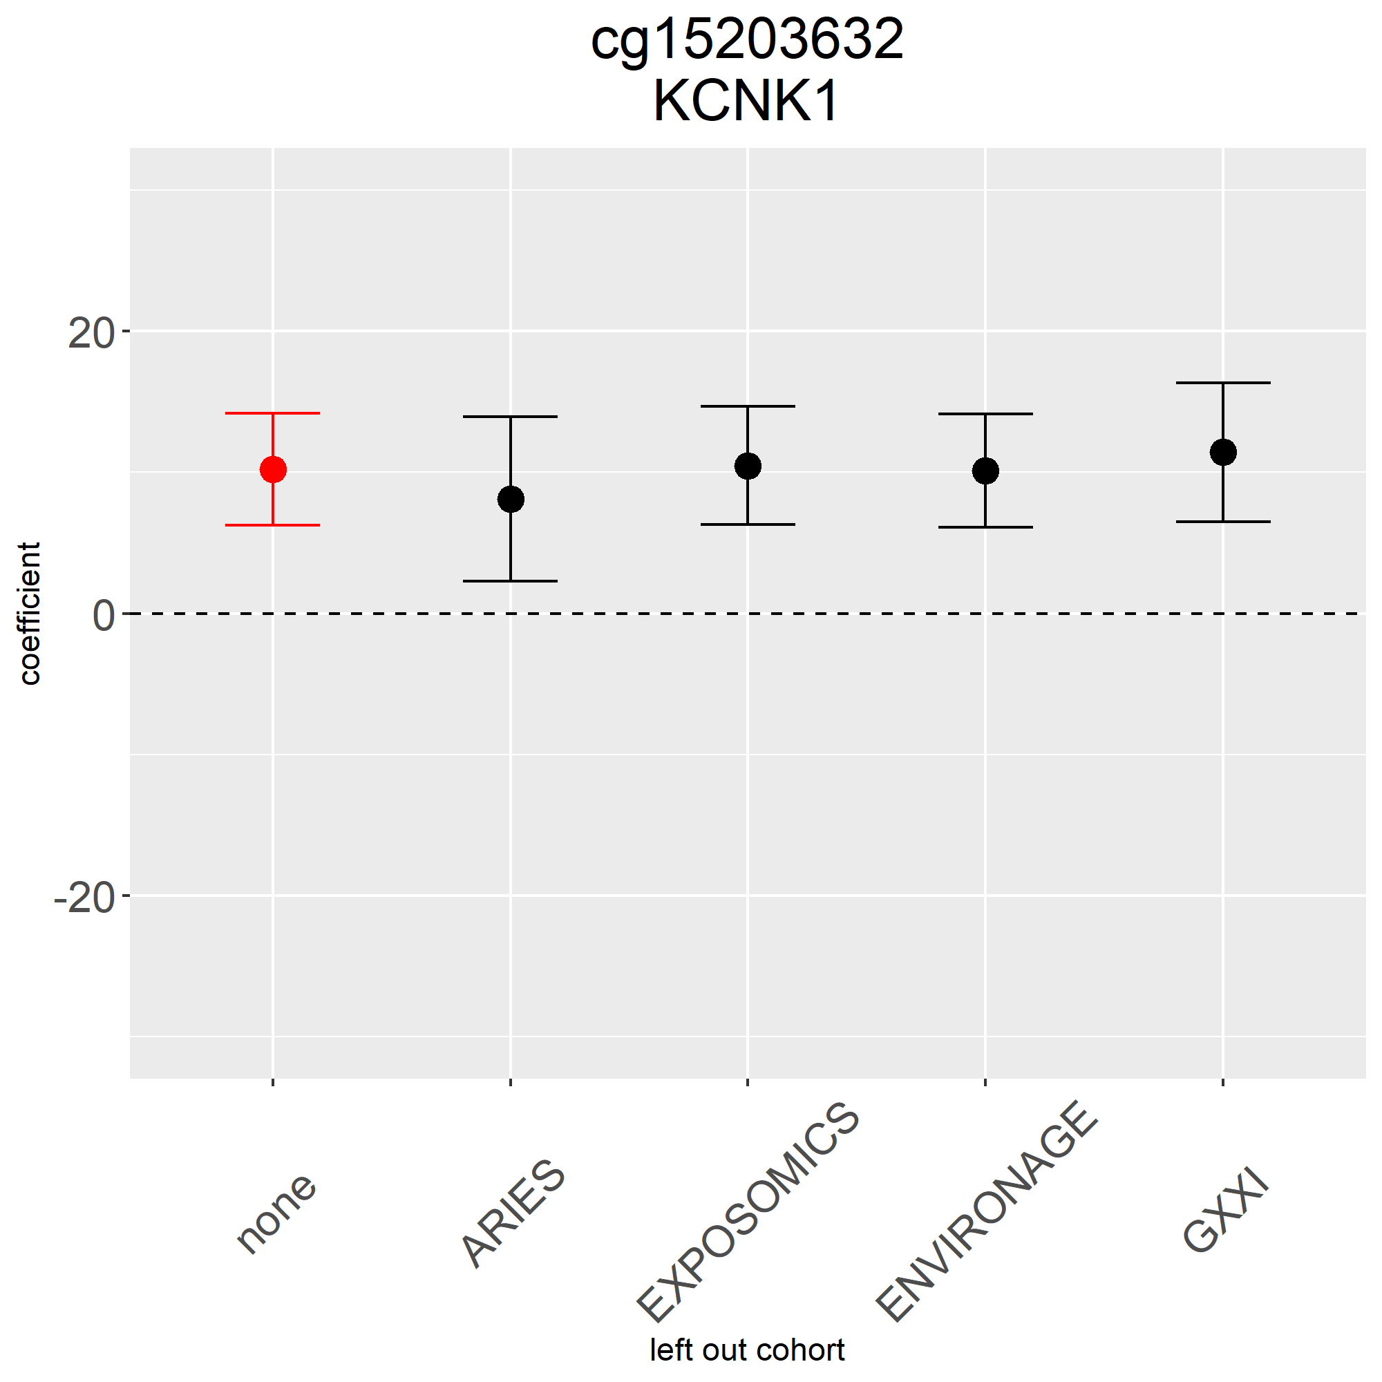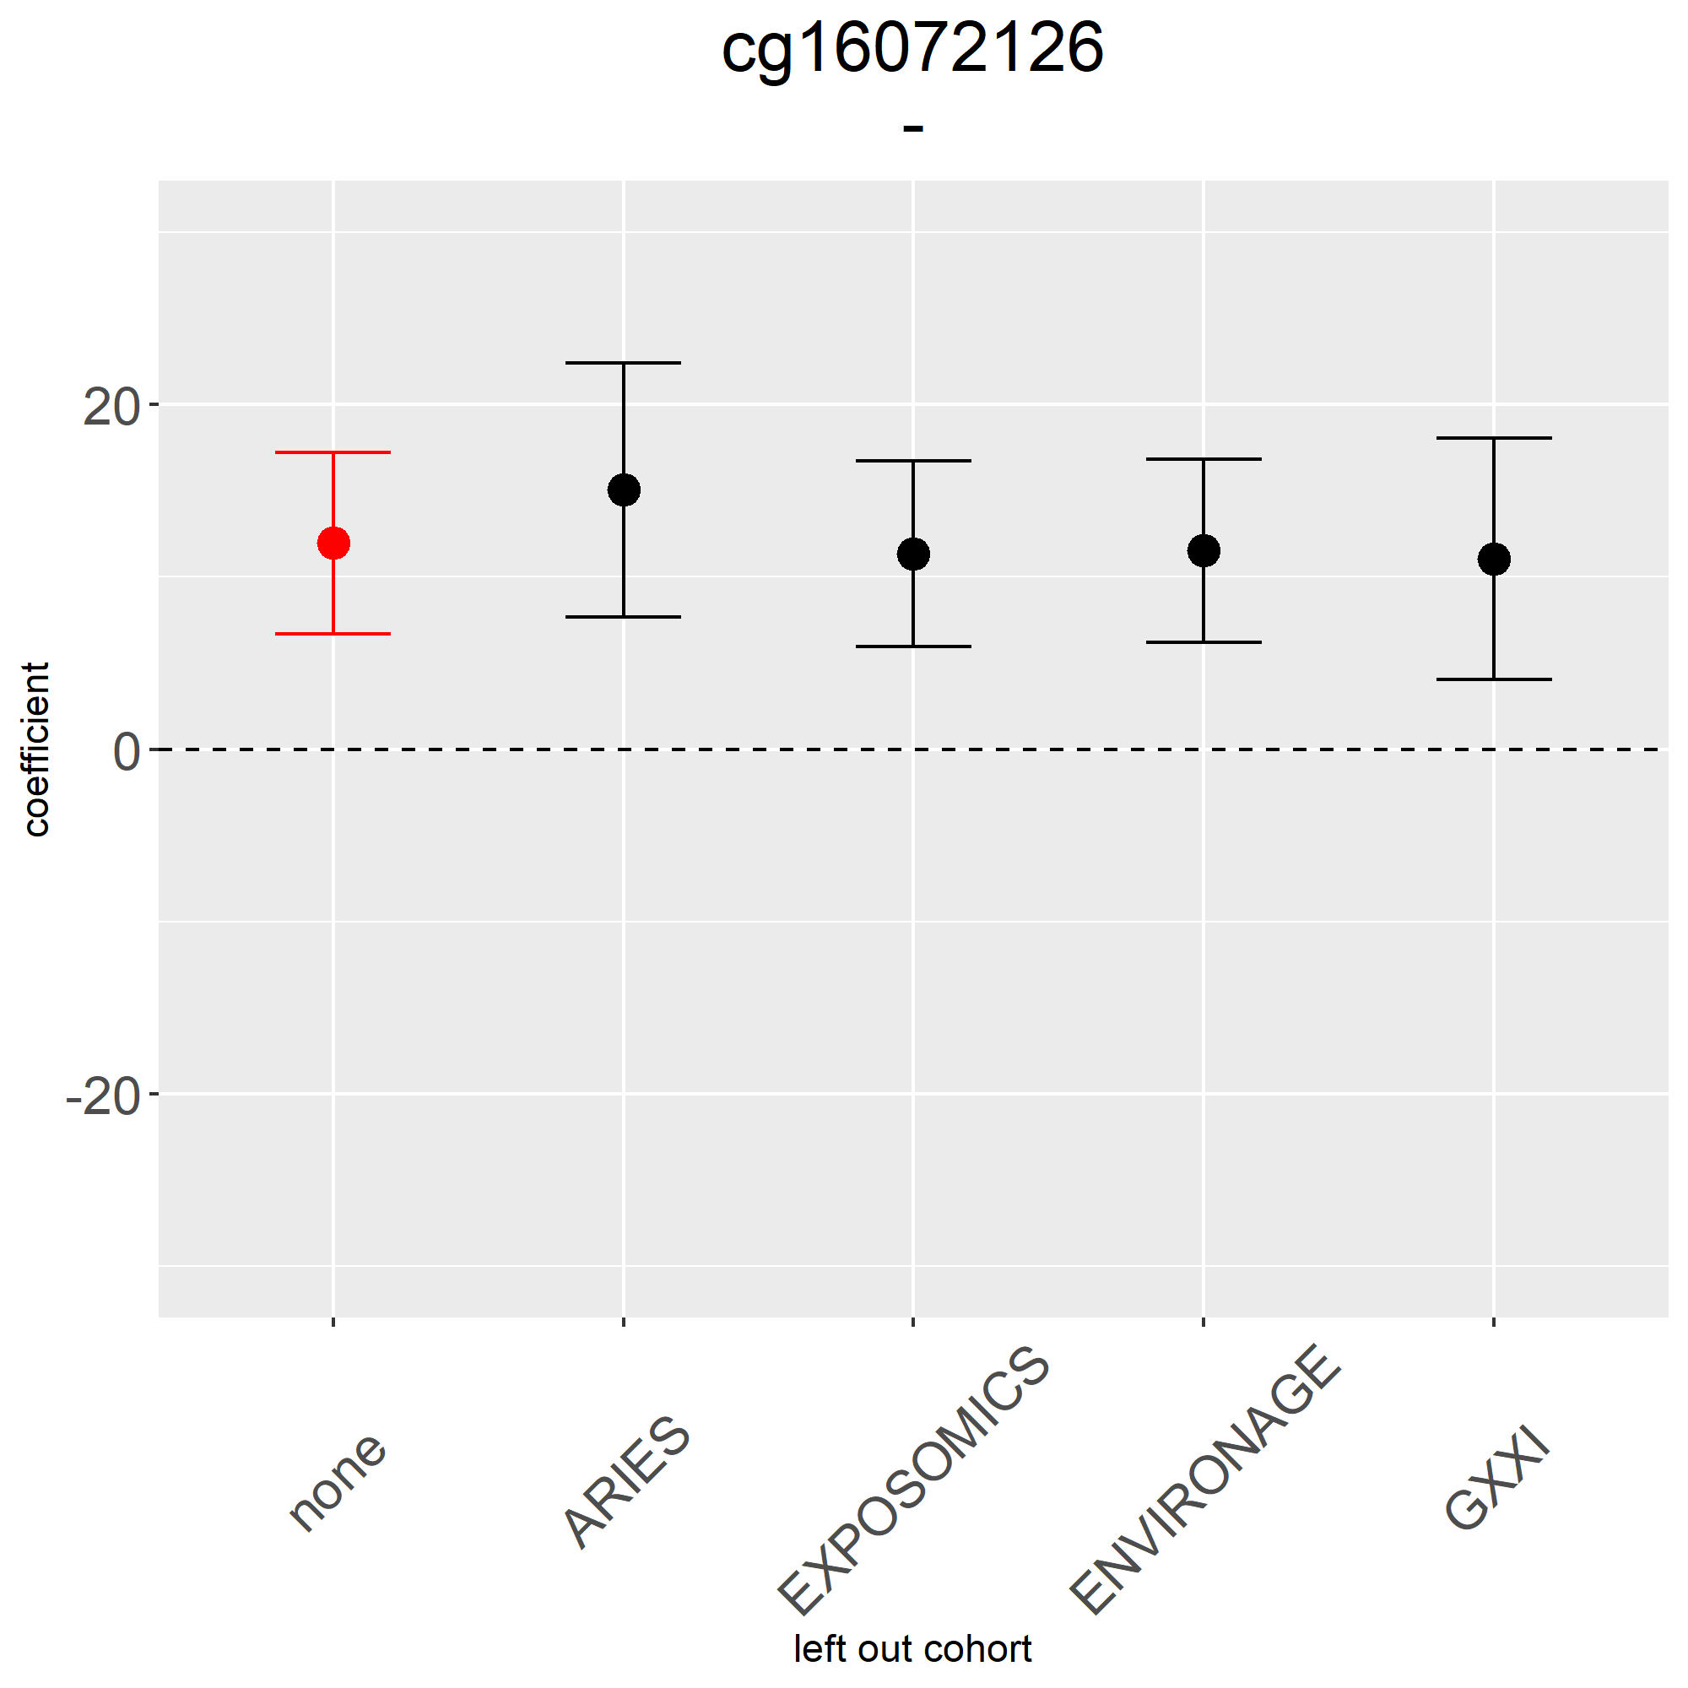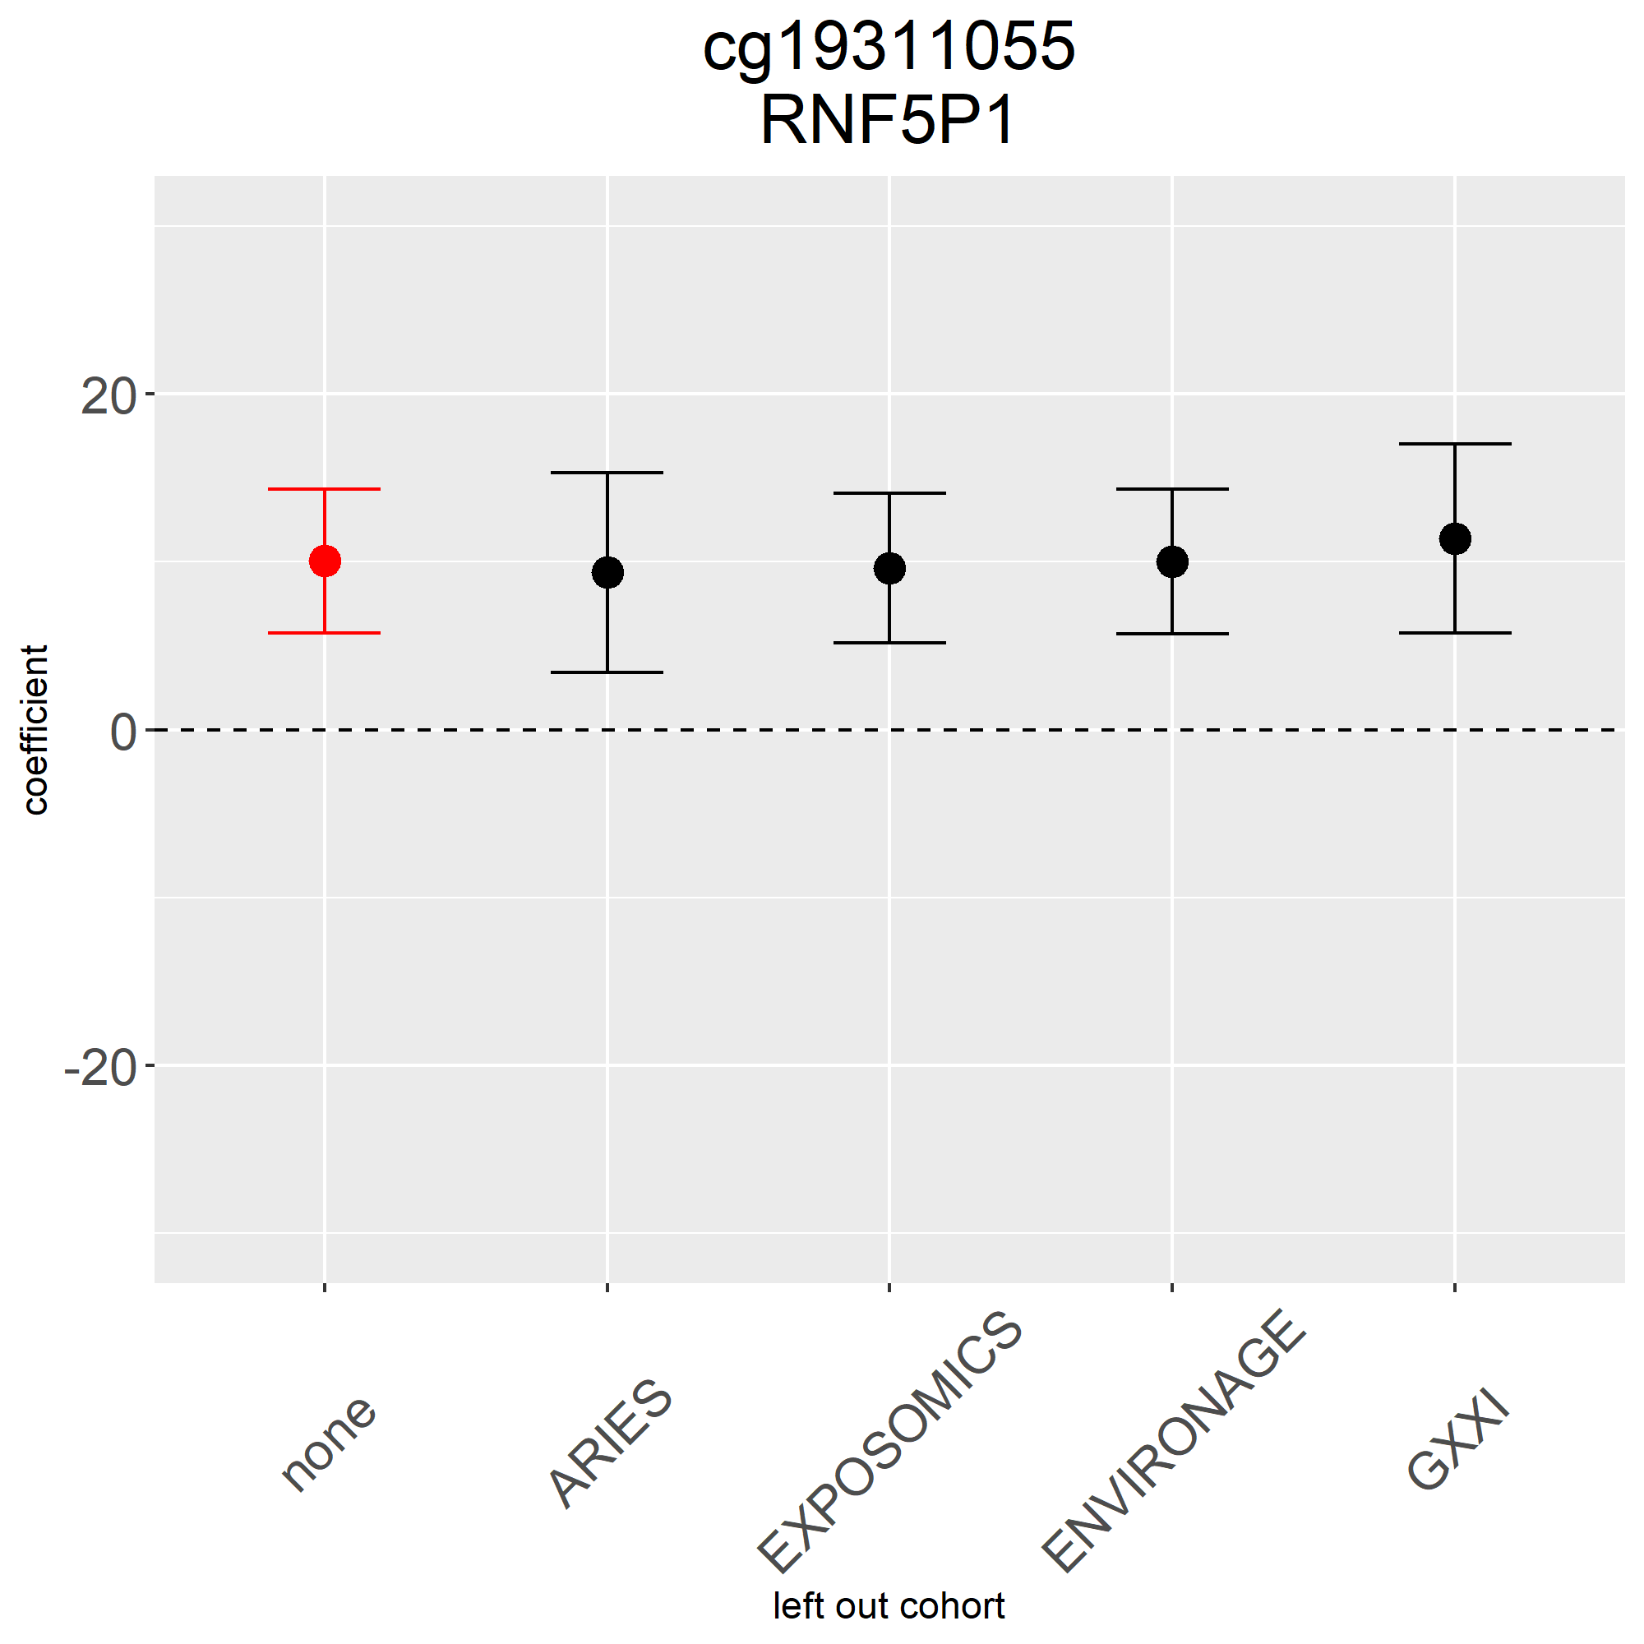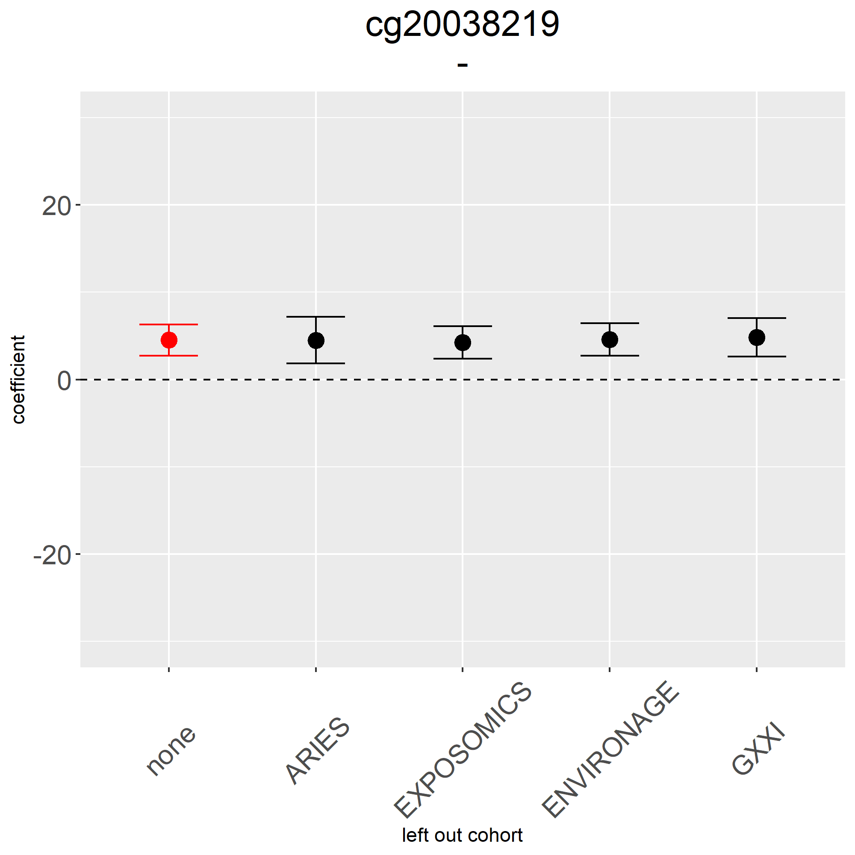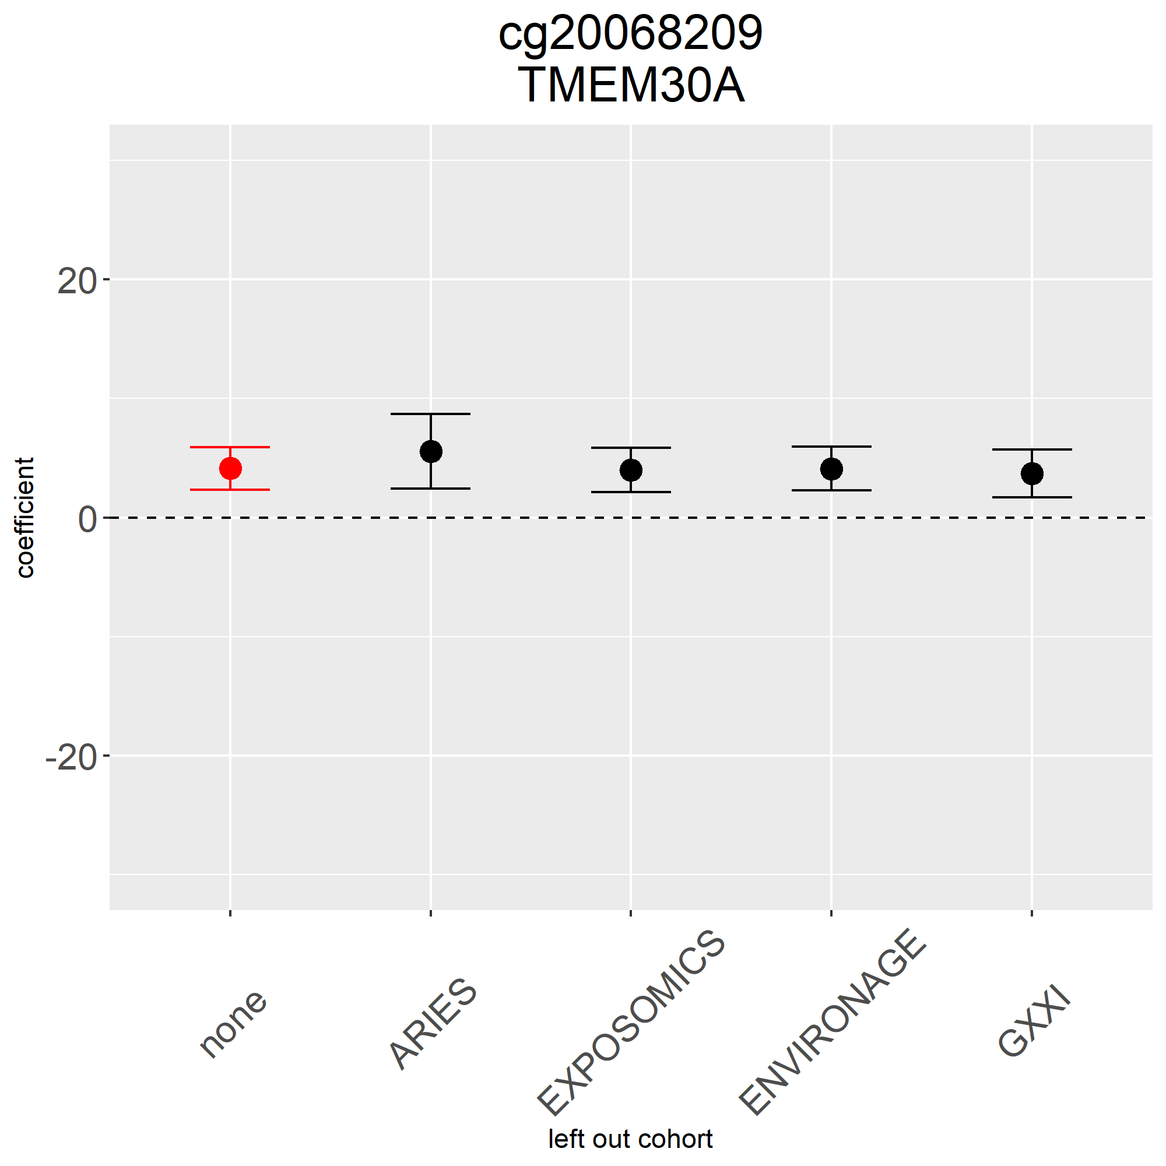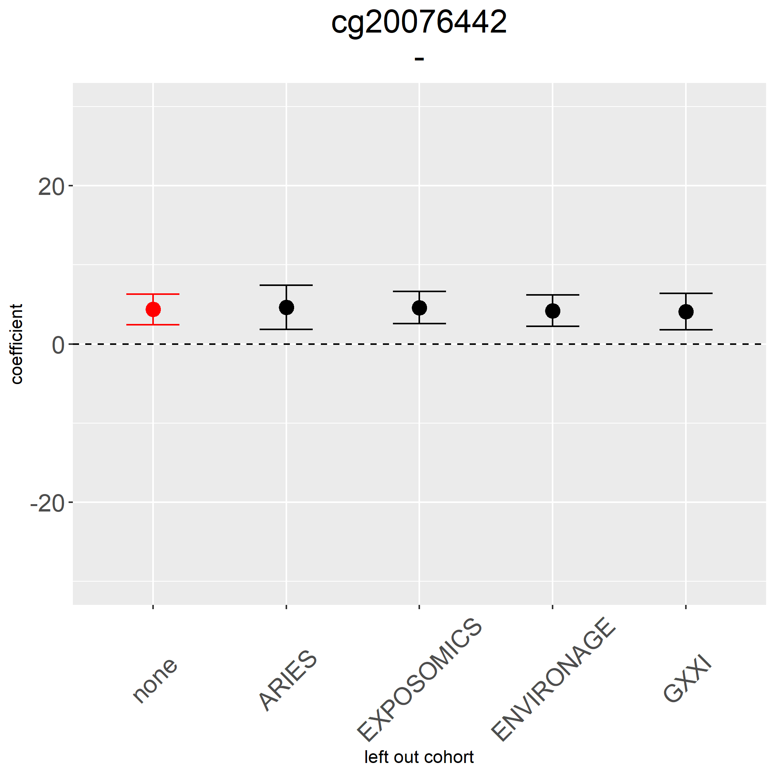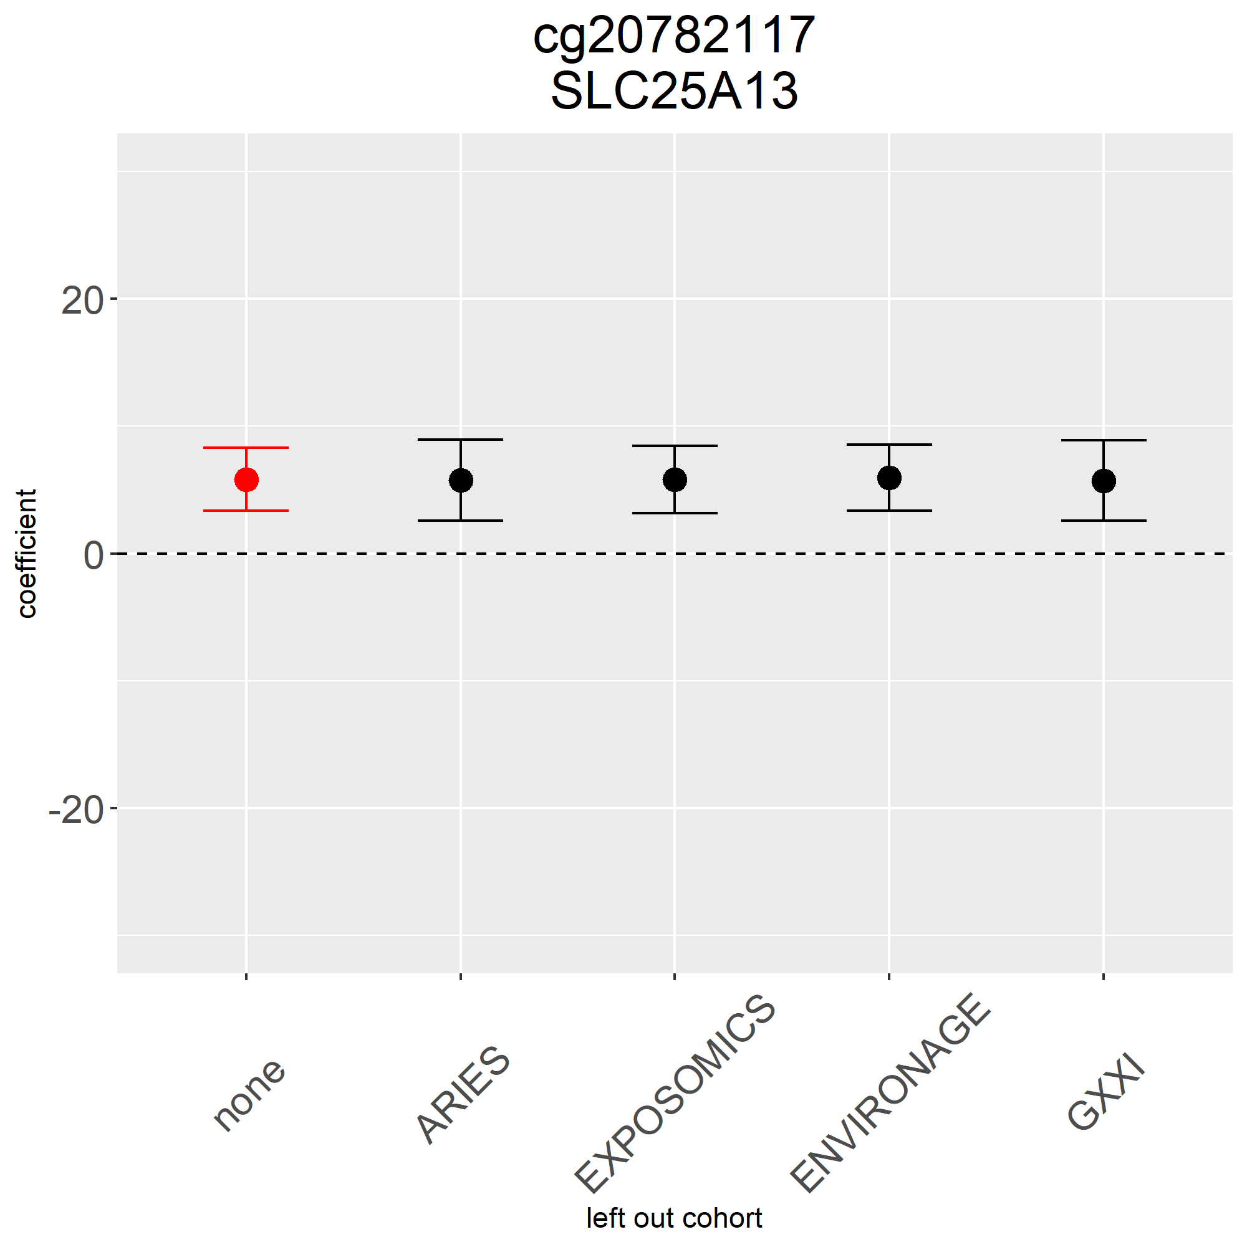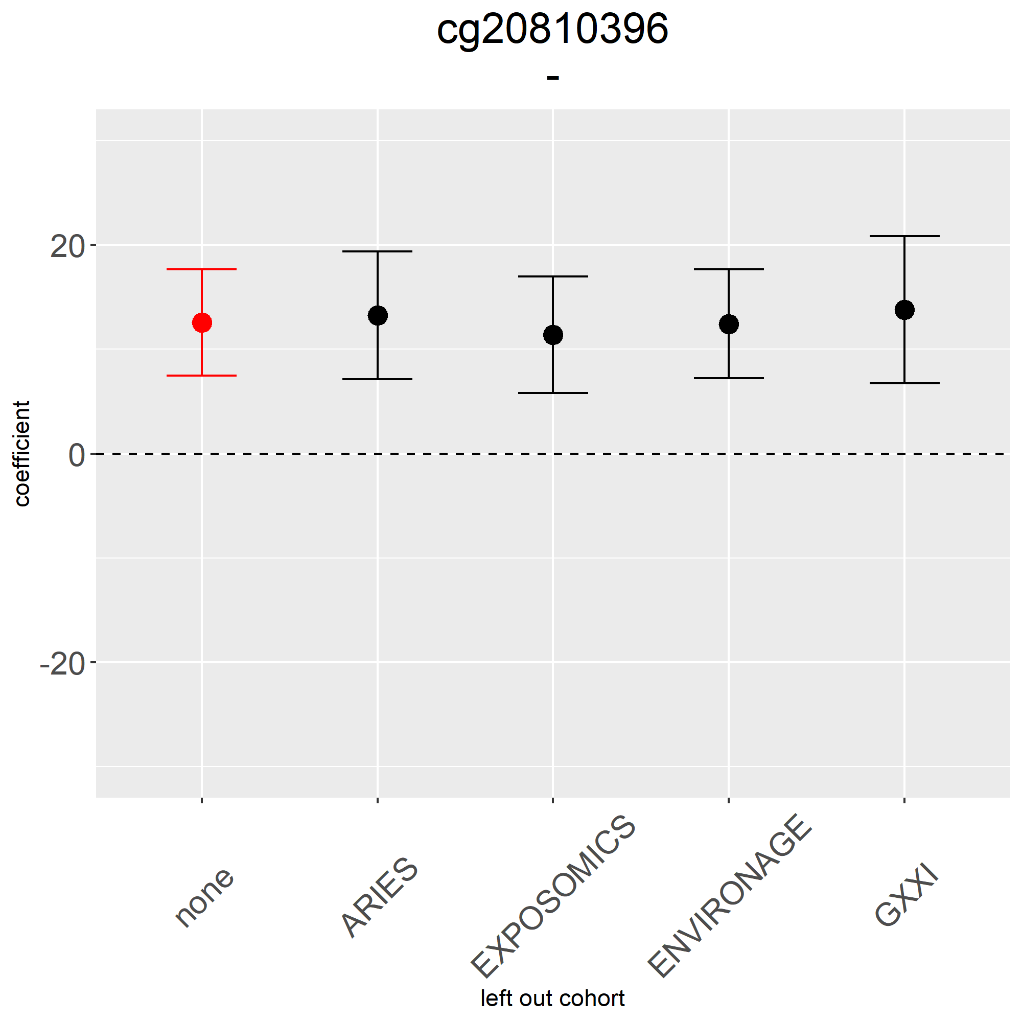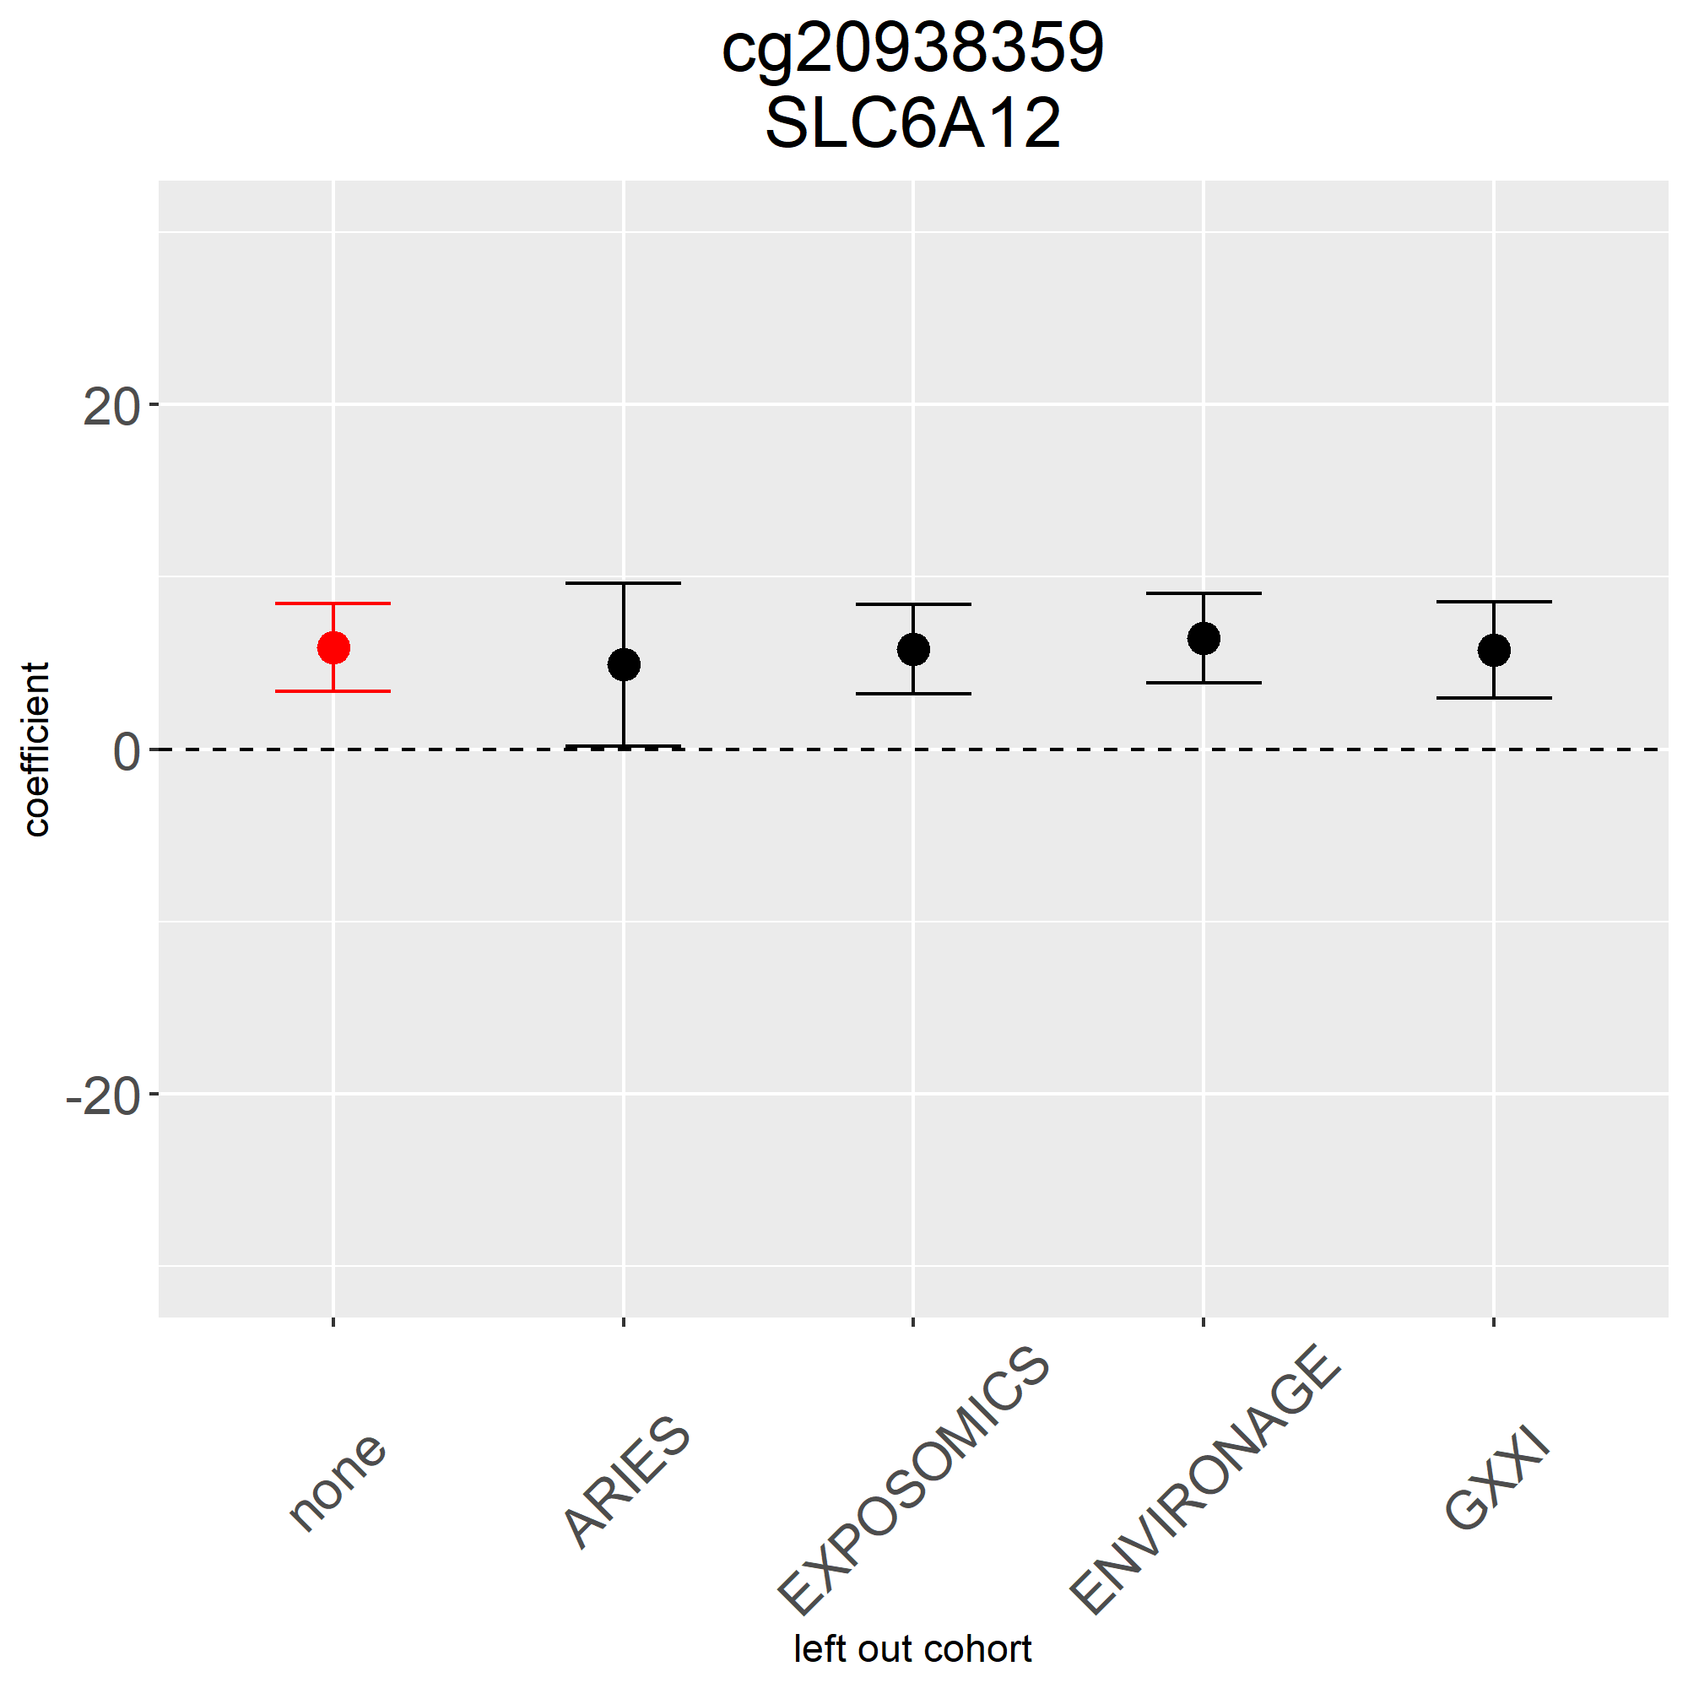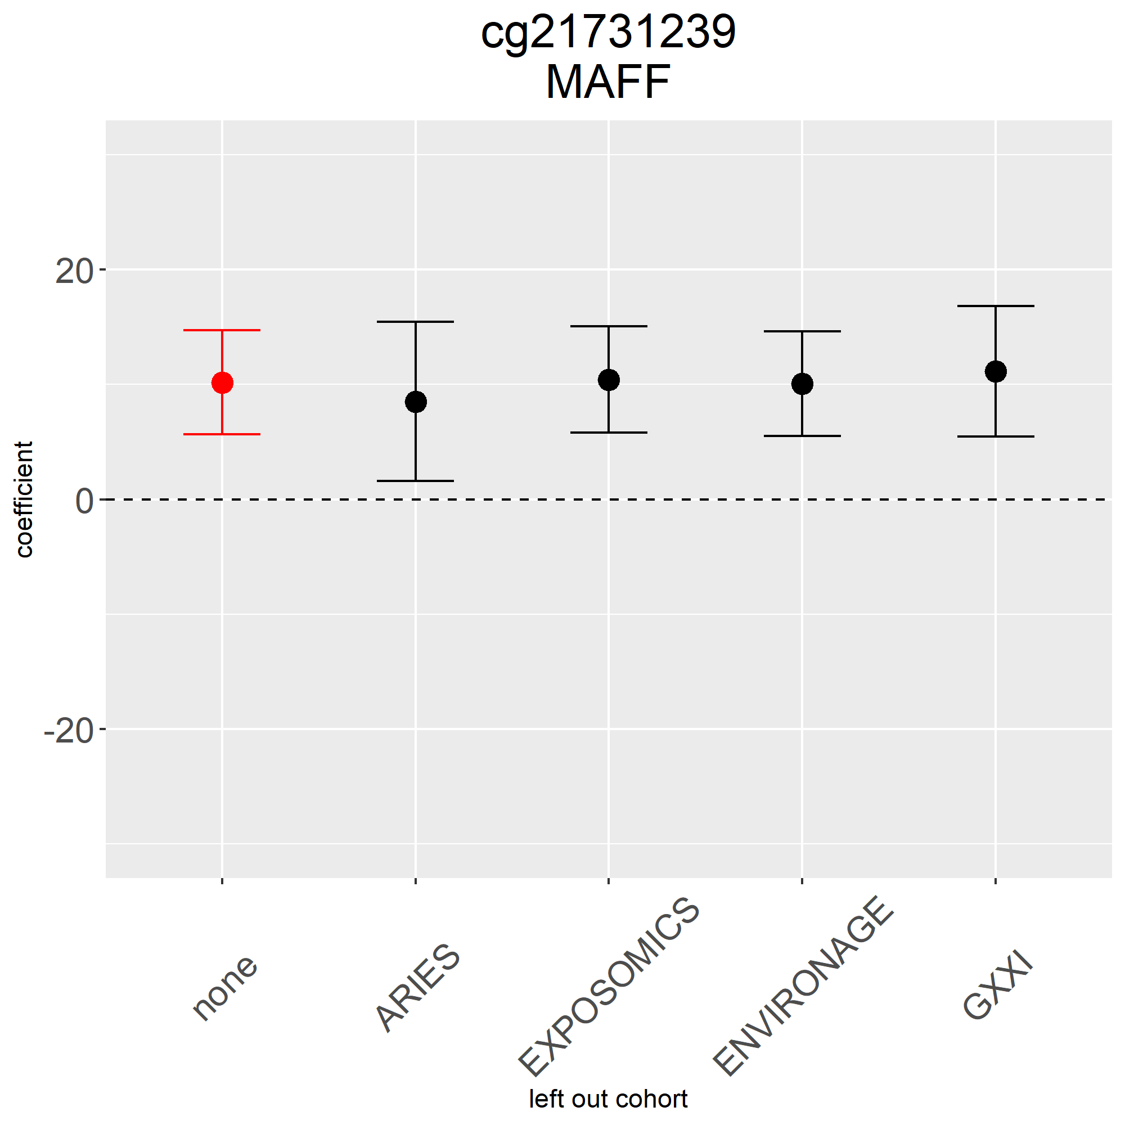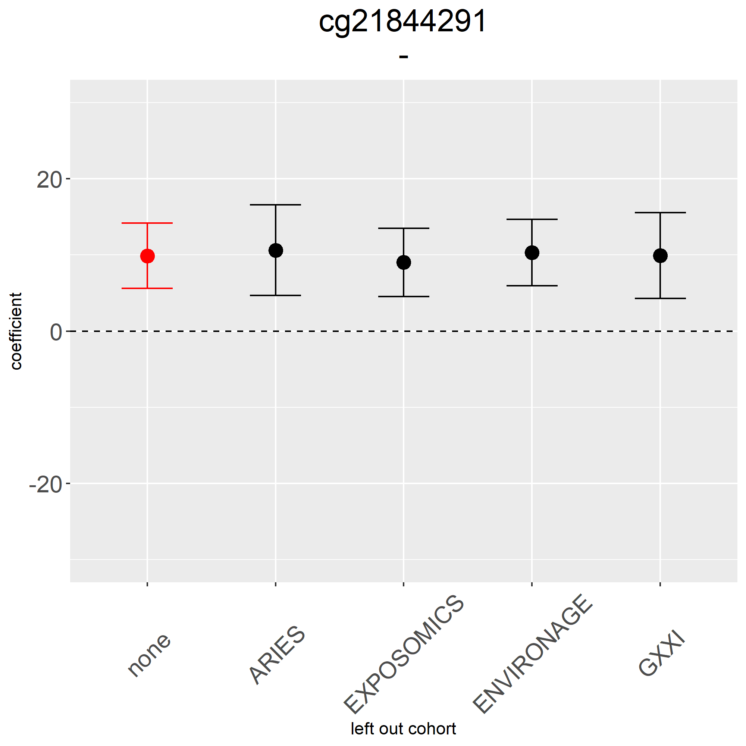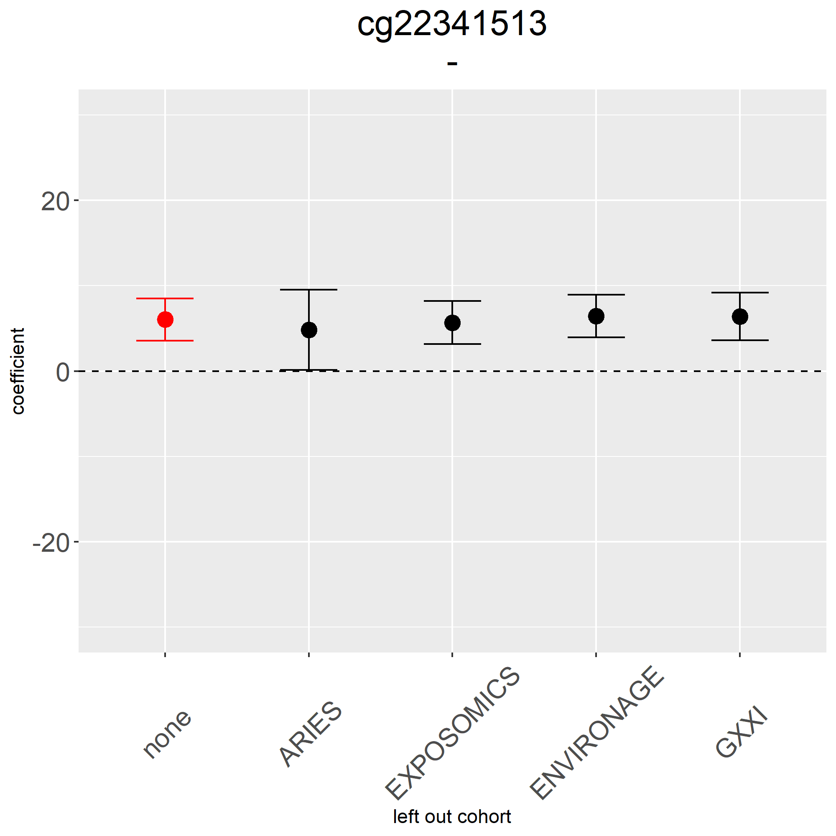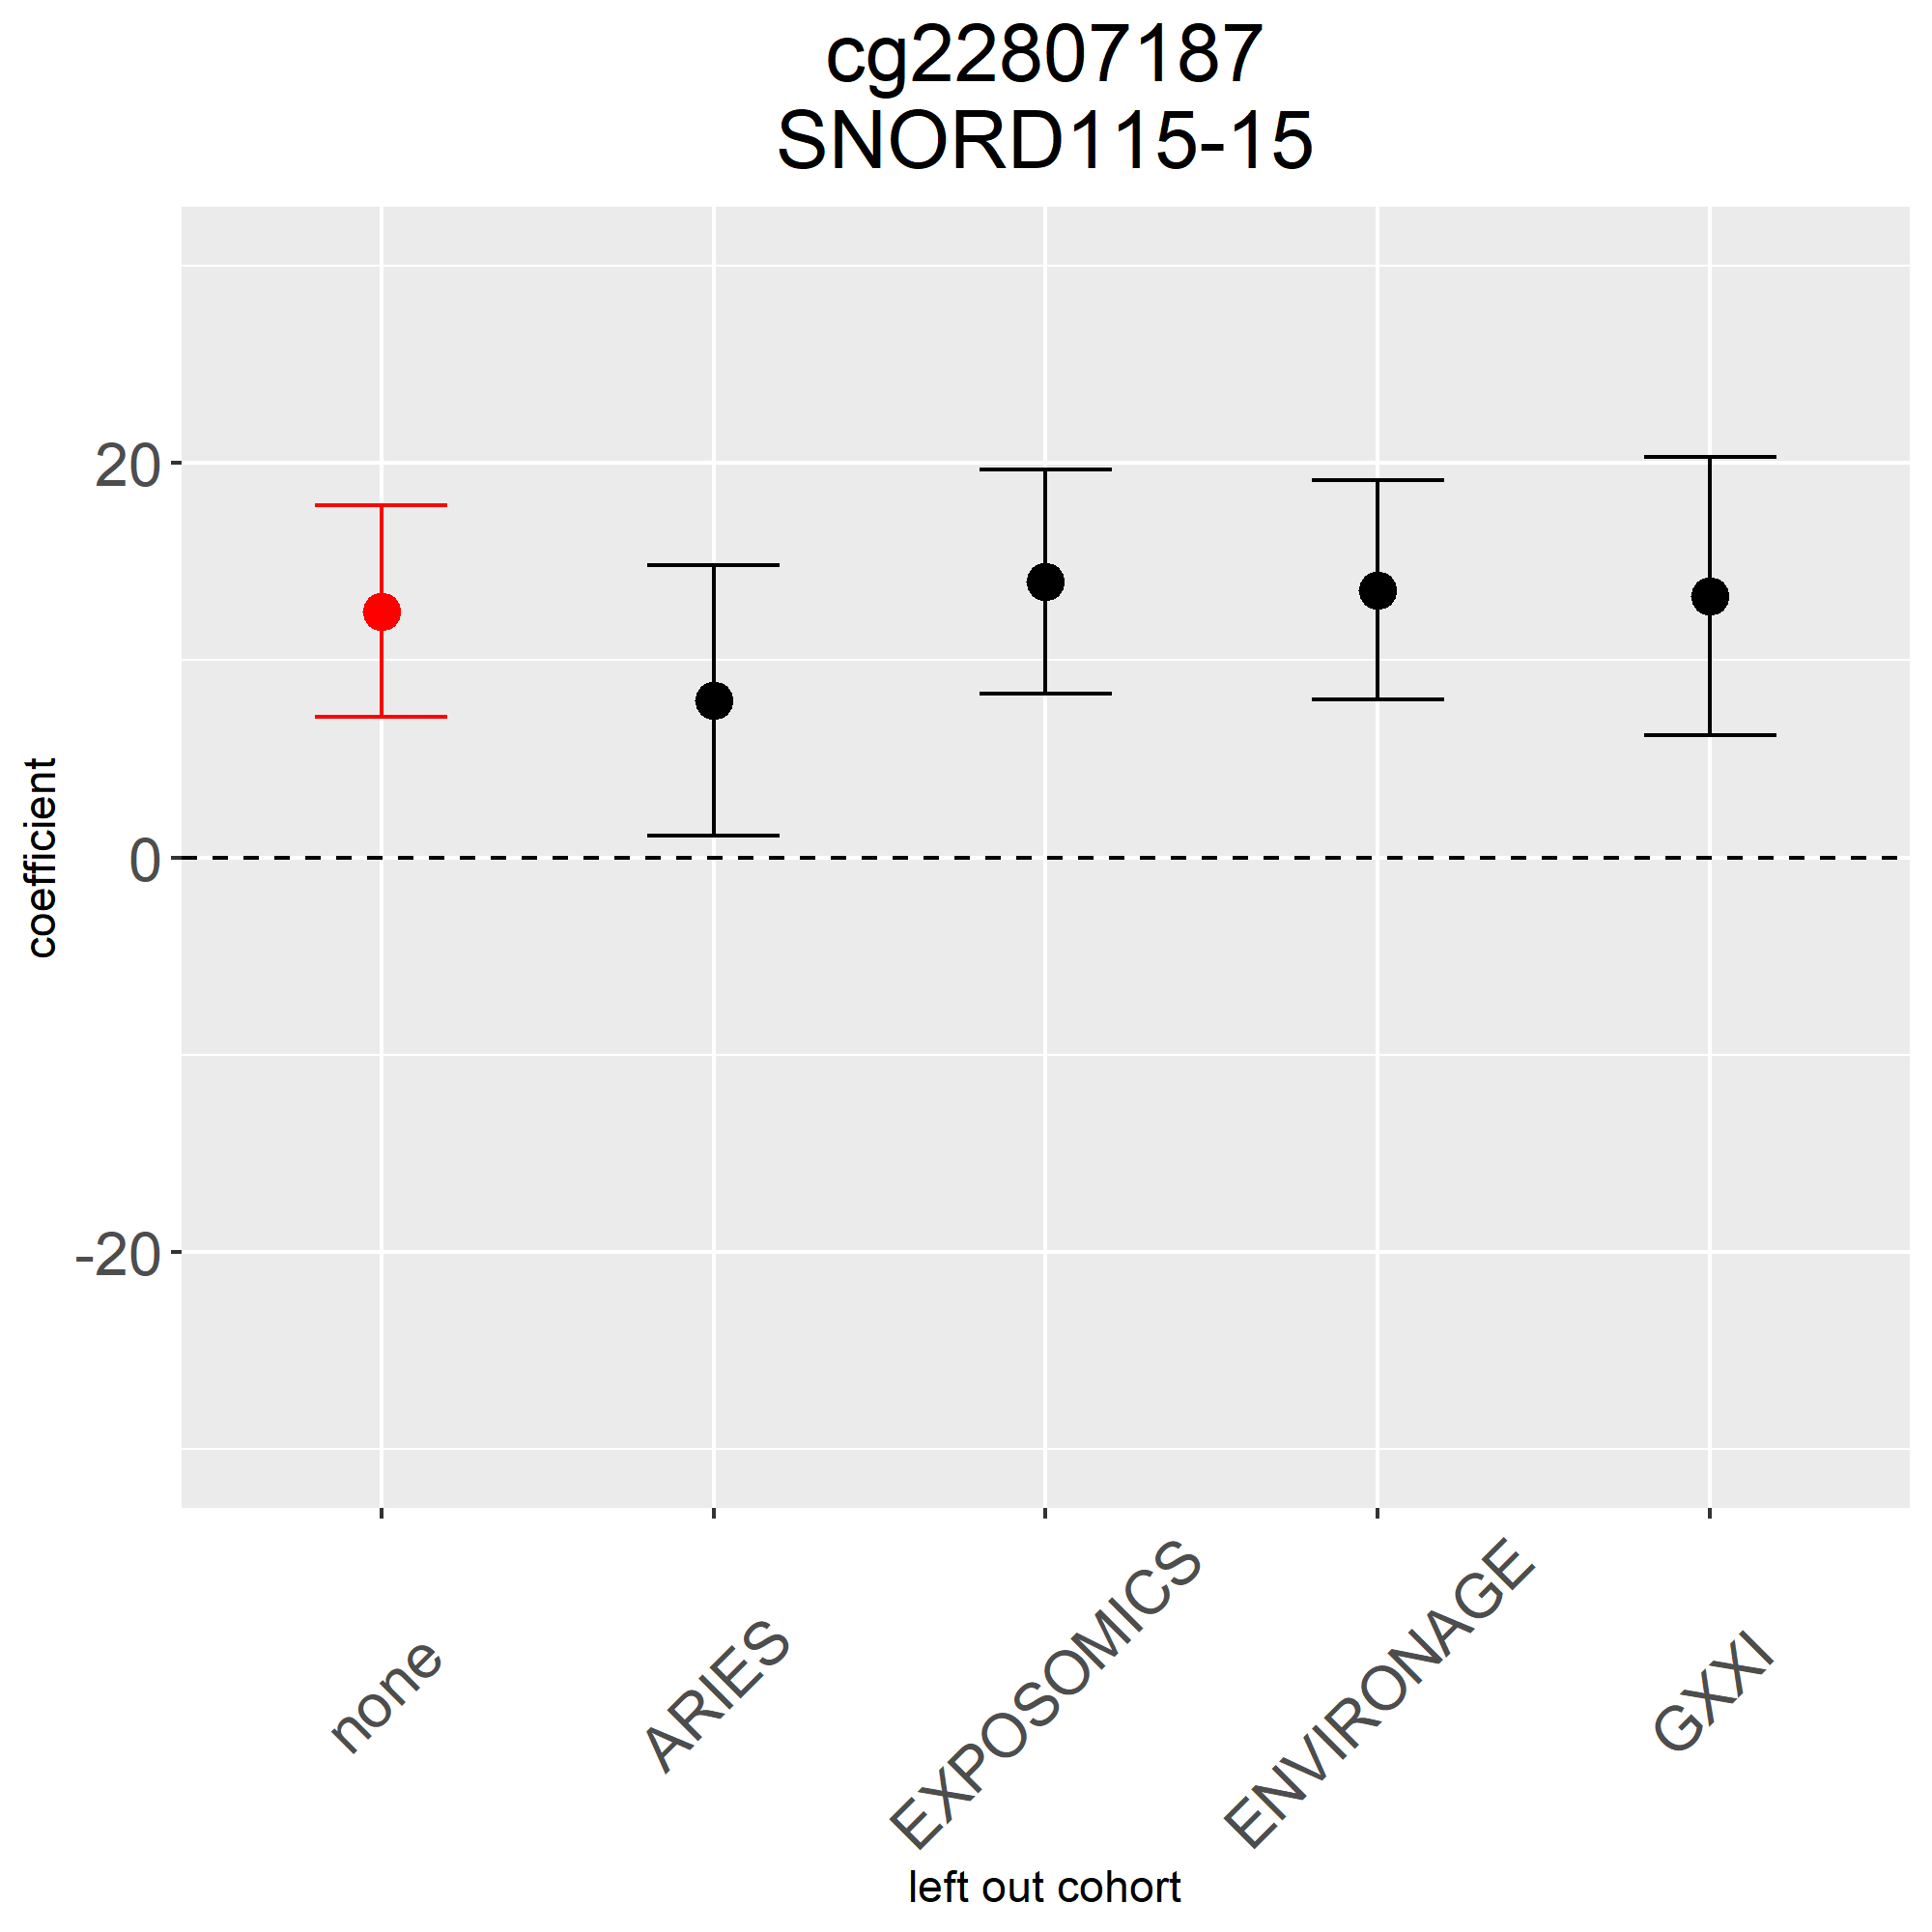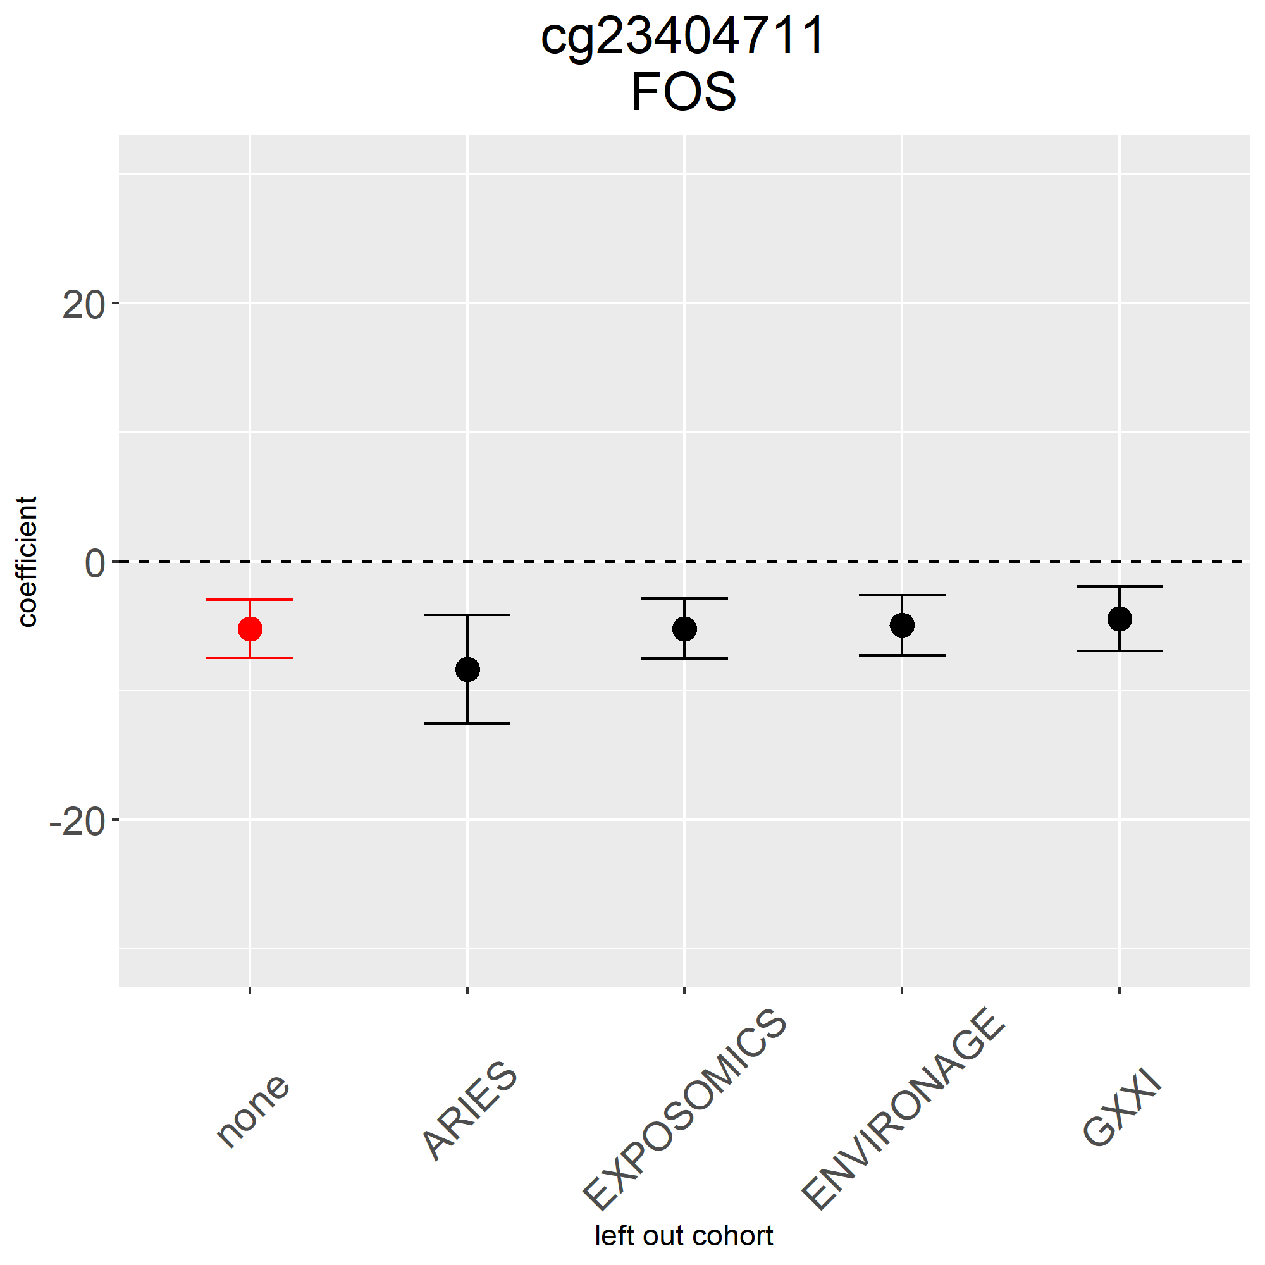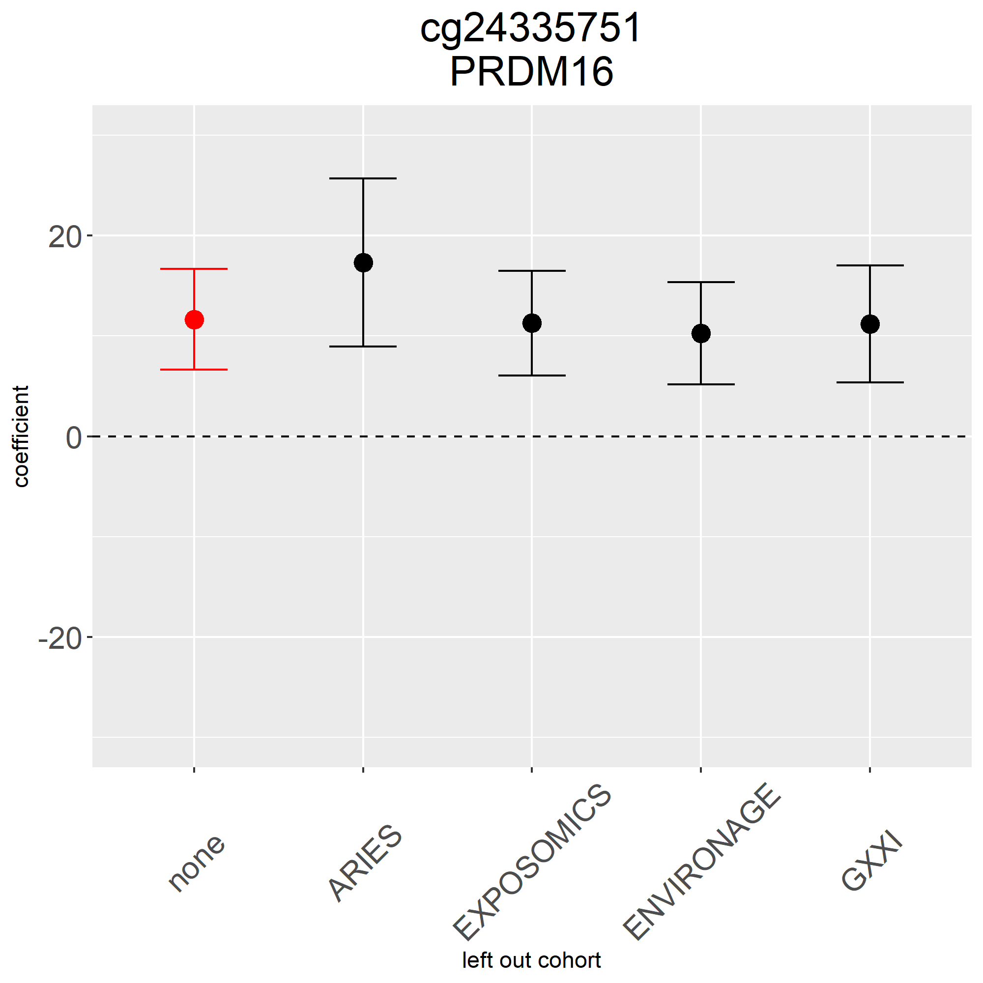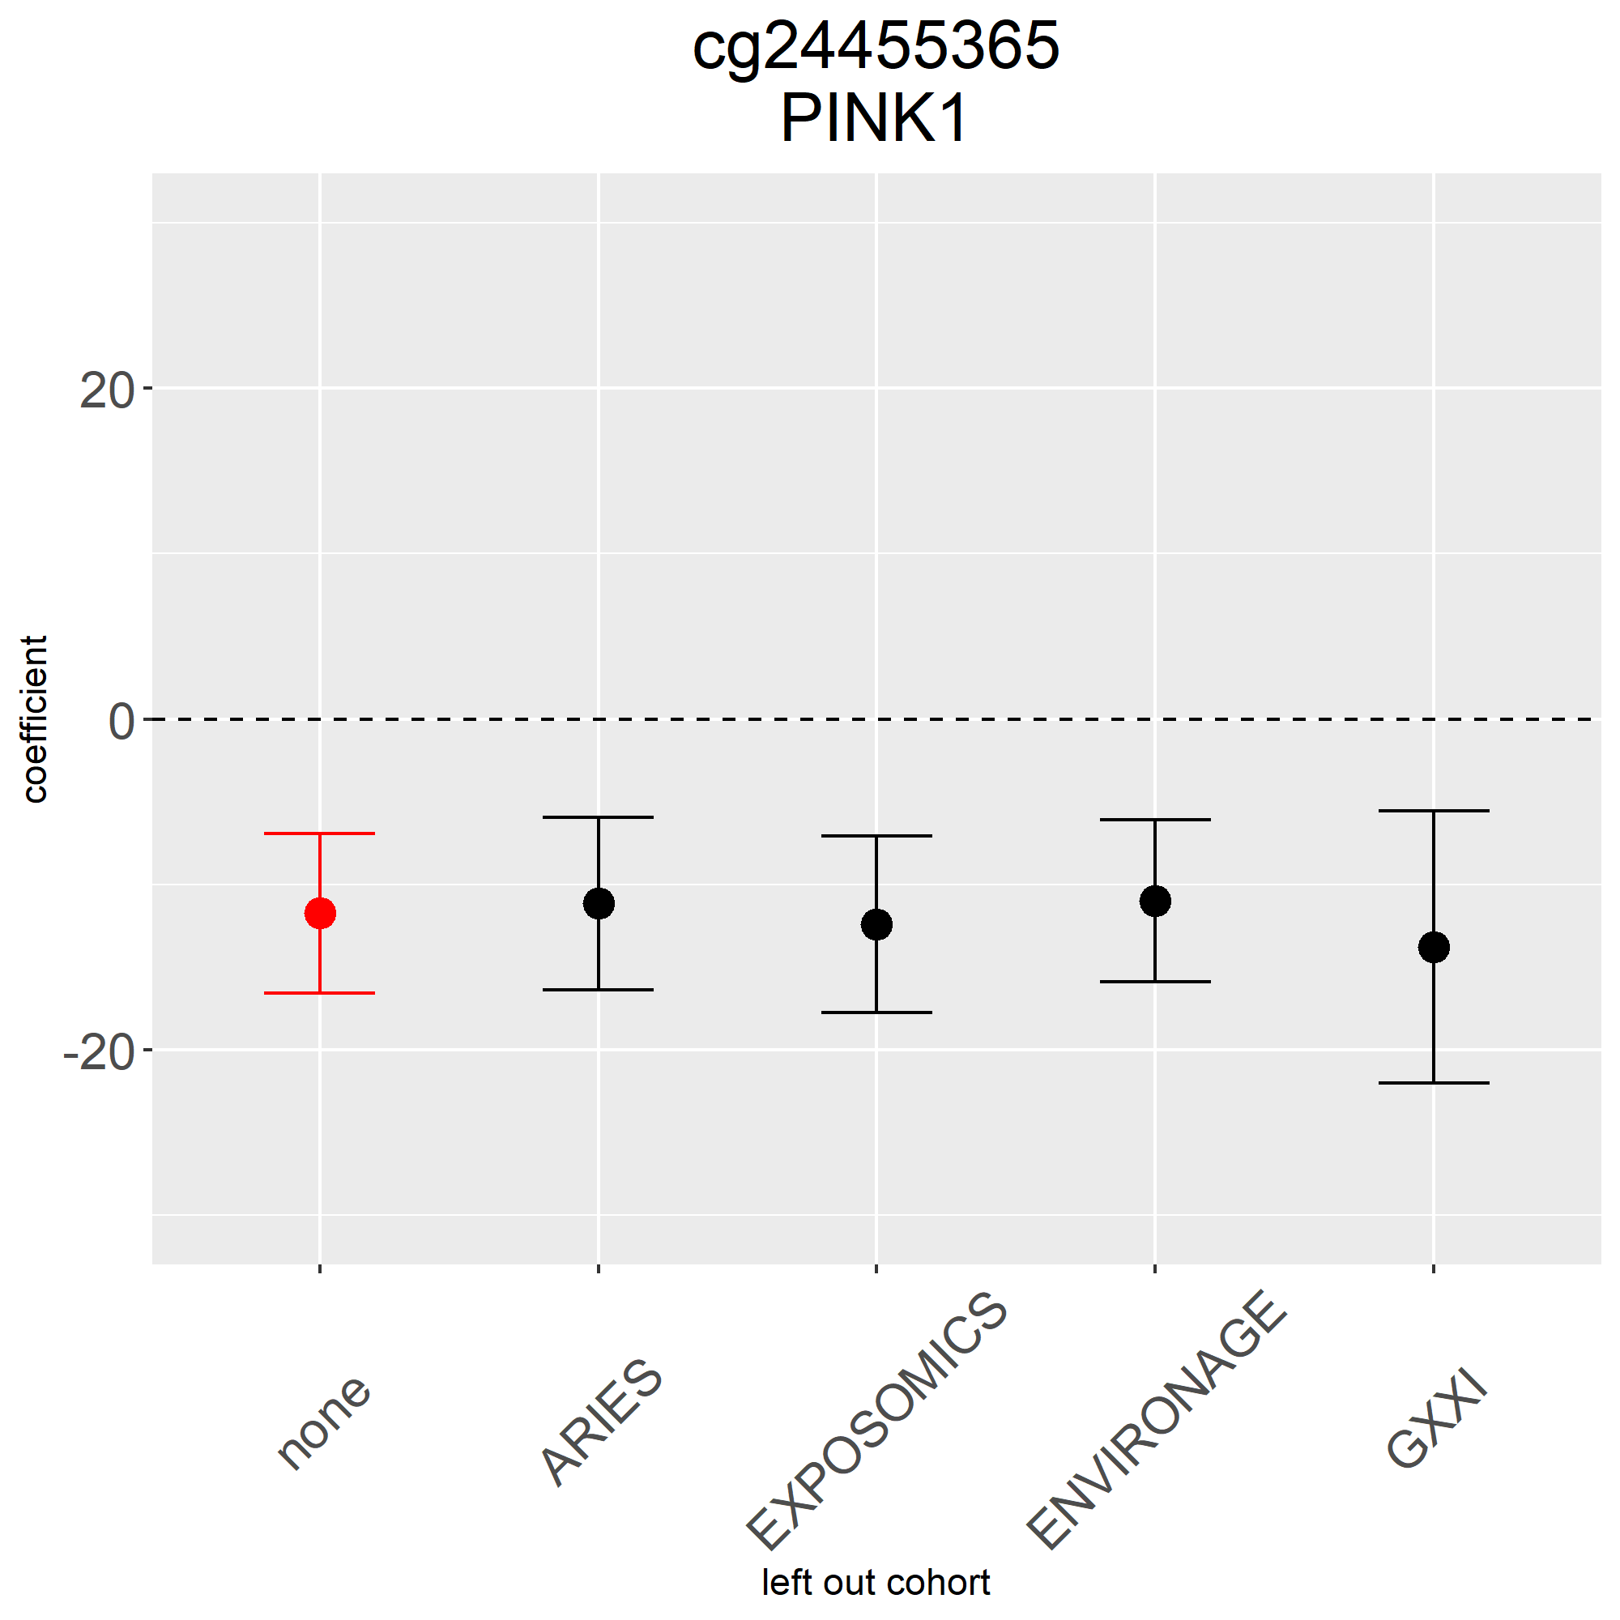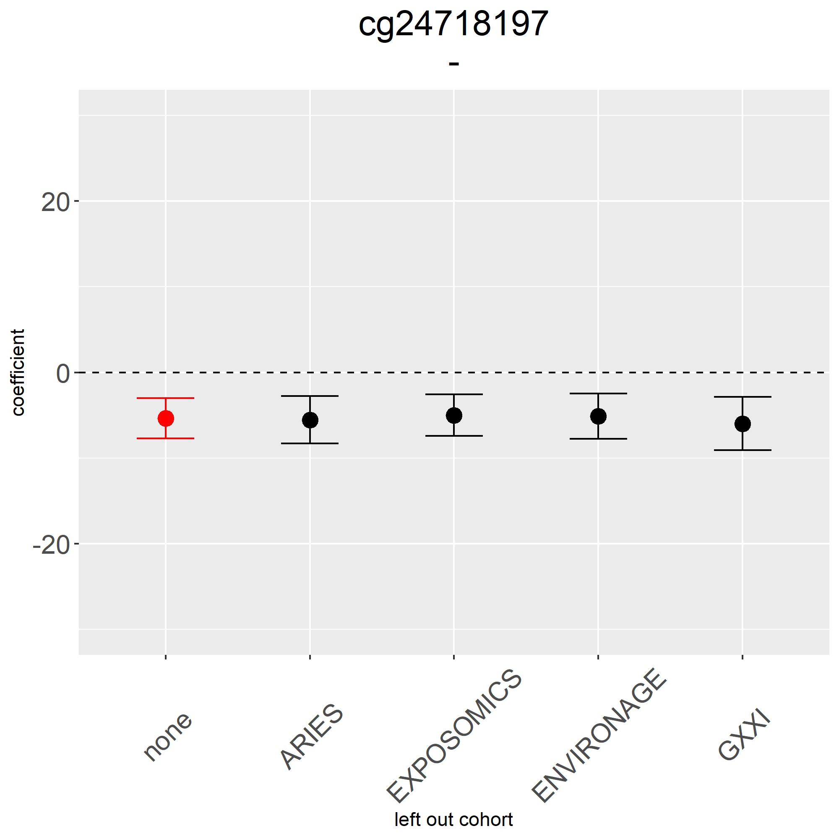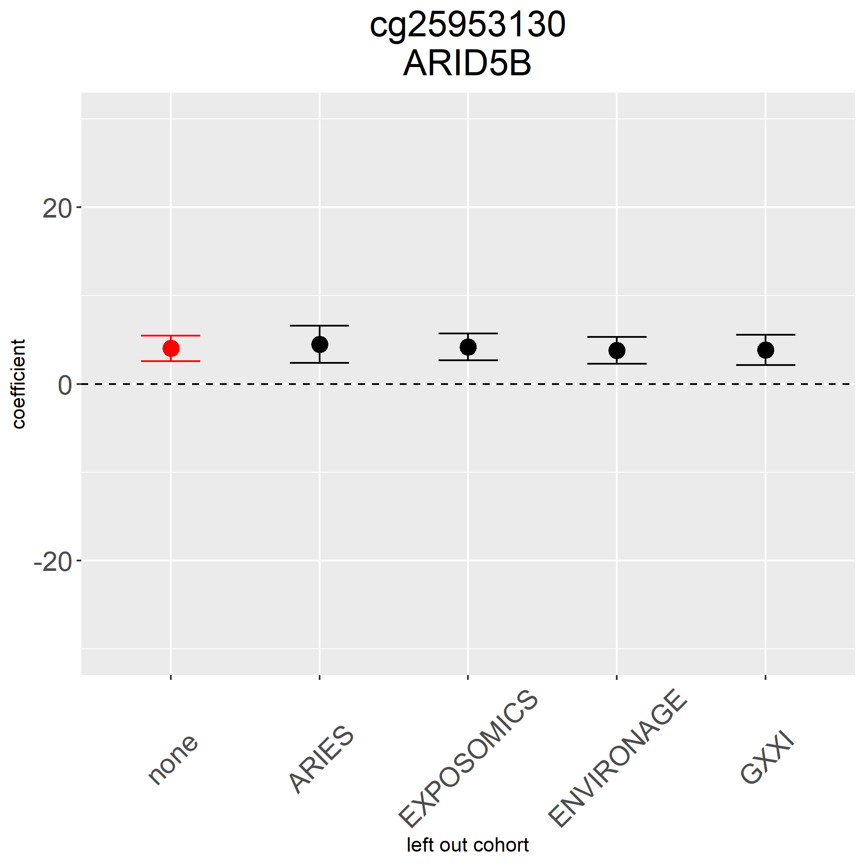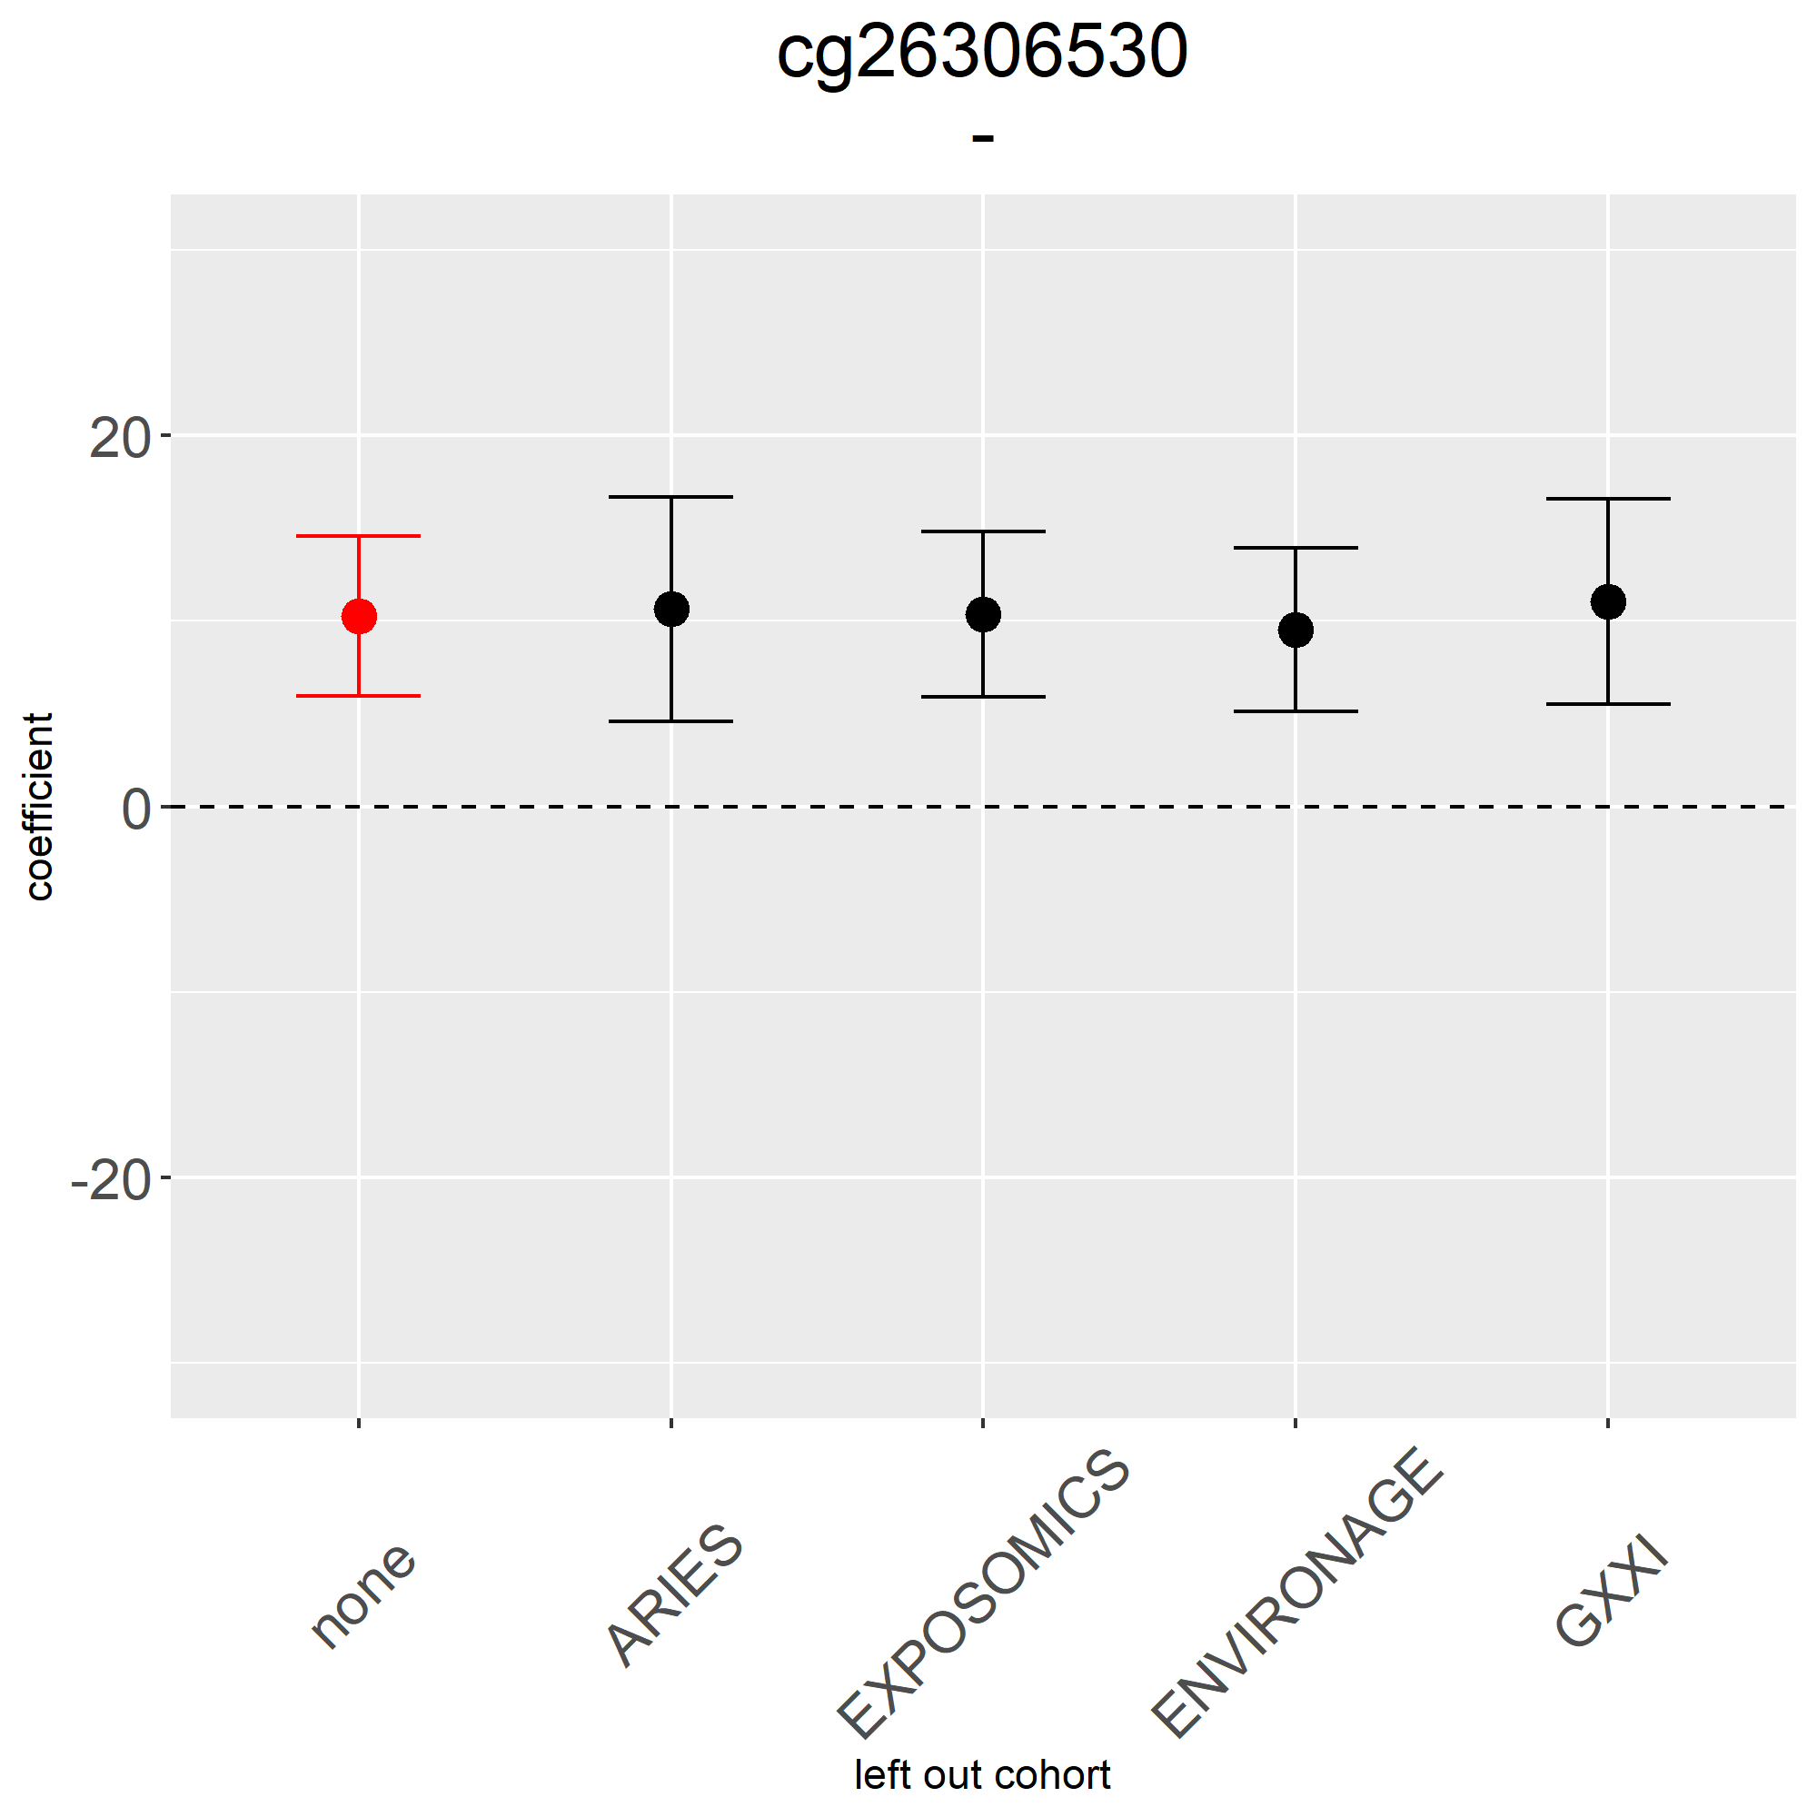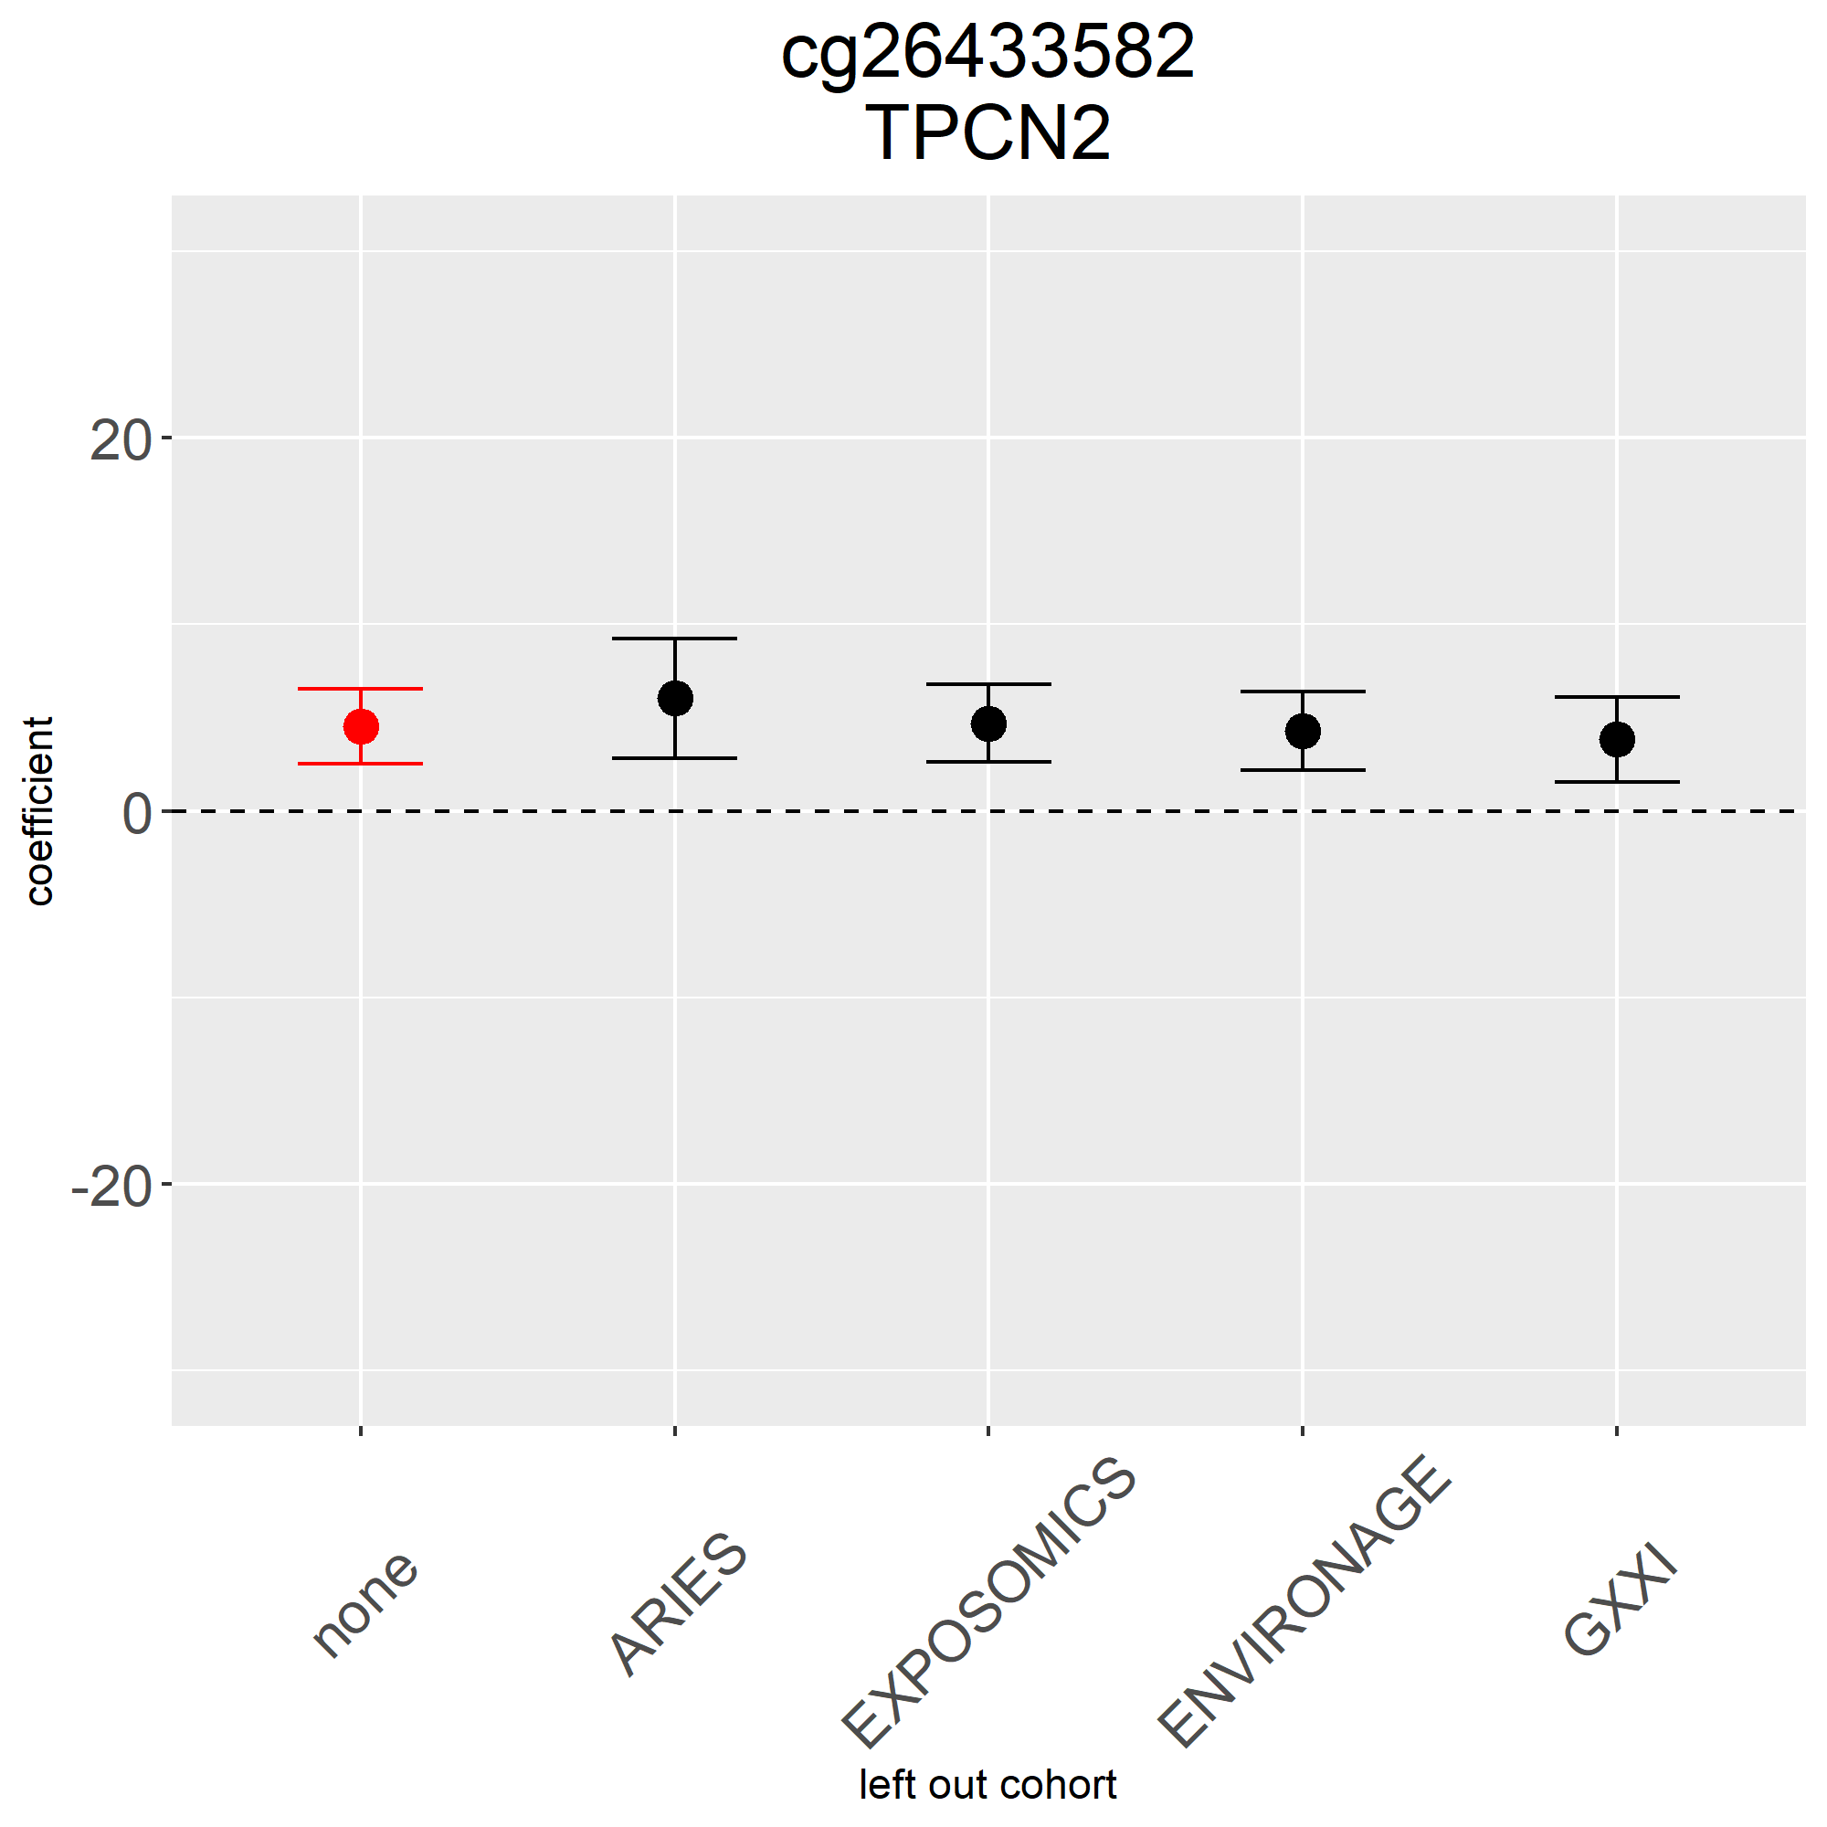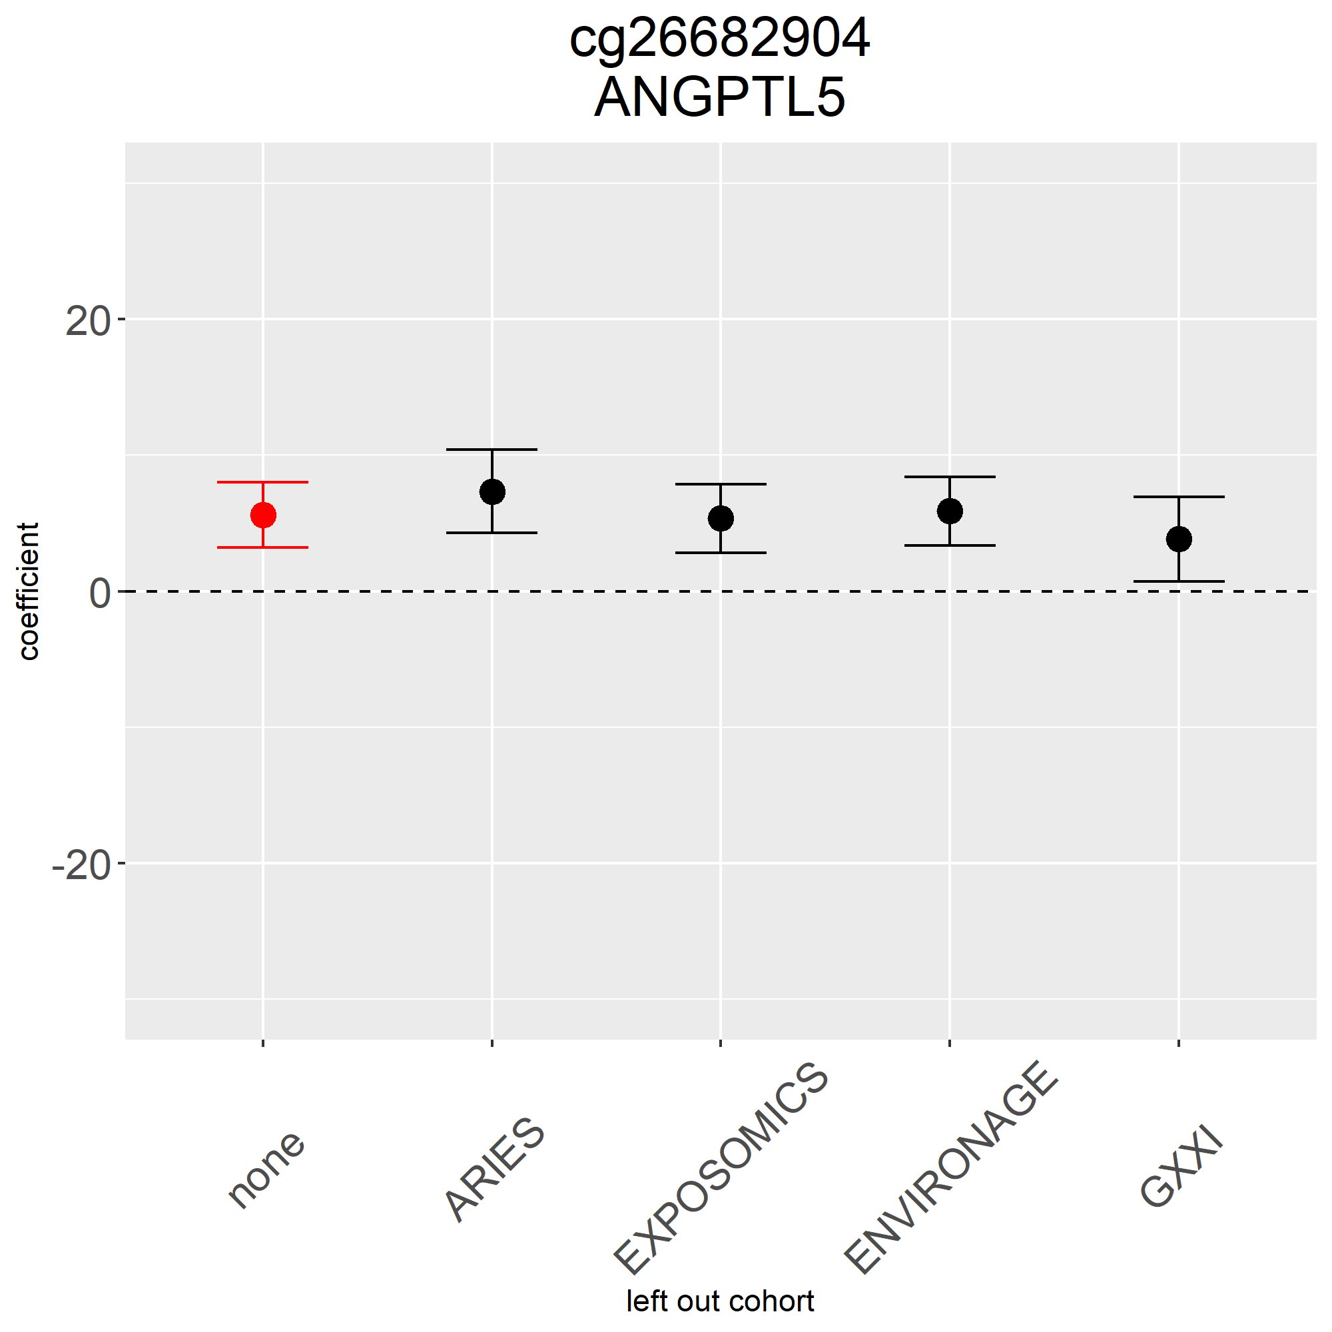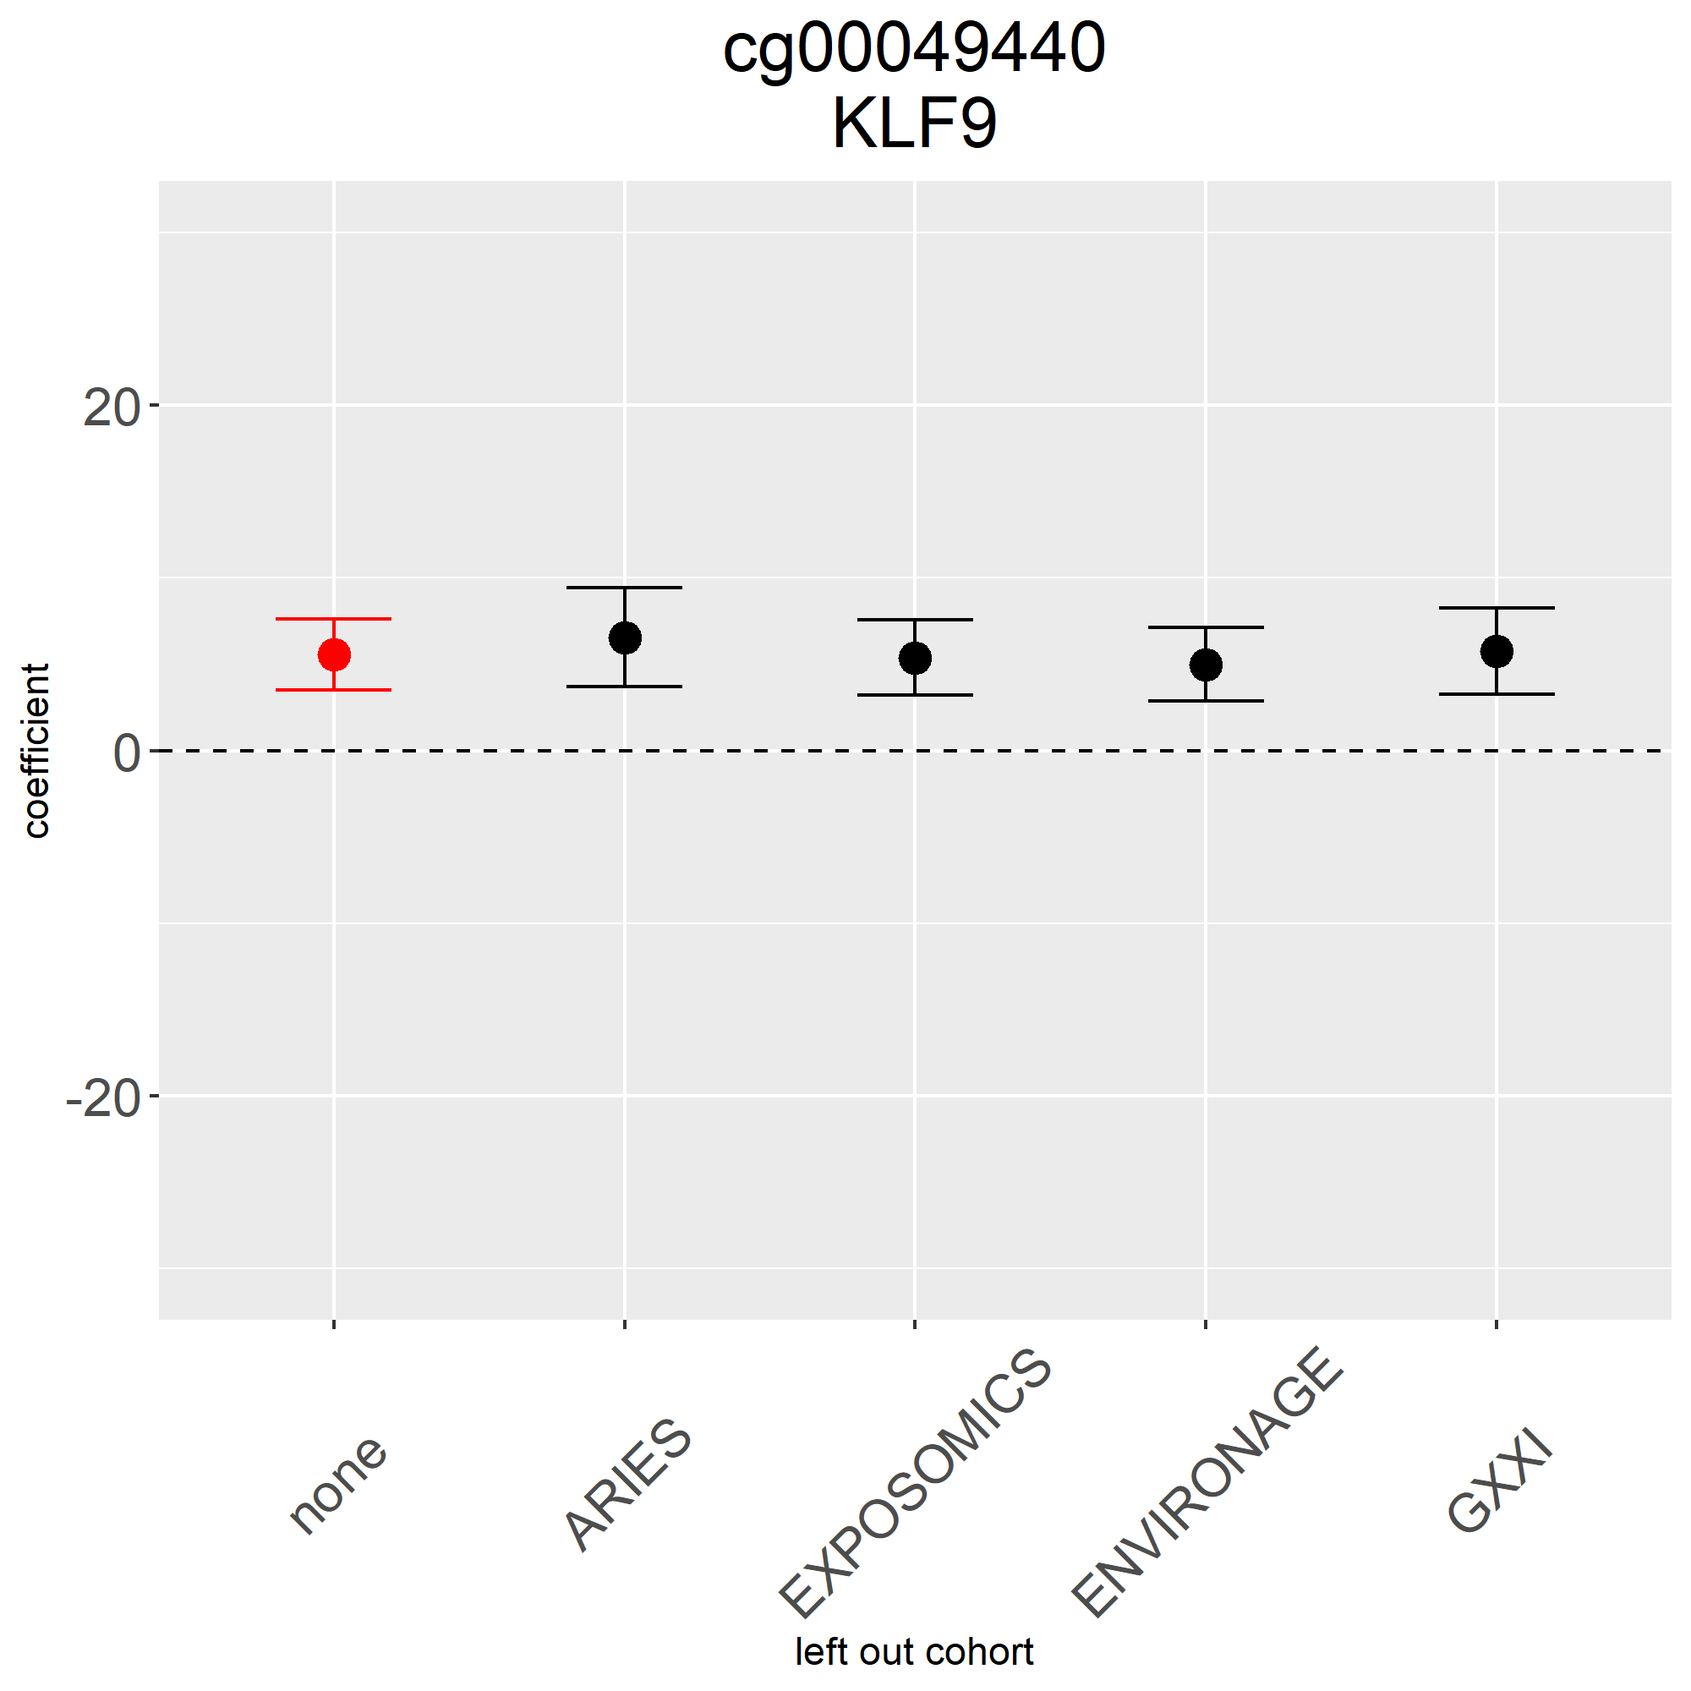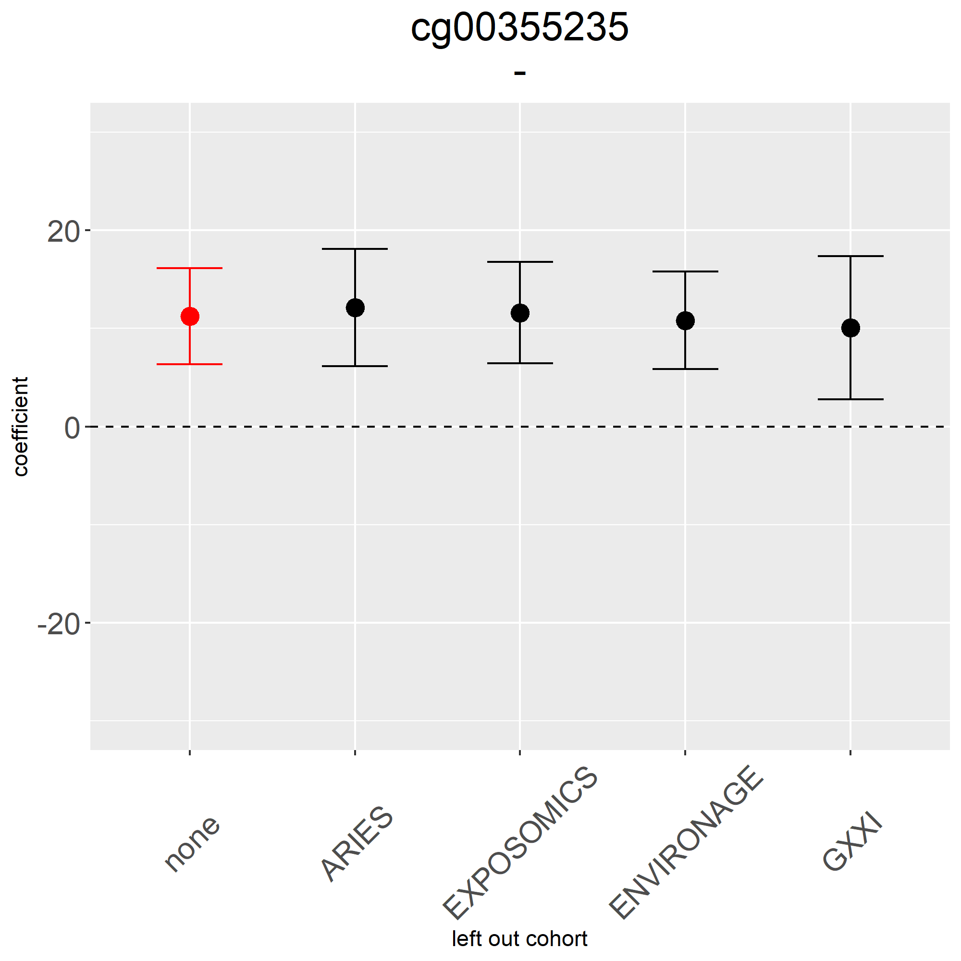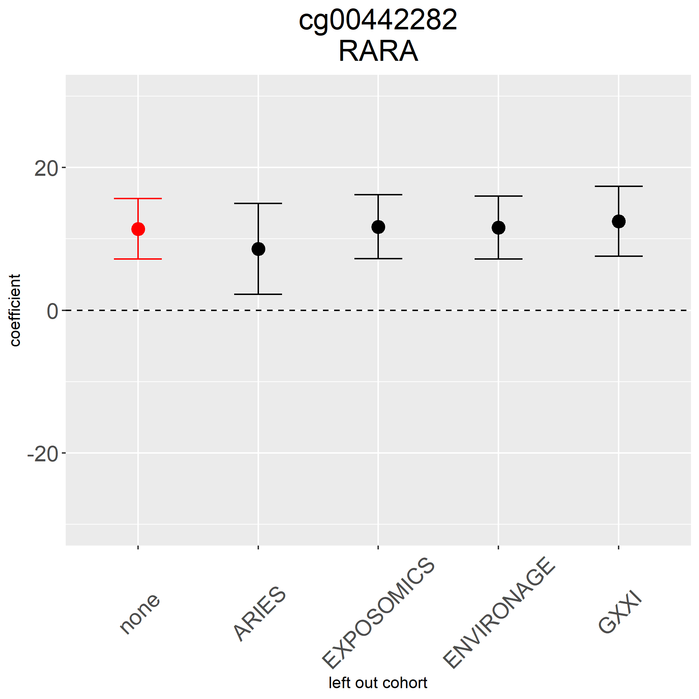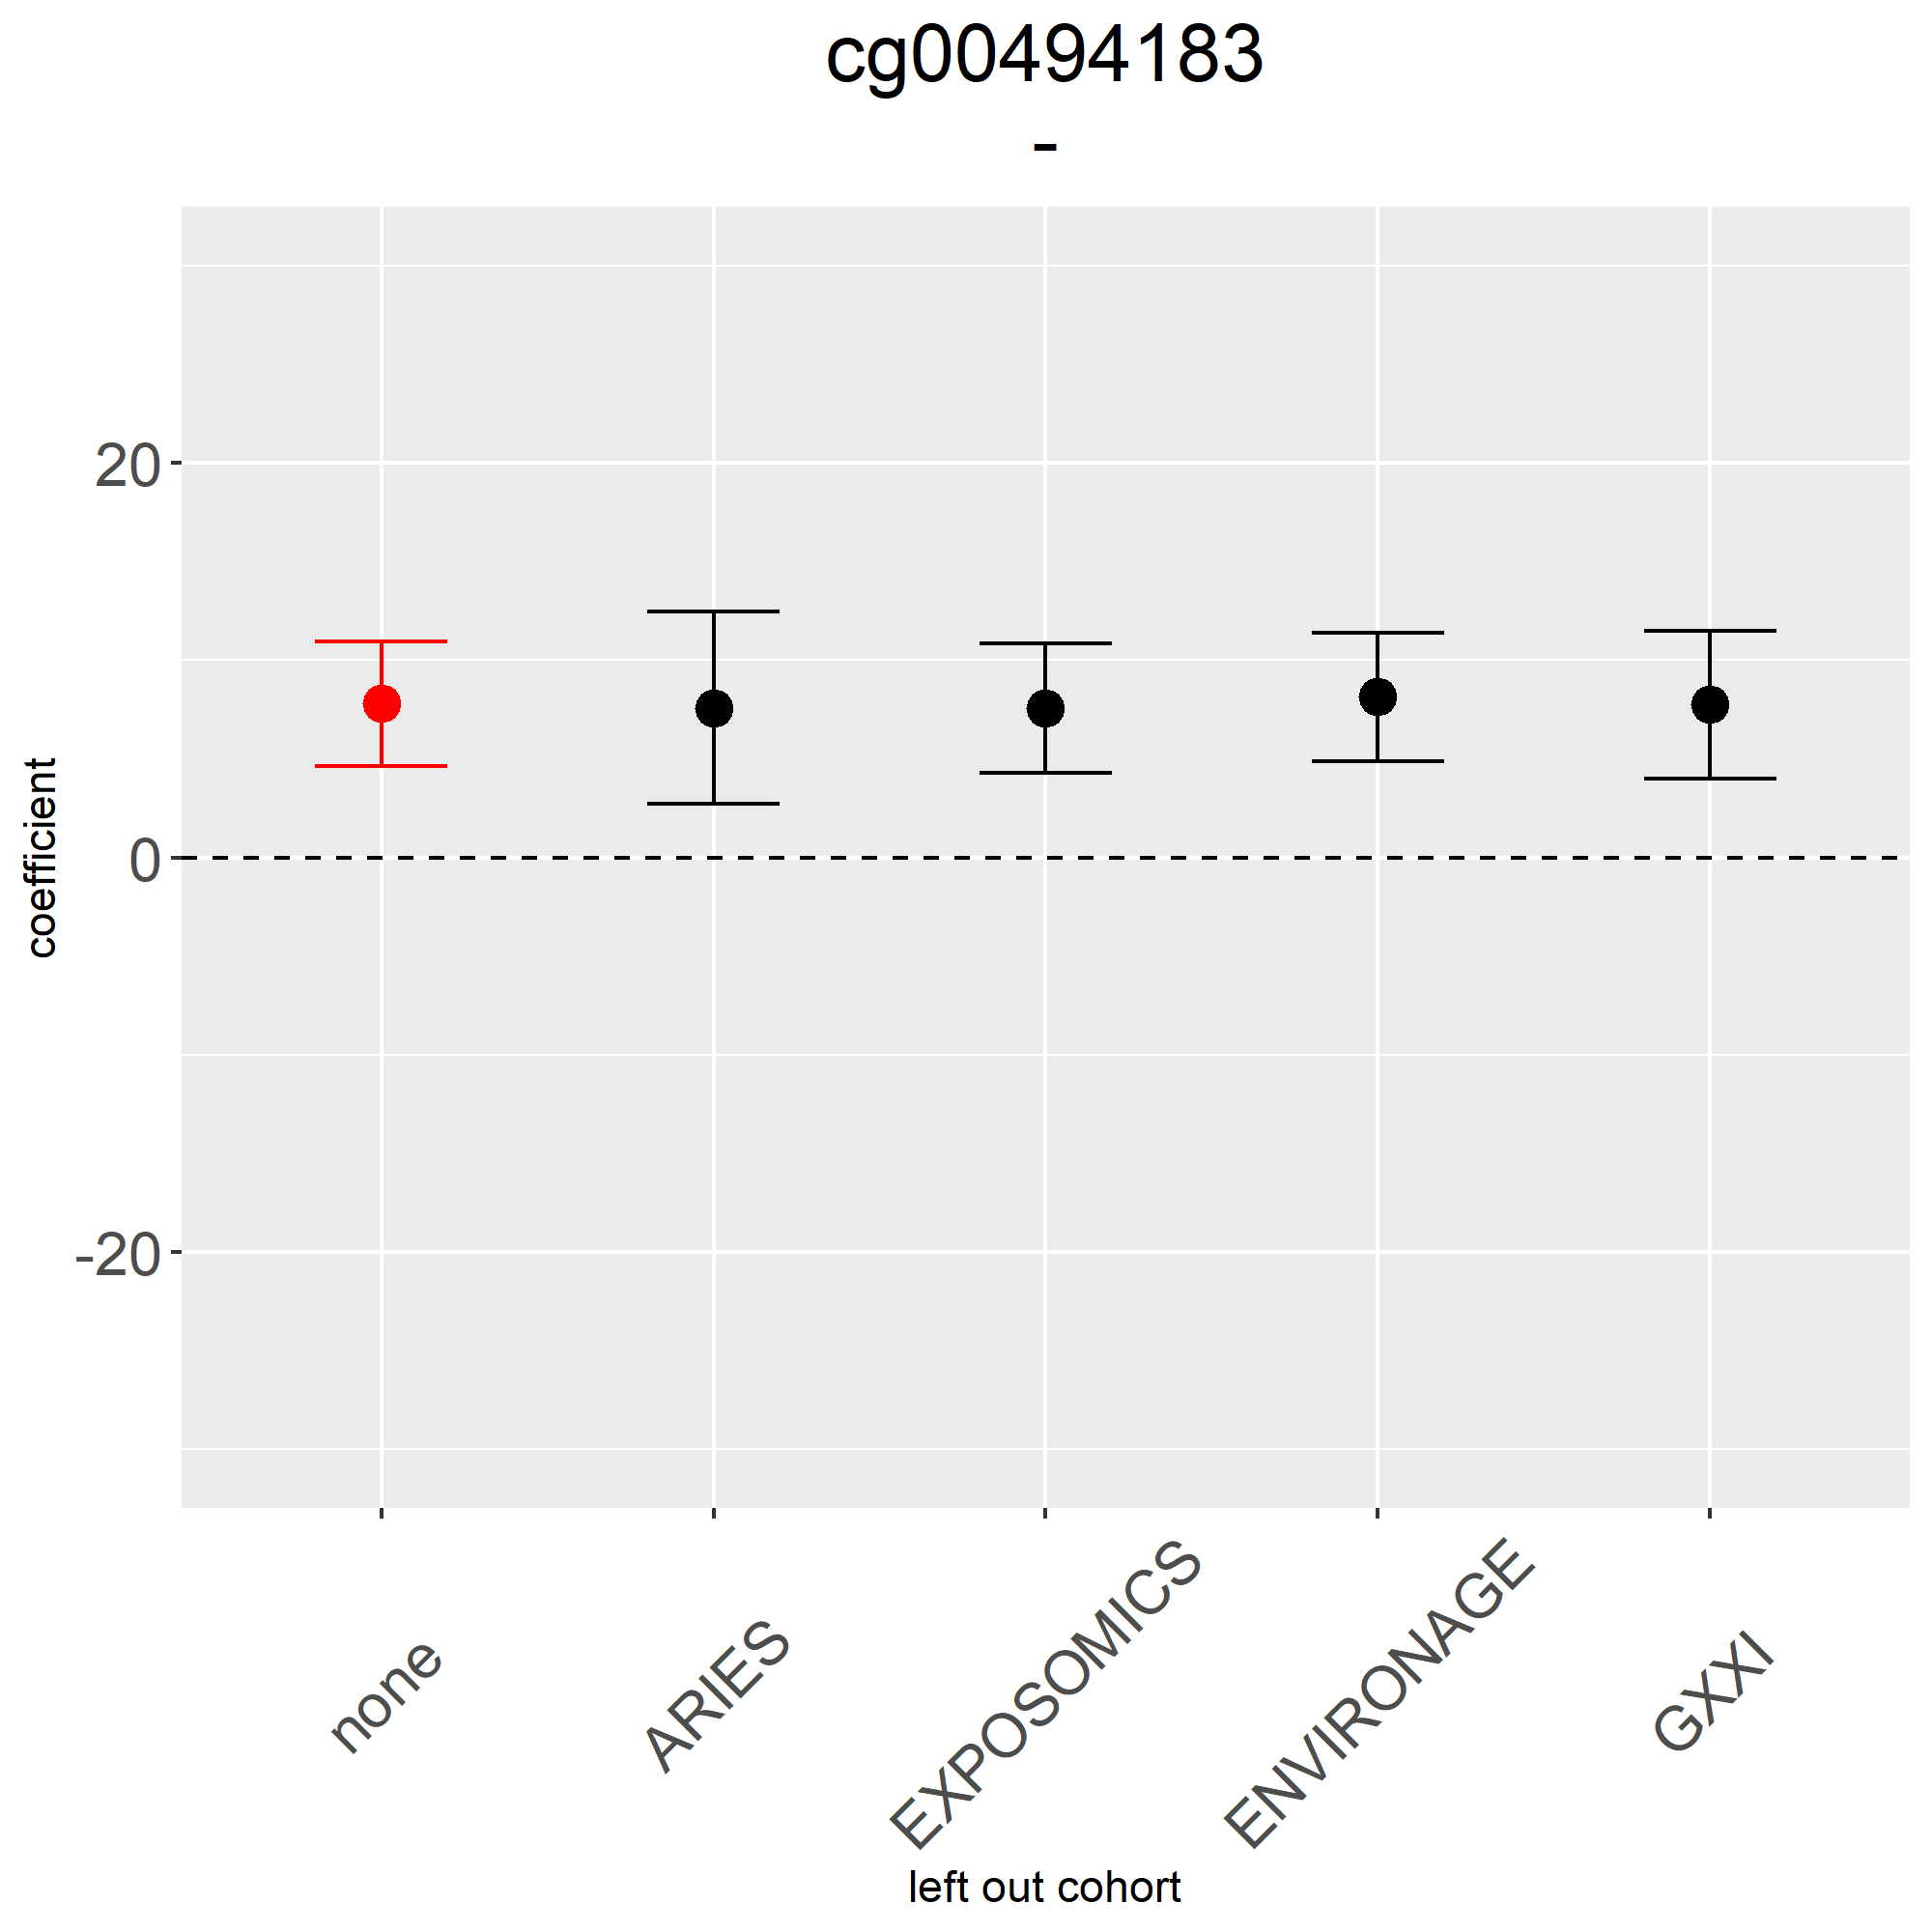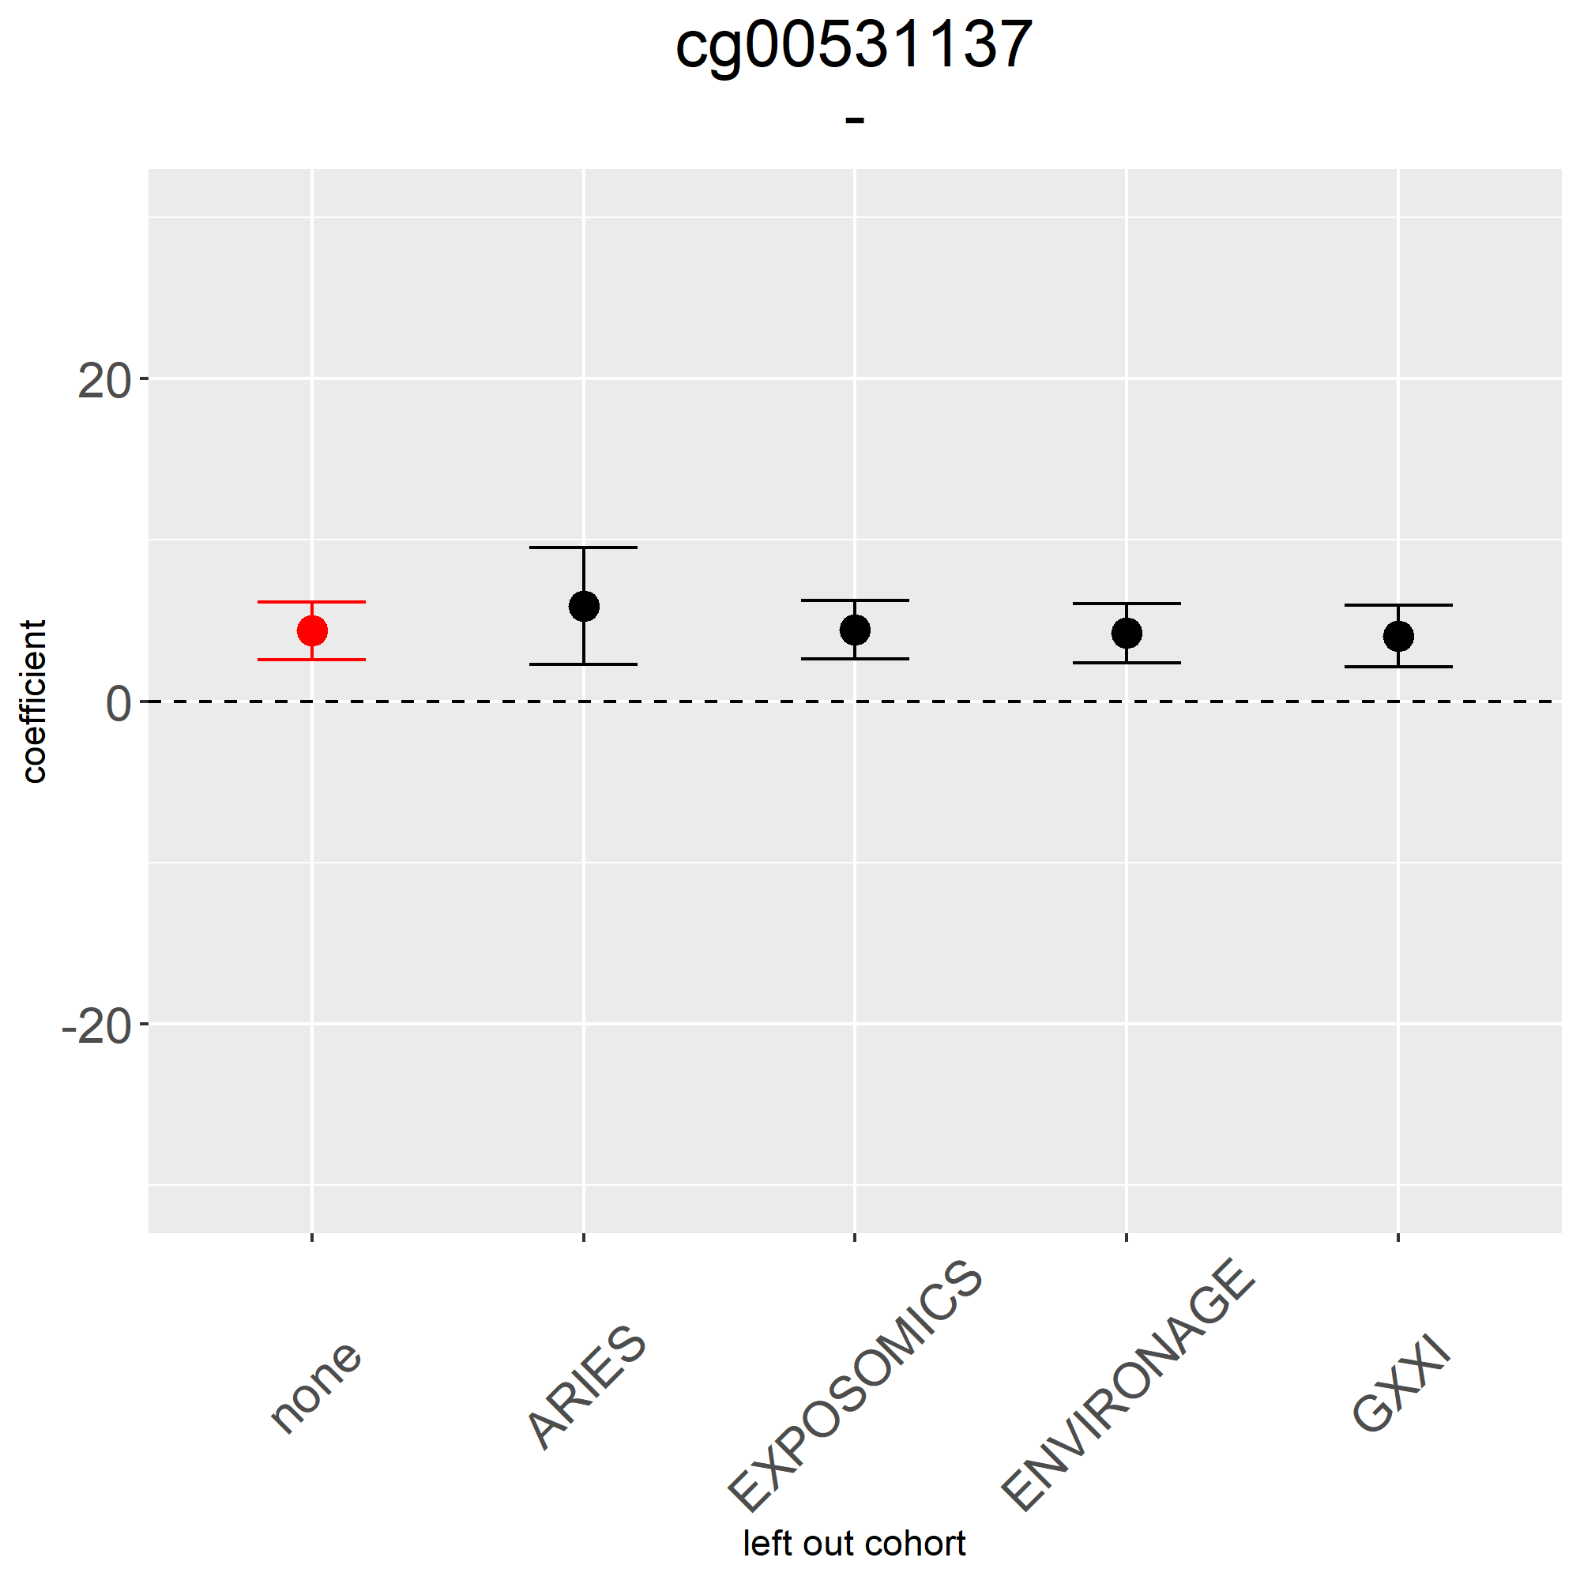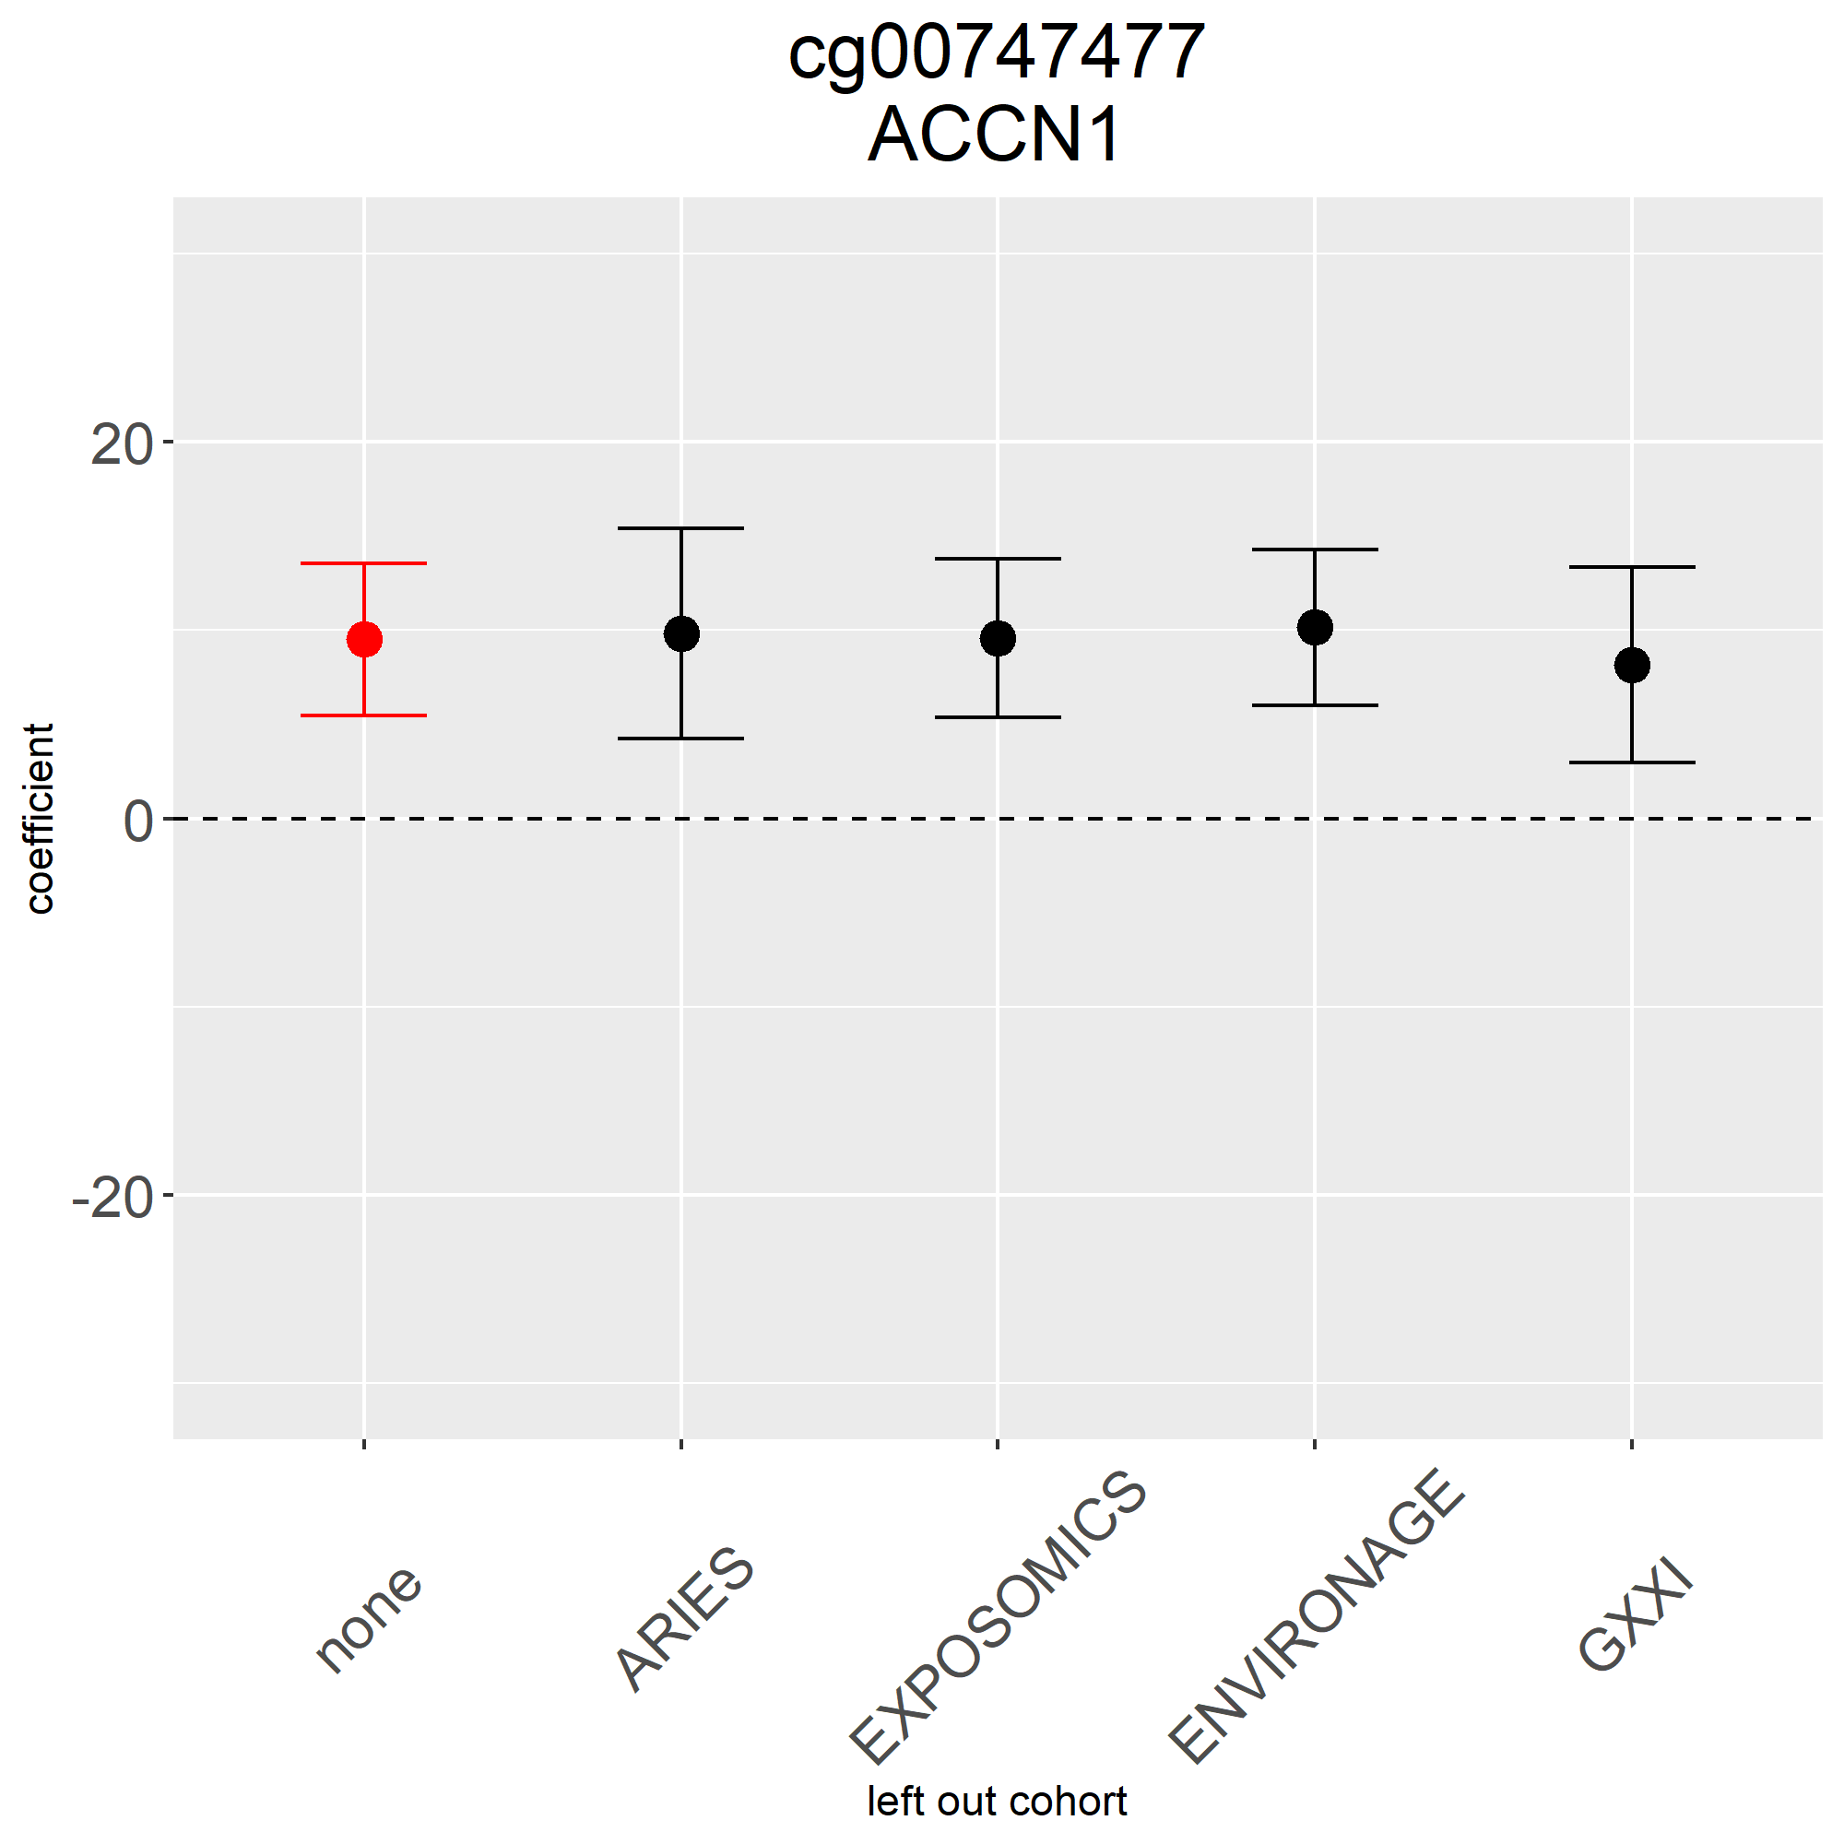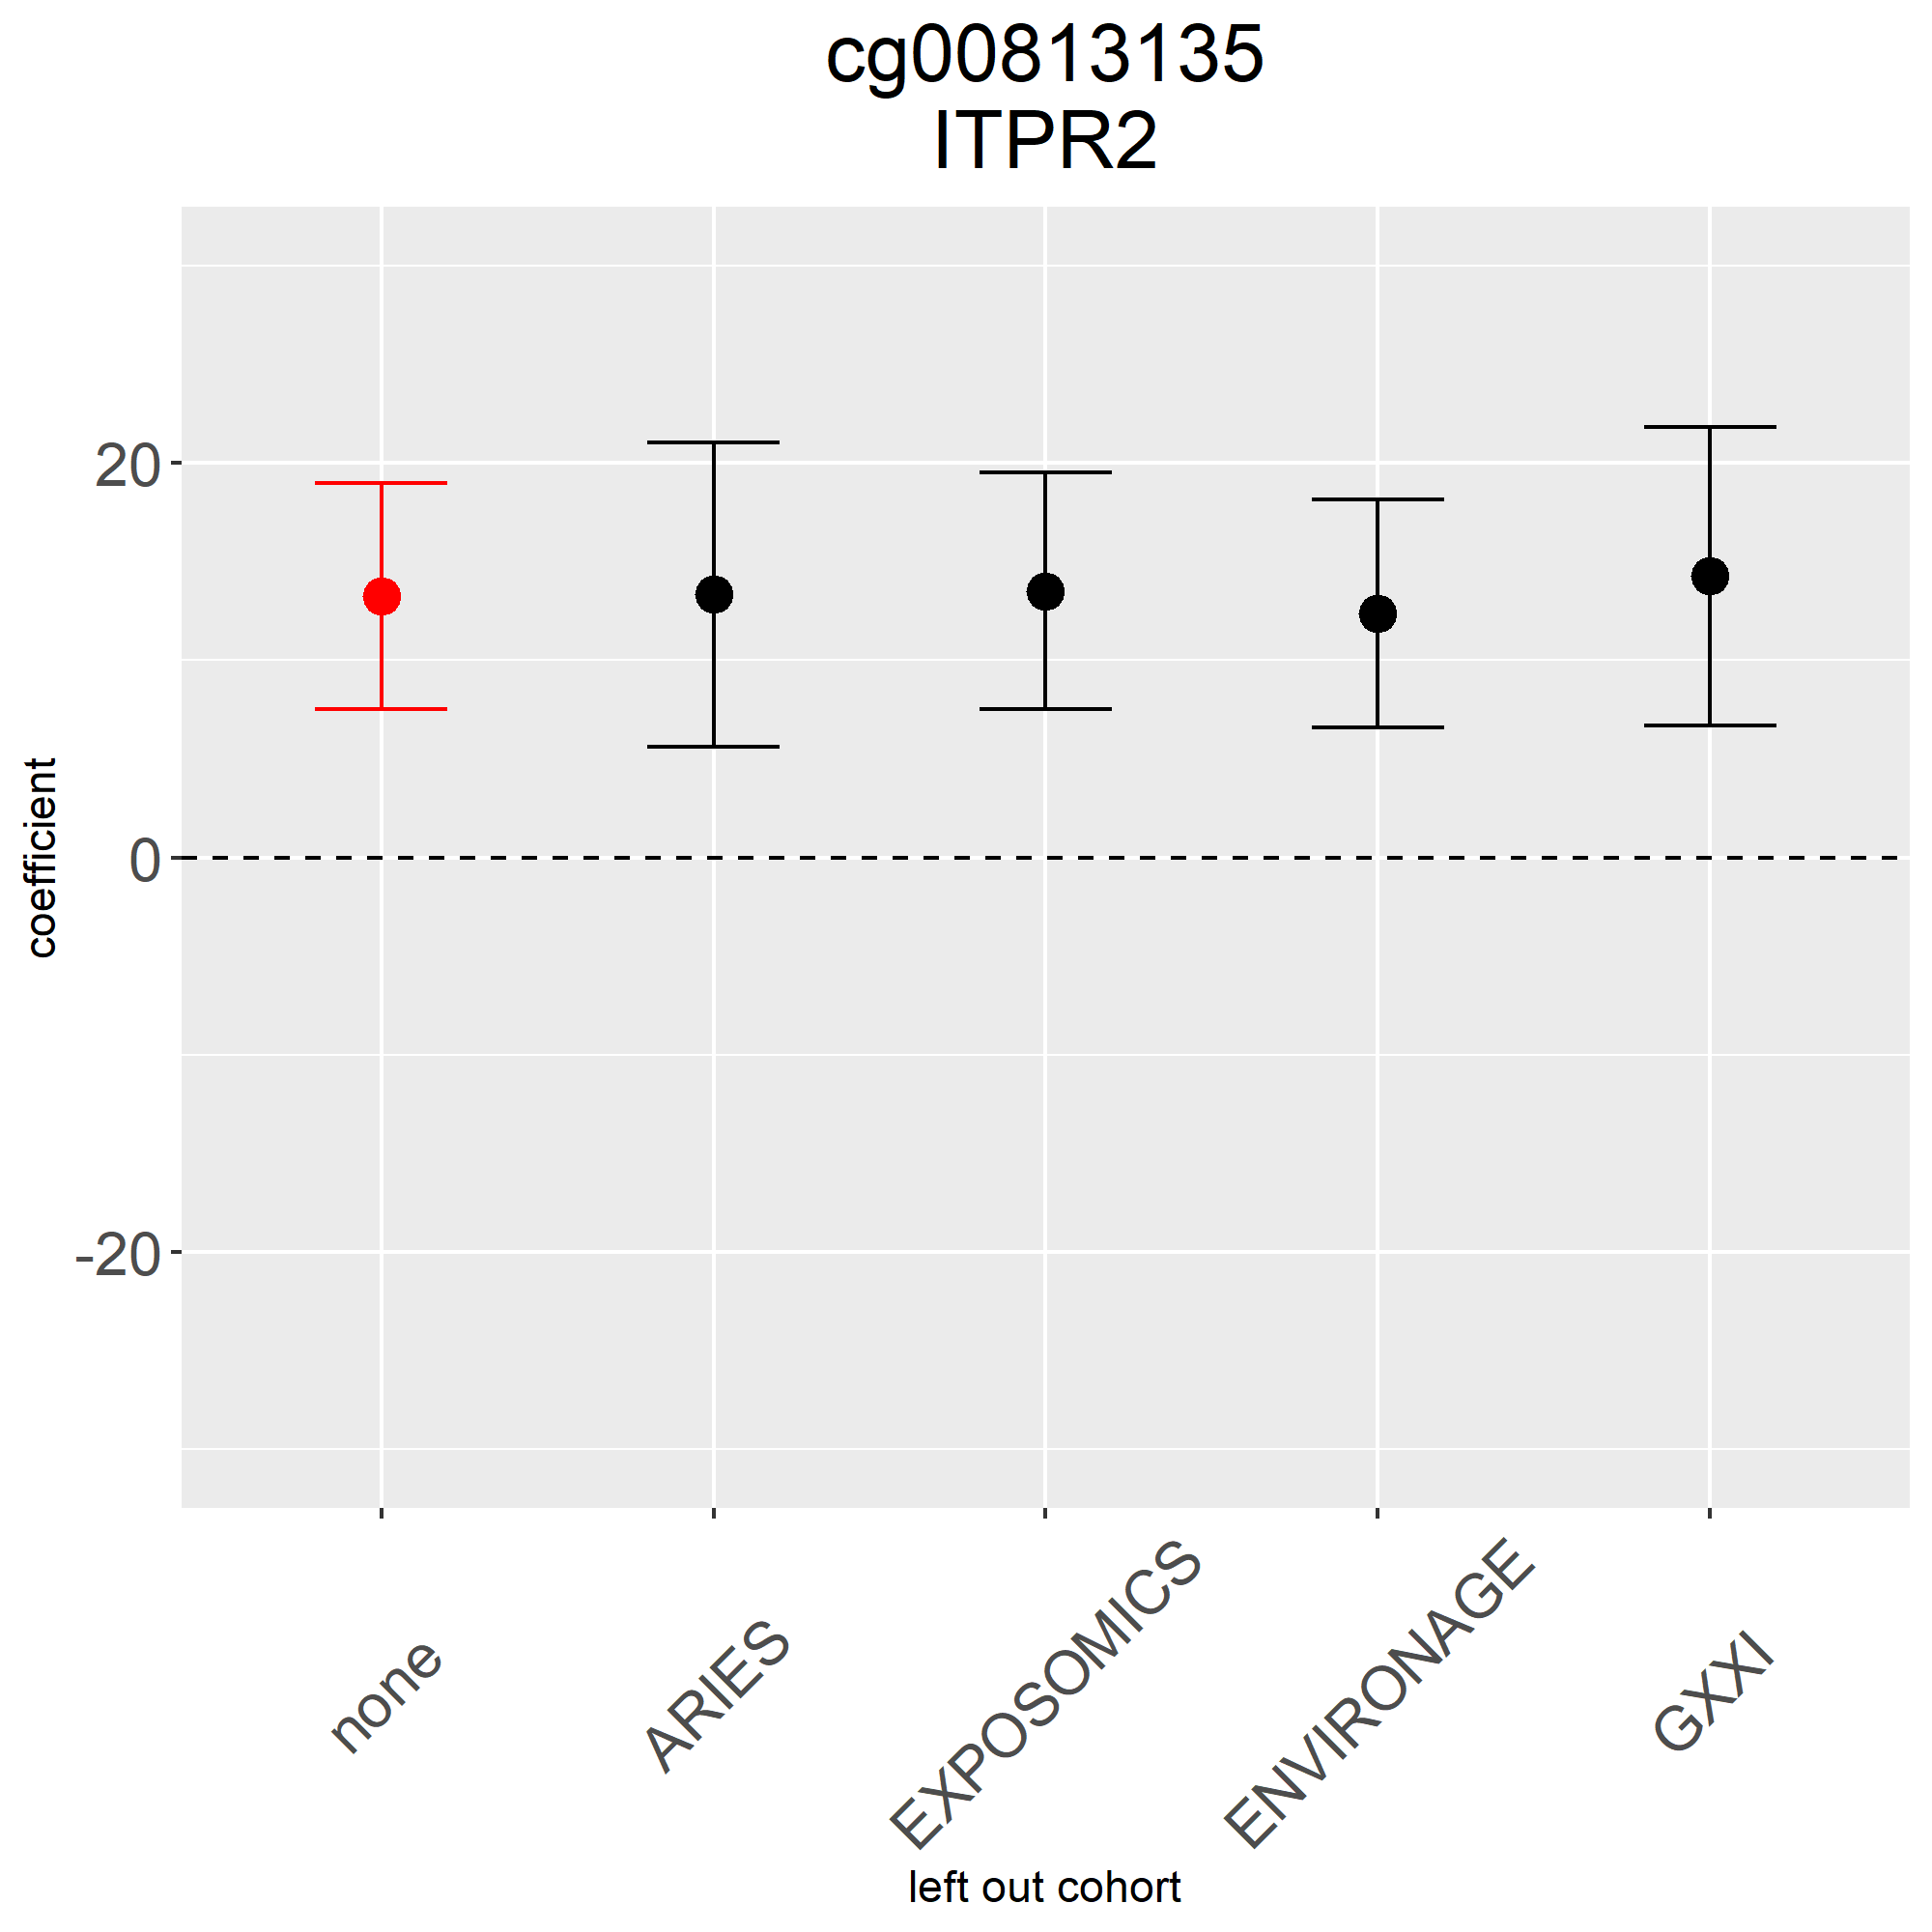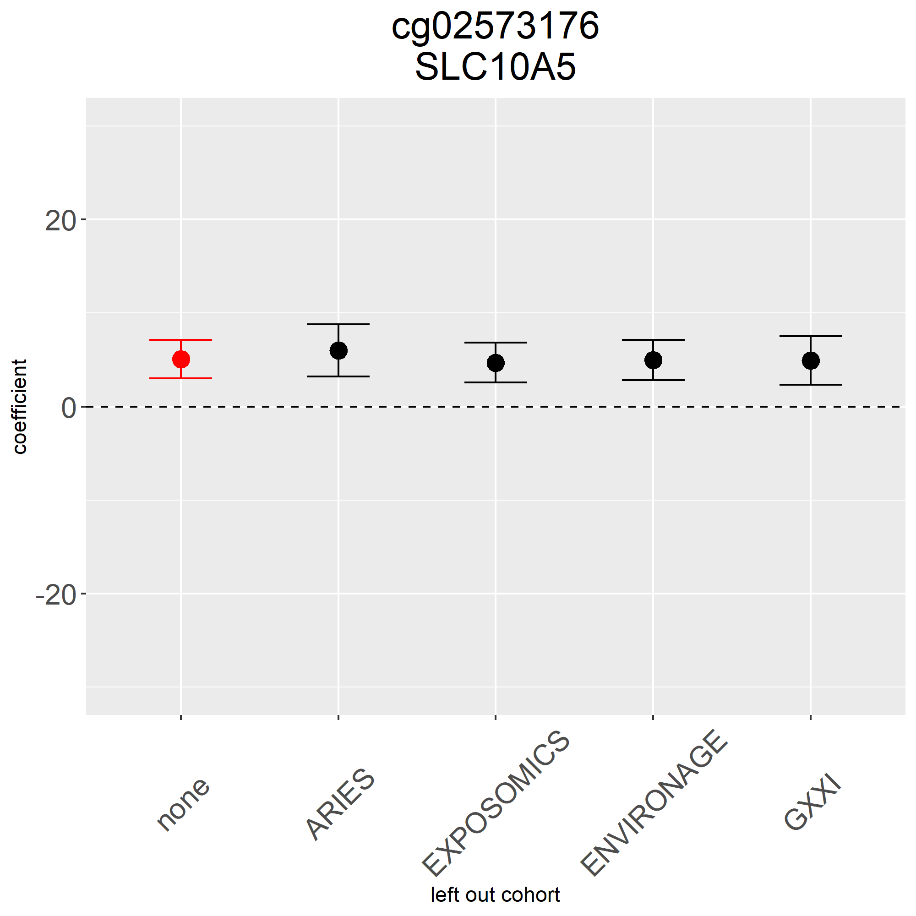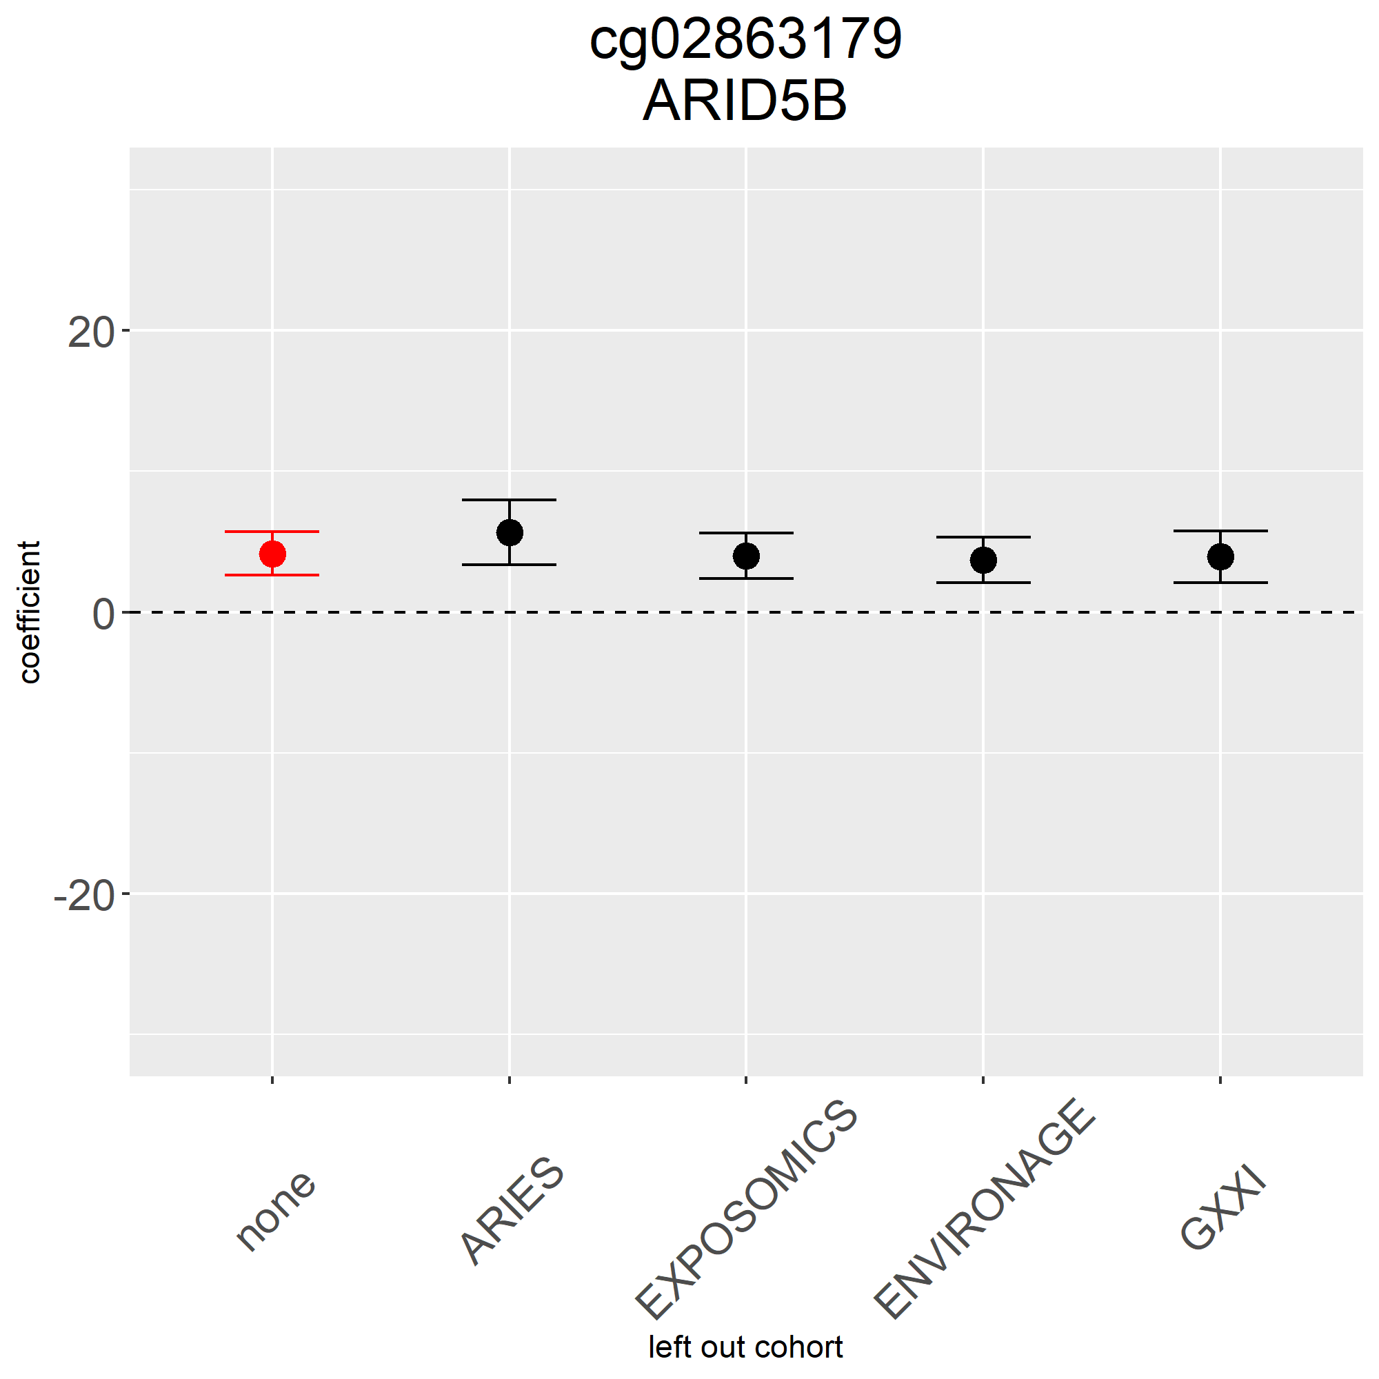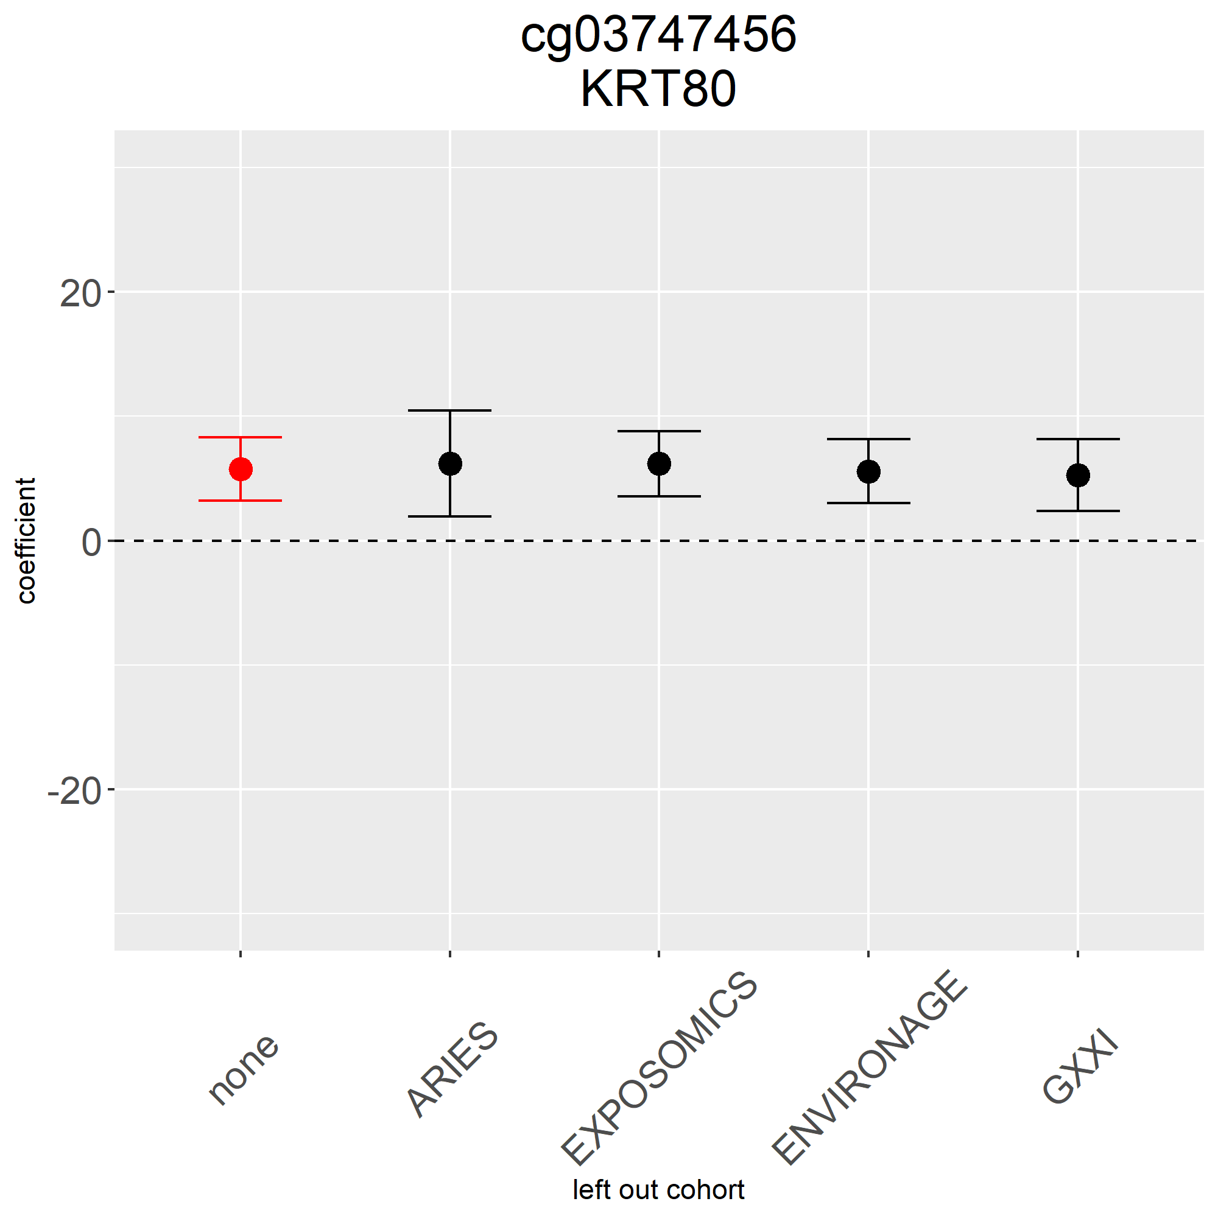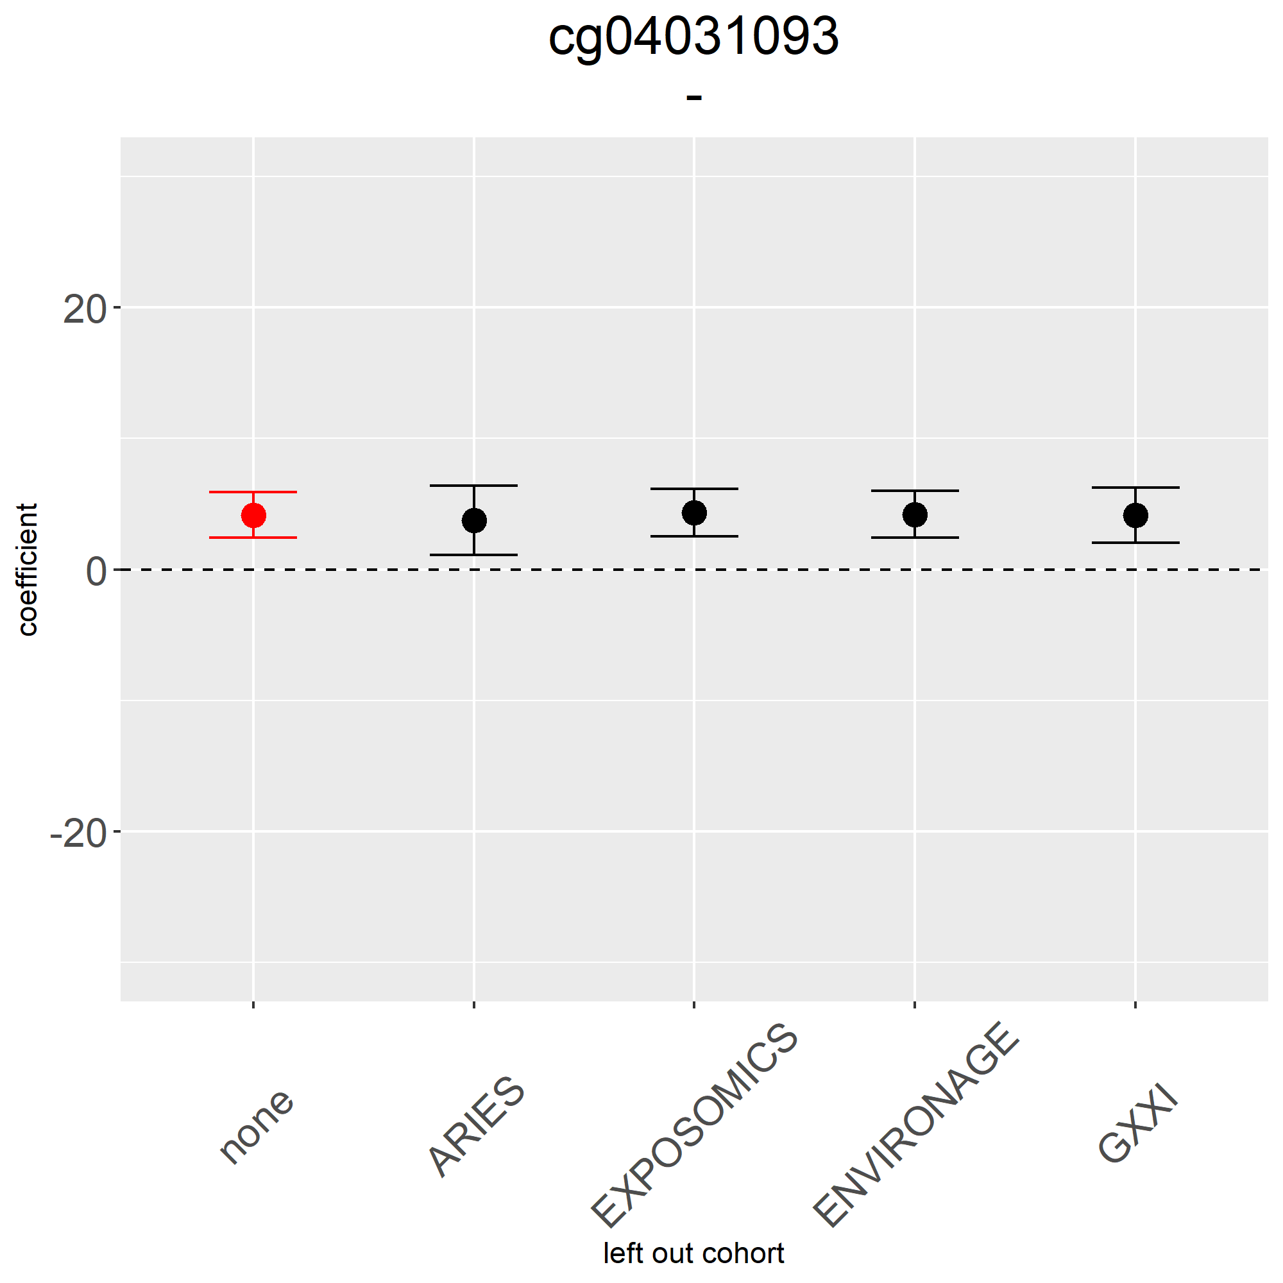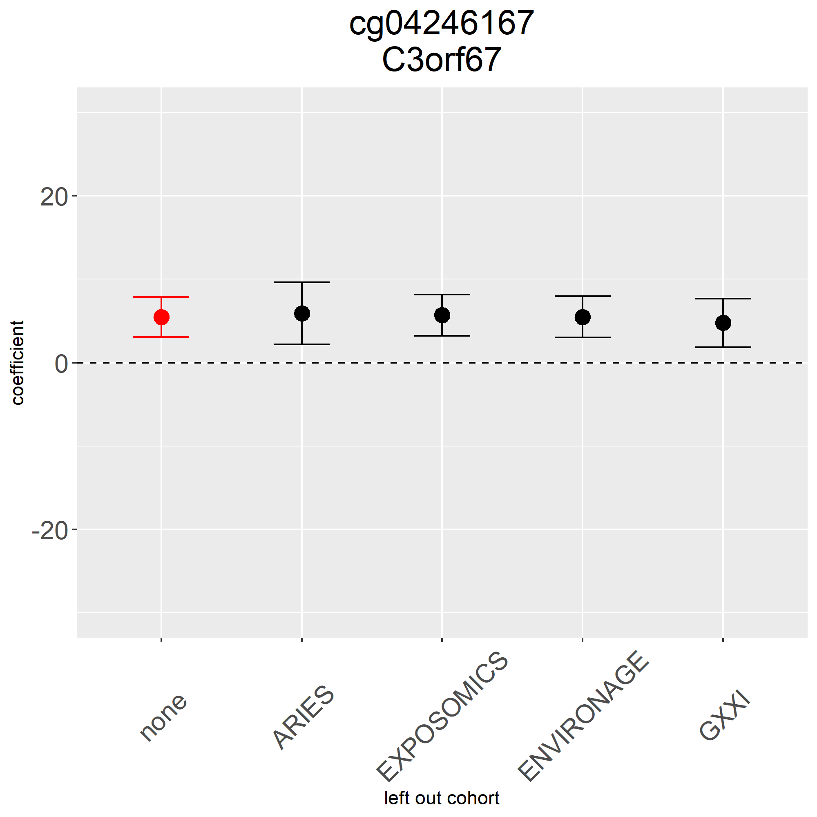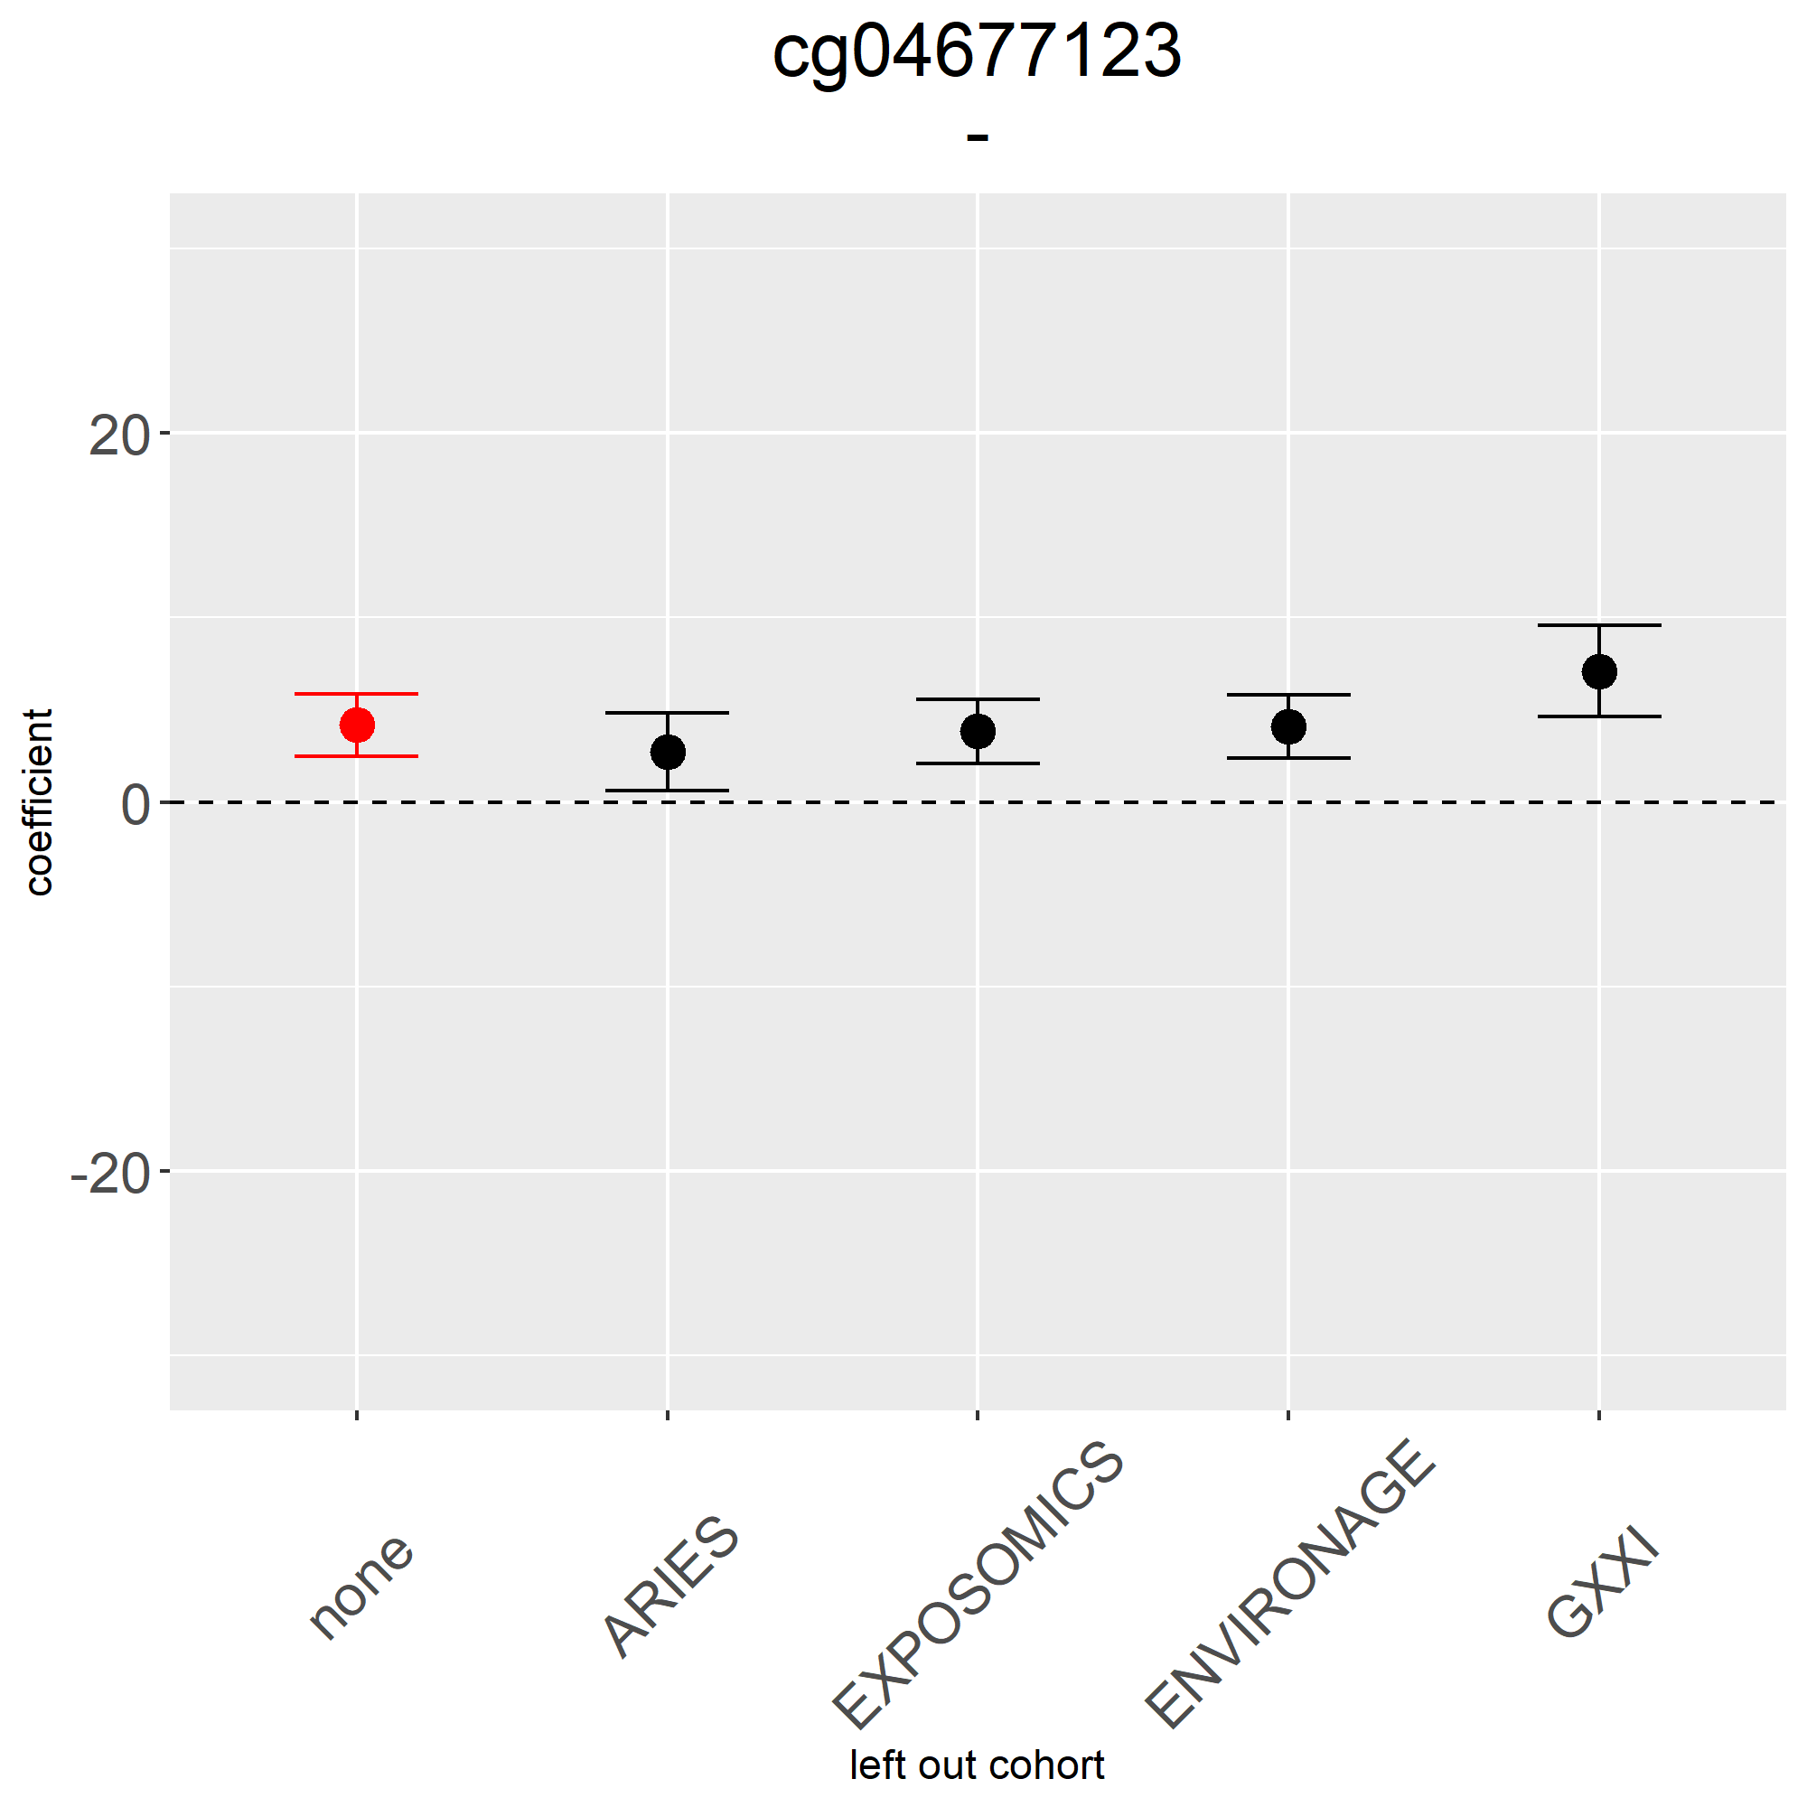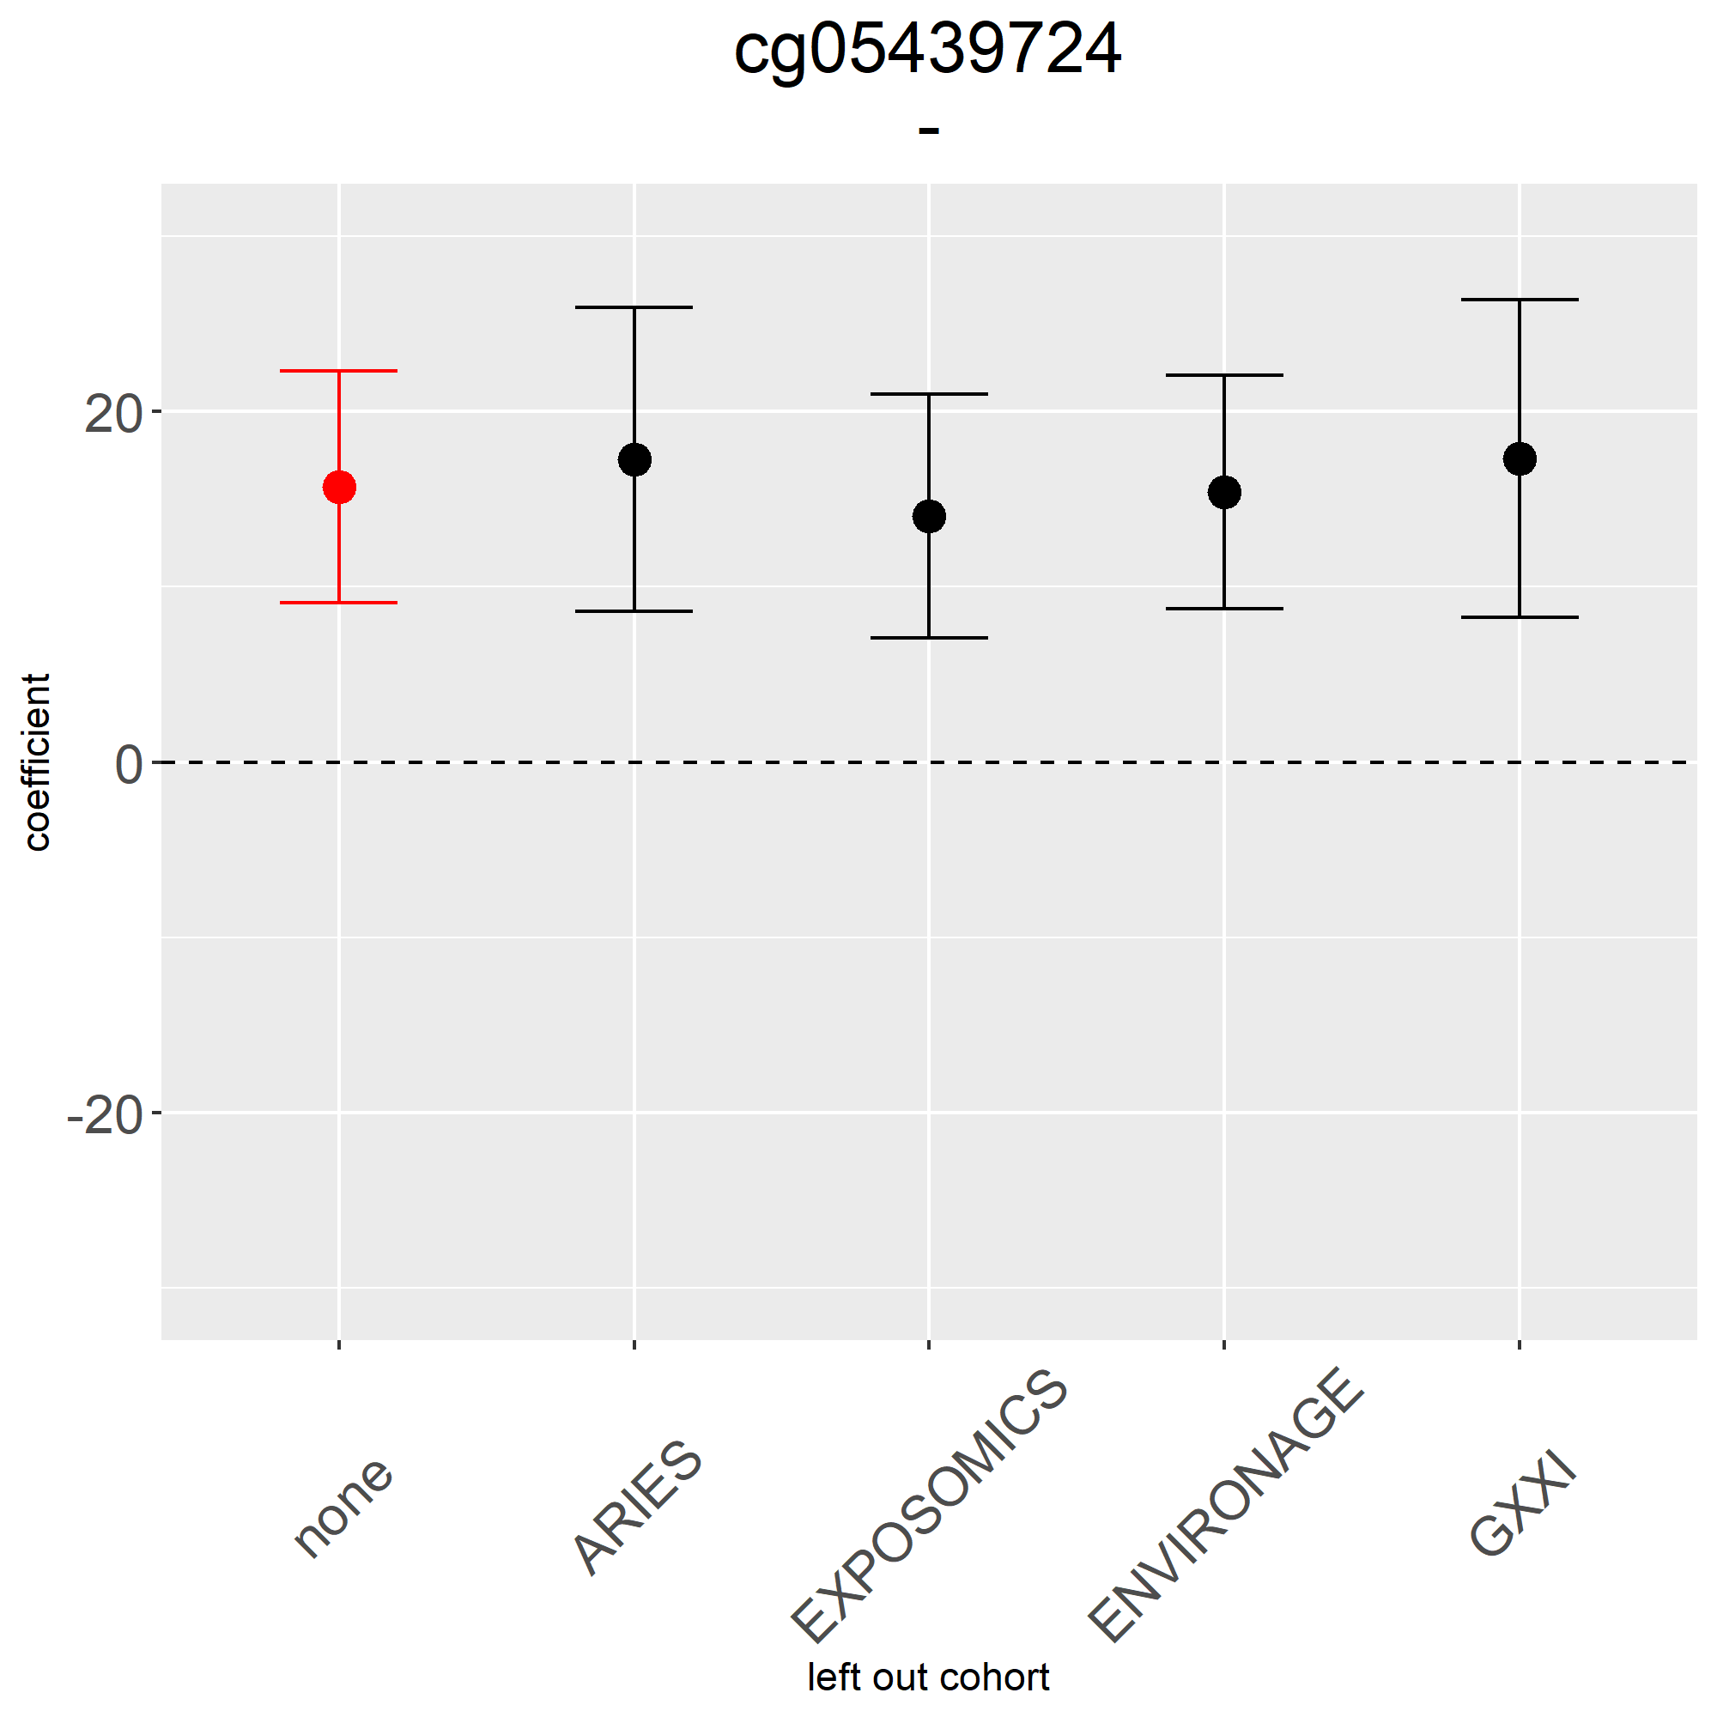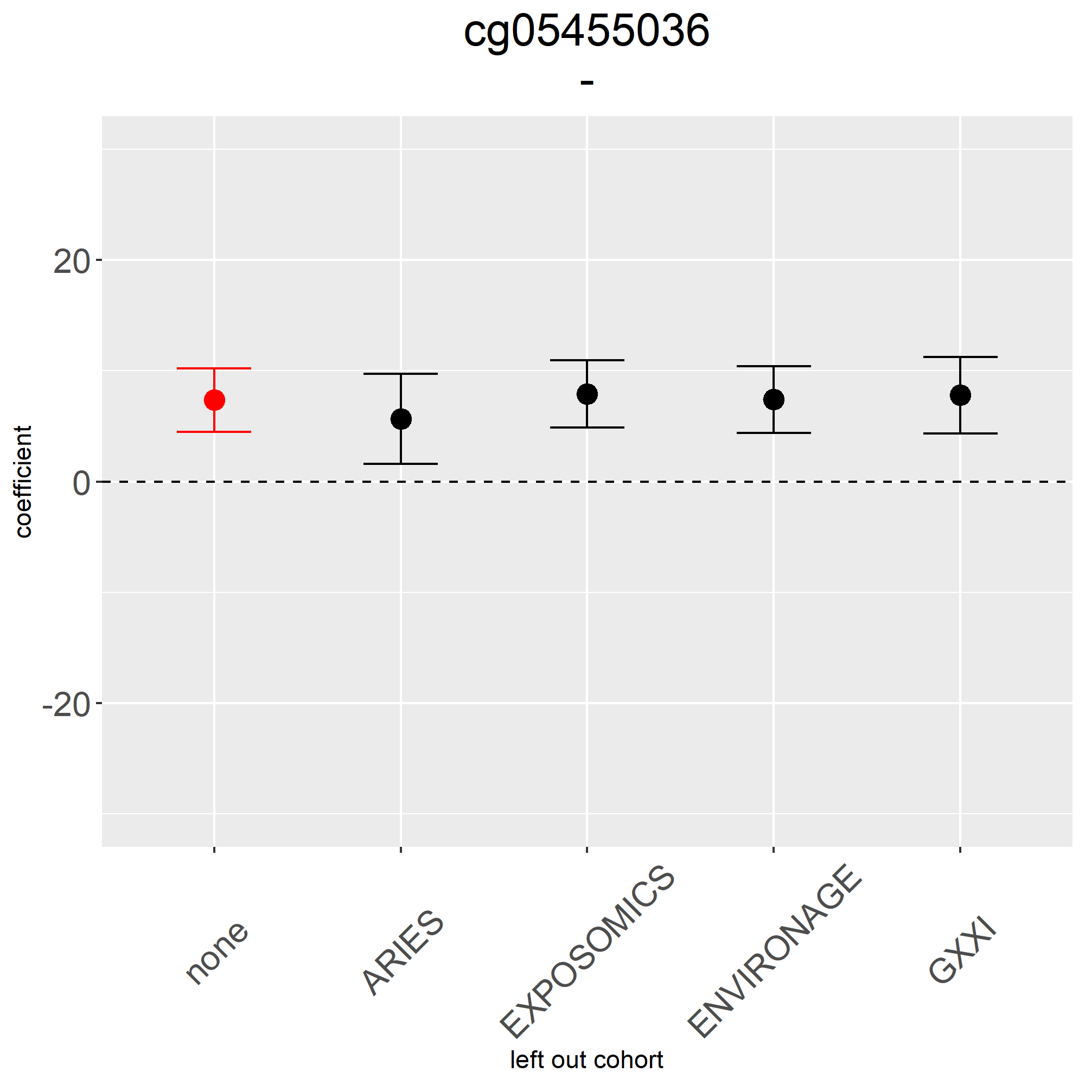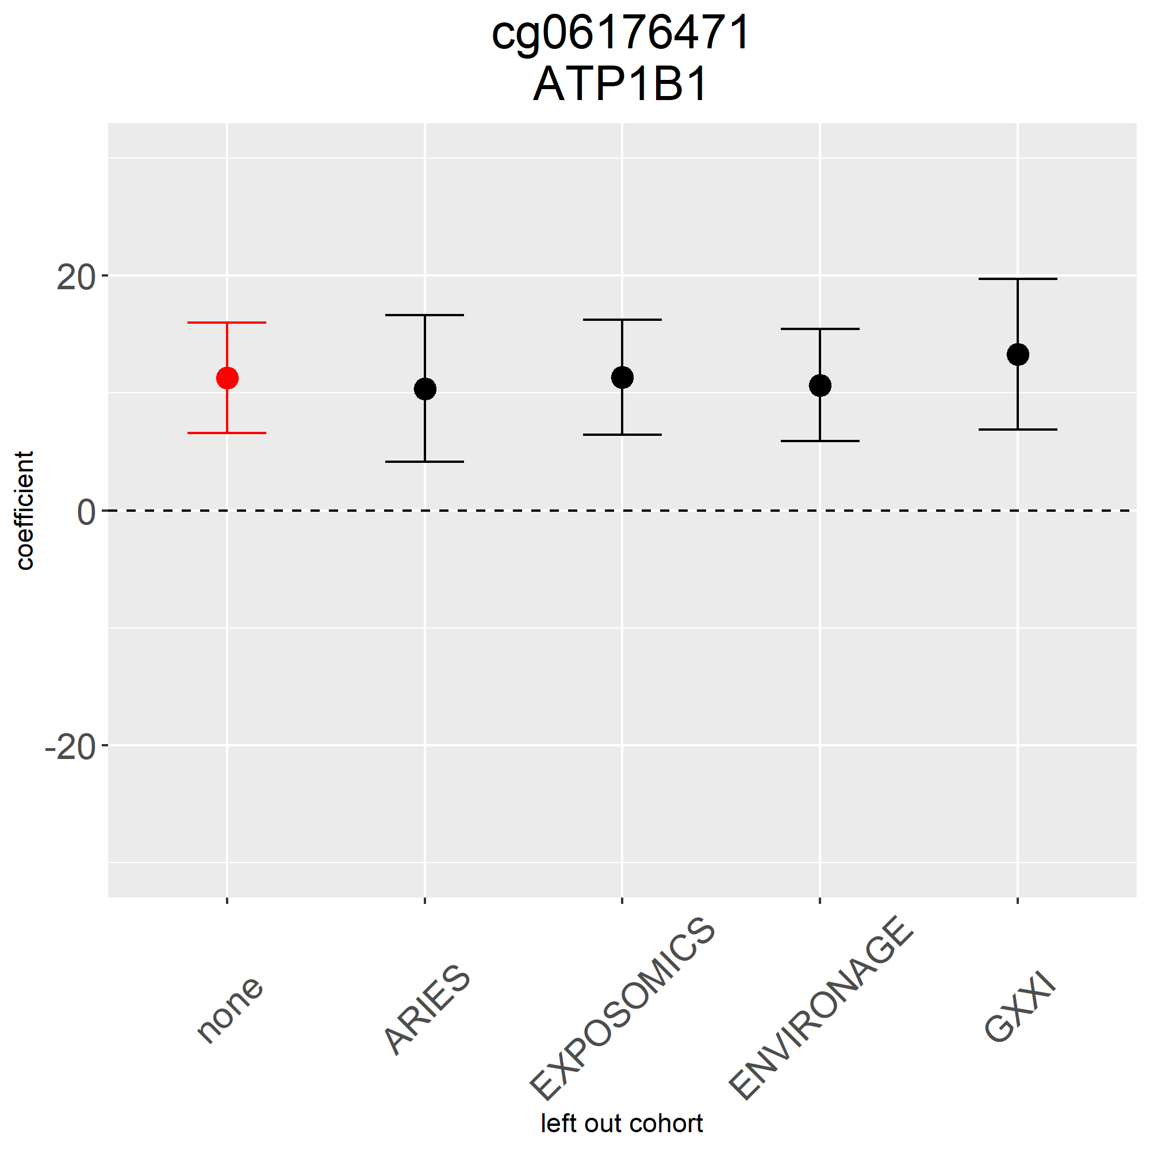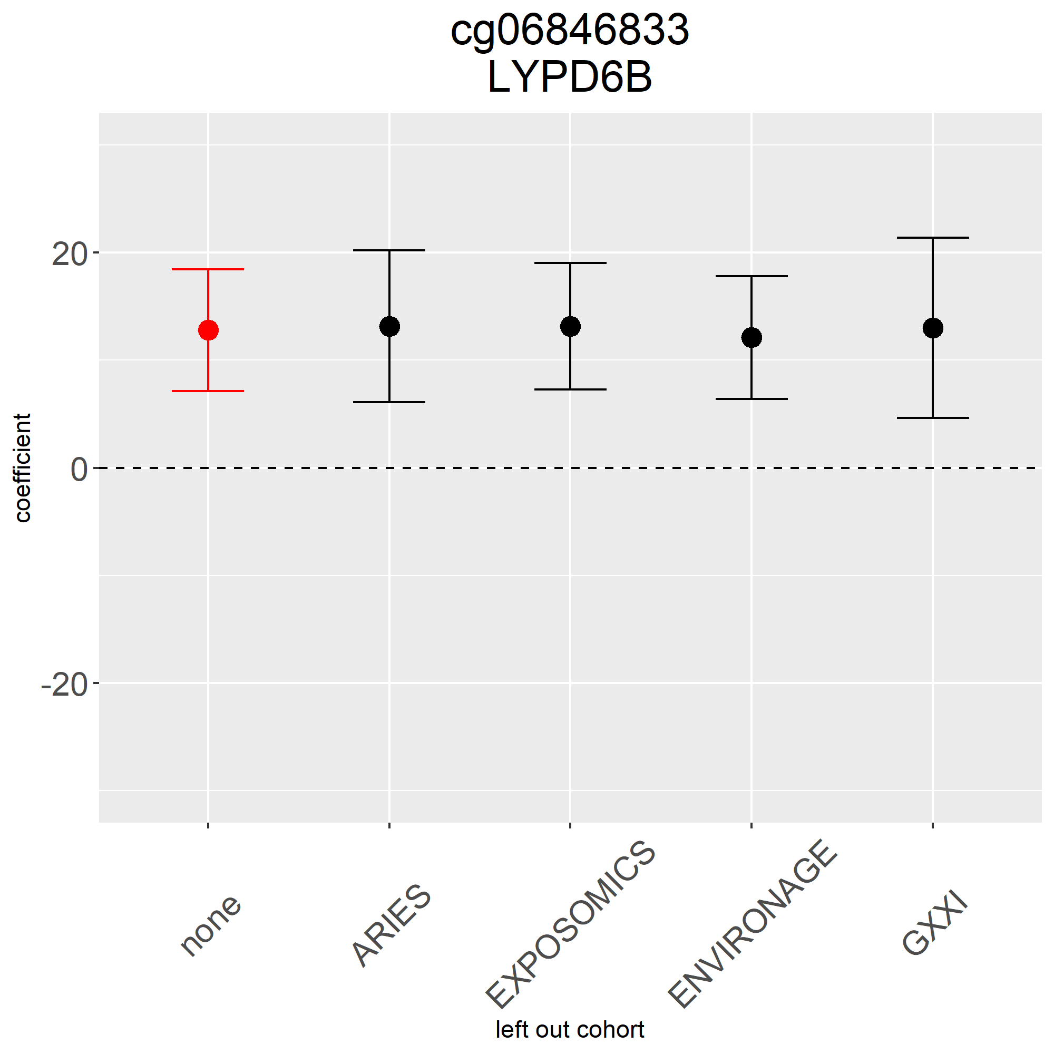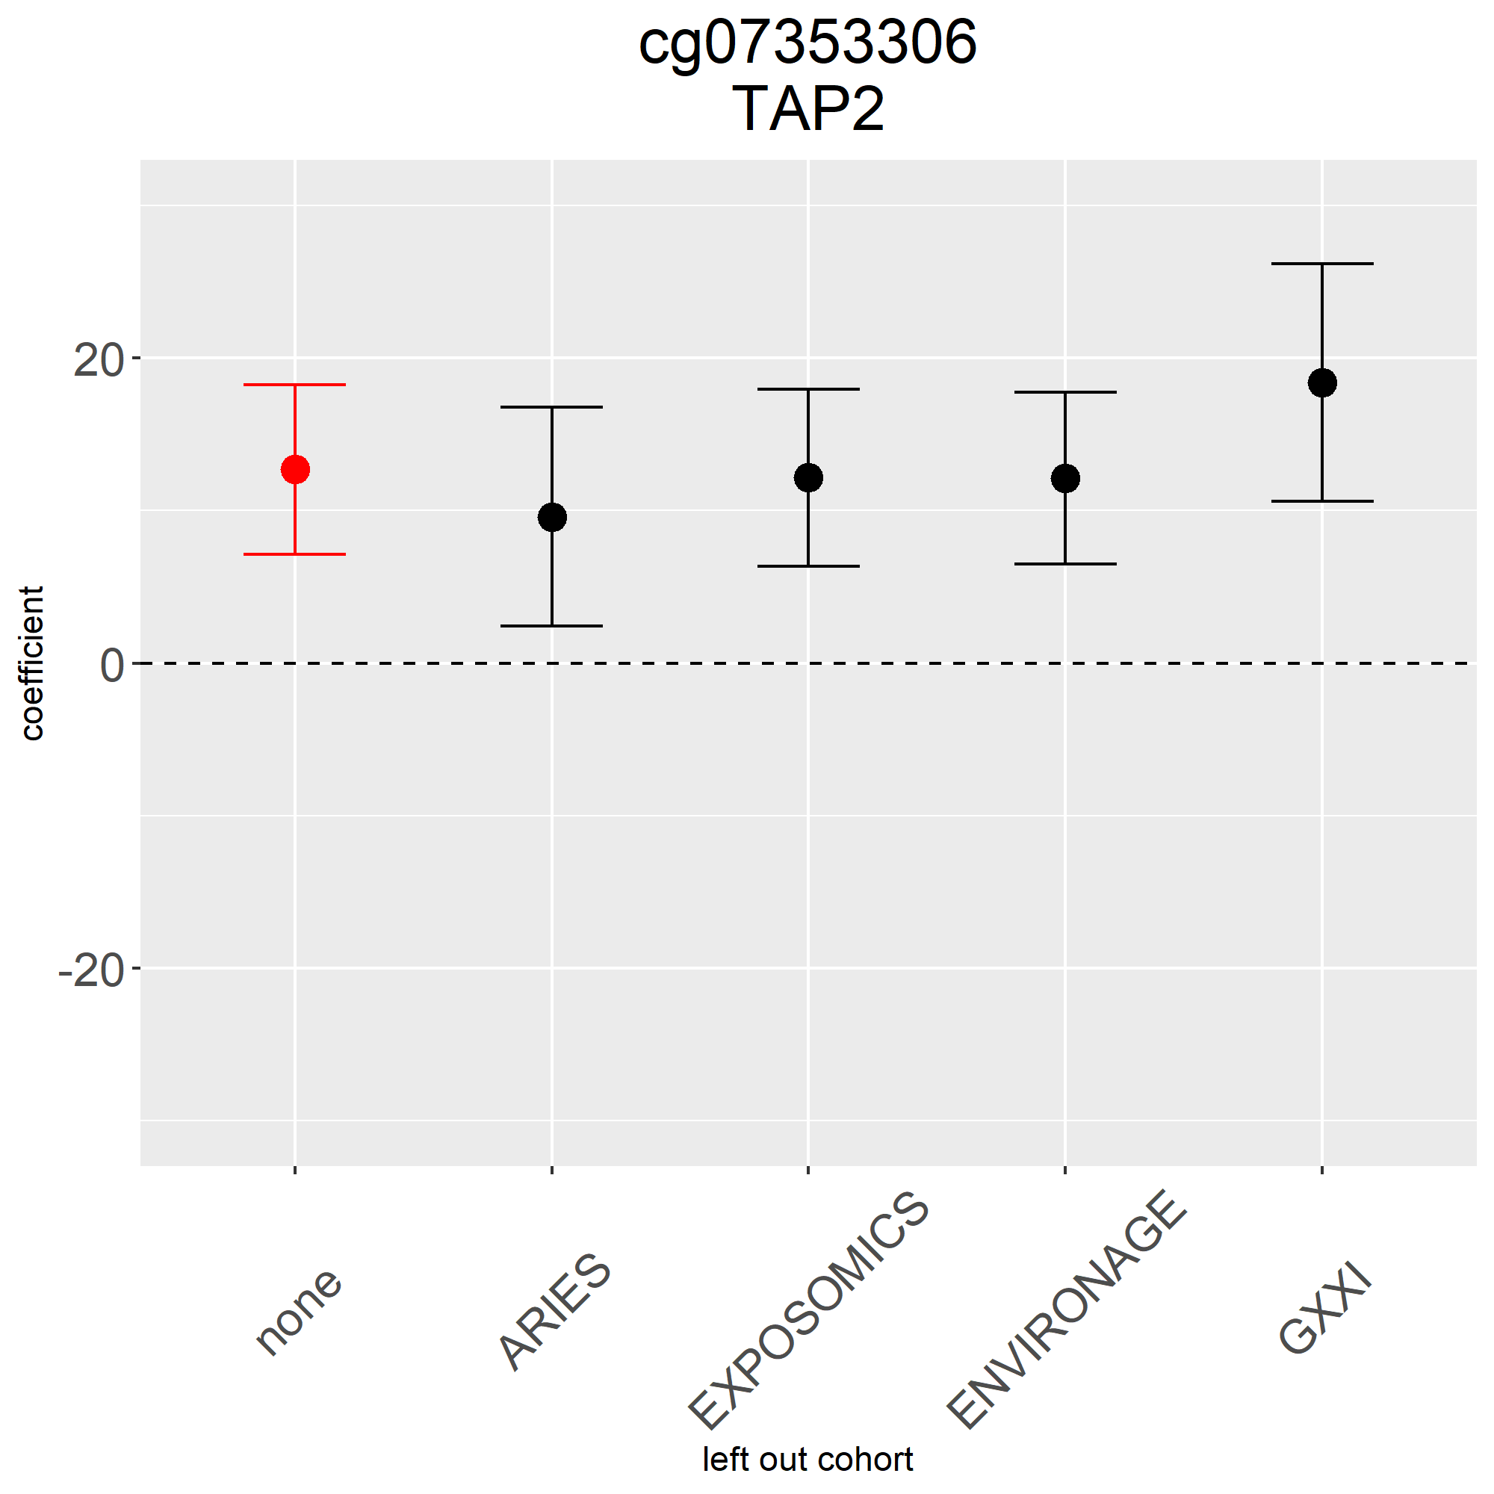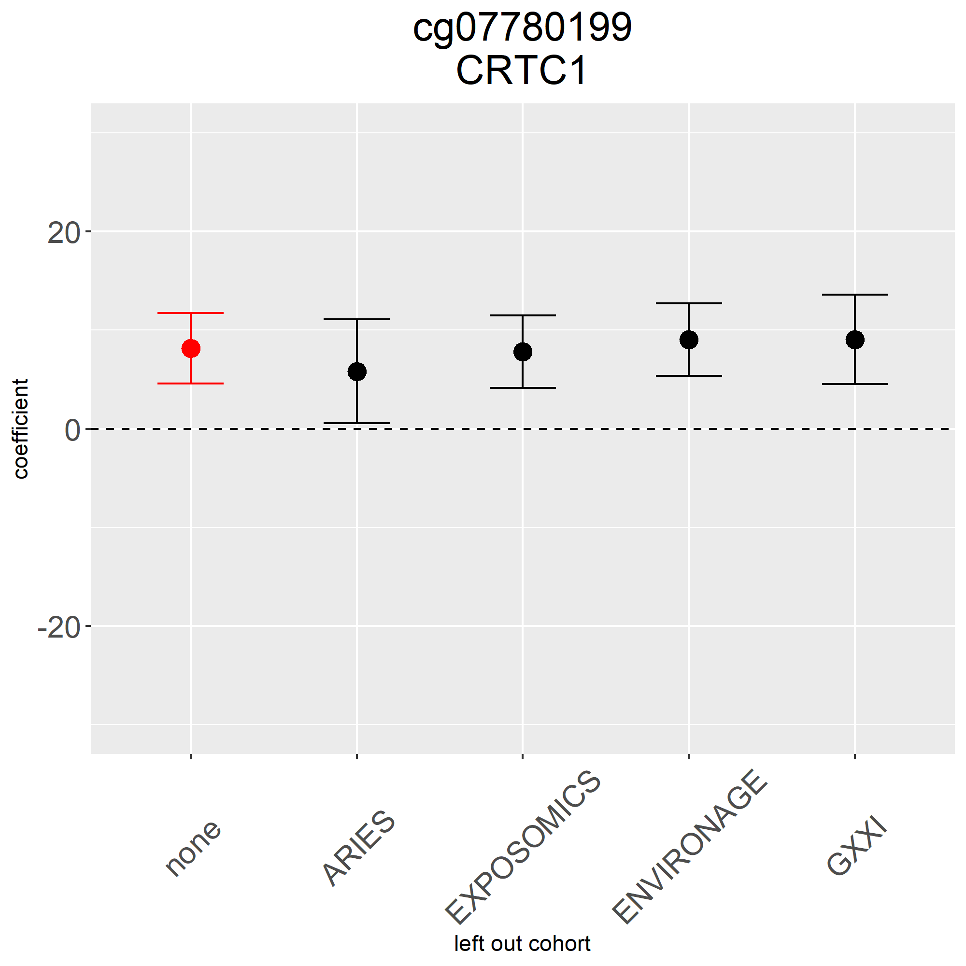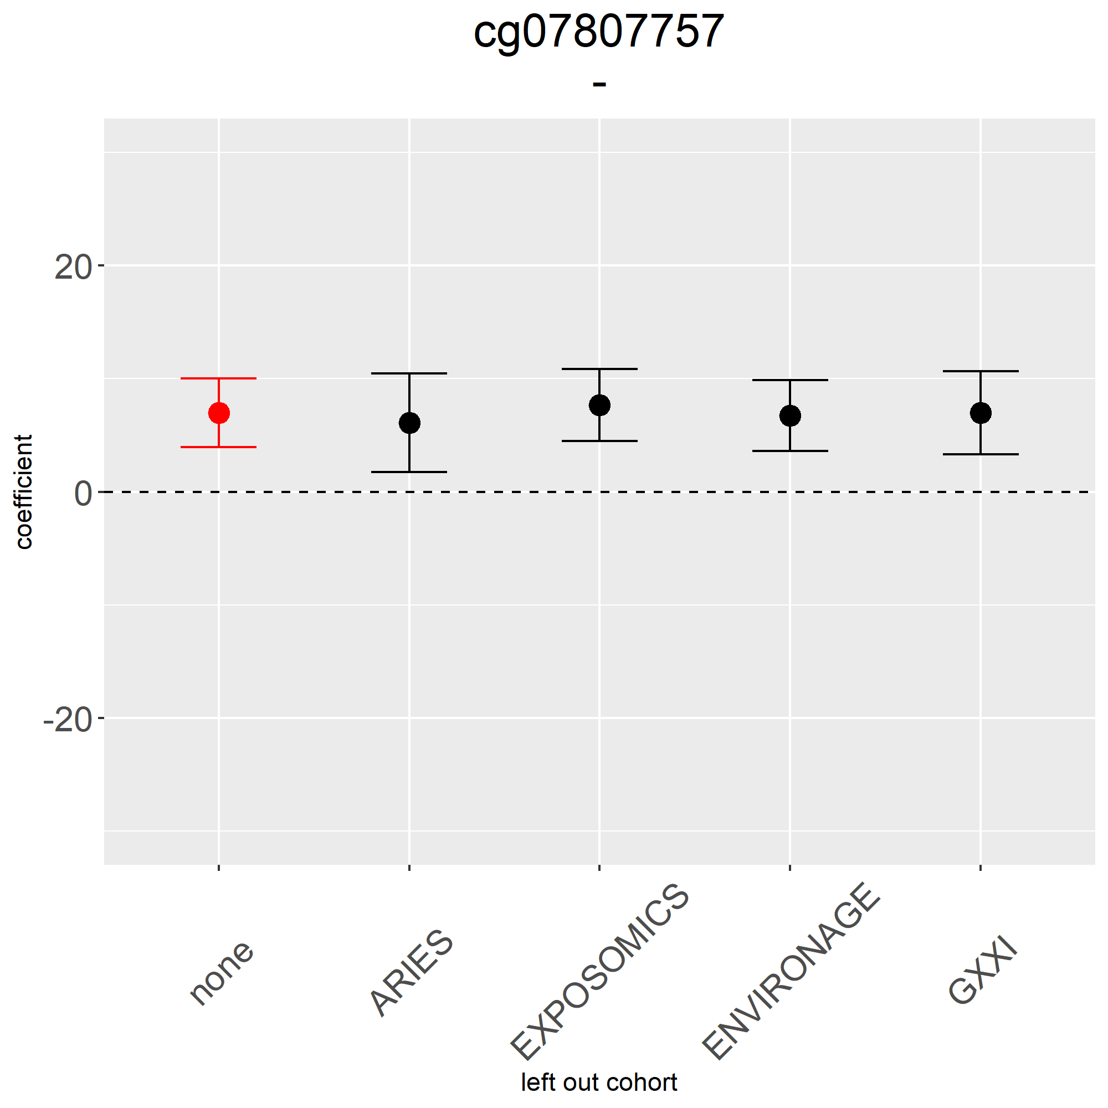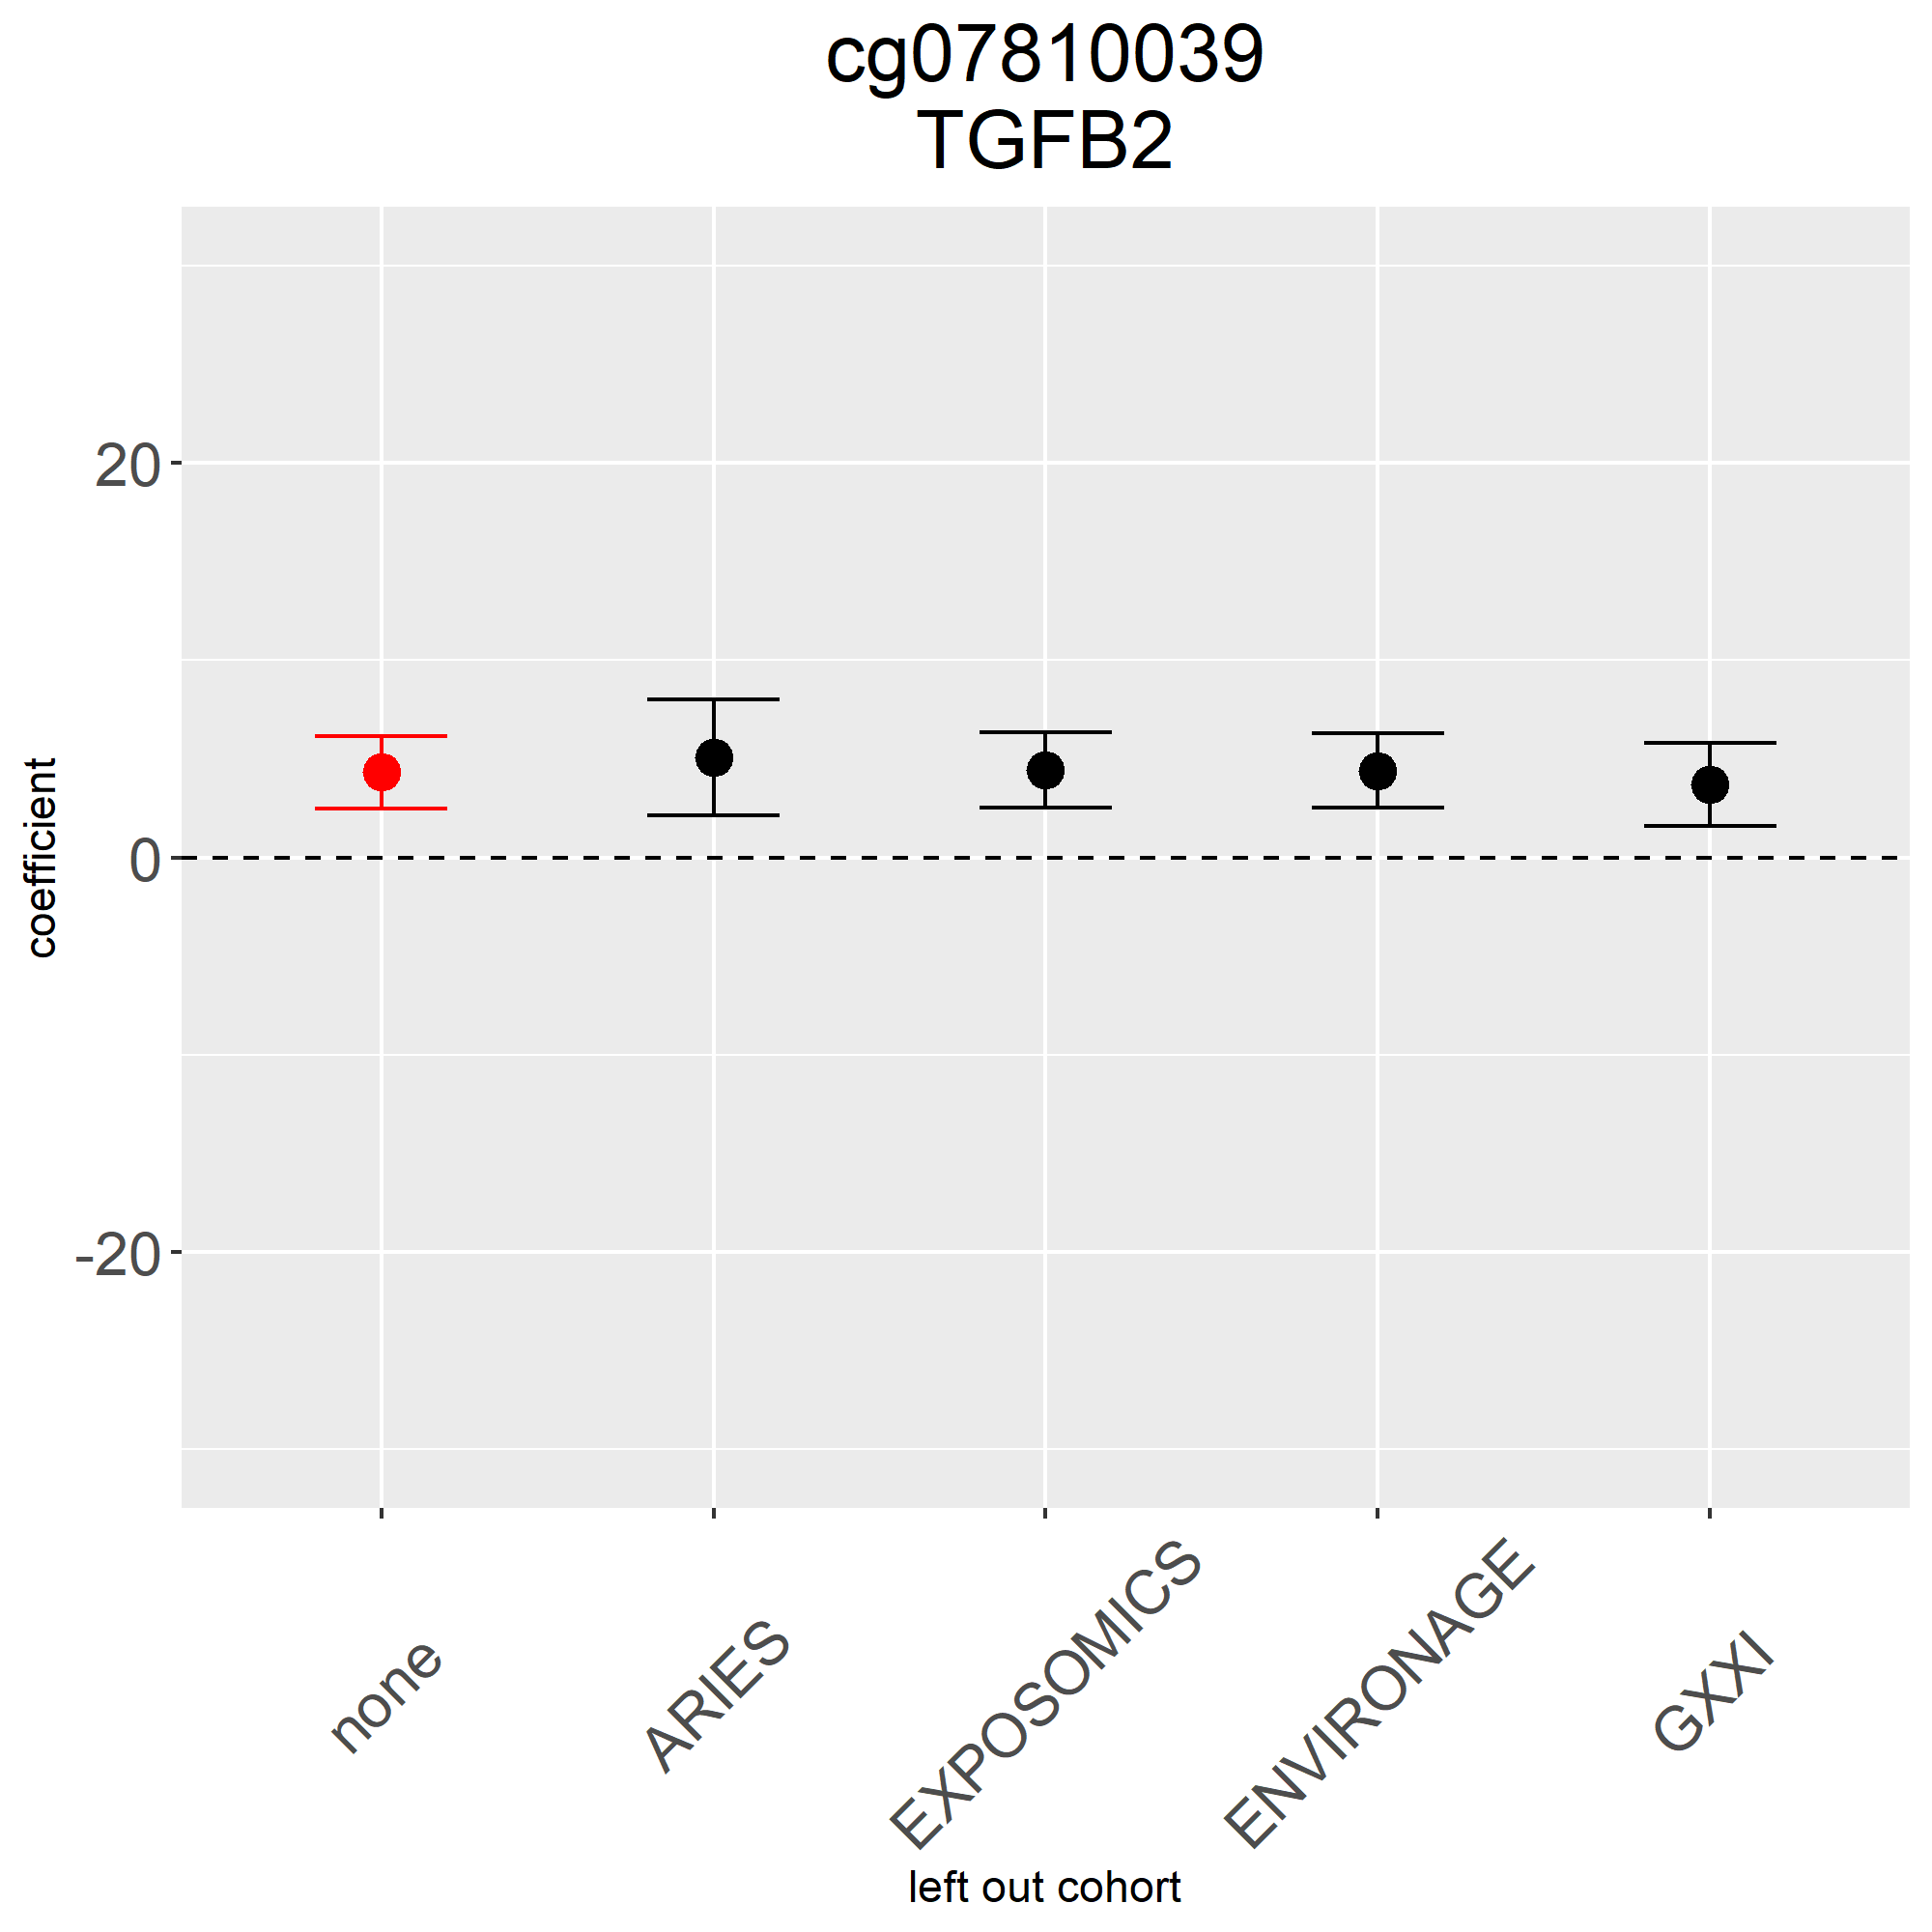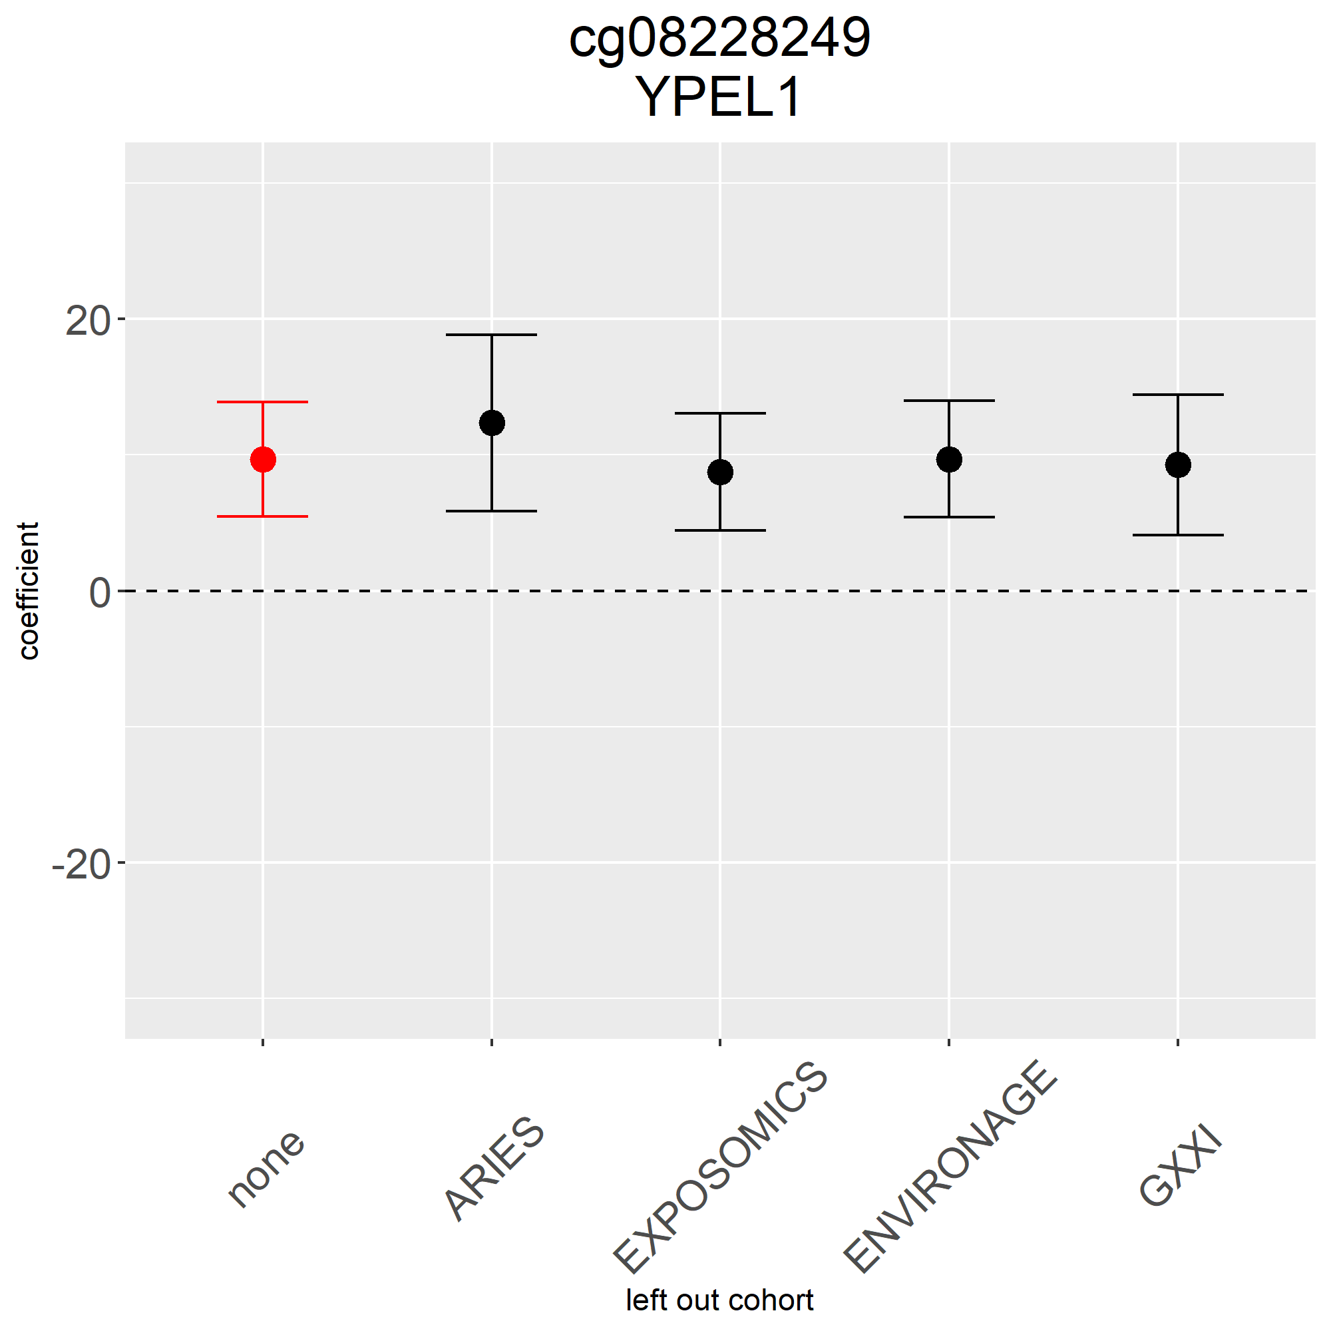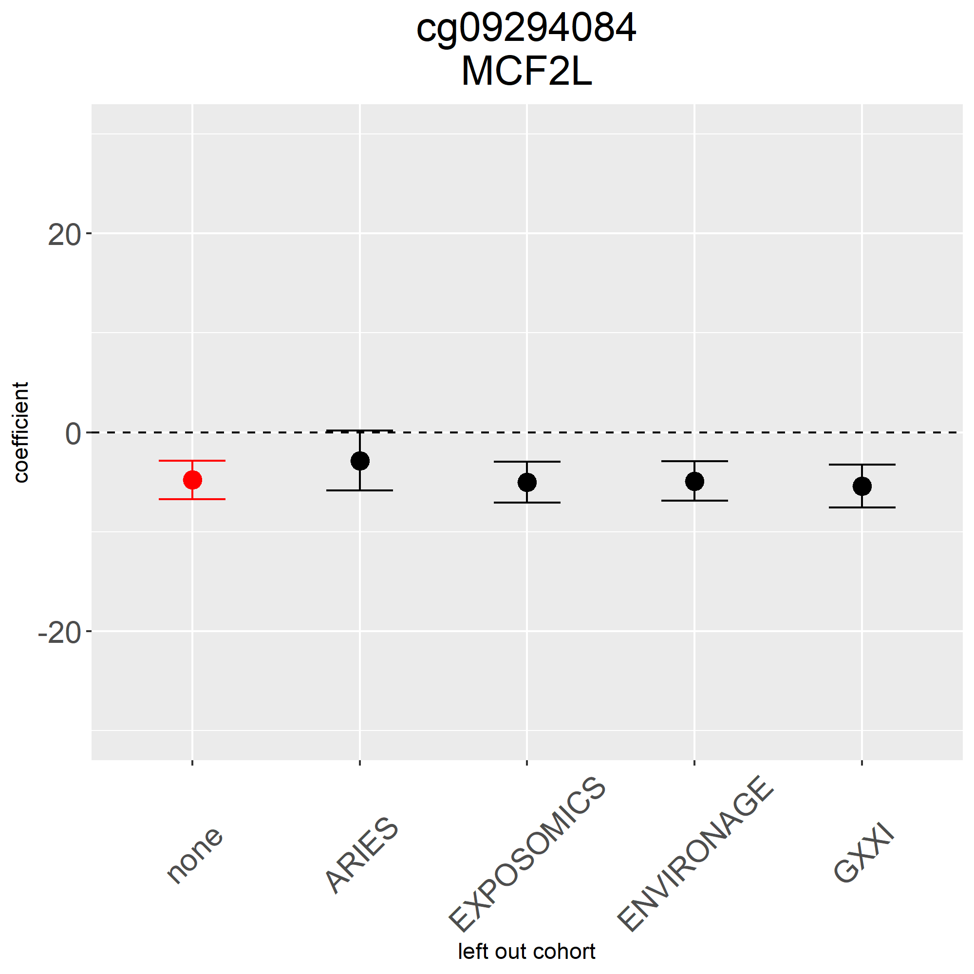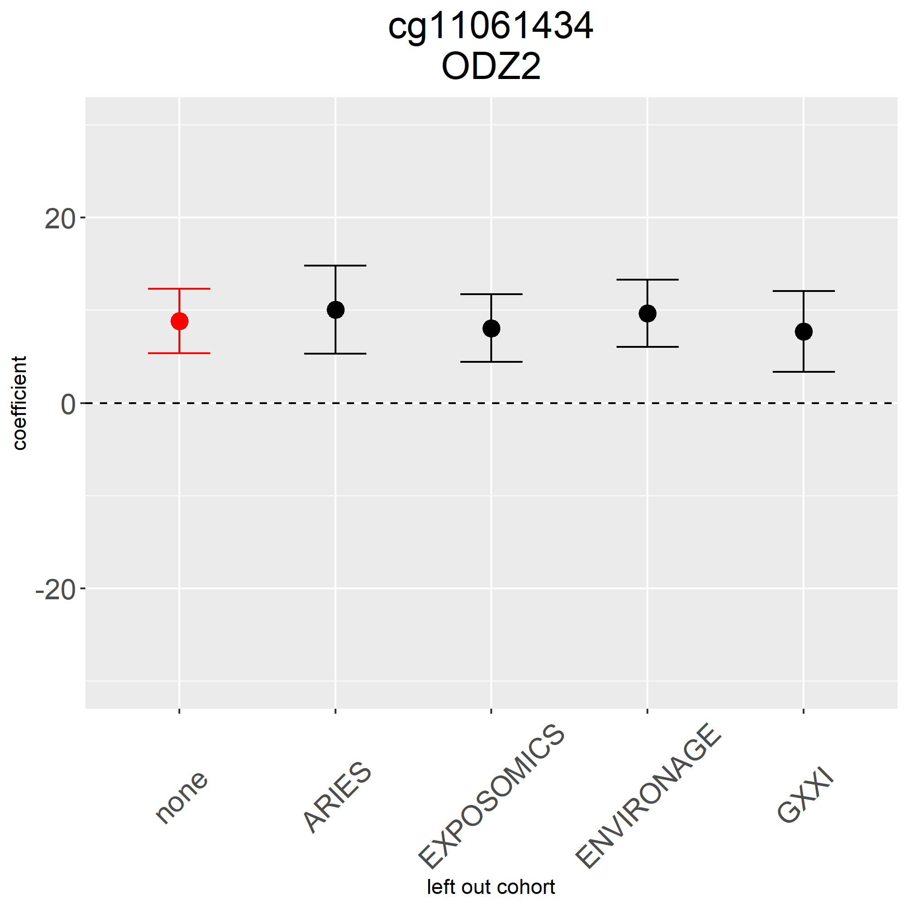

FigS3. Quality control of cohort specific EWAS of rapid weight growth. Coefficients, standard errors and p-values distributions visualized via box plots and QQ-plot.
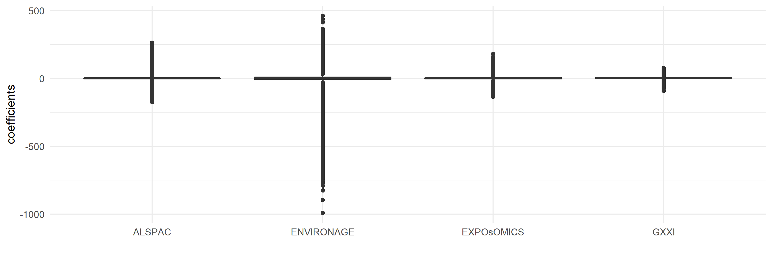
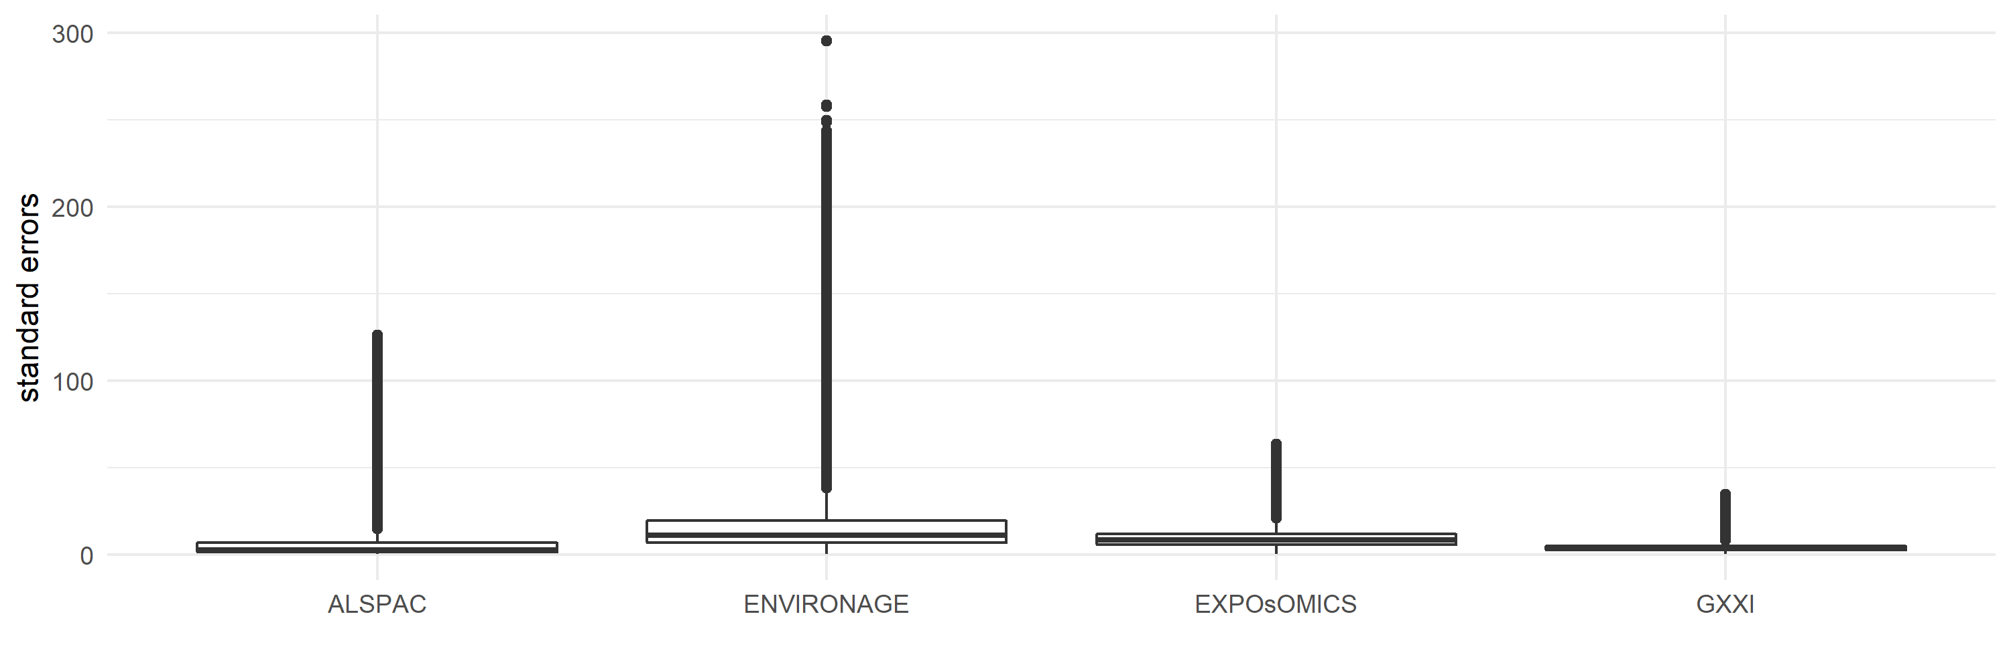
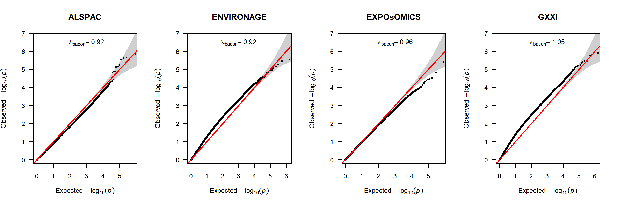

FigS4. Cohort specific correlation plots between chronological and DNA methylation gestational age.
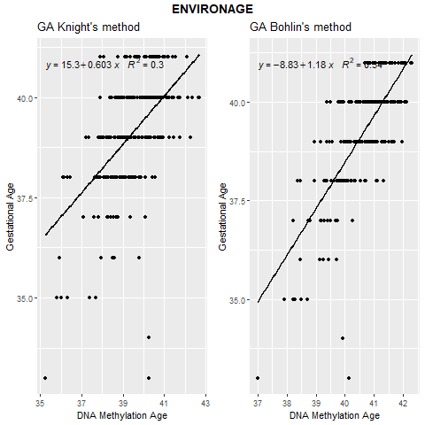
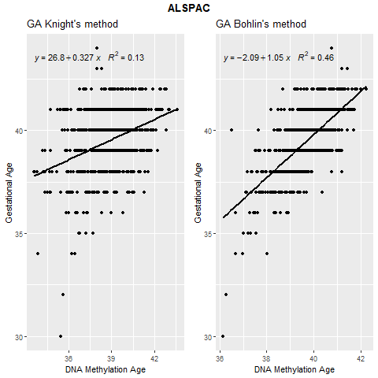
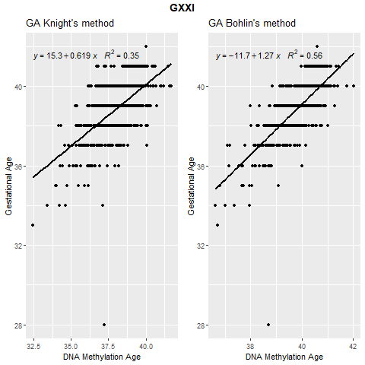
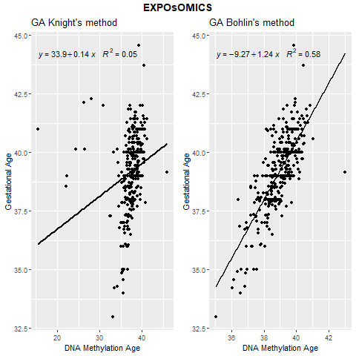
GA= gestational age

FigS5. Forrest plot of the meta-analysis of gestational age acceleration and rapid weight growth in sensitivity analyses adding (A) delivery mode, (B) removing cell types from confounders, excluding mothers with (C) gestational diabetes and (D) non-white European children.

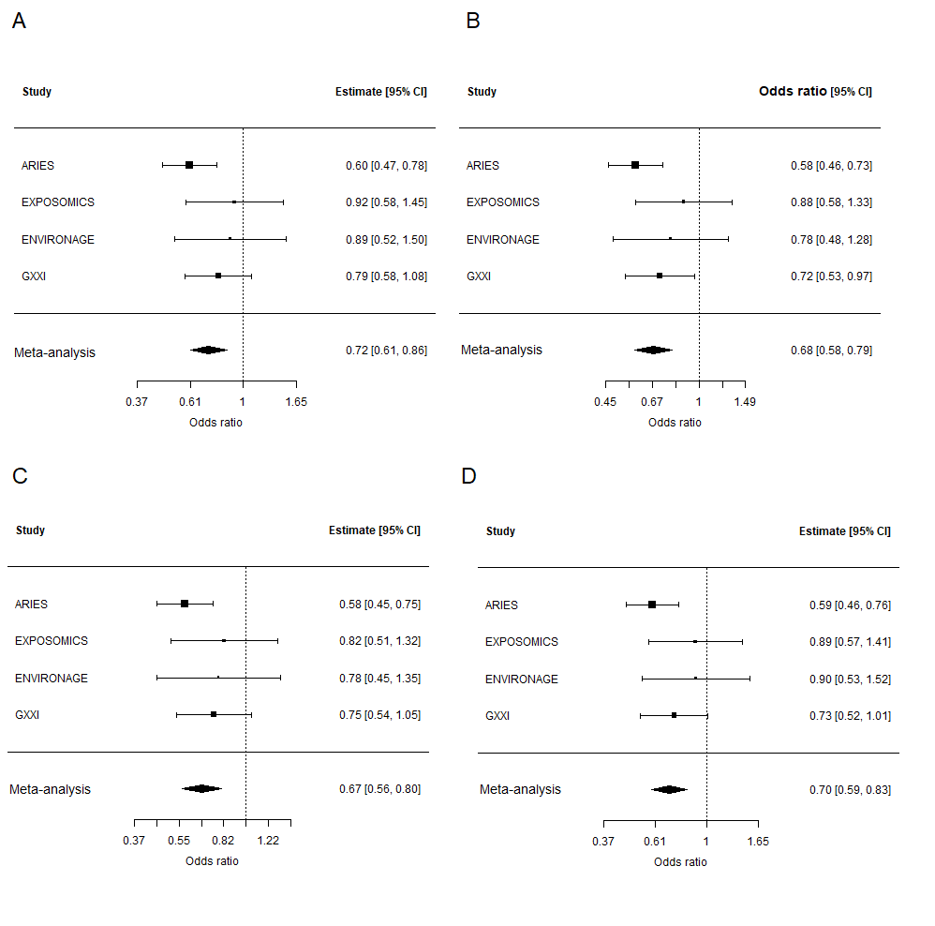
95% CI=95% confidence interval

FigS6. Calibration plots of Random Forest models of rapid weight growth including (A) conventional risk factors, (B) CpGs related to rapid weight growth and (C) both.
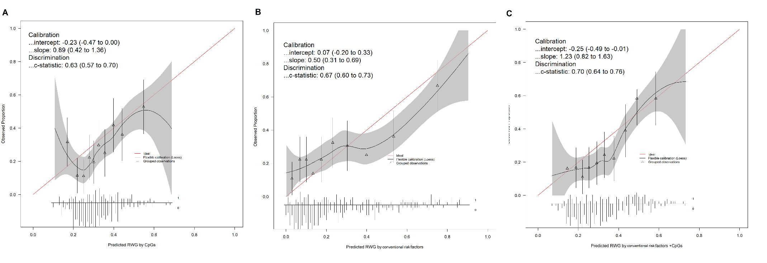

FigS7. Calibration plots of Random Forest models of rapid weight growth including (A) conventional risk factors, (B) CpGs belonging to DMRs related to rapid weight growth and (C) both.
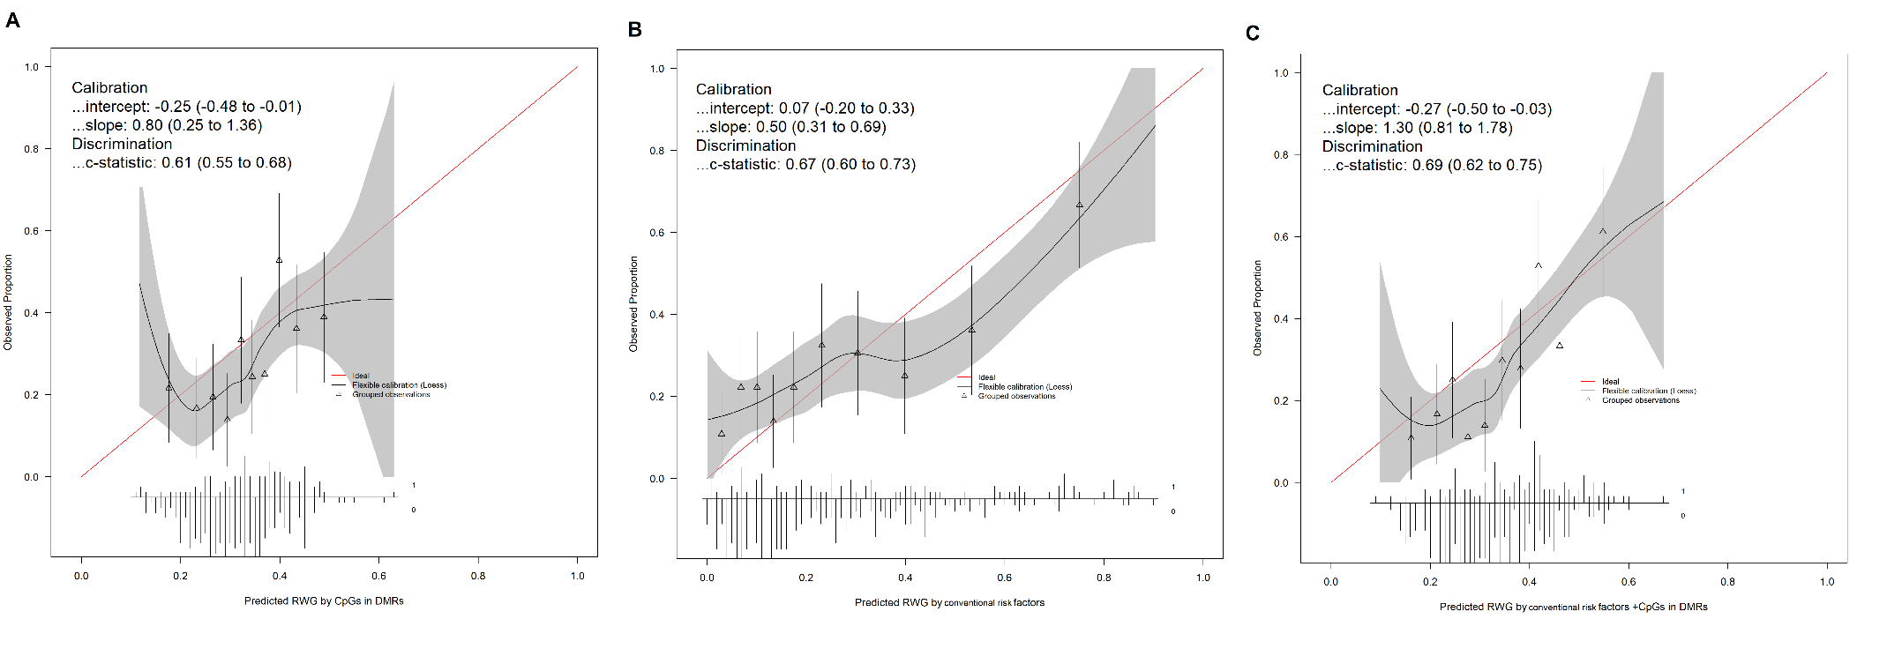

FigS8. Heatmap shows Pearson’s correlation between methylation levels of the 44 CpGs associated with P_{Suggestive} <1e-05 in the meta-analysis of EWAS of rapid weight growth. Red boxes indicate the three CpGs identified in mediation analyses.
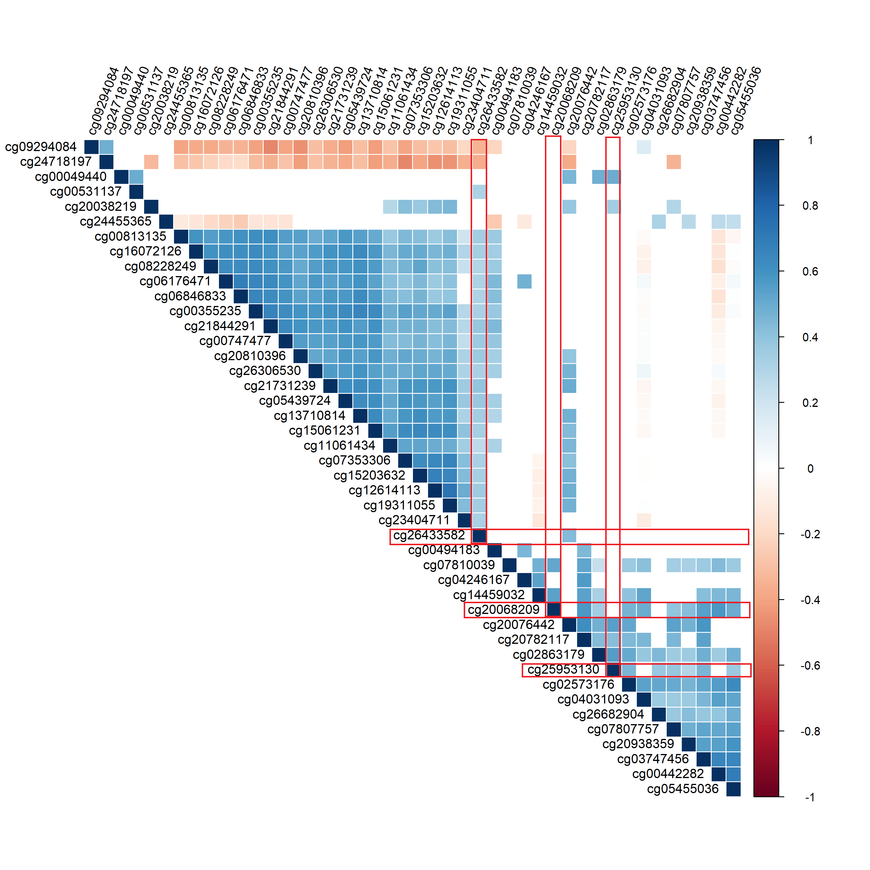

FigS9. Volcano plots of the association between the 44 CpGs associated with rapid weight growth at P_{Suggestive} < 1e-05/the 96 CpGs belonging to the 16 DMRs associated with rapid weight growth at FDR-adjusted p-value in DMRcate and Siddak p-values in ENmix-comb-p <0.01 and the entire transcriptome (A/C) and restricted to cis transcripts (B/D). Red lines represent Bonferroni-significant threshold, and black lines suggestive threshold (p-value=10-e05). For analyses restricted to cis transcripts only Bonferroni-significant threshold is represented.

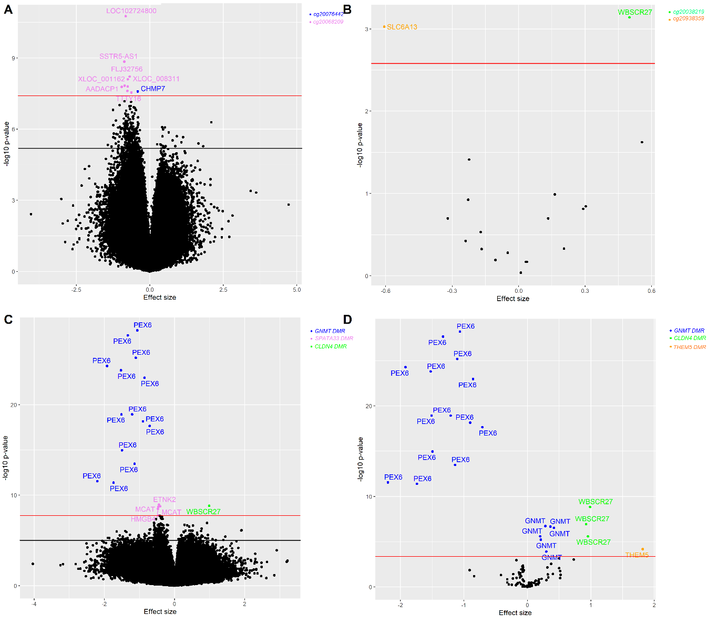
DMR= differentially methylated regions; FDR= false discovery rate. Labels represent gene names for gene expression and are coloured according to the associated DNA methylation signals as reported in the legend.

FigS10. Volcano plots of the association between the 44 CpGs associated with rapid weight growth at P_{Suggestive} < 1e-05/the 96 CpGs belonging to the 16 DMRs associated with rapid weight growth at FDR-adjusted p-value in DMRcate and Siddak p-values in ENmix-comb-p <0.01 and the entire metabolome (A/B). Red lines represent Bonferroni-significant threshold, and black lines suggestive threshold (p-value=10-e05).

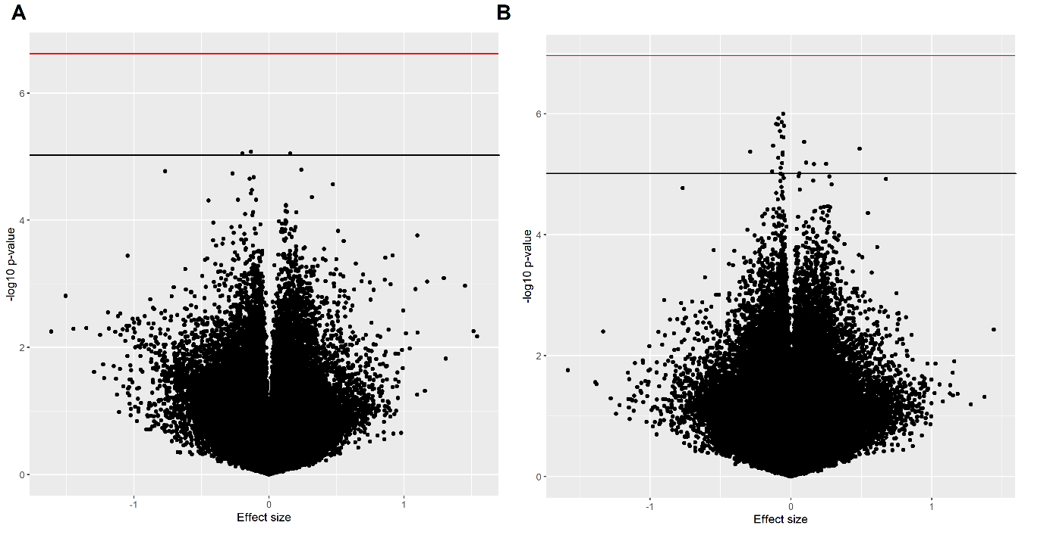

FigS11. Forrest plot of the meta-analysis of the analysis of gestational age acceleration and childhood overweight.
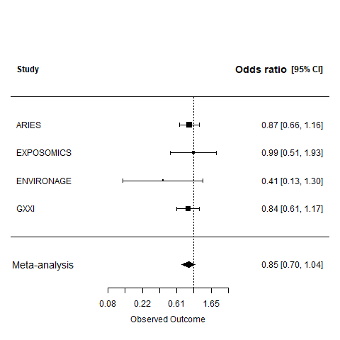
95% CI=95% confidence interval

FigS12. Volcano plot from the look-up in the study population of the CpG sites associated with child anthropometrics in a previous systematic review by Alfano et al. [60]

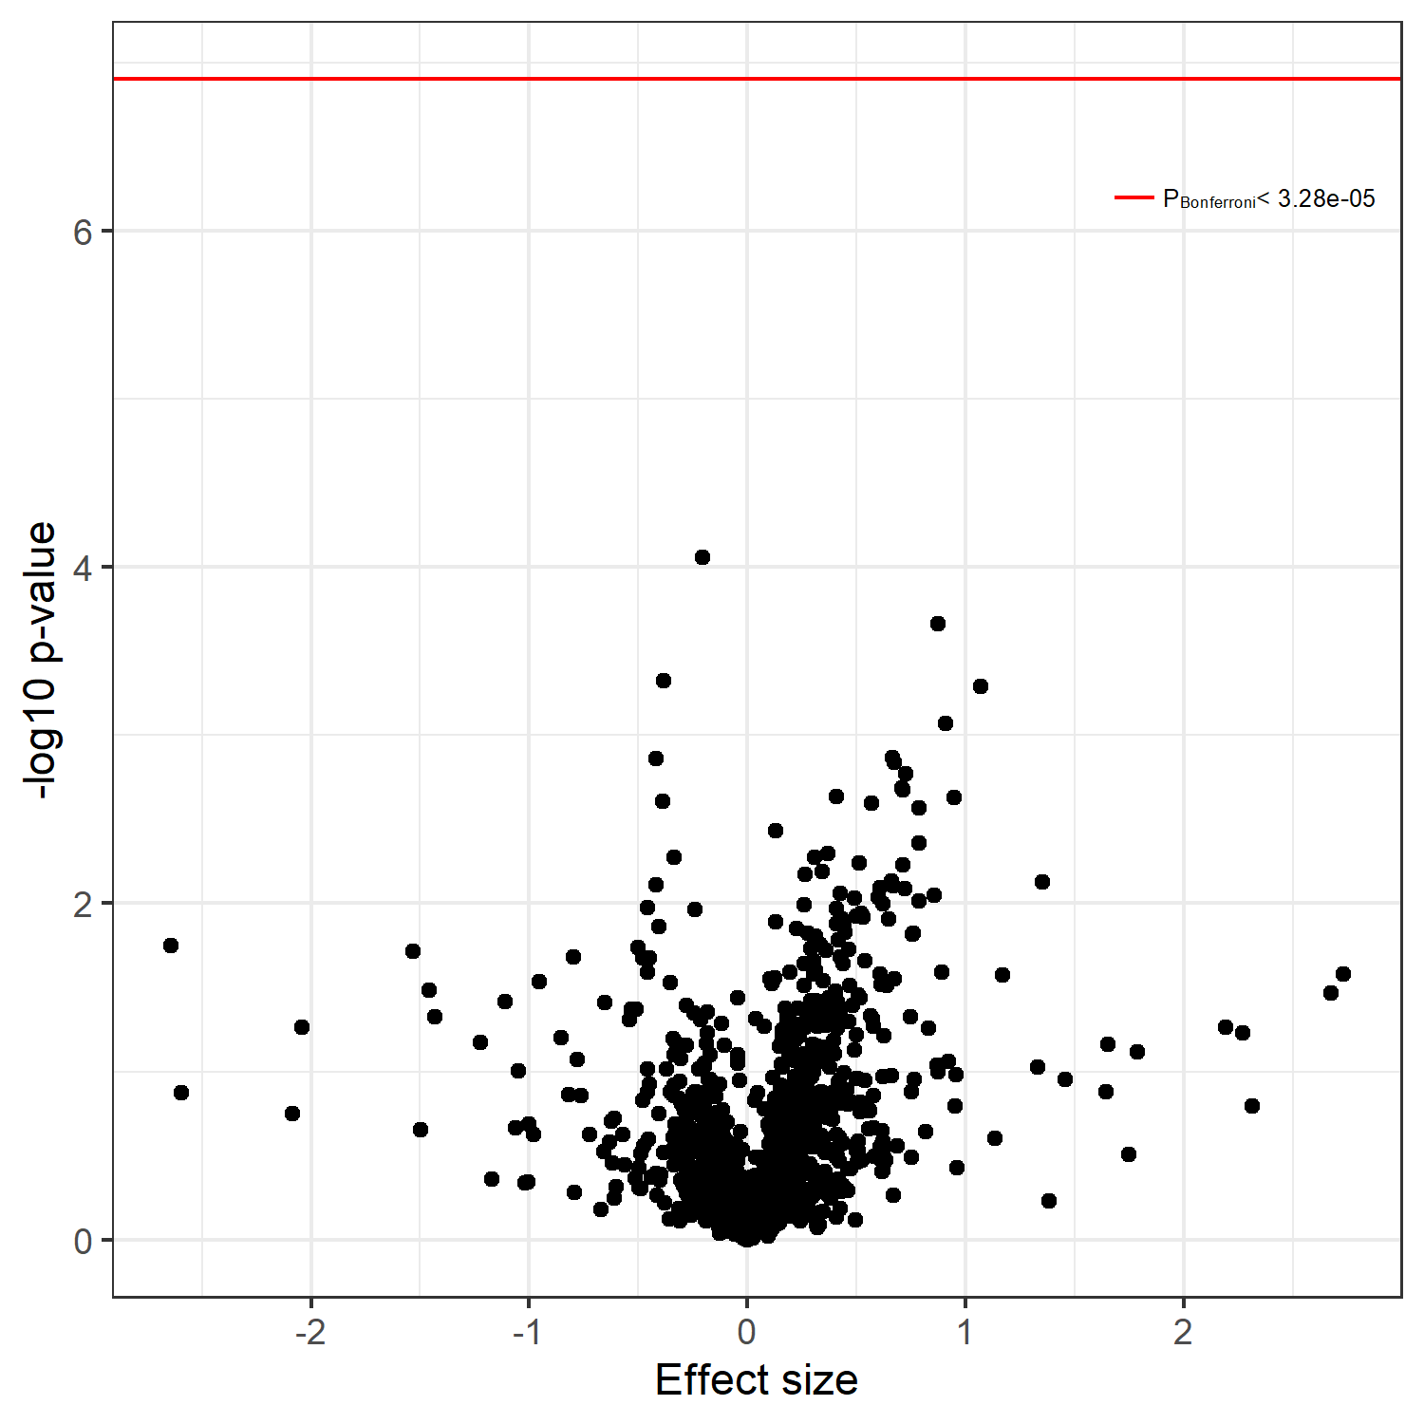
Alfano R, Robinson O, Handakas E, Nawrot TS, Vineis P, Plusquin M. Perspectives and challenges of epigenetic determinants of childhood obesity: A systematic review. Obes Rev. 2021;23 Suppl 1:e13389.

