Retinal nerve fiber layer thinning as a novel fingerprint for cardiovascular events: results from the prospective UK Biobank and a Chinese cohort

Running title: RNFL Thinning Predicts Cardiovascular Events Risk

Authors: Yanping Chen, MD¹*, Yixiong Yuan, MD¹*, Shiran Zhang, MD¹, Shaopeng Yang, MD¹, Junyao Zhang, BBiomedSc², Xiao Guo, MD¹, Wenyong Huang, MD, PhD^{1,} Zhuoting Zhu, MD, PhD²†, Mingguang He, MD, PhD1,²†, Wei Wang, MD, PhD¹†

Affiliation and institute
1. State Key Laboratory of Ophthalmology, Zhongshan Ophthalmic Center, Sun Yat-sen University, Guangdong Provincial Key Laboratory of Ophthalmology and Visual Science, Guangdong Provincial Clinical Research Center for Ocular Diseases, Guangzhou, China.
2. Centre for Eye Research Australia, Royal Victorian Eye and Ear Hospital, Melbourne, Australia.
*Co-first authors.
†Co-corresponding authors.

Corresponding authors:
Wei Wang, MD & PhD, Zhongshan Ophthalmic Center, State Key Laboratory of Ophthalmology, Sun Yat-sen University, Guangzhou, China. Email: wangwei@gzzoc.com

Mingguang He, MD & PhD & FRANZCO, NHMRC Leadership Fellow, Professor of Ophthalmic Epidemiology, University of Melbourne, Centre for Eye Research Australia. Level 7, 32 Gisborne Street, East Melbourne, VIC 3004, Australia.
Email: mingguang.he@unimelb.edu.au | M: 0458118880

Zhuoting Zhu, MD&PhD, Centre for Eye Research Australia, University of Melbourne. Level 7, 32 Gisborne Street, East Melbourne, VIC 3002, Australia, Email: lisa.zhu@unimelb.edu.au

Word count: Abstract: 338; Whole paper: 3932.
Figures: 3
Tables: 4
Supplementary Figures: 2
Supplementary Tables: 5

Figure S1. Flowchart showing inclusion and exclusion criteria of the population from UK Biobank
SD-OCT=spectral domain optical coherence tomography; CVD=cardiovascular disease; RNFL=retinal nerve fiber layer; IOP=intraocular pressure; BMI= body mass index.

Figure S2. Macular OCT retinal layers segmentation in one sample OCT image from the UK Biobank
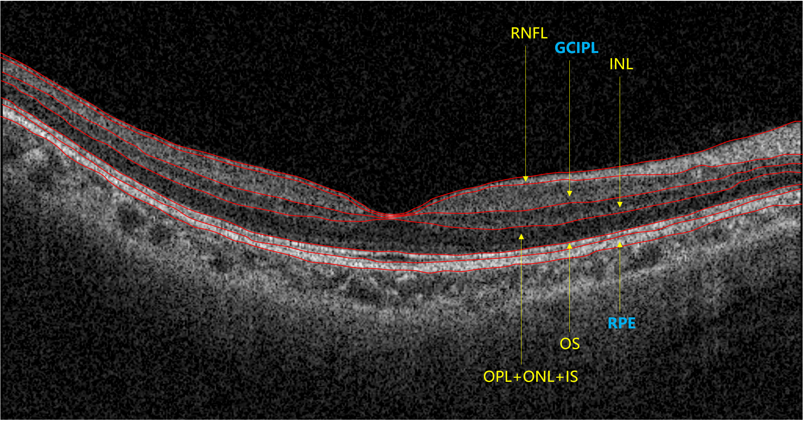
Macular RNFL refers to the innermost layer of the retina.
RNFL=retinal nerve fiber layer; GCIPL=ganglion cell-inner plexiform layer; INL=inner nuclear layer; OPL=outer plexiform layer; ONL=outer nuclear layer; IS=photoreceptor inner segment; OS=photoreceptor outer segment; RPE=retinal pigment epithelium.

Table S1. Definition of variables in touchscreen questionnaire, verbal interview, and inpatient records of diagnosis
Variable | Data category | Data field | Data code
Age at recruitment | Population characteristics | 21022
Sex | Population characteristics | 31
UK Biobank assessment center | Recruitment | 54
Average total household income before tax | Touchscreen questionnaire | 738
Townsend deprivation index | Population characteristics | 189
Smoking status | Touchscreen questionnaire | 20116
Alcohol drinker status | Touchscreen questionnaire | 20117
Ethnic background | Touchscreen questionnaire | 21000
Qualifications | Touchscreen questionnaire | 6138
BMI (Body mass index) | Physical measures | 21001
MET minutes per week for moderate activity | Touchscreen questionnaire | 22038
MET minutes per week for vigorous activity | Touchscreen questionnaire | 22039
logMAR, final (left) | Eye measures | 5208
logMAR, final (right) | Eye measures | 5201
Cylindrical power (left) | Eye measures | 5086
Cylindrical power (right) | Eye measures | 5087
Spherical power (left) | Eye measures | 5085
Spherical power (right) | Eye measures | 5084
Intra-ocular pressure,  corneal-compensated (left) | Eye measures | 5262
Intra-ocular pressure,  corneal-compensated (right) | Eye measures | 5254
Average retinal nerve  fibre layer thickness (left) | Eye measures | 28500
Average retinal nerve  fibre layer thickness (right) | Eye measures | 28501
Diabetes | Hospital inpatients (ICD-10) | 41270 | E11-E14
Diabetes | Touchscreen questionnaire | 6148 | 1
Diabetes | Touchscreen questionnaire | 2443 | 1
Diabetes | Verbal interview | 20002 | 1276, 1220, 1222, 1223, 1468, 1521, 1607
Cardiovascular diseases | Hospital inpatients (ICD-10) | 41270 | I20-I25, I50, I60-I64
Cardiovascular diseases | Touchscreen questionnaire | 6150 | 1, 2, 3
Cardiovascular diseases | Verbal interview | 20002 | 1074, 1075, 1076, 1081,  1082, 1086, 1491, 1583
Hypertension | Hospital inpatients (ICD-10) | 41270 | I10, I15
Hypertension | Touchscreen questionnaire | 6150 | 4
Hypertension | Verbal interview | 20002 | 1065, 1072
Glaucoma | Hospital inpatients (ICD-10) | 41270 | H40, H42
Glaucoma | Touchscreen questionnaire | 6148 | 2
Glaucoma | Verbal interview | 20002 | 1277
Retinal diseases | Hospital inpatients (ICD-10) | 41270 | H30-H36
Retinal diseases | Touchscreen questionnaire | 6148 | 1, 5
Retinal diseases | Verbal interview | 20002 | 1275, 1281, 1282, 1528

Table S2. Incidence rates of CVD Events in UK Biobank stratified by mRNFL thickness tertiles
Average mRNFL thickness | No. of CVD incidence | Person-Years Follow-up | Incidence Rate of CVD/1000  Person-Years | 95% CI (%)
Highest Tertile  (29.94-53.43 μm) | 345 | 65,000 | 5.33 | 4.80-5.92
Second Tertile  (26.51-29.93 μm) | 432 | 64,000 | 6.74 | 6.13-7.40
Lowest Tertile  (12.53-26.50 μm) | 504 | 64,000 | 7.91 | 7.25-8.63
P for trend |  |  |  | <0.001
mRNFL=macular retinal nerve fibre layer; CVD=cardiovascular disease; CI=confidence interval.

Table S3. Baseline characteristics of participants in GDES stratified by incident CVD
Baseline Characteristics | Non-CVD group | CVD group | P value
No. | 606 | 29 | -
Age (year) | 64.24 (7.64) | 71.71 (5.98) | <0.001
Female, No. (%) | 353 (58.15) | 9 (29.03) | 0.001
Body mass index (kg/m²) | 24.43 (3.19) | 23.86 (2.03) | 0.326
Systolic blood pressure (mmHg) | 133.31 (18.31) | 143.23 (18.34) | 0.003
Diastolic blood pressure (mmHg) | 70.72 (9.70) | 71.13 (9.75) | 0.820
Duration of diabetes (year) | 9.26 (6.83) | 13.62 (8.16) | <0.001
HbA1c (%) | 6.83 (1.28) | 8.18 (1.56) | <0.001
Total cholesterol (mg/dl) | 183.77 (38.50) | 179.28 (50.29) | 0.534
High-density lipoprotein cholesterol (mg/dl) | 50.84 (15.08) | 49.07 (16.13) | 0.527
Low-density lipoprotein cholesterol (mg/dl) | 116.94 (35.39) | 106.19 (30.42) | 0.097
Smoking status, No. (%) |  |  | 0.269
Never | 479 (83.60) | 18 (75.00)
Ever/Current | 94 (16.40) | 6 (25.00)
Drinking status, No. (%) |  |  | 0.001
Never | 513 (89.53) | 16 (66.67)
Ever/Current | 60 (10.47) | 8 (33.33)
Insulin usage, No. (%) |  |  | <0.001
No | 487 (80.23) | 16 (53.33)
Yes | 120 (19.77) | 14 (46.67)
Intraocular pressure (mmHg) | 16.38 (2.82) | 16.26 (2.70) | 0.812
Axial length (mm) | 23.66 (1.08) | 24.43 (1.31) | <0.001
Image quality score | 61.59 (9.11) | 60.67 (7.50) | 0.672
Data are presented as No. (percentage) or mean (standard deviation [SD]).
CVD=cardiovascular disease; GDES=Guangzhou Diabetes Eye Study.

Table S4. Distribution of baseline peripapillary RNFL (pRNFL) of participants in GDES stratified by incident CVD
pRNFL | Non-CVD group | CVD group | P value
Average pRNFL (μm) | 110.41 (12.07) | 91.21 (20.14) | <0.001
Superior pRNFL (μm) | 130.77 (21.17) | 104.12 (27.40) | <0.001
Inferior pRNFL (μm) | 143.35 (23.28) | 111.46 (38.90) | <0.001
Nasal pRNFL (μm) | 87.07 (19.52) | 76.29 (20.67) | 0.004
Temporal pRNFL (μm) | 80.28 (16.67) | 73.06 (18.31) | 0.024
Data are presented as mean (standard deviation [SD]).
pRNFL=peripapillary retinal nerve fibre layer; CVD=fatal and non-fatal cardiovascular disease; GDES=Guangzhou Diabetes Eye Study.

Table S5. Summary of previous cross-sectional studies on RNFL and cardiovascular diseases
Study | Exposure | Outcome | Primary findings
Kim et al. [42] | Localized pRNFLT | Cerebral small vessel disease (SVD) | Thinning in cerebral SVD
Wang et al. [9] | Localized pRNFLT | Stroke | Thinning in stroke
Kanar et al. [10] | pRNFLT | Heart failure | Thinning in serious heart failure
Neoh et al. [12] | pRNFLT | Coronary artery disease (CAD) | Thinning in CAD
de Aguiar et al. [41] | pRNFLT, mRNFLT | Congenital heart disease (CHD) | Thinning in CHD
Xu et al. [44] | Localized pRNFLT | Hypertension | Thinning in hypertension
Wang et al. [43] | pRNFLT | Carotid artery stenosis | Thinning in carotid artery stenosis
Shin et al. [13] | Localized pRNFLT | ASCVD risk score | Thinning in higher ASCVD risk score
Zhang et al. [15] | pRNFLT | Ideal cardiovascular health | No correlation
Lamparter et al. [14] | pRNFLT | Cardiovascular factors | No correlation
pRNFLT=peripapillary retinal nerve fiber layer thickness; mRNFLT=macular retinal nerve fiber layer thickness; ASCVD=atherosclerotic cardiovascular disease.

