Additional File 1
Supplemental Methods
Method S1. Detailed Start and Censor for Each Health-Related Data Linkage 2
Method S2. Primary Care Data Linkage, Cleaning, and Harmonization. 2
Supplemental Tables
Table S1. Definitions of Cardiovascular Disease 3
Table S2. Original Questions for Self-Reported Sleep Characteristics 3
Table S3. Definitions of Clinical Sleep Disorders in ICD and OPCS 4
Table S4. Definitions of Clinical Sleep Disorders in CTV3 4
Table S5. Definition of Sleep Pill Prescription in BNF. 7
Table S6. Original Questions and Definitions for Covariates 8
Table S7. Comparison Sample Characteristics between Participants Excluded and Included 9
Table S8. Basic Characteristics of Participants with Different Self-Reported Sleep Characteristics 12
Table S9. Basic Characteristics of Participants with Different Diagnosed Sleep Disorders 14
Table S10. Detailed Total, CVD-Free, with CVD Life Expectancy Estimation at Age 40 16
Table S11. Total Life Expectancy and Years of Life Lost at Age 40 among Participants with Different Sleep Exposures 17
Table S12. Confusion Matrix of Self-Reported Insomnia/Snoring with Diagnosed Insomnia/Sleep-Related Breathing Disorders 18
Supplemental Figures
Figure S1. Primary Care Clinical Events Data Flowchart 19
Figure S2. Primary Care Prescription Data Flowchart 19
Figure S3. a priori Defined Directed Acyclic Graphs 20
Figure S4. Total and Cardiovascular Disease-Free Life Expectancy at Age 40 among Participants with Self-Reported Sleep Characteristics 21
Figure S5. Risks for Cardiovascular Diseases between Participants with Different Self-Reported Sleep Characteristic 22
Figure S6. Risks for Cardiovascular Diseases between Participants with Different Diagnosed Sleep Disorders 26

Supplemental Methods
Method S1. Detailed Start and Censor for Each Health-Related Data Linkage
Inpatient records started from 1997, 1998, and 1981, while censoring on 19 March 2021, 20 March 2021, and 15 Apr 2020, for England, Wales, and Scotland, respectively. Death records started from the UK Biobank enrolment and censored on 22 February 2021 and 03 March 2021 for England/Wales and Scotland, respectively. Primary care records started from the date when participants registered for a primary care service, as early as 1 January 1948 (England Vision), 5 July 1942 (England TPP), 9 November 1946 (Wales), or 31 December 1942 (Scotland), and censored on primary care resignment or data linkage censoring date (8 June 2017 (England Vision), 20 September 2018 (England TPP), 19 April 2017 (Wales), or 15 June 2016 (Scotland)) whichever applicable came first. The median dates when participants registered for a primary care service were 08 November 1999 (England Vision), 26 June 1997 (England TPP), 9 June 1988 (Wales), or 24 March 1993 (Scotland).

Method S2. Primary Care Data Linkage, Cleaning, and Harmonization
The Phoenix Partnership (TPP) and the Egton Medical Information Systems Health (EMIS) supply primary care data for England and Wales/Scotland, respectively, while the Vision Health provides data across the UK.
Primary care clinical events are coded with Read codes version 2 (Read v2) in Scotland and Wales, or in both Read v2 and Clinical Terms Version 3 (CTV3) in England, depending on the data providers. Firstly, we converted both Read v2 and CTV3 into the following coding systems (ordered in priority), International Classification of Diseases (ICD) 10, Office of Population Censuses and Surveys Classification of Surgical Operations and Procedures (OPCS) 4, and ICD-9. Prescription codes shown in clinical events were excluded as misclassification. Then, the residual Read v2 records were all converted into CTV3. Finally, CTV3 was directly (look-up, LKP) referred to clinical events. As shown in Fig. 1., 7.4%, 2.1%, and 0.2% of records were recoded into ICD-10, OPSC-4, and ICD-9, respectively.
Primary care prescriptions are coded diversely. In Wales, only Read v2 was used. In Scotland, British National Formulary (BNF) and corresponding Read v2 were recorded, with some records only in Read v2. In England, TPP applies a modified version of BNF (TPPBNF) with a lower resolution compared to the original BNF, while Vision uses Dictionary of Medicines and Devices (dm+d), with some records with corresponding Read v2 available. As shown in Fig. 2., we tried to convert all records into BNF. In this study, 96.0% records were included with at least Section details available (see the BNF website for the definition of Section, https://openprescribing.net/bnf/).

Supplemental Tables
Table S1. Definitions of Cardiovascular Disease
Condition | ICD-9 | ICD-10
Cardiovascular disease (CVD)  (excluding essential (primary) hypertension, hypertensive renal disease, secondary hypertension, pulmonary embolism,  other diseases of pulmonary vessels, other heart disorders in diseases classified elsewhere, oesophageal varices, varicose veins of other sites, but including senility) | 390 to 398, 402, 404, 411 to 415.0, 416, 417, 420 to 449, 451 to 455, 456.3 to 456.6, 456.8, 459 to 459, 797 | I0, I11, I13, I21 to I25, I27, I3, I4, I50, I51, I6, I7, I80 to I84, I87 to I9, R54

Table S2. Original Questions for Self-Reported Sleep Characteristics
Characteristic | UK Biobank Code | UK Biobank Questionnaire | Healthy Answer | Unhealthy Answer
Insomnia Complaint | 1200 | Do you have trouble falling asleep at night or do you wake up in the middle of the night? | Never/rarely; Sometimes | Usually
Sleep Duration | 1160 | About how many hours sleep do you get in every 24 hours? (please include naps) (in integer). | 7 to <9 hr/d. | <7 or >=9 hr/d.
Snoring | 1210 | Does your partner or a close relative or friend complain about your snoring? | No | Yes
Chronotype | 1180 | Do you consider yourself to be? | Definitely a “morning” person;  More a “morning” than “evening” person. | More an “evening” than a “morning person;  Definitely an “evening” person.
Daytime Sleepiness | 1220 | How likely are you to doze off or fall asleep during the daytime when you don't mean to? (e.g. when working, reading or driving) | Never/rarely; Sometimes | Often; All the Time

Table S3. Definitions of Clinical Sleep Disorders in ICD and OPCS
Condition | ICD-9 | ICD-10/ OPCS4
Insomnia | 327.0, 307.44, 780.61, 780.52 | G47.0, F51.0, Z72.820
Hypersomnia | 327.1, 780.53, 780.54 | G47.1, G47.4, F51.1
Sleep-related breathing disorders | 327.2, 780.57 | G47.3, E66.2, R06.3, R06.00, R06.8, R06.09
Circadian rhythm sleep disorders | 327.3, 307.45, 780.45 | G47.2
Parasomnias  (including sleep-related bruxism) | 327.4, 307.42, 307.46, 307.47, 307.48, 307.49, 780.56, 780.59 | G47.5, F51.3, F51.4, F51.5, F51.8
Non-specific | 327, 307.4, 780.5 | G47, F51
Abbreviations: ICD, International Classification of Diseases; OPCS, Office of Population Censuses and Surveys Classification of Surgical Operations and Procedures.

Table S4. Definitions of Clinical Sleep Disorders in CTV3
Condition | CTV3 | LKP Description
Insomnia | .1B1B | Cannot sleep - insomnia
Insomnia | .1BX0 | Delayed onset of sleep
Insomnia | .E4A. | Insomnia
Insomnia | .R051 | [D]Insomnia with sleep apnoea
Insomnia | .R052 | [D]Insomnia
Insomnia | 1B1B. | C/O - insomnia
Insomnia | 1B1B0 | Initial insomnia
Insomnia | 1B1B1 | Middle insomnia
Insomnia | 1B1B2 | Late insomnia
Insomnia | 1BX0. | Delayed onset of sleep
Insomnia | E2741 | Insomnia NOS
Insomnia | E2742 | Persistent insomnia
Insomnia | Eu510 | Nonorganic insomnia
Insomnia | Fy00. | Disorders of initiating and maintaining sleep
Insomnia | R0051 | [D]Insomnia with sleep apnoea
Insomnia | R0052 | [D]Insomnia NOS
Insomnia | X007s | Insomnia NOS
Insomnia | X007t | Nonorganic insomnia
Insomnia | X007u | Cannot get off to sleep
Insomnia | X0089 | Delayed sleep phase syndrome
Insomnia | X76AF | Cannot sleep at all
Insomnia | Xa7wV | Difficulty sleeping
Insomnia | XaIti | Delayed onset of sleep
Insomnia | XE0ux | Cannot sleep - insomnia
Insomnia | XE2Pv | Insomnia
Insomnia | XM0CT | C/O - insomnia
Insomnia | XM0yu | [D]Insomnia
Hypersomnia | .1BX1 | Excessive sleep
Hypersomnia | .R053 | [D]Hypersomnia with sleep apnoea
Hypersomnia | .R054 | [D]Hypersomnia
Hypersomnia | 1BX1. | Excessive sleep
Hypersomnia | E274. | Hypersomnia of non-organic origin
Hypersomnia | E2743 | Hypersomnia NOS
Hypersomnia | E2744 | Persistent hypersomnia
Hypersomnia | Eu511 | Hypersomnia of non-organic origin
Hypersomnia | Fy06. | Kleine-Levin syndrome
Hypersomnia | R0054 | [D]Hypersomnia NOS
Hypersomnia | X007w | Episodic cluster headache
Hypersomnia | X007x | Hypersomnia NOS
Hypersomnia | X007y | Hypersomnia of non-organic origin
Hypersomnia | X008E | Kleine-Levin syndrome
Hypersomnia | X76AQ | Cannot wake up
Hypersomnia | XaC0p | [D]Hypersomnia
Hypersomnia | XE2nU | [D]Hypersomnia with sleep apnoea
Sleep-related breathing disorders | .F36Z | Ondine's curse
Sleep-related breathing disorders | .H66. | SAS - Sleep apnoea syndrome
Sleep-related breathing disorders | .R053 | [D]Hypersomnia with sleep apnoea
Sleep-related breathing disorders | F28yz | Ondine's curse
Sleep-related breathing disorders | Fy03. | Obstructive sleep apnoea
Sleep-related breathing disorders | Fy04. | Obstructive sleep apnoea
Sleep-related breathing disorders | H5B.. | SAS - Sleep apnoea syndrome
Sleep-related breathing disorders | H5B0. | Obstructive sleep apnoea
Sleep-related breathing disorders | Q318. | Ondine's curse
Sleep-related breathing disorders | X0083 | SAS - Sleep apnoea syndrome
Sleep-related breathing disorders | X0084 | Obstructive sleep apnoea
Sleep-related breathing disorders | X0085 | CSA - Central sleep apnoea
Sleep-related breathing disorders | X0086 | Mixed sleep apnoea
Sleep-related breathing disorders | X0087 | Alveolar sleep apnoea
Sleep-related breathing disorders | X008F | Ondine syndrome, Sleep-related respiratory failure
Sleep-related breathing disorders | X00pU | Pharyngeal operation for obstructive sleep apnoea and snoring
Sleep-related breathing disorders | X20M9 | Insertion of appliance for sleep apnoea
Sleep-related breathing disorders | Xa08C | Ondine's curse
Sleep-related breathing disorders | XaEGP | [D]Sleep apnoea syndrome
Sleep-related breathing disorders | XE18D | Ondine's curse
Sleep-related breathing disorders | XE2nU | [D]Hypersomnia with sleep apnoea
Sleep-related breathing disorders | XM0Go | Appliance for sleep apnoea
Circadian rhythm sleep disorders | .1BX3 | Early morning waking
Circadian rhythm sleep disorders | .E4A1 | Early waking
Circadian rhythm sleep disorders | .R055 | [D]Sleep rhythm inversion
Circadian rhythm sleep disorders | .R056 | [D]Sleep rhythm irregular
Circadian rhythm sleep disorders | .R057 | [D]Sleep-wake rhythm non-24-hour cycle
Circadian rhythm sleep disorders | 1BX3. | Early morning waking
Circadian rhythm sleep disorders | E274F | Inversion of sleep rhythm
Circadian rhythm sleep disorders | Eu512 | [X] Nonorganic disorder of the sleep-wake schedule: [psychogenic inversion of circadian rhythm (including nyctohemeral rhythm and sleep rhythm)]
Circadian rhythm sleep disorders | Fy02. | Circadian dysregulation
Circadian rhythm sleep disorders | R0055 | [D]Sleep rhythm inversion
Circadian rhythm sleep disorders | R0056 | [D]Sleep rhythm irregular
Circadian rhythm sleep disorders | R0057 | [D]Sleep-wake rhythm non-24-hour cycle
Circadian rhythm sleep disorders | X0080 | 24 hour hypersomnolence
Circadian rhythm sleep disorders | X0082 | Excess daytime sleepiness with sleep paralysis
Circadian rhythm sleep disorders | X008A | Non-24 hour sleep-wake cycle
Circadian rhythm sleep disorders | X76AE | Sleep rhythm problem
Circadian rhythm sleep disorders | X76AK | Early waking
Circadian rhythm sleep disorders | XaIv5 | Early morning waking
Circadian rhythm sleep disorders | XE1Zr | Non-organic disorder of the sleep-wake schedule
Circadian rhythm sleep disorders | XM06j | Irregular sleep-wake pattern
Circadian rhythm sleep disorders | XM06k | Circadian dysregulation
Parasomnias (including sleep-related bruxism) | .1B1D | C/O nightmares
Parasomnias (including sleep-related bruxism) | .663N | Asthma disturbing sleep
Parasomnias (including sleep-related bruxism) | .66Yg | Chronic obstructive pulmonary disease disturbs sleep
Parasomnias (including sleep-related bruxism) | .E4A0 | Night terrors
Parasomnias (including sleep-related bruxism) | .E4A2 | Nocturnal sleep-related eating disorder
Parasomnias (including sleep-related bruxism) | .R058 | [D]Sleep dysfunction with sleep stage disturbance
Parasomnias (including sleep-related bruxism) | .R059 | [D]Sleep dysfunction with arousal disturbance
Parasomnias (including sleep-related bruxism) | .R05Z | [D]Sleep dysfunction NEC
Parasomnias (including sleep-related bruxism) | 1B1D. | C/O nightmares
Parasomnias (including sleep-related bruxism) | 663N. | Asthma disturbing sleep
Parasomnias (including sleep-related bruxism) | 663N0 | Asthma causing night waking
Parasomnias (including sleep-related bruxism) | 663N1 | Asthma disturbs sleep weekly
Parasomnias (including sleep-related bruxism) | 663N2 | Asthma disturbs sleep frequently
Parasomnias (including sleep-related bruxism) | 66Yg. | Chronic obstructive pulmonary disease disturbs sleep
Parasomnias (including sleep-related bruxism) | A86.. | Sleeping sickness
Parasomnias (including sleep-related bruxism) | E2747 | Sleepwalking
Parasomnias (including sleep-related bruxism) | E2748 | Night terrors
Parasomnias (including sleep-related bruxism) | E2749 | Nightmares
Parasomnias (including sleep-related bruxism) | E274A | Sleep drunkenness
Parasomnias (including sleep-related bruxism) | E274B | Repeated rapid eye movement sleep interruptions
Parasomnias (including sleep-related bruxism) | E274C | Other sleep stage or arousal dysfunction
Parasomnias (including sleep-related bruxism) | E274D | (Repetitive intrusions of sleep) or (restless sleep)
Parasomnias (including sleep-related bruxism) | E274y | (Dreams) or (other non-organic sleep disorder)
Parasomnias (including sleep-related bruxism) | Eu513 | Sleepwalking
Parasomnias (including sleep-related bruxism) | Eu514 | Night terrors
Parasomnias (including sleep-related bruxism) | Eu515 | [X] Nightmares or dream anxiety disorder
Parasomnias (including sleep-related bruxism) | Eu51y | [X]Other nonorganic sleep disorders
Parasomnias (including sleep-related bruxism) | Fy01. | Disorders of excessive somnolence
Parasomnias (including sleep-related bruxism) | Fy05. | Nocturnal sleep-related eating disorder
Parasomnias (including sleep-related bruxism) | Fyu58 | [X]Other sleep disorders
Parasomnias (including sleep-related bruxism) | R0058 | [D]Sleep dysfunction with sleep stage disturbance
Parasomnias (including sleep-related bruxism) | R0059 | [D]Sleep dysfunction with arousal disturbance
Parasomnias (including sleep-related bruxism) | R005z | [D]Sleep dysfunction NOS
Parasomnias (including sleep-related bruxism) | X008H | Parasomnia
Parasomnias (including sleep-related bruxism) | X764D | Low level of awareness whilst sleep walking
Parasomnias (including sleep-related bruxism) | X764E | Low level of reactivity whilst sleep walking
Parasomnias (including sleep-related bruxism) | X764F | Low level of motor skill whilst sleep walking
Parasomnias (including sleep-related bruxism) | X764G | Blank, staring face whilst sleep walking
Parasomnias (including sleep-related bruxism) | X764H | Unresponsive to communication whilst sleep walking
Parasomnias (including sleep-related bruxism) | X764I | Not easily wakened from sleep walking
Parasomnias (including sleep-related bruxism) | X764J | No recollection of sleep walk
Parasomnias (including sleep-related bruxism) | X764K | Sleep automatism
Parasomnias (including sleep-related bruxism) | X76AJ | Wakes and cannot sleep again
Parasomnias (including sleep-related bruxism) | X76AL | Circumstances interfere with sleep
Parasomnias (including sleep-related bruxism) | X76AM | Symptoms interfere with sleep
Parasomnias (including sleep-related bruxism) | XaKv8 | Chronic obstructive pulmonary disease disturbs sleep
Parasomnias (including sleep-related bruxism) | XE1Yi | Repetitive intrusions of sleep
Parasomnias (including sleep-related bruxism) | XM06i | Dyssomnia
Non-specific | .1B1Q | Poor sleep pattern
Non-specific | .1BX9 | Light sleep
Non-specific | .E4A. | Sleep disorders (& [insomnia] or [nightmares] or [sleepwalking (& somnambulism)])
Non-specific | .R05. | [D]Sleep disturbances (& [hypersomnia] or [insomnia])
Non-specific | .R050 | [D]Sleep disturbance, unspecified
Non-specific | 1B1Q. | Poor sleep pattern
Non-specific | 1BX9. | Light sleep
Non-specific | E274. | Non-organic sleep disorders (& [hypersomnia] or [insomnia])
Non-specific | E2740 | Unspecified non-organic sleep disorder
Non-specific | E274z | Non-organic sleep disorder NOS
Non-specific | Eu51. | Non-organic sleep disorder
Non-specific | Eu51z | [X]Nonorganic sleep disorder, unspecified
Non-specific | Fy0.. | Sleep disorders
Non-specific | R005. | [D]Sleep disturbances
Non-specific | R0050 | [D]Sleep disturbance, unspecified
Non-specific | R0053 | ([D]Hypersomnia with sleep apnoea) or (sleep apnoea syndrome)
Non-specific | Ua0Lq | Sleeping rough
Non-specific | Ua1FL | Disturbing sleep
Non-specific | X007q | Sleep disorders
Non-specific | X007v | Broken sleep
Non-specific | X76AG | Not getting enough sleep
Non-specific | X76AN | Restless sleep
Non-specific | X76AO | Unrefreshed by sleep
Non-specific | Xa7wV | Difficulty sleeping
Non-specific | XaFqr | Poor sleep pattern
Non-specific | XE1bI | Sleep disorders (& [insomnia] or [nightmares] or [sleepwalking (& somnambulism)])
Non-specific | XE1gP | [D]Sleep dysfunction NEC
Non-specific | XE2cd | [D]Sleep disturbances (& [hypersomnia] or [insomnia])
Non-specific | XE2Q5 | Non-organic sleep disorder
Non-specific | XSGLz | Light sleep
Abbreviations: CTV, Clinical Terms Version; LKP, directly LooK-Up.

Table S5. Definition of Sleep Pill Prescription in BNF.
BNF Description | BNF Code
Chapter 4: Central Nervous System | 04
Section 1: Hypnotics and anxiolytics | 0401 (The definition used in the current study)
Paragraph (subsection) 1: Hypnotics | 040101
Paragraph (subsection) 2: Anxiolytics | 040102
Paragraph (subsection) 3: Barbiturates | 040103
Abbreviations: BNF, British National Formulary.

Table S6. Original Questions and Definitions for Covariates
Variable | UK Biobank Code | UK Biobank Questionnaire/Definition | Modification in the Present Study | Category
Socioeconomic status (Townsend deprivation index) | 189 | Each participant is assigned a score corresponding to the output area in which their postcode is located. The higher the score, the more deprived the area. | Derived into quantiles. | 1st quantile;  2nd quantile;  3rd quantile;  4th quantile.
Mental health  issue | 2090, 2100 | Have you ever seen a general practitioner (GP)/ psychiatrist for nerves, anxiety, tension or depression? | If either is true then true. | Yes;  No
Perceived health | 2178 | In general how would you rate your overall health? | NA | Excellent; Good;  Fair; Poor
Body mass index (BMI) | 21001 | BMI value here is constructed from height and weight measured during the initial Assessment Centre visit. | Derived into three groups. | <30;  30 to <40;  >= 40
Economic activity and shift work | 6142, 3426,  826 | Which of the following describes your current situation? (In paid employment or self-employed; Retired; Looking after home and/or family; Unable to work because of sickness or disability; Unemployed; Doing unpaid or voluntary work; Full or part-time student)  Does your work involve  night shifts/ shift work? (Never/rarely; Sometimes; Usually; Always) | Four derived groups based on 'Current employment status' (6142), 'Job involves night shift work' (3426), and 'Job involves shift work' (826). | retired/not in the workforce; employed not in shift work;  employed in night shift work; employed in day shift work
Cigarette smoking | 20116 | This field summarizes the current/past smoking status of the participant. | NA | Never;  Previous smoker; Current smoker
Alcohol consumption | 1558, 1568, 1578, 1588, 1598, 1608, 5364. 20117 | The level of overall alcohol consumption as the number of UK units of alcohol (10 mL/unit) consumed per week was calculated; participants were categorized based on the consumption according to the UK guideline (14 UK units/wk). See https://biobank.ndph.ox.ac.uk/showcase/label.cgi?id=100051 for full questionnaire details. |  | Never;  Previous drinker;  Within guidelines (14 units/wk) (including occasional drinkers);  Above guidelines (14-28 units/wk);  Double guidelines (>28 units/wk).
Diet quality | 1289, 1299,  1309, 1319,  1329, 1339,  1349, 1369,  1379, 1389, | Four healthy diet patterns were evaluated based on the American Heart Asociation (AHA), >4.5 servings/d fruits and vegetables, >= 2 times/wk fish intake, <2 times/wk processed meat, <5 times/wk red meat intake. Participants got one score for each criterion. We then categorized them based on the score. See https://biobank.ndph.ox.ac.uk/showcase/label.cgi?id=100052 for full questionnaire details. |  | Poor (<= 1 score);  Intermediate (2 to 3 score);  Healthy (> 4 score).
Discretionary screen time | 1070, 1080 | In a typical DAY, how many hours do you spend watching TV/ the computer? (in integer) | The total daily hours of both. | (Continuous) hr/d
Physical activity | 864, 874, 884, 894, 904, 914 | The UK Biobank applied a the modified-version short-form International Physical Activity Questionnaire (IPAQ). We summarized weekly PA using weekly total Metabolic Equivalent Task (MET), calculated by multiplying the MET value of activity by the number of PA hours per week. Based on the lower and upper limits of the World Health Organization (WHO) PA guideline, we categorized PA into three groups. Another category “No moderate-to-vigorous PA” was further defined. See https://biobank.ndph.ox.ac.uk/showcase/label.cgi?id=100054 for full questionnaire details. |  | No moderate-to-vigorous PA;  Low (0 to < 600 MET-mins/wk); Medium (600 to < 1200 MET-mins/wk);  High (≥ 1200 MET-mins/wk).

Table S7. Comparison Sample Characteristics between Participants Excluded and Included
 |  |  |  | Excluded |  |  | Included
label | Total N | Missing N | Levels | Females | Males | Total | Females | Males | Total
Total N (%) | ·· | ·· | ·· | 99807 (52) | 93969 (48) | 193776 | 173546 (56) | 135137 (44) | 308683
Chronotype | 135461 | 58315 | Evening | 27507 (28) | 23607 (25) | 51114 (26) | 63635 (37) | 51677 (38) | 115312 (37)
 |  |  | Early | 46493 (47) | 37854 (40) | 84347 (44) | 109911 (63) | 83460 (62) | 193371 (63)
 |  |  | (Missing) | 25807 (26) | 32508 (35) | 58315 (30) | ·· | ·· | ··
Duration | 189562 | 4214 | Inadequate | 35659 (36) | 33166 (35) | 68825 (36) | 51765 (30) | 40992 (30) | 92757 (30)
 |  |  | Adequate | 61586 (62) | 59151 (63) | 120737 (62) | 121781 (70) | 94145 (70) | 215926 (70)
 |  |  | (Missing) | 2562 (3) | 1652 (2) | 4214 (2) | ·· | ·· | ··
Insomnia | 192273 | 1503 | Usual | 35212 (35) | 25036 (27) | 60248 (31) | 51880 (30) | 29248 (22) | 81128 (26)
 |  |  | No Usual | 63921 (64) | 68104 (72) | 132025 (68) | 121666 (70) | 105889 (78) | 227555 (74)
 |  |  | (Missing) | 674 (1) | 829 (1) | 1503 (1) | ·· | ·· | ··
Snore | 156726 | 37050 | Yes | 23003 (23) | 37598 (40) | 60601 (31) | 47873 (28) | 64873 (48) | 112746 (37)
 |  |  | No | 53677 (54) | 42448 (45) | 96125 (50) | 125673 (72) | 70264 (52) | 195937 (63)
 |  |  | (Missing) | 23127 (23) | 13923 (15) | 37050 (19) | ·· | ·· | ··
Daytime Sleepiness | 190042 | 3734 | Frequent | 3321 (3) | 3689 (4) | 7010 (4) | 3692 (2) | 3391 (3) | 7083 (2)
 |  |  | Not Frequent | 94682 (95) | 88350 (94) | 183032 (94) | 169854 (98) | 131746 (97) | 301600 (98)
 |  |  | (Missing) | 1804 (2) | 1930 (2) | 3734 (2) | ·· | ·· | ··
Follow-up Time (yr) | 193776 | 0 | Mean (SD) | 11·7 (1·9) | 11·4 (2·3) | 11·5 (2·1) | 11·9 (1·2) | 11·8 (1·4) | 11·8 (1·3)
Incident CVD | 193776 | 0 | No | 54271 (54) | 40031 (43) | 94302 (49) | 148595 (86) | 107024 (79) | 255619 (83)
 |  |  | Yes | 19610 (20) | 22067 (23) | 41677 (22) | 24951 (14) | 28113 (21) | 53064 (17)
 |  |  | Before Enrolment | 25926 (26) | 31871 (34) | 57797 (30) | ·· | ·· | ··
All-Cause Death | 193776 | 0 | No | 91780 (92) | 81108 (86) | 172888 (89) | 167494 (97) | 127399 (94) | 294893 (96)
 |  |  | Yes | 8027 (8) | 12861 (14) | 20888 (11) | 6052 (3) | 7738 (6) | 13790 (4)
Age of Enrollment | 193776 | 0 | Mean (SD) | 58·2 (7·8) | 58·7 (8·0) | 58·4 (7·9) | 56·1 (8·0) | 56·2 (8·2) | 56·2 (8·1)
Socioeconomic Status | 193153 | 623 | Highest Deprivation | 29192 (29) | 28582 (30) | 57774 (30) | 37778 (22) | 29908 (22) | 67686 (22)
 |  |  | 2nd Deprivation | 25169 (25) | 22954 (24) | 48123 (25) | 44057 (25) | 33282 (25) | 77339 (25)
 |  |  | 3rd Deprivation | 23396 (23) | 21549 (23) | 44945 (23) | 45431 (26) | 35130 (26) | 80561 (26)
 |  |  | Least Deprivation | 21723 (22) | 20588 (22) | 42311 (22) | 46280 (27) | 36817 (27) | 83097 (27)
 |  |  | (Missing) | 327 (0) | 296 (0) | 623 (0) | ·· | ·· | ··
Mental Health Issues | 191599 | 2177 | No | 55008 (55) | 65928 (70) | 120936 (62) | 104680 (60) | 101522 (75) | 206202 (67)
 |  |  | Yes | 43733 (44) | 26930 (29) | 70663 (36) | 68866 (40) | 33615 (25) | 102481 (33)
 |  |  | (Missing) | 1066 (1) | 1111 (1) | 2177 (1) | ·· | ·· | ··
Perceived Health | 190290 | 3486 | Excellent | 12021 (12) | 10453 (11) | 22474 (12) | 34298 (20) | 25079 (19) | 59377 (19)
 |  |  | Good | 54607 (55) | 47079 (50) | 101686 (52) | 106933 (62) | 80374 (59) | 187307 (61)
 |  |  | Fair | 24825 (25) | 26556 (28) | 51381 (27) | 28089 (16) | 25887 (19) | 53976 (17)
 |  |  | Poor | 6540 (7) | 8209 (9) | 14749 (8) | 4226 (2) | 3797 (3) | 8023 (3)
 |  |  | (Missing) | 1814 (2) | 1672 (2) | 3486 (2) | ·· | ·· | ··
Body Mass Index (kg/m2) | 190672 | 3104 | <30 | 70879 (71) | 65742 (70) | 136621 (71) | 136713 (79) | 103783 (77) | 240496 (78)
 |  |  | 30 to <40 | 24273 (24) | 24981 (27) | 49254 (25) | 33384 (19) | 29897 (22) | 63281 (21)
 |  |  | >= 40 | 3196 (3) | 1601 (2) | 4797 (2) | 3449 (2) | 1457 (1) | 4906 (2)
 |  |  | (Missing) | 1459 (1) | 1645 (2) | 3104 (2) | ·· | ·· | ··
Economic Activity and Shift Work | 188025 | 5751 | Retired/not in the workforce | 50755 (51) | 44396 (47) | 95151 (49) | 70322 (41) | 44118 (33) | 114440 (37)
 |  |  | Employed not in shift work | 37769 (38) | 36119 (38) | 73888 (38) | 89084 (51) | 74480 (55) | 163564 (53)
 |  |  | Employed in night shift work | 3625 (4) | 6357 (7) | 9982 (5) | 5974 (3) | 9407 (7) | 15381 (5)
 |  |  | Employed in day shift work | 4560 (5) | 4444 (5) | 9004 (5) | 8166 (5) | 7132 (5) | 15298 (5)
 |  |  | (Missing) | 3098 (3) | 2653 (3) | 5751 (3) | ·· | ·· | ··
Cigarette Smoking | 190828 | 2948 | Never | 57036 (57) | 41939 (45) | 98975 (51) | 105000 (61) | 69521 (51) | 174521 (57)
 |  |  | Cessation | 31005 (31) | 37785 (40) | 68790 (35) | 54436 (31) | 49818 (37) | 104254 (34)
 |  |  | Current | 10254 (10) | 12809 (14) | 23063 (12) | 14110 (8) | 15798 (12) | 29908 (10)
 |  |  | (Missing) | 1512 (2) | 1436 (2) | 2948 (2) | ·· | ·· | ··
Alcohol Drinking | 192121 | 1655 | Never | 7746 (8) | 3437 (4) | 11183 (6) | 8232 (5) | 2969 (2) | 11201 (4)
 |  |  | Quit | 4695 (5) | 4283 (5) | 8978 (5) | 5285 (3) | 3836 (3) | 9121 (3)
 |  |  | < 14 UK Units/wk | 67030 (67) | 40949 (44) | 107979 (56) | 116520 (67) | 56458 (42) | 172978 (56)
 |  |  | 14 to <28 UK Units/wk | 14313 (14) | 23127 (25) | 37440 (19) | 31948 (18) | 37148 (27) | 69096 (22)
 |  |  | >= 28 UK Units/wk | 5195 (5) | 21346 (23) | 26541 (14) | 11561 (7) | 34726 (26) | 46287 (15)
 |  |  | (Missing) | 828 (1) | 827 (1) | 1655 (1) | ·· | ·· | ··
Dietary Quality | 188965 | 4811 | Poor | 3964 (4) | 10276 (11) | 14240 (7) | 5795 (3) | 14142 (10) | 19937 (6)
 |  |  | Intermediate | 57803 (58) | 59263 (63) | 117066 (60) | 100078 (58) | 88933 (66) | 189011 (61)
 |  |  | Healthy | 36002 (36) | 21657 (23) | 57659 (30) | 67673 (39) | 32062 (24) | 99735 (32)
 |  |  | (Missing) | 2038 (2) | 2773 (3) | 4811 (2) | ·· | ·· | ··
Discretionary Screen Time (hr/d) | 188046 | 5730 | Mean (SD) | 3·8 (2·1) | 4·2 (2·4) | 4·0 (2·3) | 3·6 (1·9) | 4·0 (2·1) | 3·8 (2·0)
Physical Activity | 146652 | 47124 | No MVPA | 16526 (17) | 15802 (17) | 32328 (17) | 28252 (16) | 18958 (14) | 47210 (15)
 |  |  | < 10 MET hrs/wk | 7275 (7) | 7689 (8) | 14964 (8) | 18041 (10) | 14267 (11) | 32308 (10)
 |  |  | 10 to <20 MET hrs/wk | 10296 (10) | 10290 (11) | 20586 (11) | 27516 (16) | 19885 (15) | 47401 (15)
 |  |  | >= 20 MET hrs/wk | 36879 (37) | 41895 (45) | 78774 (41) | 99737 (57) | 82027 (61) | 181764 (59)
 |  |  | (Missing) | 28831 (29) | 18293 (19) | 47124 (24) | ·· | ·· | ··
Data were shown in N (% vertically) or Mean (S.D.) for categorical or continuous variables, respectively. Abbreviations: CVD, cardiovascular diseases; MET, metabolic equivalent task; MVPA, moderate-to-vigorous physical activity

Table S8. Basic Characteristics of Participants with Different Self-Reported Sleep Characteristics
Variables | Poor | Intermediate | Healthy | Total
n | 6479 (2) | 117374 (38) | 184830 (60) | 308683
Early Chronotype | 516 (8) | 47763 (41) | 145092 (79) | 193371 (63)
Adequate Duration (7 to <9 hr/d) | 249 (4) | 50726 (43) | 164951 (89) | 215926 (70)
No Usual Insomnia | 299 (5) | 58972 (50) | 168284 (91) | 227555 (74)
No Snoring | 372 (6) | 49417 (42) | 146148 (79) | 195937 (63)
No Frequent Daytime Sleepiness | 4653 (72) | 112863 (96) | 184084 (100) | 301600 (98)
Follow-up Time (yr) | 11·8 (1·4) | 11·8 (1·3) | 11·9 (1·2) | 11·8 (1·3)
Incident CVD | 1568 (24) | 22134 (19) | 29362 (16) | 53064 (17)
All-Cause Death | 393 (6) | 5776 (5) | 7621 (4) | 13790 (4)
Age of Enrollment | 56·2 (7·7) | 56·4 (7·9) | 56·0 (8·2) | 56·2 (8·1)
Sex
Female | 3407 (53) | 61966 (53) | 108173 (59) | 173546 (56)
Male | 3072 (47) | 55408 (47) | 76657 (41) | 135137 (44)
Socioeconomic Status
Highest Deprivation | 1987 (31) | 27688 (24) | 38011 (21) | 67686 (22)
2nd Deprivation | 1648 (25) | 29529 (25) | 46162 (25) | 77339 (25)
3rd Deprivation | 1464 (23) | 29891 (25) | 49206 (27) | 80561 (26)
Least Deprivation | 1380 (21) | 30266 (26) | 51451 (28) | 83097 (27)
Mental Health Issues | 3286 (51) | 44125 (38) | 55070 (30) | 102481 (33)
Perceived Health
Excellent | 483 (7) | 16855 (14) | 42039 (23) | 59377 (19)
Good | 2893 (45) | 69029 (59) | 115385 (62) | 187307 (61)
Fair | 2201 (34) | 26763 (23) | 25012 (14) | 53976 (17)
Poor | 902 (14) | 4727 (4) | 2394 (1) | 8023 (3)
Body Mass Index (kg/m2)
<30 | 3863 (60) | 85456 (73) | 151177 (82) | 240496 (78)
30 to <40 | 2274 (35) | 29307 (25) | 31700 (17) | 63281 (21)
>= 40 | 342 (5) | 2611 (2) | 1953 (1) | 4906 (2)
Economic Activity and Shift Work
Retired/not in the workforce | 2831 (44) | 44725 (38) | 66884 (36) | 114440 (37)
Employed not in shift work | 2798 (43) | 59436 (51) | 101330 (55) | 163564 (53)
Employed in night shift work | 491 (8) | 7078 (6) | 7812 (4) | 15381 (5)
Employed in day shift work | 359 (6) | 6135 (5) | 8804 (5) | 15298 (5)
Cigarette Smoking
Never | 2937 (45) | 61107 (52) | 110477 (60) | 174521 (57)
Cessation | 2467 (38) | 42017 (36) | 59770 (32) | 104254 (34)
Current | 1075 (17) | 14250 (12) | 14583 (8) | 29908 (10)
Alcohol Drinking
Never | 234 (4) | 4006 (3) | 6961 (4) | 11201 (4)
Quit | 312 (5) | 3581 (3) | 5228 (3) | 9121 (3)
< 14 UK Units/wk | 3353 (52) | 62239 (53) | 107386 (58) | 172978 (56)
14 to <28 UK Units/wk | 1240 (19) | 26460 (23) | 41396 (22) | 69096 (22)
>= 28 UK Units/wk | 1340 (21) | 21088 (18) | 23859 (13) | 46287 (15)
Dietary Quality
Poor | 717 (11) | 9456 (8) | 9764 (5) | 19937 (6)
Intermediate | 4123 (64) | 73499 (63) | 111389 (60) | 189011 (61)
Healthy | 1639 (25) | 34419 (29) | 63677 (34) | 99735 (32)
Discretionary Screen Time (hr/d) | 4·6 (2·6) | 4·0 (2·1) | 3·6 (1·9) | 3·8 (2·0)
Physical Activity
No MVPA | 1579 (24) | 20628 (18) | 25003 (14) | 47210 (15)
< 10 MET hrs/wk | 852 (13) | 13662 (12) | 17794 (10) | 32308 (10)
10 to <20 MET hrs/wk | 896 (14) | 18093 (15) | 28412 (15) | 47401 (15)
>= 20 MET hrs/wk | 3152 (49) | 64991 (55) | 113621 (61) | 181764 (59)
Data were shown in N (% vertically) or Mean (S.D.) for categorical or continuous variables, respectively.

Table S9. Basic Characteristics of Participants with Different Diagnosed Sleep Disorders
 | Females |  |  | Males |  |  | All
Variables | None | With Any Disorders | Total | None | With Any Disorders | Total | None | With Any Disorders | Total
n | 75564 (95) | 3662 (5) | 79226 | 58030 (95) | 2925 (5) | 60955 | 133594 (95) | 6587 (5) | 140181
Insomnia | ·· | 853 (23) | 853 (1) | ·· | 350 (12) | 350 (1) | ·· | 1203 (18) | 1203 (1)
Sleep-Related Breathing Disorders | ·· | 957 (26) | 957 (1) | ·· | 1484 (51) | 1484 (2) | ·· | 2441 (37) | 2441 (2)
Other Sleep Disorders | ·· | 3613 (99) | 3613 (5) | ·· | 2876 (98) | 2876 (5) | ·· | 6489 (99) | 6489 (5)
Hypersomnia | ·· | 28 (1) | 28 (0) | ·· | 48 (2) | 48 (0) | ·· | 76 (1) | 76 (0)
Circadian Rhythm Sleep Disorders | ·· | 20 (1) | 20 (0) | ·· | 13 (0) | 13 (0) | ·· | 33 (1) | 33 (0)
Parasomnias | ·· | 168 (5) | 168 (0) | ·· | 77 (3) | 77 (0) | ·· | 245 (4) | 245 (0)
Non-Specific Sleep Disorders | ·· | 1686 (46) | 1686 (2) | ·· | 1003 (34) | 1003 (2) | ·· | 2689 (41) | 2689 (2)
Early Chronotype | 47971 (63) | 2172 (59) | 50143 (63) | 35981 (62) | 1796 (61) | 37777 (62) | 83952 (63) | 3968 (60) | 87920 (63)
Adequate Duration (7 to <9 hr/d) | 53284 (71) | 2138 (58) | 55422 (70) | 40824 (70) | 1713 (59) | 42537 (70) | 94108 (70) | 3851 (58) | 97959 (70)
No Usual Insomnia | 53176 (70) | 1902 (52) | 55078 (70) | 45630 (79) | 1873 (64) | 47503 (78) | 98806 (74) | 3775 (57) | 102581 (73)
No Snoring | 54559 (72) | 2338 (64) | 56897 (72) | 30380 (52) | 1178 (40) | 31558 (52) | 84939 (64) | 3516 (53) | 88455 (63)
No Frequent Daytime Sleepiness | 74051 (98) | 3500 (96) | 77551 (98) | 56669 (98) | 2737 (94) | 59406 (97) | 130720 (98) | 6237 (95) | 136957 (98)
Follow-up Time (yr) | 11·9 (1·1) | 11·8 (1·1) | 11·8 (1·1) | 11·8 (1·3) | 11·7 (1·3) | 11·8 (1·3) | 11·8 (1·2) | 11·7 (1·2) | 11·8 (1·2)
Incident CVD | 10277 (14) | 792 (22) | 11069 (14) | 11445 (20) | 966 (33) | 12411 (20) | 21722 (16) | 1758 (27) | 23480 (17)
All-Cause Death | 2479 (3) | 170 (5) | 2649 (3) | 3108 (5) | 239 (8) | 3347 (5) | 5587 (4) | 409 (6) | 5996 (4)
Age of Enrollment | 56·1 (8·0) | 56·1 (7·8) | 56·1 (8·0) | 56·2 (8·2) | 56·5 (8·1) | 56·2 (8·2) | 56·1 (8·1) | 56·3 (7·9) | 56·1 (8·1)
Sex
Female | ·· | ·· | ·· | ·· | ·· | ·· | 75564 (57) | 3662 (56) | 79226 (57)
Male | ·· | ·· | ·· | ·· | ·· | ·· | 58030 (43) | 2925 (44) | 60955 (43)
Socioeconomic Status
Highest Deprivation | 15835 (21) | 974 (27) | 16809 (21) | 12348 (21) | 797 (27) | 13145 (22) | 28183 (21) | 1771 (27) | 29954 (21)
2nd Deprivation | 19552 (26) | 948 (26) | 20500 (26) | 14442 (25) | 734 (25) | 15176 (25) | 33994 (25) | 1682 (26) | 35676 (25)
3rd Deprivation | 20003 (26) | 854 (23) | 20857 (26) | 15287 (26) | 698 (24) | 15985 (26) | 35290 (26) | 1552 (24) | 36842 (26)
Least Deprivation | 20174 (27) | 886 (24) | 21060 (27) | 15953 (27) | 696 (24) | 16649 (27) | 36127 (27) | 1582 (24) | 37709 (27)
Mental Health Issues | 30096 (40) | 2324 (63) | 32420 (41) | 14362 (25) | 1275 (44) | 15637 (26) | 44458 (33) | 3599 (55) | 48057 (34)
Perceived Health
Excellent | 14944 (20) | 357 (10) | 15301 (19) | 10813 (19) | 276 (9) | 11089 (18) | 25757 (19) | 633 (10) | 26390 (19)
Good | 46721 (62) | 2061 (56) | 48782 (62) | 34801 (60) | 1470 (50) | 36271 (60) | 81522 (61) | 3531 (54) | 85053 (61)
Fair | 12103 (16) | 987 (27) | 13090 (17) | 10915 (19) | 917 (31) | 11832 (19) | 23018 (17) | 1904 (29) | 24922 (18)
Poor | 1796 (2) | 257 (7) | 2053 (3) | 1501 (3) | 262 (9) | 1763 (3) | 3297 (2) | 519 (8) | 3816 (3)
Body Mass Index (kg/m2)
<30 | 59344 (79) | 2540 (69) | 61884 (78) | 44701 (77) | 1770 (61) | 46471 (76) | 104045 (78) | 4310 (65) | 108355 (77)
30 to <40 | 14802 (20) | 914 (25) | 15716 (20) | 12818 (22) | 1009 (34) | 13827 (23) | 27620 (21) | 1923 (29) | 29543 (21)
>= 40 | 1418 (2) | 208 (6) | 1626 (2) | 511 (1) | 146 (5) | 657 (1) | 1929 (1) | 354 (5) | 2283 (2)
Economic Activity and Shift Work
Retired/not in the workforce | 30796 (41) | 1696 (46) | 32492 (41) | 18918 (33) | 1135 (39) | 20053 (33) | 49714 (37) | 2831 (43) | 52545 (37)
Employed not in shift work | 38515 (51) | 1637 (45) | 40152 (51) | 31884 (55) | 1428 (49) | 33312 (55) | 70399 (53) | 3065 (47) | 73464 (52)
Employed in night shift work | 2648 (4) | 135 (4) | 2783 (4) | 4111 (7) | 194 (7) | 4305 (7) | 6759 (5) | 329 (5) | 7088 (5)
Employed in day shift work | 3605 (5) | 194 (5) | 3799 (5) | 3117 (5) | 168 (6) | 3285 (5) | 6722 (5) | 362 (5) | 7084 (5)
Cigarette Smoking
Never | 46024 (61) | 2097 (57) | 48121 (61) | 30219 (52) | 1310 (45) | 31529 (52) | 76243 (57) | 3407 (52) | 79650 (57)
Cessation | 23504 (31) | 1166 (32) | 24670 (31) | 21153 (36) | 1234 (42) | 22387 (37) | 44657 (33) | 2400 (36) | 47057 (34)
Current | 6036 (8) | 399 (11) | 6435 (8) | 6658 (11) | 381 (13) | 7039 (12) | 12694 (10) | 780 (12) | 13474 (10)
Alcohol Drinking
Never | 3591 (5) | 207 (6) | 3798 (5) | 1257 (2) | 68 (2) | 1325 (2) | 4848 (4) | 275 (4) | 5123 (4)
Quit | 2310 (3) | 179 (5) | 2489 (3) | 1620 (3) | 126 (4) | 1746 (3) | 3930 (3) | 305 (5) | 4235 (3)
< 14 UK Units/wk | 50732 (67) | 2433 (66) | 53165 (67) | 23997 (41) | 1211 (41) | 25208 (41) | 74729 (56) | 3644 (55) | 78373 (56)
14 to <28 UK Units/wk | 13876 (18) | 571 (16) | 14447 (18) | 16026 (28) | 753 (26) | 16779 (28) | 29902 (22) | 1324 (20) | 31226 (22)
>= 28 UK Units/wk | 5055 (7) | 272 (7) | 5327 (7) | 15130 (26) | 767 (26) | 15897 (26) | 20185 (15) | 1039 (16) | 21224 (15)
Dietary Quality
Poor | 2444 (3) | 151 (4) | 2595 (3) | 6083 (10) | 335 (11) | 6418 (11) | 8527 (6) | 486 (7) | 9013 (6)
Intermediate | 43400 (57) | 2145 (59) | 45545 (57) | 38021 (66) | 1919 (66) | 39940 (66) | 81421 (61) | 4064 (62) | 85485 (61)
Healthy | 29720 (39) | 1366 (37) | 31086 (39) | 13926 (24) | 671 (23) | 14597 (24) | 43646 (33) | 2037 (31) | 45683 (33)
Discretionary Screen Time (hr/d) | 3·6 (1·9) | 3·8 (2·1) | 3·6 (1·9) | 4·0 (2·1) | 4·4 (2·4) | 4·0 (2·1) | 3·8 (2·0) | 4·1 (2·3) | 3·8 (2·0)
Physical Activity
No MVPA | 12504 (17) | 727 (20) | 13231 (17) | 8188 (14) | 530 (18) | 8718 (14) | 20692 (15) | 1257 (19) | 21949 (16)
< 10 MET hrs/wk | 7826 (10) | 403 (11) | 8229 (10) | 5900 (10) | 354 (12) | 6254 (10) | 13726 (10) | 757 (11) | 14483 (10)
10 to <20 MET hrs/wk | 11874 (16) | 583 (16) | 12457 (16) | 8411 (14) | 417 (14) | 8828 (14) | 20285 (15) | 1000 (15) | 21285 (15)
>= 20 MET hrs/wk | 43360 (57) | 1949 (53) | 45309 (57) | 35531 (61) | 1624 (56) | 37155 (61) | 78891 (59) | 3573 (54) | 82464 (59)
Data were shown in N (% vertically) or Mean (S.D.) for categorical or continuous variables, respectively.

Table S10. Detailed Total, CVD-Free, with CVD Life Expectancy Estimation at Age 40
 | Females |  |  | Males
Exposures | CVD-free | With CVD | Total | CVD-free | With CVD | Total
Total included participants | 33·05 [32·91-33·21] | 6·02 [5·86-6·16] | 39·07 [38·95-39·17] | 30·03 [29·88-30·20] | 8·26 [8·08-8·42] | 38·29 [38·16-38·41]
Primary Care Subsample | 33·30 [33·09-33·52] | 5·90 [5·67-6·11] | 39·20 [39·03-39·35] | 30·12 [29·90-30·37] | 8·16 [7·90-8·40] | 38·28 [38·09-38·46]
Sleep Characteristic
Usual Insomnia | 32·98 [32·67-33·28] | 6·31 [6·02-6·61] | 39·29 [39·09-39·46] | 30·09 [29·66-30·50] | 8·34 [7·93-8·75] | 38·44 [38·15-38·69]
No Usual | 33·28 [33·07-33·47] | 5·78 [5·58-5·99] | 39·06 [38·91-39·19] | 30·23 [30·01-30·45] | 7·97 [7·74-8·19] | 38·20 [38·04-38·36]
Inadequate Sleep Duration | 32·63 [32·32-32·93] | 6·39 [6·10-6·72] | 39·03 [38·82-39·22] | 29·86 [29·50-30·21] | 8·18 [7·82-8·52] | 38·05 [37·78-38·28]
Adequate | 33·26 [33·05-33·45] | 5·76 [5·56-5·97] | 39·02 [38·87-39·16] | 30·18 [29·94-30·42] | 7·98 [7·74-8·21] | 38·16 [37·98-38·33]
Snoring | 33·07 [32·76-33·37] | 6·19 [5·88-6·50] | 39·26 [39·05-39·44] | 30·06 [29·80-30·32] | 8·42 [8·15-8·69] | 38·48 [38·30-38·65]
No | 33·26 [33·06-33·45] | 5·78 [5·59-5·98] | 39·05 [38·90-39·18] | 30·41 [30·16-30·66] | 7·92 [7·67-8·17] | 38·34 [38·16-38·50]
Evening Chronotype | 33·21 [32·93-33·47] | 5·74 [5·47-6·01] | 38·95 [38·75-39·14] | 30·20 [29·90-30·51] | 7·84 [7·52-8·15] | 38·04 [37·81-38·26]
Morning | 33·20 [32·99-33·39] | 5·85 [5·64-6·06] | 39·05 [38·89-39·19] | 30·29 [30·05-30·52] | 7·99 [7·74-8·22] | 38·27 [38·10-38·44]
Frequent Daytime Sleepiness | 32·33 [31·00-33·37] | 6·86 [5·71-8·07] | 39·19 [38·36-39·72] | 29·85 [28·40-30·98] | 8·36 [7·00-9·66] | 38·20 [37·06-38·96]
Infrequent | 33·24 [33·06-33·41] | 5·79 [5·61-5·96] | 39·03 [38·91-39·15] | 30·26 [30·05-30·46] | 7·99 [7·76-8·19] | 38·24 [38·09-38·37]
Composite Sleep Score
≤ 1 | 31·46 [30·36-32·48] | 7·72 [6·61-8·76] | 39·18 [38·28-39·72] | 27·96 [26·80-29·02] | 10·17 [8·95-11·34] | 38·13 [37·03-38·87]
2 | 32·73 [32·27-33·19] | 6·37 [5·88-6·79] | 39·10 [38·72-39·41] | 29·36 [28·86-29·86] | 9·06 [8·52-9·56] | 38·42 [38·04-38·74]
3 | 32·78 [32·51-33·09] | 6·26 [5·96-6·54] | 39·05 [38·82-39·25] | 29·84 [29·57-30·15] | 8·41 [8·09-8·69] | 38·25 [38·01-38·46]
4 | 33·32 [33·09-33·58] | 5·93 [5·67-6·15] | 39·25 [39·06-39·41] | 30·30 [30·06-30·57] | 8·10 [7·81-8·35] | 38·40 [38·19-38·59]
5 | 33·36 [33·07-33·68] | 5·63 [5·29-5·93] | 38·99 [38·72-39·22] | 30·17 [29·81-30·56] | 8·04 [7·61-8·42] | 38·22 [37·87-38·50]
Poor (≤ 1) | 31·46 [30·36-32·48] | 7·72 [6·61-8·76] | 39·18 [38·28-39·72] | 27·96 [26·80-29·02] | 10·17 [8·95-11·34] | 38·13 [37·03-38·87]
Intermediate (2 To 3) | 32·77 [32·54-33·03] | 6·30 [6·04-6·52] | 39·07 [38·88-39·24] | 29·72 [29·48-29·97] | 8·54 [8·27-8·79] | 38·26 [38·06-38·45]
Healthy (≥ 4) | 33·26 [33·08-33·46] | 5·77 [5·57-5·95] | 39·03 [38·87-39·17] | 30·27 [30·07-30·49] | 8·02 [7·78-8·23] | 38·29 [38·11-38·45]
Diagnosed Sleep Disorder
Insomnia | 31·77 [28·23-33·78] | 6·23 [3·98-8·59] | 38·00 [34·36-39·30] | 26·32 [21·34-29·73] | 13·46 [8·54-17·64] | 39·78 [34·81-40·68]
Without This Condition | 33·36 [33·11-33·57] | 5·88 [5·67-6·09] | 39·24 [39·06-39·38] | 30·16 [29·92-30·39] | 8·07 [7·84-8·31] | 38·23 [38·03-38·41]
Sleep-Related Breathing Disorders | 26·01 [22·80-28·21] | 10·20 [7·48-12·54] | 36·22 [32·27-38·09] | 23·48 [21·54-25·10] | 12·77 [10·67-14·76] | 36·25 [34·14-37·61]
Without This Condition | 33·34 [33·09-33·56] | 5·90 [5·69-6·12] | 39·24 [39·07-39·38] | 30·21 [29·96-30·44] | 8·05 [7·81-8·29] | 38·26 [38·05-38·43]
Other Sleep Disorders | 31·91 [29·81-33·34] | 7·50 [5·83-9·14] | 39·41 [37·92-40·05] | 29·19 [27·11-30·77] | 8·59 [6·69-10·39] | 37·78 [35·78-38·87]
Without This Condition | 33·33 [33·09-33·55] | 5·88 [5·67-6·10] | 39·21 [39·04-39·36] | 30·18 [29·93-30·41] | 8·07 [7·84-8·31] | 38·25 [38·05-38·43]
With Any Sleep Disorders | 30·64 [29·46-31·74] | 7·65 [6·44-8·69] | 38·29 [37·08-39·06] | 26·46 [25·30-27·58] | 10·67 [9·27-11·96] | 37·12 [35·91-38·02]
Without Sleep Disorders | 33·37 [33·16-33·60] | 5·85 [5·61-6·06] | 39·22 [39·05-39·37] | 30·24 [30·01-30·50] | 8·05 [7·77-8·29] | 38·29 [38·09-38·47]
Data were shown in life expectancy estimation [95% CI]. For all the estimation, we applied median or mean value for categorical or numerous covariates, respectively, and for estimations of each self-reported sleep characteristic or each diagnosed sleep disorder, the remaining characteristics or disorders were set to healthy.

Table S11. Total Life Expectancy and Years of Life Lost at Age 40 among Participants with Different Sleep Exposures
 | Females |  | Males
Exposures | Total Life Expectancy | Total Years of Life Lost | Total Life Expectancy | Total Years of Life Lost
Total included participants | 39·07 [38·95-39·17] | ·· | 38·29 [38·16-38·41] | ··
Primary Care Subsample | 39·20 [39·03-39·35] | ·· | 38·28 [38·09-38·46] | ··
Sleep Characteristic*
Usual Insomnia | 39·29 [39·09-39·46] | -0·23 [-0·29--0·15] | 38·44 [38·15-38·69] | -0·24 [-0·35--0·11]
No Usual Insomnia | 39·06 [38·91-39·19] | ·· | 38·20 [38·04-38·36] | ··
Inadequate Sleep Duration | 39·03 [38·82-39·22] | 0·00 [-0·07-0·08] | 38·05 [37·78-38·28] | 0·11 [0·04-0·21]
Adequate Duration | 39·02 [38·87-39·16] | ·· | 38·16 [37·98-38·33] | ··
Snoring | 39·26 [39·05-39·44] | -0·21 [-0·27-0·14] | 38·48 [38·30-38·65] | -0·15 [-0·17-0·12]
No Snoring | 39·05 [38·90-39·18] | ·· | 38·34 [38·16-38·50] | ··
Evening Chronotype | 38·95 [38·75-39·14] | 0·09 [0·04-0·15] | 38·04 [37·81-38·26] | 0·23 [0·17-0·30]
Morning Chronotype | 39·05 [38·89-39·19] | ·· | 38·27 [38·10-38·44] | ··
Frequent Daytime Sleepiness | 39·19 [38·36-39·72] | 0·15 [-0·57-0·55] | 38·20 [37·06-38·96] | 0·04 [-0·59-1·02]
Infrequent Daytime Sleepiness | 39·03 [38·91-39·15] | ·· | 38·24 [38·09-38·37] | ··
Composite Sleep Score†
≤ 1 | 39·18 [38·28-39·72] | 0·19 [-0·56-0·51] | 38·13 [37·03-38·87] | 0·08 [-0·41-0·90]
2 | 39·10 [38·72-39·41] | 0·11 [-0·23-0·04] | 38·42 [38·04-38·74] | -0·20 [-0·31--0·07]
3 | 39·05 [38·82-39·25] | 0·06 [-0·13-0·01] | 38·25 [38·01-38·46] | -0·04 [-0·16-0·06]
4 | 39·25 [39·06-39·41] | -0·26 [-0·34--0·18] | 38·40 [38·19-38·59] | -0·18 [-0·32--0·08]
5 | 38·99 [38·72-39·22] | ·· | 38·22 [37·87-38·50] | ··
Poor (≤ 1) | 39·18 [38·28-39·72] | -0·15 [-0·58-0·62] | 38·13 [37·03-38·87] | 0·16 [-0·43-1·12]
Intermediate (2 to 3) | 39·07 [38·88-39·24] | -0·04 [-0·08-0·01] | 38·26 [38·06-38·45] | 0·03 [-0·01-0·07]
Healthy (≥ 4) | 39·03 [38·87-39·17] | ·· | 38·29 [38·11-38·45] | ··
Clinical Diagnosed Sleep Disorder*
Insomnia | 38·00 [34·36-39·30] | 1·23 [0·06-4·73] | 39·78 [34·81-40·68] | -1·55 [-2·31-3·27]
Without This Condition | 39·24 [39·06-39·38] | ·· | 38·23 [38·03-38·41] | ··
Sleep-Related Breathing Disorders | 36·22 [32·27-38·09] | 3·02 [1·29-6·81] | 36·25 [34·14-37·61] | 2·01 [0·77-3·93]
Without This Condition | 39·24 [39·07-39·38] | ·· | 38·26 [38·05-38·43] | ··
Other Sleep Disorders | 39·41 [37·92-40·05] | 0·19 [-0·71-1·14] | 37·78 [35·78-38·87] | 0·47 [-0·47-2·28]
Without This Condition | 39·21 [39·04-39·36] | ·· | 38·25 [38·05-38·43] | ··
With Any Sleep Disorders | 38·29 [37·08-39·06] | 0·93 [0·31-1·97] | 37·12 [35·91-38·02] | 1·16 [0·43-2·21]
Without Any Sleep Disorders | 39·22 [39·05-39·37] | ·· | 38·29 [38·09-38·47] | ··
Data were shown in estimation [95% CI], with values in bold denoting statistical significance. For all the estimation, we applied median or mean value for categorical or numerous covariates, respectively, and for estimations of each self-reported sleep characteristic or each diagnosed sleep disorder, the remaining characteristics or disorders were set to healthy. *Compared to those without poor sleep characteristics/diagnosed conditions.

Table S12. Confusion Matrix of Self-Reported Insomnia/Snoring with Diagnosed Insomnia/Sleep-Related Breathing Disorders
 | Diagnosed Insomnia |  |  |  | Diagnosed Sleep-Related Breathing
Self-reported* | Yes | No | Total | Self-reported† | Yes | No | Total
Usual Insomnia | 748 | 36852 | 37600 | Snoring | 1609 | 50117 | 51726
No Usual Insomnia | 455 | 102126 | 102581 | No Snoring | 832 | 87623 | 88455
Total | 1203 | 138978 | 140181 | Total | 2441 | 138042 | 140181
*Sensitivity: 0·62 [0·59, 0·65]; Specificity: 0·73 [0·73, 0·74]; Positive Predictive Value, 0·02 [0·02, 0·02]; Negative Predictive Value: 1·00 [1·00, 1·00].
†Sensitivity: 0·66 [0·64, 0·68]; Specificity: 0·64 [0·63, 0·64]; Positive Predictive Value, 0·03 [0·03, 0·03]; Negative Predictive Value: 0·99 [0·99, 0·99].

Supplemental Figures
Figure S1. Primary Care Clinical Events Data Flowchart
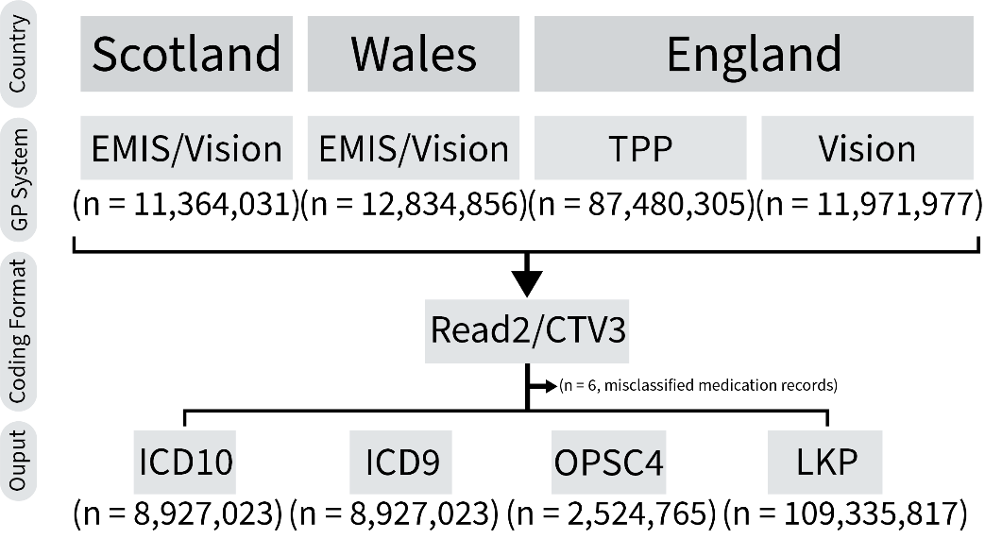
Abbreviations: CTV, Clinical Terms Version; ICD, International Classification of Diseases; LKP, directly LooK-Up; OPCS, Office of Population Censuses and Surveys Classification of Surgical Operations and Procedures.

Figure S2. Primary Care Prescription Data Flowchart
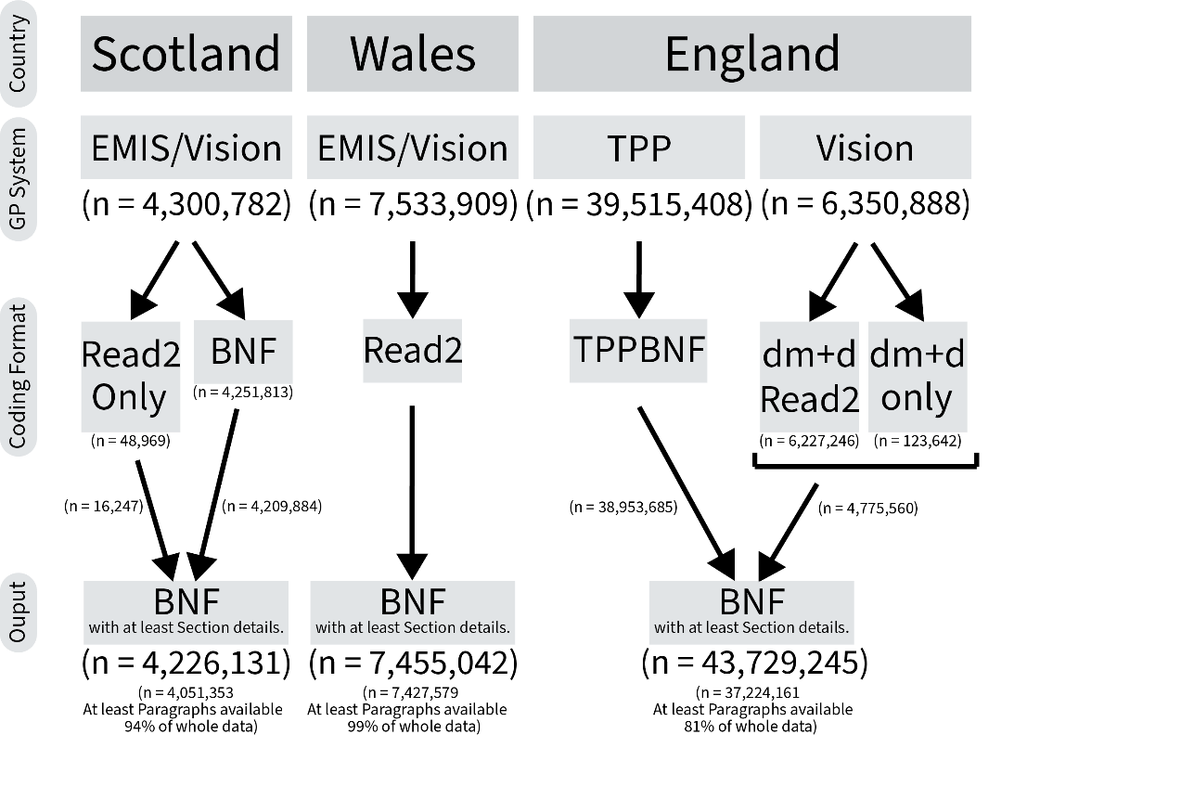
Abbreviations: BNF, British National Formulary; dm+d, Dictionary of Medicines and Devices; EMIS, the Egton Medical Information Systems health; Read2, Read codes version 2; TPP, The Phoenix Partnership; Vision, the Vision health.

Figure S3. a priori Defined Directed Acyclic Graphs
(A)
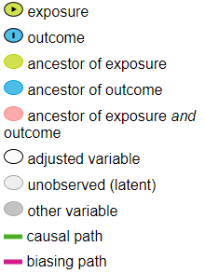
(B)
(A) By controlling lifestyle behaviors and mental/physical health underlying sleep, we could block the backdoor path introduced by the unmeasurable confounder “health consciousness”. Age served as a time-varying variable in the life expectancy estimation. We also controlled socioeconomic status with rationales explained in B. (B) The potential unmeasured or unknown sleep-related variables remains as a theoretical limitation of observational studies. Although by conditioning on age and socioeconomic status, we could avoid the potential backdoor path introduced by the colliders of lifestyle behaviors and mental/physical health underlying sleep, we still could not fully rule out the potential direct biasing path via the unmeasured/unknown variables.

The directed acyclic graphs above were generated via an open-source application (Johannes Textor, Benito van der Zander, Mark K. Gilthorpe, Maciej Liskiewicz, George T.H. Ellison. Robust causal inference using directed acyclic graphs: the R package 'dagitty'.
International Journal of Epidemiology 45(6):1887-1894, 2016. https://doi.org/10.1093/ije/dyw341), and further modified by Adobe Illustrator (Adobe Inc., 2019., available at: https://adobe.com/products/illustrator.)
Figure S4. Total and Cardiovascular Disease-Free Life Expectancy at Age 40 among Participants with Self-Reported Sleep Characteristics

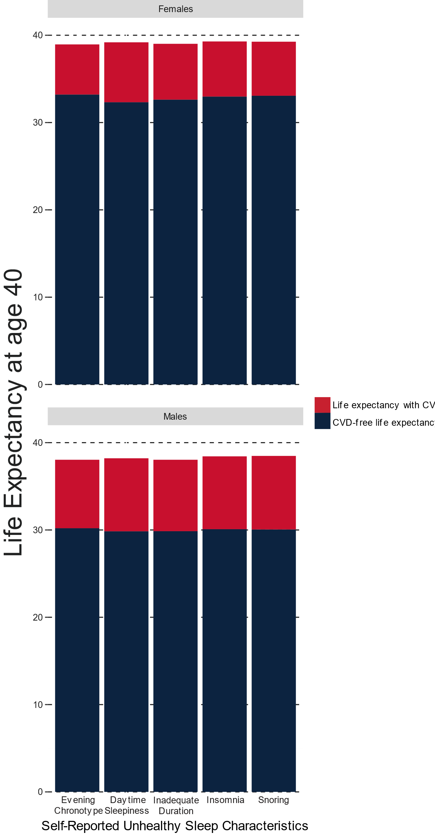

Figure S5. Risks for Cardiovascular Diseases between Participants with Different Self-Reported Sleep Characteristic
(A) Females with different composite sleep score

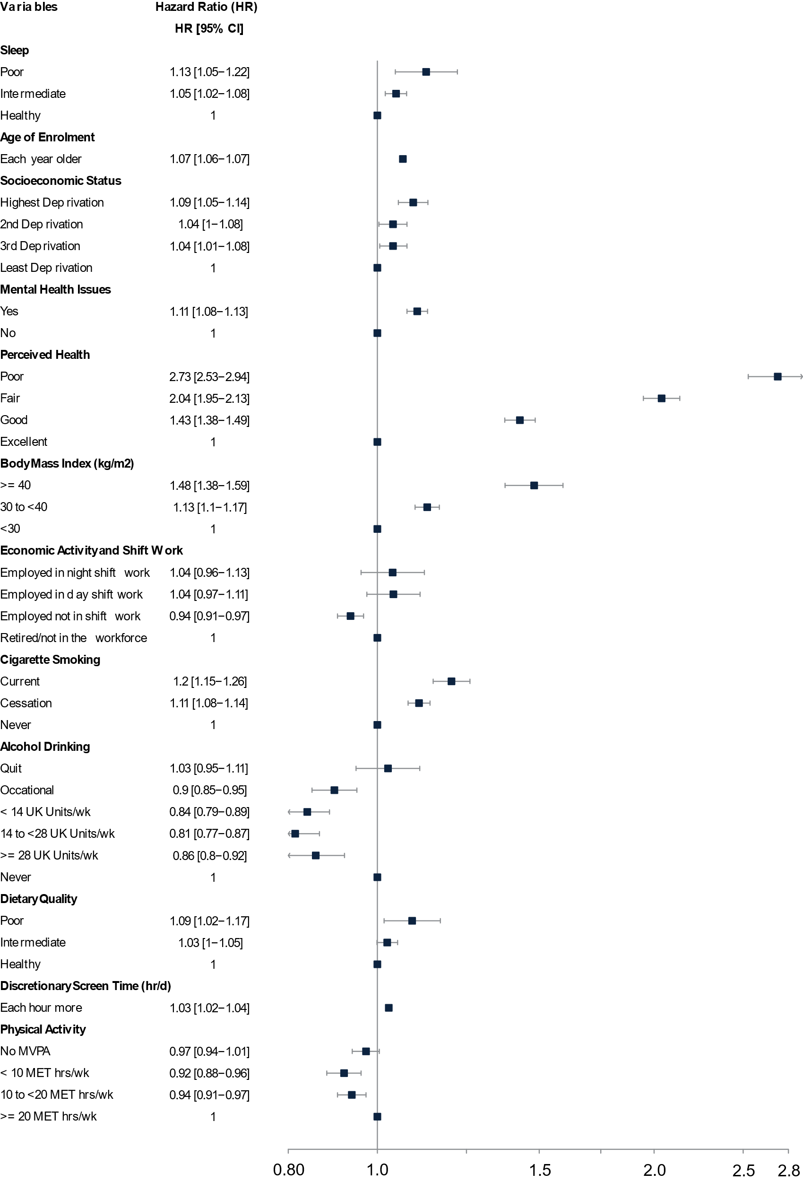

(B) Males with different composite sleep score

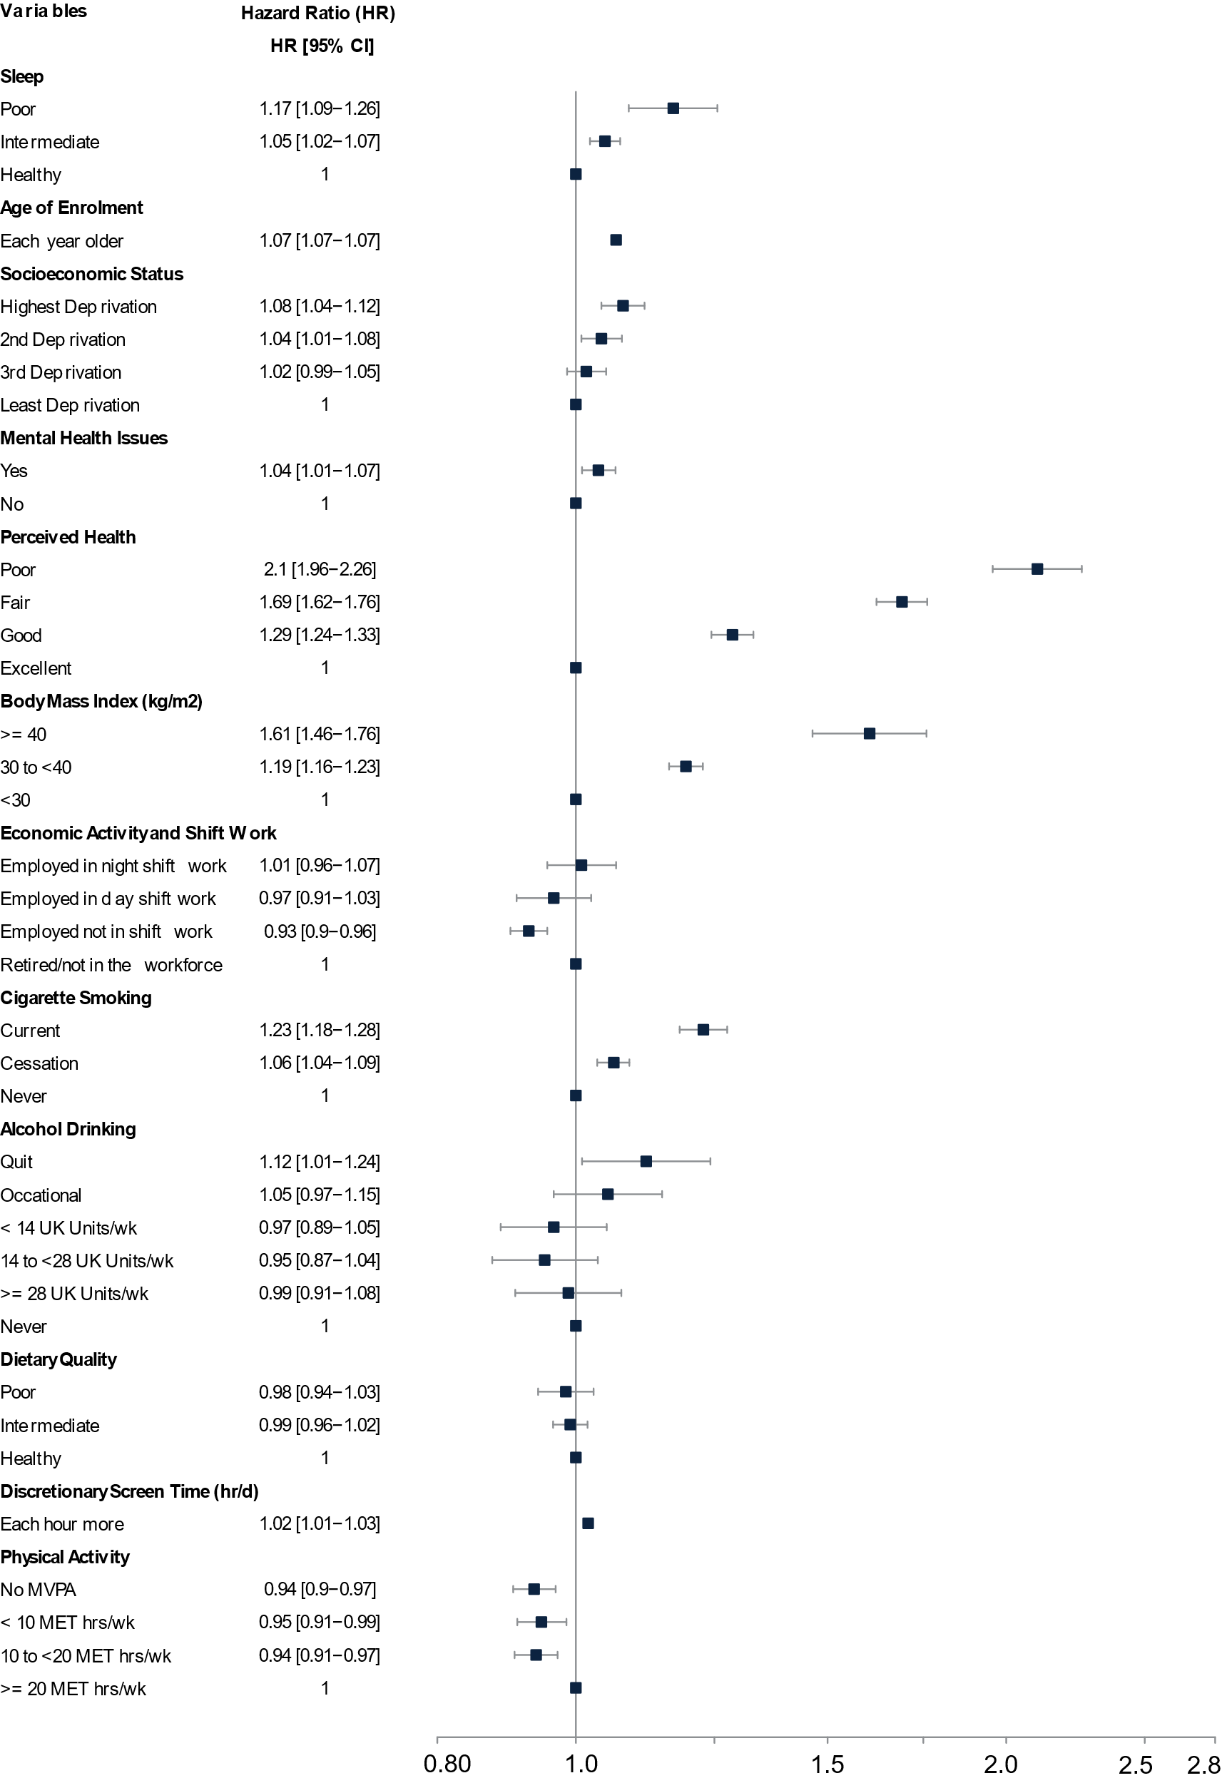

(C) Females with different sleep characteristics

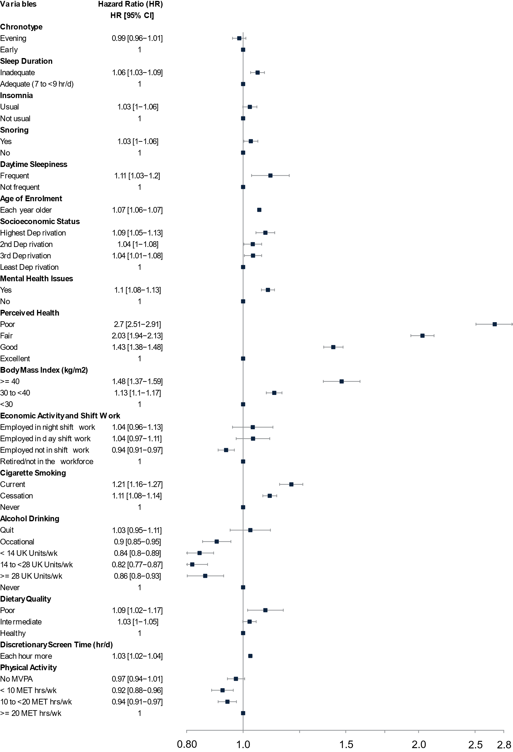

(D) Males with different sleep characteristics

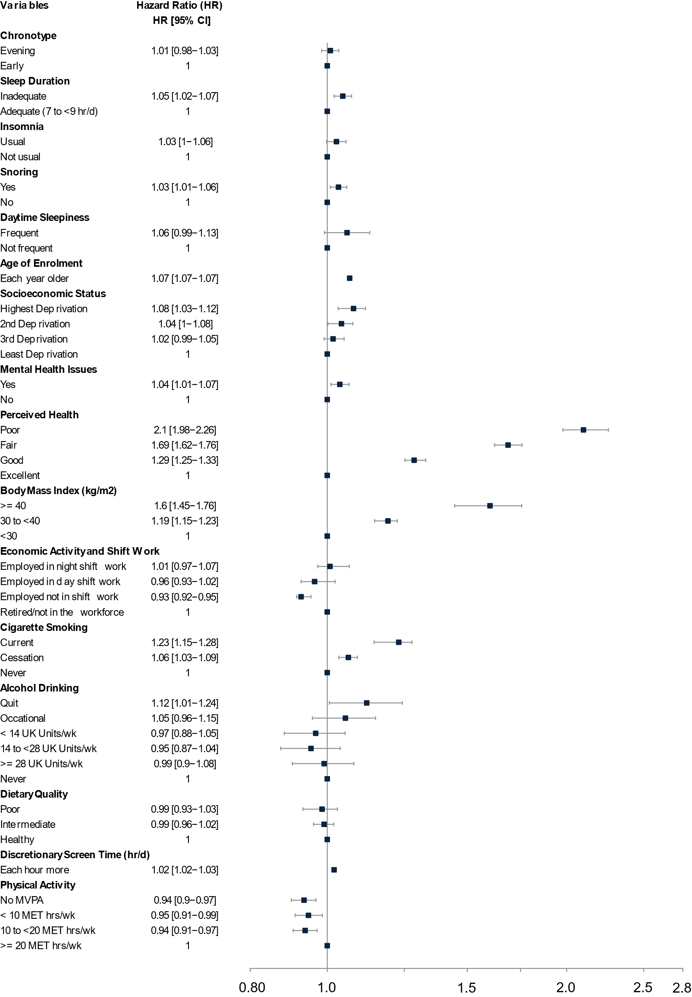
Figure S6. Risks for Cardiovascular Diseases between Participants with Different Diagnosed Sleep Disorders
(A) Females with any diagnosed sleep disorders

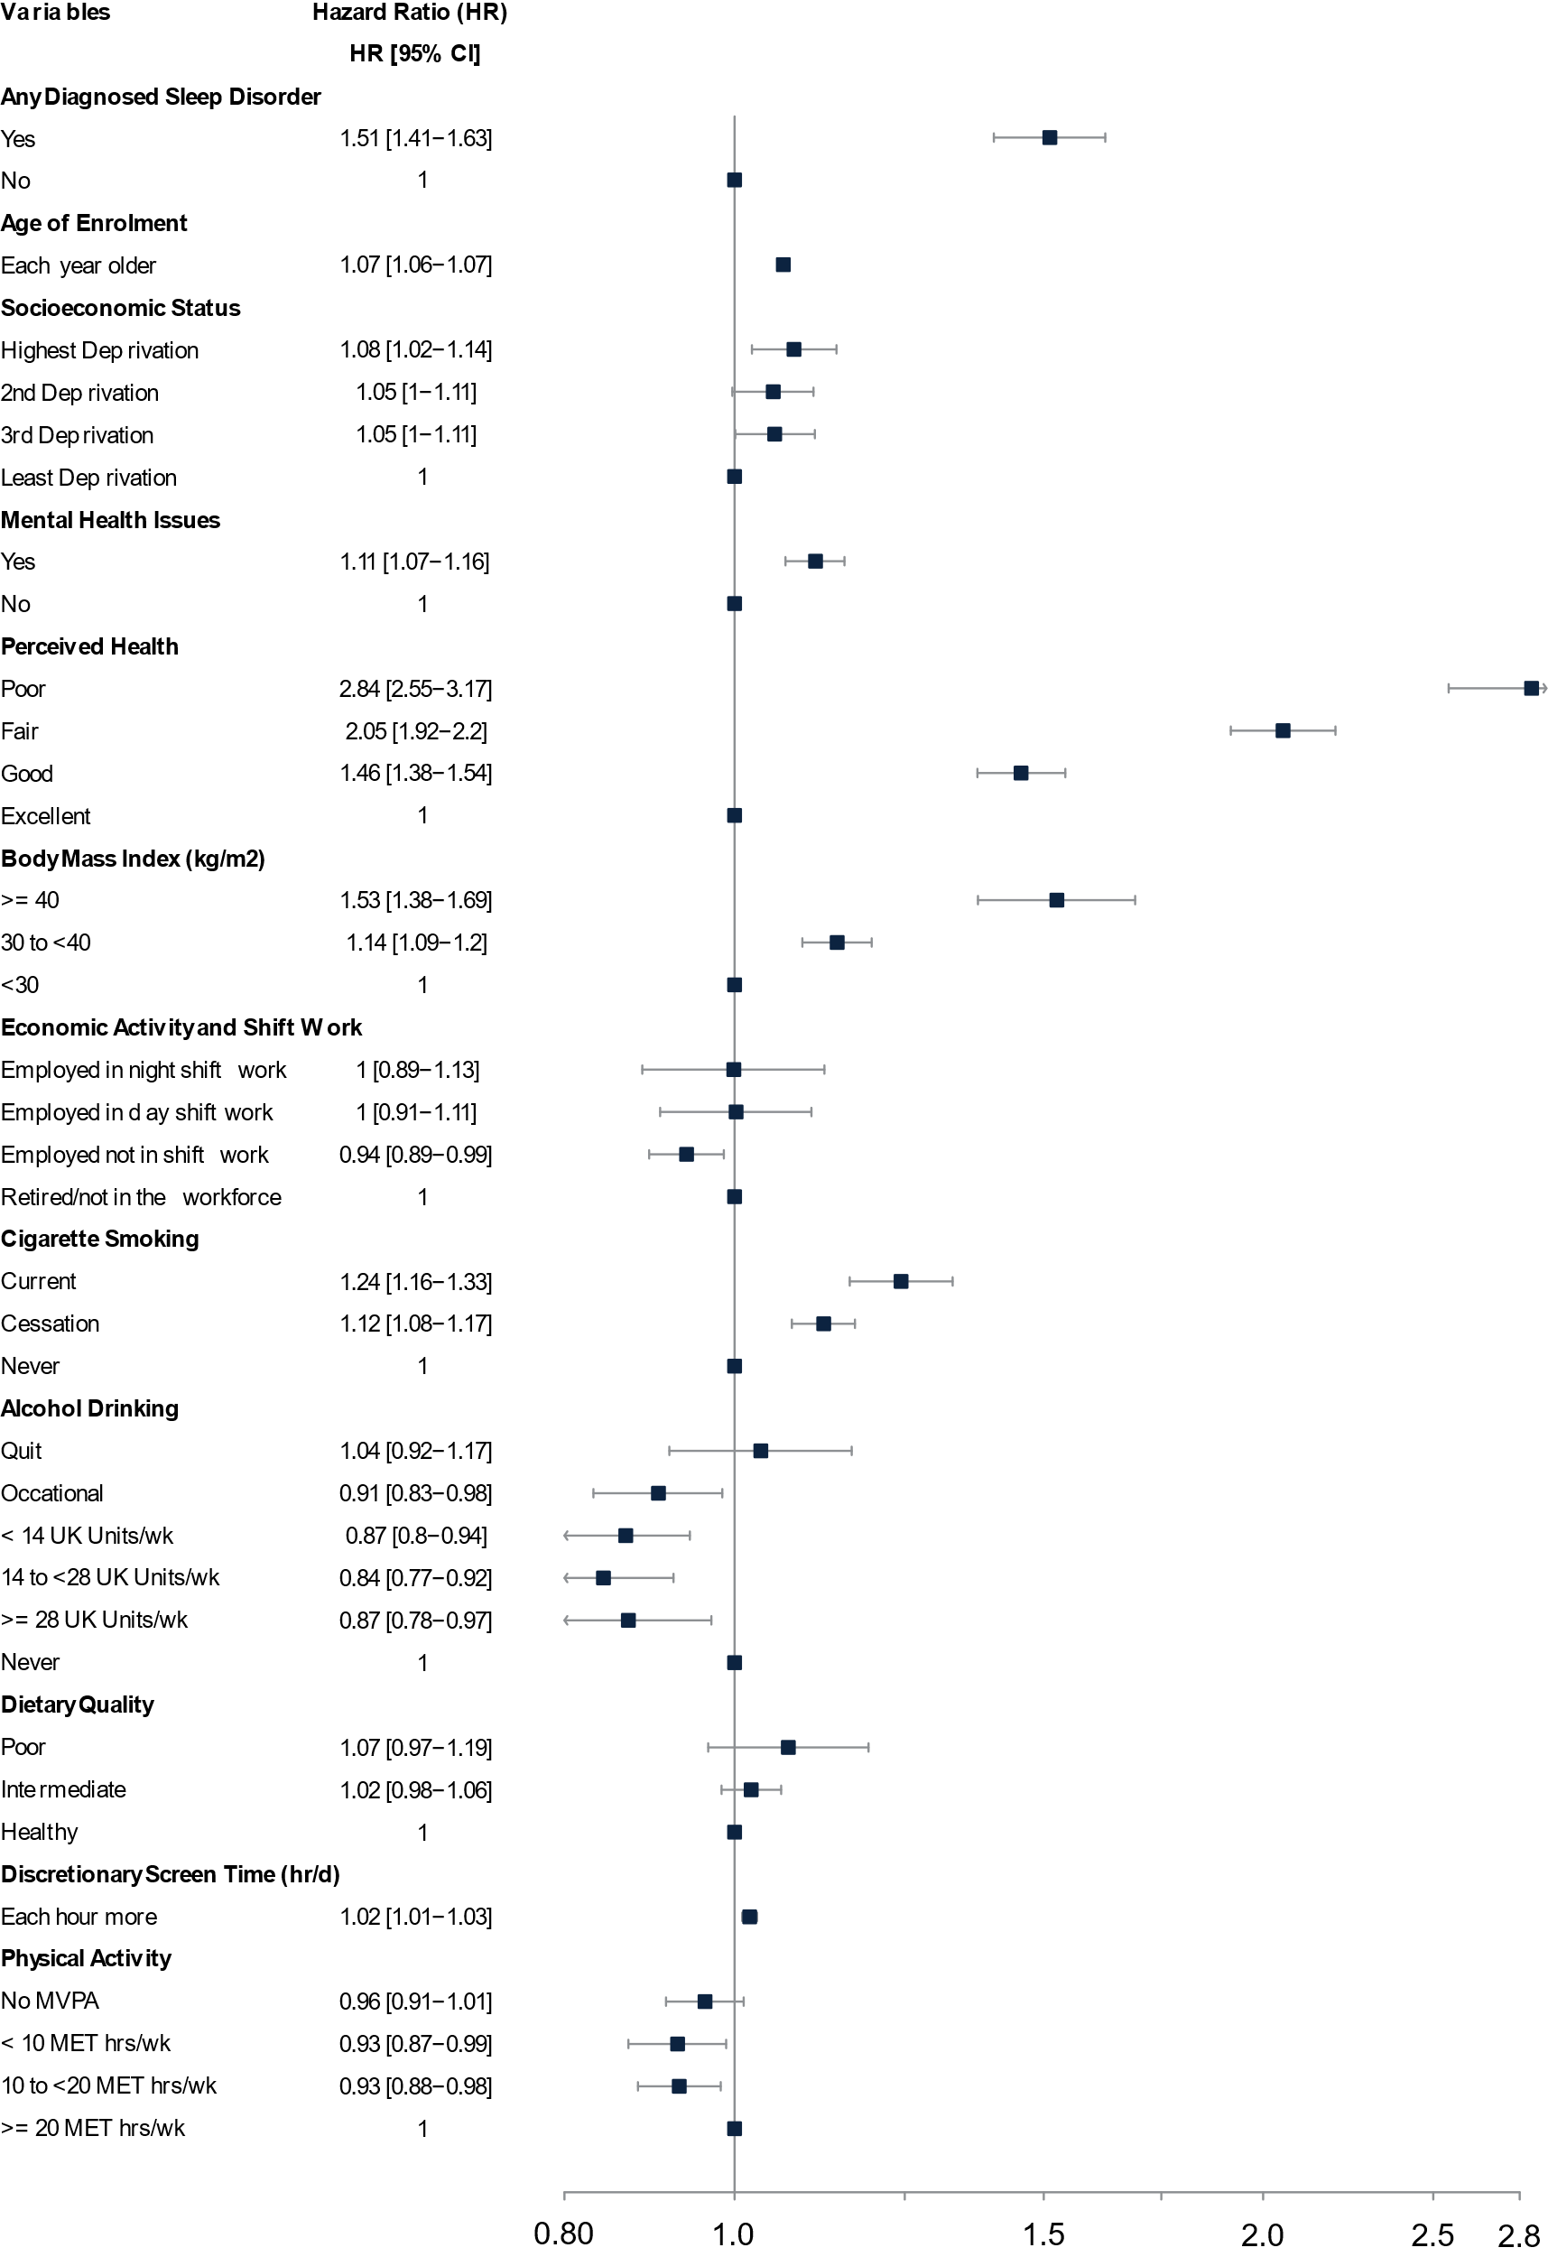
(B) Males with any diagnosed sleep disorders

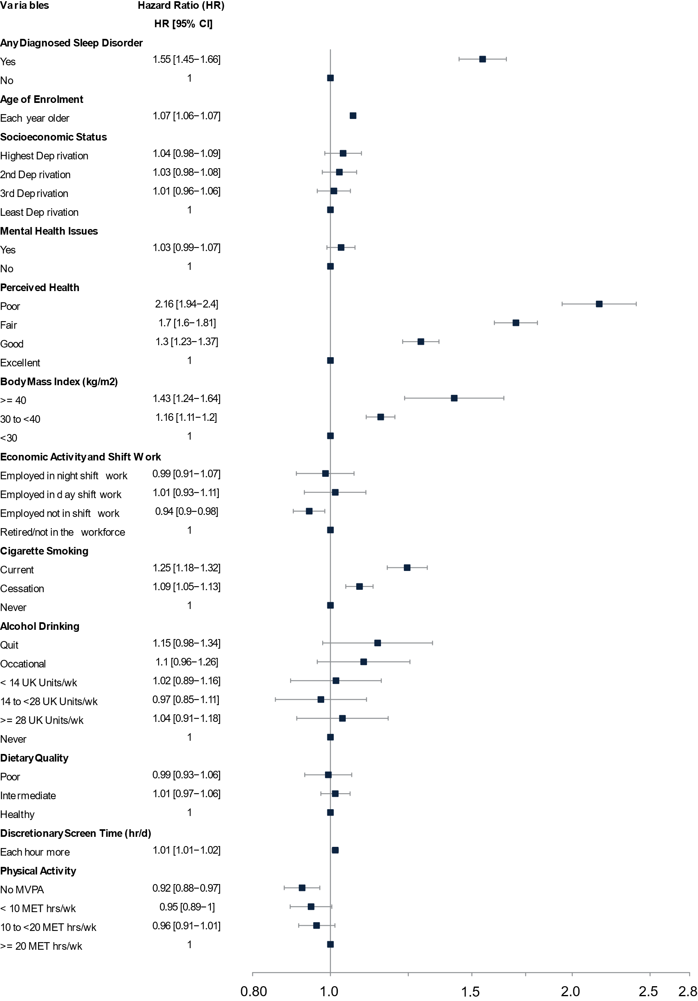
(C) Females with different diagnosed sleep disorders

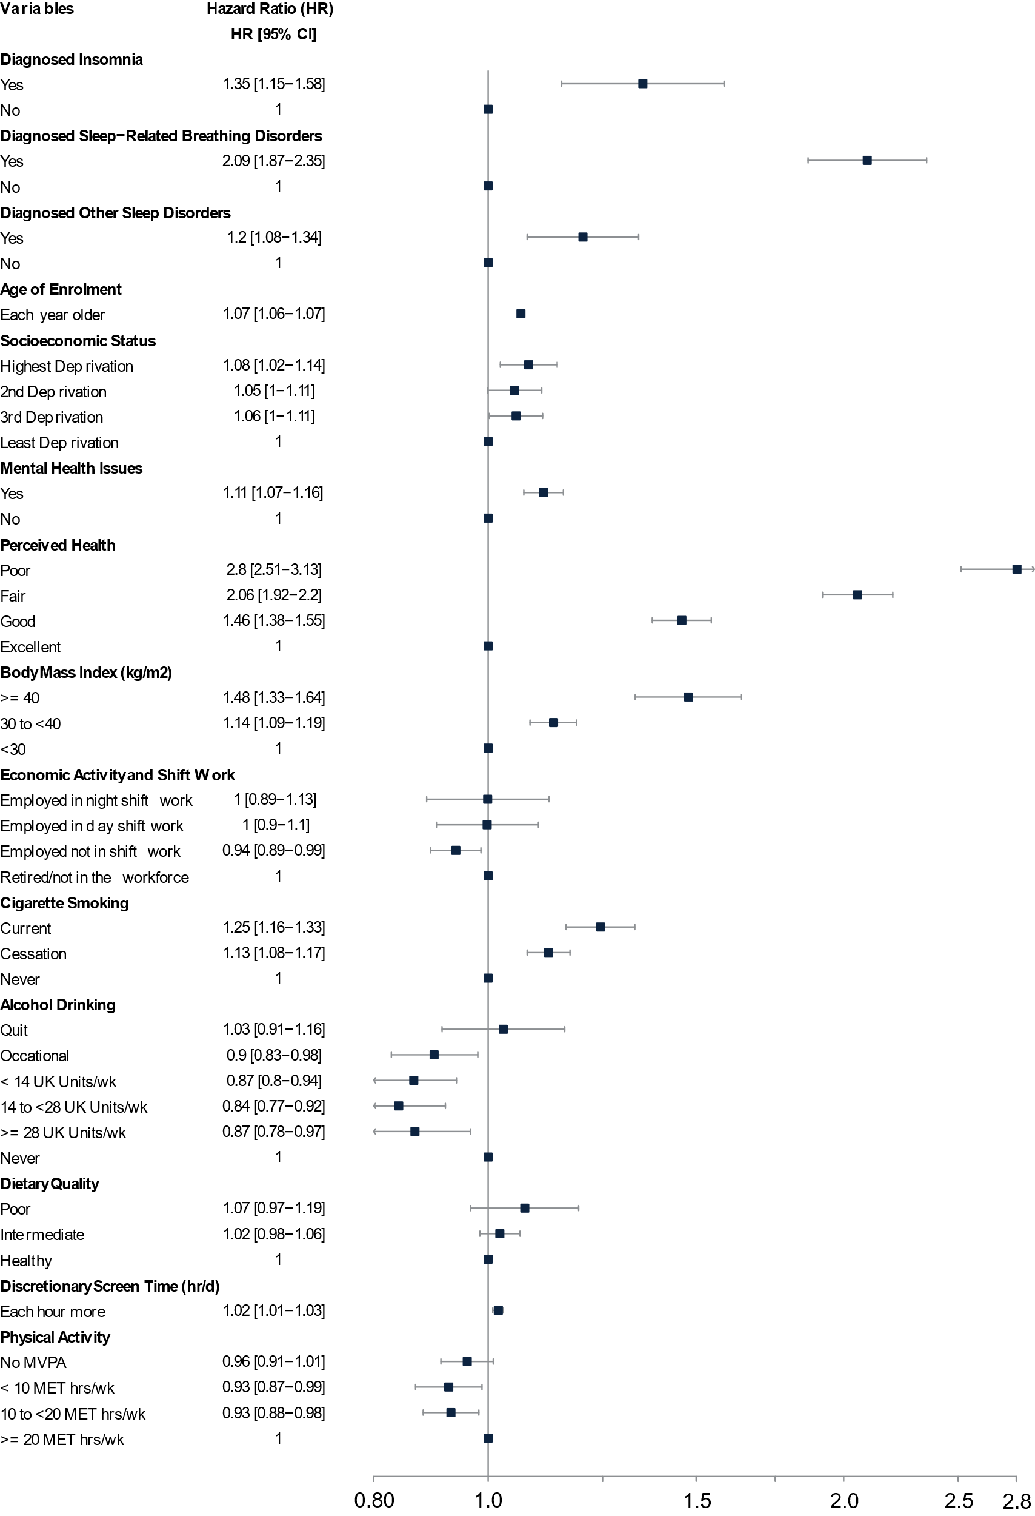
(D) Males with different diagnosed sleep disorders

