Additional file 2

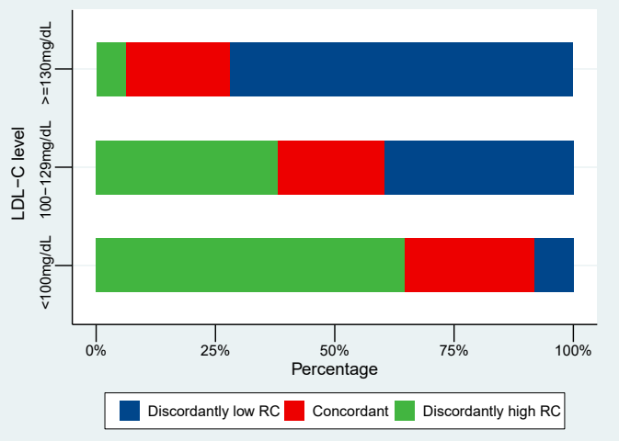

Figure S1: Proportions of concordance/discordance among individuals according to LDL-C clinical cutpoints.
Abbreviations: RC, remnant cholesterol; LDL-C, low-density lipoprotein cholesterol.
- Concordant was defined as RC percentile and LDL-C percentile within ±10 percentile units; (ii) Discordantly low RC was defined as LDL-C percentile > RC percentile by 10 percentile units; and (iii) Discordantly high RC was defined as RC percentile > LDL-C percentile by 10 percentile units.

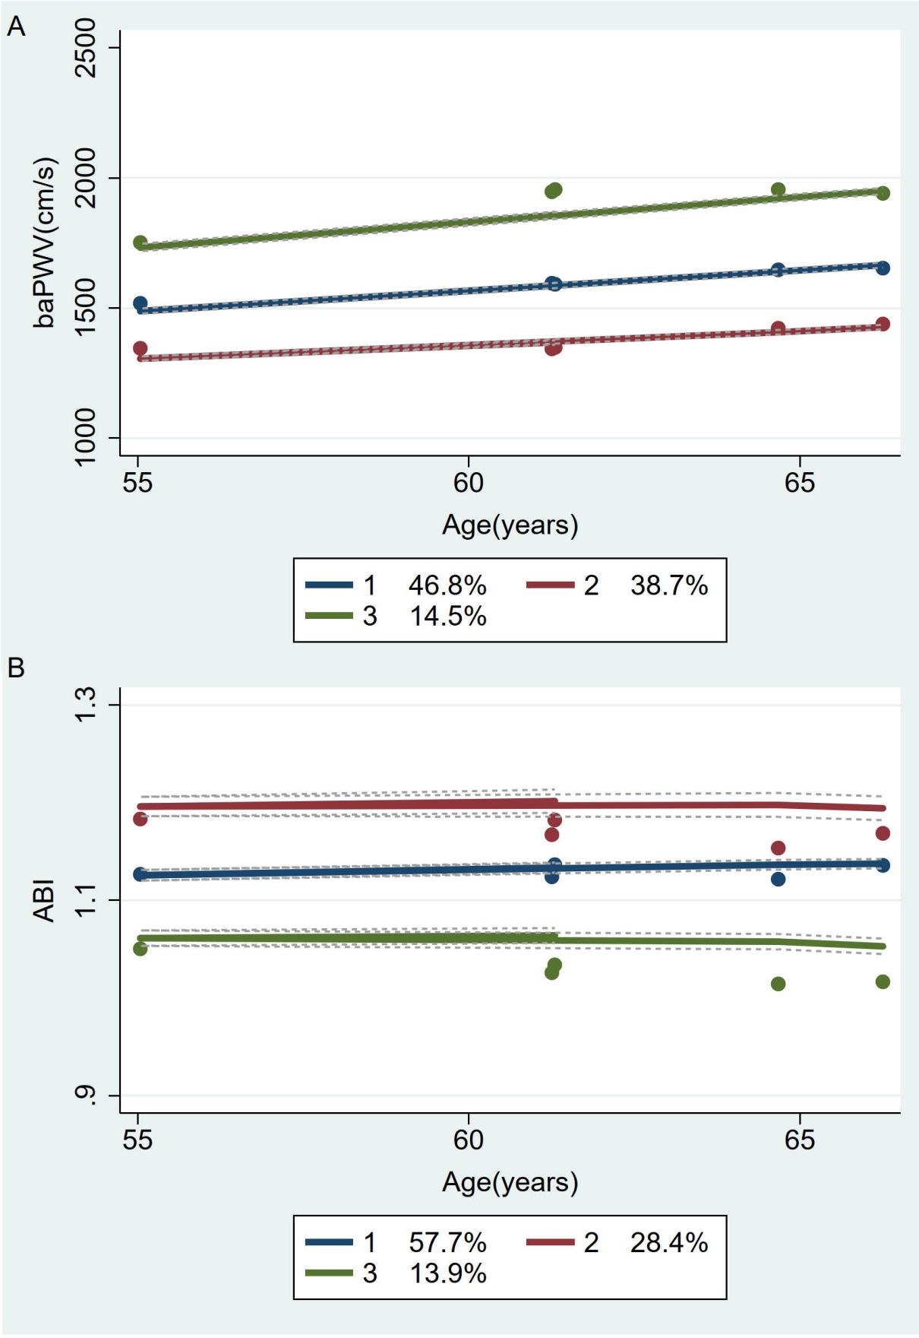

Figure S2: Progression trajectories of separate baPWV and ABI.

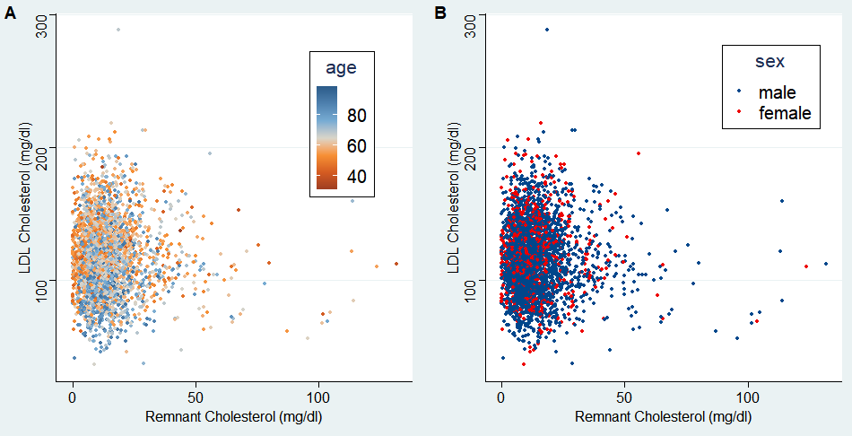

Figure S3: The scatter plots between remnant cholesterol and LDL cholesterol stratified by age and sex.

