Supplementary Materials for

Plasma lipidomic profiling reveals metabolic adaptations to pregnancy and signatures of cardiometabolic risk: a preconception and longitudinal cohort study

Li Chen, Sartaj Ahmad Mir, Anne K. Bendt, Chua W.L. Esther, Kothandaraman Narasimhan, Karen Mei-Ling Tan, See Ling Loy, Kok Hian Tan, Lynette Shek, Jerry Chan, Fabian Yap, Michael J. Meaney, Shiao-Yng Chan, Yap Seng Chong, Peter D. Gluckman, Johan G. Eriksson, Neerja Karnani, Markus R. Wenk

Additional File 1: Fig. S1-S13
Fig. S1 Flowchart of sample selection and analysis steps in this study
Fig. S2 Pairwise Pearson correlation coefficient heat map of fasting glucose, 2-h post-load glucose, fasting insulin, HOMA-IR and HbA1c
Fig. S3 Histograms and pair-wise scatter plots of fasting glucose and 2-h post-load glucose concentrations at preconception, pregnancy and postpartum using trio subjects
Fig. S4 Histograms and pair-wise scatter plots of fasting insulin concentration and HOMA-IR at preconception, pregnancy and postpartum using trio subjects
Fig. S5 Histograms and pair-wise scatter plots of glycated haemoglobin (HbA1c, %) at preconception, pregnancy and postpartum using trio subjects
Fig. S6 Forest plots of fasting glucose concentration at postpartum, 2-h post-load glucose concentration at preconception, and HbA1c level at preconception, pregnancy and postpartum
Fig. S7 Scatter plots of effect sizes at preconception, pregnancy and postpartum in the fasting glucose, 2-h post-load glucose, fasting insulin, HOMA-IR association studies
Fig. S8 Venn diagrams of significant lipid species at preconception, pregnancy and postpartum for fasting glucose concentration, 2-h post-load glucose concentration and GDM status based on nominal p-value cut-off and the profiles of six selected lipid species from the 37 preconception signatures of GDM
Fig. S9 Association results of plasma fasting insulin concentration with plasma lipidomic profiles at preconception, pregnancy and postpartum
Fig. S10 Association results of fasting glucose, 2-h post-load glucose, impaired glucose tolerance status, fasting insulin, HOMA-IR and HbA1c levels at preconception
Fig. S11 Scatter plots of effect sizes in the association results of fasting glucose, 2-h post-load glucose, fasting insulin and HOMA-IR at preconception using trio and all subjects.
Fig. S12 Percentage of individual lipid species within phosphatidylcholine, phosphatidylethanolamine and phosphatidylinositol classes
Fig. S13 Lipid ratios for enzyme indices of phosphatidylethanolamine n-methyltransferase (PEMT), lecithin-cholesterol acyltransferase (LCAT) and phospholipase A2 (PLA2).

S-PRESTO Cohort
(N=1032)

Based on availability and quality of plasma samples
Plasma lipidomics at three time points
preconception (N=976), pregnancy (N=337) and postpartum (N=282)

Adaptations in lipid metabolism to pregnancy
Step 1: Lipidomic differences between pre-pregnant (n=360) and non-pregnant (n=494) subjects at preconception

Lipidomic profiles of trio subjects (n=263)

Step 2: Longitudinal changes in lipid concentration (paired t-test)

Step 3: Patterns of lipid changes across three time points

Lipid signatures of cardiometabolic risk traits
Step 4: Association of changes in lipid concentration with body weight changes

Step 5: Association of pre-pregnancy BMI with lipidomic profiles at three time points

Step 6: Association of measures of glucose homeostasis and insulin resistance with lipidomic profiles at three time points

Step 7: Association of measures of glucose homeostasis and insulin resistance with lipidomic profiles at preconception (n=936)

Fig. S1. Flowchart of sample selection and analysis steps in this study

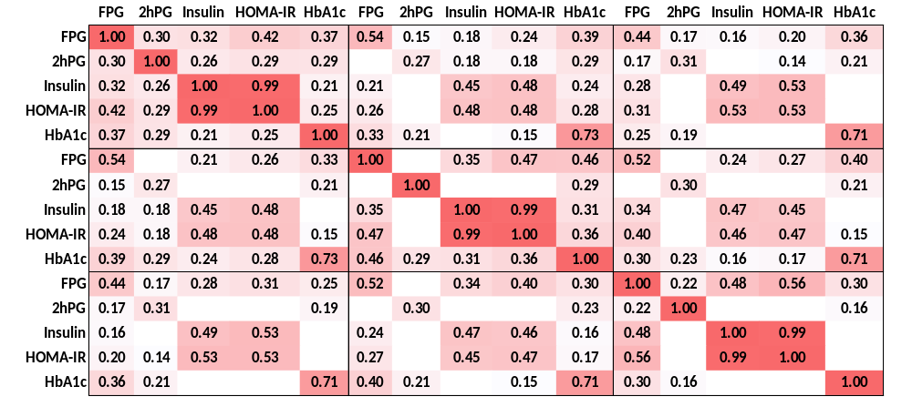
Postpartum
Pregnancy
Preconception
Postpartum
Pregnancy
Preconception

Fig. S2. Pairwise Pearson correlation coefficient heat map (R) of fasting glucose (FPG, mmol/L), 2-h post-load glucose (2hPG, mmol/L), fasting insulin (mU/mL), HOMA-IR and HbA1c (%) at preconception, pregnancy and postpartum.

A Fasting Glucose Concentration (mmol/L)
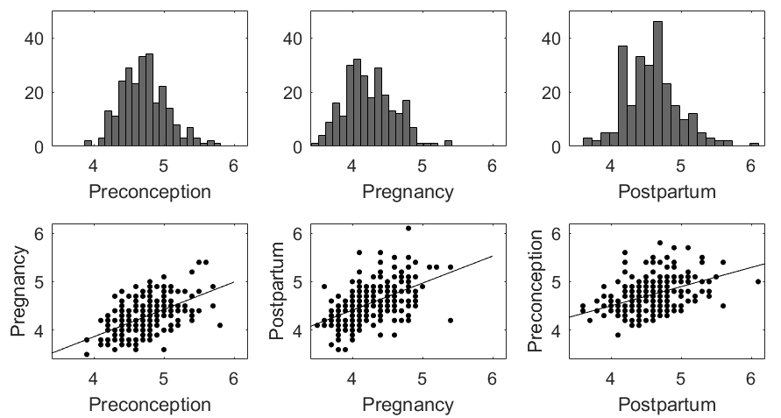
Count
4.56±0.38
4.73±0.34
4.27±0.35
R²=0.27
R²=0.29
R²=0.20
B 2-h post-load glucose concentration (mmol/L)
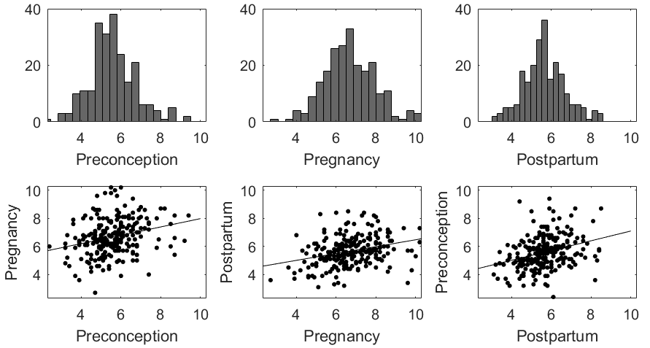
Count
6.67±1.29
5.66±1.05
5.59±1.17
R²=0.10
R²=0.09
R²=0.07

Fig. S3 Histograms and pair-wise scatter plots of (A) fasting glucose concentration (n=249, mmol/L) and (B) 2-h post-load glucose concentration (n=226, mmol/L) at preconception, pregnancy and postpartum using trio subjects

A Fasting Insulin Concentration (mU/mL)
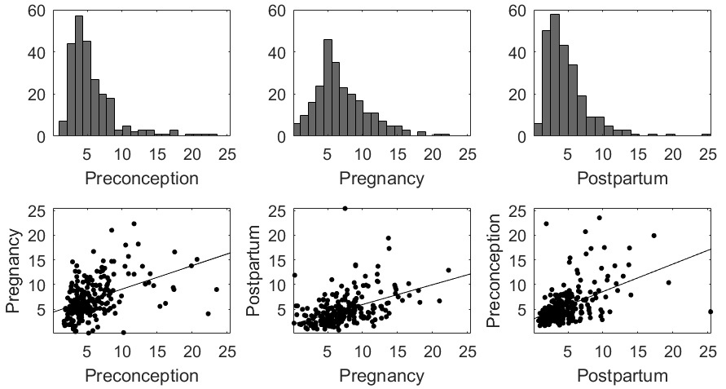
Count
4.80±3.20
7.07±3.78
5.70±3.61
R²=0.22
R²=0.24
R²=0.20
B HOMA-IR
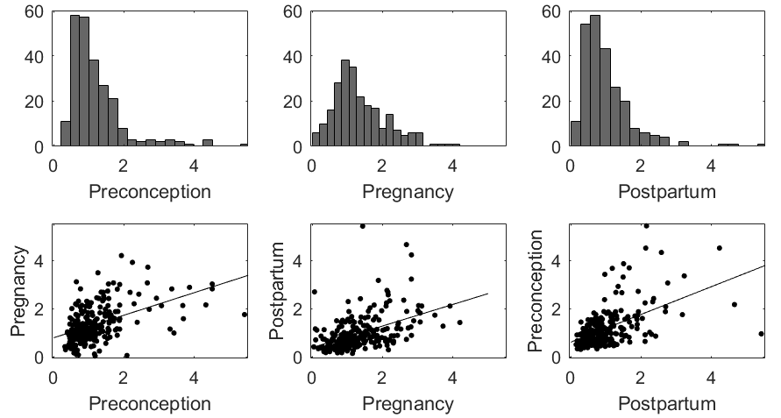
Count
1.00±0.72
1.35±0.76
1.19±0.78
R²=0.28
R²=0.23
R²=0.22

Fig. S4 Histograms and pair-wise scatter plots of (A) fasting insulin concentration (n=243, mU/mL) and (B) HOMA-IR (n=240) at preconception, pregnancy and postpartum using trio subjects

HbA1c (%)
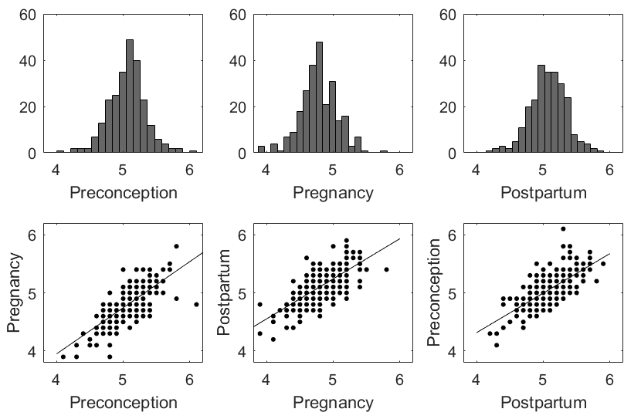
R²=0.51
R²=0.54
R²=0.51
5.06±0.27
4.79±0.29
5.10±0.28
Count

Fig. S5 Histograms and pair-wise scatter plots of glycated haemoglobin (HbA1c, %) at preconception, pregnancy and postpartum using trio subjects (n=249)

A B
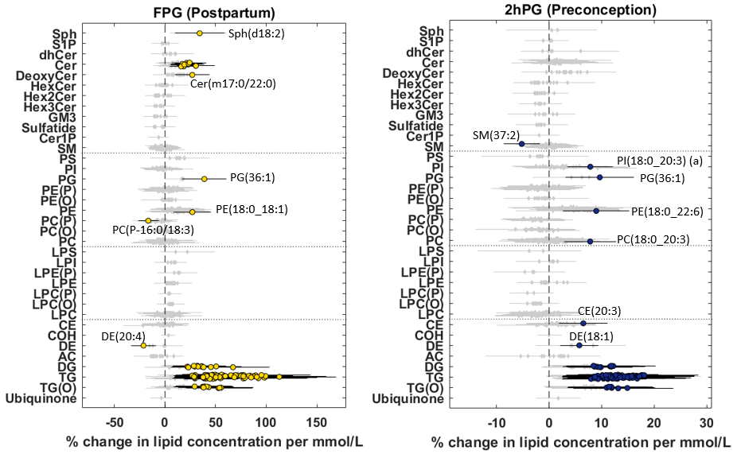
C
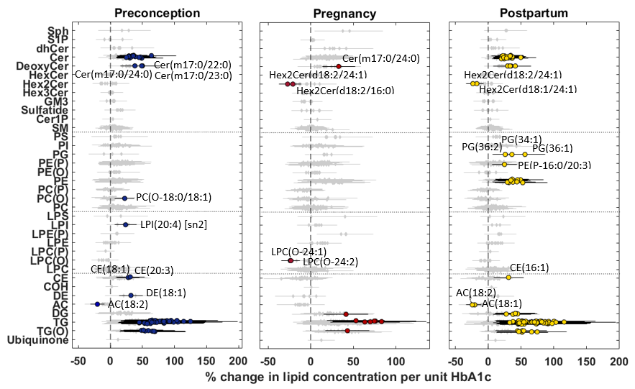
Fig. S6 Forest plots of the association results of (A) fasting glucose concentration (FPG) at postpartum, (B) 2-h post-load glucose concentration (2hPG) at preconception, and (C) HbA1c level (%) at preconception, pregnancy and postpartum. Diamond – P_{adj} ≥ 0.05 (grey) and circle – P_{adj} <0.05 in forest plots. Error bar – 95% confidence interval.

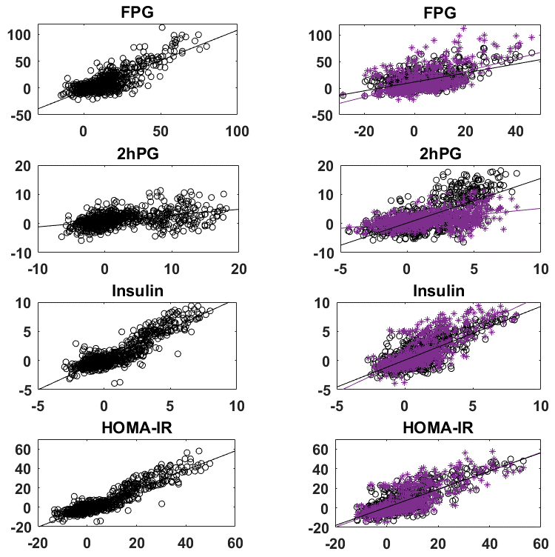
A B
R²=0.30
R²=0.65
R²=0.32

R²=0.18
R²=0.47

R²=0.18

Effect Size (Postpartum)
R²=0.80
R²=0.57
Effect Size (o-Preconception; *-Postpartum)
R²=0.60

R²=0.85
R²=0.63

R²=0.59

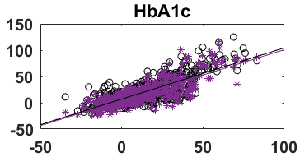
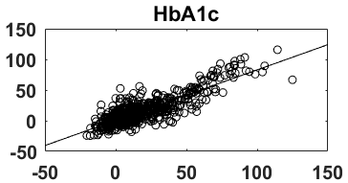
R²=0.64
R²=0.73
R²=0.67

Effect Size (Pregnancy)
Effect Size (Preconception)

Fig. S7 Scatter plots of effect sizes at preconception, pregnancy and postpartum in the association studies of fasting glucose concentration (FPG, mmol/L), 2-h post-load glucose concentration (2hPG, mmol/L), fasting insulin concentration (mU/mL), HOMA-IR and HbA1c level (%). (A) Postpartum vs. Preconception, (B) Preconception or Postpartum vs. Pregnancy. Effect size is % change in lipid concentration per mmol/L (FPG and 2hPG) or per mU/mL (Insulin) or per unit HOMA-IR or per unit HbA1c.

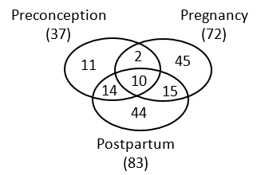
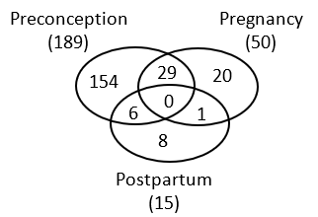
GDM
C
B
A
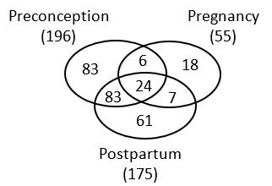
2hPG
FPG
D
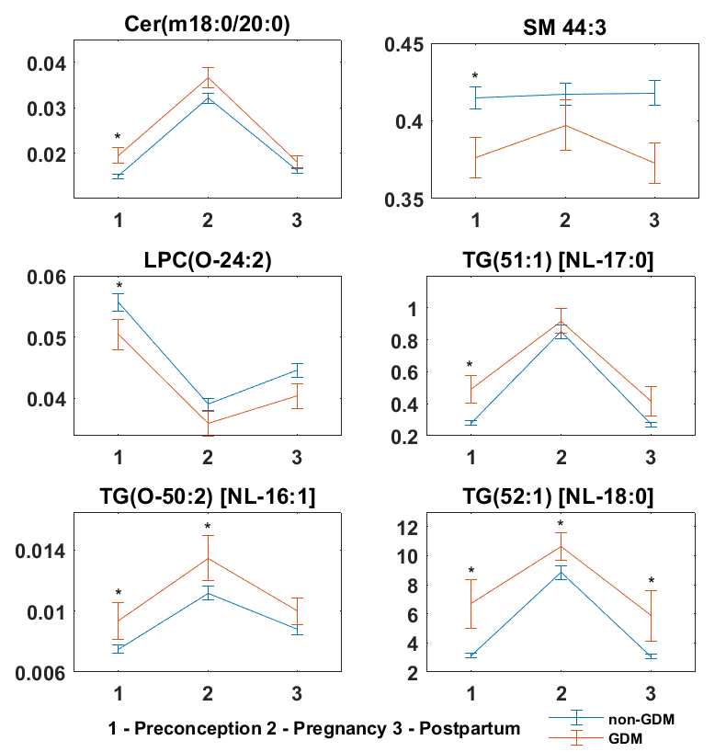

Lipid Concentration (µmol/L)

Fig. S8 Venn diagrams of significant lipid species at preconception, pregnancy and postpartum for (A) fasting glucose concentration, (B) 2-h post-load glucose concentration, (C) GDM status based on nominal p-value cut-off (<0.05) and (D) the profiles of six selected lipid species from the 37 preconception signatures of GDM (* - nominal p-value < 0.05). Related to Table S4A-D.

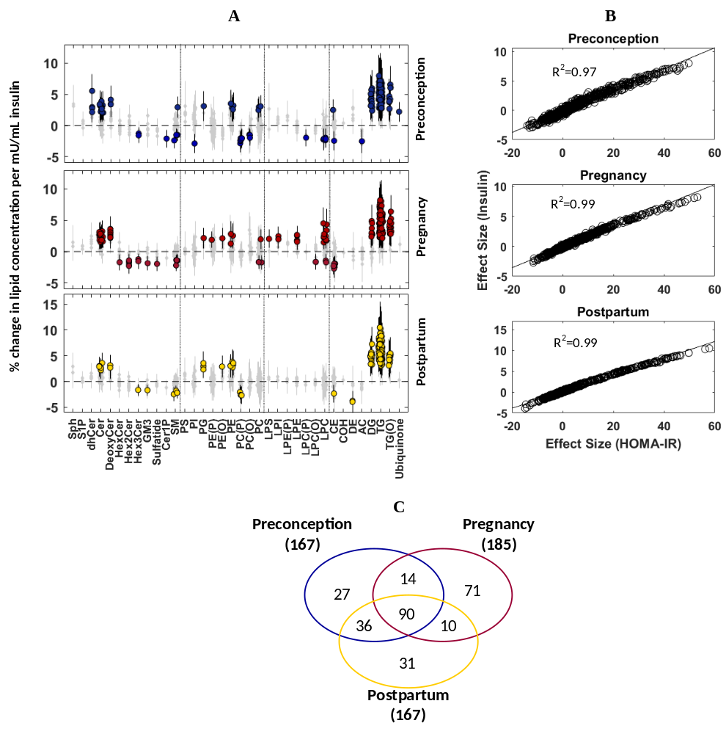

Fig. S9 Association results of plasma fasting insulin concentration with plasma lipidomic profiles at preconception, pregnancy and postpartum using trio subjects. (A) Forest plots, and (B) Scatter plots of effect sizes in the fasting insulin (% change in lipid concentration per mU/mL insulin) and HOMA-IR association studies (% change in lipid concentration per unit HOMA-IR)

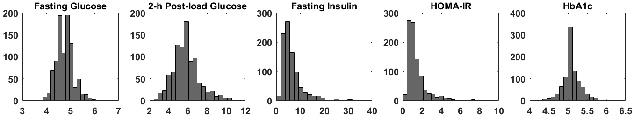
A
Count
HOMA-IR
HbA1c (%)
Insulin (mU/mL)
2hPG (mmol/L)
FPG (mmol/L)
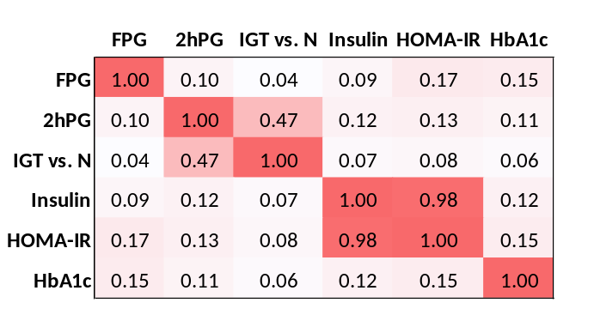
B

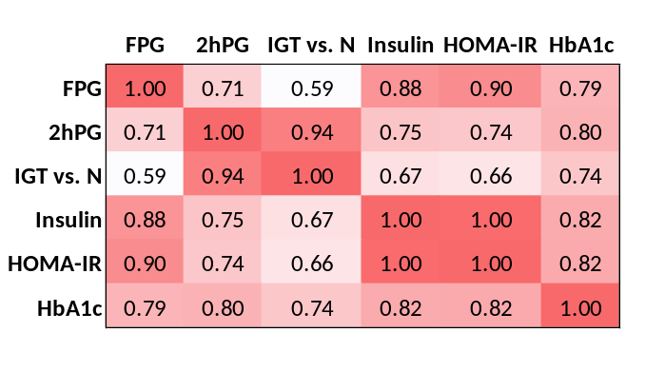
C

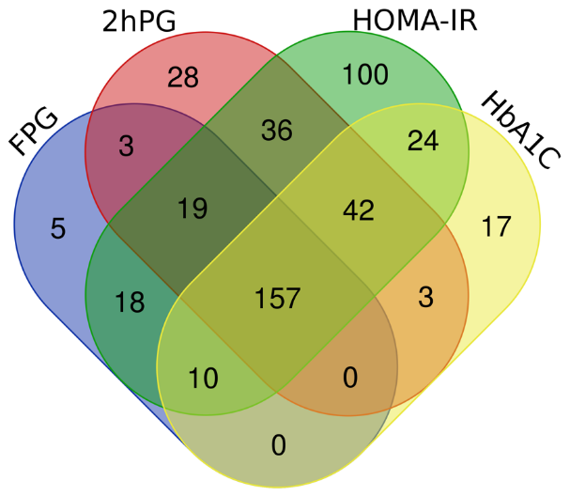
D

Fig. S10 Association results of fasting glucose concentration (FPG), 2-h post-load glucose concentration (2hPG), impaired glucose tolerance status (IGT vs. Normal), fasting insulin concentration, HOMA-IR and HbA1c (%) at preconception (n=936). (A) Histograms, (B) Pairwise Pearson correlation heat map (R²) of six variables, (C) Pairwise Pearson correlation heat map (R²) of effect sizes in the association studies of six variables with plasma lipidomic profiles, and (D) Venn-diagram of significant lipids in the FPG, 2hPG, HOMA-IR and HbA1c studies.

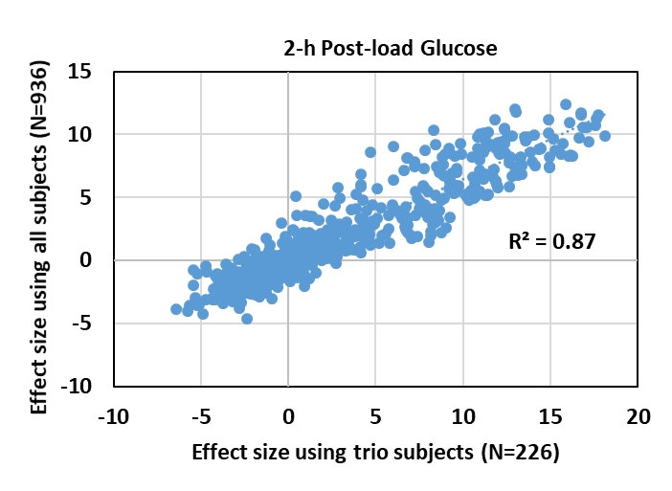
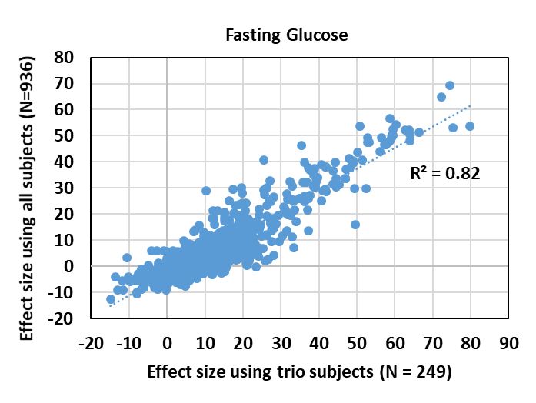
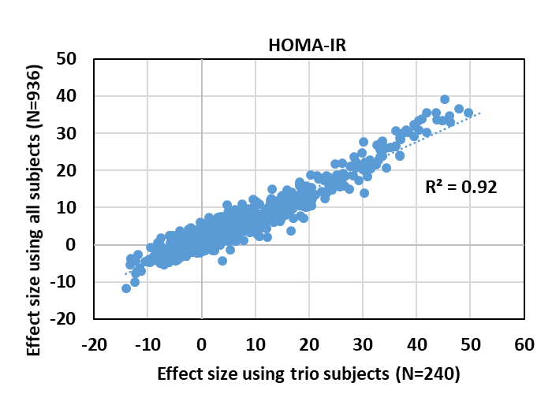
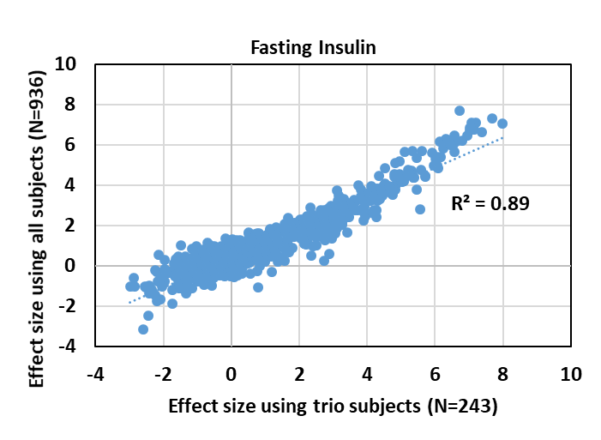
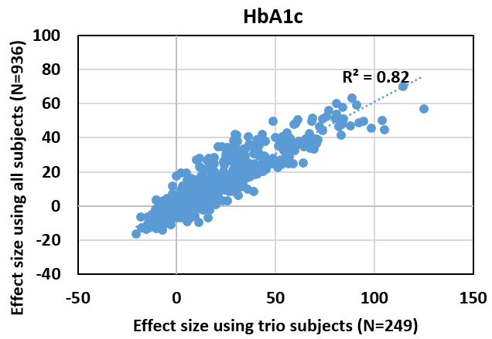

Fig. S11 Scatter plots of effect sizes in the association results of fasting glucose (FPG), 2-h post-load glucose (2hPG), fasting insulin, HOMA-IR and HbA1c at preconception using trio and all subjects. Effect sizes are presented by % change in lipid concentration per mmol/L in FPG and 2hPG, per mU/mL insulin, per unit HOMA-IR and per unit HbA1c (%).

A
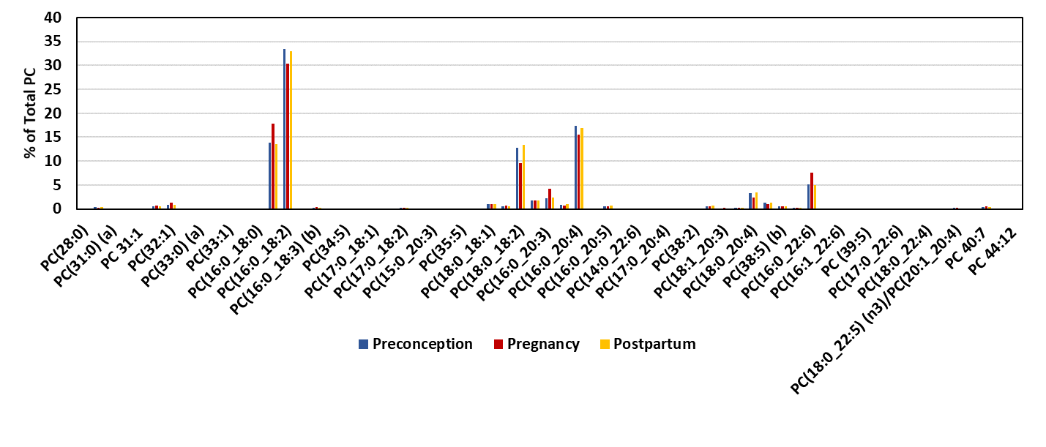
B
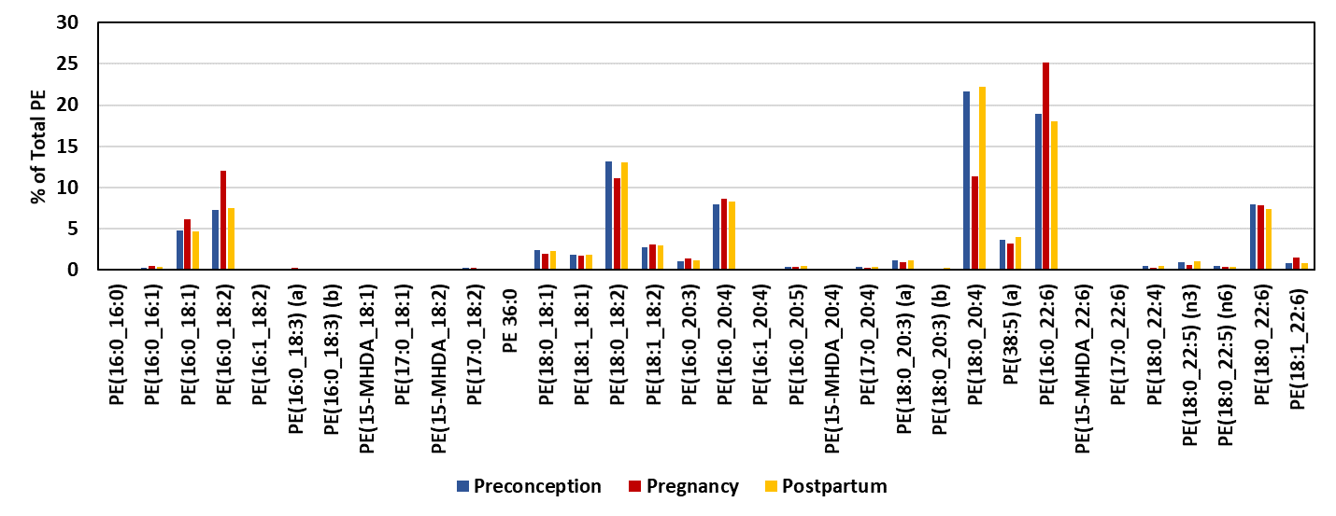
C
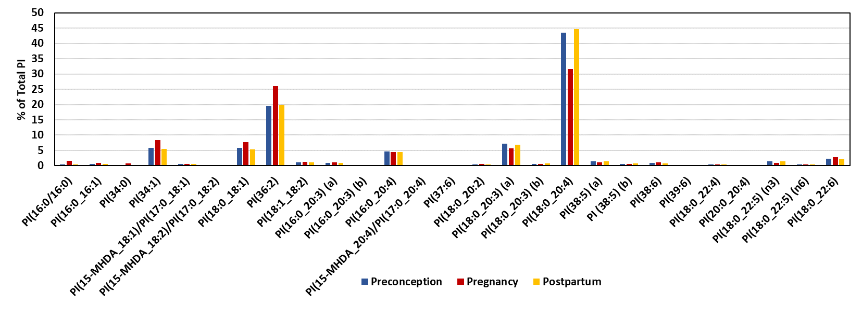
Fig. S12 Percentage of each lipid species within (A) phosphatidylcholine (PC), (B) phosphatidylethanolamine (PE), and (C) phosphatidylinositol (PI) classes.

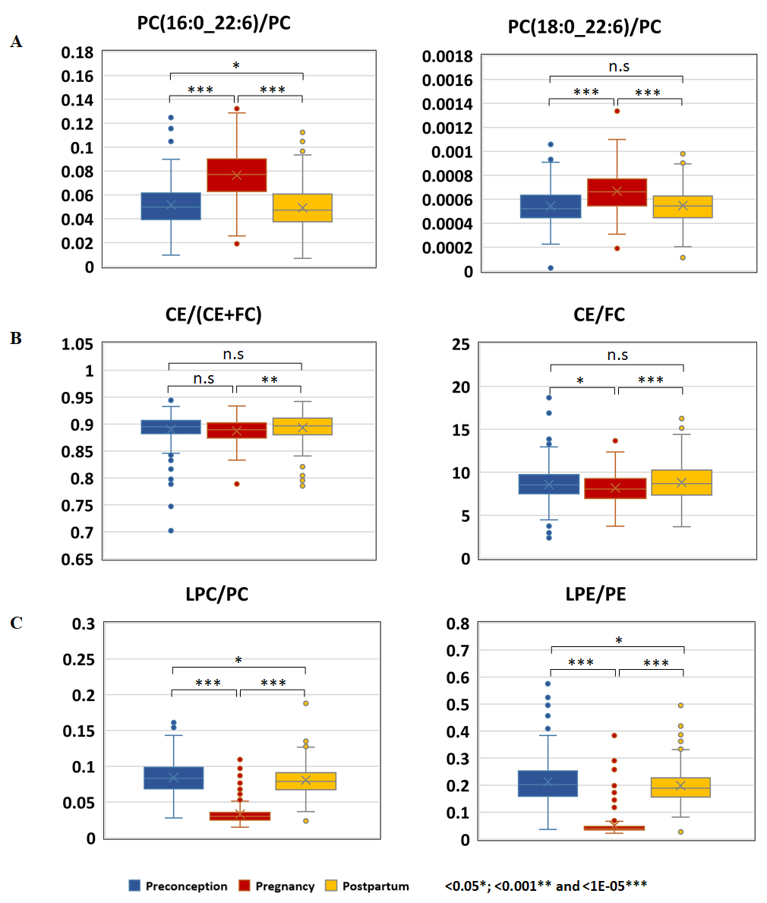
Ratio
Ratio
Ratio

Fig. S13 Lipid ratios for enzyme indices of phosphatidylethanolamine n-methyltransferase (PEMT), lecithin-cholesterol acyltransferase (LCAT) and phospholipase A2 (PLA2). (A) PEMT, (B) LCAT, and (C) PLA2

