Additional file 1: Table S1 The description of registers used in the study
Data source | Information
National Patient Register |  | Information for all citizens on hospital discharge diagnoses since 1977, and outpatient diagnoses are included from 1995
Medical Birth Register |  | Information on gestational age, birth weight, Apgar score at 5 minutes, date of birth, sex, and singleton status since, and maternal smoking during pregnancy since 2004
Danish Civil Registration System |  | Information on individual personal identification number, place of birth, marital status, and vital statistics since 1981
Integrated database for labour  market research |  | Information on personal labour market affiliation and education establishments since 1981
Psychiatric central research register |  | Information of patients treated at psychiatric departments since 1970

Additional file 1: Table S2 The diagnostic classification of comorbid neurodevelopmental disorders used in Denmark
Diseases | ICD codes
Attention-deficit/hyperactivity disorder | ICD-8: 308 and ICD-10: F90.0, F98.8
Autism spectrum disorder | ICD-8: 299 and ICD-10: F84
Epilepsy | ICD-8: 345 excluding 345.29 and ICD-10: G40.0
Cerebral palsy | ICD-8: 343.99, 344.99 and ICD--10: G80
Intracranial tumors | ICD-8: 191, 225 and ICD-10: C70-C71, D32-D33
Severe head trauma | ICD-8: 851, 854 and ICD-10: S06.1-S06.9
Intracranial infection | ICD-8: 320, 323 and ICD-10: G00-G09
ICD: International Statistical Classification of Diseases and Related Health Problems.
Additional file 1: Table S3 The diagnostic classification of cardiovascular disease in Denmark
 | ICD codes
Ischemic heart disease | ICD-8: 410-414 and ICD-10: I20-I25
Cerebrovascular disease | ICD-8: 430-438 and ICD-10: I60-I69
Stroke | ICD-8: 430-436 and ICD-10: I61-I64
Heart failure | ICD-8: 427.0, 427.1, 782.4 and ICD-10: I110, I130, I132, I50
Atrial fibrillation | ICD-8: 427.93, 427.94 and ICD-10: I48
Hypertensive disease | ICD-8: 400-404 and ICD-10: I10-I15
Deep vein thrombosis | ICD-8: 451.00 and ICD-10: I80.1-I80.3
ICD: International Statistical Classification of Diseases and Related Health Problems.

Additional file 1: Table S4 The HRs for the associations between ID and overall and type-specific CVD stratification by preterm birth
 | Preterm birth
 | No | Yes
 | HR (95% CI) | HR (95% CI)
Overall CVD | 1.20 (1.10 to 1.31) | 1.46 (1.19 to 1.81)
Ischemic heart diseases | 1.08 (0.71 to 1.67) | 2.18 (1.02 to 4.68)
Cerebrovascular diseases | 2.33 (1.83 to 2.96) | 3.44 (2.03 to 5.82)
Stroke | 2.05 (1.52 to 2.75) | 2.94 (1.55 to 5.58)
Heart failure | 3.65 (2.34 to 5.71) | 2.17 (0.68 to 6.95)
Atrial fibrillation | 1.26 (0.76 to 2.10) | 0.55 (0.08 to 3.96)
Hypertensive disease | 1.26 (1.17 to 1.35) | 1.15 (0.95 to 1.39)
Deep vein thrombosis | 2.00 (1.48 to 2.70) | 2.12 (0.99 to 4.53)
Adjusted for sex, calendar year, parity, maternal age, maternal education, maternal country of origin, maternal psychiatric disorders, and cardiovascular disorders before childbirth; HR: hazard ratio; CI: confidence interval; ID indicates intellectual disability; CVD indicates cardiovascular diseases.

Additional file 1: Table S5 The HRs for the associations between ID and overall and type-specific CVD stratification by maternal psychiatric disorders
 | Maternal psychiatric disorders
 | No | Yes
 | HR (95% CI) | HR (95% CI)
Overall CVD | 1.22 (1.13 to 1.33) | 1.38 (1.09 to 1.75)
Ischemic heart diseases | 1.16 (0.72 to 1.87) | 1.27 (0.72 to 2.25)
Cerebrovascular diseases | 3.05 (2.39 to 3.90) | 1.42 (0.91 to 2.21)
Stroke | 2.79 (2.08 to 3.75) | 1.09 (0.62 to 1.93)
Heart failure | 3.92 (2.42 to 6.35) | 2.68 (1.26 to 5.70)
Atrial fibrillation | 1.07 (0.57 to 2.00) | 1.52 (0.75 to 3.06)
Hypertensive disease | 1.32 (1.24 to 1.41) | 1.27 (1.20 to 1.36)
Deep vein thrombosis | 2.08 (1.48 to 2.92) | 1.95 (1.25 to 3.04)
Adjusted for sex, calendar year, parity, maternal age, maternal education, maternal country of origin, and cardiovascular disorders before childbirth; HR: hazard ratio; CI: confidence interval; ID indicates intellectual disability; CVD indicates cardiovascular diseases.

Additional file 1: Table S6 The HRs for the associations between ID and overall and type-specific CVD among all individuals born in Denmark between 1995-2016
 | Rate per 1000 person-years |  | HR (95% CI)
 | Individuals without ID | Individuals with ID | Model 1 | Model 1
Overall CVD | 1.14 | 1.43 | 1.21 (1.00 to 1.45) | 1.21 (1.00 to 1.45)
Type-specific CVD
Ischemic heart diseases | 0.01 | 0.01 | 0.70 (0.10 to 4.99) | 0.60 (0.08 to 4.30)
Cerebrovascular diseases | 0.07 | 0.14 | 2.33 (1.32 to 4.12) | 2.23 (1.26 to 3.96)
Stroke | 0.05 | 0.08 | 1.83 (0.87 to 3.86) | 1.76 (0.83 to 3.71)
Heart failure | 0.01 | 0.01 | 1.05 (1.15 to 7.51) | 1.09 (0.15 to 7.79)
Atrial fibrillation | 0.01 | 0.04 | 3.11 (0.99 to 9.77) | 3.02 (0.96 to 9.54)
Hypertensive disease | 3.44 | 2.43 | 0.76 (0.66 to 0.88) | 0.73 (0.63 to 0.84)
Deep vein thrombosis | 0.02 | 0.02 | 1.23 (0.31 to 4.95) | 1.11 (0.27 to 4.47)
Model 1 adjusted for sex and calendar year; Model 2 additionally adjusted for parity, maternal age, maternal education, maternal country of origin, maternal psychiatric disorders and cardiovascular disorders before childbirth; HR: hazard ratio; CI: confidence interval; ID indicates intellectual disability; CVD indicates cardiovascular diseases.

Additional file 1: Table S7 The HRs for the associations between intellectual disability and overall and type-specific CVD among all individuals born in Denmark between 1978-2016 including individuals diagnosed with chromosomal abnormalities or congenital heart diseases
 | HR (95% CI)
 | Model 1 | Model 2
Overall CVD | 1.44 (1.35 to 1.54) | 1.37 (1.28 to 1.47)
Ischemic heart diseases | 1.65 (1.22 to 2.23) | 1.40 (1.02 to 1.90)
Cerebrovascular diseases | 2.57 (2.12 to 3.13) | 2.45 (2.01 to 2.99)
Stroke | 2.33 (1.85 to 2.95) | 2.21 (1.74 to 2.81)
Heart failure | 3.31 (2.47 to 4.45) | 3.20 (2.37 to 4.34)
Atrial fibrillation | 1.68 (1.17 to 2.41) | 1.53 (1.04 to 2.23)
Hypertensive disease | 1.44 (1.36 to 1.52) | 1.42 (1.34 to 1.50)
Deep vein thrombosis | 2.31 (1.82 to 2.94) | 2.14 (1.67 to 2.74)
Adjusted for sex, calendar year, parity, maternal age, maternal education, maternal country of origin, and cardiovascular disorders before childbirth; HR: hazard ratio; CI: confidence interval; ID indicates intellectual disability; CVD indicates cardiovascular diseases.

Additional file 1: Table S8 The HRs for the associations between intellectual disability and overall and type-specific CVD among all individuals born in Denmark between 1978-2016 including individuals diagnosed congenital heart diseases
 | HR (95% CI)
 | Model 1 | Model 2
Overall CVD | 1.35 (1.25 to 1.45) | 1.28 (1.18 to 1.37)
Ischemic heart diseases | 1.64 (1.20 to 2.25) | 1.37 (0.99 to 1.89)
Cerebrovascular diseases | 2.62 (2.14 to 3.21) | 2.48 (2.02 to 3.05)
Stroke | 2.32 (1.81 to 2.97) | 2.19 (1.70 to 2.81)
Heart failure | 2.80 (1.97 to 3.98) | 2.74 (1.92 to 3.92)
Atrial fibrillation | 1.54 (1.04 to 2.29) | 1.37 (0.90 to 2.08)
Hypertensive disease | 1.35 (1.27 to 1.44) | 1.33 (1.25 to 1.41)
Deep vein thrombosis | 2.29 (1.77 to 2.95) | 2.10 (1.61 to 2.73)
Adjusted for sex, calendar year, parity, maternal age, maternal education, maternal country of origin, and cardiovascular disorders before childbirth; HR: hazard ratio; CI: confidence interval; ID indicates intellectual disability; CVD indicates cardiovascular diseases.

Additional file 1: Table S9 The HRs for the associations between intellectual disability and overall and type-specific CVD among all individuals born in Denmark between 1978-2016 including individuals diagnosed with chromosomal abnormalities
 | HR (95% CI)
 | Model 1 | Model 2
Overall CVD | 1.35 (1.25 to 1.45) | 1.29 (1.19 to 1.39)
Ischemic heart diseases | 1.45 (1.03 to 2.04) | 1.20 (0.84 to 1.71)
Cerebrovascular diseases | 2.59 (2.11 to 3.18) | 2.48 (2.02 to 3.06)
Stroke | 2.31 (1.80 to 2.97) | 2.18 (1.69 to 2.81)
Heart failure | 3.88 (2.66 to 5.64) | 3.55 (2.40 to 5.25)
Atrial fibrillation | 1.30 (0.84 to 2.02) | 1.24 (0.79 to 1.95)
Hypertensive disease | 1.37 (1.29 to 1.46) | 1.35 (1.27 to 1.43)
Deep vein thrombosis | 2.27 (1.76 to 2.92) | 2.09 (1.61 to 2.71)
Adjusted for sex, calendar year, parity, maternal age, maternal education, maternal country of origin, and cardiovascular disorders before childbirth; HR: hazard ratio; CI: confidence interval; ID indicates intellectual disability; CVD indicates cardiovascular diseases.

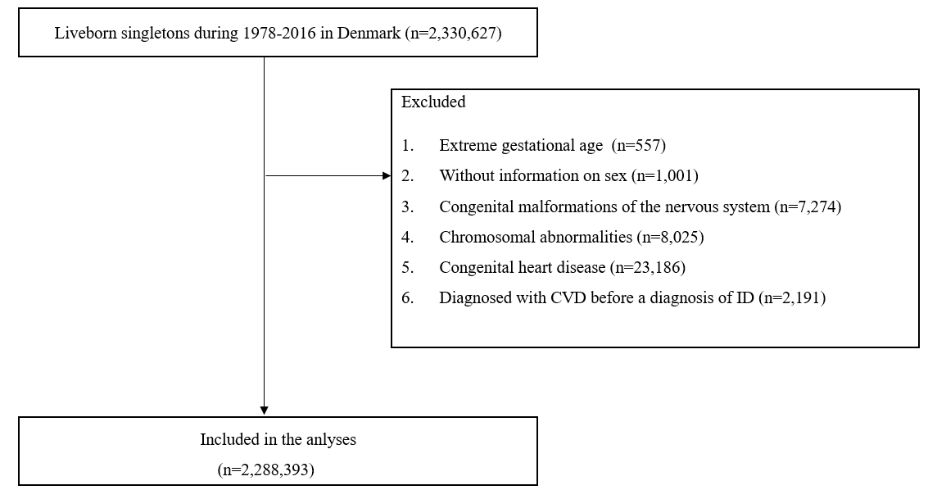
Additional file 1: Figure S1 Overview of the study population

