Additional File 4: Components of direct medical costs
Components of direct medical costs per RSV episode
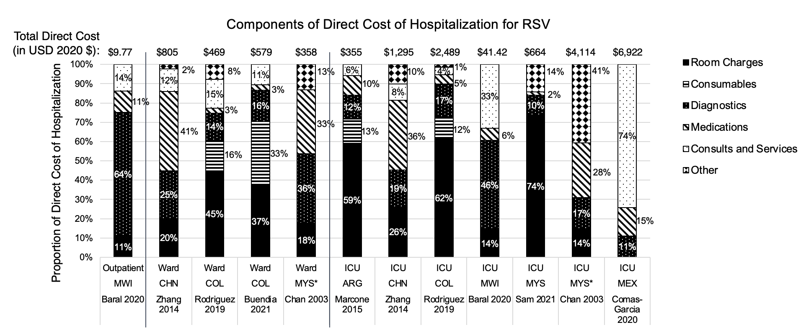
Notes: * Chan 2003: Comparison groups are for full-term infants vs. pre-term infants, which are included in the Ward and ICU categories, respectively, for comparison by disease severity; Components of direct medical costs were not available for Bhuket et al or Bhuiyan et al.; Currency is reported in 2020 USD

