p-eIF2α (afatinib, sorafenib and ponatinib)
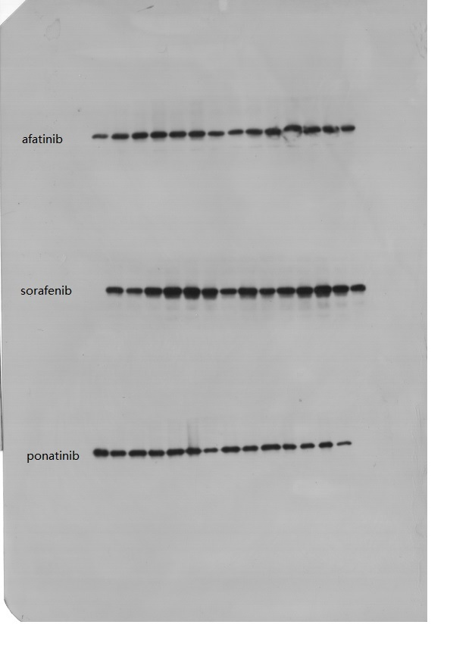

.

XBP1s (afatinib, sorafenib and ponatinib) in two repeats
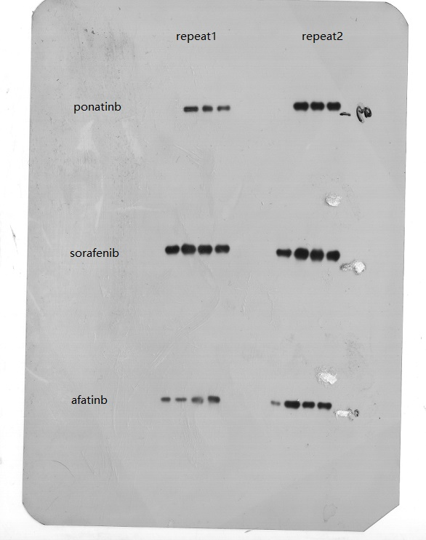

ATF6 and GAPDH (afatinib and ponatinib)
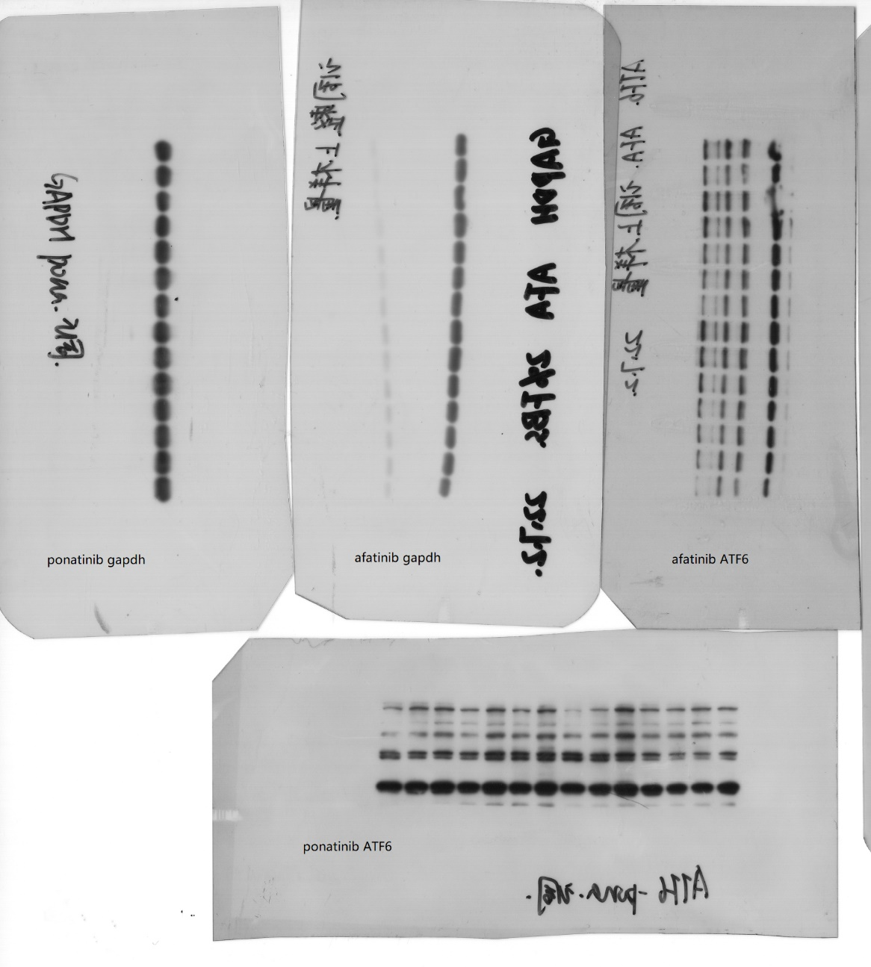

ATF6 and GAPDH (sorafenib)
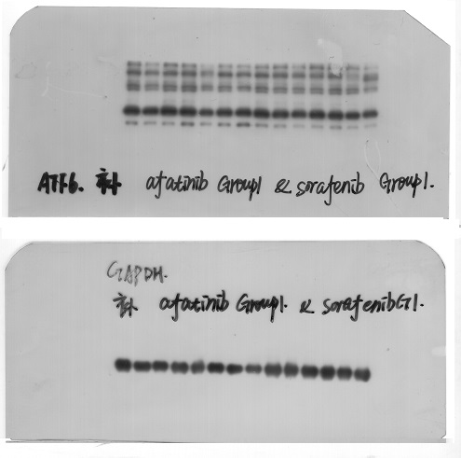

ATF6 (ponatinib)
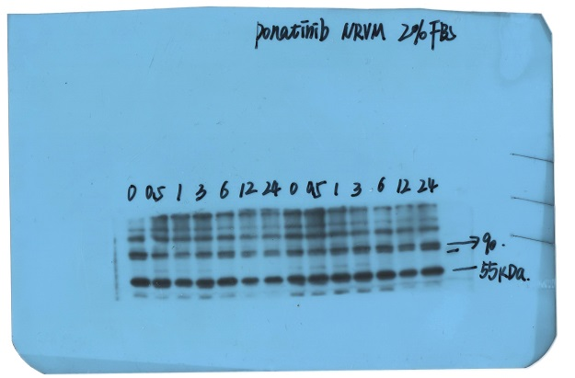

ATF6 (sorafenib)
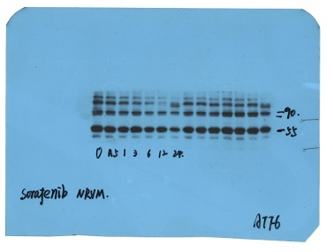

GAPDH (sorafenib and ponatinib)
