Change in habitual intakes of flavonoid-rich foods and mortality in US men and women

Nicola P. Bondonno, Lydia Liu, Yan Zheng, Kerry Ivey, Walter C. Willett, Meir J. Stampfer, Eric B. Rimm, Aedín Cassidy

Online Data Supplement

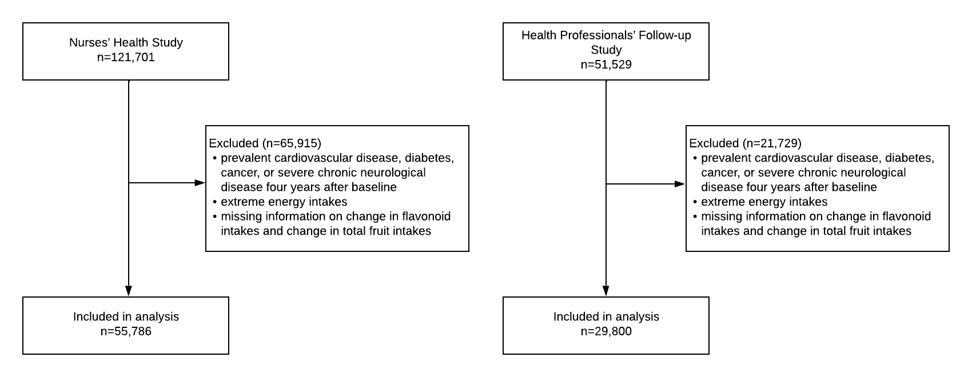

Fig. S1. Flow chart of participants.

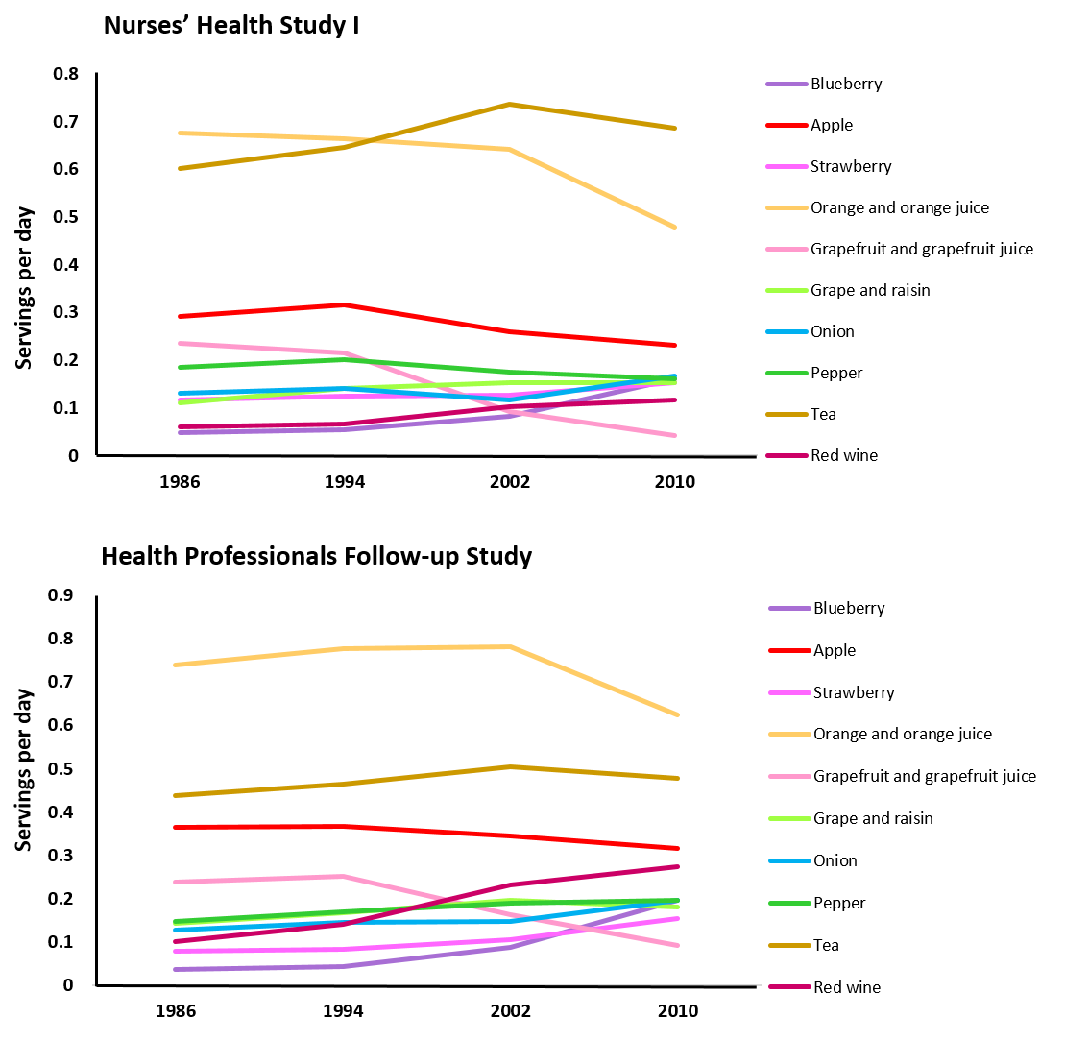
Fig. S2. Time trends in mean intakes of flavonoid-rich foods in the Nurses’ Health Study (1986-2010) and Health Professionals Follow-Up Study (1986-2010).

Table S1. Associations between all-cause mortality (Hazard ratios, 95% confidence intervals)¹ and 8-year change in intake of flavonoid-rich foods
 | 8-year change in intake levels, serving/wk
 |  | Decrease |  |  |  | Increase
 | ≥2 | 1-1.99 | 0.5-0.99 | No change | ≥2 | 1-1.99 | 0.5-0.99 |  | Every  3.5 servings/wk change³
Blueberry
NHS
Model 1² |  | 1.40 (1.24, 1.60) | 1.10 (0.99, 1.22) | 1.00 | 0.88 (0.80, 0.96) | 0.86 (0.81, 0.91) |  |  | 0.78 (0.73, 0.82)
HPFS
Model 1² |  | 1.13 (0.94, 1.36) | 1.16 (0.96, 1.41) | 1.00 | 0.94 (0.83, 1.06) | 0.94 (0.87, 1.01) |  |  | 0.92 (0.87, 0.98)
Apple
NHS
Model 1² | 1.05 (1.00, 1.11) | 1.06 (0.87, 1.30) | 1.11 (1.00, 1.22) | 1.00 | 1.02 (0.90, 1.16) | 1.04 (0.84, 1.28) | 0.98 (0.93, 1.02) |  | 0.94 (0.91, 0.97)
HPFS
Model 1² | 1.04 (0.97, 1.10) | 1.08 (0.90, 1.31) | 1.16 (0.98, 1.38) | 1.00 | 1.11 (0.90, 1.36) | 0.87 (0.71, 1.07) | 0.98 (0.92, 1.03) |  | 0.94 (0.91, 0.97)
Orange and orange juice
NHS
Model 1² | 1.02 (0.98, 1.07) | 0.96 (0.89, 1.05) | 0.89 (0.82, 0.96) | 1.00 | 1.09 (0.99, 1.19) | 0.98 (0.90, 1.08) | 1.07 (1.02, 1.11) |  | 1.01 (0.99, 1.02)
HPFS
Model 1² | 1.03 (0.97, 1.09) | 0.90 (0.80, 1.01) | 1.00 (0.89, 1.13) | 1.00 | 0.91 (0.80, 1.04) | 0.88 (0.78, 0.99) | 1.03 (0.97, 1.09) |  | 0.99 (0.97, 1.00)
Tea |  |  |  |  |  |  |  |  | ³1 serving/day
NHS
Model 1² | 1.00 (0.95, 1.05) | 0.89 (0.78, 1.00) | 1.02 (0.93, 1.12) | 1.00 | 0.90 (0.82, 1.00) | 0.78 (0.68, 0.91) | 0.89 (0.86, 0.93) |  | 0.95 (0.93, 0.97)
HPFS
Model 1² | 1.02 (0.96, 1.09) | 0.84 (0.70, 1.00) | 1.01 (0.89, 1.15) | 1.00 | 0.96 (0.84, 1.08) | 0.85 (0.71, 1.02) | 0.94 (0.89, 1.00) |  | 0.96 (0.93, 0.99)
Grapefruit and grapefruit juice
NHS
Model 1² | 0.92 (0.86, 0.99) | 0.89 (0.78, 1.01) | 0.97 (0.91, 1.03) | 1.00 | 1.16 (1.03, 1.31) | 1.13 (0.94, 1.37) | 1.01 (0.94, 1.09) |  | 1.05 (1.01, 1.09)
HPFS
Model 1² | 0.99 (0.91, 1.06) | 0.97 (0.81, 1.15) | 1.00 (0.91, 1.10) | 1.00 | 1.20 (1.04, 1.38) | 0.91 (0.73, 1.11) | 1.04 (0.97, 1.12) |  | 1.03 (0.99, 1.07)
Red wine
NHS
Model 1² |  | 1.00 (0.91, 1.11) | 0.92 (0.80, 1.05) | 1.00 | 0.74 (0.63, 0.86) | 0.75 (0.69, 0.81) |  |  | 0.87 (0.83, 0.91)
HPFS
Model 1² |  | 1.07 (0.97, 1.17) | 1.21 (1.04, 1.41) | 1.00 | 0.84 (0.71, 0.97) | 0.82 (0.76, 0.87) |  |  | 0.91 (0.88, 0.94)
Strawberry
NHS
Model 1² |  | 1.14 (1.04, 1.24) | 1.20 (1.11, 1.30) | 1.00 | 1.03 (0.94, 1.15) | 1.01 (0.96, 1.07) |  |  | 0.93 (0.88, 0.98)
HPFS
Model 1² |  | 0.97 (0.85, 1.12) | 1.20 (1.04, 1.39) | 1.00 | 1.06 (0.93, 1.21) | 1.08 (1.00, 1.16) |  |  | 1.04 (0.98, 1.11)
Onion
NHS
Model 1² |  | 0.91 (0.87, 0.96) | 0.93 (0.87, 0.99) | 1.00 | 1.10 (0.97, 1.25) | 1.03 (0.95, 1.10) |  |  | 1.09 (1.05, 1.14)
HPFS
Model 1² |  | 0.99 (0.90, 1.08) | 0.97 (0.85, 1.11) | 1.00 | 0.96 (0.86, 1.07) | 1.03 (0.97, 1.10) |  |  | 1.03 (0.98, 1.08)
Peppers
NHS
Model 1² |  | 1.17 (1.10, 1.25) | 1.24 (1.14, 1.35) | 1.00 | 1.01 (0.89, 1.14) | 0.88 (0.83, 0.93) |  |  | 0.82 (0.78, 0.86)
HPFS
Model 1² |  | 1.04 (0.95, 1.13) | 1.02 (0.88, 1.18) | 1.00 | 1.02 (0.88, 1.19) | 0.92 (0.87, 0.99) |  |  | 0.93 (0.88, 0.97)
Grape and raisin
NHS
Model 1² |  | 1.00 (0.95, 1.05) | 1.01 (0.93, 1.10) | 1.00 | 0.93 (0.86, 1.01) | 0.90 (0.85, 0.95) |  |  | 0.94 (0.91, 0.97)
HPFS
Model 1² |  | 1.01 (0.93, 1.09) | 0.99 (0.87, 1.13) | 1.00 | 1.10 (0.96, 1.25) | 0.96 (0.90, 1.02) |  |  | 0.96 (0.93, 1.00)
¹ All hazard ratios (95% confidence intervals) were calculated using Cox proportional hazard models. HPFS, Health Professionals Follow-up Study; NHS, Nurses’ Health Study.
² Model 1 was adjusted for age and baseline intakes of the exposure variable.
³ Except for tea, where the hazard ratio (95%CI) is presented for an 8-year change in intake of 1 serve per day.

