Additional File 1
Figure S1 Schematic diagram of transgenic mice
Gene: Gt(ROSA)26Sor (ENSMUSG00000086429)
http://asia.ensembl.org/Mus_musculus/Gene/Summary?db=core;g=ENSMUSG00000086429;r=6:113067428-113077333
Sites: Chromosome 6: 113,076,031 (Ensembl)
Adipsin^{LSL/+} mice
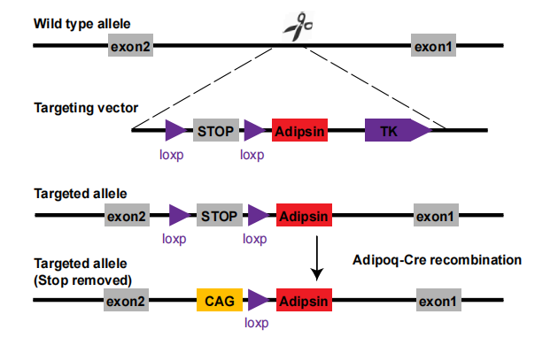
Adipoq-Cre mice
Gene: transgene insertion 1, Evan Rosen
Mice harboring the Adipoq-Cre BAC transgene express Cre recombinase under control of the mouse adiponectin (Adipoq) promoter/enhancer regions within the BAC transgene. The transgene integration site was identified to be on chromosome 9 between exons 6 and 7 of the Tbx18 locus.

Figure S2 Construction of Adeno-associated Virus 9 (AAV9)

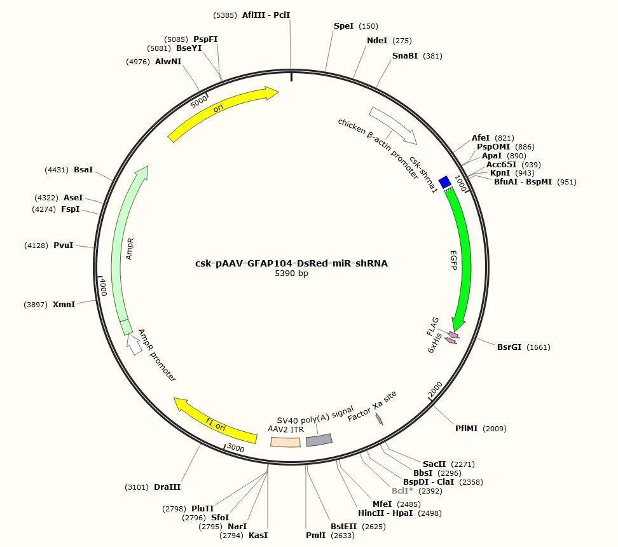
Csk-shRNA:
GAAGCGCACAGACAAAGGCTCGAGCCTTTGTCTGTGCGCTTCTTTTT

Table S1 Antibody information and dilutions
Genes | Manufacturer | Number | Application
Adipsin | Abcam | ab204917 | WB 1:5000
Csk | Abcam | ab244414 | WB 1:1000  IF 1:100
Transferrin | Abcam | ab82411 | WB 1:10000
Pho-VE-cadherin (Tyr685) | Abcam | ab119785 | WB 1:1000
Adipsin | ABclonal | A8117 | WB 1:1000
Calnexin | ABclonal | A15631 | WB 1:1000
VE-cadherin | Thermo Fisher Scientific | 36-1900 | WB 1:2000  IF 1:100
Src | Thermo Fisher Scientific | 44-656G | WB 1:1000
Phos-Src  (Tyr416) | Thermo Fisher Scientific | PA5-97364 | WB 1:1000
Connexin-43 | Proteintech | 26980-1-AP | WB 1:4000
JAM-A | Proteintech | 16183-1-AP | WB 1:1000
TSG101 | Proteintech | 67381-1-Ig | WB 1:5000
Calnexin | Proteintech | 10427-2-AP | WB 1:5000
CD81 | Proteintech | 66866-1-Ig | WB 1:1000
CD9 | Proteintech | 20597-1-AP | WB 1:1000
Gapdh | Proteintech | 10494-1-AP | WB 1:5000
β-actin | Proteintech | 20536-1-AP | WB 1:5000
β-catenin | Proteintech | 66379-1-Ig | WB 1:5000
Adipsin | Santa Cruz Biotechnology | sc-376015 | WB 1:1000  IP 1:50  IF 1:50
ZO-1 | Servicebio | GB111402 | WB 1:1000
CD31 | Servicebio | GB12063 | IF 1:100
Occludin | Cell Signaling Technology | 91131S | WB 1:1000
Claudin-5 | Cell Signaling Technology | 49564 | WB 1:1000
Pho-VE-cadherin (Tyr731) | Sigma-Aldrich | SAB4504676 | WB 1:1000

Table S2 Primer sequences
Genes | Forward primer (5'—3') | Reverse primer (5'—3')
Adipsin | GCAGCACAGCCCCGAG | GTCGTCATCCGTCACTCCAT
β-actin | AACAGTCCGCCTAGAAGCAC | CGTTGACATCCGTAAAGACC
VE-cadherin | CACTGCTTTGGGAGCCTTC | GGGGCAGCGATTCATTTTTCT
β-catenin | ATGGAGCCGGACAGAAAAGC | CTTGCCACTCAGGGAAGGA
ZO-1 | GCCGCTAAGAGCACAGCAA | TCCCCACTCTGAAAATGAGGA
Occludin | TTGAAAGTCCACCTCCTTACAGA | CCGGATAAAAAGAGTACGCTGG
Connexin-43 | ACAGCGGTTGAGTCAGCTTG | GAGAGATGGGGAAGGACTTGT
JAM-A | TCTCTTCACGTCTATGATCCTGG | TTTGATGGACTCGTTCTCGGG
Claudin-5 | GCAAGGTGTATGAATCTGTGCT | GTCAAGGTAACAAAGAGTGCCA
Csk | TTCCCTTCTGCAAAGGAGATGT | ACCAGGGCATAAGGCTGAGT

Table S3 General characteristics of healthy individuals and type 2 diabetic patients.
Clinical Characteristic | Healthy Individuals(n=30) | T2DM(n=30)
Male  n(%) | 23  (76.7) | 24  (80.0)
Age  (years) | 64.10±10.23 | 64.30±7.92
Body mass index  (kg/m2) | 24.16±2.20 | 24.15±2.55
Total cholesterol  (mmol/L) | 3.31±0.72 | 3.47±1.13
Triglyceride  (mmol/L) | 1.32±0.56 | 1.63±1.01
High-density lipoprotein  (mmol/L) | 1.11±0.27 | 1.04±0.24
Low-density lipoprotein  (mmol/L) | 1.67±0.48 | 1.91±1.06
Systolic blood pressure  mmHg | 123.60±12.37 | 126.70±22.89
Diastolic blood pressure  mmHg | 68.83±6.48 | 70.20±11.11
HbA1c  (%) | 5.27±1.20 | 8.64±1.45*
Fasting blood glucose  (mmol/L) | 5.19±1.03 | 10.09±0.96*
Serum Adipsin  (ng/ml) | 2588.0±534.0 | 1538.0±323.0*
Data were presented as mean ± SD. *p < 0.05 vs. Healthy Individuals.
Table S4 Blood glucose in mice
Blood glucose  (mmol/L) | Non-DM |  | DM
Blood glucose  (mmol/L) | Adipsin^{LSL/LSL} | Adipsin^{LSL/LSL}-Cre | Adipsin^{LSL/LSL} | Adipsin^{LSL/LSL}-Cre
0 | 9.10±1.33 | 9.31±1.50 | 9.10±1.89 | 8.80±1.40
4 | 10.16±1.99 | 9.94±1.43 | 10.53±1.75 | 9.83±3.31
8 | 8.89±1.61 | 8.60±1.68 | 19.86±2.08* | 19.64±1.40#
12 | 9.79±1.94 | 9.70±1.29 | 24.77±4.36* | 23.16±3.60#
16 | 9.33±2.53 | 10.40±1.55 | 23.37±4.16* | 25.60±4.28#

Data were presented as mean ± SEM. *p < 0.05 vs. Adipsin^{LSL/LSL} + Non-DM group. #p < 0.05 vs. Adipsin^{LSL/LSL}-Cre + Non-DM group.

Table S5 Mass spectrometry protein analysis
Protein | Protein Name | MolWeight | LFQ intensity
Q8BQS4 | Protein FAM102B | 36.513 | 354210
P41241 | Tyrosine-protein kinase CSK | 50.716 | 116357.5
Q9WTX8 | Mitotic spindle assembly checkpoint protein MAD1 | 83.54 | 103420
Q9QXS1 | Plectin | 534.18 | 94135
P05977 | Myosin light chain 1/3, skeletal muscle isoform | 20.594 | 86651
O35598 | Disintegrin and metalloproteinase domain-containing protein 10 | 83.967 | 48161
E9Q557 | Desmoplakin | 332.91 | 42438.2
Q9JHR7 | Insulin-degrading enzyme | 117.77 | 24283.5
Q9QXB9 | Developmentally-regulated GTP-binding protein 2 | 40.718 | 22569
P26043 | Radixin | 68.542 | 14753.1
P42932 | T-complex protein 1 subunit theta | 59.555 | 11382.5
P12710 | Fatty acid-binding protein, liver | 14.245 | 10878.5
Q6IRU2 | Tropomyosin alpha-4 chain | 28.467 | 10342.5
Q8K268 | ATP-binding cassette sub-family F member 3 | 79.864 | 8838
O55236 | mRNA-capping enzyme | 68.683 | 7532
P60766 | Cell division control protein 42 homolog | 21.258 | 7282
Q8BWQ4 | Cap-specific mRNA (nucleoside-2'-O-)-methyltransferase 2 | 87.142 | 6615.5
Q9Z280 | Phospholipase D1 | 123.97 | 6400.5
O35730 | E3 ubiquitin-protein ligase RING1 | 42.63 | 5533
Q9D2C6 | DNA-directed RNA polymerase III subunit RPC8 | 22.948 | 3061.6
Q9CYC6 | m7GpppN-mRNA hydrolase | 48.379 | 2302.35
P99027 | 60S acidic ribosomal protein P2 | 11.651 | 2141.95
Q8BRH4 | Histone-lysine N-methyltransferase 2C | 540.18 | 1751.2
Q80WQ2 | Protein VAC14 homolog | 88.047 | 749.5

