Additional File 2
Figure S1
Figure S1 Changes in blood glucose levels. (A) Changes in blood glucose levels at 0 weeks, 4 weeks, 8 weeks, 12 weeks, and 16 weeks following high-fat diet feeding. (B) Blood glucose levels of the glucose tolerance test. (C) The glucose levels of the insulin tolerance test.

Figure S2
Figure S2 Changes in Adipsin levels. (A) Adipsin mRNA levels were quantified in different types of adipose tissues. BAT, brown adipose tissue; eWAT, epididymal white adipose tissue; iWAT, inguinal white adipose tissue. (B) Representative Western blot images of Adipsin levels in different adipose tissues. (C) Quantitative analysis of Adipsin levels in Figure S2B. Data were presented as mean ± SEM. Students't‐test was used for statistical analysis.

Figure S3
Figure S3 Adipsin levels in exosomes. (A-B) Quantitative analysis of Adipsin levels in Figure 4F. (C) Serum Adipsin levels determined using ELISA after ultracentrifugation. Data were presented as mean ± SEM. Students't‐test was used for statistical analysis.

Figure S4
Figure S4 Expression levels of cell junction molecules are unaffected in CMECs treated with Adipsin^{LSL/LSL}&Exosomes or Adipsin^{LSL/LSL}-Cre&Exosomes under HG + PA challenge. (A) Relative mRNA levels of cell junction-associated proteins quantified in different groups. (B) Representative Western blot images of cell junction-associated proteins in different groups. (C-H) Quantitative analysis of Western blot images from three independent experiments in Figure S4B. Data were presented as mean + SEM. For A, students't‐test was used for statistical analysis. For C-H, one-way ANOVA was used for statistical analysis.
Figure S5
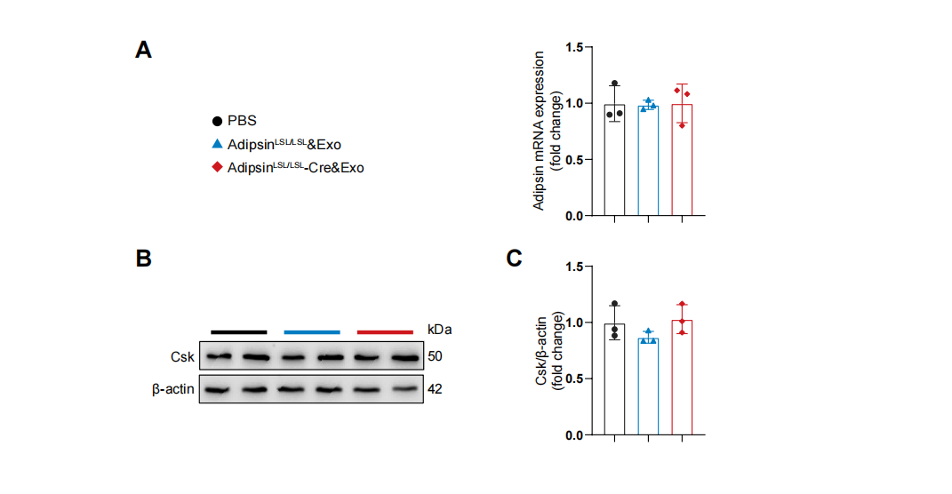
Figure S5 Adipsin^{LSL/LSL}-Cre&Exosomes administration has no effects on Csk expression in CMECs. (A) Csk mRNA levels were quantified in different groups. (B) Representative Western blot images of Csk levels in different groups. (C) Quantitative analysis of Csk levels in Figure S5B. Data were presented as mean ± SEM. One-way ANOVA was used for statistical analysis.

