Additional file 3
Original Western blots
Fig. 1D
Adipsin

TRF

Fig. 1G
Adipsin

β-actin


Fig. 2A
Adipsin

TRF


Fig. 2A
Adipsin

β-actin


Fig. 4C
TSG101

CD9
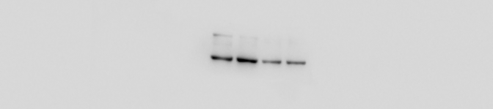
CD81


Calnexin


Fig. 4F
Adipsin
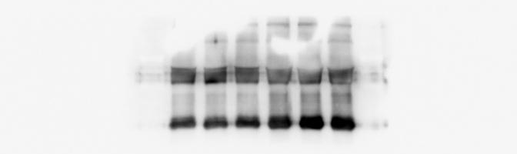
Adipsin


Fig. 7C
VE-cadherin
VE-cadherin (Tyr685)

VE-cadherin (Tyr731)

β-actin


Fig. 7G
VE-cadherin (Total)

VE-cadherin (Mem)

VE-cadherin (Tyr685)

VE-cadherin (Tyr731)

Src (Total)

Src (Tyr416)

β-actin


Fig. 8C
Csk

Adipsin

Csk

Adipsin


Fig. 8G
VE-cadherin (Total)

VE-cadherin (Mem)

VE-cadherin (Tyr685)

VE-cadherin (Tyr731)

Src

Src (Tyr416)

β-actin

Additional File 2：Fig. S2B
Adipsin

β-actin


Fig. S4B
ZO-1

β-catenin

Occludin

Connexin-43

JAM-A

Claudin-5

β-actin


Fig. S5B
Csk

β-actin


