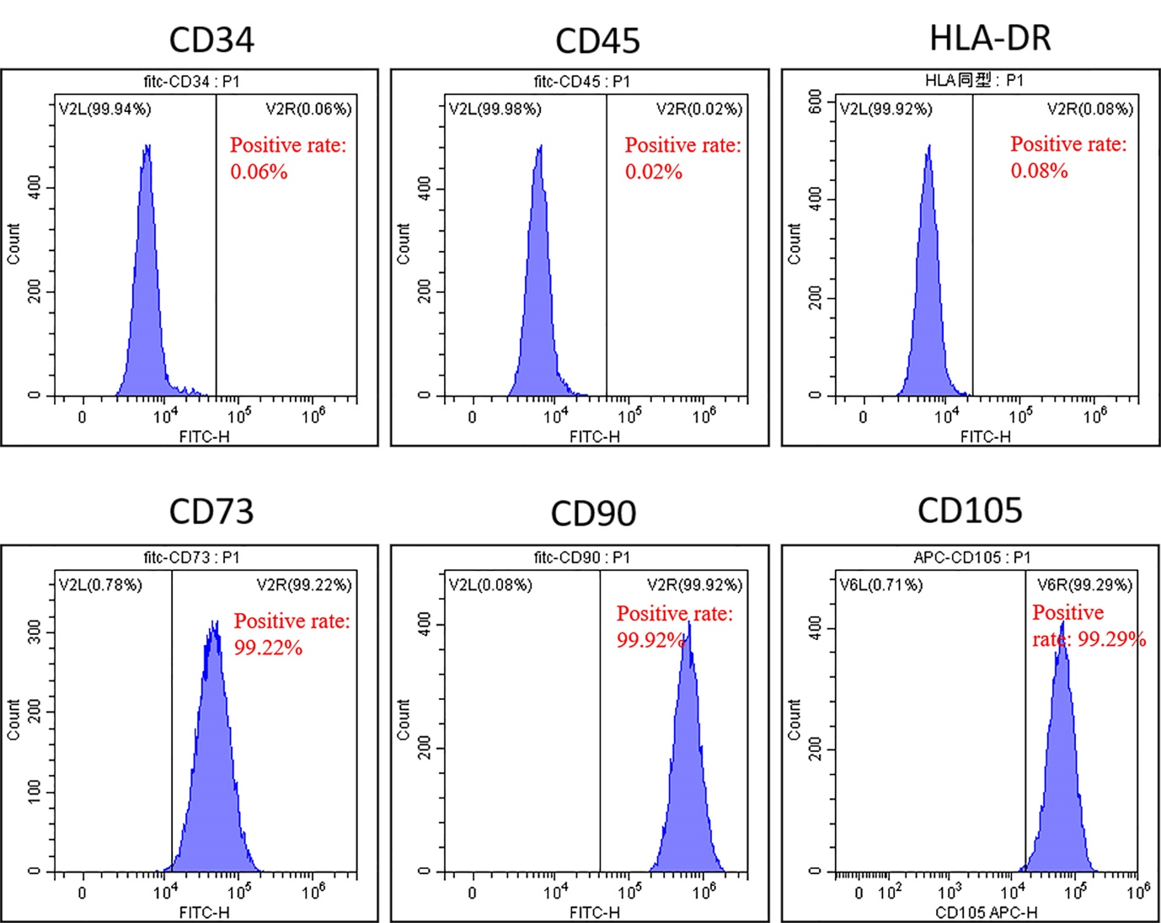
Figure S7. Surface marker identification of hucMSCs by flow cytometry.

