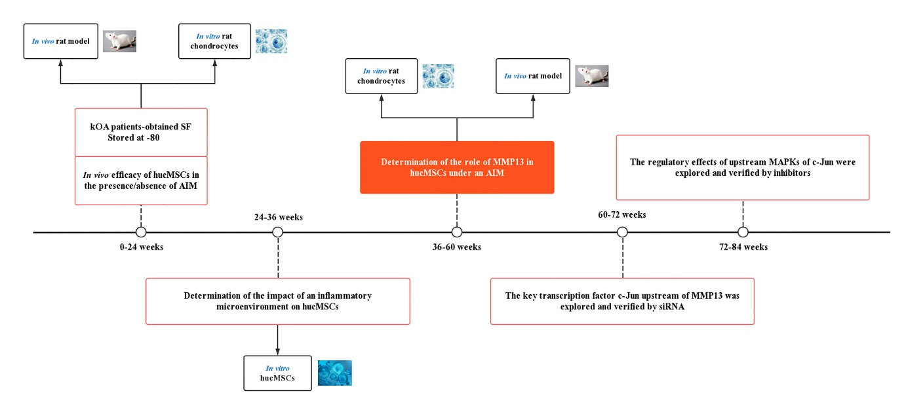
Figure S1. The design flowchart for this study.

