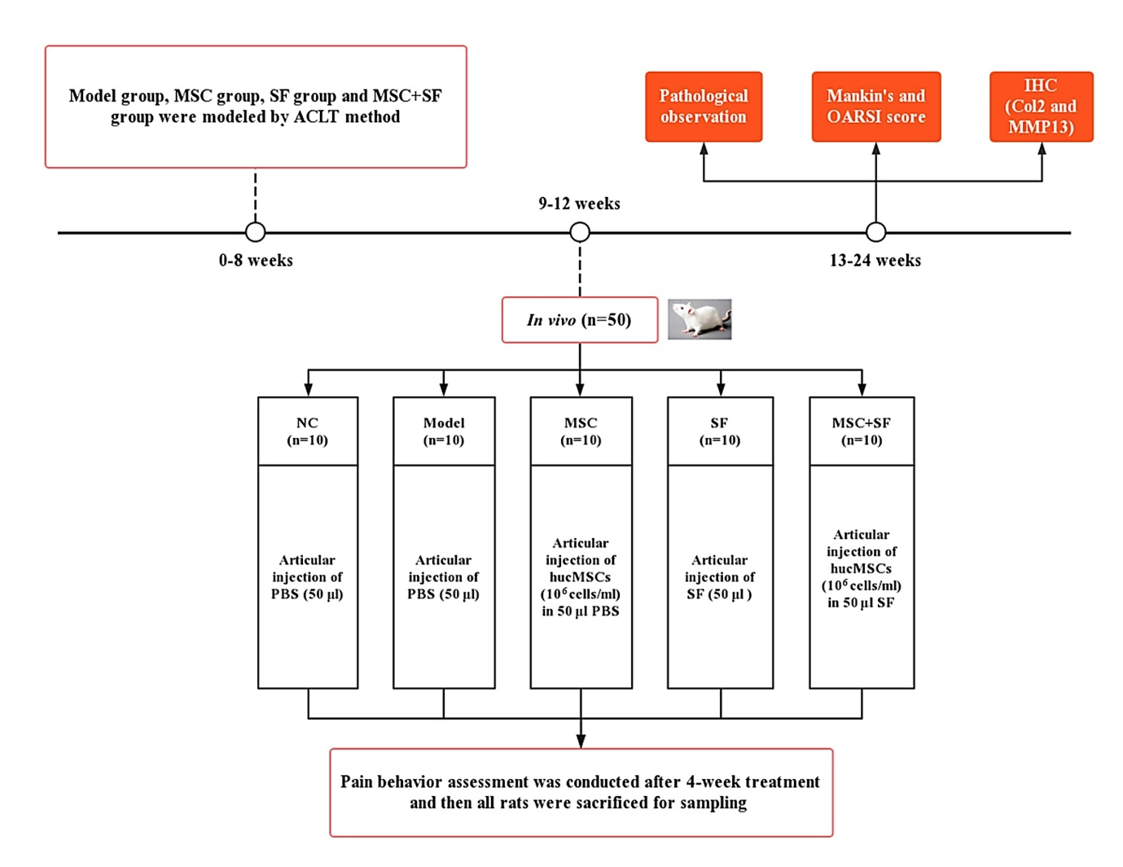
Figure S2. The design flowchart for in vivo efficacy evaluation of hucMSCs in the presence/absence of AIM.

