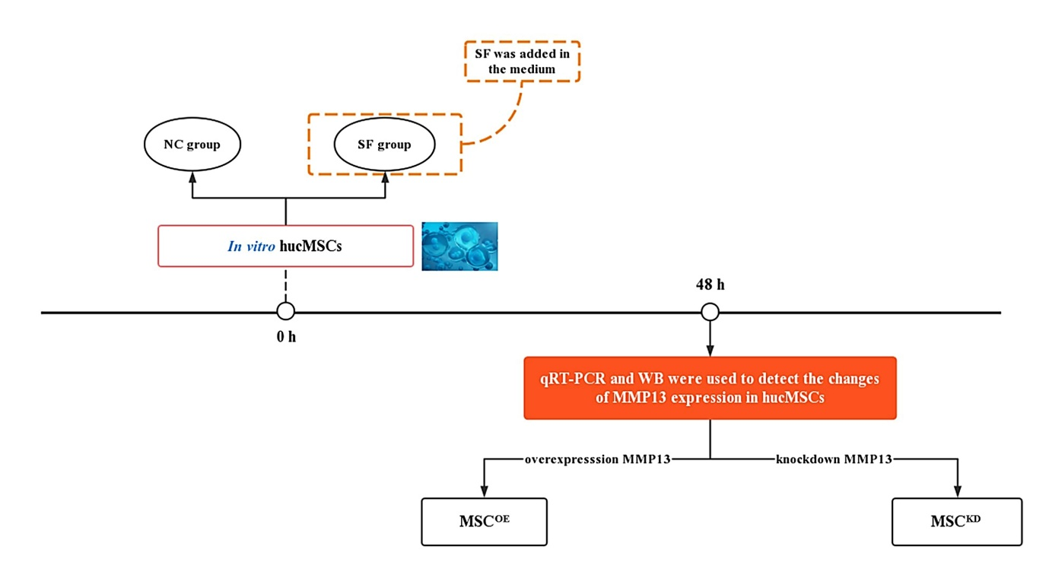
Figure S3. The design flowchart for in vitro evaluation of the impact of AIM on the state of hucMSCs.

