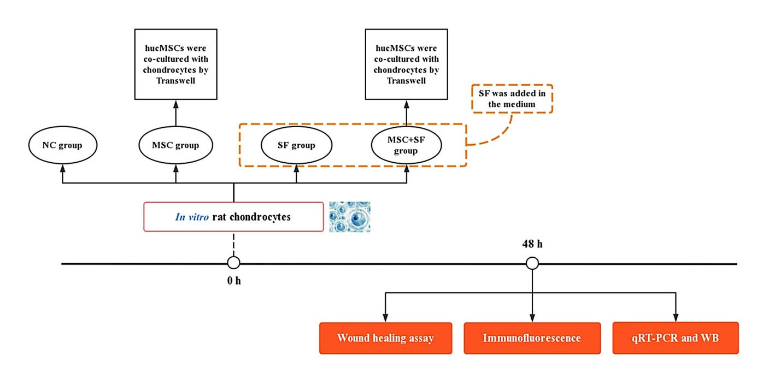
Figure S4. The design flowchart for in vitro evaluation of the impact of AIM on the function of hucMSCs.

