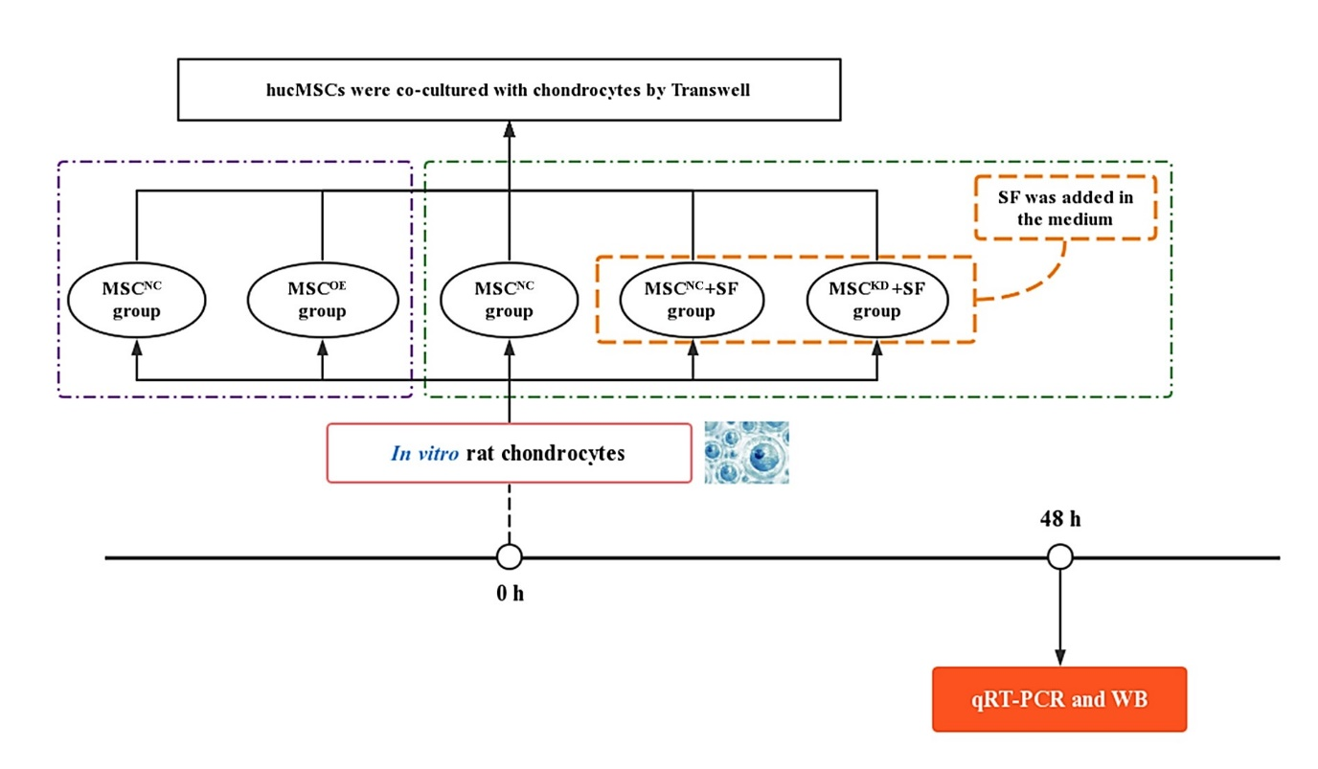
Figure S5. The design flowchart for in vitro determination of the role of MMP13 in hucMSCs under an AIM.

