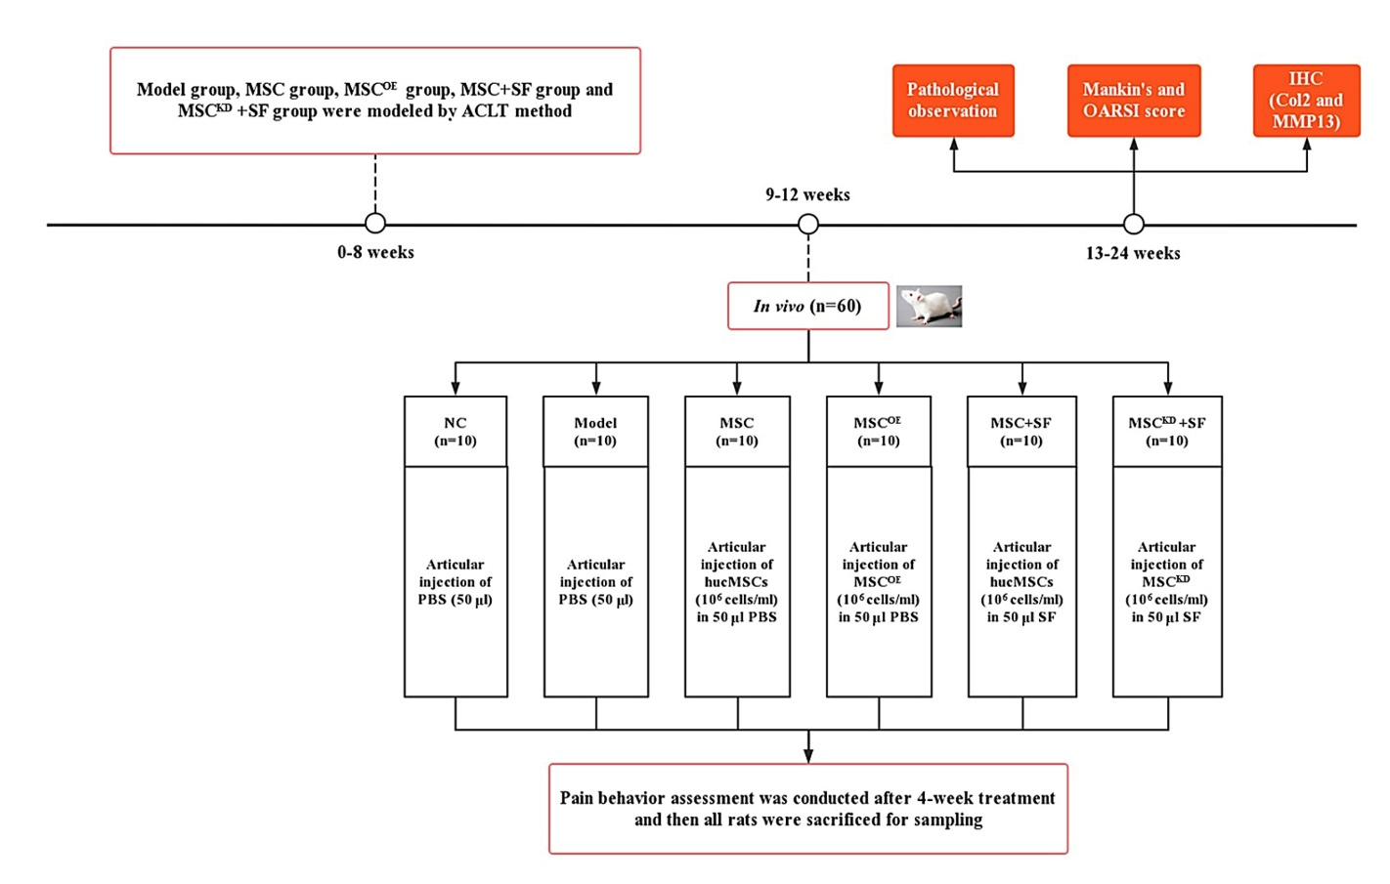
Figure S6. The design flowchart for in vivo determination of the role of MMP13 in hucMSCs under an AIM.

