Additional file 1

Table S1. Antibodies
Table S2. Primers used in qPCR
Table S3. Clinical characteristics of patients with CD and healthy individuals in transcriptome sequencing
Table S4. Clinical characteristics of patients with CD and healthy individuals analyzed for TMIGD1 expression
Table S5. Clinical characteristics of patients with CD and healthy individuals analyzed for IHC staining of TMIGD1
Table S6. Clinical characteristics of anti-TNF responding and non-responding patients with CD before anti-TNF treatment

Fig. S1. Verification of Tmigd1^{INT-KO} mice
Fig. S2. Chemically induced colitis in Tmigd1^{INT-KO} mice show more severe inflammation
Fig. S3. Chemically induced colitis in Tmigd1^{INT-KO} mice show more severe barrier dysfunction
Fig. S4. TMIGD1 is downregulated after TNF-α stimulation
Fig. S5. TMIGD1 modulates barrier function and inflammation
Fig. S6. TMIGD1 binds to BANF1
Fig. S7. TMIGD1 modulates BANF1 and inactivates NF-κB pathway
Fig. S8. BANF1 is crucial for TMIGD1 to maintain barrier function and inhibit inflammation
Fig. S9. Restoring TMIGD1 and BANF1 repairs barrier function and attenuates inflammation
Fig. S10. The proposed model for the landscape of TMIGD1-BANF1-NF-κB pathway in CD

Table S1. Antibodies

Antibodies | Application | Cat. | Company
TMIGD1 | WB (1:500), IHC (1:200), IF (1:200) | #ABC938 | Millipore
BANF1 | WB (1:500), IHC (1:100), IF (1:100), IP (1:50) | sc-166324 | Santa Cruz
BANF1  β-Actin | WB (1:1000)  WB (1:1000) | ab129074  #4970 | Abcam  CST
CLDN3 | WB (1:1000), IF (1:100) | ab214487 | Abcam
CLDN4 | WB (1:1000), IF (1:100) | ab53156 | Abcam
ZO-1 | WB (1:1000), IF (1:100) | ab276131 | Abcam
E-cadherin | WB (1:1000), IF (1:200) | #3195 | CST
MPO | IF (1:100) | ab208670 | Abcam
CD4 | IHC (1:1000) | ab183685 | Abcam
IgG  IgG | IP (1:250)  IP (1:250) | #3900  #5415 | CST  CST
Flag  Flag | IP (1:50)  IP (1:50) | #14793  #8146 | CST  CST
GST | WB (1:100) | #2625 | CST
NF-κB Pathway Antibody Kit | WB (1:1000) | #9936 | CST
Lamin B1 | WB (1:1000) | ab133741 | Abcam
HRP Goat Anti-Rabbit IgG (H+L) | WB (1:2000) | #7074 | CST
HRP Goat Anti-Mouse IgG (H+L) | WB (1:2000) | #7076 | CST
SignalStain® Boost IHC Detection Reagent (HRP, Rabbit)  SignalStain® Boost IHC Detection Reagent (HRP, Mouse)  Anti-mouse IgG (H+L), F(ab')2 Fragment (Alexa Fluor® 555 Conjugate) | IHC  IHC  IF (1:500) | #8114  #8125  #4409 | CST  CST  CST
Anti-rabbit IgG (H+L), F(ab')2 Fragment (Alexa Fluor® 488 Conjugate) | IF (1:500) | #4412 | CST
CST, Cell Signaling Technology
Table S2. Primers used in qPCR

Gene |  | Forward Primer |  | Reverse Primer
Human TMIGD1 | CAGTTGAGGAAGGCAGTAATGT |  | CGGCTTTTCTCTAAATCGAGGAG
Human BANF1 | GTGGCTTGAGGTATCCGCAG |  | TGCCCAGGACTTCACCAATC
Human β-Actin | CTAAGTCATAGTCCGCCTAGAAGCA |  | TGGCACCCAGCACAATGAA
Human IL-1β | CAGAAGTACCTGAGCTCGCC |  | AGATTCGTAGCTGGATGCCG
Human IL-6  Human IL-23A  Human TNF-α | TTCGGTCCAGTTGCCTTCTC  CCCAAGGACTCAGGGACAAC  GCTGCACTTTGGAGTGATCG |  | CTGAGATGCCGTCGAGGATG  AGAGAAGGCTCCCCTGTGAA  TCACTCGGGGTTCGAGAAGA
Human IFN-γ  Human CLDN3  Human CLDN4  Human ZO-1  Human E-cadherin | ACTGACTTGAATGTCCAACGC  TCGGCCAACACCATTATCCG  CCTGGAGACTGATCCCCTCT  CAACATACAGTGACGCTTCACA  TGGACCGAGAGAGTTTCCCT |  | TATTGCAGGCAGGACAACCA  CCGTGTACTTCTTCTCGCGT  AGGACTTCCAAGGGTGAAGC  CACTATTGACGTTTCCCCACTC  TTAGCCTCGTTCTCAGGCAC
Mouse TMIGD1 | GGTGTCCAAGCATCTCTGGAA |  | CCATTGTCACTTTCGTTGATGGG
Mouse BANF1 | GCATAAAACGACCCGGAAGC |  | GATCAGGCTTAACCGGAGGC
Mouse β-Actin | CCACTGTCGAGTCGCGT |  | CCACGATGGAGGGGAATACAG
Mouse IL-1β | GCAGTGGTTCGAGGCCTAAT |  | TCATCACTGTCAAAAGGTGGCA
Mouse IL-6  Mouse TNF-α | GTCCTTCCTACCCCAATTTCCA  GTAGCCCACGTCGTAGCAAA |  | TAACGCACTAGGTTTGCCGA  ACAAGGTACAACCCATCGGC

Table S3. Clinical characteristics of patients with CD and healthy individuals in transcriptome sequencing

 | Sex | Age (years) | Sampling  location | CDAI | CRP (mg/L) | SES-CD | GHAS
CD1 | male | 24.0 | colon | 240.4 | 42.64 | 5 | 11
CD2 | female | 37.0 | colon | 368.6 | 163.03 | 8 | 12
CD3 | male | 38.0 | colon | 442.2 | 61.22 | 8 | 11
CD4 | male | 42.0 | colon | 465.0 | 134.88 | 11 | 15
CD5 | male | 34.0 | colon | 366.0 | 189.15 | 9 | 13
CD6 | male | 17.0 | colon | 487.8 | 107.31 | 10 | 14
CD7 | male | 19.0 | colon | 243.4 | 27.04 | 3 | 10
NC1 | male | 29.0 | colon | - | - | - | -
NC2 | female | 63.0 | colon | - | - | - | -
NC3 | male | 22.0 | colon | - | - | - | -
NC4 | female | 69.0 | colon | - | - | - | -
NC5 | female | 48.0 | colon | - | - | - | -
NC6 | male | 55.0 | colon | - | - | - | -
NC7 | female | 32.0 | colon | - | - | - | -
NC8 | male | 37.0 | colon | - | - | - | -
NC9 | female | 31.0 | colon | - | - | - | -
NC10 | female | 66.0 | colon | - | - | - | -

Table S4. Clinical characteristics of patients with CD and healthy individuals analyzed for TMIGD1 mRNA expression

 | Patients with CD (n=64) | Healthy controls (n=55)
Male, n (%) | 46 (71.9) | 38 (69.1)
Female, n (%) | 18 (28.1) | 17 (30.9)
Age, years, median (IQR) | 27.0 (18.0-32.0) | 28.0 (20.0-35.0)
Disease location
L1 (ileal disease), n (%) | 2 (3.1) | -
L2 (colonic disease), n (%) | 4 (6.3) | -
L3 (ileocolonic disease), n (%) | 58 (90.6) | -
Sampling location
Terminal ileum, n (%) | 3 (4.7) | 0 (0.0)
Ascending colon, n (%) | 9 (14.1) | 10 (18.2)
Transverse colon, n (%) | 38 (59.4) | 34 (61.8)
Descending colon, n (%)  Sigmoid colon, n (%) | 11 (17.2)  3 (4.7) | 8 (14.5)  3 (5.5)
Disease behavior
B1 (non-stricturing, non-penetrating), n (%) | 37 (57.8) | -
B2 (stricturing), n (%) | 17 (26.6) | -
B3 (penetrating), n (%) | 10 (15.6) | -
Perianal disease, n (%) | 42 (65.6) | -
Presence of extraintestinal manifestations, n (%) | 5 (7.8) | -
Medication
5-Aminosalicyclic acid, n (%) | 19 (29.7) | -
Immunomodulator (e.g., Thiopurine), n (%)  Corticosteroids, n (%) | 7 (10.9)  4 (6.3) | -  -
Biologic agents, n (%) | 3 (4.7) | -
None (treatment-naive), n (%)  Abdominal surgery, n (%) | 31 (48.4)  2 (3.1) | -  -
IQR: interquartile range
Table S5. Clinical characteristics of patients with CD and healthy individuals analyzed for IHC staining of TMIGD1

 | Healthy individuals  (n=13) | Patients with CD,  CDAI＜150 (n=10) | Patients with CD,  150≤CDAI＜220 (n=12) | Patients with CD,  220≤CDAI＜450 (n=15) | Patients with CD,  450≤CDAI (n=5)
Male, n (%) | 7 (53.8) | 5 (50.0) | 6 (50.0) | 9 (60.0) | 3 (60.0)
Female, n (%) | 6 (46.2) | 5 (50.0) | 6 (50.0) | 6 (40.0) | 2 (40.0)
Age, years, median (IQR) | 28.0 (21.0-35.0) | 26.0 (20.0-33.0) | 27.0 (21.0-33.0) | 22.0 (16.0-27.0) | 24.0 (17.0-27.0)
Disease location
L1 (ileal disease), n (%) | - | 1 (10.0) | 1 (8.3) | 0 (0.0) | 0 (0.0)
L2 (colonic disease), n (%) | - | 0 (0.0) | 0 (0.0) | 1 (6.7) | 0 (0.0)
L3 (ileocolonic disease), n (%) | - | 9 (90.0) | 11 (91.7) | 14 (93.3) | 5 (100.0)
Sampling location
Ascending colon, n (%) | 2 (15.4) | 2 (20.0) | 2 (16.7) | 2 (13.3) | 1 (20.0)
Transverse colon, n (%) | 9 (69.2) | 6 (60.0) | 7 (58.3) | 8 (53.3) | 3 (60.0)
Descending colon, n (%) | 2 (15.4) | 2 (20.0) | 3 (25.0) | 5 (33.3) | 1 (20.0)
Disease behavior
B1 (non-stricturing, non-penetrating), n (%) | - | 6 (60.0) | 6 (50.0) | 9 (60.0) | 2 (40.0)
B2 (stricturing), n (%) | - | 3 (30.0) | 3 (25.0) | 2 (13.3) | 1 (20.0)
B3 (penetrating), n (%) | - | 1 (10.0) | 3 (25.0) | 4 (26.7) | 2 (40.0)
Perianal disease, n (%) | - | 5 (50.0) | 9 (75.0) | 11 (73.3) | 4 (80.0)
Presence of extraintestinal manifestations, n (%) | - | 1 (10.0) | 1 (8.3) | 1 (6.7) | 1 (20.0)
Medication
5-Aminosalicyclic acid, n (%) | - | 2 (20.0) | 2 (16.7) | 2 (13.3) | 1 (20.0)
Immunomodulator (e.g., Thiopurine), n (%)  Biologic agents, n (%) | -  - | 0 (0.0)  0 (0.0) | 0 (0.0)  0 (0.0) | 0 (0.0)  0 (0.0) | 0 (0.0)  0 (0.0)
None (treatment-naive), n (%)  Abdominal surgery, n (%) | -  - | 8 (80.0)  0 (0.0) | 10 (83.3)  0 (0.0) | 13 (86.7)  0 (0.0) | 4 (80.0)  0 (0.0)
IQR: interquartile range.
Table S6. Clinical characteristics of anti-TNF responding and non-responding patients with CD before anti-TNF treatment

 | Responders  (n=10) | Non-responders (n=10) | p
Male, n (%) | 6 (60.0) | 7 (70.0) | ns
Female, n (%) | 4 (40.0) | 3 (30.0) | ns
Age, years, median (IQR) | 43.0 (36.0-50.0) | 46.5 (38.0-50.0) | ns
Disease location
L1 (ileal disease), n (%) | 1 (10.0) | 1 (10.0) | -
L2 (colonic disease), n (%) | 1 (10.0) | 1 (10.0) | -
L3 (ileocolonic disease), n (%) | 8 (80.0) | 8 (80.0) | -
Sampling location
Ascending colon, n (%) | 3 (30.0) | 2 (20.0) | -
Transverse colon, n (%) | 5 (50.0) | 5 (50.0) | -
Descending colon, n (%) | 2 (20.0) | 3 (30.0) | -
Disease behavior
B1 (non-stricturing, non-penetrating), n (%) | 5 (50.0) | 4 (40.0) | -
B2 (stricturing), n (%) | 3 (30.0) | 4 (40.0) | -
B3 (penetrating), n (%) | 2 (20.0) | 2 (20.0) | -
Perianal disease, n (%) | 5 (50.0) | 7 (70.0) | -
Presence of extraintestinal manifestations, n (%) | 1 (10.0) | 1 (10.0) | -
Medication
5-Aminosalicyclic acid, n (%) | 10 (100.0) | 10 (100.0) | -
Immunomodulator (e.g., Thiopurine), n (%)  Corticosteroids, n (%) | 9 (90.0)  9 (90.0) | 9 (90.0)  9 (90.0) | -  -
Biologic agents, n (%)  None (treatment-naive), n (%) | 0 (0.0)  0 (0.0) | 0 (0.0)  0 (0.0) | -  -
Abdominal surgery, n (%) | 0 (0.0) | 0 (0.0) | -
CDAI, median (IQR) | 259.5 (221.5-290.0) | 254.5 (223.0-294.0) | ns
SES-CD, median (IQR) | 20.0 (13.0-24.0) | 22.0 (14.5-25.0) | ns
GHAS, median (IQR) | 7.0 (6.0-8.0) | 6.5 (6.0-8.0) | ns
CRP, mg/L, median (IQR) | 18.8 (11.7-46.9) | 22.1 (6.0-53.7) | ns
IQR: interquartile range; CDAI: Crohn's disease activity index; SES-CD: simple endoscopic score for Crohn's disease; GHAS: Geboes histology activity score; CRP: C-reactive protein; ns: no significance.

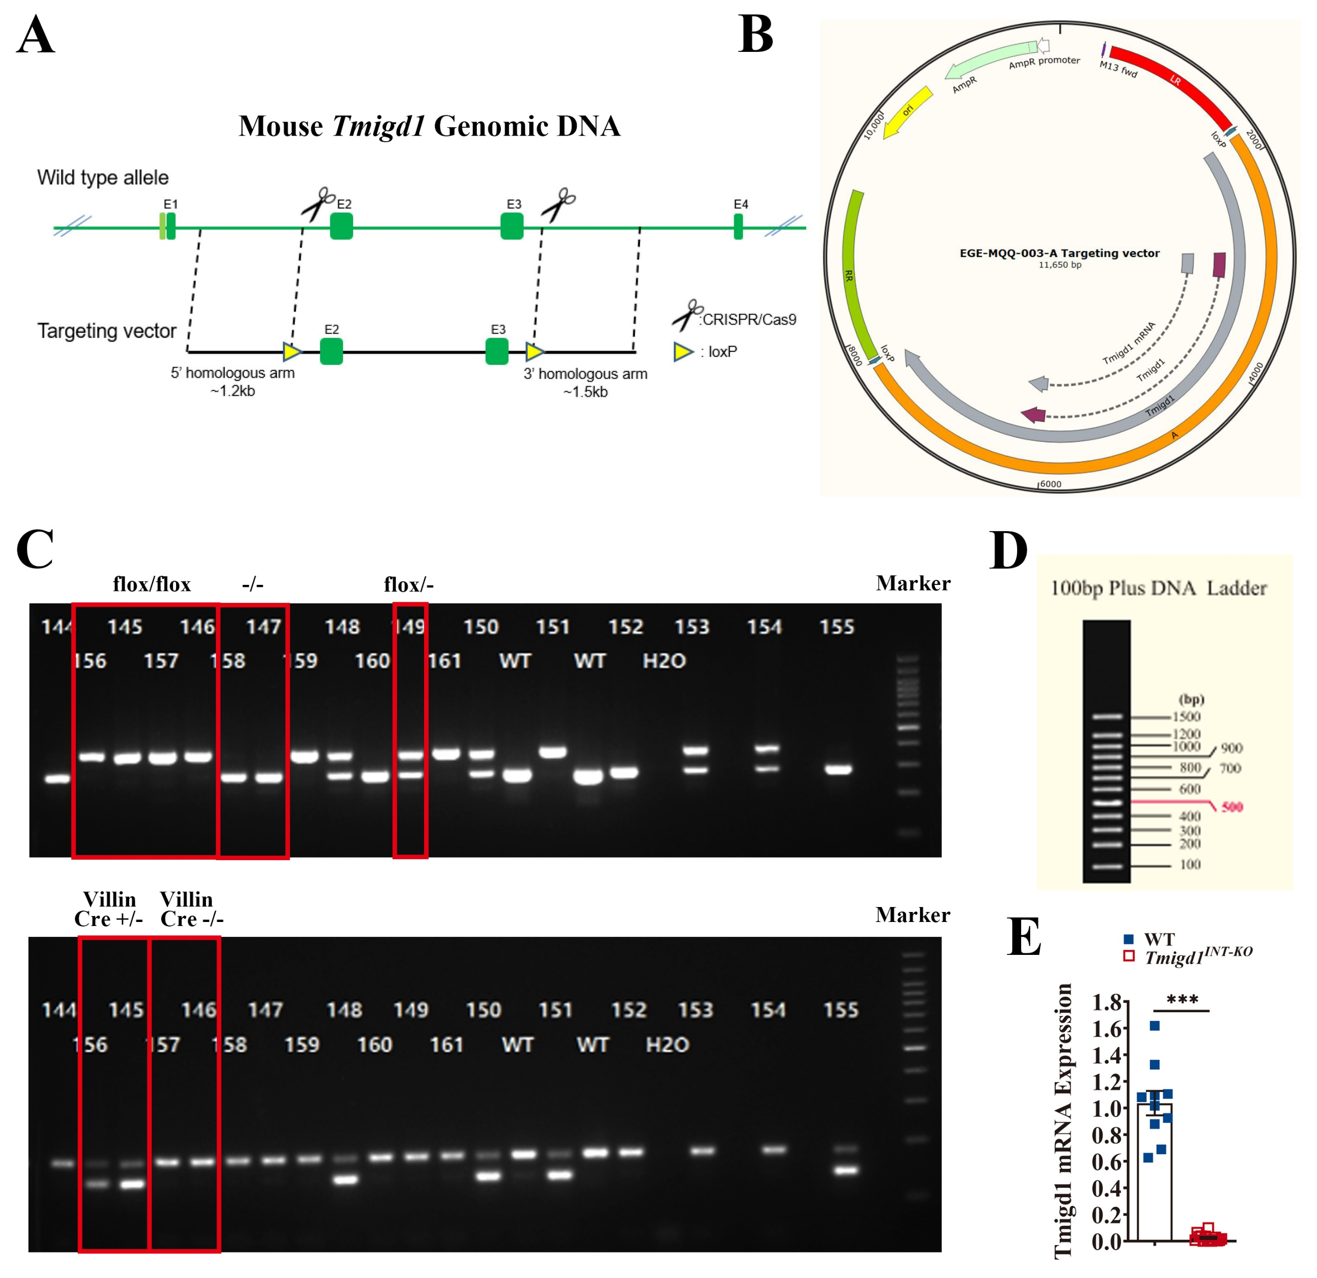

Fig. S1. Verification of Tmigd1^{INT-KO} mice
(A) Schematic illustration of the strategy to generate Tmigd1^{flox/flox} mice. SgRNAs were designed to delete exons 2 to 3 of the Tmigd1 gene. (B) Targeting plasmid in the generation of Tmigd1^{flox/flox} mice. (C) Genomic identification of Tmigd1^{flox/flox} mice (e.g., No. 145, 146, 156, 157), Tmigd1^{flox/-} (e.g., No. 149) and wild type (e.g., No. 147, 158) (up). Genomic identification of mice with villin cre (e.g., No. 145, 156) and without villin cre (e.g., No. 146, 157) (down). That is to say, Tmigd1^{INT-KO} mice (e.g., No. 145, 156), flox control (WT) mice (e.g., No. 146, 157) and wild type mice (e.g., No. 147, 158) were generated. (D) The legend of DNA marker. (E) The expression of Tmigd1 mRNA in Tmigd1^{INT-KO} mice (n=15) and WT mice (n=10).
Data are expressed as mean ± SEM. *** p<0.001.
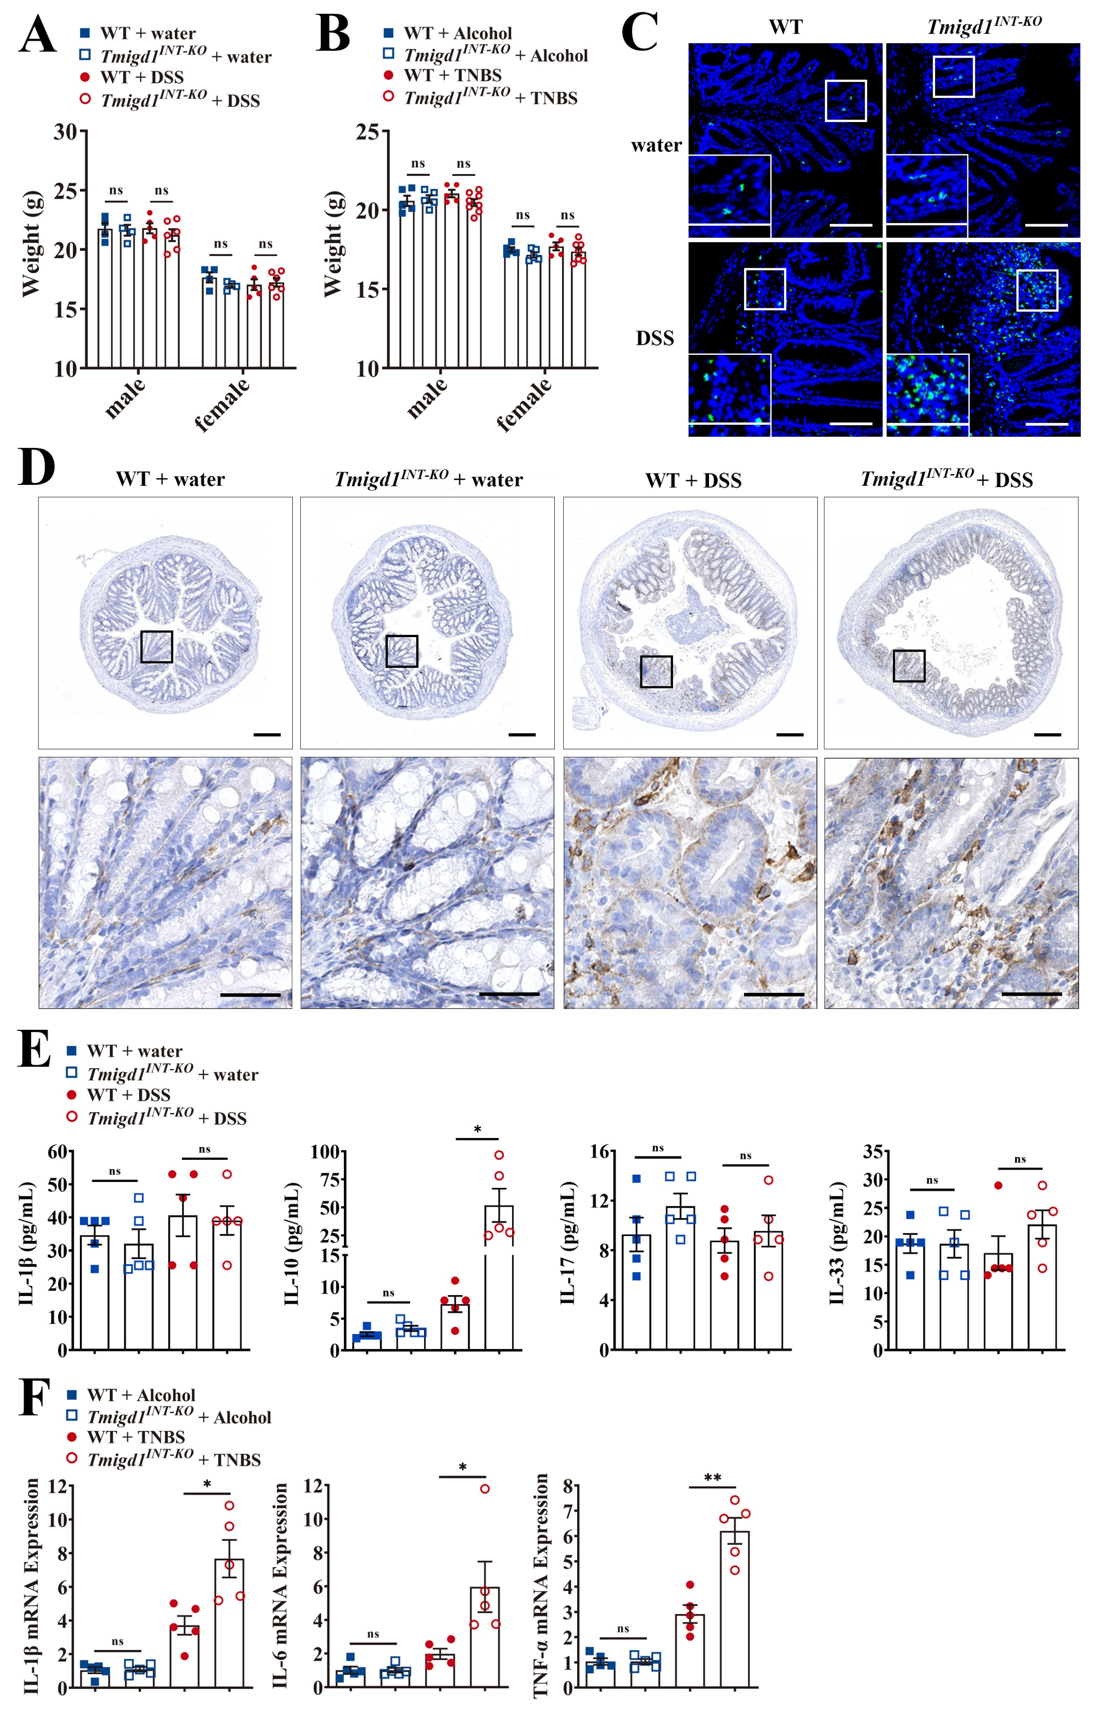

Fig. S2. Chemically induced colitis in Tmigd1^{INT-KO} mice show more severe inflammation
(A) Body weight at Day 0; WT+water (male, n=4; female, n=4), Tmigd1^{INT-KO}+water (male, n=4; female, n=4), WT+DSS (male, n=5; female, n=5), Tmigd1^{INT-KO}+DSS (male, n=6; female, n=6). (B) Body weight at Day 0; WT+Alcohol (male, n=5; female, n=5), Tmigd1^{INT-KO}+Alcohol (male, n=5; female, n=5), WT+TNBS (male, n=5; female, n=5), Tmigd1^{INT-KO}+TNBS (male, n=8; female, n=7). (C) Representative images of MPO-stained colon sections. Scale bars, 100 μm. (D) Representative images of CD4-stained colon sections. Scale bars, 200 μm (top) and 50 μm (bottom). (E) Serum IL-1β, IL-10, IL-17, and IL-33 concentrations were tested using multiELISA; Every group, n=5. (F) Pro-inflammatory cytokines mRNA in colonic tissues. Every group, n=5.
Data are expressed as mean ± SEM. ns, no significance, * p<0.05, ** p<0.01, *** p<0.001.

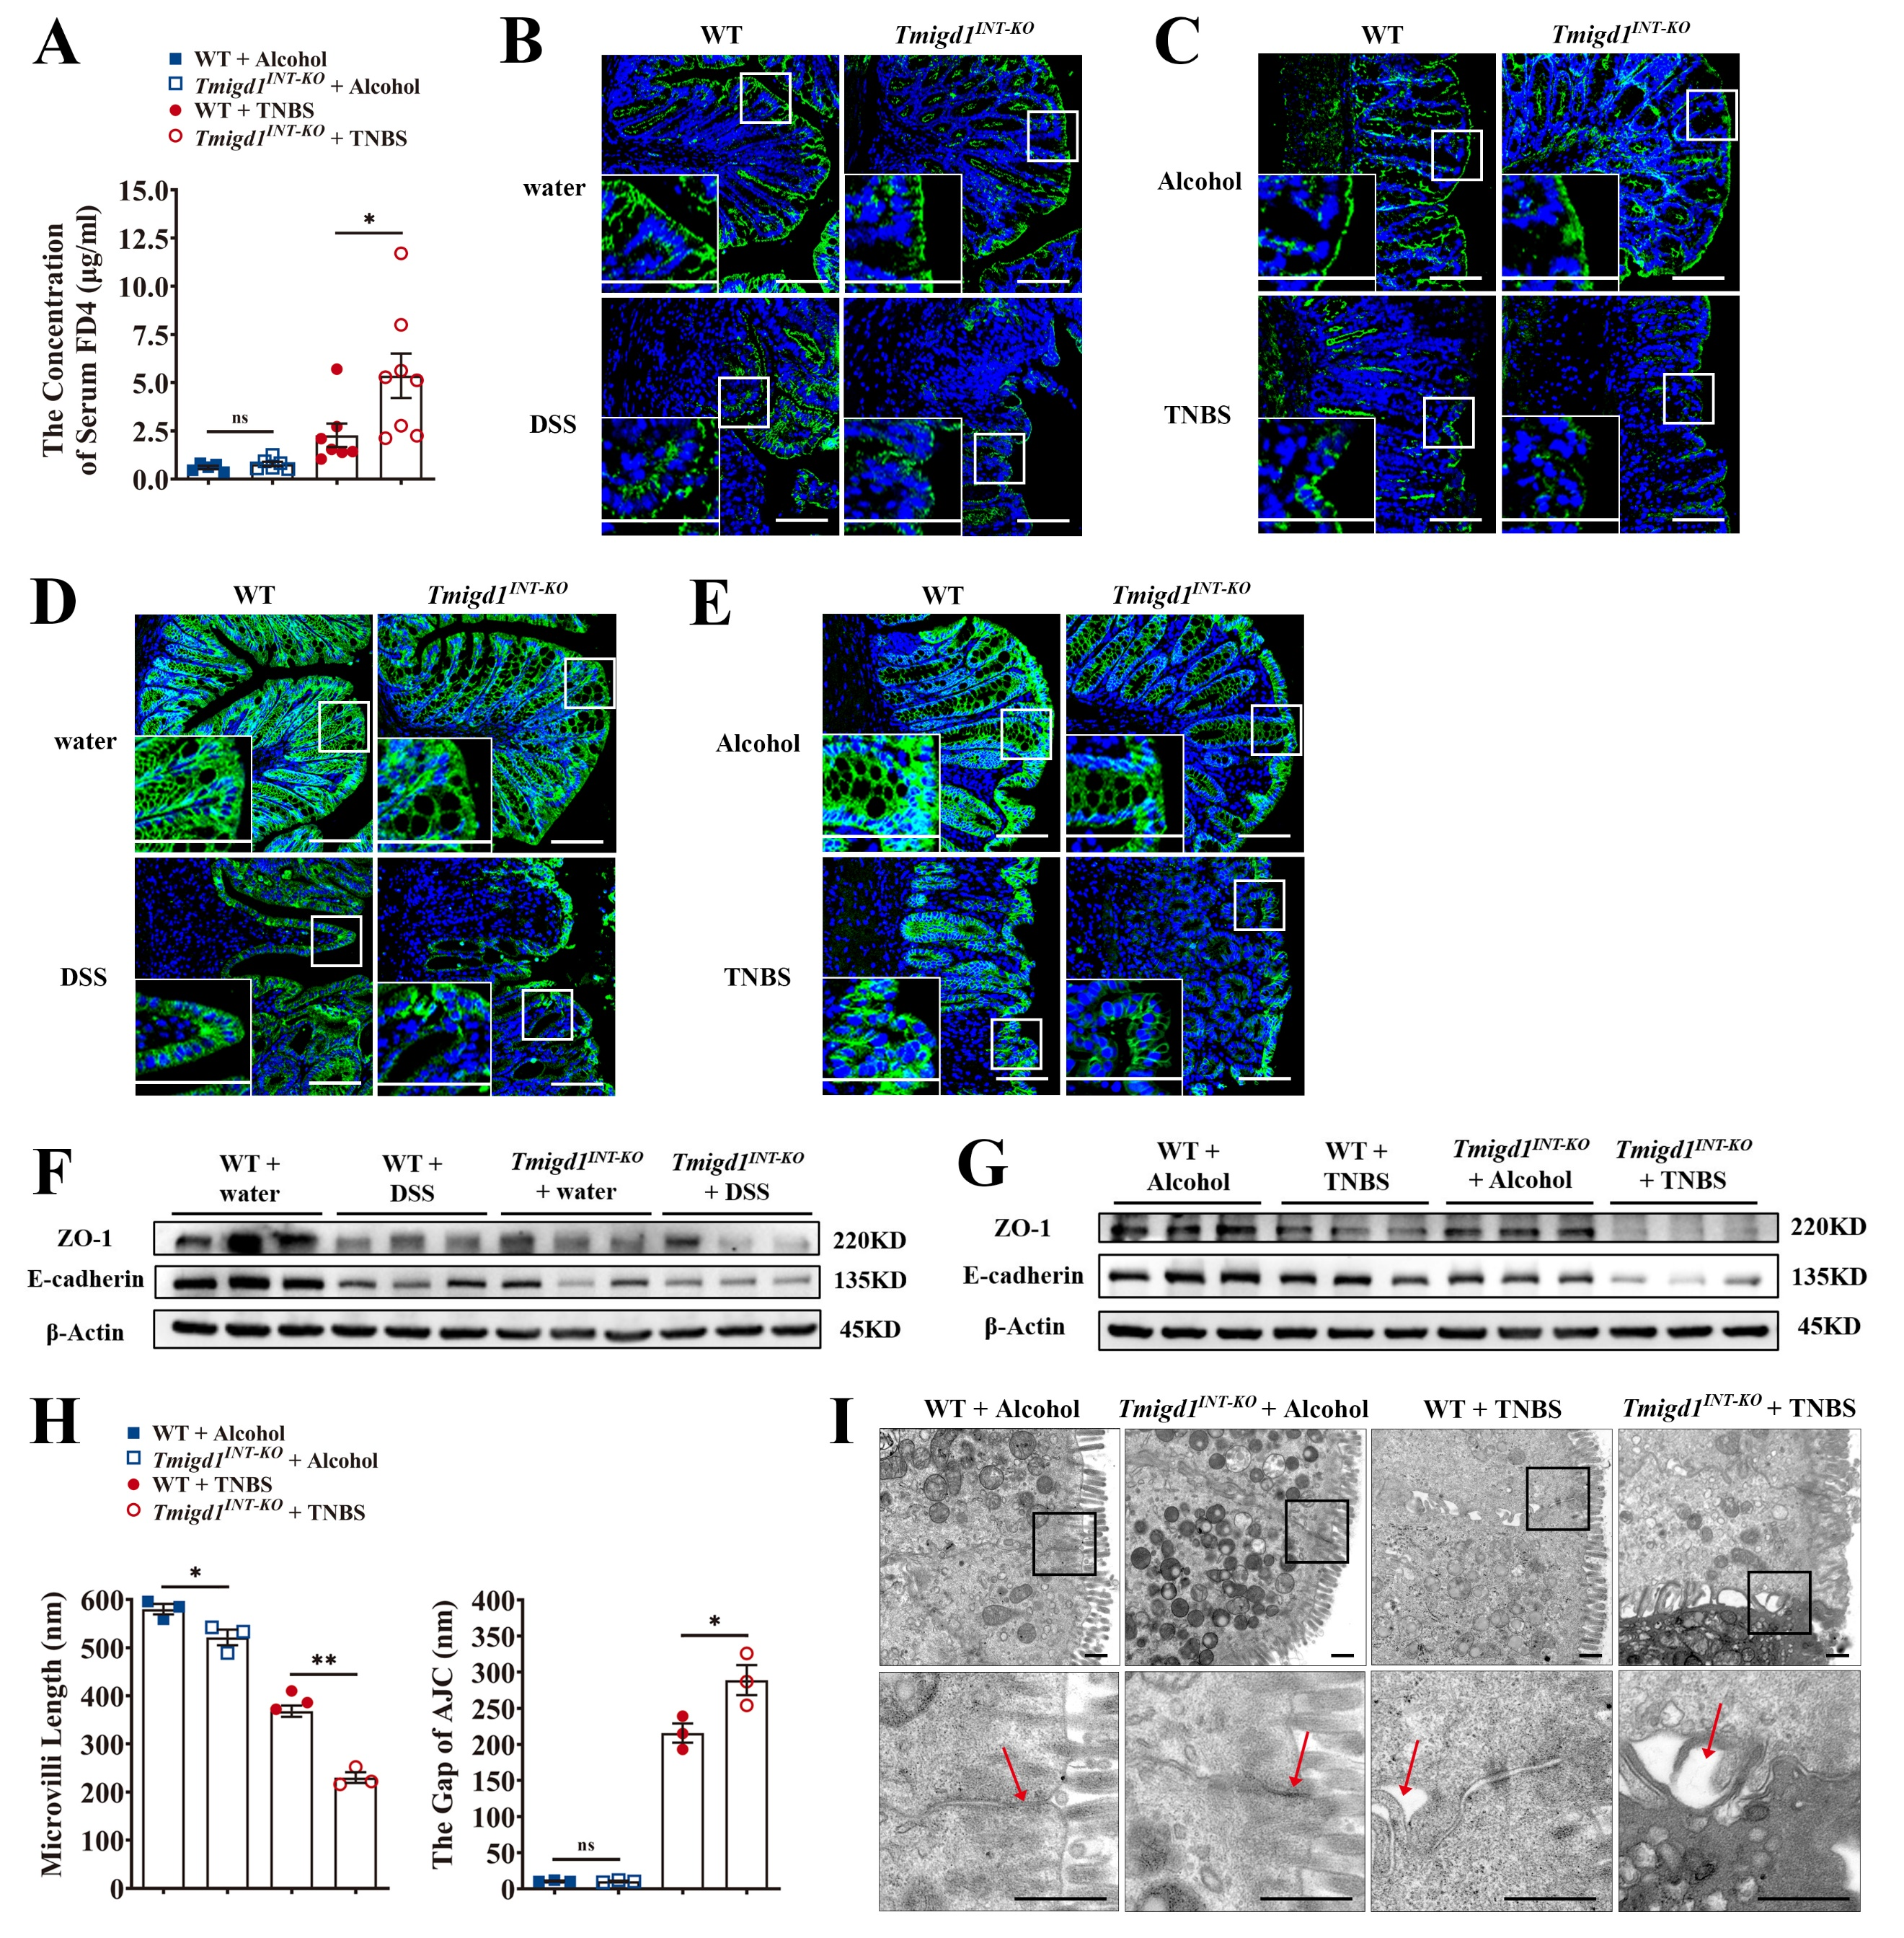

Fig. S3. Chemically induced colitis in Tmigd1^{INT-KO} mice show more severe barrier dysfunction
(A) The concentration of FD4 in serum; WT+Alcohol (n=5), Tmigd1^{INT-KO}+Alcohol (n=6), WT+TNBS (n=7), Tmigd1^{INT-KO}+TNBS (n=8). (B-C) Representative images of ZO-1-stained colon sections. Scale bars, 100 μm. (D-E) Representative images of E-cadherin-stained colon sections. Scale bars, 100 μm. (F-G) The expression of AJC proteins. (H) Measurement of microvilli length and AJC gaps in colonic epithelial cells using TEM. Every group, n=3. (I) Representative TEM images of the colonic mucosa. The arrowheads indicate AJC. Scale bars, 500 nm.
Data are expressed as mean ± SEM. ns, no significance, * p<0.05, ** p<0.01.
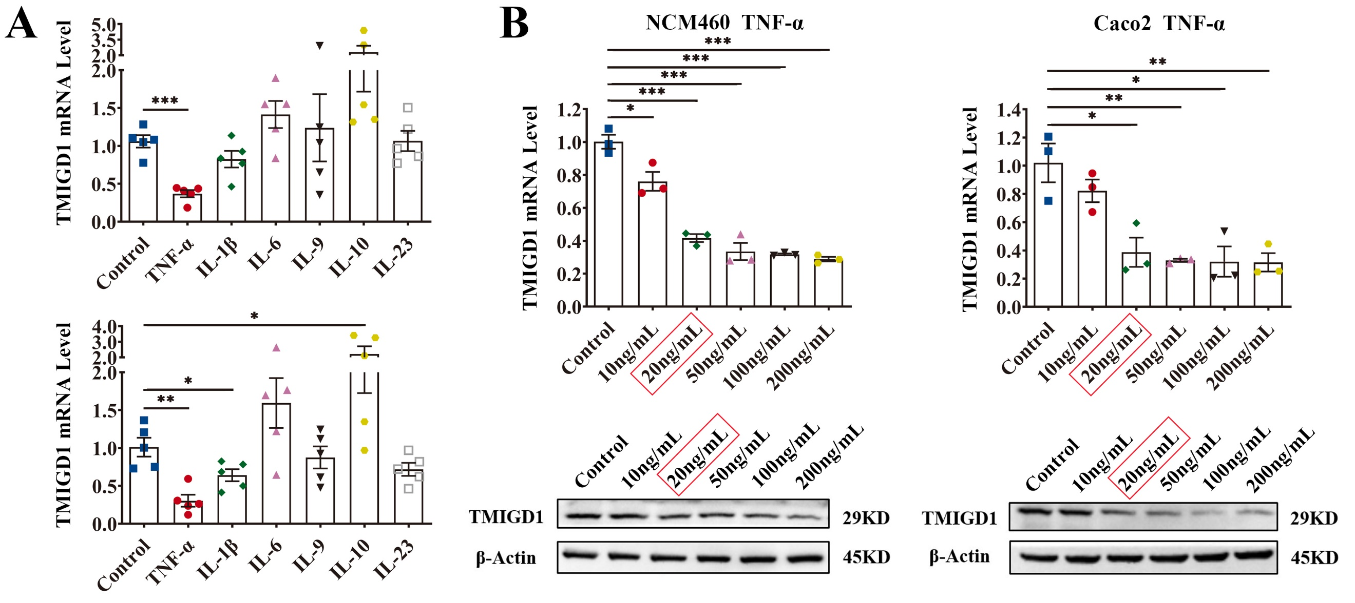

Fig. S4. TMIGD1 is downregulated after TNF-α stimulation
(A) TMIGD1 mRNA expression after cytokines treatment in NCM460 (up) and Caco2 cells (down) for 48 h. (B) The expression of TMIGD1 mRNA and protein in NCM460 (left) and Caco2 cells (right) after TNF-α stimulation at different concentrations for 48 h.
Data are expressed as mean ± SEM. ns, no significance, * p<0.05, ** p<0.01, *** p<0.001.
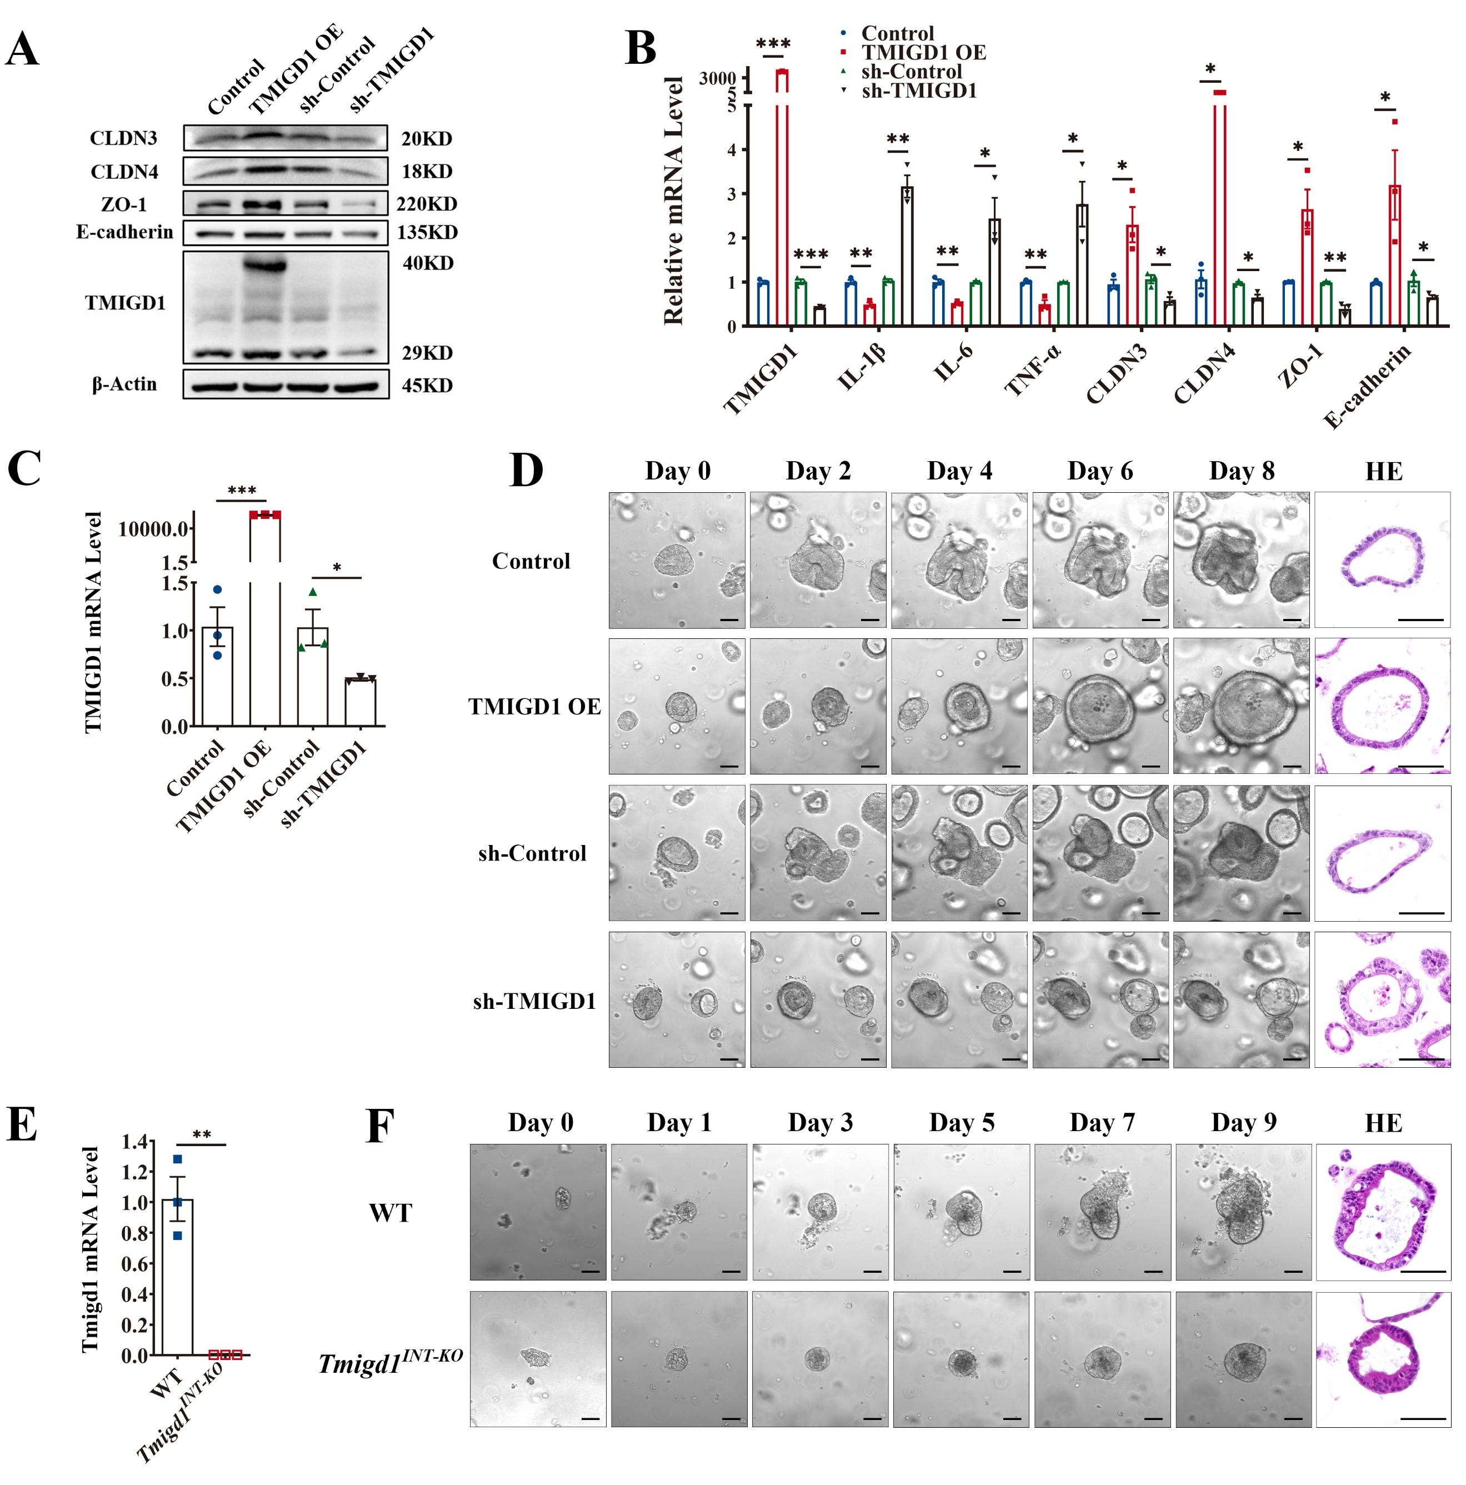

Fig. S5. TMIGD1 modulates barrier function and inflammation
(A-B) The expression of AJC proteins (A) and inflammation-relevant cytokine mRNA and AJC mRNA (B) in Caco2 cells after TNF-α stimulation. (C) The expression of TMIGD1 in human colonic organoids. (D) Cultivation of human colonic organoids and representative HE images. Scale bars, 50 μm. (E) The expression of Tmigd1 in colonic organoids generated from WT and Tmigd1^{INT-KO} mice. (F) Cultivation of murine colonic organoids and representative HE images from WT and Tmigd1^{INT-KO} mice. Scale bars, 50 μm.
Data are expressed as mean ± SEM. * p<0.05, ** p<0.01, *** p<0.001.

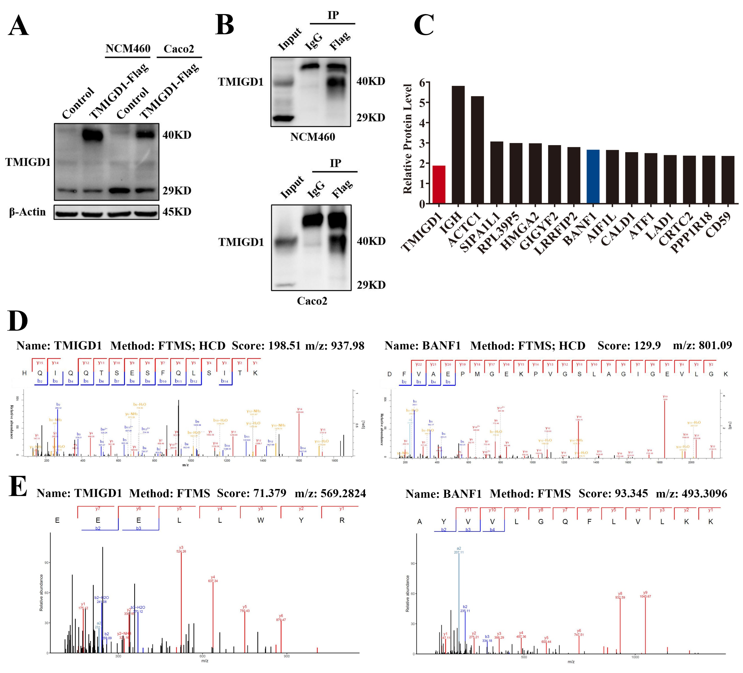

Fig. S6. TMIGD1 binds to BANF1
(A) Overexpression of FLAG-tagged TMIGD1 in NCM460 and Caco2 cells. (B) Immunoprecipitation by anti-FLAG antibody from the lysates of NCM460 or Caco2 cells transfected with lentivirus overexpressing FLAG-tagged TMIGD1. (C) Proteomic analysis shows the 15 most enriched proteins in the immunoprecipitate of Caco2 cells. (D-E) The mass spectrum of TMIGD1 protein and BANF1 protein from the immunoprecipitate of NCM460 (D) and Caco2 cells (E).

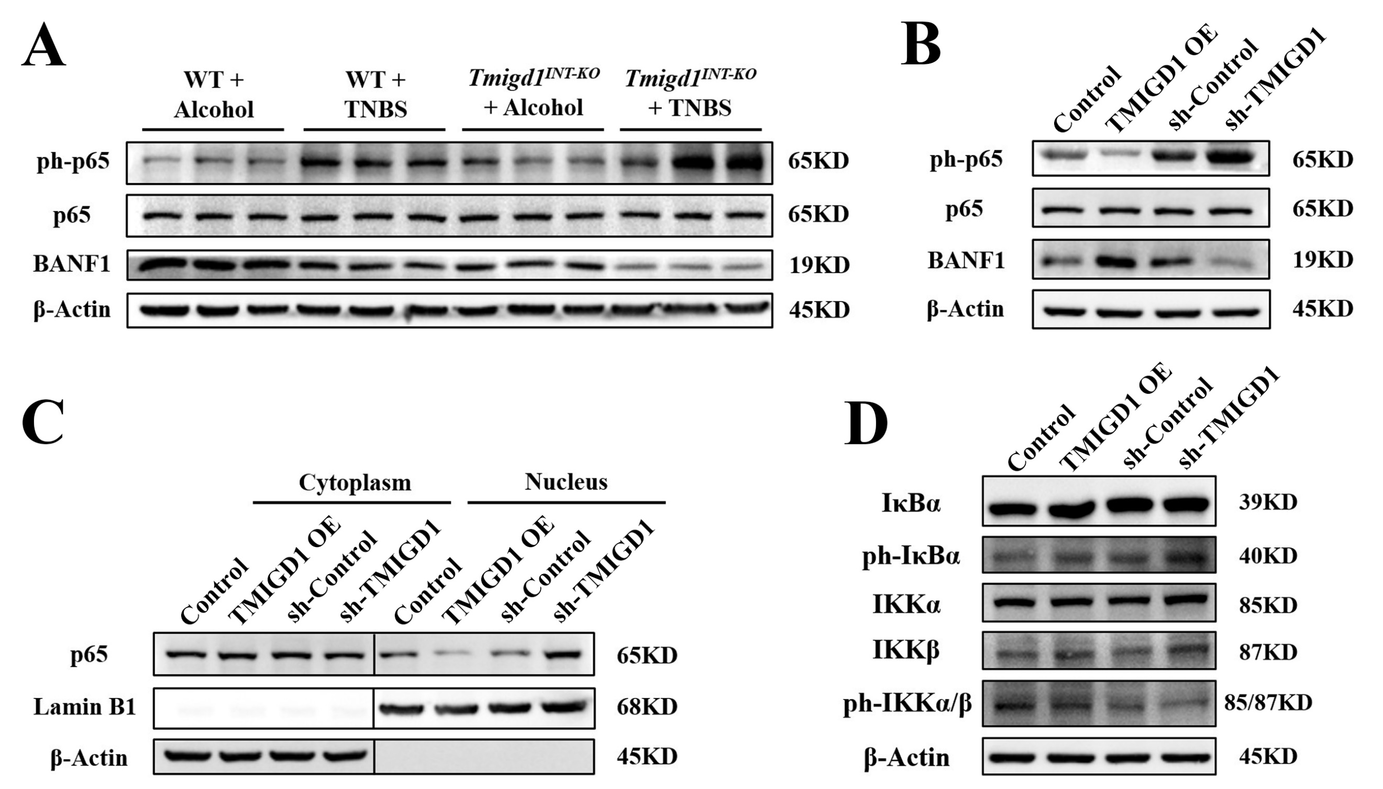

Fig. S7. TMIGD1 modulates BANF1 and inactivates NF-κB pathway
(A) Protein levels of BANF1, p65, and phosphorylated p65. (B) Protein levels of BANF1, p65, and phosphorylated p65 after TNF-α stimulation in Caco2 cells. (C) P65 in the cytoplasmic and nuclear fractions of Caco2 cells after TNF-α stimulation. (D) Protein levels of NF-κB pathway after TNF-α stimulation in NCM460 cells.

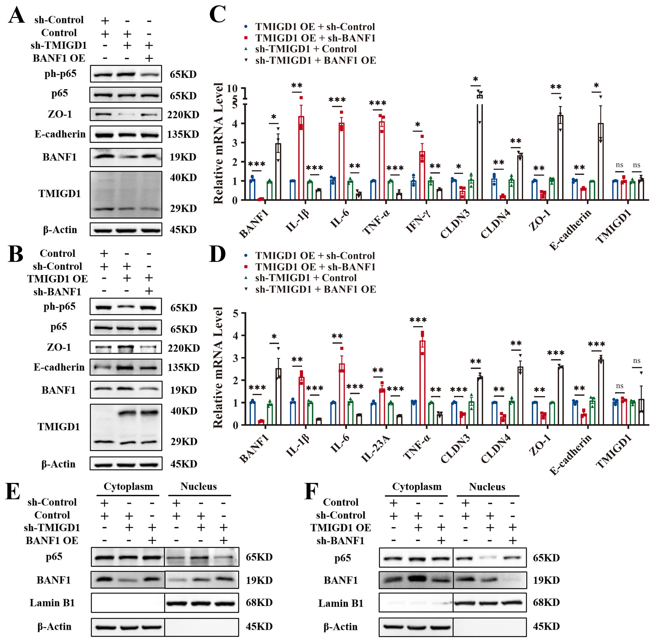

Fig. S8. BANF1 is crucial for TMIGD1 to maintain barrier function and inhibit inflammation
(A-B) The protein expression of AJC, p65, and phosphorylated p65 in Caco2 cells after TNF-α stimulation. (C-D) The mRNA levels of cytokine and AJC in NCM460 cells (C) and Caco2 cells (D) after TNF-α stimulation. (E-F) BANF1 and p65 in the cytoplasmic and nuclear fractions of Caco2 cells after TNF-α stimulation.
Data are expressed as mean ± SEM. ns, no significance, * p<0.05, ** p<0.01, *** p<0.001.

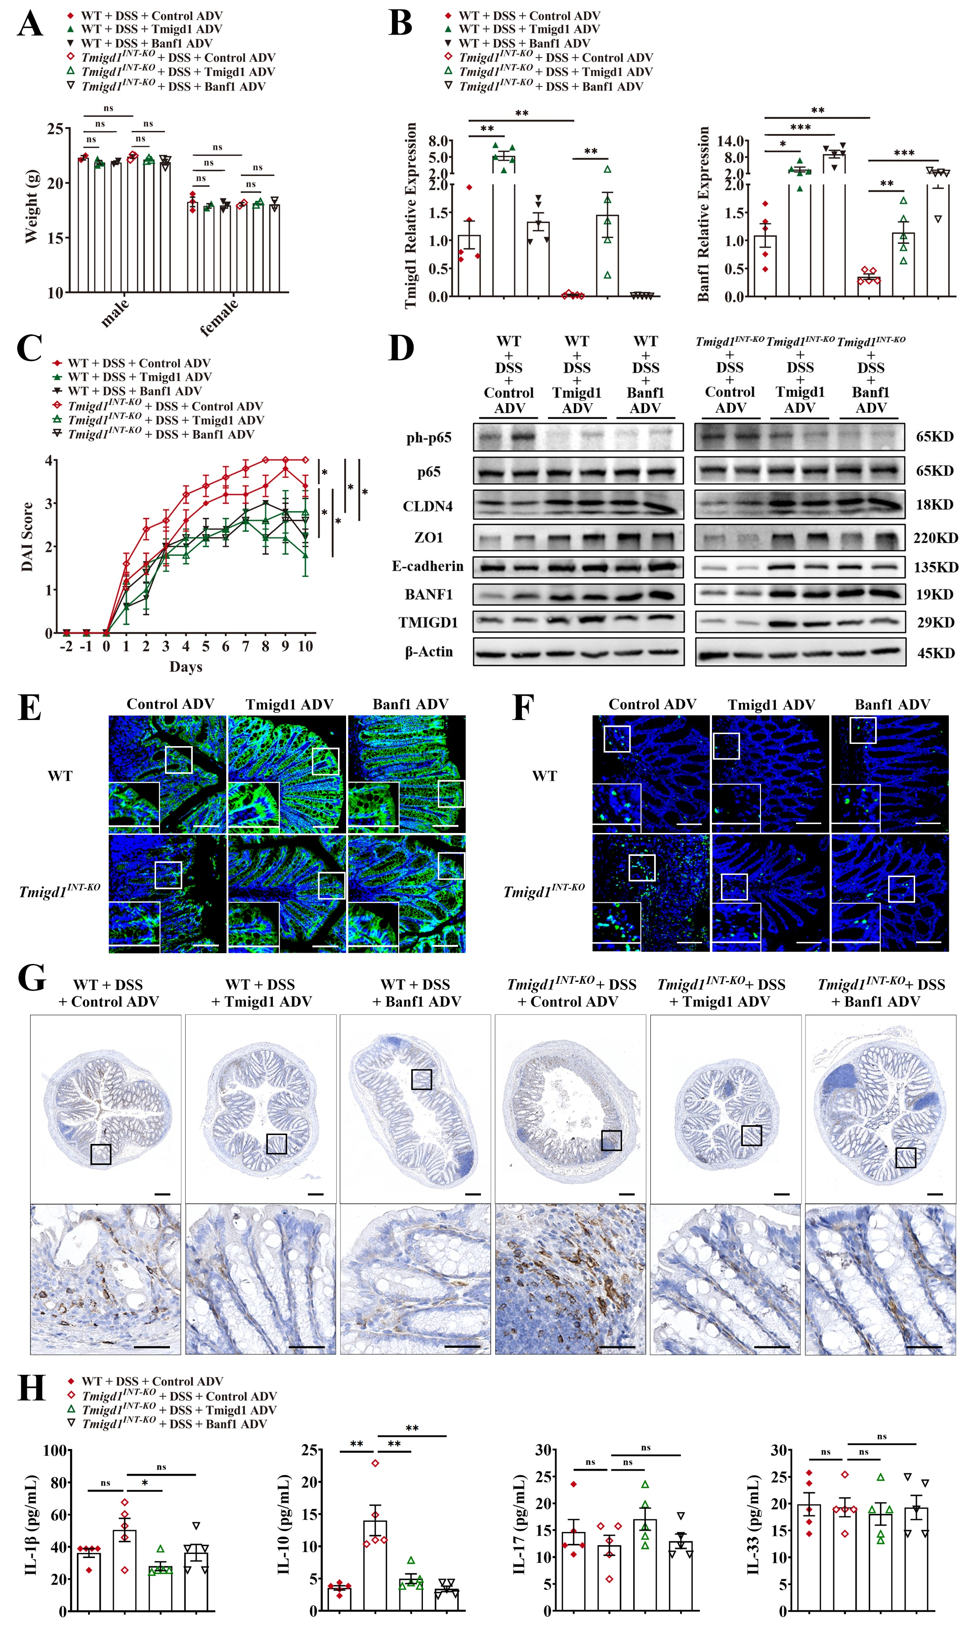
Fig. S9. Restoring TMIGD1 and BANF1 repairs barrier function and attenuates inflammation
(A) Body weight at Day -2; WT+DSS+Control ADV (male, n=2; female, n=3), WT+DSS+Tmigd1 ADV (male, n=3; female, n=2), WT+DSS+Banf1 ADV (male, n=2; female, n=3), Tmigd1^{INT-KO}+DSS+Control ADV (male, n=3; female, n=2), Tmigd1^{INT-KO} +DSS+Tmigd1 ADV (male, n=3; female, n=2) and Tmigd1^{INT-KO}+DSS+Banf1 ADV (male, n=3; female, n=2). (B) The mRNA expression of Tmigd1 and Banf1 in colonic tissues. Every group, n=5. (C) DAI scores. Every group, n=5. (D) The protein expression of AJC, p65, and phosphorylated p65 in mice colonic tissues. (E-F) Representative images of E-cadherin-stained (E) and MPO-stained (F) colon sections. Scale bars, 100 μm. (G) Representative images of CD4-stained colon sections. Scale bars, 200 μm (top) and 50 μm (bottom). (H) Serum IL-1β, IL-10, IL-17, and IL-33 concentrations were detected using multiELISA; Every group, n=5.
Data are expressed as mean ± SEM. ns, no significance, * p<0.05, ** p<0.01, *** p<0.001.

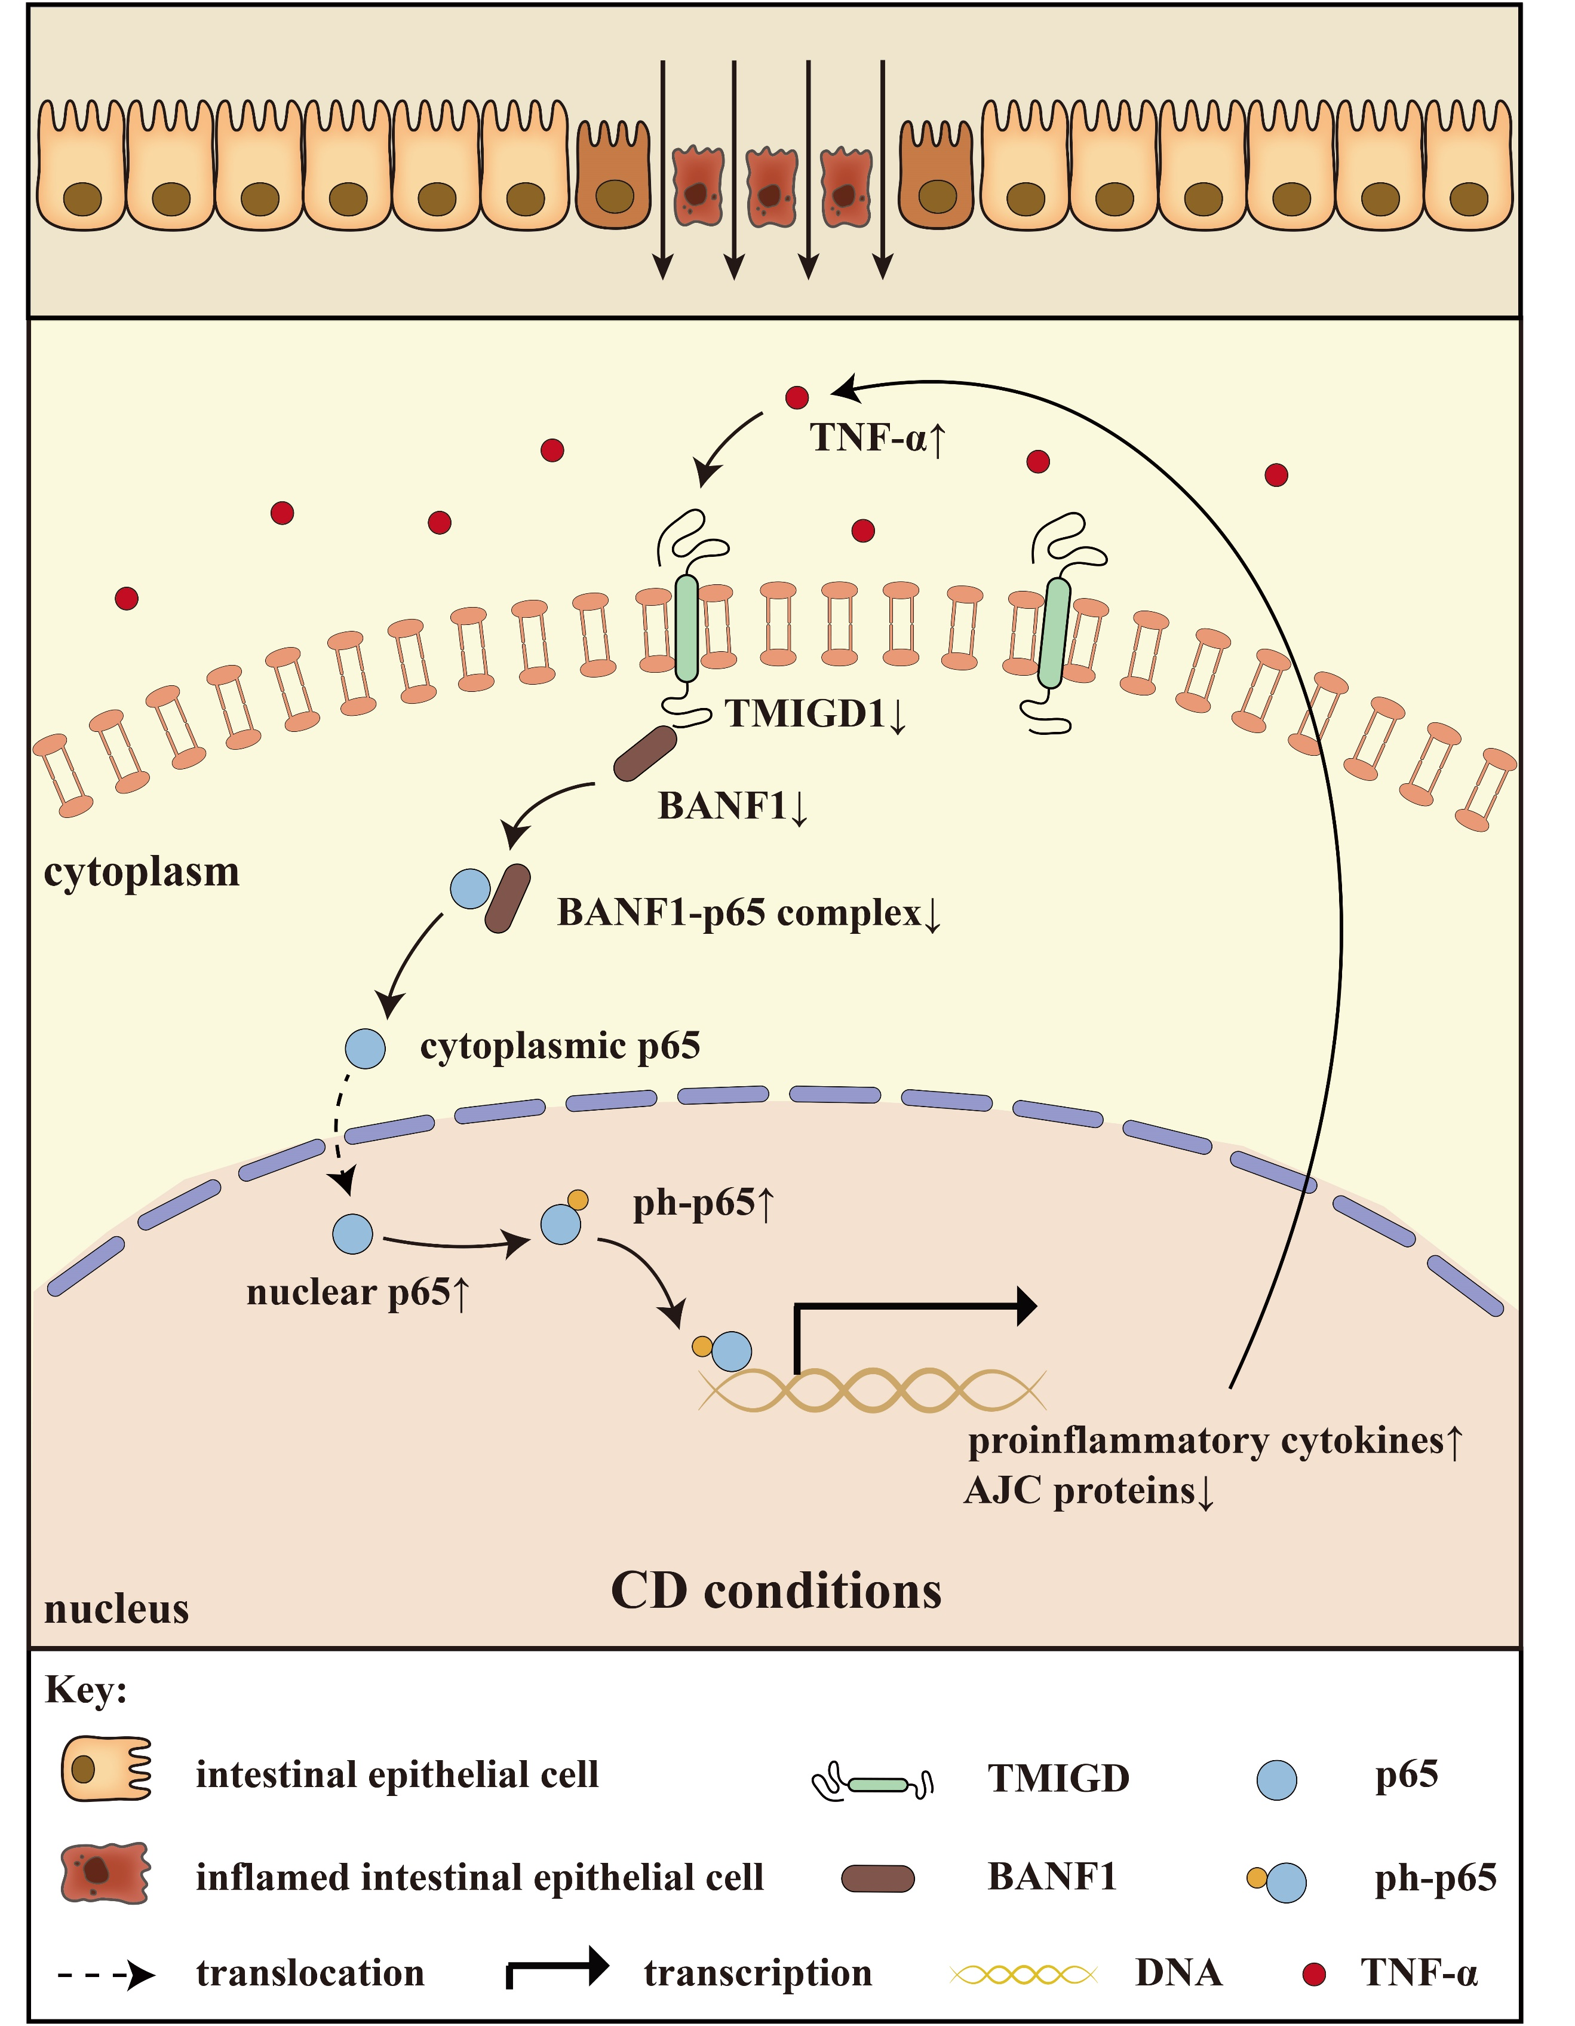

Fig. S10. The proposed model for the landscape of TMIGD1-BANF1-NF-κB pathway in CD

