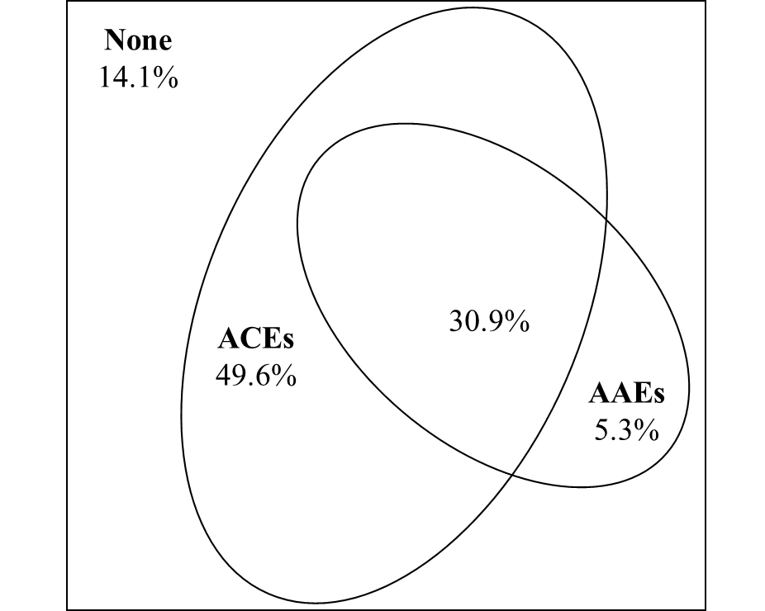
Figure S1. Overlapping exposure to adverse childhood experiences (ACEs) and adverse adulthood experiences (AAEs).

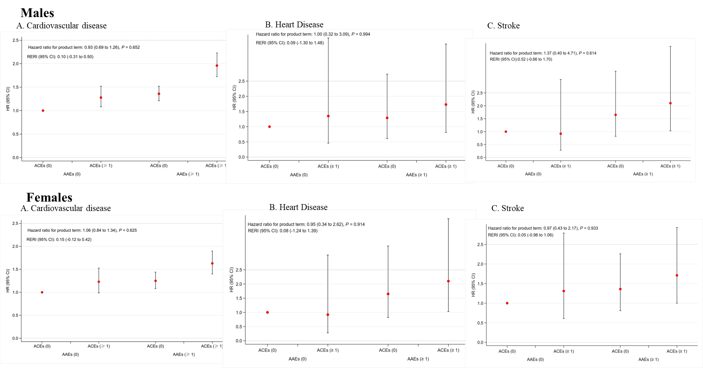

Figure S2. Interaction and joint analysis of adverse childhood experiences (ACEs) and adverse adulthood experience (AAEs) with incident cardiovascular disease (CVD): subgroup analyses by sex.

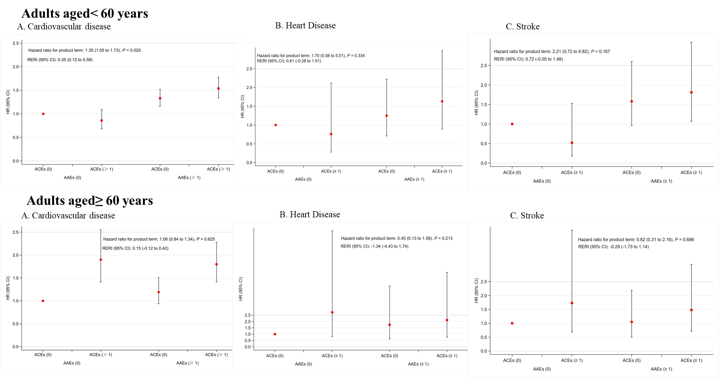
Figure S3. Interaction and joint analysis of adverse childhood experiences (ACEs) and adverse adulthood experience (AAEs) with incident cardiovascular disease (CVD): subgroup analyses by age.

Figure S4. Interaction and joint analysis of adverse childhood experiences (ACEs) and adverse adulthood experience (AAEs) with incident CVD: using the complete dataset.

