Additional file 1

Figure S1. Flow chart of participants included in the present UK Biobank study
Figure S2. Priori defined Directed Acyclic Graph
Figure S3. Cumulative incidence of NAFLD by quintiles of PDIs.
Figure S4. Joint associations of three PDIs and genetic risk with NAFLD risk
Figure S5. Joint associations of three PDIs and genetic risk with MRI-PDFF
Figure S6. Stratified analyses by sex for associations of PDIs quintiles with NAFLD risk and MRI-PDFF

Table S1. Example of food items, Filed ID in the UK Biobank, and scoring for plant-based diet indices in 17 food groups
Table S2. Definitions of NAFLD in the UK Biobank
Table S3. Characteristics of NAFLD-associated SNPs in the UK biobank
Table S4. Baseline characteristics between total participants and those with MRI-PDFF data
Table S5. Baseline characteristics by NAFLD status
Table S6. Associations between plant-based diet indices and MRI-PDFF
Table S7. Subgroup analysis of the association between overall PDI and the risk of NAFLD by genetic risk
Table S8. Subgroup analysis of the association between hPDI and the risk of NAFLD by genetic risk
Table S9. Subgroup analysis of the association between uPDI and the risk of NAFLD by genetic risk
Table S10. Hazard ratios (95% confidence intervals) of NAFLD according to sex-specific quintiles of overall plant-based diet index, healthful plant-based diet index, and unhealthful plant-based diet index
Table S11. β-coefficient (95% confidence intervals) of MRI-PDFF according to sex-specific quintiles of overall plant-based diet index, healthful plant-based diet index, and unhealthful plant-based diet index
Table S12. Subgroup analyses for the associations of PDI, hPDI, and uPDI with the risk of NAFLD per 10-point increment in each index by major confounders
Table S13. Subgroup analyses for the associations of PDI, hPDI, and uPDI with MRI-PDFF per 10-point increment in each index by major confounders
Table S14. Sensitivity analyses for associations between plant-based diet indices and NAFLD risk
Table S15. Mediating effect of BMI on associations between plant-based diet indices and NAFLD risk
Table S16. Hazard ratio (95% confidence intervals) for NAFLD according to modified plant-based diet indices (per 10-point increment) with additional adjustment for the excluded food group (servings/day)

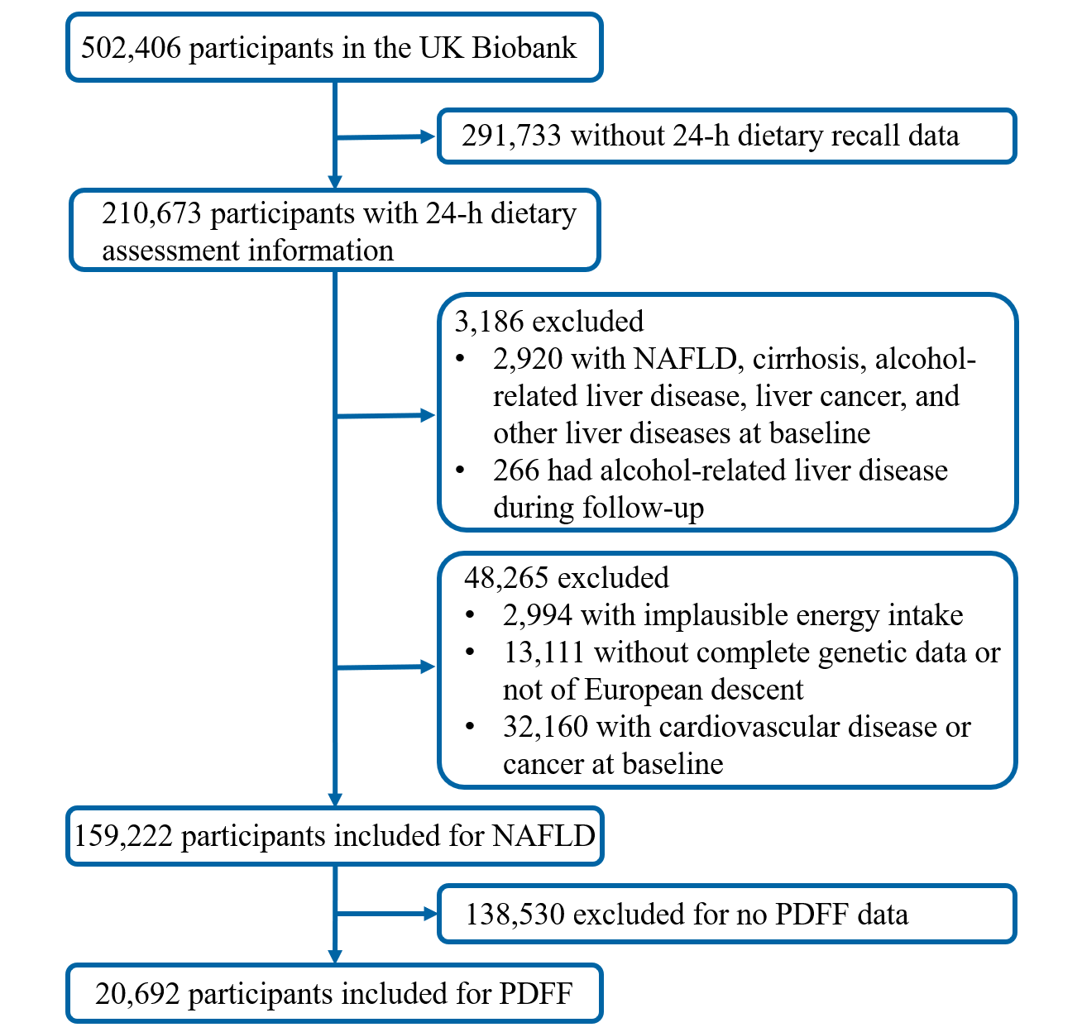
Figure S1. Flow chart of participants included in the present UK Biobank study

Abbreviations: NAFLD, non-alcoholic fatty liver disease; PDFF, proton density fat fraction;

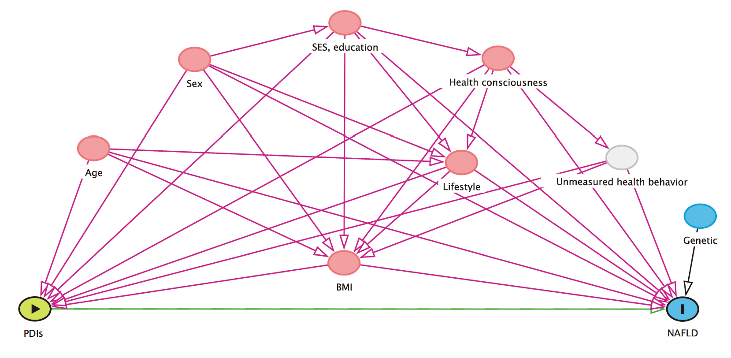
Figure S2. Priori defined Directed Acyclic Graph

The directed acyclic graph above was generated via an open-source application DAGitty based on R package 'dagitty' ( http://dagitty.net/dags.html).

Reference: Johannes Textor, Benito van der Zander, Mark K. Gilthorpe, Maciej Liskiewicz, George T.H. Ellison. Robust causal inference using directed acyclic graphs: the R package 'dagitty'. International Journal of Epidemiology 45(6):1887-1894, 2016. https://doi.org/10.1093/ije/dyw341.

Abbreviations: BMI, body mass index; NAFLD, non-alcoholic fatty liver disease; PDIs, plant-based diet indices; SES; socioeconomic status
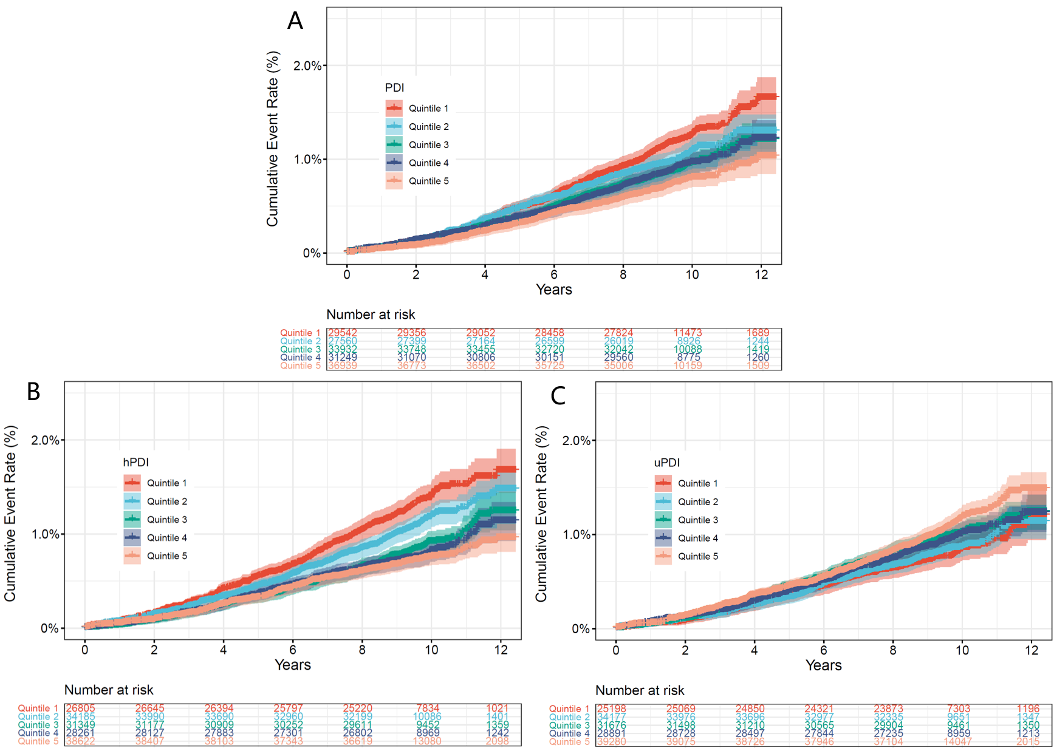
Figure S3. Cumulative incidence of NAFLD by quintiles of PDIs.
A: Cumulative incidence of NAFLD by quintiles of overall PDI
B: Cumulative incidence of NAFLD by quintiles of hPDI
C: Cumulative incidence of NAFLD by quintiles of uPDI

Abbreviations: hPDI, healthful plant-based diet index; NAFLD, non-alcoholic fatty liver disease; PDI, plant-based diet index; uPDI, unhealthful plant-based diet index.

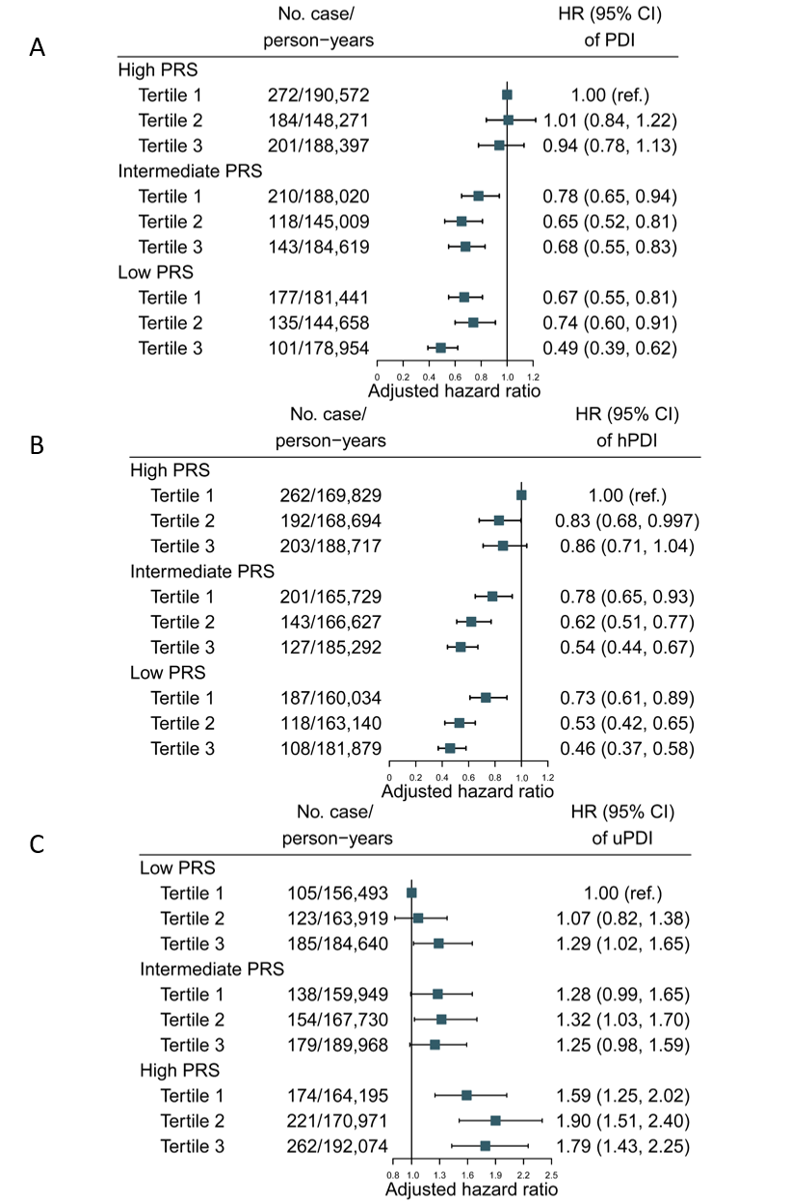
Figure S4. Joint associations of plant-based diet indices and PRS with NAFLD risk
Adjusted for age at the last dietary assessment, sex, education, household income, Townsend deprivation index, assessment centers, smoking, alcohol consumption, physical activity, total energy, BMI, first 10 principal components of ancestry, and genotype measurement batch.

A: Joint association of overall PDI and PRS with NAFLD risk.
B: Joint association of hPDI and PRS with NAFLD risk
C: Joint association of uPDI and PRS with NAFLD risk

Abbreviations: BMI, body mass index; CI, confidence interval; hPDI, healthful plant-based diet index; HR, hazards ratio; NAFLD, non-alcoholic fatty liver disease; PDI, plant-based diet index; PRS, polygenic risk score; ref., reference; uPDI, unhealthful plant-based diet index.

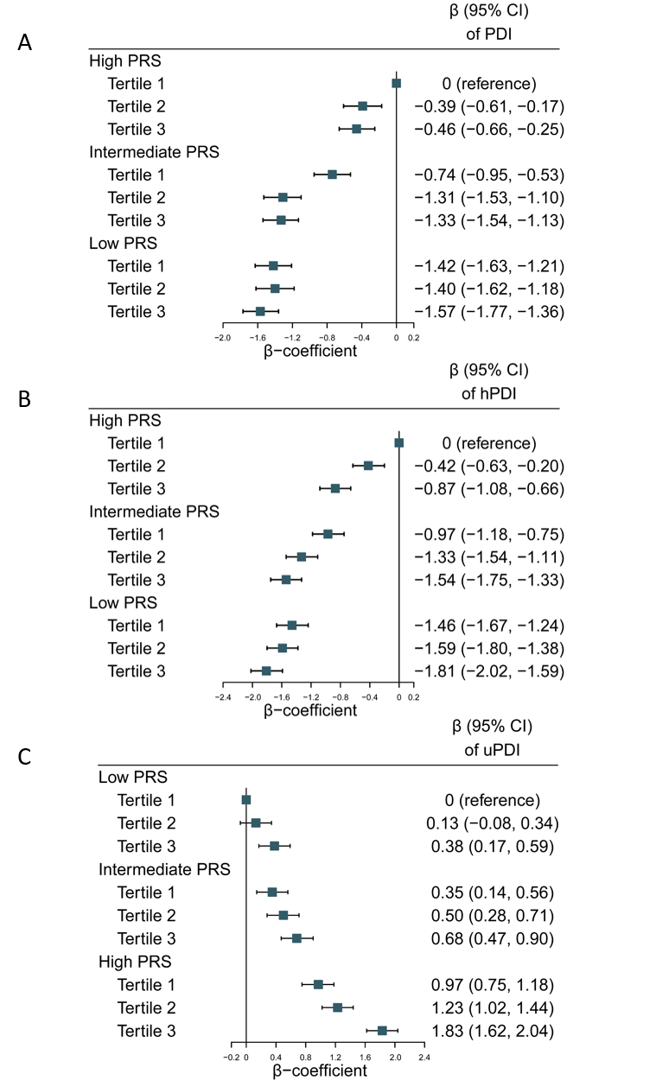
Figure S5. Joint associations of plant-based diet indices and PRS with MRI-PDFF
Adjusted for age at the last dietary assessment, age at MRI scan, sex, education, household income, Townsend deprivation index, assessment centers, smoking, alcohol consumption, physical activity, total energy, BMI, first 10 principal components of ancestry, and genotype measurement batch.

A: Joint association of overall PDI and PRS with MRI-PDFF.
B: Joint association of hPDI and PRS with MRI-PDFF
C: Joint association of uPDI and PRS with MRI-PDFF

Abbreviations: BMI, body mass index; CI, confidence interval; hPDI, healthful plant-based diet index; MRI, magnetic resonance imaging; NAFLD, non-alcoholic fatty liver disease; PDFF, proton density fat fraction; PDI, plant-based diet index; PRS, polygenic risk score; uPDI, unhealthful plant-based diet index.

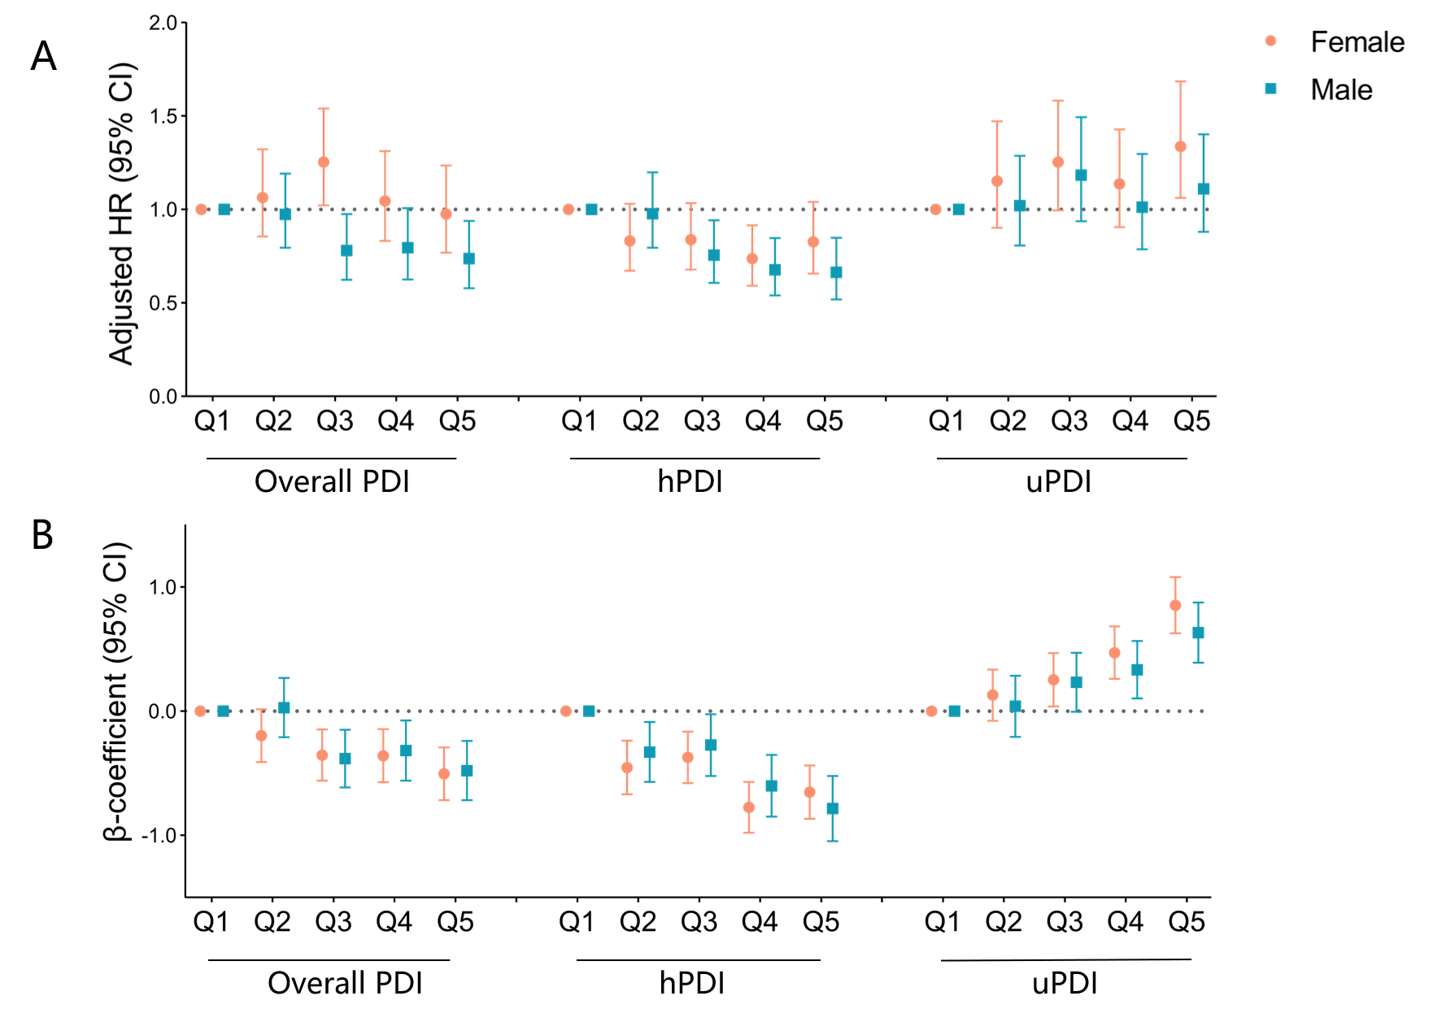

Figure S6. Stratified analyses by sex for associations of PDIs quintiles with NAFLD risk and MRI-PDFF

Adjusted for age at the last dietary assessment, age at MRI scan (for MRI-PDFF only), sex, education, household income, Townsend deprivation index, assessment centers, smoking, alcohol consumption, physical activity, total energy, BMI, PRS, first 10 principal components of ancestry, and genotype measurement batch.
A: Hazard ratios (95% CI) for NAFLD risk according to PDIs quintiles by sex
B: β-coefficient (95% CI) for MRI-PDFF according to PDIs quintiles by sex

Abbreviations: BMI, body mass index; CI, confidence interval; hPDI, healthful plant-based diet index; MRI, magnetic resonance imaging; NAFLD, non-alcoholic fatty liver disease; PDFF, proton density fat fraction; PDI, plant-based diet index; PRS, polygenic risk score; uPDI, unhealthful plant-based diet index.

Table S1. Example of food items, Filed ID in the UK Biobank, and scoring for plant-based diet indices in 17 food groups

Food groups | Food items | Field ID | Scoring for PDI | Scoring for hPDI | Scoring for uPDI
Plant-based food groups
Healthy
Whole grains | Porridge, muesli, plain cereal, bran cereal, whole-wheat cereal, oatcakes, wholemeal bread (flour type: wholemeal), whole meal pasta, brown rice, couscous, other cooked grains (such as bulgur). | 100770, 100800, 100830, 100840, 100850, 100950, 20091, 101020, 20092, 101090, 20093, 101160, 20094, 101260, 102720, 102740, 102780 | Positive | Positive | Reverse
Fruits | Stewed fruit, prune, dried fruit, mixed fruit, apple, banana, berries, cherries, grapefruit, grapes, mango, melon, orange, orange-like small fruits, peach/nectarine, pear, pineapple, plum, other fruits, olives | 104410, 104420, 104430, 104440, 104450, 104460, 104470, 104480, 104490, 104500, 104510, 104520, 104530, 104540, 104550, 104560, 104570, 104580, 104590, 102490 | Positive | Positive | Reverse
Vegetables | Mixed vegetables, vegetable pieces, coleslaw, side salad, avocado, beetroot, broccoli, butternut squash, cabbage/kale, carrots, cauliflower, celery, courgette, cucumber, garlic, leeks, lettuce, mushrooms, onion, parsnip, sweet peppers, spinach,  sprouts, sweetcorn, fresh tomatoes, cooked or tinned tomatoes, turnip/swede, watercress, other vegetable intake | 104060, 104070, 104080, 104090, 104100, 104130, 104140, 104150, 104160, 104170, 104180, 104190, 104200, 104210, 104220, 104230, 104240, 104250, 104260, 104270, 104290, 104300, 104310, 104320, 104340, 104350, 104360, 104370, 104380 | Positive | Positive | Reverse
Nuts | Salted peanuts, unsalted peanuts, salted nuts, unsalted nuts, seeds | 102410, 102420, 102430, 102440, 102450 | Positive | Positive | Reverse
Legumes | Vegetarian sausages/burgers, tofu, quorn, other vegetarian alternative, baked beans, pulse, broad beans, green beans, peas | 103260, 103270, 103280, 103290, 104000, 104010, 104110, 104120, 104280 | Positive | Positive | Reverse
Tea and coffee | Instant coffee, filtered coffee, cappuccino, latte, espresso, other coffee drinks, standard tea, rooibos tea, green tea, herbal tea, other tea, low calorie hot chocolate, hot chocolate | 100250, 100270, 100290, 100300, 100310, 100330, 100400, 100410, 100420, 100430, 100440, 100540, 100550 | Positive | Positive | Reverse
Less healthy
Refined grains | Oat crunch, sweetened cereal, other cereal, white bread (flour types: white, mix, and others), naan bread, garlic bread, crispbread, other bread, white pasta, white rice, snackpot, couscous, pancake, scotch pancake, croissant, scone, savoury biscuits, cheesy biscuits, sweet potato, other savoury snack | 100810, 100820, 100860, 101230, 101240, 101250, 101270, 102710, 102730, 102760, 102770, 102010, 102020, 102050, 102070, 102470, 102480, 102500, 104330 | Positive | Reverse | Positive
Potatoes | Fried potatoes, boiled/baked potatoes, mashed potatoes, crisps (e.g., potato chips) | 102460, 104020, 104030, 104050 | Positive | Reverse | Positive
Sugary drinks | Low calorie or diet drinks (e.g. fizzy, squash), carbonated (fizzy) drinks, squash or cordial | 100160, 100170, 100180 | Positive | Reverse | Positive
Fruit juices | Orange juice, grapefruit juice, other fruit/vegetable juice, fruit smoothie | 100190, 100200, 100210, 100220 | Positive | Reverse | Positive
Sweets and desserts | Double crust pie, single crust pie/flan, crumble topping, Yorkshire pudding, Danish pastry, fruitcake, cake, doughnuts, sponge pudding, other dessert, chocolate bar, white chocolate, milk chocolate, dark chocolate, chocolate-covered raisin, chocolate sweet, diet sweets, chocolate-covered biscuits, chocolate biscuits, sweet biscuits, other sweets | 101970, 101980, 101990, 102030, 102060, 102170, 102180, 102190, 102200, 102210, 102230, 102260, 102270, 102280, 102290, 102300, 102310, 102320, 102330, 102340, 102350, 102360, 102370, 102380 | Positive | Reverse | Positive
Animal-based food groups
Animal fat | Butter on bread/crackers (spreadable, low fat, normal fat, or unknown type), dairy spread on bread/crackers (very low fat, low fat, normal fat, unknown type) | 101310, 101350, 101390, 101430, 101470, 101510, 101550 | Reverse | Reverse | Reverse
Dairy | Milk, dairy smoothie, flavored milk, yogurt, ice-cream, cheesecake, milk-based pudding, other milk-based pudding, low fat hard cheese, hard cheese, soft cheese, blue cheese, low fat cheese spread, cheese spread, cottage cheese, feta cheese, mozzarella cheese, goat's cheese, other cheese | 100230, 100520, 100530, 102090, 102120, 102140, 102150, 102220, 102810, 102820, 102830, 102840, 102850, 102860, 102870, 102880, 102890, 102900, 102910 | Reverse | Reverse | Reverse
Eggs | Whole eggs, omelettes or scrambled egg, eggs in sandwiches, scotch egg, other egg dishes | 102940, 102950, 102960, 102970, 102980 | Reverse | Reverse | Reverse
Fish or seafood | Tinned tuna, oily fish, breaded fish, battered fish, white fish, prawns, lobster/crab, shellfish, other fish intake | 103150, 103160, 103170, 103180, 103190, 103200, 103210, 103220, 103230 | Reverse | Reverse | Reverse
Meat | Sausage, beef, pork, lamb, crumbed or deep-fried poultry, poultry, bacon, ham, liver, other meat intake | 103010, 103020, 103030, 103040, 103050, 103060, 103070, 103080, 103090, 103100 | Reverse | Reverse | Reverse
Miscellaneous animal-based foods | Pizza, Indian snacks | 102000, 102040 | Reverse | Reverse | Reverse

Abbreviations: hPDI, healthful plant-based diet index; PDI, plant-based diet index; uPDI, unhealthful plant-based diet index.

Table S2. Definitions of NAFLD in the UK Biobank

 | ICD-9 | ICD-10 | Primary care
NAFLD | 5718 | K760 | J61y., J61y0, J61y1, J61y2, J61y7, J61y9, J61yz (Read V2); J61y., J61y0, J61y1, J61y2, J61y7, J61yz, X307v, X307W, XE2Zz (Read CTV3)

Abbreviations: NAFLD, non-alcoholic fatty liver disease; ICD, International Classification of Diseases.
Table S3. Characteristics of NAFLD-associated SNPs in the UK biobank

SNP | Chr | Gene | Risk allele | Reference allele | Beta
rs738409 | 22 | PNPLA3 | G | C | 0.594
rs58542926 | 19 | TM6SF2 | T | C | 0.166
rs641738 | 19 | MBOAT7 | T | C | 0.073
rs1260326 | 2 | GCKR | T | C | 0.271
rs72613567 | 4 | HSD17B13 | T | TA | 0.216
Abbreviations: Chr, chromosome; NAFLD, non-alcoholic fatty liver disease; SNP, single nucleotide polymorphisms.
Table S4. Baseline characteristics between total participants and those with MRI-PDFF data
Characteristics | Total participants (n=159,222) | With MRI-PDFF data (n=20,692)
Age, mean (SD), y | 58.0 (8.0) | 57.5 (7.4)
Male, n (%) | 10,545 (44.3) | 9,815 (47.4)
Townsend Deprivation Index, median (IQR) | -2.4 (-3.8, -0.1) | -2.7 (-3.9, -0.6)
Deprivation fifth, n (%)
First (least deprived) | 31,807 (20.0) | 4,691 (22.7)
Second to fourth | 95,416 (59.9) | 12,524 (60.5)
Fifth (most deprived) | 31,804 (20.0) | 3,462 (16.7)
Unknown | 195 (0.1) | 15 (0.1)
Education
College or university | 68,790 (43.2) | 10,422 (50.4)
Vocational | 15,997 (10.1) | 1,913 (9.3)
Upper secondary | 21,397 (13.4) | 2,861 (13.8)
Lower secondary | 40,041 (25.2) | 4,520 (21.8)
Others | 12,419 (7.8) | 942 (4.6)
Unknown | 578 (0.4) | 34 (0.2)
Household income, £
<18,000 | 20,202 (12.7) | 1,935 (9.4)
18,000-30,999 | 33,545 (21.1) | 4,027 (19.5)
31,000-51,999 | 41,687 (26.2) | 5,849 (28.3)
52,000-100,000 | 37,108 (23.3) | 5,753 (27.8)
>100,000 | 11,114 (7.0) | 1,587 (7.7)
Unknown | 15,566 (9.8) | 1,541 (7.5)
Alcohol consumption among drinkers, median (IQR), g/day | 11.9 (5.1, 21.6) | 12.4 (6.0, 22.7)
Current smoker, n (%) | 12,144 (7.6) | 1,154 (5.6)
Body mass index, mean (SD), kg/m² | 26.8 (4.6) | 26.3 (4.1)
Waist circumference, mean (SD), cm | 88.5 (13.1) | 87.4 (12.5)
Total physical activity, MET-mins/week
0-599 | 24,064 (15.1) | 3,268 (15.8)
600-1199 | 24,933 (15.7) | 3,373 (16.3)
≥1200 | 86,396 (54.3) | 11,416 (55.2)
Unknown | 23,829 (15.0) | 2,635 (12.7)
Energy intake (kcal/d) | 2,002.1 (1,679.1, 2,370.0) | 2,028.5 (1,721.0, 2,379.3)
Alanine aminotransferase, median (IQR), U/L | 19.6 (15.1, 26.5) | 19.5 (15.0, 26.3)
Albumin, median (IQR), g/L | 45.4 (43.7, 47.1) | 45.4 (43.8, 47.1)
Gamma glutamyltransferase, median (IQR), U/L | 24.5 (17.6, 37.6) | 23.7 (17.2, 36.1)
Glucose, mean (SD), mmol/L | 5.1 (1.1) | 5.0 (1.0)
Glycated haemoglobin, mean (SD), mmol/mol | 35.3 (5.6) | 34.8 (5.0)
Triglycerides, median (IQR), mmol/L | 125.5 (89.2, 181.3) | 121.5 (86.6, 175.7)
Depression, n (%) | 21,710 (13.6) | 2,422 (11.7)
Dyslipidemia, n (%) | 74,740 (46.9) | 9,078 (43.9)
Hypertension, n (%) | 79,218 (49.8) | 9,340 (45.4)
Diabetes, n (%) | 6,392 (4.0) | 638 (3.1)
PDI, median (IQR) | 50 (47, 54) | 51 (47, 54)
hPDI, median (IQR) | 54 (50, 58) | 54 (50, 58)
uPDI, median (IQR) | 55 (51, 59) | 55 (51, 59)
Abbreviations: hPDI, healthful plant-based diet index; IQR, interquartile range; MRI, magnetic resonance imaging; PDFF, proton density fat fraction; PDI, plant-based diet index; SD, standard deviation; uPDI, unhealthful plant-based diet index.
Table S5. Baseline characteristics by NAFLD status
Characteristics | Non NAFLD cases (n=157,681) | NAFLD cases (n=1,541)
Age, mean (SD), y | 58.0 (8.0) | 58.0 (7.9)
Male, n (%) | 69,792 (44.3) | 753 (48.9)
Townsend Deprivation Index, median (IQR) | -2.4 (-3.8, -0.1) | -2.7 (-3.9, -0.6)
Deprivation fifth, n (%)
First (least deprived) | 31,561 (20.0) | 246 (16.0)
Second to fourth | 94,549 (60.0) | 867 (56.3)
Fifth (most deprived) | 31,379 (19.9) | 425 (27.6)
Unknown | 192 (0.1) | 3 (0.2)
Education
College or university | 68,284 (43.3) | 506 (32.8)
Vocational | 15,793 (10.0) | 204 (13.2)
Upper secondary | 21,195 (13.4) | 202 (13.1)
Lower secondary | 39,608 (25.1) | 433 (28.1)
Others | 12,230 (7.8) | 189 (12.3)
Unknown | 571 (0.4) | 7 (0.5)
Household income, £
<18,000 | 19,946 (12.7) | 256 (16.6)
18,000-30,999 | 33,162 (21.0) | 383 (24.9)
31,000-51,999 | 41,299 (26.2) | 388 (25.2)
52,000-100,000 | 36,826 (23.4) | 282 (18.3)
>100,000 | 11,036 (7.0) | 78 (5.1)
Unknown | 15,412 (9.8) | 154 (10.0)
Alcohol consumption among drinkers, median (IQR), g/day | 11.9 (5.1, 21.5) | 10.6 (3.4, 25.5)
Current smoker, n (%) | 11971 (7.6) | 173 (11.2)
Body mass index, mean (SD), kg/m² | 26.7 (4.5) | 30.9 (5.4)
Waist circumference, mean (SD), cm | 88.4 (13.1) | 99.5 (13.2)
Total physical activity, MET-mins/week
0-599 | 23,701 (15.0) | 363 (23.6)
600-1199 | 24,713 (15.7) | 220 (14.3)
≥1200 | 85,709 (54.4) | 687 (44.6)
Unknown | 23,558 (14.9) | 271 (17.6)
Energy intake (kcal/d) | 2,001.9 (1,679.2, 2,369.5) | 2,018.0 (1,652.8, 2,420.3)
Alanine aminotransferase, median (IQR), U/L | 19.5 (15.0, 26.4) | 29.6 (20.7, 43.8)
Albumin, median (IQR), g/L | 45.4 (43.7, 47.1) | 45.5 (43.6, 47.3)
Gamma glutamyltransferase, median (IQR), U/L | 24.4 (17.5, 37.4) | 41.8 (26.8, 71.7)
Glucose, mean (SD), mmol/L | 5.1 (1.0) | 5.5 (1.8)
Glycated haemoglobin, mean (SD), mmol/mol | 35.2 (5.6) | 37.9 (8.8)
Triglycerides, median (IQR), mmol/L | 125.1 (89.0, 180.7) | 172.1 (122.0, 243.0)
Depression, n (%) | 21366 (13.6) | 344 (22.3)
Dyslipidemia, n (%) | 73,596 (46.7) | 1,144 (74.2)
Hypertension, n (%) | 78,175 (49.6) | 1,043 (67.7)
Diabetes, n (%) | 6,165 (3.9) | 227 (14.7)
PDI, median (IQR) | 51 (47, 54) | 50 (46, 53)
hPDI, median (IQR) | 54 (50, 58) | 53 (49, 57)
uPDI, median (IQR) | 55 (51, 59) | 56 (52, 60)
Abbreviations: hPDI, healthful plant-based diet index; IQR, interquartile range; MRI, magnetic resonance imaging; PDFF, proton density fat fraction; PDI, plant-based diet index; SD, standard deviation; uPDI, unhealthful plant-based diet index.
Table S6. Associations between plant-based diet indices and MRI-PDFF
 | Quintile of dietary score |  |  |  |  | P for trend | per 10-point increment
 | Quintile 1 | Quintile 2 | Quintile 3 | Quintile 4 | Quintile 5 | P for trend | per 10-point increment
Overall plant-based diet index
Median score (IQR) | 43 (41, 44) | 48 (47, 49) | 51 (50, 52) | 54 (53, 55) | 58 (57, 60)
Minimize model | 0 (ref.) | -0.32 (-0.49, -0.15) | -0.67 (-0.84, -0.50) | -0.72 (-0.90, -0.54) | -0.96 (-1.13, -0.78) | <.0001 | -0.62 (-0.71, -0.52)
Multivariable-adjusted model | 0 (ref.) | -0.13 (-0.28, 0.03) | -0.36 (-0.53, -0.20) | -0.37 (-0.54, -0.20) | -0.51 (-0.68, -0.34) | <.0001 | -0.34 (-0.44, -0.25)
Multivariable-adjusted without BMI | 0 (ref.) | -0.21 (-0.38, -0.05) | -0.52 (-0.70, -0.35) | -0.55 (-0.73, -0.37) | -0.79 (-0.97, -0.61) | <.0001 | -0.53 (-0.63, -0.43)
Healthful plant-based diet index
Median score (IQR) | 47 (44, 48) | 51 (50, 52) | 54 (53, 55) | 57 (56, 58) | 62 (61, 64)
Minimize model | 0 (ref.) | -0.53 (-0.71, -0.36) | -0.67 (-0.84, -0.51) | -1.09 (-1.26, -0.93) | -1.18 (-1.35, -1.01) | <.0001 | -0.73 (-0.82, -0.65)
Multivariable-adjusted model | 0 (ref.) | -0.33 (-0.49, -0.16) | -0.40 (-0.55, -0.24) | -0.68 (-0.84, -0.53) | -0.71 (-0.87, -0.55) | <.0001 | -0.45 (-0.54, -0.36)
Multivariable-adjusted without BMI | 0 (ref.) | -0.48 (-0.65, -0.30) | -0.61 (-0.77, -0.44) | -0.99 (-1.16, -0.83) | -1.10 (-1.28, -0.93) | <.0001 | -0.69 (-0.79, -0.60)
Unhealthful plant-based diet index
Median score (IQR) | 48 (46, 49) | 52 (51, 53) | 55 (54, 56) | 58 (57, 59) | 63 (62, 65)
Minimize model | 0 (ref.) | 0.10 (-0.07, 0.27) | 0.25 (0.08, 0.42) | 0.49 (0.32, 0.65) | 0.98 (0.81, 1.15) | <.0001 | 0.56 (0.47, 0.65)
Multivariable-adjusted model | 0 (ref.) | 0.07 (-0.09, 0.23) | 0.23 (0.08, 0.39) | 0.38 (0.23, 0.53) | 0.72 (0.56, 0.88) | <.0001 | 0.41 (0.32, 0.49)
Multivariable-adjusted without BMI | 0 (ref.) | 0.09 (-0.08, 0.25) | 0.22 (0.05, 0.38) | 0.44 (0.28, 0.60) | 0.84 (0.67, 1.02) | <.0001 | 0.49 (0.39, 0.58)
Minimize model adjusted for age at the last dietary assessment, age at MRI scan, and sex; Multivariable-adjusted model further adjusted for education, household income, Townsend deprivation index, assessment centers, smoking, alcohol consumption, physical activity, total energy, BMI, NAFLD-PRS, first 10 principal components of ancestry, and genotype measurement batch. We conducted an additional model without BMI as a covariate given that BMI might be in the PDI and NAFLD pathway.
Abbreviations: BMI, body mass index; IQR, interquartile range; MRI, magnetic resonance imaging; NAFLD, non-alcoholic fatty liver disease; PDFF, proton density fat fraction; PRS, polygenic risk score; ref., reference.
Table S7. Subgroup analysis of the association between overall PDI and the risk of NAFLD by genetic risk

Polygenic risk score group | No. of cases/  person-years | HR (95% CI) | P for  interaction
Low PRS |  |  | 0.16
Tertile 1 | 177/181,441 | 1.00 (ref.) | 0.16
Tertile 2 | 135/144,658 | 1.11 (0.89, 1.40) | 0.16
Tertile 3 | 101/178,954 | 0.74 (0.58, 0.96) | 0.16
Per 10-point increment |  | 0.84 (0.70, 1.001) | 0.16
Intermediate PRS |  |  | 0.16
Tertile 1 | 210/188,020 | 1.00 (ref.) | 0.16
Tertile 2 | 118/145,009 | 0.82 (0.65, 1.02) | 0.16
Tertile 3 | 143/184,619 | 0.84 (0.67, 1.05) | 0.16
Per 10-point increment |  | 0.82 (0.70, 0.97) | 0.16
High PRS |  |  | 0.16
Tertile 1 | 272/190,572 | 1.00 (ref.) | 0.16
Tertile 2 | 184/148,271 | 1.01 (0.84, 1.22) | 0.16
Tertile 3 | 201/188,397 | 0.95 (0.78, 1.14) | 0.16
Per 10-point increment |  | 0.97 (0.84, 1.11) | 0.16

Adjusted for age at the last dietary assessment, sex, education, household income, Townsend deprivation index, assessment centers, smoking, alcohol consumption, physical activity, total energy, BMI, first 10 principal components of ancestry, and genotype measurement batch.

Abbreviations: BMI, body mass index; CI, confidence interval; HR, hazards ratio; NAFLD, non-alcoholic fatty liver disease; PDI, plant-based diet index; PRS, polygenic risk score; ref., reference.
Table S8. Subgroup analysis of the association between hPDI and the risk of NAFLD by genetic risk

Polygenic risk score group | No. of cases/  person-years | HR (95% CI) | P for  interaction
Low PRS |  |  | 0.03
Tertile 1 | 187/160,034 | 1.00 (ref.) | 0.03
Tertile 2 | 118/163,140 | 0.69 (0.55, 0.87) | 0.03
Tertile 3 | 108/181,879 | 0.59 (0.46, 0.77) | 0.03
Per 10-point increment |  | 0.70 (0.59, 0.84) | 0.03
Intermediate PRS |  |  | 0.03
Tertile 1 | 201/165,729 | 1.00 (ref.) | 0.03
Tertile 2 | 143/166,627 | 0.82 (0.66, 1.02) | 0.03
Tertile 3 | 127/185,292 | 0.72 (0.57, 0.91) | 0.03
Per 10-point increment |  | 0.79 (0.67, 0.92) | 0.03
High PRS |  |  | 0.03
Tertile 1 | 262/169,829 | 1.00 (ref.) | 0.03
Tertile 2 | 192/168,694 | 0.83 (0.68, 1.003) | 0.03
Tertile 3 | 203/188,717 | 0.88 (0.72, 1.07) | 0.03
Per 10-point increment |  | 0.88 (0.77, 1.01) | 0.03

Adjusted for age at the last dietary assessment, sex, education, household income, Townsend deprivation index, assessment centers, smoking, alcohol consumption, physical activity, total energy, BMI, first 10 principal components of ancestry, and genotype measurement batch.

Abbreviations: BMI, body mass index; CI, confidence interval; hPDI, healthful plant-based diet index; HR, hazards ratio; NAFLD, non-alcoholic fatty liver disease; PRS, polygenic risk score; ref., reference.

Table S9. Subgroup analysis of the association between uPDI and the risk of NAFLD by genetic risk

Polygenic risk score group | No. of cases/  person-years | HR (95% CI) | P for  interaction
Low PRS |  |  | 0.40
Tertile 1 | 105/156,493 | 1.00 (ref.) | 0.40
Tertile 2 | 123/163,919 | 1.06 (0.81, 1.37) | 0.40
Tertile 3 | 185/184,640 | 1.27 (0.99, 1.63) | 0.40
Per 10-point increment |  | 1.25 (1.06, 1.48) | 0.40
Intermediate PRS |  |  | 0.40
Tertile 1 | 138/159,949 | 1.00 (ref.) | 0.40
Tertile 2 | 154/167,730 | 1.05 (0.83, 1.32) | 0.40
Tertile 3 | 179/189,968 | 0.99 (0.79, 1.25) | 0.40
Per 10-point increment |  | 1.01 (0.86, 1.18) | 0.40
High PRS |  |  | 0.40
Tertile 1 | 174/164,195 | 1.00 (ref.) | 0.40
Tertile 2 | 221/170,971 | 1.19 (0.98, 1.46) | 0.40
Tertile 3 | 262/192,074 | 1.13 (0.93, 1.37) | 0.40
Per 10-point increment |  | 1.17 (1.03, 1.34) | 0.40

Adjusted for age at the last dietary assessment, sex, education, household income, Townsend deprivation index, assessment centers, smoking, alcohol consumption, physical activity, total energy, BMI, first 10 principal components of ancestry, and genotype measurement batch.

Abbreviations: BMI, body mass index; CI, confidence interval; HR, hazards ratio; NAFLD, non-alcoholic fatty liver disease; PRS, polygenic risk score; ref., reference; uPDI, unhealthful plant-based diet index.

Table S10. Hazard ratios (95% confidence intervals) of NAFLD according to sex-specific quintiles of overall plant-based diet index, healthful plant-based diet index, and unhealthful plant-based diet index
 | Quintile of dietary score |  |  |  |  | P for trend | Per 10-point increment
 | Quintile 1 | Quintile 2 | Quintile 3 | Quintile 4 | Quintile 5 | P for trend | Per 10-point increment
Overall plant-based diet index
Median score | 43 (41, 45) | 47 (47, 48) | 51 (50, 51) | 53 (53, 54) | 58 (56, 60)
Cases/person-years | 357/298,768 | 354/320,276 | 337/334,481 | 251/286,668 | 242/309,747
Age and sex-adjusted model | 1.00 (ref.) | 0.91 (0.79, 1.06) | 0.84 (0.73, 0.98) | 0.73 (0.62, 0.86) | 0.65 (0.55, 0.77) | <.0001 | 0.74 (0.68, 0.81)
Multivariable-adjusted model | 1.00 (ref.) | 1.04 (0.89, 1.20) | 1.01 (0.87, 1.18) | 0.92 (0.78, 1.09) | 0.86 (0.73, 1.02) | 0.054 | 0.89 (0.81, 0.97)
Multivariable-adjusted without BMI | 1.00 (ref.) | 0.98 (0.85, 1.14) | 0.94 (0.81, 1.09) | 0.83 (0.70, 0.98) | 0.75 (0.63, 0.88) | 0.0002 | 0.81 (0.74, 0.89)
Healthful plant-based diet index
Median score | 48 (46, 49) | 52 (51, 53) | 55 (55, 56) | 59 (58, 59) | 63 (62, 65)
Cases/person-years | 448/330,993 | 300/269,469 | 285/309,190 | 278/350,315 | 230/289,972
Age and sex-adjusted model | 1.00 (ref.) | 0.82 (0.71, 0.95) | 0.67 (0.58, 0.78) | 0.58 (0.50, 0.67) | 0.58 (0.49, 0.68) | <.0001 | 0.68 (0.63, 0.74)
Multivariable-adjusted model | 1.00 (ref.) | 0.90 (0.78, 1.04) | 0.79 (0.68, 0.92) | 0.70 (0.60, 0.82) | 0.74 (0.63, 0.87) | <.0001 | 0.80 (0.73, 0.88)
Multivariable-adjusted without BMI | 1.00 (ref.) | 0.83 (0.72, 0.96) | 0.70 (0.60, 0.81) | 0.60 (0.51, 0.70) | 0.59 (0.50, 0.70) | <.0001 | 0.70 (0.64, 0.76)
Unhealthful plant-based diet index
Median score | 48 (46, 49) | 52 (51, 53) | 55 (55, 56) | 59 (58, 59) | 63 (62, 65)
Cases/person-years | 261/313,738 | 284/305,985 | 322/307,605 | 304/315,979 | 370/306,634
Age and sex-adjusted model | 1.00 (ref.) | 1.10 (0.93, 1.31) | 1.26 (1.07, 1.49) | 1.18 (0.999, 1.39) | 1.46 (1.24, 1.72) | <.0001 | 1.27 (1.16, 1.38)
Multivariable-adjusted model | 1.00 (ref.) | 1.09 (0.92, 1.29) | 1.23 (1.04, 1.45) | 1.09 (0.92, 1.28) | 1.24 (1.05, 1.46) | 0.03 | 1.14 (1.05, 1.24)
Multivariable-adjusted without BMI | 1.00 (ref.) | 1.10 (0.93, 1.30) | 1.25 (1.06, 1.47) | 1.13 (0.96, 1.34) | 1.34 (1.14, 1.58) | 0.001 | 1.20 (1.10, 1.31)
Multivariable-adjusted model further adjusted for education, household income, Townsend deprivation index, assessment centers, smoking, alcohol consumption, physical activity, total energy, BMI, NAFLD-PRS, first 10 principal components of ancestry, and genotype measurement batch. We conducted an additional model without BMI as a covariate given that BMI might be in the PDI and NAFLD pathway.
Abbreviations: BMI, body mass index; NAFLD, non-alcoholic fatty liver disease; PRS, polygenic risk score; ref., reference.
Table S11. β-coefficient (95% confidence intervals) of MRI-PDFF according to sex-specific quintiles of overall plant-based diet index, healthful plant-based diet index, and unhealthful plant-based diet index
 | Quintile of dietary score |  |  |  |  | P for trend | per 10-point increment
 | Quintile 1 | Quintile 2 | Quintile 3 | Quintile 4 | Quintile 5 | P for trend | per 10-point increment
Overall plant-based diet index
Median score (IQR) | 44 (41, 45) | 48 (47, 48) | 51 (50, 51) | 53 (53, 54) | 58 (56, 60)
Minimize model | 0 (ref.) | -0.25 (-0.42, -0.08) | -0.62 (-0.79, -0.45) | -0.66 (-0.83, -0.49) | -0.92 (-1.09, -0.75) | <.0001 | -0.62 (-0.71, -0.52)
Multivariable-adjusted model | 0 (ref.) | -0.08 (-0.24, 0.08) | -0.37 (-0.52, -0.21) | -0.34 (-0.50, -0.18) | -0.49 (-0.65, -0.33) | <.0001 | -0.34 (-0.44, -0.25)
Multivariable-adjusted without BMI | 0 (ref.) | -0.17 (-0.34, 0.00) | -0.49 (-0.65, -0.32) | -0.51 (-0.68, -0.34) | -0.77 (-0.93, -0.60) | <.0001 | -0.53 (-0.63, -0.43)
Healthful plant-based diet index
Median score (IQR) | 46 (44, 48) | 51 (50, 52) | 54 (53, 55) | 57 (56, 58) | 62 (61, 65)
Minimize model | 0 (ref.) | -0.62 (-0.80, -0.45) | -0.64 (-0.81, -0.47) | -1.12 (-1.29, -0.95) | -1.19 (-1.36, -1.02) | <.0001 | -0.73 (-0.82, -0.65)
Multivariable-adjusted model | 0 (ref.) | -0.39 (-0.55, -0.23) | -0.32 (-0.49, -0.16) | -0.70 (-0.86, -0.54) | -0.70 (-0.87, -0.53) | <.0001 | -0.45 (-0.54, -0.36)
Multivariable-adjusted without BMI | 0 (ref.) | -0.58 (-0.75, -0.41) | -0.57 (-0.74, -0.40) | -1.02 (-1.19, -0.86) | -1.11 (-1.29, -0.93) | <.0001 | -0.69 (-0.79, -0.60)
Unhealthful plant-based diet index
Median score (IQR) | 47 (45, 49) | 52 (51, 53) | 55 (54, 56) | 58 (57, 59) | 63 (62, 65)
Minimize model | 0 (ref.) | 0.13 (-0.05, 0.30) | 0.27 (0.10, 0.44) | 0.51 (0.34, 0.68) | 1.00 (0.82, 1.18) | <.0001 | 0.56 (0.47, 0.65)
Multivariable-adjusted model | 0 (ref.) | 0.08 (-0.08, 0.23) | 0.24 (0.08, 0.40) | 0.39 (0.23, 0.55) | 0.73 (0.56, 0.90) | <.0001 | 0.41 (0.32, 0.49)
Multivariable-adjusted without BMI | 0 (ref.) | 0.12 (-0.05, 0.29) | 0.24 (0.07, 0.41) | 0.46 (0.30, 0.63) | 0.87 (0.69, 1.04) | <.0001 | 0.49 (0.39, 0.58)
Minimize model adjusted for age at the last dietary assessment, age at MRI scan, and sex; Multivariable-adjusted model further adjusted for education, household income, Townsend deprivation index, assessment centers, smoking, alcohol consumption, physical activity, total energy, BMI, NAFLD-PRS, first 10 principal components of ancestry, and genotype measurement batch. We conducted an additional model without BMI as a covariate given that BMI might be in the PDI and NAFLD pathway.
Abbreviations: BMI, body mass index; IQR, interquartile range; MRI, magnetic resonance imaging; NAFLD, non-alcoholic fatty liver disease; PDFF, proton density fat fraction; PRS, polygenic risk score; ref., reference.
Table S12. Subgroup analyses for the associations of PDI, hPDI, and uPDI with the risk of NAFLD per 10-point increment in each index by major confounders
Subgroup | No. of cases/  person-years | HR (95% CI) for PDI | P for  interaction | HR (95% CI) for hPDI | P for  interaction | HR (95% CI) for uPDI | P for  interaction
Age |  |  | 0.56 |  | 0.07 |  | 0.60
<60 years | 845/846,276 | 0.87 (0.77, 0.98) |  | 0.75 (0.67, 0.85) |  | 1.16 (1.03, 1.29)
≥60 years | 696/703,663 | 0.93 (0.81, 1.06) |  | 0.88 (0.77, 1.01) |  | 1.11 (0.97, 1.26)
Obesity |  |  | 0.07 |  | 0.01 |  | 0.0009
Yes (BMI ≥30 kg/m²) | 761/306,082 | 0.91 (0.80, 1.04) |  | 0.88 (0.77, 0.996) |  | 0.99 (0.88, 1.12)
No (BMI <30 kg/m²) | 780/1,243,857 | 0.84 (0.74, 0.96) |  | 0.70 (0.61, 0.79) |  | 1.34 (1.18, 1.51)
Alcohol consumption |  |  | 0.95 |  | 0.94 |  | 0.75
Below median | 670/690,212 | 0.89 (0.78, 1.03) |  | 0.82 (0.71, 0.94) |  | 1.16 (1.02, 1.32)
Above median | 614/683,921 | 0.88 (0.77, 1.02) |  | 0.81 (0.70, 0.94) |  | 1.13 (0.98, 1.30)
Energy intake |  |  | 0.81 |  | 0.96 |  | 0.54
Below median | 756/776,615 | 0.88 (0.77, 1.01) |  | 0.80 (0.70, 0.91) |  | 1.17 (1.03, 1.33)
Above median | 785/773,325 | 0.90 (0.80, 1.02) |  | 0.81 (0.72, 0.92) |  | 1.11 (0.99, 1.25)
Physical activity |  |  | 0.50 |  | 0.53 |  | 0.17
<1200 MET-mins/wk | 1,019/888,421 | 0.89 (0.80, 0.997) |  | 0.81 (0.72, 0.90) |  | 1.12 (1.01, 1.24)
≥1200 MET-mins/wk | 522/661,518 | 0.87 (0.74, 1.01) |  | 0.78 (0.67, 0.90) |  | 1.20 (1.04, 1.39)
Adjusted for age at the last dietary assessment, sex, education, household income, Townsend deprivation index, assessment centers, smoking, alcohol consumption, physical activity, total energy, BMI, NAFLD-PRS, first 10 principal components of ancestry, and genotype measurement batch.
Abbreviations: BMI, body mass index; CI, confidence interval; hPDI, healthful plant-based diet index; HR, hazards ratio; MET, metabolic equivalent of task; NAFLD, non-alcoholic fatty liver disease; PDI, plant-based diet index; PRS, polygenic risk score; uPDI, unhealthful plant-based diet index.
Table S13. Subgroup analyses for the associations of PDI, hPDI, and uPDI with MRI-PDFF per 10-point increment in each index by major confounders
Subgroup | β-coefficient  (95% CI) for PDI | P for  interaction | β-coefficient  (95% CI) for hPDI | P for  interaction | β-coefficient  (95% CI) for uPDI | P for  interaction
Age |  | 0.03 |  | 0.005 |  | 0.15
<60 years | -0.38 (-0.51, -0.26) |  | -0.53 (-0.65, -0.41) |  | 0.45 (0.33, 0.57)
≥60 years | -0.28 (-0.42, -0.14) |  | -0.38 (-0.51, -0.25) |  | 0.39 (0.26, 0.52)
Obesity |  | 0.52 |  | 0.42 |  | 0.78
Yes (BMI ≥30 kg/m²) | -0.41 (-0.75, -0.06) |  | -0.46 (-0.79, -0.13) |  | 0.33 (0.01, 0.65)
No (BMI <30 kg/m²) | -0.39 (-0.48, -0.30) |  | -0.55 (-0.63, -0.46) |  | 0.46 (0.37, 0.55)
Alcohol consumption |  | 0.07 |  | 0.28 |  | 0.67
Below median | -0.29 (-0.43, -0.15) |  | -0.50 (-0.63, -0.37) |  | 0.46 (0.33, 0.59)
Above median | -0.45 (-0.59, -0.32) |  | -0.41 (-0.53, -0.28) |  | 0.43 (0.30, 0.56)
Energy intake |  | 0.89 |  | 0.47 |  | 0.44
below median | -0.35 (-0.48, -0.22) |  | -0.49 (-0.61, -0.36) |  | 0.45 (0.33, 0.57)
above median | -0.33 (-0.46, -0.20) |  | -0.40 (-0.53, -0.28) |  | 0.37 (0.24, 0.50)
Physical activity |  | 0.45 |  | 0.10 |  | 0.12
<1200 MET-mins/wk | -0.34 (-0.47, -0.21) |  | -0.52 (-0.64, -0.39) |  | 0.45 (0.33, 0.57)
≥1200 MET-mins/wk | -0.35 (-0.48, -0.22) |  | -0.41 (-0.54, -0.29) |  | 0.38 (0.26, 0.51)
Adjusted for age at the last dietary assessment, age at MRI scan, sex, education, household income, Townsend deprivation index, assessment centers, smoking, alcohol consumption, physical activity, total energy, BMI, NAFLD-PRS, first 10 principal components of ancestry, and genotype measurement batch.
Abbreviations: BMI, body mass index; CI, confidence interval; hPDI, healthful plant-based diet index; HR, hazards ratio; MET, metabolic equivalent of task; MRI, magnetic resonance imaging; NAFLD, non-alcoholic fatty liver disease; PDFF, proton density fat fraction; PDI, plant-based diet index; PRS, polygenic risk score; uPDI, unhealthful plant-based diet index.
Table S14. Sensitivity analyses for associations between plant-based diet indices and NAFLD risk

 | Quintile of dietary score |  |  |  |  | P for trend | Per 10-point increment
 | Quintile 1 | Quintile 2 | Quintile 3 | Quintile 4 | Quintile 5 | P for trend | Per 10-point increment
Overall plant-based diet index
Sensitivity analysis 1 | 1.00 (ref.) | 0.94 (0.81, 1.08) | 0.86 (0.73, 1.02) | 0.97 (0.83, 1.12) | 0.79 (0.66, 0.94) | 0.02 | 0.89 (0.81, 0.98)
Sensitivity analysis 2 | 1.00 (ref.) | 0.93 (0.81, 1.07) | 0.88 (0.74, 1.05) | 0.99 (0.85, 1.15) | 0.80 (0.67, 0.96) | 0.06 | 0.91 (0.83, 0.998)
Sensitivity analysis 3 | 1.00 (ref.) | 0.91 (0.78, 1.07) | 0.85 (0.70, 1.02) | 0.97 (0.82, 1.14) | 0.80 (0.66, 0.96) | 0.04 | 0.90 (0.82, 0.99)
Sensitivity analysis 4 | 1.00 (ref.) | 0.91 (0.78, 1.06) | 0.86 (0.71, 1.03) | 0.98 (0.83, 1.14) | 0.81 (0.67, 0.98) | 0.08 | 0.91 (0.83, 0.996)
Sensitivity analysis 5 | 1.00 (ref.) | 1.02 (0.85, 1.23) | 1.13 (0.92, 1.40) | 0.99 (0.82, 1.21) | 0.80 (0.64, 1.01) | 0.12 | 0.90 (0.80, 1.01)
Sensitivity analysis 6 | 1.00 (ref.) | 0.93 (0.80, 1.08) | 0.83 (0.69, 1.002) | 0.93 (0.79, 1.08) | 0.79 (0.65, 0.95) | 0.02 | 0.87 (0.79, 0.96)
Healthful plant-based diet index
Sensitivity analysis 1 | 1.00 (ref.) | 0.94 (0.81, 1.09) | 0.79 (0.68, 0.93) | 0.75 (0.64, 0.88) | 0.77 (0.65, 0.92) | 0.0001 | 0.82 (0.75, 0.90)
Sensitivity analysis 2 | 1.00 (ref.) | 0.91 (0.78, 1.05) | 0.77 (0.66, 0.90) | 0.73 (0.62, 0.85) | 0.76 (0.64, 0.89) | <0.0001 | 0.81 (0.74, 0.89)
Sensitivity analysis 3 | 1.00 (ref.) | 0.95 (0.81, 1.12) | 0.83 (0.71, 0.98) | 0.77 (0.65, 0.91) | 0.74 (0.62, 0.90) | 0.0001 | 0.83 (0.75, 0.90)
Sensitivity analysis 4 | 1.00 (ref.) | 0.95 (0.81, 1.12) | 0.83 (0.70, 0.98) | 0.78 (0.65, 0.92) | 0.75 (0.62, 0.90) | 0.0003 | 0.83 (0.76, 0.91)
Sensitivity analysis 5 | 1.00 (ref.) | 0.85 (0.71, 1.02) | 0.65 (0.53, 0.79) | 0.69 (0.55, 0.86) | 0.75 (0.61, 0.92) | 0.0005 | 0.81 (0.72, 0.91)
Sensitivity analysis 6 | 1.00 (ref.) | 0.91 (0.78, 1.07) | 0.80 (0.68, 0.94) | 0.73 (0.62, 0.86) | 0.74 (0.62, 0.88) | <0.0001 | 0.80 (0.73, 0.88)
Unhealthful plant-based diet index
Sensitivity analysis 1 | 1.00 (ref.) | 1.10 (0.92, 1.31) | 1.21 (1.03, 1.43) | 1.10 (0.93, 1.29) | 1.21 (1.03, 1.43) | 0.04 | 1.12 (1.03, 1.22)
Sensitivity analysis 2 | 1.00 (ref.) | 1.06 (0.89, 1.27) | 1.22 (1.03, 1.44) | 1.09 (0.93, 1.28) | 1.22 (1.04, 1.44) | 0.02 | 1.13 (1.04, 1.23)
Sensitivity analysis 3 | 1.00 (ref.) | 1.04 (0.86, 1.26) | 1.19 (0.997, 1.42) | 1.06 (0.89, 1.27) | 1.15 (0.96, 1.37) | 0.06 | 1.11 (1.02, 1.21)
Sensitivity analysis 4 | 1.00 (ref.) | 1.04 (0.86, 1.27) | 1.20 (1.01, 1.44) | 1.08 (0.91, 1.29) | 1.15 (0.96, 1.37) | 0.06 | 1.11 (1.02, 1.21)
Sensitivity analysis 5 | 1.00 (ref.) | 1.02 (0.82, 1.27) | 1.03 (0.84, 1.27) | 1.22 (1.002, 1.48) | 1.17 (0.95, 1.44) | 0.04 | 1.16 (1.04, 1.30)
Sensitivity analysis 6 | 1.00 (ref.) | 1.05 (0.87, 1.26) | 1.19 (1.002, 1.42) | 1.07 (0.90, 1.26) | 1.17 (0.99, 1.39) | 0.10 | 1.11 (1.02, 1.22)

Sensitivity analysis 1: further adjusted for diagnosed depression, dyslipidemia, hypertension, and diabetes at the last dietary assessment completed;
Sensitivity analysis 2: further adjusted for baseline albumin, alanine aminotransferase, and gamma-glutamyltransferase;
Sensitivity analysis 3: further adjusted for glucose, glycated haemoglobin, and triglyceride;
Sensitivity analysis 4: further adjusted for waist circumference;
Sensitivity analysis 5: excluded participants with less than twice dietary assessment, n=105,553;
Sensitivity analysis 6: excluded participants with less than 2 years of follow-up, n=158,346.
Abbreviations: BMI, body mass index; NAFLD, non-alcoholic fatty liver disease; ref., reference.

Table S15. Mediating effect of BMI on associations between plant-based diet indices and NAFLD risk

 | Direct effect, HR (95% CI) | Total effect, HR (95% CI) | Proportion of mediation | P-value
Overall plant-based diet index | 0.97 (0.95, 0.99) | 0.99 (0.96, 1.01) | 51.8% (16.6%, 85.3%) | <.0001
Healthful plant-based diet index | 0.96 (0.94, 0.99) | 0.98 (0.96, 1.00) | 47.0% (21.6%, 74.0%) | <.0001
Unhealthful plant-based diet index | 1.02 (0.99, 1.04) | 1.01 (0.99, 1.03) | 46.5% (5.7%, 92.5%) | <.0001

Adjusted for age at the last dietary assessment, sex, education, household income, Townsend deprivation index, assessment centers, smoking, alcohol consumption, physical activity, total energy, NAFLD-PRS, first 10 principal components of ancestry, and genotype measurement batch.
Abbreviations: BMI, body mass index; CI, confidence interval; HR, hazards ratio; NAFLD, non-alcoholic fatty liver disease; PRS, polygenic risk score.
Table S16. Hazard ratio (95% confidence intervals) for NAFLD according to modified plant-based diet indices (per 10-point increment) with additional adjustment for the excluded food group (servings/day)

 | Overall plant-based diet | Excluded food group
Whole grains | 0.90 (0.82, 0.99) | 0.97 (0.93, 1.01)
Fruits | 0.90 (0.81, 0.99) | 0.99 (0.97, 1.02)
Vegetables | 0.90 (0.81, 0.99) | 0.99 (0.97, 1.02)
Nuts | 0.90 (0.82, 0.99) | 0.86 (0.74, 0.99)
Legumes | 0.88 (0.80, 0.97) | 0.99 (0.88, 1.10)
Tea and coffee | 0.93 (0.84, 1.02) | 0.94 (0.92, 0.97)
Refined grains | 0.90 (0.82, 0.99) | 1.01 (0.96, 1.05)
Potatoes | 0.86 (0.78, 0.95) | 1.05 (0.97, 1.13)
Sugar-sweetened beverages | 0.85 (0.77, 0.93) | 1.13 (1.08, 1.18)
Fruit juices | 0.87 (0.80, 0.96) | 1.07 (0.98, 1.16)
Sweets and desserts | 0.90 (0.82, 0.99) | 0.97 (0.94, 1.01)
Animal fat | 0.89 (0.81, 0.98) | 1.01 (0.97, 1.04)
Dairy | 0.87 (0.79, 0.95) | 0.98 (0.93, 1.04)
Eggs | 0.90 (0.81, 0.99) | 1.06 (0.97, 1.15)
Fish and sea foods | 0.91 (0.83, 0.99) | 1.13 (1.03, 1.24)
Meat | 0.90 (0.81, 0.98) | 1.02 (0.98, 1.07)
Miscellaneous animal-based foods | 0.88 (0.80, 0.97) | 0.95 (0.83, 1.08)
 | Healthful plant-based diet | Excluded food group
Whole grains | 0.79 (0.72, 0.87) | 0.99 (0.95, 1.03)
Fruits | 0.78 (0.71, 0.87) | 1.01 (0.98, 1.04)
Vegetables | 0.79 (0.72, 0.87) | 1.00 (0.98, 1.02)
Nuts | 0.81 (0.74, 0.89) | 0.88 (0.76, 1.02)
Legumes | 0.78 (0.71, 0.86) | 1.01 (0.90, 1.12)
Tea and coffee | 0.84 (0.76, 0.92) | 0.95 (0.92, 0.97)
Refined grains | 0.78 (0.71, 0.85) | 1.01 (0.97, 1.06)
Potatoes | 0.81 (0.74, 0.89) | 1.07 (0.99, 1.15)
Sugar-sweetened beverages | 0.85 (0.78, 0.94) | 1.13 (1.08, 1.18)
Fruit juices | 0.80 (0.73, 0.87) | 1.08 (0.99, 1.17)
Sweets and desserts | 0.77 (0.71, 0.85) | 0.98 (0.94, 1.02)
Animal fat | 0.80 (0.73, 0.88) | 1.01 (0.97, 1.04)
Dairy | 0.79 (0.72, 0.86) | 0.996 (0.94, 1.06)
Eggs | 0.80 (0.73, 0.88) | 1.08 (0.99, 1.18)
Fish and sea foods | 0.81 (0.74, 0.88) | 1.15 (1.05, 1.27)
Meat | 0.80 (0.73, 0.88) | 1.03 (0.98, 1.08)
Miscellaneous animal-based foods | 0.80 (0.73, 0.87) | 0.97 (0.85, 1.11)
 | Unhealthful plant-based diet | Excluded food group
Whole grains | 1.13 (1.03, 1.24) | 0.98 (0.94, 1.02)
Fruits | 1.14 (1.03, 1.25) | 0.996 (0.97, 1.03)
Vegetables | 1.13 (1.03, 1.24) | 0.995 (0.97, 1.02)
Nuts | 1.12 (1.03, 1.23) | 0.86 (0.74, 0.99)
Legumes | 1.15 (1.05, 1.26) | 0.98 (0.88, 1.09)
Tea and coffee | 1.08 (0.98, 1.18) | 0.95 (0.92, 0.97)
Refined grains | 1.17 (1.07, 1.28) | 1.01 (0.97, 1.05)
Potatoes | 1.12 (1.03, 1.23) | 1.05 (0.97, 1.13)
Sugar-sweetened beverages | 1.06 (0.97, 1.16) | 1.14 (1.09, 1.19)
Fruit juices | 1.14 (1.04, 1.24) | 1.07 (0.99, 1.16)
Sweets and desserts | 1.20 (1.10, 1.32) | 0.97 (0.93, 1.002)
Animal fat | 1.16 (1.06, 1.26) | 1.004 (0.97, 1.04)
Dairy | 1.13 (1.03, 1.23) | 0.98 (0.92, 1.04)
Eggs | 1.17 (1.07, 1.28) | 1.07 (0.98, 1.17)
Fish and sea foods | 1.17 (1.07, 1.28) | 1.11 (1.01, 1.22)
Meat | 1.15 (1.05, 1.25) | 1.02 (0.97, 1.07)
Miscellaneous animal-based foods | 1.14 (1.04, 1.24) | 0.94 (0.83, 1.08)

Adjusted for age at the last dietary assessment, sex, education, household income, Townsend deprivation index, assessment centers, smoking, alcohol consumption, physical activity, total energy, BMI, the excluded food group intake, NAFLD-PRS, first 10 principal components of ancestry, and genotype measurement batch.
Abbreviations: BMI, body mass index; NAFLD, non-alcoholic fatty liver disease; PRS, polygenic risk score.

