Additional File 1 to “The Influence of Explainable vs. Non-Explainable Clinical Decision Support Systems on Rapid Triage Decisions: A Mixed Methods Study”

Contents:
- Figure S1: Patient Chart Cover Page
- Figure S2: Quality of Randomization
- Figure S3: Weight-of-Advice by physician and explanation
- Figure S4: Probability of admission based on rating after advice and level of qualification

Figure S1
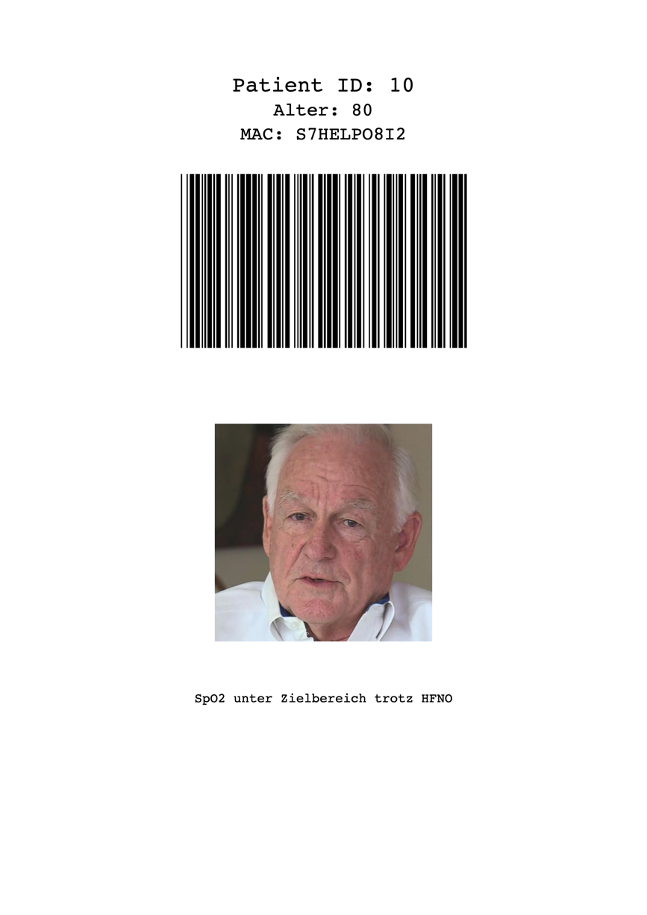

Patient Chart Cover Page
This image shows a cover of a patient chart including ID, age, barcode, image, and indication for ICU therapy. All patient images were obtained from https://this-person-does-not-exist.com/en. The text under the image translates as “SpO2 under target range despite of HFNO”.
SpO2: peripheral Oxygen saturation; HFNO: High-flow Nasal Oxygen

Supplemental Figure S2
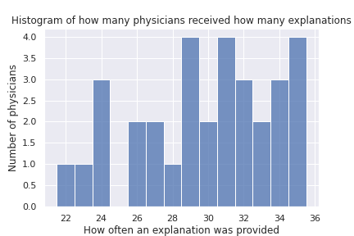

Quality of Randomization
This chart shows the quality of randomization. On the x-axis the number of patients an individual physician received an explanation on is shown (out of 59). The y-axis shows the number of physicians with this number of explanations.

Overall an explanation was provided for 955 patients while no explanation was provided for 933 patients.

Figure S3
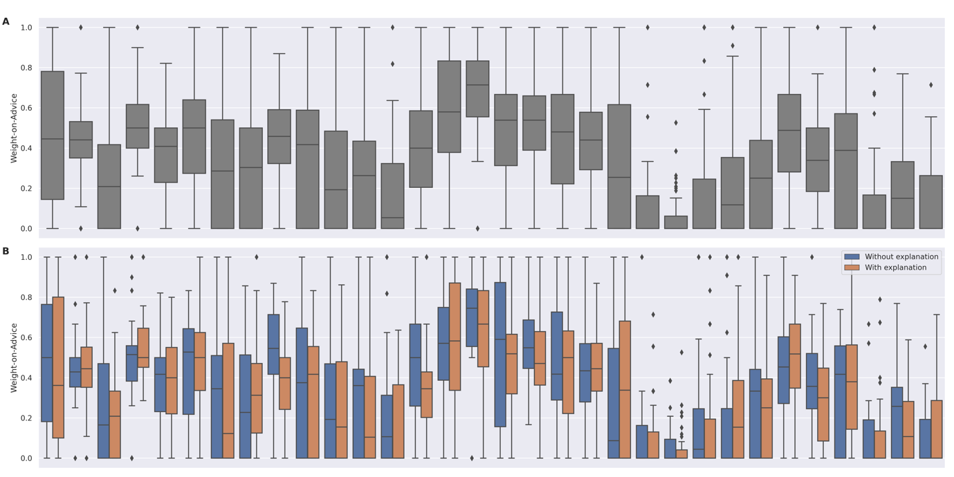

Weight-of-Advice by physician and explanation

Weight-of-Advice grouped by physician (Panel A) and grouped by physician and whether an explanation was provided (Panel B).

Figure S4
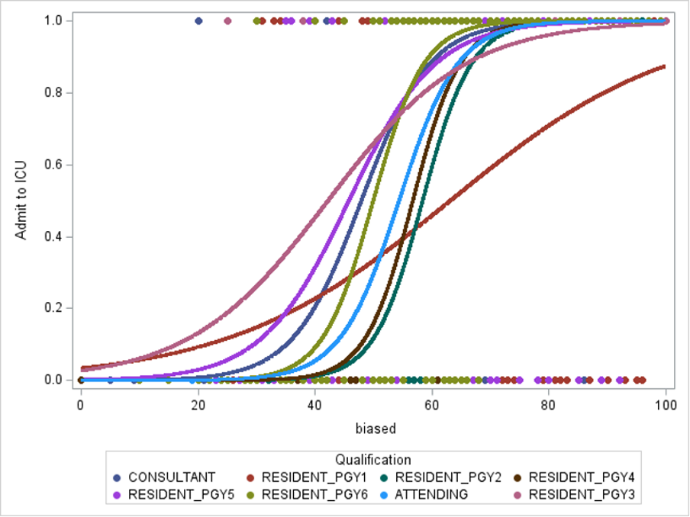
Probability of admission based on rating after advice and level of qualification
The x-axis shows the survival probability given after receiving advice. The y-axis shows ICU admittance.
PGY: Postgraduate Year. Austrian residency lasts for six years.

