The effects of creatine supplementation on cognitive performance - a randomised controlled study

Julia Fabienne Sandkühler^{1, 2}, Dr. Xenia Kersting^{2, 3}, Annika Faust², Eva Kathrin Königs², George Altman⁴, Prof. Dr. Ulrich Ettinger¹, Prof. Dr. Silke Lux², Prof. Dr. Alexandra Philipsen², Prof. Dr. Helge Müller^{2, 5}, Dr. Jan Brauner^{5, 6, 7}

¹ Department of Psychology, University of Bonn, Germany
² Department of Psychiatry and Psychotherapy, University Hospital Bonn, Germany
³ Klinik für Psychiatrie und Psychotherapie, Universitätsmedizin der Johannes Gutenberg-Universität Mainz
⁴ Manchester University NHS Foundation Trust, United Kingdom
⁵ Department of Health, Witten/Herdecke University, Germany
⁶ Department of Computer Science, University of Oxford, United Kingdom
⁷ Future of Humanity Institute, University of Oxford, United Kingdom

Inclusion criteria
All inclusion criteria were self-reported.

- No psychological or physical disorders or disabilities if they are likely to cause instabilities in test scores or interact with creatine
- Age of 18 and above
- Stable eating behaviour, i.e., being either omnivore or
vegetarian/vegan for at least 6 months
- No creatine intake in the last 6 months before the study begins
- Ability to consent
- Alcohol consumption on average not higher than 20g of alcohol per day (if female) or not
more than 40g of alcohol per day (if male)
- No consumption of recreational drugs more than once a week
- Not more than 6 hours of intense sports per week

Excluded data
We excluded the data of one Stroop test of one participant due to a technical error.

We excluded the data of one forward and backward digit span test of one participant because they had evidently cheated.

Histograms of BDS scores

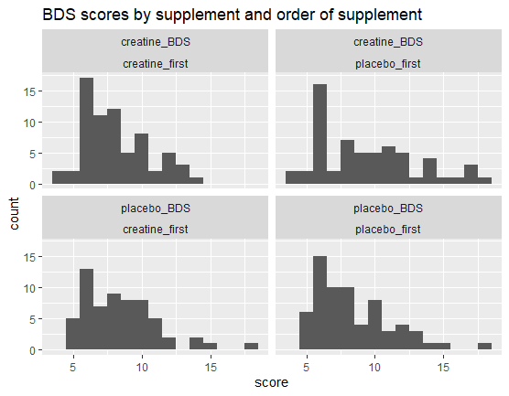

Histograms of RAPM scores
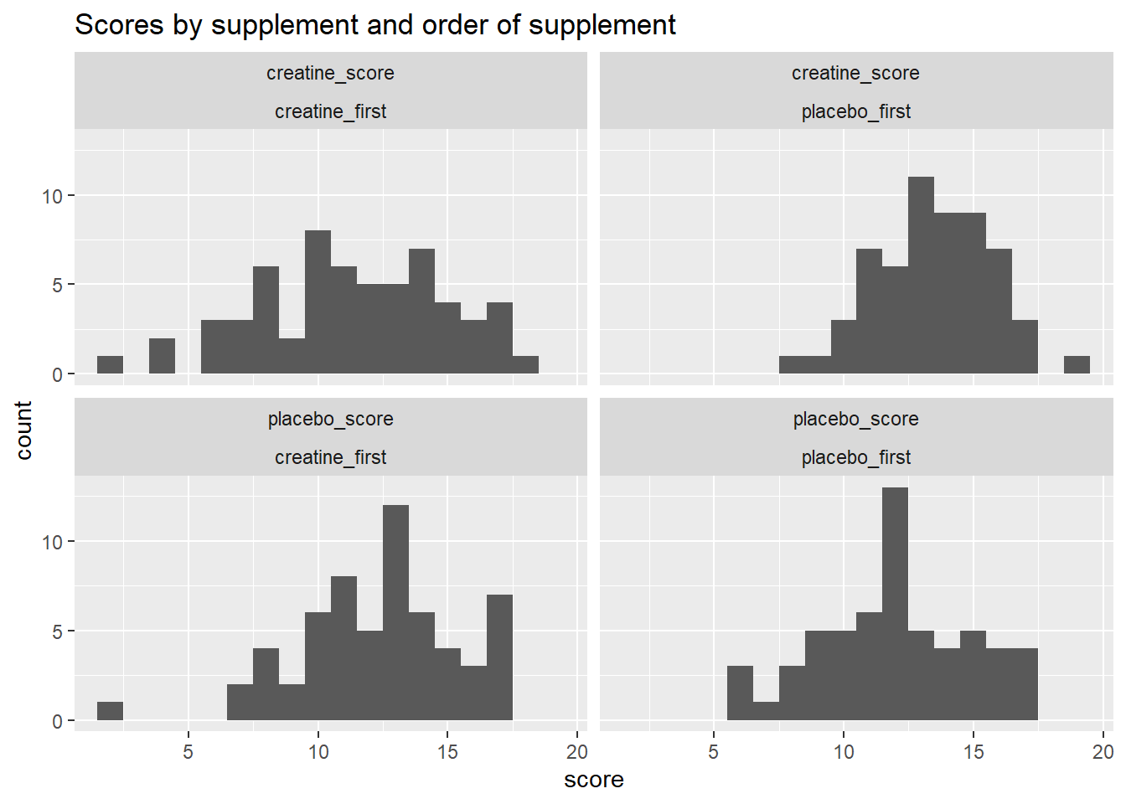

Timeline graphs
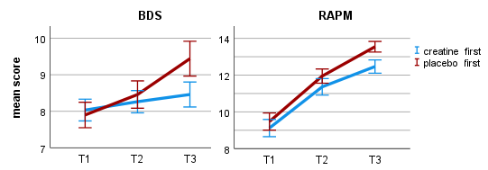
Figure X. a) Estimated marginal means for the Backward Digit Span (BDS) score at the first (baseline), second, and third testing. b) Estimated marginal means for Raven’s Advanced Progressive Matrices (RAPM) score at the first (baseline), second, and third testing. Error bars represent 95% confidence intervals.

Comparing baselines scores between supplement order groups

Test_number | Test_name | p | higher  baseline
Test01 | RAPM (abstract thought) | 0.594 | placebo_first
Test02 | BDS (working memory) | 0.77 | creatine_first
Test03 | blocktapping forward  (working memory) | 0.077 | placebo_first
Test04 | blocktapping backward  (working memory) | 0.718 | placebo_first
Test05 | BVMT-R (working memory) | 0.788 | creatine_first
Test14 | D2 | 0.008 | placebo_first
Test06 | FDS (working memory) | 0.607 | creatine_first
Test07 | Stroop - colors (reaction time) | 0.578 | creatine_first
Test08 | Stroop - colorletters (inhibition) | 0.88 | creatine_first
Test08minus07 | Stroop diff | 0.862 | placebo_first
Test09 | TMTA | 0.252 | creatine_first
Test10 | TMTB | 0.183 | creatine_first
Test11_1 | VLMT SumA1toA5 | 0.436 | placebo_first
Test11_2 | VLMT A5_minus_A6 (short term memory) | 0.716 | placebo_first
Test11_3 | VLMT A5_minus_A7 (long term memory) | 0.338 | placebo_first
Test12 | VLMT formula by Geffen 1990 (recognition memory) | 0.224 | placebo_first
Test13 | word fluency | 0.669 | placebo_first

Normality of BDS and RAPM
The BDS scores included two outliers and the RAPM scores included one outlier, defined as +/- 1.5 interquartile range from the third and first quarter, respectively. Skewness was above 1 (1.14 and 1.06) for two of the four factor combinations for the BDS scores and for no factor combination of the RAPM scores.

Full results table BDS and RAPM

BDS
Threeway ANOVA

Effect | Dfn | Dfd | F | p | pes | ges
diet | 1 | 117 | 0.182 | 0.671 | 0.002000 | 1.00e-03
order_supplement | 1 | 117 | 1.329 | 0.251 | 0.011000 | 9.00e-03
supplement | 1 | 117 | 3.412 | 0.067 | 0.028000 | 5.00e-03
diet:order_supplement | 1 | 117 | 0.402 | 0.527 | 0.003000 | 3.00e-03
diet:supplement | 1 | 117 | 0.060 | 0.808 | 0.000509 | 8.69e-05
order_supplement:supplement | 1 | 117 | 7.586 | 0.007 | 0.061000 | 1.10e-02
diet:order_supplement:supplement | 1 | 117 | 0.343 | 0.559 | 0.003000 | 4.99e-04

Twoway ANOVA
N | N (c_first) | N (p_first) | p (suppl.) | p (suppl.*order) | p (order) | creatine score  est. marg. mean,  std. error | placebo score  est. marg. mean,  std. error
121 | 61 | 60 | 0.064 | 0.007 | 0.246 | 8.85 (0.28) | 8.44 (0.25)

Effect | Dfn | Dfd | F | p | pes | ges | SSn | SSd
(Intercept) | 1 | 119 | 1274 | 2.02e-65 | 0.915 | 0.899 | 18075.796 | 1687.956
order_supplement | 1 | 119 | 1.358 | 0.246 | 0.011 | 0.009 | 19.267 | 1687.956
supplement | 1 | 119 | 3.494 | 0.064 | 0.029 | 0.005 | 10.168 | 346.311
order_supplement *supplement | 1 | 119 | 7.651 | 0.007 | 0.060 | 0.011 | 22.267 | 346.311

RAPM
Threeway ANOVA

Effect | Dfn | Dfd | F | p | pes | ges
diet | 1 | 114 | 0.367 | 5.46e-01 | 0.003 | 0.00300
order_supplement | 1 | 114 | 3.281 | 7.30e-02 | 0.028 | 0.02300
supplement | 1 | 114 | 1.017 | 3.15e-01 | 0.009 | 0.00200
diet:order_supplement | 1 | 114 | 0.530 | 4.68e-01 | 0.005 | 0.00400
diet:supplement | 1 | 114 | 0.739 | 3.92e-01 | 0.006 | 0.00100
order_supplement:supplement | 1 | 114 | 29.138 | 3.72e-07 | 0.204 | 0.04500
diet:order_supplement:supplement | 1 | 114 | 0.268 | 6.06e-01 | 0.002 | 0.00043

Twoway ANOVA

N | N (c_first) | N (p_first) | p (suppl.) | p (suppl.*order) | p (order) | creatine score  est. marg. mean,  std. error | placebo score  est. marg. mean,  std. error
118 | 60 | 58 | 0.327 | < .001 | 0.075 | 12.39 (0.28) | 12.16 (0.28)

Effect | Dfn | Dfd | F | p | pes | ges | SSn | SSd
(Intercept) | 1 | 116 | 2404 | 2.15e-79 | 0.954 | 0.944 | 35546.736 | 1714.997
order_supplement | 1 | 116 | 3.225 | 7.50e-02 | 0.027 | 0.022 | 47.685 | 1714.997
supplement | 1 | 116 | 0.968 | 3.27e-01 | 0.008 | 0.002 | 3.219 | 385.666
order_supplement *supplement | 1 | 116 | 29.231 | 3.49e-07 | 0.201 | 0.044 | 97.185 | 385.666

Post hoc tests of interaction in confirmatory analysis (learning effect)
Post-hoc t-tests of the interactions were conducted with an adjusted significance level of p = 0.05/4 = 0.013. For BDS, they find that participants in the creatine-first group do not improve significantly from timepoint 2 to timepoint 3 (p = 0.437) but participants in the placebo-first group do (p = 0.007), as would be expected if creatine had a beneficial effect. The difference in improvement is d = 0.36 - 0.1 = 0.26. For RAPM, both groups improve significantly from timepoint 2 to timepoint 3, most likely reflecting a learning effect. This improvement is more significant after creatine than placebo (p < .001 compared to p = 0.001) and the difference in improvement is d = 0.55 - 0.44 = 0.11.

task | group | p | d | Creatine M (SD) | Placebo M (SD)
BDS | creatine-first | 0.437 | -0.1 | 8.26 (2.34) | 8.46 (2.67)
BDS | placebo-first | 0.007 | 0.36 | 9.43 (3.63) | 8.42 (2.87)
RAPM | creatine-first | 0.001 | -0.44 | 11.30 (3.65) | 12.35 (3.06)
RAPM | placebo-first | < 0.001 | 0.55 | 13.48 (2.22) | 11.87 (2.91)

Table X.

Cohen’s d - this study and Rae et al. (2003)
In order to compare our study more easily to the study of Rae et al. (2003), we estimated Cohen’s d for the two studies.

Cohen’s d = mean difference/SD of mean difference = mean difference/(SE of mean difference * sqrt(N))

For BDS in our study:
d = 0.41/(0.22*sqrt(121)) = 0.17

For RAPM in our study:
d = 0.23/(0.23*sqrt(118)) = 0.09

For BDS in Rae et al. (2003): 1 to 3 depending on calculation (see below)

For RAPM in Rae et al. (2003): 1 to 3 depending on calculation (see below)

Using this calculator and F and dfs:
- RAPM: Cohen’s f = 1.6, i.e. Cohen’s d = 3.2
- BDS: Cohen’s f = 1.5, i.e. Cohen’s d = 3

Using the same calculator and the raw M(SD) after-supplement scores (but unclear how balanced the order groups were and also Rae used the two baselines too, not just these scores):
- RAPM: Hedges g (basically the same as Cohen’s d) = 1 (sanity check: improvement in raw score = 4, sd = about 4, 4/4 = 1)
- BDS: Hedges g (basically the same as Cohen’s d) = 1 (sanity check: improvement in raw score = 1.5, sd = about 1.5, 1.5/1.5 = 1)

From Rae et al. (2003):
“Supplementation with oral creatine monohydrate significantly increased intelligence (as measured by RAPMs done under time pressure, figure 1a) compared with placebo (F(3 ,33) = 32.3, p , 0.0001; repeated-measures ANOVA). There was no significant effect of treatment
order (F(1 ,33) = 1.62, p = 0.21), although there was a significant interaction with treatment order (F(3 ,99) = 6.7, p = 0.0004). The mean RAPMs raw score under placebo
was 9.7 (s.d. = 3.8) items correct in 10 min versus 13.7 (s.d. = 4.1) items correct under the experimental treatment. Supplementation with oral creatine monohydrate (figure 1b) significantly affected performance on BDS (F(3 ,34) = 29.0, p < 0.0001), with no effect of order (F(3 ,102) = 0.98, p = 0.40). Mean BDS under the placebo was 7.05 items (s.d. = 1.19), compared with a mean of 8.5 items under creatine treatment (s.d. = 1.76).”

Details on the Bayesian analysis

Models
Approach 1, point models: Approach 1 used point models for the null hypothesis and the alternative hypotheses. As the alternative hypothesis was not determined in advance and also to show to what extent the results are robust, we present the results for a range of alternative hypotheses. A point model means that we hypothesise a particular true effect size (0 for the null hypothesis, a number of small effect sizes for the alternative hypotheses). Even though a model postulates one particular effect size, the means expected to be sampled if this model was true would be normally distributed due to sampling error. So, entering a point model results in marginal model predictions that are normal and have the same standard deviation as the observed data.

Approach 2, half normal: Approach 2 compared a point null model against half normal distributions centred on zero and with the standard deviation set to half the maximum expected effect size. This distribution gives little weight to effect sizes that are larger than the maximum expected effect size and it gives more weight to an effect size the smaller it is.

For comparison, the Bayes factor calculations were also done with cauchy distributions.

Calculation 1 - point null and point alternative

The Bayes factor calculator used is here (https://bayesplay.colling.net.nz/) and the instructions on how to use it are here (http://www.lifesci.sussex.ac.uk/home/Zo).

We need the SE of the mean difference between creatine and placebo. To calculate it, I use SE = (mean difference)/t(supplement). To calculate t(supplement), I use t = sqrt(F(supplement)). F(supplement) is the F statistic for the supplement effect in the 2x2 ANOVA with supplement and supplement order.

Backward Digit Span
- F(supplement) = 3.494. So, t = sqrt(3.494) = 1.87.
- Mean difference (see estimated marginal mean of creatine and placebo score) = 8.85-8.44= 0.41.
- SE of mean difference = 0.41/1.87 = 0.22. Sanity check: SEs of creatine and placebo score are similar to SE of mean difference.

Raven’s Advanced Progressive Matrices
  - F(supplement) = 0.968. So, t = sqrt(0.968) = 0.984
  - Mean difference (see estimated marginal mean of creatine and placebo score) = 12.39-12.16 = 0.23
  - SE of mean difference = 0.23/0.984 = 0.23. Sanity check: Similar to SEs given for creatine and placebo score given by describe(my_data2).

Thus entering into the calculator:
- BDS
  - Normal data: mean = 0.41, SD = 0.22
  - Point null = 0
  - Point alternative = 0.1, 0.2, 0.4, 1.7
- RAPM
  - Normal data: mean = 0.23, SD = 0.23
  - Point null = 0
  - Point alternative = 0.1, 0.2, 0.4, 1.7

Results:

Task | 0.1 | 0.2 | 0.4 | 1.7
BDS | 2.1 | 3.6 | 5.7 | 2e-7
RAPM | 1.4 | 1.6 | 1.3 | <2e-7

Calculation 2 - point null and half normal or Cauchy alternative
Data: same as in calculation 1 (normal, mean difference based on estimated means, SD = SE of mean difference)

Null: point 0. This translates to a normal distribution with a mean of 0 and an SE equal to the SE of my data, as can be seen in the advanced output of the calculator.

For the alternative models, set SD to half the size of the smallest unlikely effect, as recommended by Lincoln Colling in private correspondence.

Alternative, small effect size: half normal/cauchy with lower limit of 0. Smallest unlikely effect size in that world: mean difference in raw scores of 0.4-1 (d = 0.2 - 0.4), i.e. 0.4-1 more matrix solved or a 0.25-0.5 longer backward digit span. So, take 0.2-0.5 as SD/scale. Why d = 0.2-0.4 as the maximum? D = 0.2-0.4 would be 3-6 points in an IQ test. That is large for a longterm effect of a supplement and more noticeable than the effect is likely to be based on everyday experience.
- BDS, SD = 0.5
  - Half normal: BF(10) = 3.3
  - Half Cauchy: BF(10) = 2.3
- BDS, SD = 0.2
  - Half normal: BF(10) = 2.9
  - Half Cauchy: BF(10) = 2.6

- RAPM, SD = 0.5
  - Half normal: BF(10) = 1.0
  - Half Cauchy: BF(10) = 0.8
- RAPM, SD = 0.2
  - Half normal: BF(10) = 1.4
  - Half Cauchy: BF(10) = 1.1

Alternative, Rae effect size: half normal/Cauchy with lower limit of 0. Smallest unlikely effect size in that world: Twice that of Rae. So, take Rae’s effect size (corresponding to a mean difference of 1.7 in the most conservative calculation) as SD/scale.
- BDS
  - Half normal: BF(10) = 1.4
  - Half Cauchy: BF(10) = 1.1
- RAPM
  - Half normal: BF(10) = 0.4
  - Half Cauchy: BF(10) = 0.3

Bayesian analysis of Solis et al. (2014)
As mentioned in the discussion, we performed a Bayesian analysis of the data in Solis et al. (2014). Their result was: “vegetarians and omnivores had comparable brain total Cr content (5.999 (SD 0.811) v. 5.917 (SD 0.665) IU, respectively; P=0.77)”.

Enter into calculator:
Normal data: mean = -0.082, SD = 0.197
Alternative models:
- point 0.3
- point 0.5
- half normal centred on 0 with SD = 0.3
- half normal centred on 0 with SD = 0.5
Null model: point 0

Alternative model | Point 0.3 | Point 0.5 | half normal centred on 0 with SD = 0.3 | half normal centred on 0 with SD = 0.5
BF(10) | 0.17 | 0.01 | 0.42 | 0.28

Calculations:

Data
- The difference in brain creatine content was 5.917-5.999 = -0.082.
- The participants were 14 vegetarians and 14 omnivores.
- The pooled SD was (0.665+0.811)/2 = 0.738.
- SE = SD/sqrt(N) = 0.738/sqrt(14) = 0.197

What are reasonable alternative hypotheses?
- The nine studies reviewed by Dolan et al. on the effect of supplementing creatine on brain creatine content found it increased by 5-10%.
- 5-10% for the brain creatine content measured by Solis et al. (2014) would be about 0.3 to 0.6 (6*0.05 to 6*0.1).

Bayesian analysis of Solis et al. (2017)
The results were virtually the same as Solis et al. (2014) - the vegetarian group had a non-significantly higher brain creatine content. Same or very similar N, very similar p-value. The Bayes factors can only be very similar.

Details on the analysis of diet

Test_number | Test_name | p (suppl.* diet) | p (suppl.*diet  * suppl-order) | p (suppl.)  OMNI group | p (suppl.)  VEG group
Test01 | RAPM (abstract thought) | 0.392 | 0.606 | 0.185 | 0.917
Test02 | BDS (working memory) | 0.808 | 0.559 | 0.13 | 0.276
Test03 | blocktapping forward  (working memory) | 0.862 | 0.976 | 0.943 | 0.761
Test04 | blocktapping backward  (working memory) | 0.275 | 0.894 | 0.276 | 0.588
Test05 | BVMT-R (working memory) | 0.806 | 0.636 | 0.557 | 0.792
Test14 | D2 | 0.261 | 0.578 | 0.06 | 0.881
Test06 | FDS (working memory) | 0.514 | 0.767 | 0.504 | 0.825
Test07 | Stroop - colors (reaction time) | 0.601 | 0.974 | 0.557 | 0.856
Test08 | Stroop - colorletters (inhibition) | 0.853 | 0.156 | 0.682 | 0.805
Test08minus07 | Stroop diff | 0.923 | 0.174 | 0.889 | 0.705
Test09 | TMTA | 0.008 | 0.223 | 0.003 | 0.471
Test10 | TMTB | 0.206 | 0.584 | 0.427 | 0.322
Test11_1 | VLMT SumA1toA5 | 0.495 | 0.916 | 0.713 | 0.553
Test11_2 | VLMT A5_minus_A6 (short term memory) | 0.624 | 0.11 | 0.856 | 0.584
Test11_3 | VLMT A5_minus_A7 (long term memory) | 0.71 | 0.71 | 0.389 | 0.586
Test12 | VLMT formula by Geffen 1990 (recognition memory) | 0.799 | 0.492 | 0.672 | 0.944
Test13 | word fluency | 0.235 | 0.391 | 0.989 | 0.13

Robust ANOVA with bootstrapping and 20% trim
Test_number | Test_name | p (suppl.*diet) | p (suppl.)  OMNI group | p (suppl.)  VEG group
Test01 | RAPM (abstract thought) | 0.447 | 0.182 | 0.448
Test02 | BDS (working memory) | 0.88 | 0.232 | 0.364

Bayesian analysis
Enter into calculator:
- Mean difference between veg group (creatine minus placebo) and omni group (creatine minus placebo), using estimated marginal means
- SE of mean difference

RAPM
- Mean difference: 0.0355-0.446 = -0.4105
  - Omni: (-0.965+1.857)/2 = 0.446
  - Veg: (-1.129+1.2)/2 = 0.0355
- SD of mean difference: (2.095+2.876+2.642+2.683)/4 = 2.57
- SE of mean difference: 2.57/sqrt(118) = 0.23
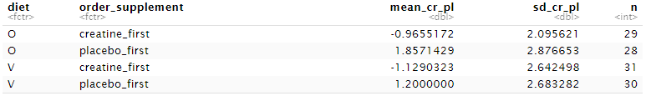

BDS
- Mean difference: 0.354-0.4625 = -0.1085
  - Omni: (-0.275+1.2)/2 = 0.4625
  - Veg: (-0.125+0.833)/2 = 0.354
- SD of mean difference: (1.943+2.618+2.012+2.995)/4 = 2.39
- SE of mean difference: 2.39/sqrt(121) = 0.22
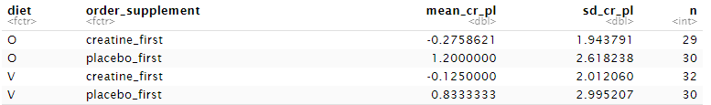

Compare point null hypothesis to the same small effect sizes used for the Bayes factors of the confirmatory analysis in the manuscript and to the effect size of Benton and Donohoe (2011), who found that creatine was more beneficial for vegetarians than for omnivores.

Calculate the effect size of Benton and Donohoe (2011)
“However, after 4 d of consuming the creatine supplement, memory was better in vegetarians rather than in those who consumed meat (F(1, 118) = 5.06; p < 0.03).”

Using this calculator and F and dfs:
- memory: Cohen’s f = 0.18, i.e. Cohen’s d = 0.36
- D = 1 corresponds to a difference in raw scores of 2.5 in our study.
- I.e. d = 0.36 corresponds to about 2.5/3 = 0.8 difference in raw scores in our study.

 | Approach 1: point models |  |  |  | Approach 2: half normal
 | Small effects |  |  | BD-sized | Small effects |  | Max. = 2xBD-size
Task | 0.1 | 0.2 | 0.4 | 0.8 | max. 0.4 | max. 1 | max. 1.6
BDS | 0.72 | 0.42 | 0.08 | < 2e-7 | 0.58 | 0.29 | 0.19
RAPM | 0.42 | 0.15 | 0.01 | < 2e-7 | 0.36 | 0.16 | 0.10

Details on the analysis of exploratory cognitive tasks
There was no indication that creatine improved performance in our additional exploratory cognitive tasks.

Test_name | N | N (c_first) | N (p_first) | p (suppl.) | p (suppl.*order) | p (order) | creatine score  est. marg. mean,  std. error | placebo score  est. marg. mean,  std. error
blocktapping forward  (working memory) | 71 | 37 | 34 | 0.779 | 0.779 | 0.591 | 10.61 (0.26) | 10.54 (0.24)
blocktapping backward  (working memory) | 70 | 37 | 33 | 0.83 | 0.525 | 0.513 | 9.62 (0.31) | 9.69 (0.24)
BVMT-R (working memory) | 119 | 61 | 58 | 0.543 | 0.997 | 0.859 | 31.42 (0.41) | 31.19 (0.45)
D2 | 104 | 51 | 53 | 0.394 | < .001 | 0.363 | 226.27 (4.19) | 227.91 (4.23)
FDS (working memory) | 117 | 60 | 57 | 0.714 | 0.133 | 0.796 | 9.28 (0.22) | 9.34 (0.22)
Stroop - colors (reaction time) | 118 | 60 | 58 | 0.813 | 0.039 | 0.885 | 44.45 (1.20) | 44.70 (1.22)
Stroop - colorletters (inhibition) | 119 | 60 | 59 | 0.626 | 0.05 | 0.971 | 67.59 (1.38) | 67.12 (1.28)
Stroop diff | 118 | 60 | 58 | 0.736 | 0.415 | 0.883 | 23.00 (0.97) | 22.66 (0.94)
TMTA | 123 | 62 | 61 | 0.129 | 0.106 | 0.393 | 22.54 (0.63) | 21.76 (0.65)
TMTB | 122 | 62 | 60 | 0.855 | 0.004 | 0.074 | 53.12 (1.98) | 53.41 (2.01)
VLMT SumA1toA5 | 119 | 60 | 59 | 0.87 | 0.49 | 0.289 | 63.20 (0.73) | 63.11 (0.76)
VLMT A5_minus_A6 (short term memory) | 119 | 60 | 59 | 0.847 | 0.454 | 0.069 | 1.11 (0.15) | 1.14 (0.17)
VLMT A5_minus_A7 (long term memory) | 118 | 60 | 58 | 0.301 | 0.389 | 0.478 | 1.38 (0.17) | 1.18 (0.17)
VLMT formula by Geffen 1990 (recognition memory) | 117 | 59 | 58 | 0.722 | 0.017 | 0.159 | 0.86 (0.1) | 0.85 (0.1)
word fluency | 122 | 60 | 62 | 0.227 | 0.928 | 0.435 | 25.47 (0.60) | 24.84 (0.61)

 | BWTRIM (20% trimmed ANOVA) | winsorised 5% | winsorised 20% | SPPB (bootstrapped and  20% trimmed ANOVA)
Test_name | p (suppl.) | p (suppl.) | p (suppl.) | p (suppl.)
blocktapping forward  (working memory) | 0.564 | 0.865 | 0.678 | 0.826
blocktapping backward  (working memory) | 0.87 | 0.482 | 0.482 | 0.59
BVMT-R (working memory) | 0.809 | 0.746 | 0.112 | 0.67
D2 | 0.382 | 0.446 | 0.291 | 0.62
FDS (working memory) | 0.795 | 0.838 | 0.721 | 0.52
Stroop - colors (reaction time) | 0.184 | 0.432 | 0.054 | 0.568
Stroop - colorletters (inhibition) | 0.877 | 0.861 | 0.547 | 0.856
TMTA | 0.040 | 0.068 | 0.021 | 0.224
TMTB | 0.622 | 0.745 | 0.567 | 0.560
VLMT SumA1toA5 | 0.744 | 0.996 | 0.883 | 0.996
VLMT A6 (short term memory) | 0.622 | 0.854 | 0.323 | 0.806
VLMT A7 (long term memory) | 0.346 | 0.462 | 0.133 | 0.540
VLMT formula by Geffen 1990 (recognition memory) | 0.327 | 0.398 | 0.635 | 0.348
word fluency | 0.631 | 0.272 | 0.119 | 0.692

Second supplementation and high-baseline participants
To investigate the effect of the first supplementation, we conducted a mixed ANOVA with time (baseline and testing after first supplementation) as the within-subjects variable, first supplement as the between-subjects variable and test score as the dependent variable. For the second supplementation, the same ANOVA was conducted except with time (baseline and testing after second supplementation) as the within-subjects variable and second supplement as the between-subjects variable. We performed these ANOVAs with the assumption of normality as well as a robust version.

To investigate the effect of baseline performance, we split participants at the median score (for each cognitive task separately) into low and high baseline participants and conducted separate ANOVAs for each group.

For both cognitive tasks, the effect of creatine was more positive after the second supplementation than the first supplementation. This pattern was more pronounced for BDS than for RAPM (Table X). For BDS but not RAPM, high baseline participants showed a robust creatine effect while low baseline participants did not. These exploratory results suggest that creatine might have a greater effect when performance at or familiarity with a task is high. Of course, this analysis was not preregistered and the result may not reproduce.

Task |  | p (creatine effect)
 | Best | normal | robust | Best | normal | robust | Best | normal | robust | Best | normal | robust
 | First supplementation |  |  | Second supplementation |  |  | Low baseline  participants |  |  | High baseline  participants
RAPM | pl | 0.649 | 0.476 | crea | 0.221 | 0.19 | crea | 0.837 | 0.872 | crea | 0.25 | 0.966
BDS | pl | 0.395 | 0.846 | crea | 0.013 | 0.246 | pl | 0.971 | 0.862 | crea | 0.018 | 0.052
Table X. Creatine effect p-values (two-tailed) for different ANOVAs, looking at the first and the second supplementation separately and at low- and high-baseline participants separately. Better score given as pl = placebo and crea = creatine. Only complete participants are included. The robust ANOVA uses bootstrap and 20% trim. For the first and second supplementation ANOVAs, the creatine effect is the supplement*time interaction. Time includes the baseline and the score after the first or second supplementation, respectively. For the ANOVAs split by baseline, the creatine effect is the supplement main effect.

Exploratory tasks: Low vs high baseline participants
Test_name | p (suppl.)  LOW baseline group | p (suppl.)  HIGH baseline group | same  direction
blocktapping forward  (working memory) | 0.822 | 0.852 | yes
blocktapping backward  (working memory) | 0.176 | 0.244 | no
BVMT-R (working memory) | 0.931 | 0.116 | no
D2 | 0.633 | 0.336 | yes
FDS (working memory) | 0.124 | 0.875 | no
Stroop - colors (reaction time) | 0.695 | 0.978 | yes
Stroop - colorletters (inhibition) | 0.735 | 0.469 | no
Stroop diff | 0.847 | 0.602 | no
TMTA | 0.062 | 0.972 | NA
TMTB | 0.282 | 0.488 | no
VLMT SumA1toA5 | 0.867 | 0.554 | no
VLMT A5_minus_A6 (short term memory) | 0.346 | 0.709 | no
VLMT A5_minus_A7 (long term memory) | 0.8 | 0.113 | no
VLMT formula by Geffen 1990 (recognition memory) | 0.87 | 0.493 | no
word fluency | 0.404 | 0.031 | no

Demographic and context variables
Participants filled out a questionnaire on their daily condition (including sleep, food, caffeine, and infections) before each testing. Before the baseline testing, they filled out the Edinburgh Handedness Inventory (Oldfield, 1971) and performed a test of crystallised intelligence called “Mehrfach-Wahl-Wortschatztest (MWT-B)” (Lehrl, 2005).

There was no indication that women benefited more from creatine than did men. There was not enough variation in adherence nor in sleep to justify analysing an effect of these variables. There was no indication that creatine affected different age groups differently, but this could very well be because we did not have enough older participants to study this question well (median = 28 years). We did not investigate any other demographic or context variables.

Details on reasons for correct guesses of supplement order
The only participants we asked were the 33 second round participants
- 11 of those stated solubility among their reasons for their guess and of those, 9(!) guessed correctly
- 4 people mentioned negative side effects as a reason and all of them guessed correctly. One of them had also mentioned solubility as a reason.
- 9 people mentioned positive side effects among their reasons and of those, 6 guessed correctly. 3 of them had also mentioned solubility (and guessed correctly)

--> Solubility and negative side effects seem to lead to correct guesses, while just positive effects don't. But solubility was mentioned almost three times more often as a reason than negative effects. However, when we break this down further we can see that two participants mentioned as positive effects a clear increase in muscle and they guessed correctly. These were two participants who exercised hard and almost exceeded our exercise limit. I don’t think their correct guess was a coincidence.

IQ point calculation
This comparison with IQ points is made to give the reader an intuition on how big or small the effect sizes of the confirmatory analyses are. The cognitive tasks given in this study did not constitute an IQ test. If they did, the improvement in terms of IQ points would be the raw difference between the estimated marginal means of the creatine and the placebo scores. To calculate what the effect would be if it was an IQ test, we divide the raw difference between the estimated marginal means of the creatine and the placebo scores by the standard deviation of a representative sample and multiply by the standard deviation of IQ, which is 15. As a sanity check, we additionally perform the same calculation but with our own baseline standard deviation instead of the standard deviation of the representative sample.

BDS
The difference in the estimated marginal means creatine and placebo scores in our study was 0.41.

Normative data: Monaco et al. (2013), Forward and backward span for verbal and visuo-spatial data: standardization and normative data from an Italian adult population
There is an important difference to our study: We always gave participants two sequences of the same length, they only gave a second sequence of the same length if the first one was incorrect. As participants either get both sequences of the same length right or both wrong most of the time, this means that the same digit span produces a mean and a standard deviation that are both twice as high in our study compared to Monaco et al. (2013). So, we divide their SD by two. The SD for ages 20-30 is 1.25, times 2 is 2.5.

Calculation with SD from normative data:
0.41/2.5 = 0.164
0.164*15 = 2.5 IQ points

Our own baseline SD was also 2.50, giving the same result.

RAPM
The difference in the estimated marginal means creatine and placebo scores in our study was 0.23.

Calculation with our own baseline SD of 3.53:
0.23/3.53 = 0.065
0.065 * 15 = 1.0 IQ points

