Additional file 3:
Figure S1. Overall Survival Rates in Women with Breast Cancer Across the Two Time Periods by Age Group. (a) 40-49, (b) 50-54, (c) 55-59, (d) 60-64, (e) 65-69

- 40-49
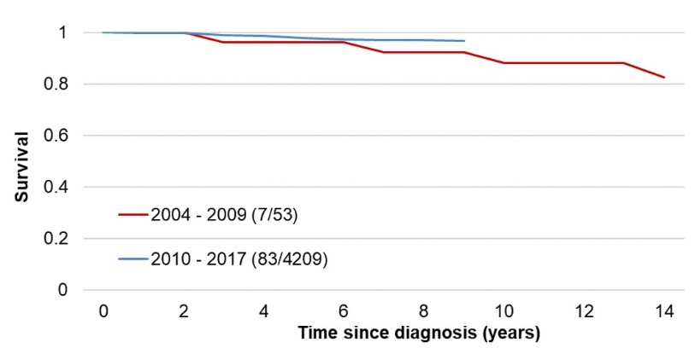
- 50-54
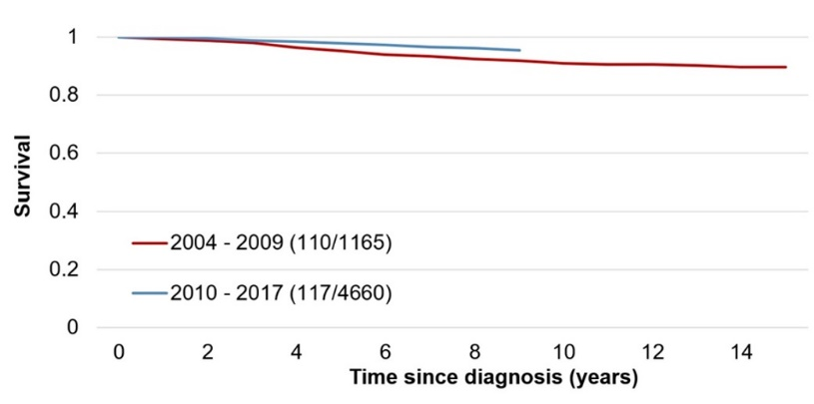
- 55-59
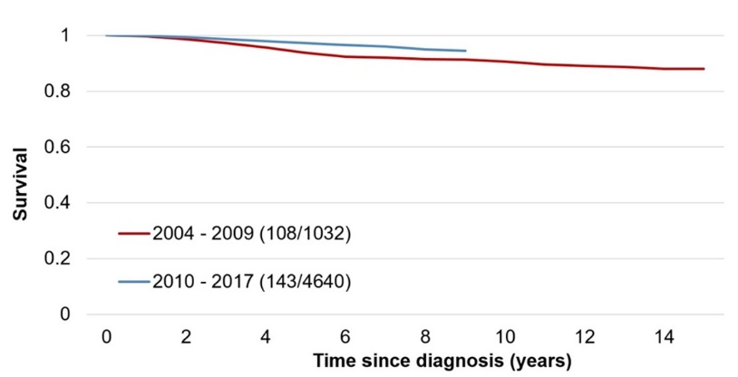
- 60-64
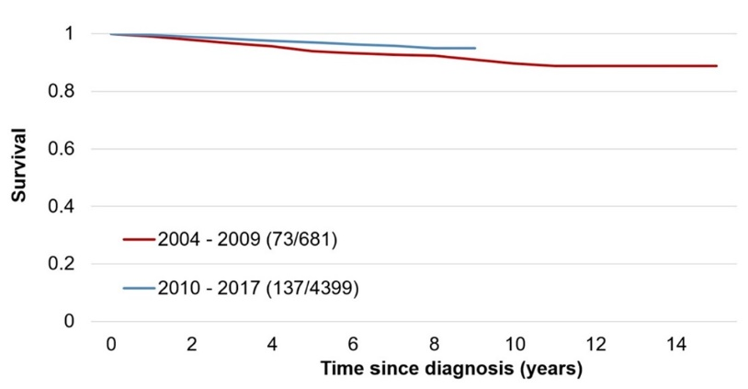
- 65-69
