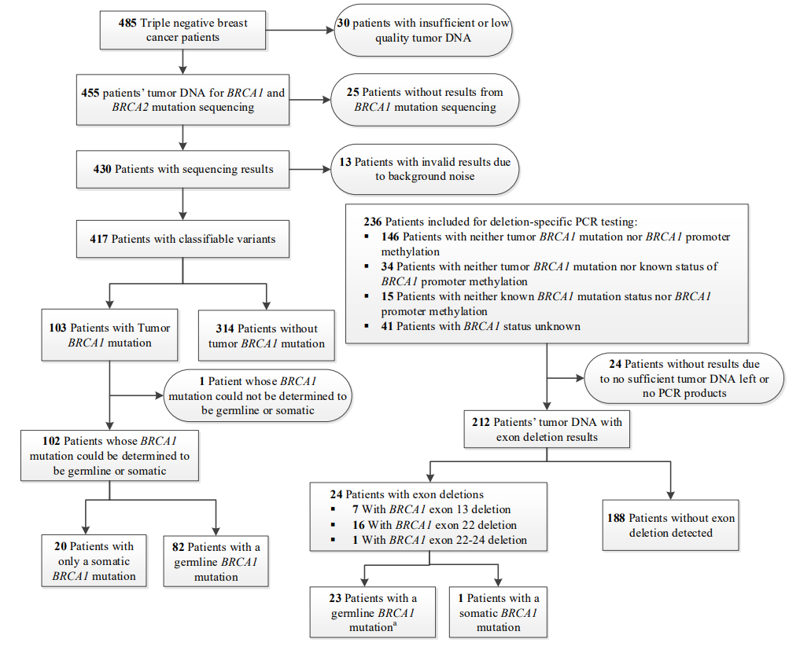
Figure S1. Flow chart of tumor BRCA1 mutation testing
ª Among the 23 cases with germline BRCA1 exon deletion, 3 were failed to be confirmed due to no germline tissue/DNA available. An expert geneticist suggested to treat them as germline, since these are recognized as common germline mutations.

