SUPPLEMENTARY MATERIAL 6 Forest plot for effect sizes of the association between daily routine disruptions (combined across types) and psychiatric symptoms.
Fig. 1 Forest plot for effect sizes of routine disruptions on depressive symptoms.
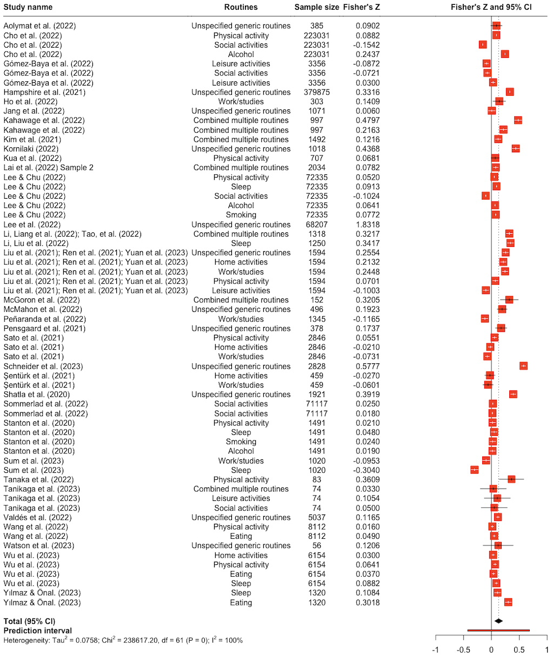
Fig. 2 Forest plot for effect sizes of routine disruptions on anxiety symptoms.
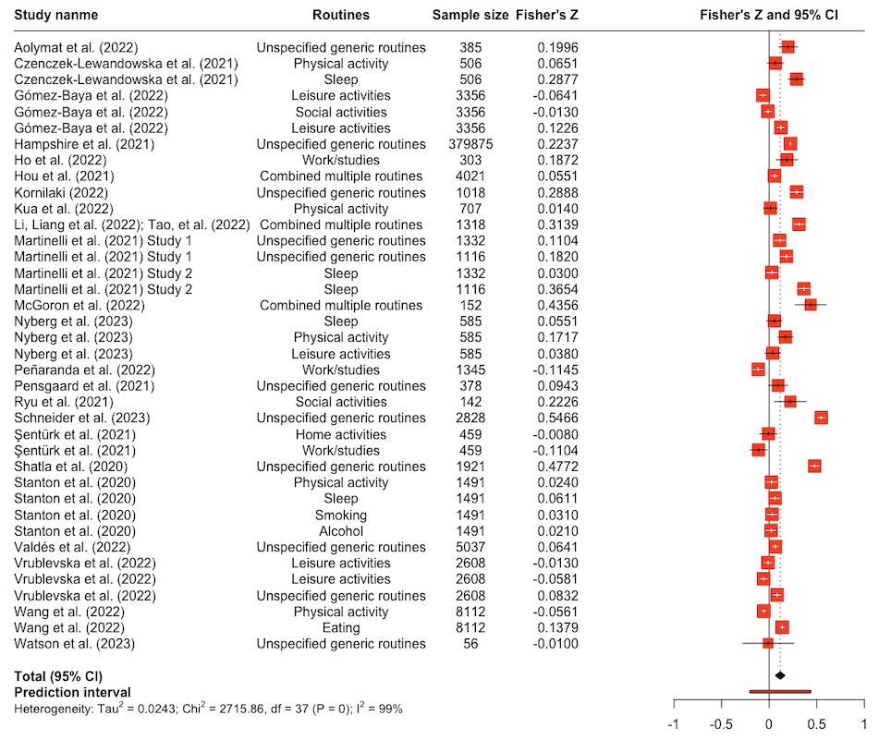

Fig. 3 Forest plot for effect sizes of routine disruptions on posttraumatic stress disorder (PTSD) symptoms.
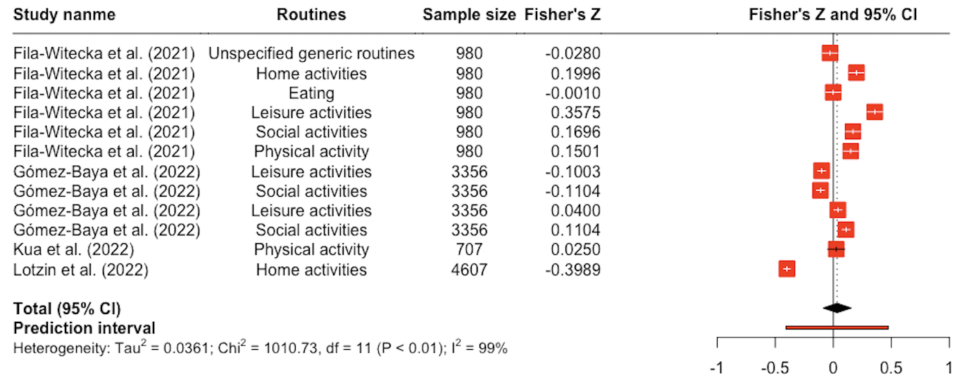

Fig. 4 Forest plot for effect sizes of routine disruptions on depressive and anxiety symptoms.
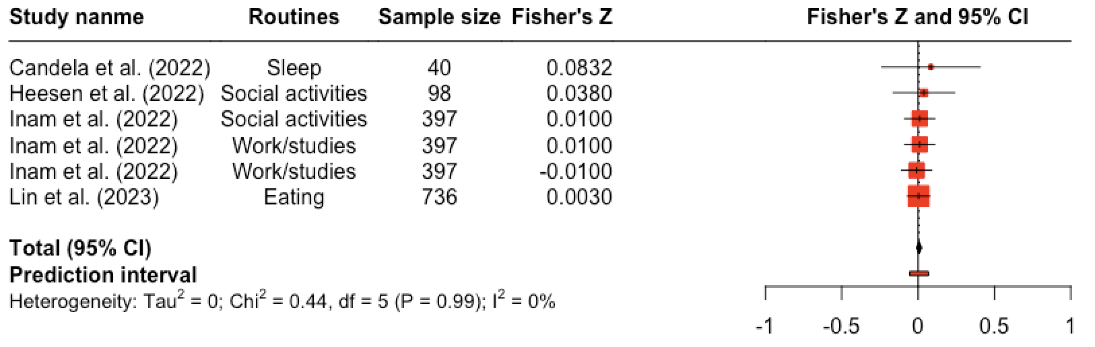

Fig. 5 Forest plot for effect sizes of routine disruptions on general psychological distress.
