SUPPLEMENTARY MATERIAL 7 Funnel plots.
Fig. 1 Depressive symptoms.
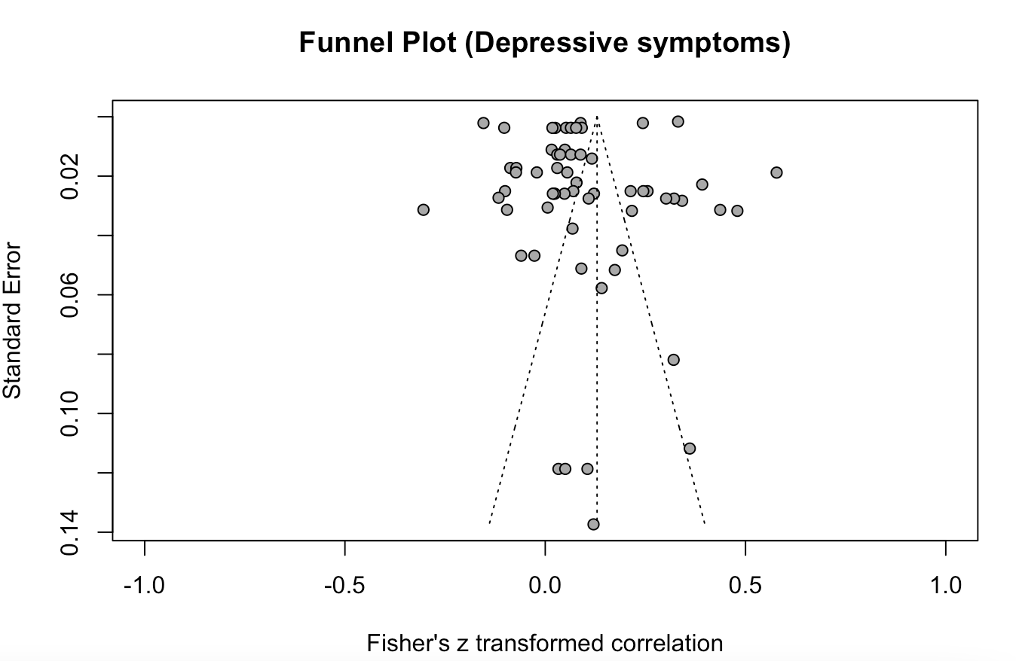

Fig. 2 Anxiety symptoms.
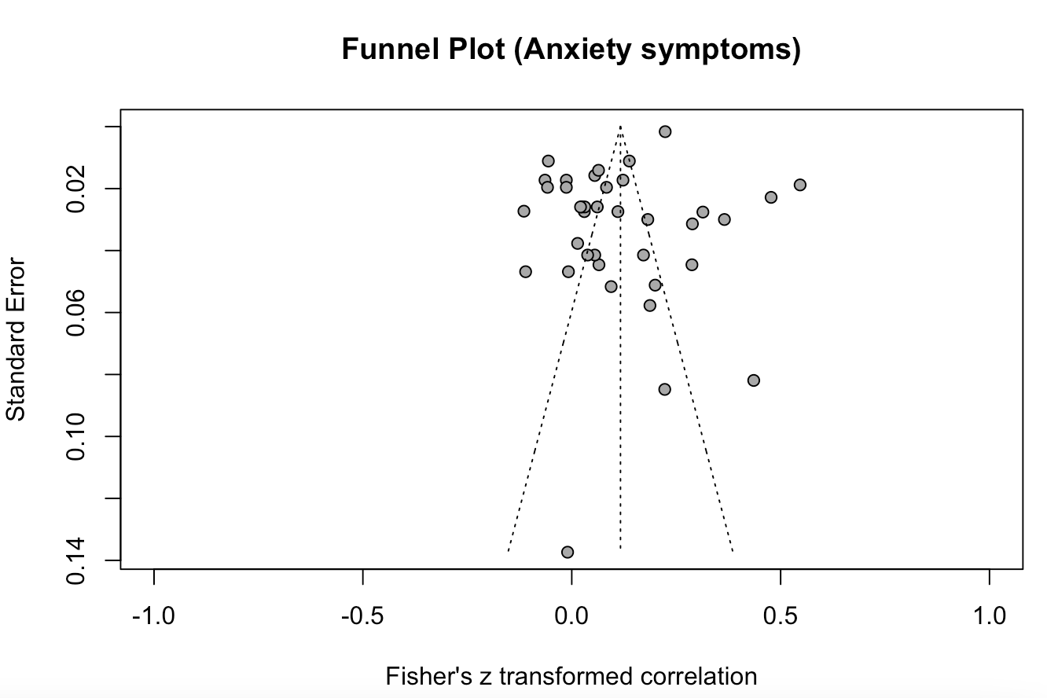

Fig. 3 Posttraumatic stress disorder (PTSD) symptoms.
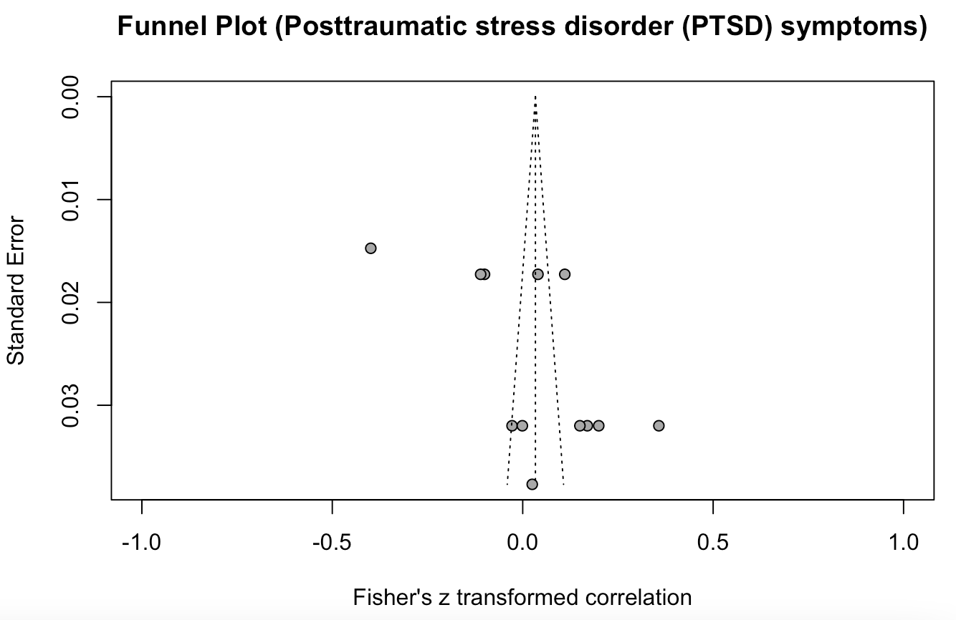

Fig. 4 Depressive and anxiety symptoms.
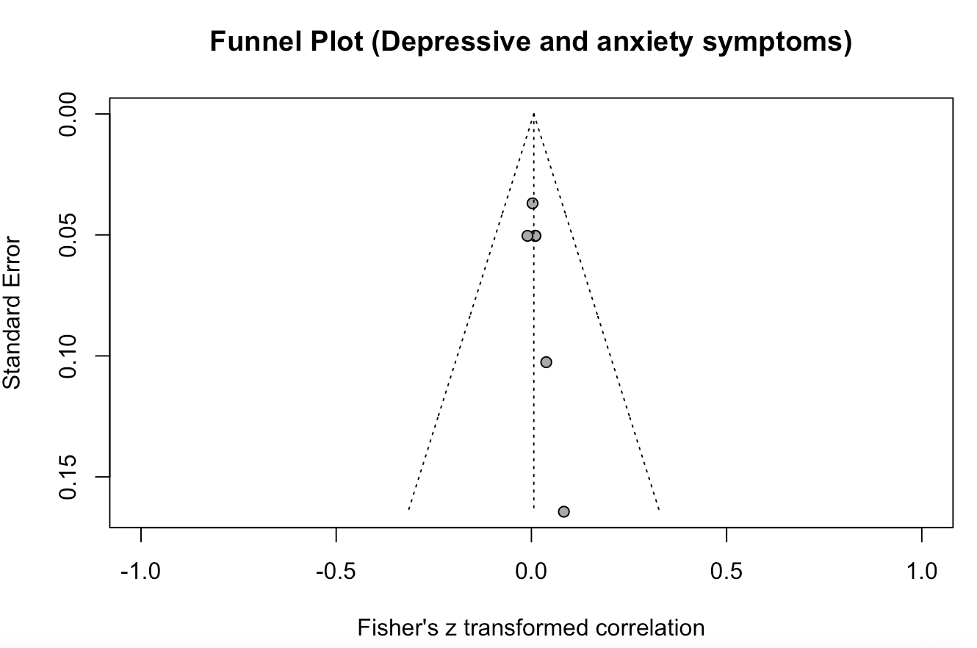

Fig. 5 General psychological distress.
